

Powered by Crisp Analytics

GIT Documentation

### **Technical Design Document**

v1.1

**Document Control**

|  |  |  |  |
| --- | --- | --- | --- |
| **Version** | **Author** | **Published Date** | **Remarks** |
| 1.0 | Shaik Muhammad Irfan | Feb 23, 2022 | Initial Draft |

# 

# Table Of Contents

Exercise 1 4

Exercise 2 5

# Exercise 1

Individual Level Assignment, provide the ss for every command that you will perform

1. Create a new folder

Created a new folder Git_assig in git using command

mkdir Git_assig

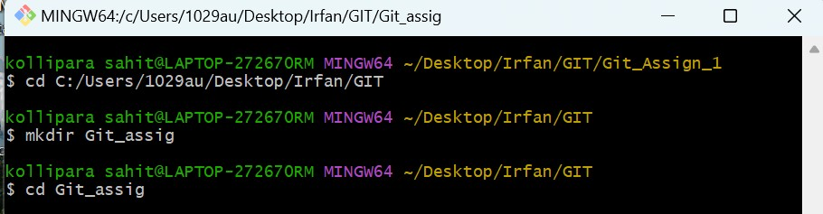

# 

# 

1. Initialize an empty git repository.

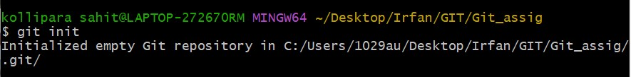git init command is used to initialize an empty repository.

1. Create more than 2 files in that folder.

Three files are created inside the folder namely index.html, index.css, and text.txt.

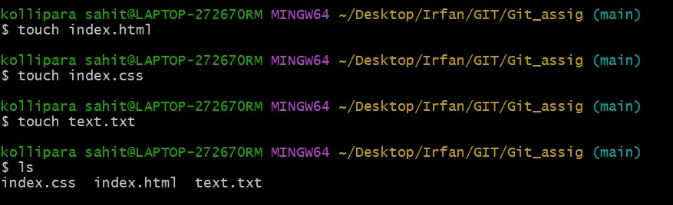

1. Push your changes.

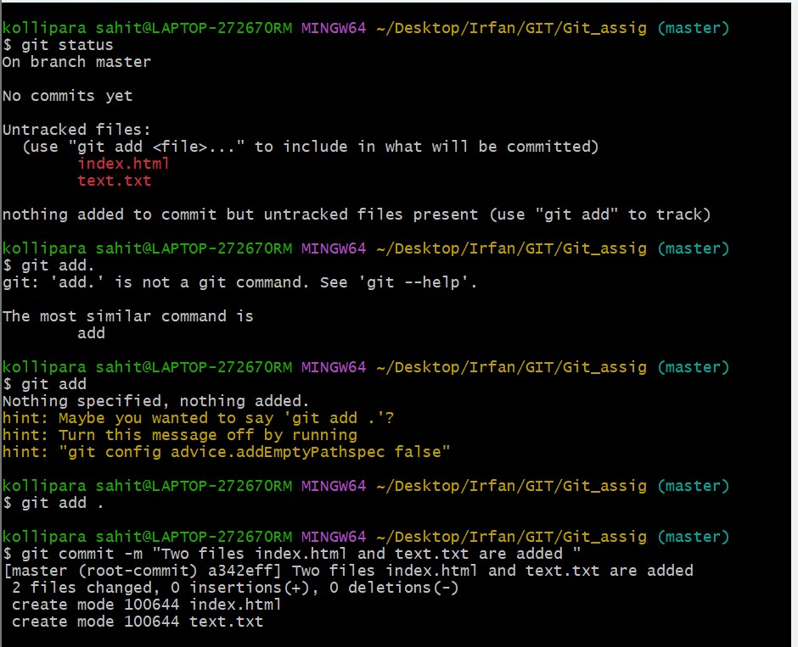

1. Create a scenario of conflicts, solve those conflicts and push

Creating a conflict scenario in html and css files by modifying the same lines of code in both the master and Irfan branches.

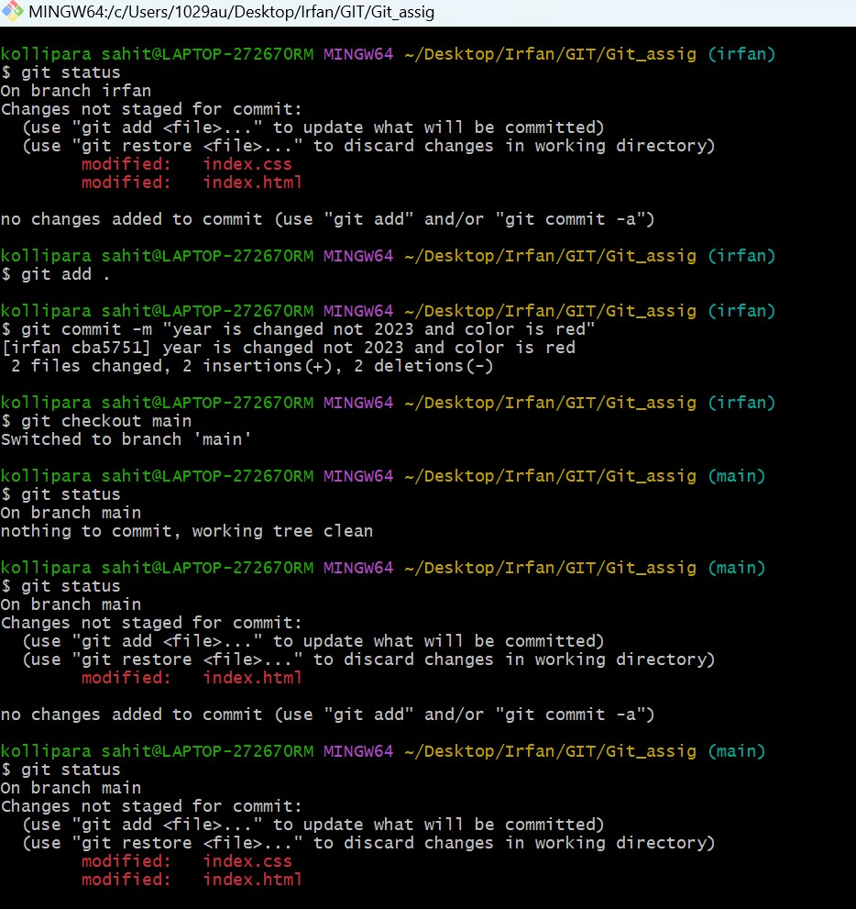

Arise of conflict while trying to merge the irfan and main branches.

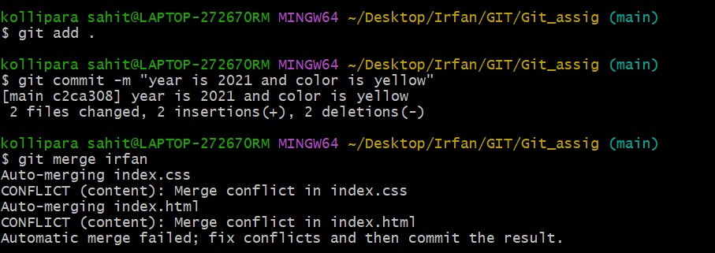

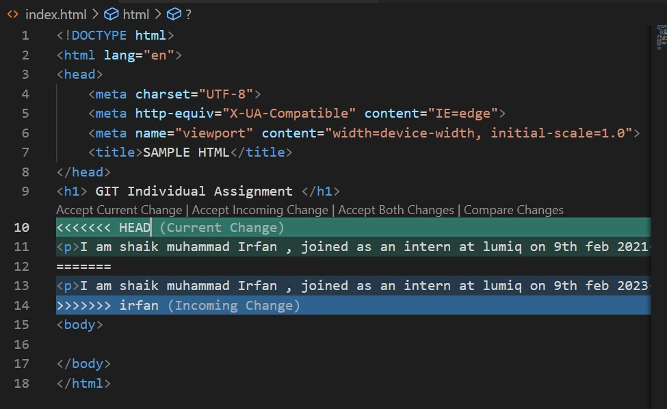

Conflict in HTML.

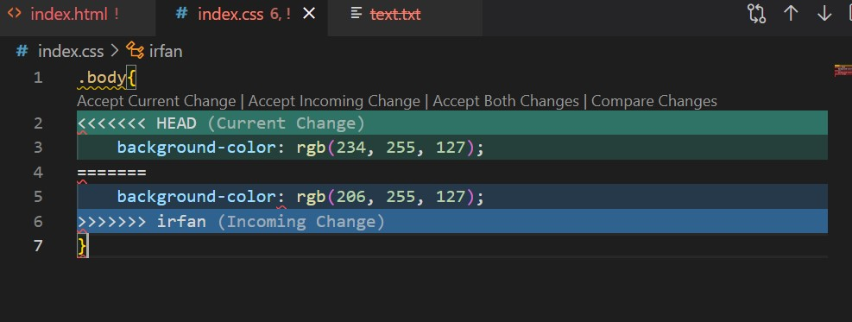

Conflict in CSS.

Resolving the conflict by accepting the incoming correct changes.

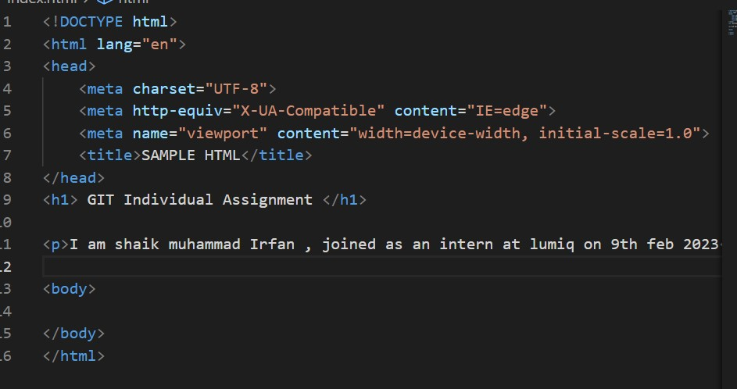

Resolved html conflict.



Resolved CSS conflict.

1. Revert changes and push the previous committee

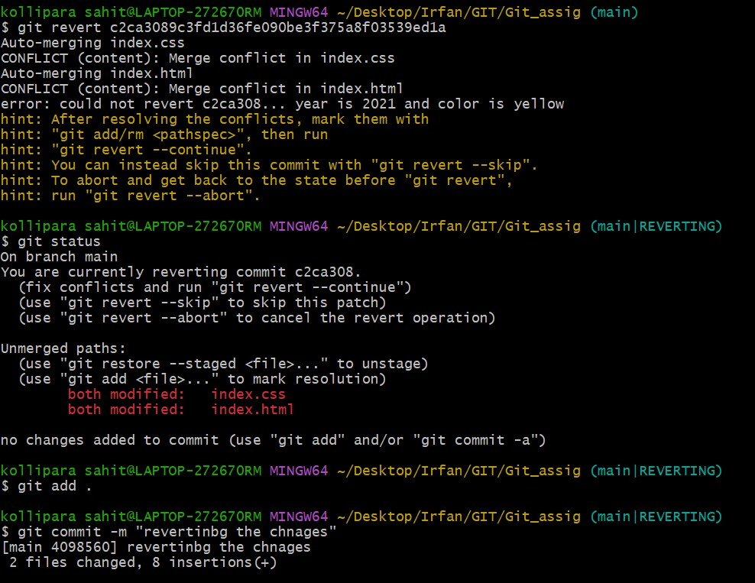

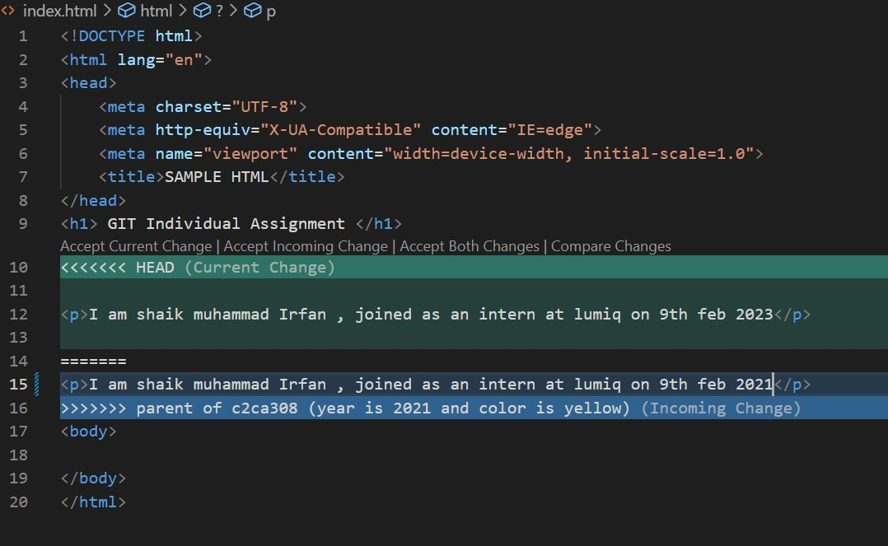reverted to the previous version and pushed the previous commit’s.

Reverted to the previous version(HTML).

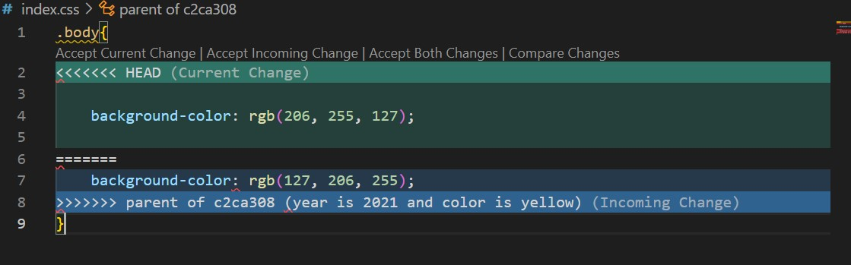

Reverted to the previous version(CSS).

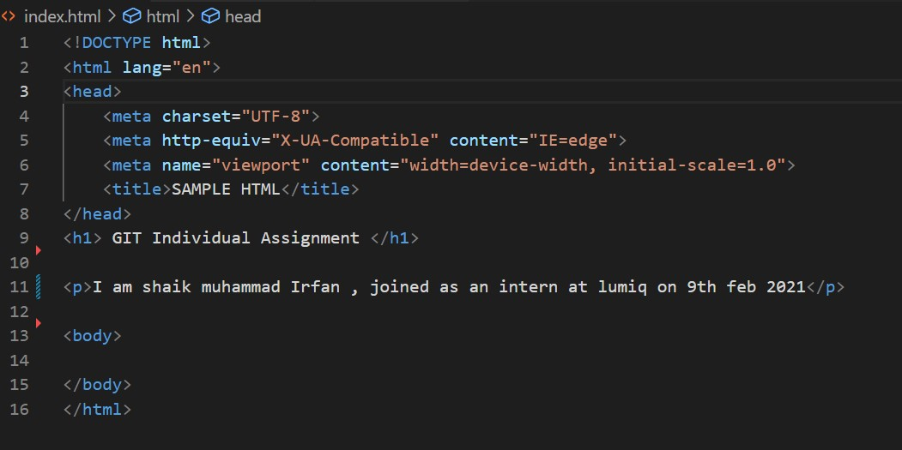

Back to the previous state after pushing the previous commits (HTML)

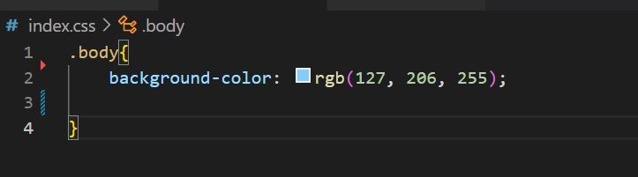

Back to the previous state after pushing the previous commits (CSS)

1. 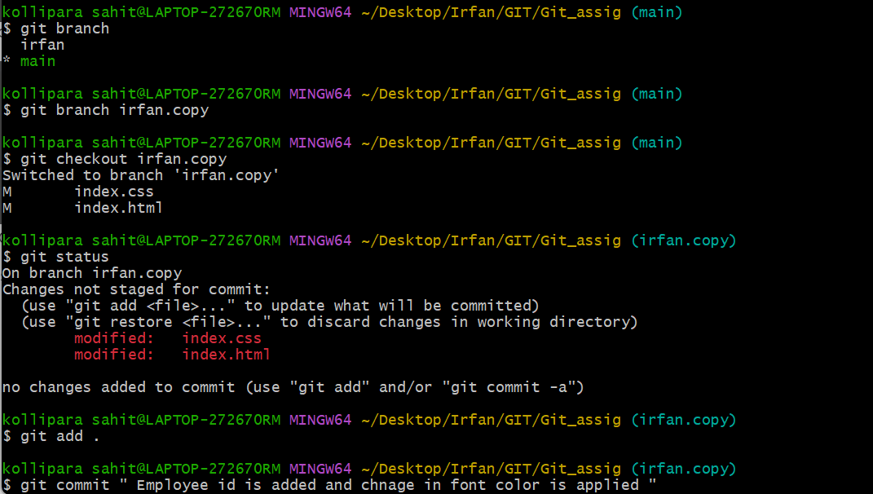Create multiple branches to add new features and merge those features into the main branch

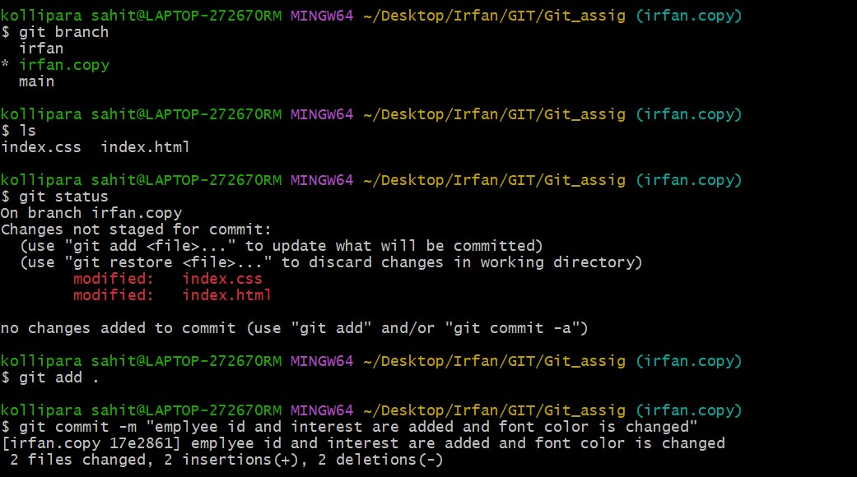 Multiple branches are created

Additional features are added from the new branch.

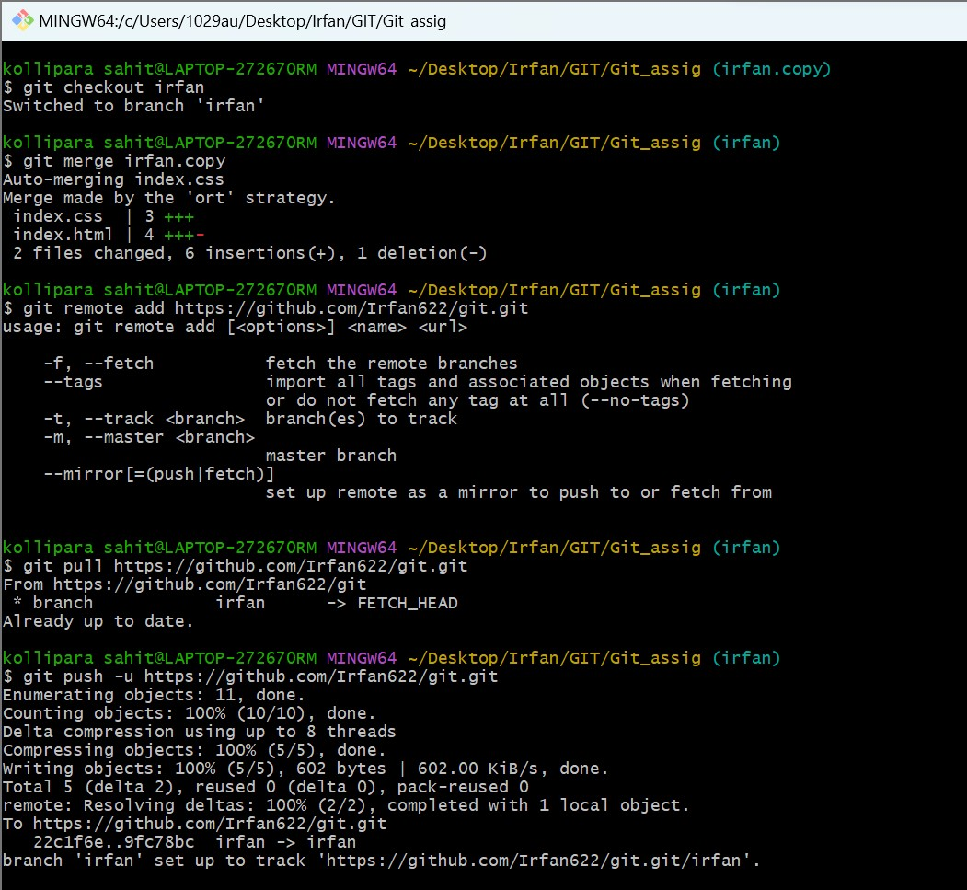 Merging the new branch

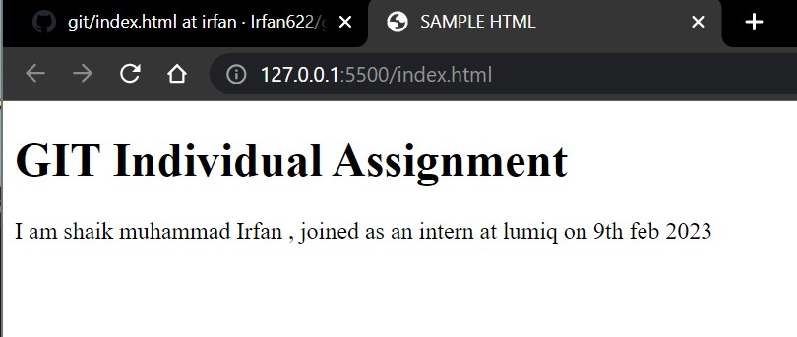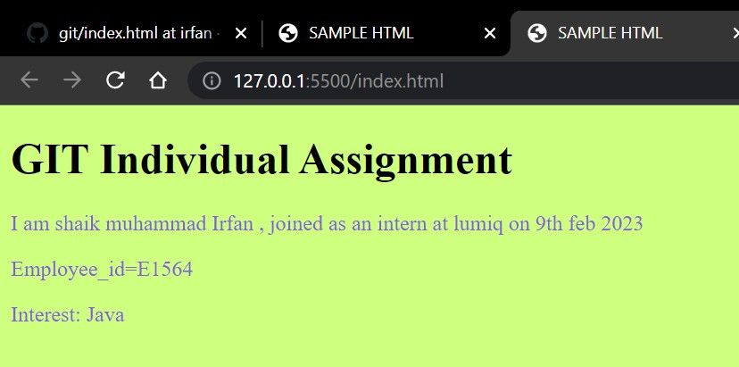

Before merge After Merge

# Exercise 2