**Maven Project Setup- Selenium with Java**

Testing the system against all odds is a challenging task and you need a tool which can help you in this process. One such predominantly used tool by [Automation Testers is Selenium](https://www.edureka.co/testing-with-selenium-webdriver)*.*

In this document we have got all the steps to do project setup for maven project in Eclipse IDE which will be having TestNG and Selenium library steps are as below:

**Create A Maven Project In Eclipse IDE with TestNG library and selenium dependency**

1. Open Eclipse and right click on Package Explorer. Select **New >> Maven** project and click the Next button.

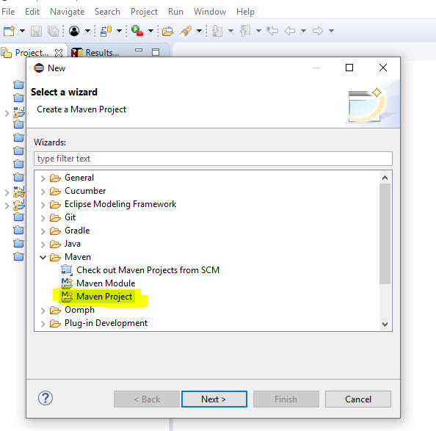

2. Select Create simple Project checkbox and click next.

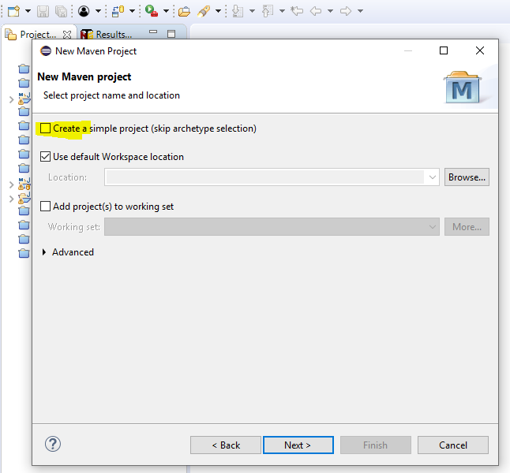

3. Fill Group Id, artifact id and other details and click submit button.

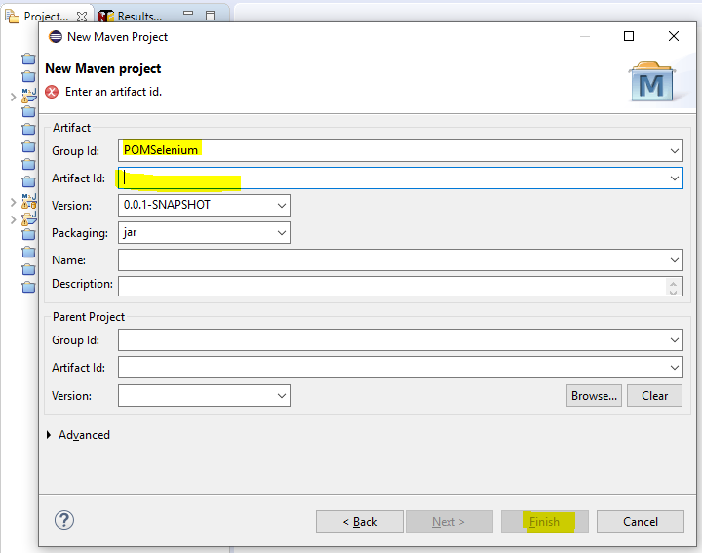

4. Project should get created and folder structure should look like something below:

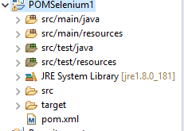

5. We must make sure that the correct JRE is added in case of any differences navigate **Right Click >> Build Path >> Click Configure Build Path**.

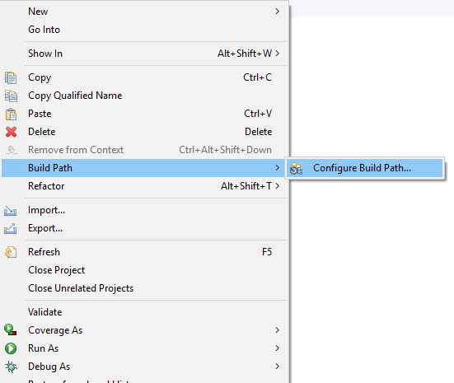

6. Navigate to Library tab and check version if it is incorrect select and remove.

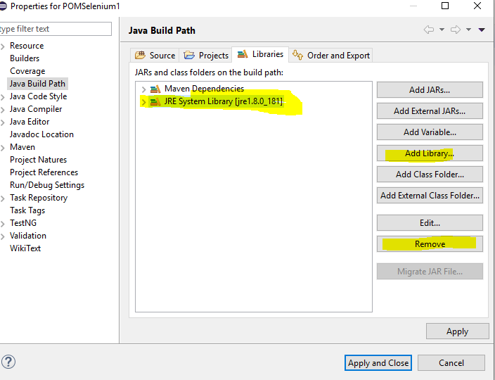

7. Once removed click Add Library >> Select JRE System Library and click next

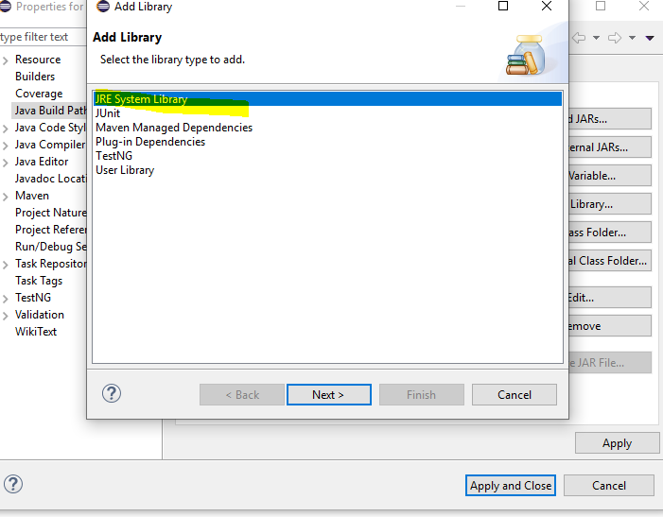

8. Make selection and click Finish, library should get added.

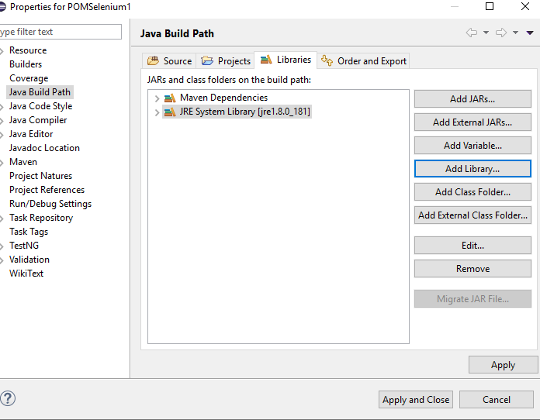

9. Again click Add Library button and select TestNG then click Next button.

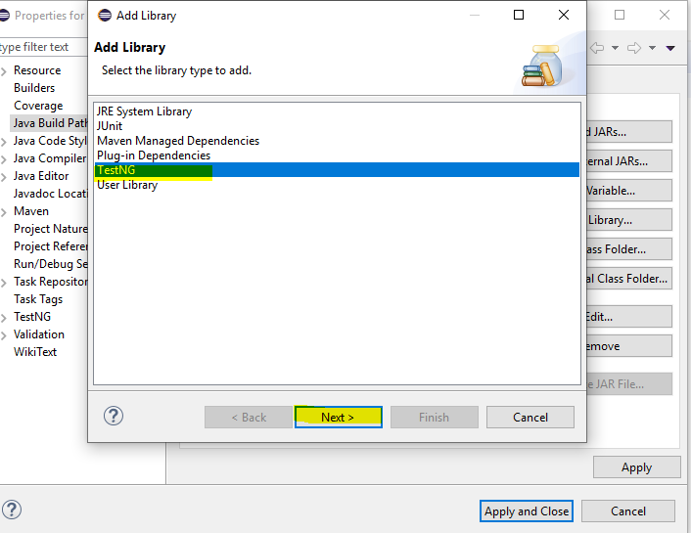

10. Click Finish Button.

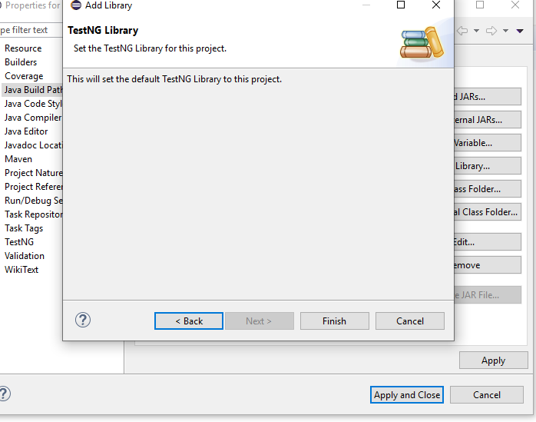

11. TestNG library will be added and click on “Apply and Close”

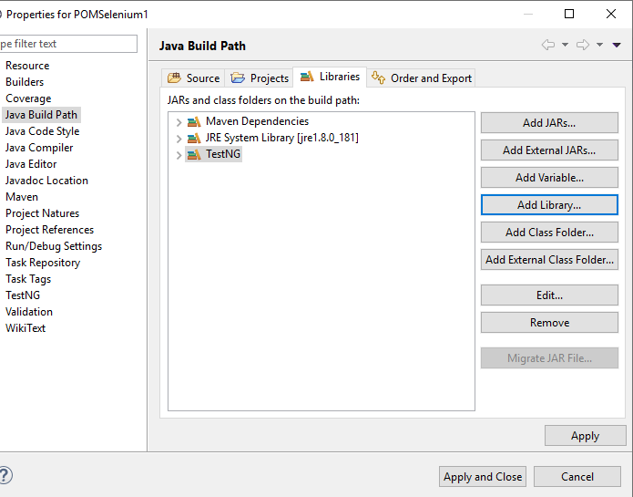

12. You should be ready with basic setup and all Library should be added.

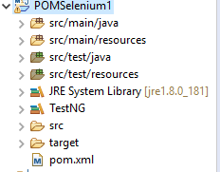

13. Open pom.xml file and add required dependencies ex. Selenium, POI etc. Sample file is attached.



**Create basic framework and testing.xml file**

1. Right click on any folder name e.g. “src/main/java” to create packages.

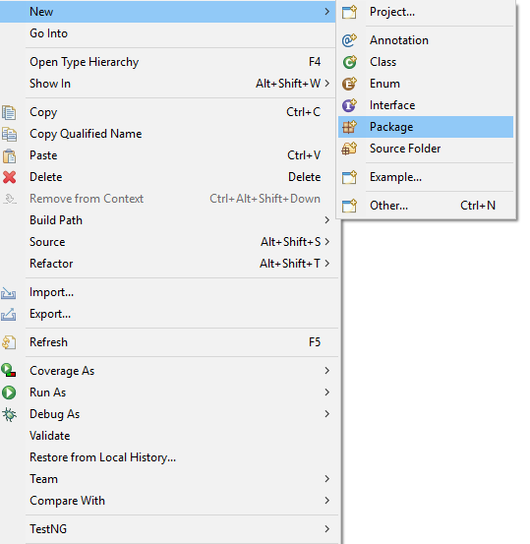

1. Right click on any package to create class files.

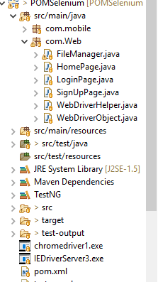

1. Add Driver files in project to make application run on different browsers.
2. Create Testng.xml file to run test cases by right click on Project >>TestNG>> Create TestNG class.

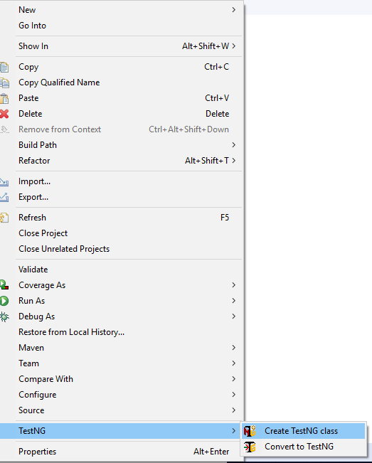

1. You should be able to see testing.xml file in project.

