MODEL RECOVERY AND EVOLUYION COMPARISON TOOL

FINAL YEAR PROJECT



Project Team

Student Name (Muhammad Irfan)
(Reg # 2462-FBAS/BSSE/F14)

Student Name (Samiullah)
(Reg # 2058-^{FBAS}/BSSE/F13)

Proposed Supervisor
(Mr. Waseem)
Department of Computer Science and software engineering
International Islamic

Department of Computer Science and Software Engineering
Faculty of Basic and Applied Sciences
International Islamic University Islamabad
2017

Introduction

Software design is the process of defining software system methods, functions, objects, and the overall structure and interaction of your code. Design Model is an object model describing the realization of use cases, and serves as an abstraction of the implementation model and its source code. Model Recovery from Source Code: domain knowledge is recoverable from “modern legacy” code and therefore domain model recovery can be a valuable component of a domain re-engineering process

We want to make a Web Based Application that recover the design model from Source Code. Usually this Source Code organize release wise on online Repository such as GitHub, SVN or CVS. Our Tool will have the ability to recourse the model and compare for Evolution and then generate the comparison Result Table.

Objective
- To Extract Class diagram from subsequent Releases of selected system.
- Comparison of Extract Model for Evolution.
- Generate the Comparison Result.

Problem Description
A developer can interact with Source Code for building a software, A Software can be change (Addition, deletion, modification) with the passage of time in maintenance period. When a new version release of this software. A software may be consist on thousand line of code, so it is difficult or some time impossible to find the changes.
Methods: Therefor we are going to build a Web Base Application which is built on java language. This Application Extract Class diagram & Package diagram from Source Code of Local System or Online Repository (GitHub, SVN, CVS). Then compare both Class diagram and make a Result Table which consist different column like Addition, deletion, modification. Which provide the information of changes.
- System Features
- Extract Class diagram from Local & Online Hosted Code.
Our Tool can extract Class diagram from Source Code which is save in Local System or Online Repository (Github, CVS, SVN) through Connectivity links.
- Extract Package diagram from Local & Online Hosted Code
Our Tool can extract Package diagram from Source Code which is save in Local System or Online Repository (Github, CVS, SVN) through Connectivity links.
- Visualize Class diagram from Source Code
Can Visualize Class diagram information with connectivity links.
- Visualize Package diagram from Source Code
Can Visualize Package diagram information with connectivity links.

- Comparing Subsequent Class diagram.
After Extract & Visualize of Class diagrams we can compare both Class diagram of newly iterated and existing diagram to identify the changes.
- Comparing Subsequent Package diagram.
After Extract & Visualize of Package diagrams we can compare both Package diagram of newly iterated and existing diagram, to identify the changes.
- Generates Result Table.
After comparing the Class diagram or Package diagram our Tool make Result Table for those changes which consist in different column like Addition, Deletion, and Modification.

- Project Planning (Gantt Chart)

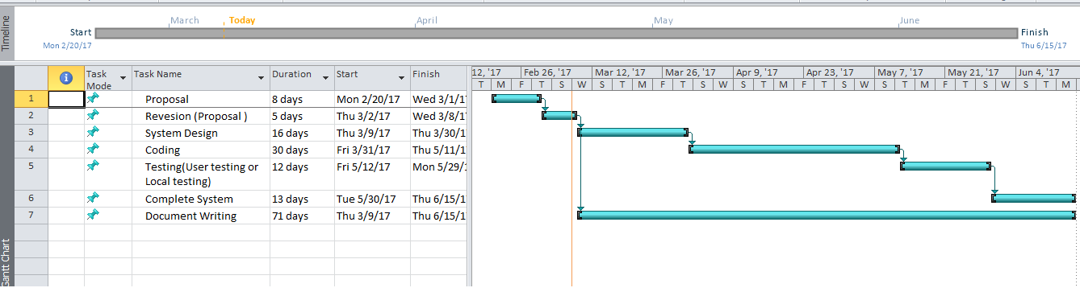

- Hardware and Software Requirements
- We will use JAVA Language to develop our Tool.
- We will use GitHub, CVN or SVN as a source code provider.
- Eclipse as a platform.

- Diagrammatic Representation of the Overall System
