|  |  |
| --- | --- |
| Perusahaan | Pekerja |
|  |  |

Flowchart yang sedang berjalan

|  |  |  |
| --- | --- | --- |
| User | Perusahaan | Pekerja |
|  |  |  |

Flowchart sistem yang diusulkan



Pekerja



Perusahaan

Use Case 1.1

Use Case 1.2

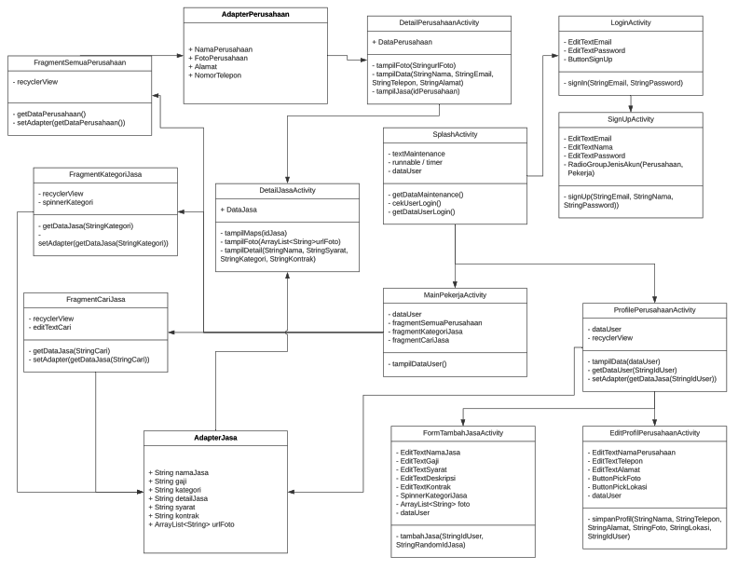

ClassDiagram

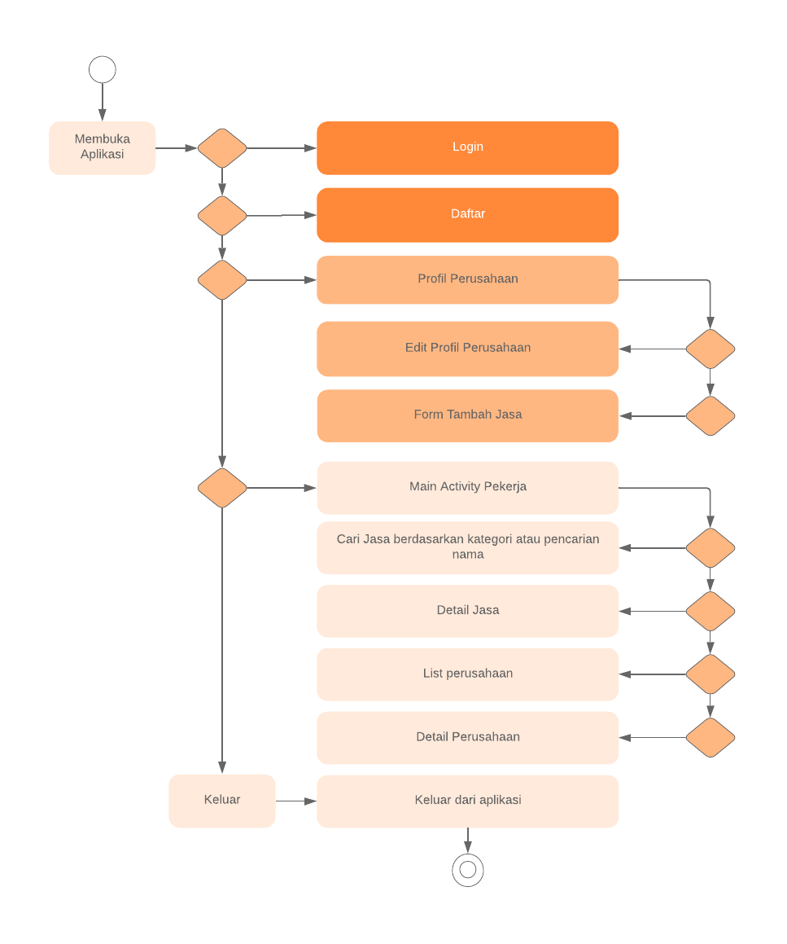

ActivityDiagram

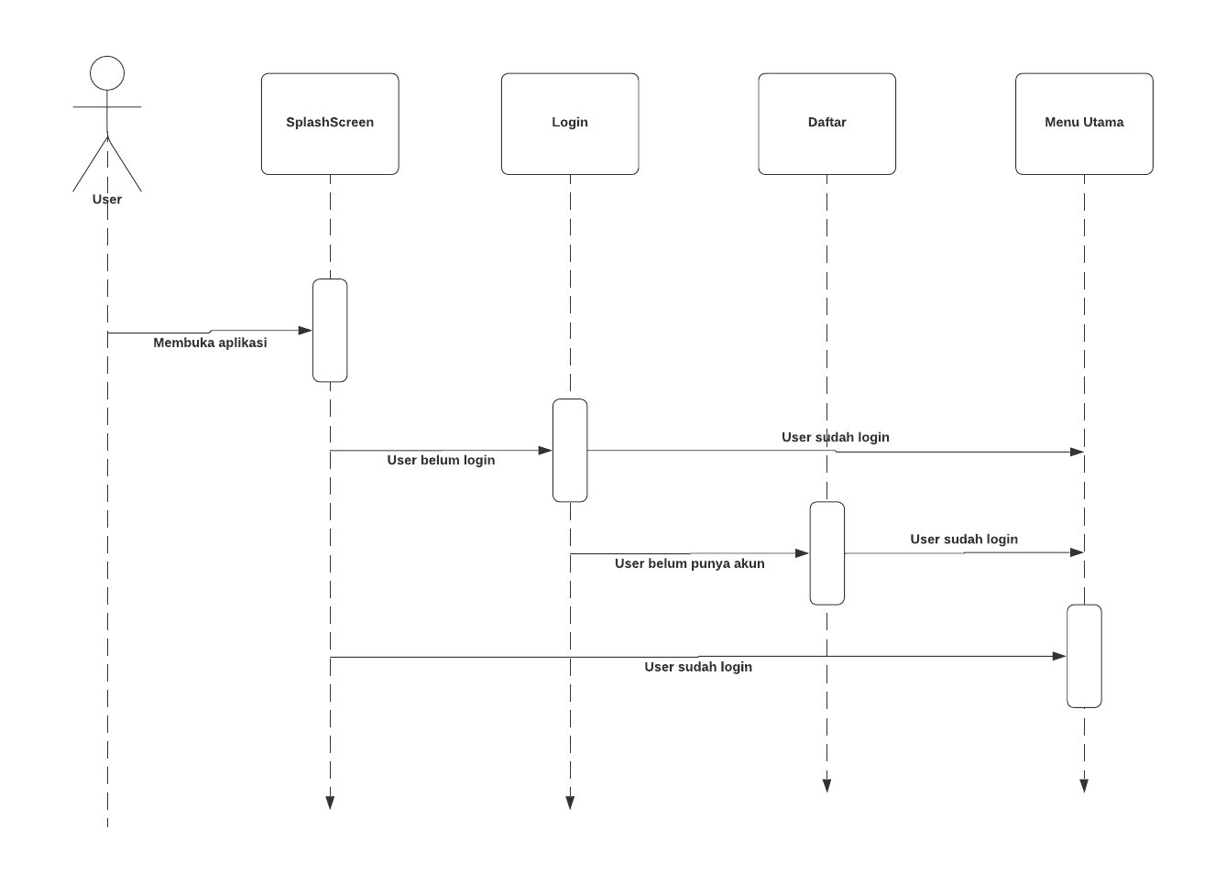

Sequence Diagram Authentikasi User

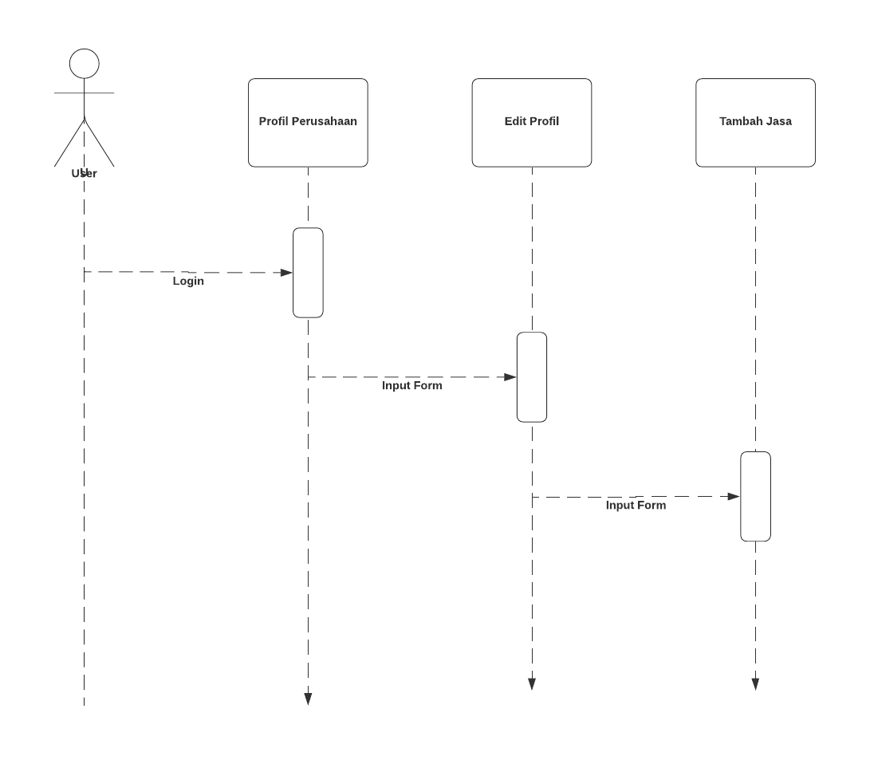

Sequence Diagram Tambah Jasa Perusahaan

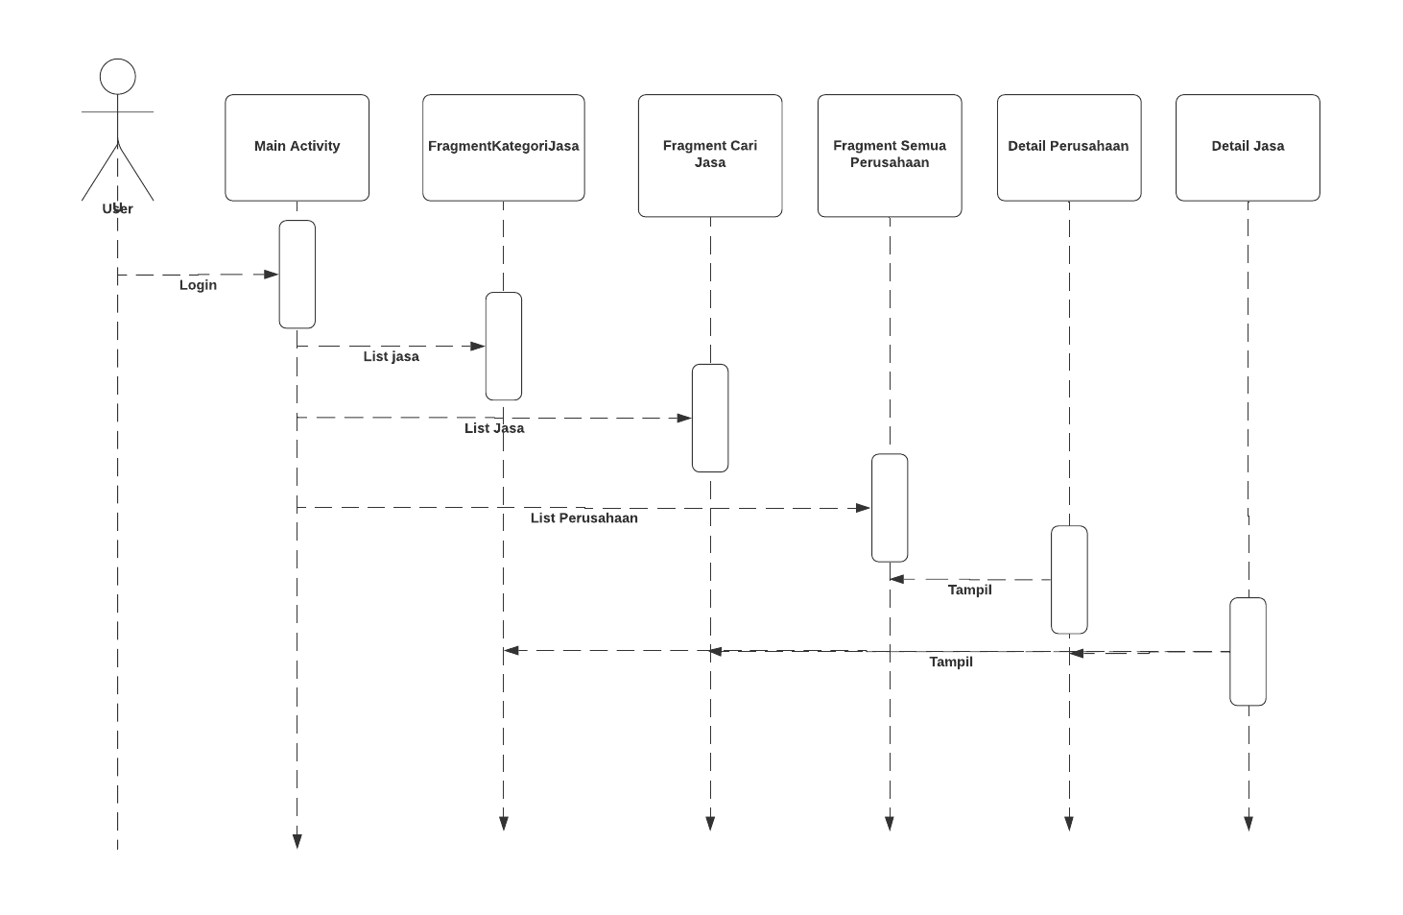

Sequence Diagram Melihat Detail Jasa

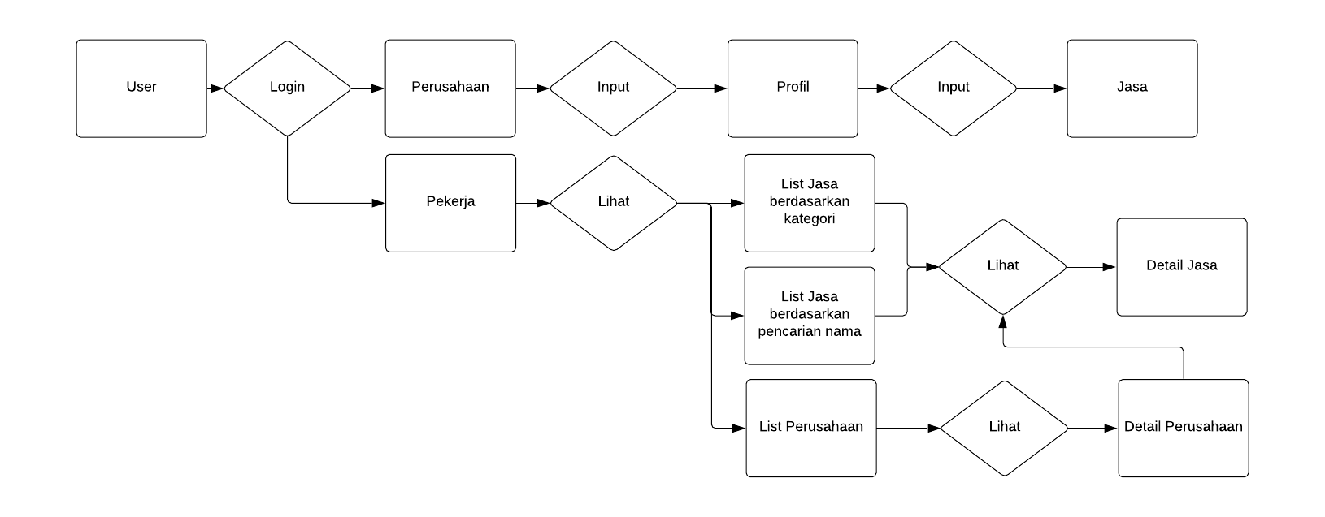

Entity Relationship Diagram

|  |  |  |  |  |
| --- | --- | --- | --- | --- |
| No | Nama_Field | Tipe data | Panjang Data | Keterangan |
| 1 | uid | String | 20 | Primary_key |
| 2 | Email | String | 25 |  |
| 3 | jenisAkun | String | 10 |  |
| 4 | namaLengkap | String | 25 |  |

Tabel User Pekerja

|  |  |  |  |  |
| --- | --- | --- | --- | --- |
| No | Nama_Field | Tipe data | Panjang Data | Keterangan |
| 1 | uid | String | 20 | Primary_key |
| 2 | Email | String | 25 |  |
| 3 | jenisAkun | String | 10 |  |
| 4 | namaLengkap | String | 25 |  |
| 5 | Alamat | String | 50 |  |
| 6 | Foto | String | 100 |  |
| 7 | locationPoint | String | 50 |  |
| 8 | noHp | String | 15 |  |

Tabel User Perusahaan

|  |  |  |  |  |
| --- | --- | --- | --- | --- |
| No | Nama_Field | Tipe data | Panjang Data | Keterangan |
| 1 | Id | String | 20 | Primary_key |
| 2 | Gaji | String | 25 |  |
| 3 | Kategori | String | 10 |  |
| 4 | Uid_user | String | 20 |  |
| 5 | UrlFoto | ArrayList<String> | 100 |  |

Tabel Jasa