**NAME: SHAIK IRFAN**

**REG NO: 192210415**

**EXP NO 1: CREATE A SIMPLE CLOUD SOFTWARE APPLICATION AND PROVIDE IT AS A SERVICE USING ANY CLOUD SERVICE PROVIDER TO DEMONSTRATE SOFTWARE AS A SERVICE (SAAS).**

**AIM:** To create a simple cloud software application and provide it as a service using any cloud service provider to demonstrate software as a service (saas).

**PROCEDURE:**

**STEP1:** GOTO ZOHO.COM

**STEP 2:** LOGIN TO THE ZOHO.COM

**STEP 3:** SELECT ONE APPLICATION

**STEP 4:** ENTER APPLICATION

NAME

**STEP 5:** CREATED NEW APPLICATION

**STEP 6:** SELECT ONE FORM

**STEP 7:** THE SOFTWARE HASE BEEN CREATED.

**IMPLEMENTATION:**

**STEP1: GOTO ZOHO.COM**



**STEP 2: LOGIN INTO THE ZOHO.COM**



#### STEP 3: SELECT CREATE FROM SCRATCH

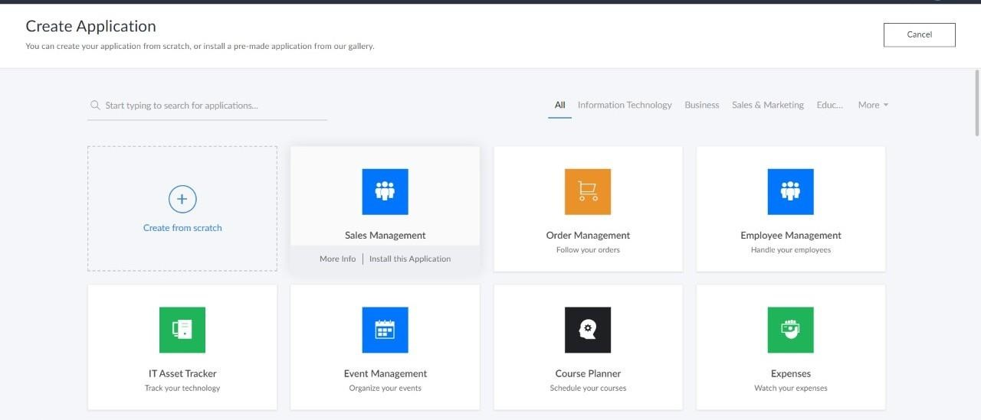

**STEP 4: ENTER APPLICATION NAME AS FLIGHT RESERVATION SYSTEM**

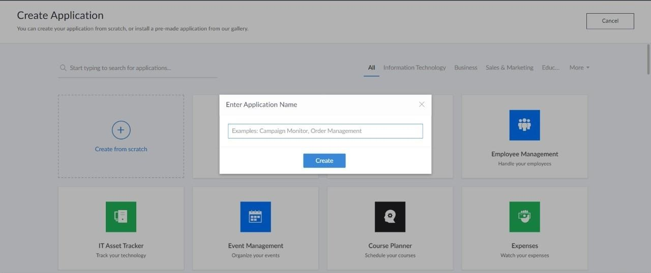

**STEP 5: CREATED NEW APPLICATION**

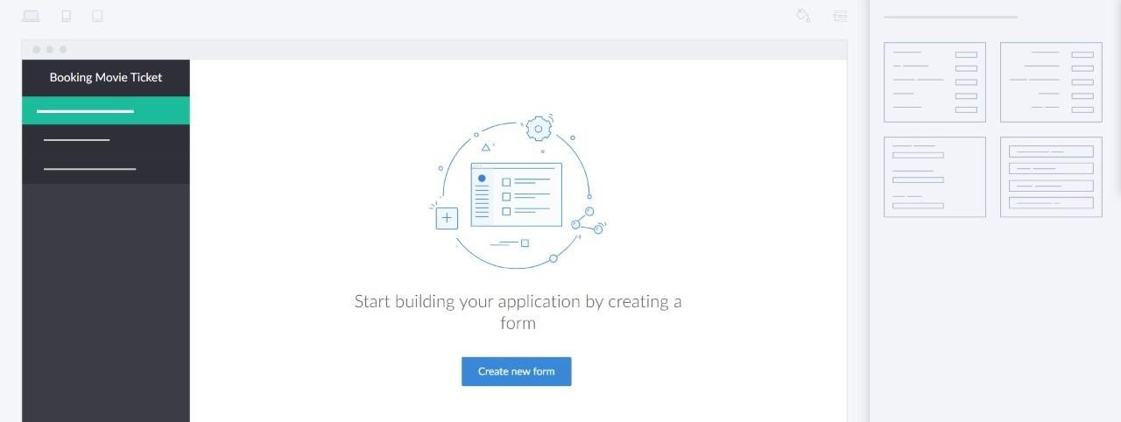

**STEP 6: SELECT ONE FORM**

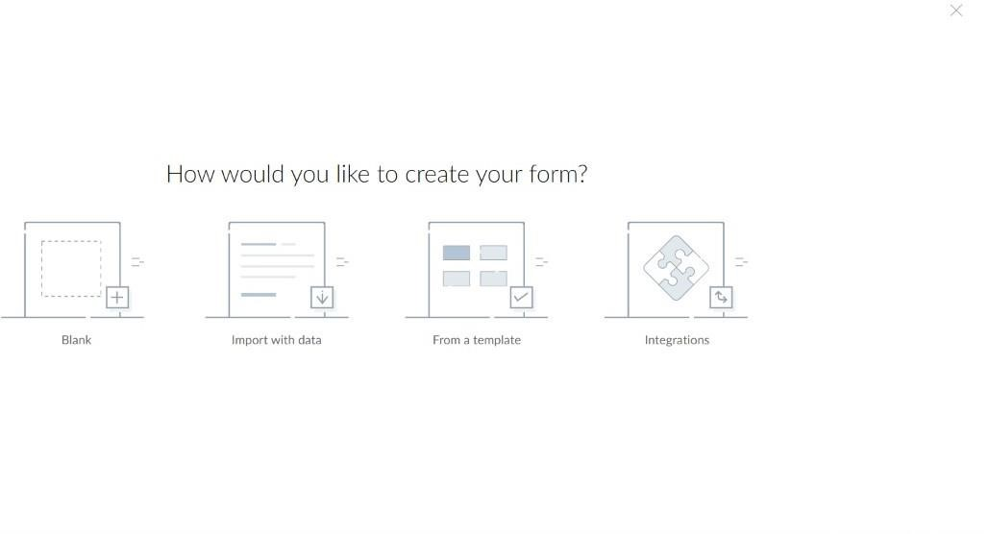

**STEP 7: THE SOFTWARE HASE BEEN CREATED.**

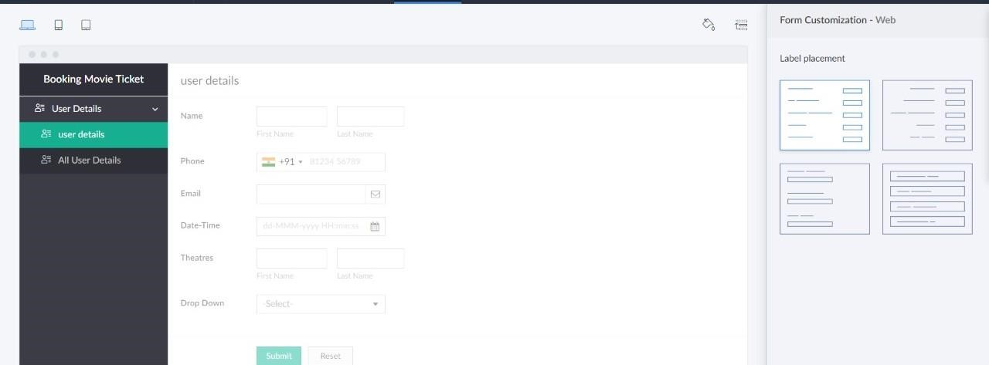

**OUTPUT:**

