**NAME: SHAIK IRFAN**

**REG NO: 192210415**

**EXPNO 10: CREATE A CLONING OF A VM AND TEST IT BY LOADING THE PREVIOUS VERSION/CLONED VM.**

**AIM:** To create a cloning of a vm and test it by loading the previous version/cloned vm.

**PROCEDURE:**

**STEP 1**: GO TO VM AND GOTO MANAGE AND CLICK CLONE

**STEP 2:** CLICK CLONE

**STEP 3:** SELECT THE FULL CLONE

**STEP 4**: AFTER CLONE AGAIN OR VM IS OPENED.

**IMPLEMENTATION:**

**STEP 1: GO TO VM AND GOTO MANAGE AND CLICK CLONE**

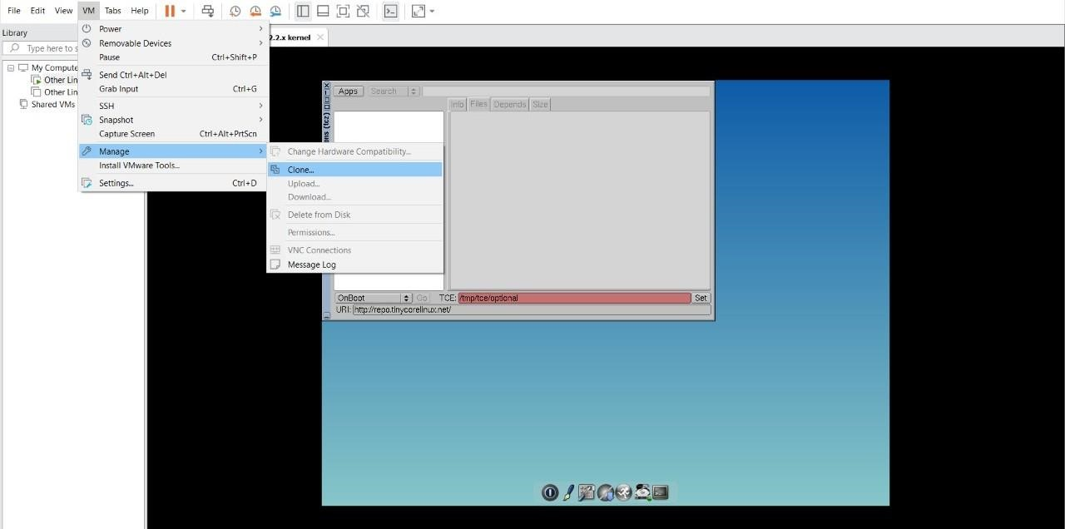

**STEP 2: CLICK CLONE**

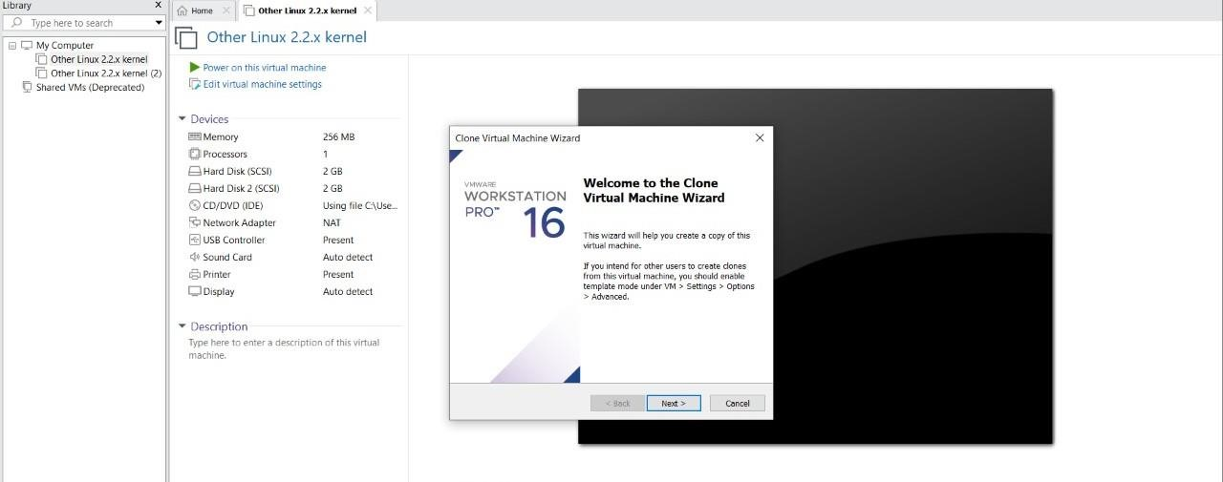

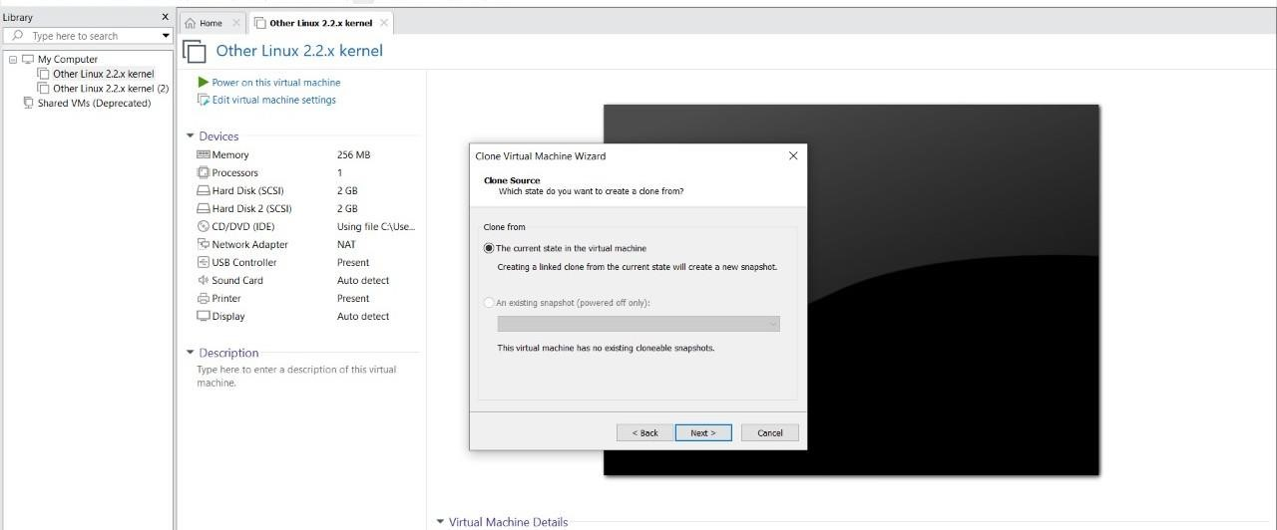

**STEP 3: SELECT THE FULL CLONE**

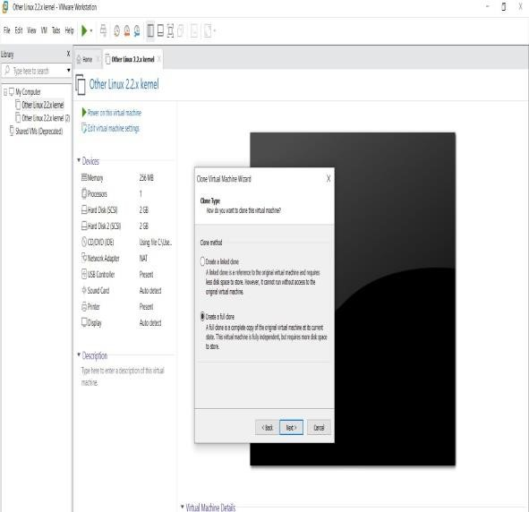

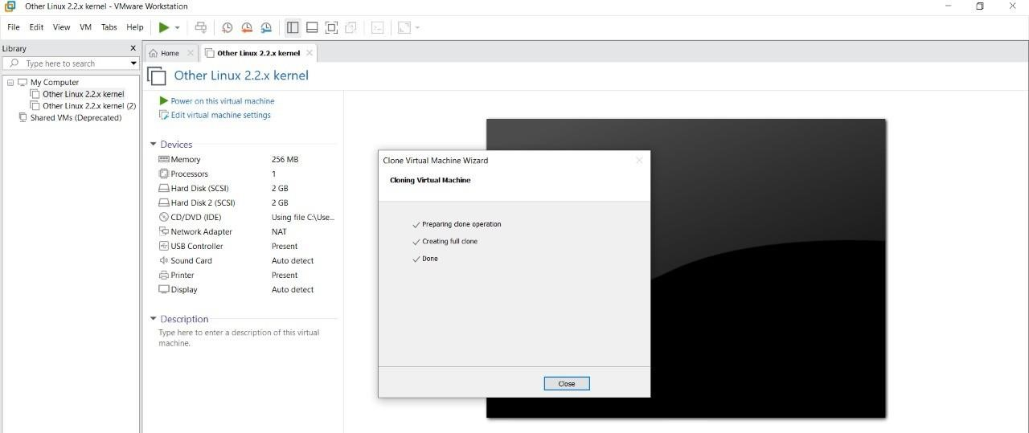

**STEP 4: AFTER CLONE AGAIN OR VM IS OPENED.**

