**NAME: SHAIK IRFAN**

**REG NO: 192210415**

**EXP NO 3: CREATE A SIMPLE CLOUD SOFTWARE APPLICATION FOR CAR BOOKING RESERVATION SYSTEM USING ANY CLOUD SERVICE PROVIDER TO DEMONSTRATE SAAS.**

**AIM:** To Create a simple cloud software application for Car Booking Reservation System using any Cloud Service Provider to demonstrate SaaS.

**PROCEDURE:**

**step1:** Go to zoho.com.

**step 2:** Log into the zoho.com.

**step 3:** Select one application step.

**step4:** Enter application name as Car Booking Reservation System.

**step 5:** Created new application as Car Booking Reservation System.

**step 6:** Select one form

**step 7:** The software has been created.

**IMPLEMENTATION:**

**STEP1: GOTO ZOHO.COM**



#### STEP 2: LOGINTOTHE ZOHO.COM



#### STEP 3: SELECT ONE APPLICATION

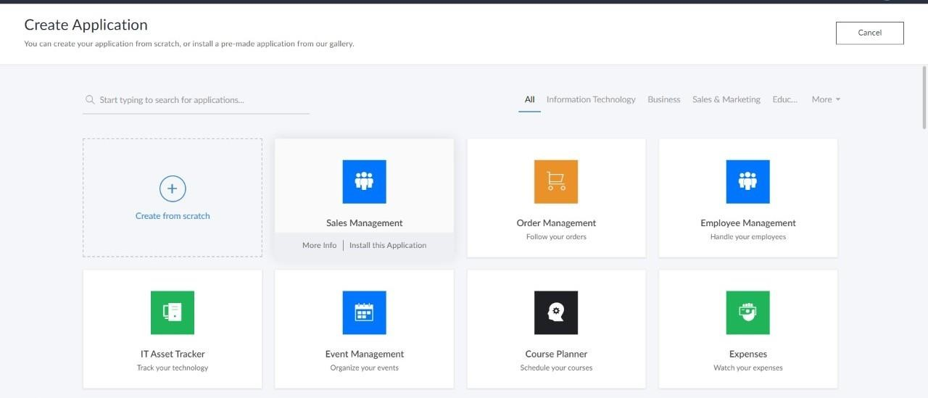

**STEP 4: ENTER APPLICATION NAME**

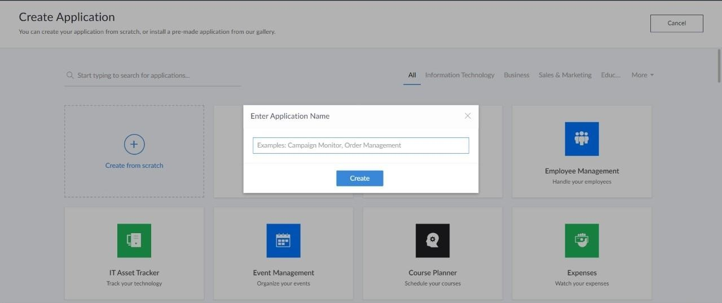

**STEP 5: CREATED NEW APPLICATION**

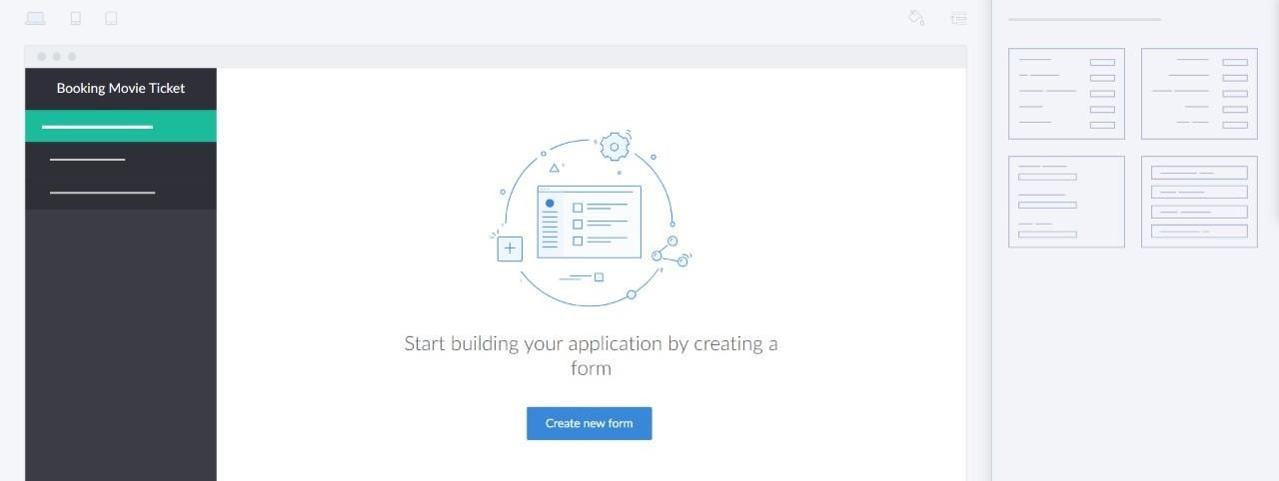

**STEP 6: SELECT ONE FORM**

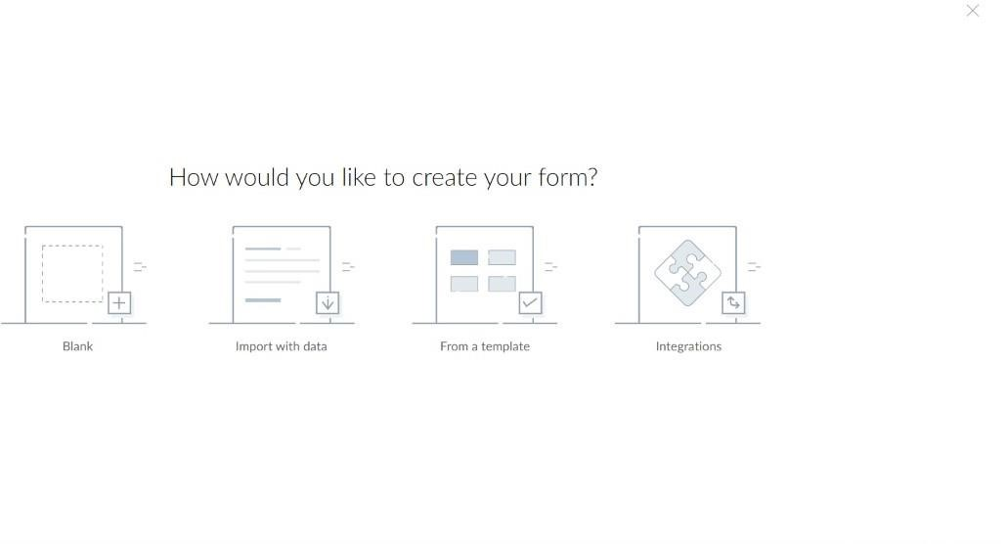

**STEP 7: THE SOFTWARE HASE BEEN CREATED.**

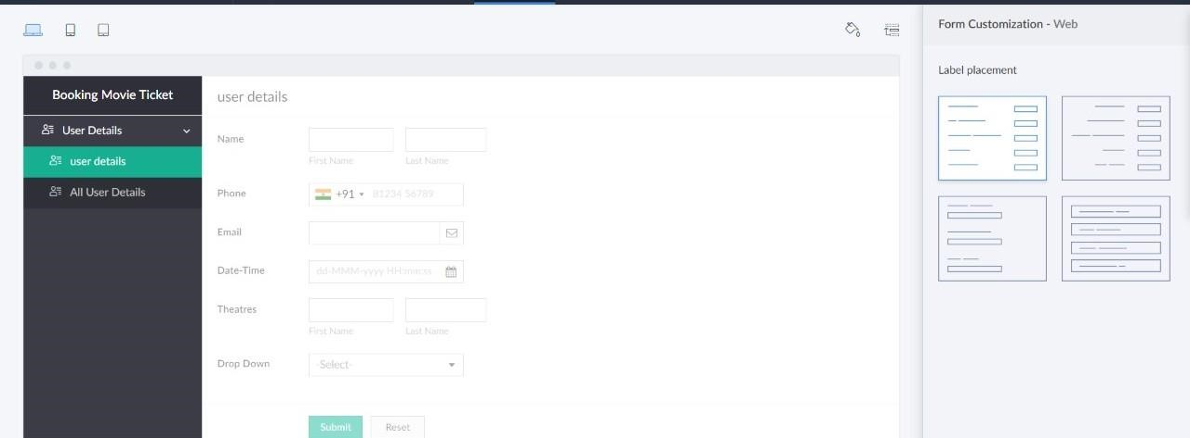

**OUTPUT:**

