**NAME: SHAIK IRFAN**

**REG NO: 192210415**

**EXP NO 6: DEMONSTRATE VIRTUALIZATION BY INSTALLING TYPE-2 HYPERVISOR IN YOUR DEVICE, CREATE AND CONFIGURE VM IMAGE WITH A HOST OPERATING SYSTEM (EITHER WINDOWS/LINUX).**

**AIM:** To demonstrate virtualization by installing type-2 hypervisor in your device, create and configure VM image with a host operating system (either windows/linux).

**PROCEDURE:**

**STEP 1:**Dowload VMware workstation and installed as type 2 hypervisor.

**STEP2:**Dowload ubuntu or tiny OS as iso image file.

**STEP 3:** In VMware workstation->create new VM.

**STEP 4:** Do the basic configuration settings.

**STEP 5:** Created tiny OS virtual machine.

**STEP 6:** Launch the VM.

IMPLEMENTATION:

**STEP 1:DOWLOAD VMWARE WORKSTATION AND INSTALLED AS TYPE 2 HYPERVISOR**

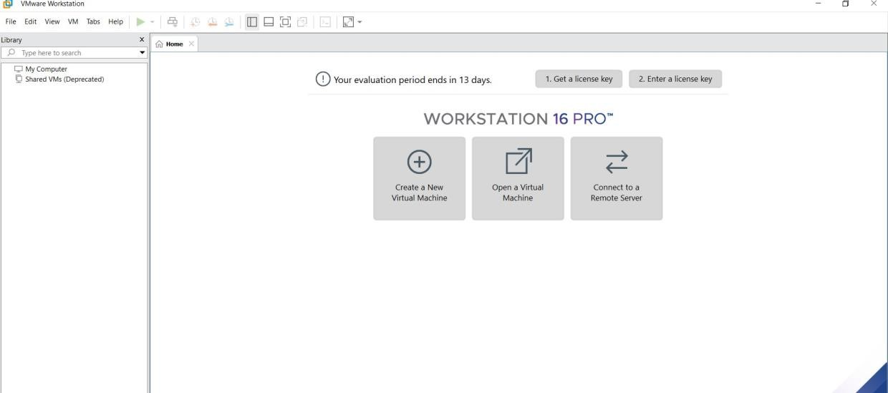

**STEP2: DOWLOAD UBUNTU OR TINY OS AS ISO IMAGE FILE**

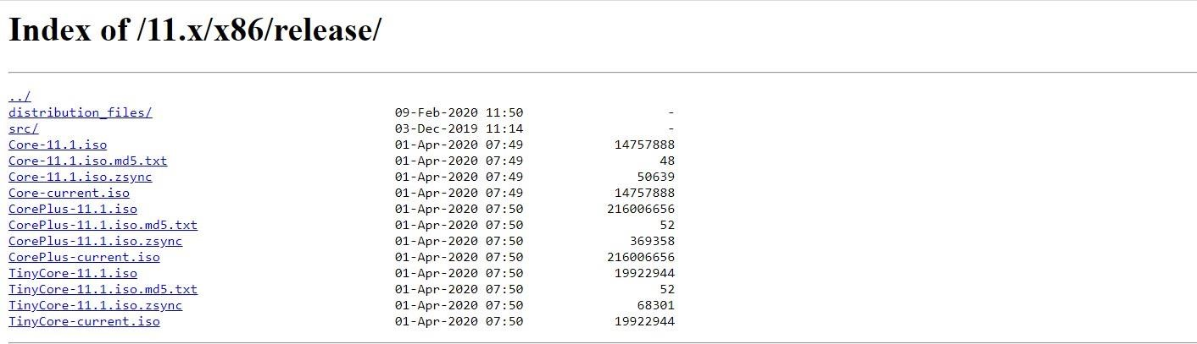

**STEP 3: IN VMWARE WORKSTATION->CREATE NEW VM**

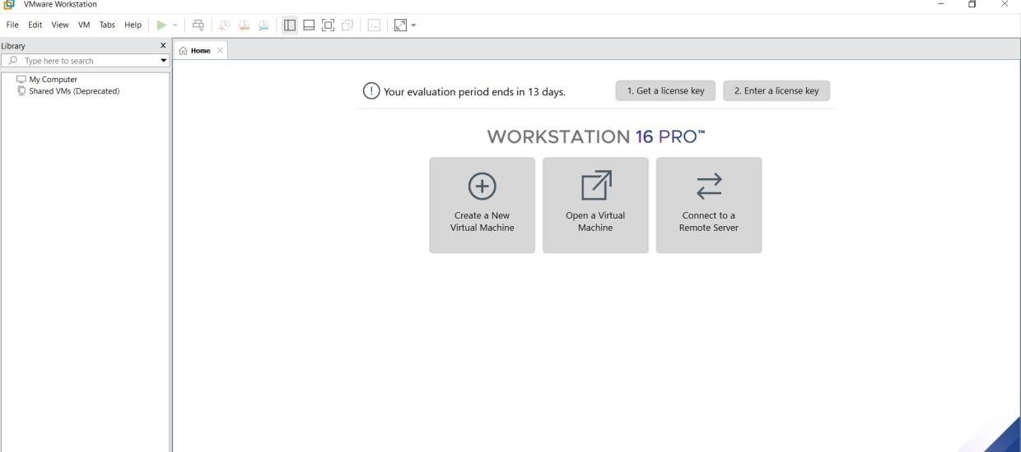

**STEP 4: DO THE BASIC CONFIGURATION SETTINGS.**

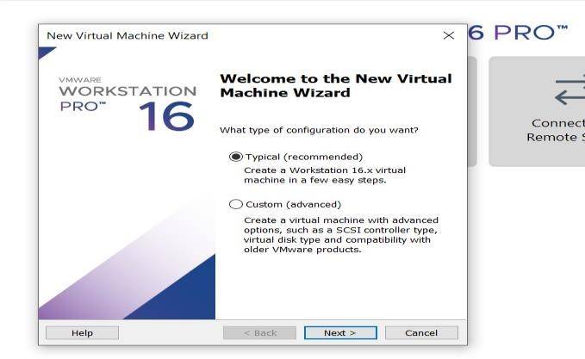

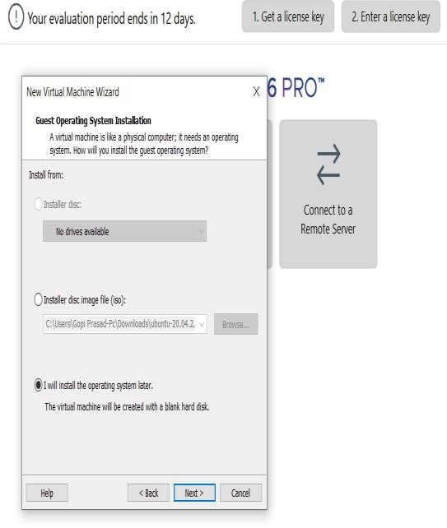

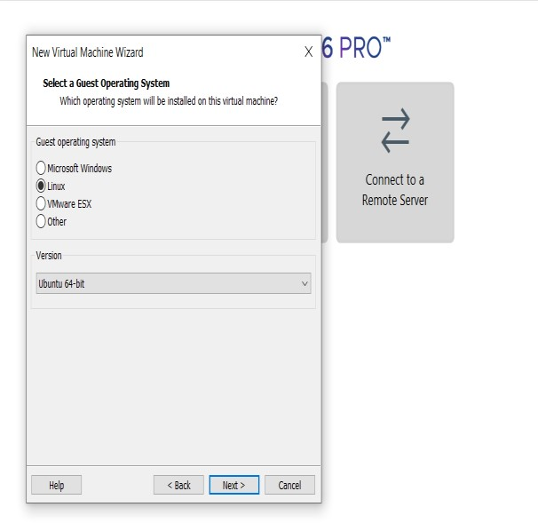

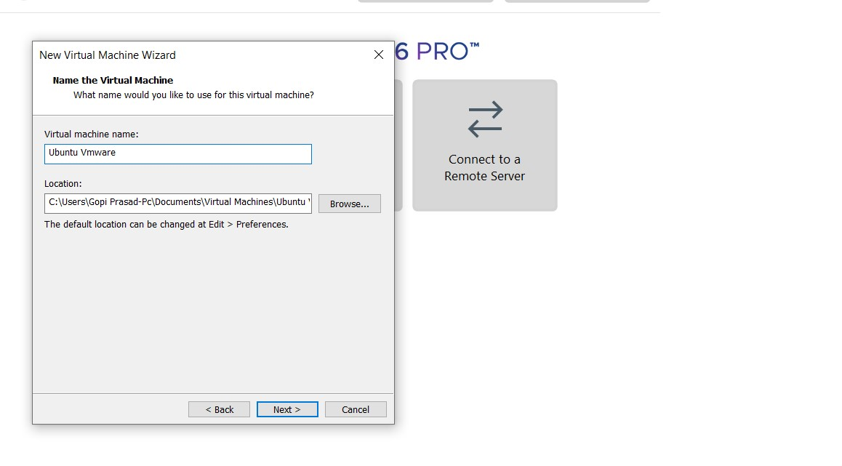

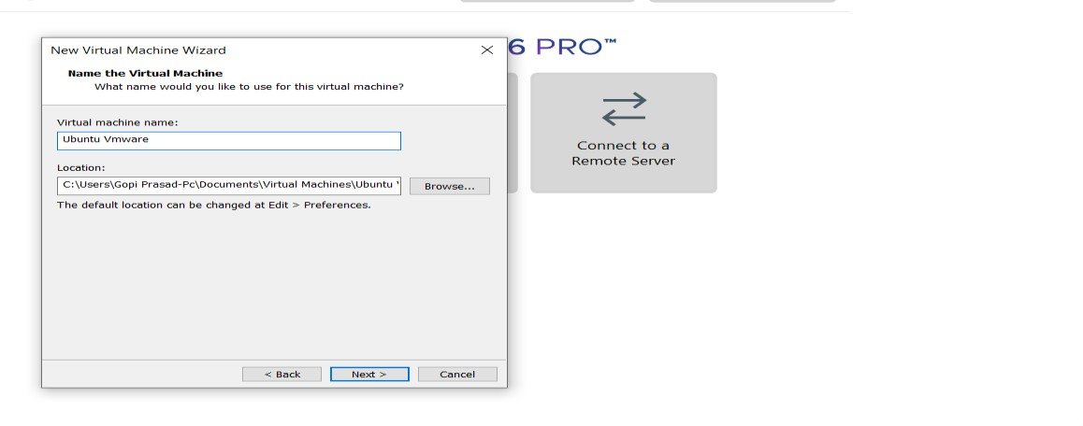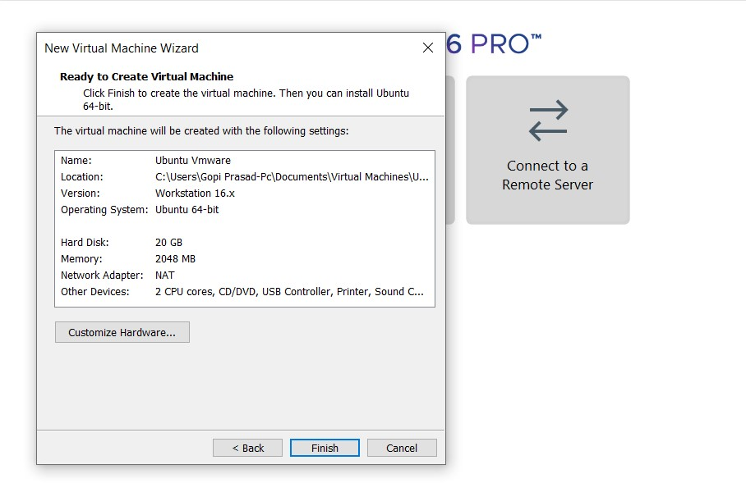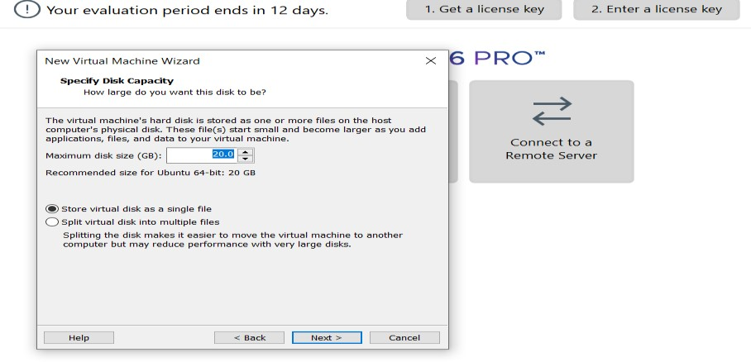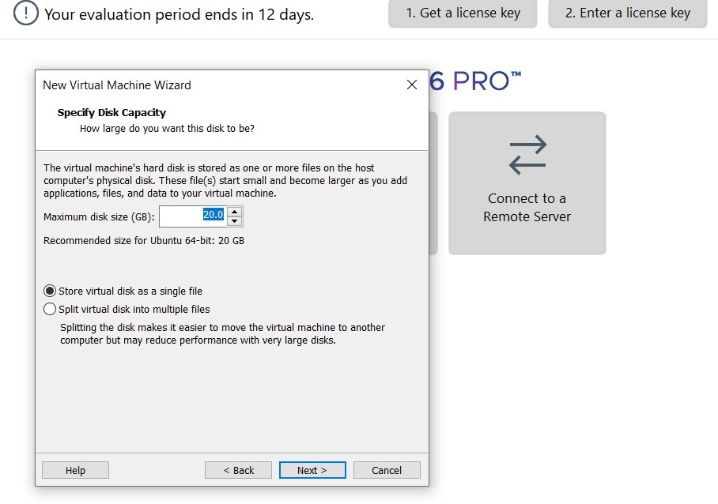

**STEP 5: CREATED TINYOS VIRTUAL MACHINE**

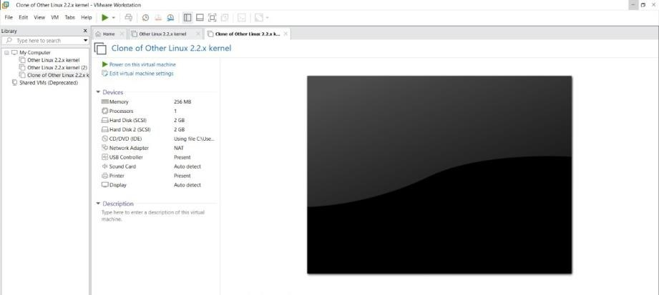

**STEP 6: LAUNCH THE VM**

