**NAME: SHAIK IRFAN**

**REG NO: 192210415**

**EXPNO 9: CREATE A SNAPSHOT OF A VM AND TEST IT BY LOADING THE PREVIOUS VERSION/CLONED VM**

**AIM:** To create a snapshot of a vm and test it by loading the previous version/cloned vm

**PROCEDURE:**

**STEP 1:** GOTO VMWARE WORKSTATION**.**

**STEP 2:** CREATE FILES ON DESKTOP.

**STEP 3**: CLICK ON VM AND SELECTS SNAPSHOT-> TAKE SNAPSHOT.

**STEP 4:** SNAPSHOT IS BEING DONE

**IMPLEMENTATION:**

**STEP 1: GOTO VMWARE WORKSTATION**

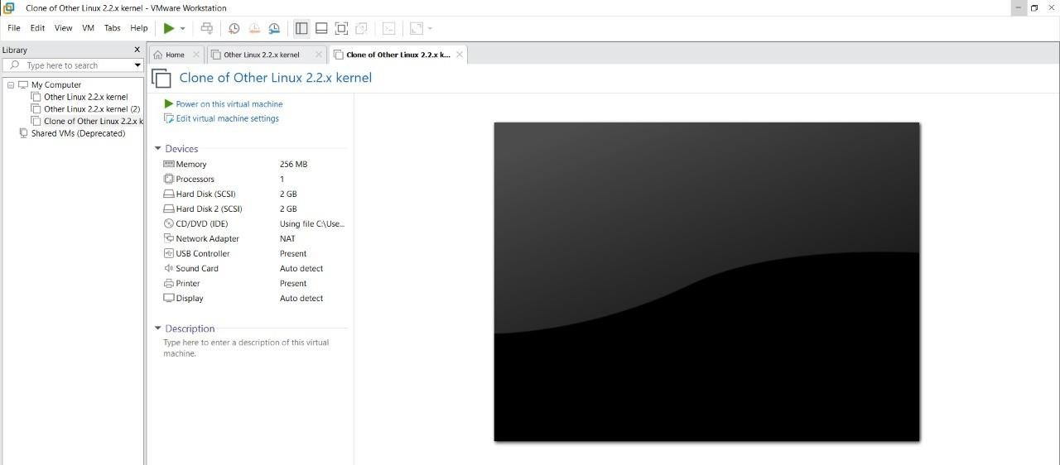

**STEP 2: CREATE FILES ON DESKTOP**

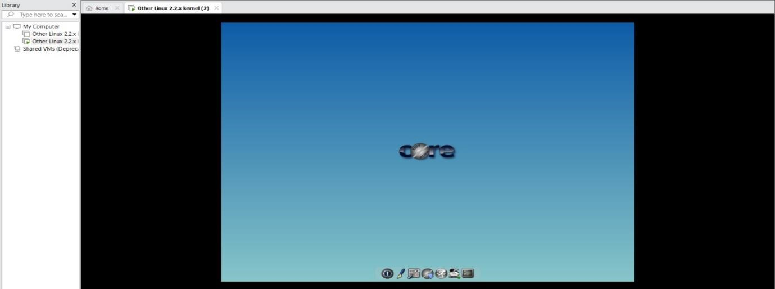

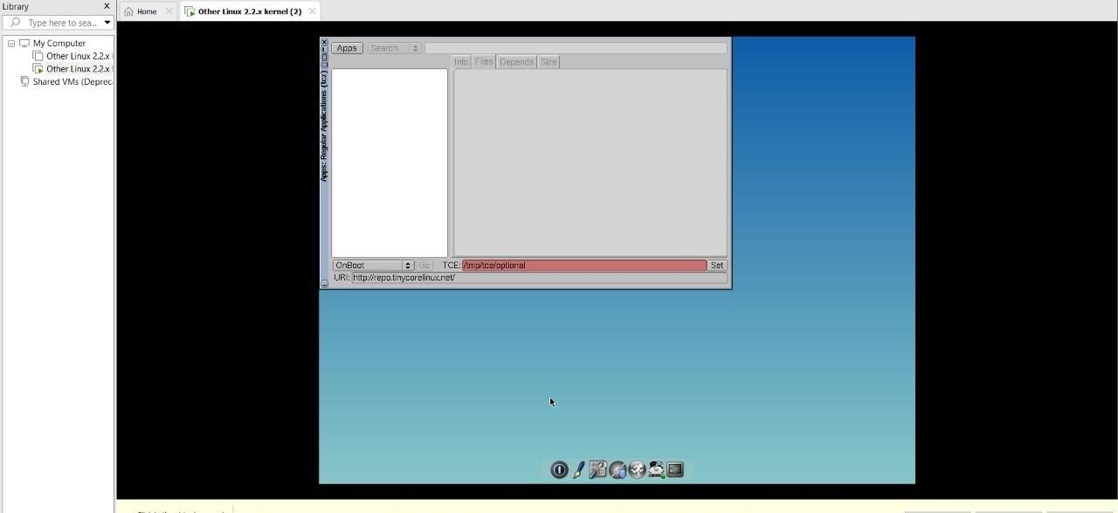

**STEP 3: CLICK ON VM AND SELECTS SNAPSHOT-> TAKE SNAPSHOT.**

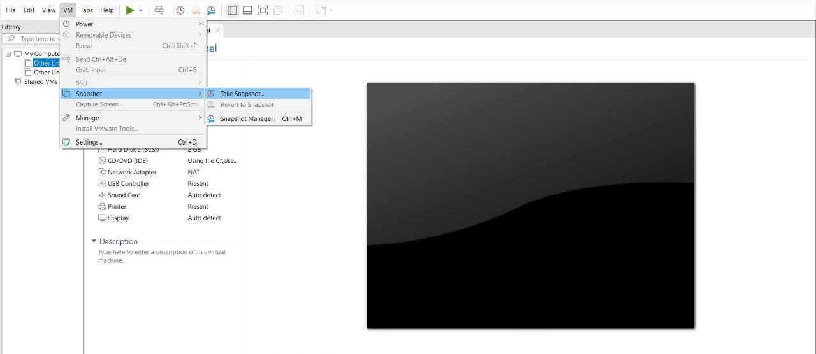

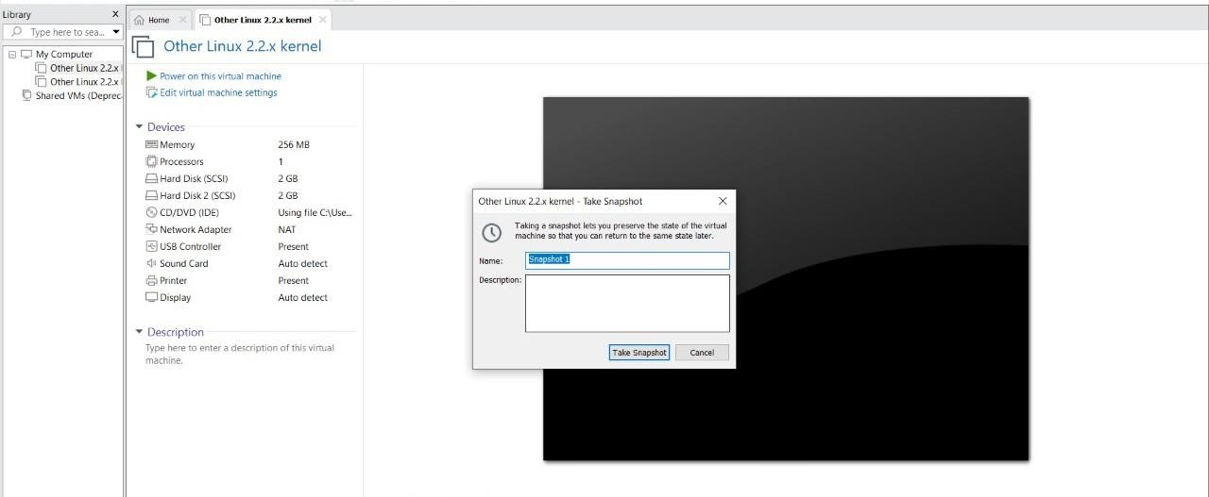

**STEP 4: SNAPSHOT IS BEING DONE**

