

**FYP-Proposal**

**Title:** Words In Action

**Group:**

**Shan Akbar**

**Irfan Ullah**

**Hamza Taraq**

**Short FYP Title**

Words in Action

**Complete FYP Title**

Generating animations automatically from scripts.

**Type of Project**

Research and Development (R&D)

**FYP Group Information**

**Member No. 1:**

Name: Shan Akbar

Roll No. : I16-0149

CGPA: 2.85

E-mail: [I160149@nu.edu.pk](mailto:I160149@nu.edu.pk)

**Member No. 2:**

Name: Hamza Tariq

Roll No. : I16-0134

CGPA: 2.77

E-mail: [I160134@nu.edu.pk](mailto:I160134@nu.edu.pk)

**Member No. 3:**

Name: Irfan ULLAH

Roll No. : I16-0533

CGPA: 2.56

E-mail: [I160533@nu.edu.pk](mailto:I160533@nu.edu.pk)

**FYP Supervisor:**

**Name:** Dr. Mirza Omer Beg **Signature:** ________________

**Project Overview**

What we see is what we learn, nowadays animation is the most effective and attractive way to make anything understandable, to someone, and to entertain. Also the visual modalities are one of the most important modalities in any multimedia presentation.

Making someone understand a scenario or to give groups of people a same view through language is quite a difficult task, because the way of thinking varies from person to person. So each individual would think in a different way.

Moreover, each and every child is now addicted to animated videos and learn many things from these videos which may make parents satisfied or dissatisfied, as every community has different values, traditions, likes, and dislikes. Everyone want their generation to be brought up in such a way that they follow their ancestor’s traditions. This is not possible unless each video, which is made, take into consideration the values and traditions of every community, which itself is impossible.

To tackle such problems one should make the decisions that result in effective graphics, and this requires expertise in visual design with significant effort and time, all of which are indispensable for traditional 3D animation authoring. However, effort and time could be spared by using automated knowledge-based design of 3D animations. That make animation automatically from the script or any type of text.

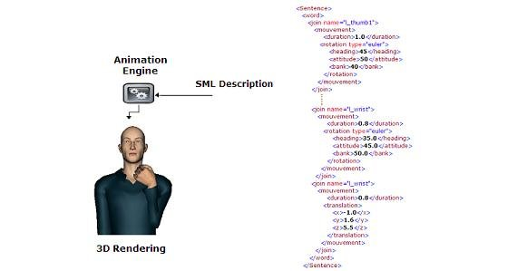

**Motivation**

If a picture tells a thousand words then animation tells a million. 3D animations are one of the best ways to tell stories. Animations (and pictures) often describe objects or physical actions more clearly than language does. In contrast, language often conveys information about abstract objects, properties, and relations more effectively than pictures can. Using these modalities together they can complement and reinforce each other to enable more effective communication than can either modality alone. In this sense, animation generator may present scripts more effectively than oral storytelling.

Generating animation automatically from the script would definitely explain the stories in a better way and would give a good, and quick understanding of the moral. This would not only reduce the time to make animation of each story but would also be a great help to those who do not know anything about animation. But, still want to make animations of their own type to make their children learn what they want. And to make other people understand in a better way their views, way of thinking and solution to the problem.

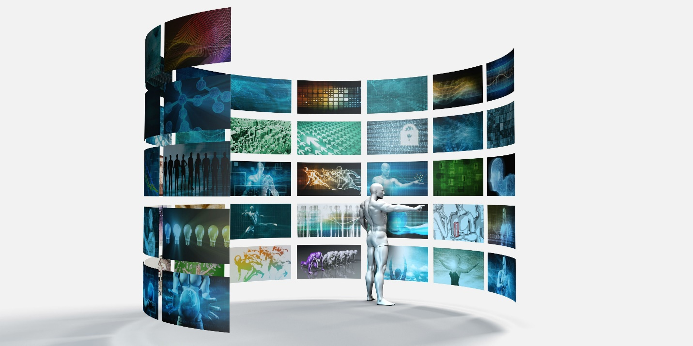

**GOALS**

1. A better understanding

a) To give a better understanding of a story.

b) To teach children the basic visualization of the actions.

c) To provide the facility of understanding an idea or a concept by its 3d construction.

2) Educational Purpose

a)To facilitate parents to control what their children are learning. Using this system, parents can generate animations suitable for their children, by providing their own scripts.

3) Visualization

a) To facilitate artists to pre visualize a concept or art, before its creation.

**Scope**

Since we have limited type of animations, set of actions, so it puts a restriction on the type of scripts. The project is more towards, children educational purpose, to teach them basic visualization of human actions, instructional animated videos and to visualize a scenario. Complex sentences will also be handled using breakdown of sentences into simple subject-verb-object format to easily map one simple action to animation.

After construction of simple pipeline, which generates simple sentences to simple animations, we can add more animation clips and script parsing models to generate animations of other fields like jungle, animals, and birds etc.

**Involved tools & Technologies**

|  |  |  |  |  |
| --- | --- | --- | --- | --- |
| **Name** | **Tools Involved** | | | |
|  | **Unity/Blender** | **Natural language processing(NLP)** | **Angular & Node js** | **GitHub** |
| **Shan Akbar** | 3 | 2 | 1 | 7 |
| **Hamza Tariq** | 3 | 3 | 1 | 7 |
| **Irfan ULLAH** | 2 | 1 | 3 | 7 |

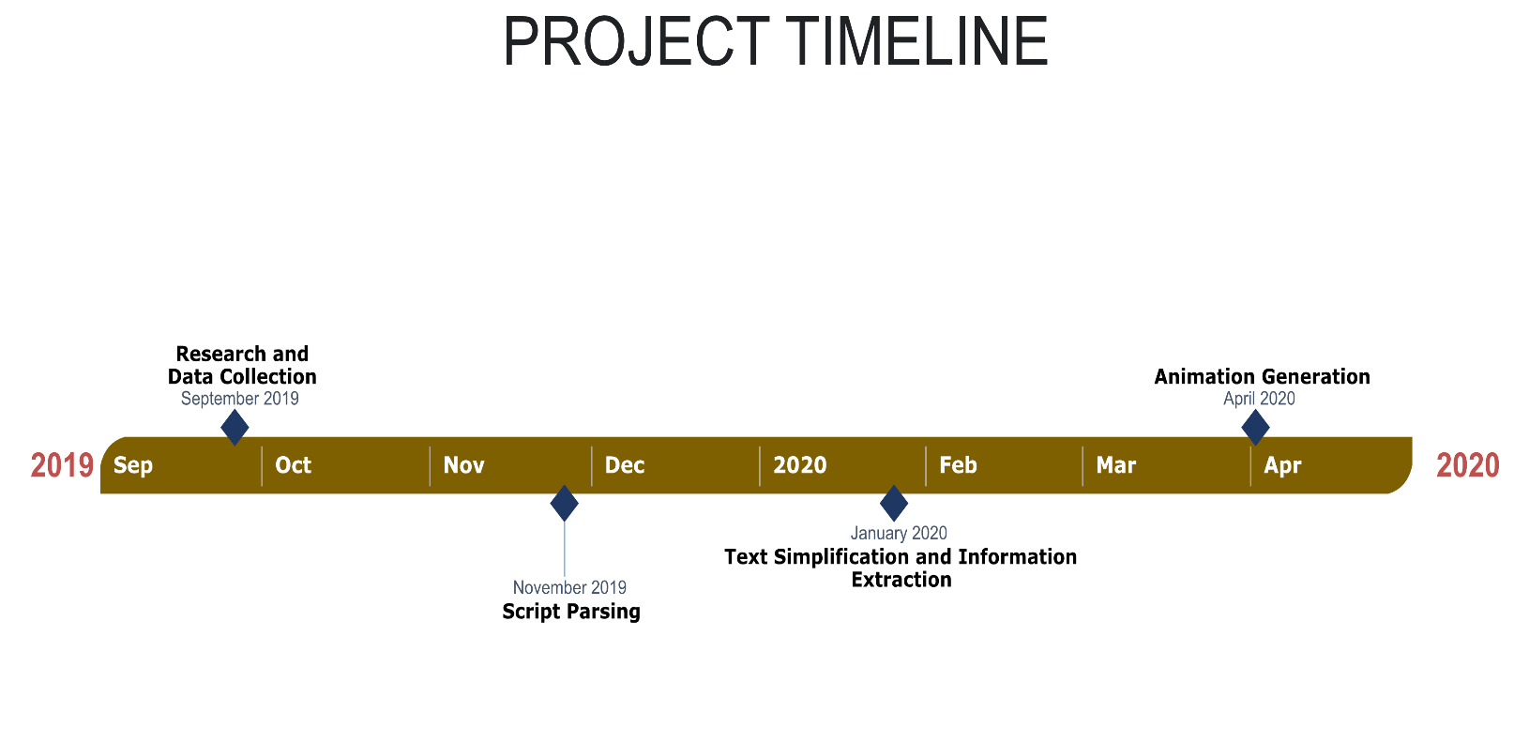

**Diagram**

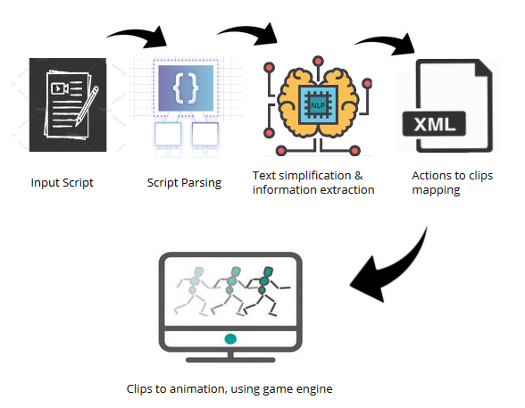

**References**

Zhi-Qiang Liu and Ka-Ming Leung. 2006. Script visualization (scriptviz): a smart system that makes writing fun. Soft Computing, 10(1):34–40.

M. Oshita 2009. Generating animation from natural language texts and framework of motion database. In International Conference on CyberWorlds, 2009. CW’09, 146–53. DOI:10.1109/CW.2009.46. Masaki

Oshita. 2010. Generating animation from natural language texts and semantic analysis for motion search and scheduling. Vis. Comput. 26, 5, 339–52. DOI:10.1007/s00371-010-0423-4.

Hyunju Shim, Bogyeong Kang, and Kyungsoo Kwag. 2009. Web2Animation - automatic generation of 3D animation from the web text. In IEEE/WIC/ACM International Joint Conferences on Web Intelligence and Intelligent Agent Technologies, 2009. WI-IAT’09, 1:596–601. DOI:10.1109/WI-IAT.2009.101.