NAME: IRFAN Y
BATCH:C3
USN: 1NT20IS404

DATABASE CREATION

OUTPUT

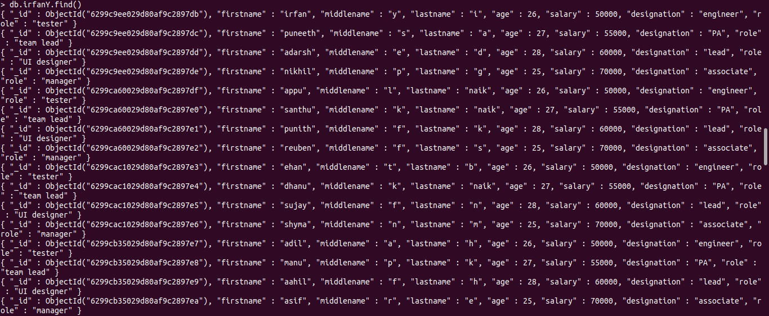

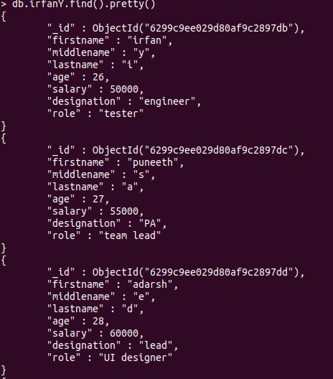

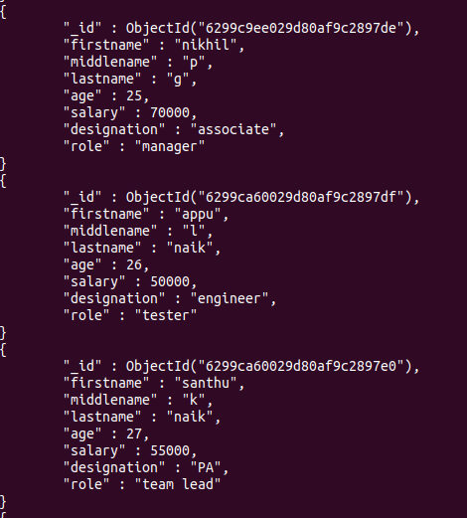

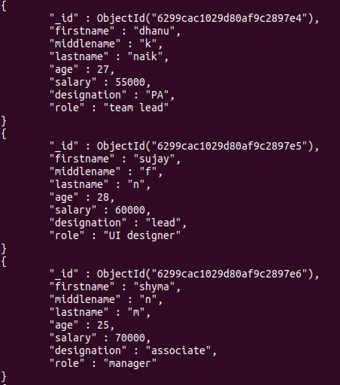

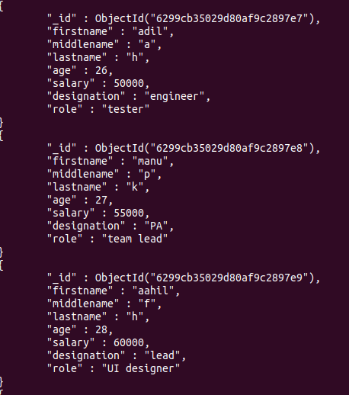

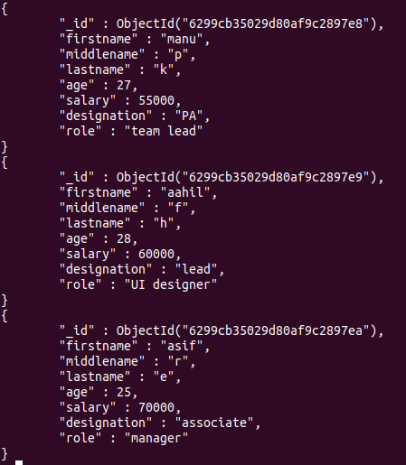

1. Populate the database with atleast 15 documents

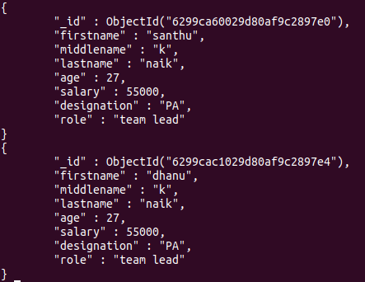

2. List all the records having salary in the range of 20000 - 35000(Exclusive)

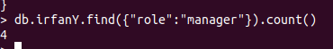

3. List all the Employee whose Middle name is "Kumar"
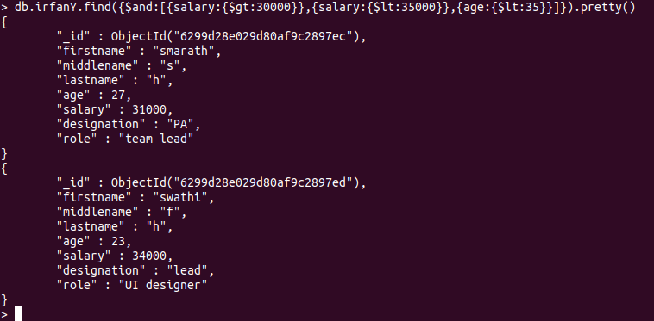
4. Count the number of Employees who has a role "Manager" in the Role eld

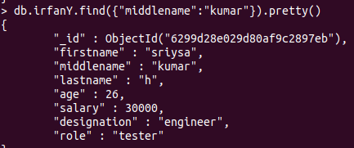

5. Find out all the documents who have age < 35 and salary in the range of 30000-35000

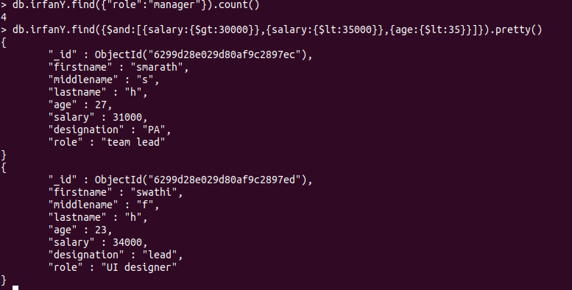
6. Delete an Employee whose "Firstname" is "Rajesh" and having the designation as "Scientist"

7. Update all the Employees whose role is "Team Lead" with a salary of 55650 INR

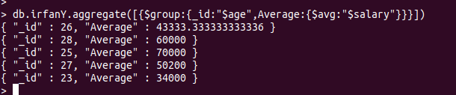

8. Group all the Employees by their age(common age should be there) and calculate the average salary obtained in the each group

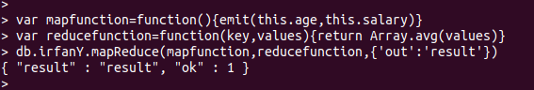

9. Apply the map-reduce to perform the above operation and obtain the results

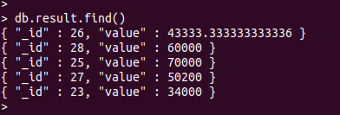

HADOOP
EXPERIMENT 1
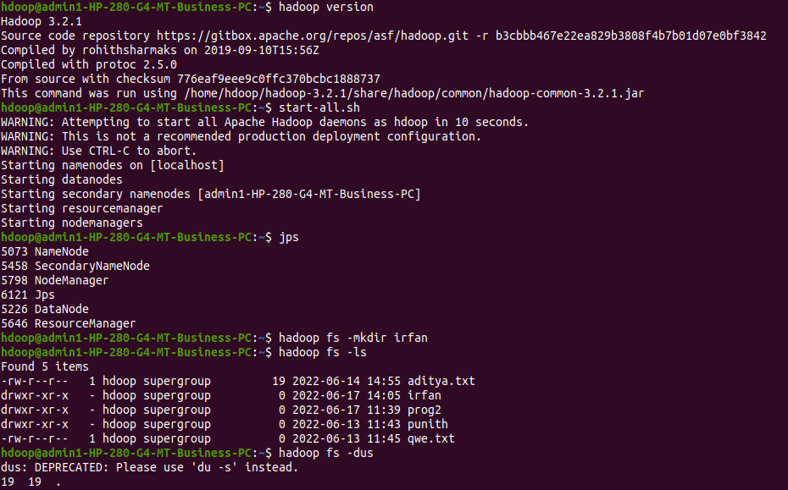
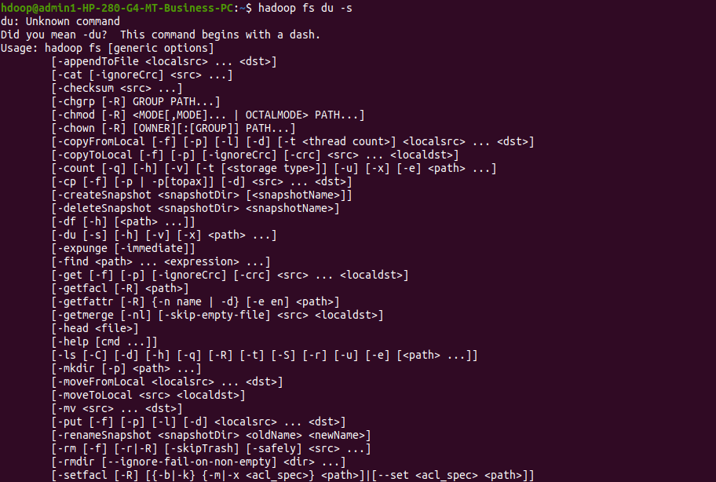
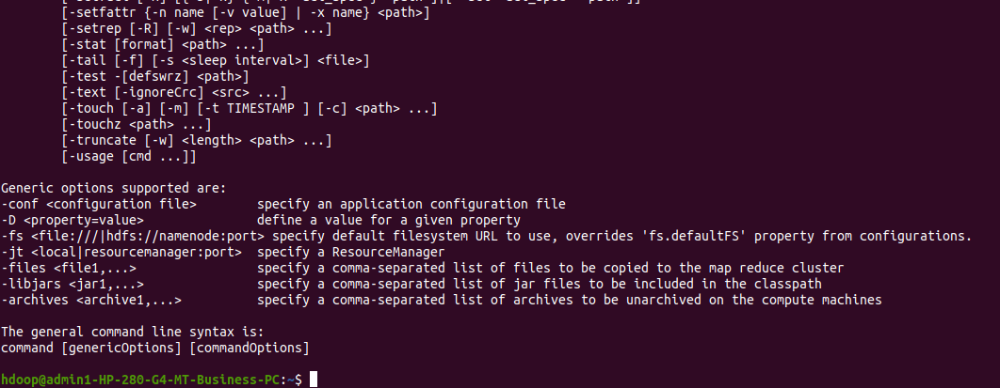

EXPERIMENT 2:

