PR 3

1706039585 / Muhammad Irfan Amrullah

Sysprog C

1. – Bourne Again Shell:

Advantages: - The most used shell in the worlds

* Many guides that assumpt that you use this bash
* Unlimited size indexed arrays

Disadvantages: - not intuitive

* Doesn’t support mouse
* KornShell:

Advantages:

* Having a better loop syntax
* Easier way to repeat commands
* Associative arrays

Disadvantages:

* No file completion by default
* Tcsh:

Advantages:

* Scripting language look familiar with C
* Autocompletion with tab
* History tab completion work

Disadvantages:

* Doesn’t support mouse
* No command enditor
* Zsh:

Advantages:

* Spelling correction
* Theming
* Sharing command history across multiple terminals

Disadvantages:

* No disadvantages
* Probably high loading time ccause of extension
* Fish:

Advantages:

* Autosuggestions
* Command completion
* Clean scripting

Disadvantages:

* Not POSIX-compatible

|  |  |  |
| --- | --- | --- |
| Command | Example of Use | Description |
| Ls | 1. $ls 2. $ ls -lrt | 1. Lists file in the current directory 2. Lists file in the long format |
| Cd | 1. $ cd /arora/applications | 1. change to application directory |
| mv | 1. $ mv /arora/applications/majorapps /arora/applications/minorapps | 1. moving applications that in majorapps to minorapps folder |
| Man | 1. $ man cd | 1. Will show the manual or all relevant information for the change directory command. |
| Mkdir | 1. $ mkdir testdirectory | 1. make the directory “testdirectory” |
| Rmdir | 1. $ rmdir testdirectory | 1. remove “testdirectory” directory |
| Touch | 1. $ touch testfile.txt | 1. create testfile.txt file |
| Rm | 1. $ rm testfile.txt | 1. remove testfile.txt |
| Locate | 1. $ locate -I *red*house**city* | 1. locate a file with name containing “red”, “house”, and “City” |
| Clear | 1. $ clear | 1. take back to the start prompt of whatever directory you are currently operating in |
| Alias | 1. $ alias home=’cd /home/tecmint/public_html’ | 1. Create and alias called home for /home/teccmint/public_html directory |
| Bc | 1. $ echo 20.05 + 15.00 | bc | 1. Calling a cli calculator which adding 20.05 with 15.00 |
| Cal | 1. $ cal | 1. Print a calendar on standard output |
| Cat | 1. $ cat file.txt | 1. View contents of file.txt |
| Chmod | 1. $ chmod +x sysinfo.sh | 1. Change file access permissions on sysinfo.sh |
| Cmp | 1. $ cmp file1 file2 | 1. Performs byte to byte comparison between file1 and file2 |
| Comm | 1. $ comm file1 file2 | 1. Compare file1 and file 2 line by line |
| Date | 1. $ date | 1. Printing date that on the system |
| Df | 1. $ df -h | 1. Show file system disk space usage |
| Env | 1. $ Env | 1. List all the current environment variables and used to set them as well |

Src = <https://www.tecmint.com/linux-commands-cheat-sheet/>

* Total 6004 means the number file system blocks that the directory’s files occupy.
* Each line supplies details on a single item.
* The first character specifies the folder or file type. It is a directory if the letter “d” appears. UNIX uses hyphens to identify standard files; various letters denote specialized data files and links. The identifier followed by a set of nine letters and hyphens. They disclose the item’s security permissions. The first three permissions apply to the file’s owner, and the next set pertains to members of the owner’s group. The final three characters identify access permissions for all the other users.

A user or group is allowed to read an item if its permissions contain the letter “r”. The letter “w” indicates that someone can modify the file by writing to it. An “x” means that users have permission to run the file if it’s an executable program. Hyphens appear when permissions have not been granted.

The next item in each ls -l listing is the number of links. A file typically has one link, but there are more links if it has aliases. The count starts at two for folders because UNIX considers the parent and current directories to be links. This figure includes the number of subdirectories in a folder as well

The UNIX ls -l command’s listings also indicate the owner and group assigned to a file. You can use this data in conjunction with the permission flags to determine what access rights you have. The file size follows the group namel it is measured in bytes. Regardless of how many files it contains, the size of a directory is normally 2048 bytes.

A calendar date appears after the file size. It may also include the year or a specific time. This is the date when the item was last modified; you will see the creation date if a file has naver been changed. Finally, the name of a file or directory appears at the end of each line.

* Character pertama menunjukkan tipe file.

Didalam contoh ditandai dengan ‘d’ di character pertamanya menandai bahwa ini adalah sebuah file direktori. Berikut kemungkinan tipe file yang yang ada di character pertama di ls -l.

* – file normal
* d directory
* s socket file
* l link file
* Tergantung dari file apa yang kamu buat. Jika kamu buat direktori maka hurufnya akan d, dan seterusnya

Src: http://www.livefirelabs.com/unix_commands/the-unix-ls-l-command-explained.htm

1. –

* A shell variable adalah variable yang hanya ada di shell sekarang. Kebalikannya, sebuah environment variable tersedia secara luas dan bisa digunakan oleh aplikasi lain di system
* $* expands to a single argument with all the elements delimited by spaces

$@ expands to multiple arguments.

* Command & means “run command in the backfround”

Command1 && command2 meands “run command1 and if it completes successfully, run command2 afterwards”

* The lifespan of a variable inside shell script is only until the end of execution

Part B: Simple Program

1. The output is 0. $# mengeluarkan jumlah positional parameter dari script kamu.

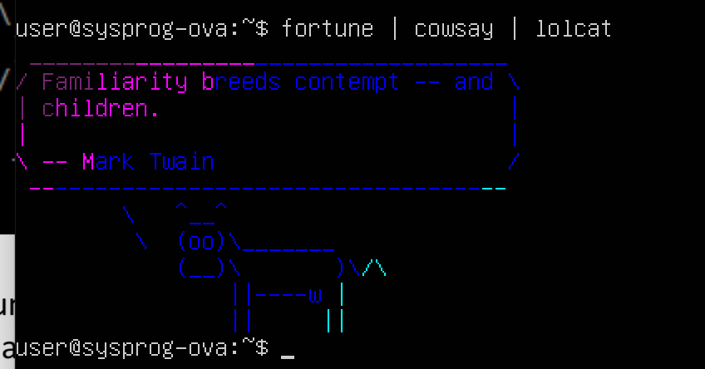

Salah satu hasil output dari fortune dan cowsay. How to install is easy.

1. Sudo apt-get install cowsay
2. Sudo apt-get install fortune
3. Sudo apt-get install ruby

The cowsay function si to generate ascii with a shape of cow, and fortune will generate random sentences.

1. My bash Script

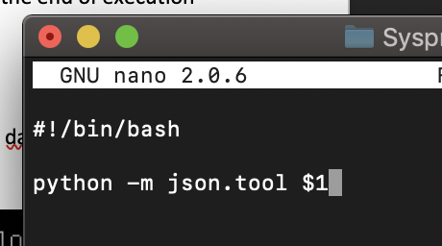

How to run it is easy. You should have python installed first. I named my program as beautify and accepting arg1. Just type ./beautify yourfilename and it will show you the beautified version of your json in terminal.

Berikut salah sebagian screenshot dari hasil program saya.