PR 4

Sysprog C

Muhammad Irfan Amrullah / 1706039585

1. My bash_prompt.sh script make your terminal show the times and dates at the time. After I close my bash prompt, the settings back to normal. To make it permanent, I should add the PS1 settings in the ~/.bashrc file.



And the content of my bash_prompt.sh is

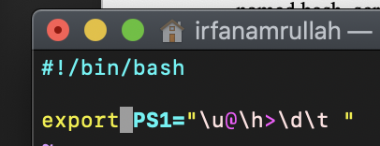

Part B : Scripting

1. Here’s my script.

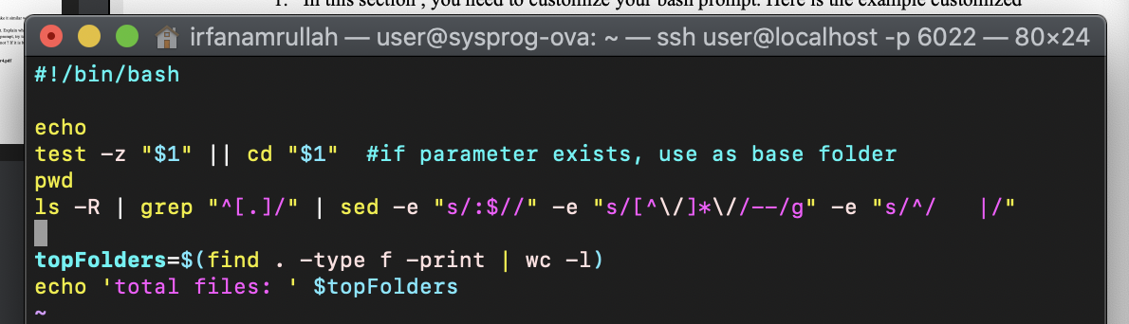

Here’s my script, It will show you the tree folder. And the count of how many files in it.

Part C : Regex

1. a. The regex is “/^dudut .+ CHuchu$/g”
2. a. Regex is a sequence of characters that define a search pattern. Biasa digunakan untuk algoritma pencarian string utamanya seperti mencari, mengganti, dan memvalidasi string.

Source: https://en.wikipedia.org/wiki/Regular_expression

b.

