***Acme AI Fellowship Program 2025***

*Submitted By :* [*Irhamul Islam*](https://www.linkedin.com/in/irhamul-islam-54164a136/)

Firebase link : <https://budgetdb-7d811-default-rtdb.firebaseio.com/>

Acme_budget_api : <https://acme-budget-api.onrender.com>

Acme_budget_Dashboard : <https://acme-budget-dashboard.onrender.com>

Or try this : <https://acme-budget-dashboard-irham.streamlit.app/>

Note : The API and dashboard are hosted on Render's free tier, which means they may enter a sleep mode when inactive. If there is no traffic for some time, the services will temporarily shut down. When accessed again, they may take up to a minute to restart before becoming fully functional. Please allow some time for the services to load when checking the provided links.

**Github Links :**

1.Dashboard : <https://github.com/Irhamul1907093/Acme_budget_dashboard>

2.Backend Api : <https://github.com/Irhamul1907093/Acme_budget_api>

3.All codes together(all the approaches I took) : <https://github.com/Irhamul1907093/Acme_AI_Internship>

***Report***

* **Backend Development**

The backend is implemented using Firebase Realtime Database, structured as follows:

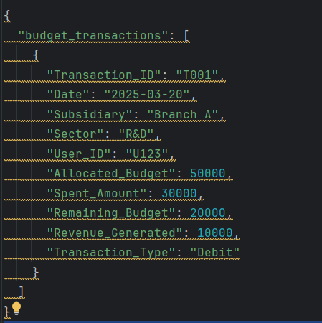

* **API Implementation**

*A FastAPI backend is deployed at:*

[*🔗 API Endpoint*](https://acme-budget-api.onrender.com/) *->* (READ IN JSON FOR BETTER UNDERSTANDING)

Key API functionalities:

* Fetch budget summaries (total, subsidiary-wise, sector-wise).
* Fetch transaction history.
* Add & delete transactions (admin only).

**Note:** The API is hosted on Render's free tier, which may cause a slight delay (up to 1 minute) when waking up from sleep mode.

* **Interactive Dashboard**

Dashboard Features :

Developed using Streamlit, the dashboard provides:

* + - * Total Budget Overview (Allocated, Used, Remaining).
      * Subsidiary-wise Breakdown (Branch A, B, C).
      * Sector-wise Breakdown (Operations, HR, R&D, Marketing, IT).
      * Transaction History View.
      * Real-time Filtering by Subsidiary & Sector.

🔗 [Interactive Dashboard](https://acme-budget-dashboard-irham.streamlit.app/)

* **User Access Control**

User Roles & Permissions

|  |  |  |  |  |
| --- | --- | --- | --- | --- |
| Role | View Budget | Filter Data | Add/Delete Transaction | Update Transaction |
| Viewer | **✓** | **✓** | **×** | **×** |
| Admin | **✓** | **✓** | **✓** | **✓** |

* Viewer: Can see budget data and filter by subsidiary & sector.
* Admin: Can perform all actions, including adding and deleting transactions.
* **Security Measures:**

Firebase Rules: Access is allowed until May 2, 2025