

XML SCHEMA DOCUMENTATION



Table of Contents

1. Summary 4

2. Conventions used in this document 4

3. Description of XML Nodes 5

3.1.1 Node “report” 5

3.2.1 Node transaction 9

3.2.2 Transaction Additional Info Type 12

3.3 Node Activity 14

3.4.1 Node t_from_my_client 15

3.4.2 Node t_from 16

3.5.1 Node t_to_my_client 18

3.5.2 Node t_to 20

3.6.1 Node t_party 21

3.7 Subnode goods_services 23

4. Description Of Common Types Used in the Schema 25

*4.1.1 Type* t_account_my_client/t_account 25

*4.1.2 Type* Signatory 30

*4.1.3 Type* Account Related Persons 31

*4.1.4 Type* Account Related Accounts 31

*4.1.5 Type* Account Related Entity 32

*4.1.6 Type* Account Funds 32

4.2.1 Type t_entity_my_client/t_entity 33

*4.2.2 Type* Entity Related Persons 38

*4.2.3 Type* Entity Related Entities 38

*4.2.4* Entity Identifications 39

4.3.1 Type t_person_my_client/t_person 40

4.3.2 Type

Names 46

4.3.3 Type Social Account 47

4.3.4 Type Employment History 47

4.3.5 Type t_person_identification 49

4.3.6 Type PEPS 50

4.3.7 Type Person Related Persons 50

4.4.1 Type t_person_registration_in_report 51

4.4.2 Type t_conductor/t_conductor_my_client 51

*4.5 Type* t_address 52

4.6 Type t_phone 54

4.7 Type t_foreign_currency 55

4.8 Type report_party_type 56

4.9.1 Network Device Type 57

4.9.2 IP Address Type 58

4.10 Relation Date Range Type 59

4.11 Comments Type 60

4.12 Business Relationship 60

4.13 Additional Information 61

4.14 Sanctions Node 62

4.15 Means of Transportation Node 63

5. Lookup Values 65

5.1 Submission type 65

5.2 Funds type 65

5.3 Account type 66

5.4 Account status type 66

5.5 Identifier type 67

5.6 Conduction Type 67

5.7 Transaction Item Status 67

5.8 Report Code 68

5.9 Contact Type 68

5.10 Communication Type 68

5.11 Entity Legal Form Type 69

5.12 Transaction Item Type 69

5.13 Currencies 69

5.14 Country Codes 74

5.15 Account Person Role Type 79

5.16 Entity Person Role Type 80

5.17 Entity-Entity Relation Type 81

5.18 Transaction Type 81

5.19 Transaction Status 82

5.20 Account Category Type 82

5.21 Account-Entity Relation Type 82

5.22 Account-Account Relation Type 83

5.23 Person-Person Relation Type 83

5.24 Operating Systems Type 83

5.25 Criminality / Indicators Type 84

# Summary

The purpose of this specifications document is to provide both the reporting entities and reporting persons with the requirements and conditions for creating compatible XML files using the provided XML- Schema for the different supported report types.

A report file contains the following information which can be represented in the goAML Client after uploading and verifying the XML file.

* Basic information about the report.
* Where does the money come from?
* Who conducted the transaction?
* Where does the money go to?
* Was the transaction related to a property transfer?
* Who reported the transaction(s) (Optional)
* What was the reason for the report and which actions have been taken (Optional)?
* In multi-party transactions, list of all involved parties and their respective roles in the transactions.

An XML report is linked to one Reporting Entity but may contain multiple transactions. An uploaded report can be from ONE report type.

This document will provide a reference to the schema, nodes and types as well as the lookup tables for enumeration values. (e.g., Country Codes)

# Conventions used in this document

The following conventions are used in this document:

|  |  |
| --- | --- |
|  | Required field  Required, 1 to N values |
|  | Optional field |
|  | Optional sub node  Required sub node |
|  | Optional, but one of the two nodes should be provided |
| Integer | A 32 bit value |
| Date time | A date and time value in the following format: YYYY-MM-DDTHH:MM:SS |
|  | Sequence to sub nodes |
|  | Used to indicate that only one of the included elements can be reported (Choice) |

# Description of XML Nodes

## 3.1.1 Node “report”

Basic information about Reporting Entity, reporting date and type of report. It can contain one or multiple transactions or describe an event (activity) without the need to report any transaction.

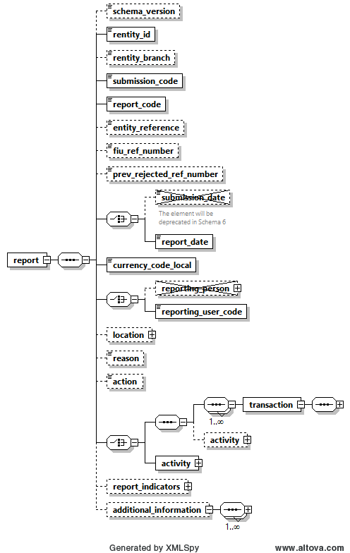

Figure 1: Overview node “report”

|  |  |  |  |  |  |  |  |  |  |  |  |  |  |  |  |  |  |
| --- | --- | --- | --- | --- | --- | --- | --- | --- | --- | --- | --- | --- | --- | --- | --- | --- | --- |
| **Name** | | | | **#Schema**  **#App** | | | | **Description** | | | | **Length** | | **Req.** | | **Example** | |
| schema_version | | | | Schema 5.0.1  App 5.1 | | | | Host the schema version which was used to generate the XML. | | | | 25 | | N | | 4.0.2  5.0.1 | |
| **rentity_id** | | | |  | | | | Reporting Entity number defined by FIC | | | | Integer  >= 1 | | **Y** | | 1237 | |
| rentity_branch | | | |  | | | | Branch of current reporting entity. | | | | 255 | | **N** | | Branch of Western Union who reported the transactions | |
| **submission_code** | | | |  | | | | Type of submission | | | | Enumeration | | **Y** | | See 5.1 Submission type | |
| **report_code** | | | |  | | | | Type of transaction (STR/CTR) | | | | Enumeration | | **Y** | | 5.8 Report Code | |
| entity_reference | | | |  | | | | Optional reference to the report, used by reporting entity | | | | 255 | | N | | STR Rep 392 | |
| FIC_ref_number | | | |  | | | | Optional ref. number to be used as communication channel between the FIC and the Reporting Entity when providing follow-up reports on the original report | | | | 255 | | N | | STR20230225 | |
| prev_rejected_ref_number | | | | Schema 5.0.1  App 5.1 | | | | Ref Number of a rejected report, to allow the FIC to better follow-up on rejected reports (entity_ref_number or Original Web Report Key if entity_ref_number is not available) | | | | 255 | | N | | 100-0-0 | |
| ~~submission_date~~ | | | | |  | | | ~~Not in use~~ | | | | ~~Not in use~~ | | ~~Y~~ | | ~~Not in use~~ | | |
| **report_date** | | | | | Schema 5.0.1  App 5.0 | | | This is a suggestion to phase out the current “submission_date” and replace it with better name. | | | | Datetime | | **Y** | | 2023-02-25T11:55:00 | | |
| **currency_code_**  **local** | | | |  | | | | Local Currency code | | | | Type “Currency-type” | | **Y** | | EUR | |
| ~~reporting_person~~ | | | | |  | | | ~~Not in use~~ | | | | ~~Not in use~~ | | N | |  | | |
| **reporting_user_**  **code** | | | | | **Schema 5.0.1**  **App 5.0** | | | **Currently, “reporting person” node can contain any name/details of a person, with no way to check if he/she is indeed a compliance officer in that RE. The “user_code” will be forced to have a valid user code of the RE or its delegation structure.** | | | | **50** | | **N** | | **User1** | | |
| **Location** | | | |  | | | | **Describes location of the reported report** | | | | **Type “t_address”** | | **N** | | **Mandatory: Same as “reporting pesrson”** | |
| **reason** | | | |  | | | | **Why the report was reported (especially or STRs)** | | | | **4000** | | **N** | | **Mandatory only on STR, SAR, TFR”** | |
| **action** | | | |  | | | | **Describes action related to the report** | | | | **4000** | | **N** | | **Mandatory only on STR, SAR, TFR”** | |
|  | | |  | | | |  | | |
|  | | | **transaction** | | | | | | **type**  **transaction** | **Y** | | | | **See 3.2 Node transaction** | | |
| **Activity (5.0)** | | | | | |  | **N** | | | | Optional Activity in Transactional Report | | |
|  | | | **Activity** | | | | | |  | **Y** | | | | See 3.3 Node activity | | |
| report_indicators | | | |  | | | | List of indicators for the current reports | | | | Type “indicator” | | N | | See 3.11 Subnode report_indicators **[Mandatory to suspicious reports]** | |
| additional_information | | | | Schema 5.0.1  App 5.2 | | | | A new optional generic node for adding any unplanned extra information | | | | Additional information type | | N | |  | |

Table 1: Details node “report”

3.1.2 Subnode report_indicators

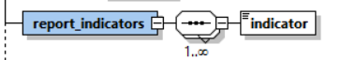

Figure 2: Overview subnode report_indicators

|  |  |  |  |  |
| --- | --- | --- | --- | --- |
| **Name** | **Description** | **Length** | **Req.** | **Example** |
| indicator | Some classification for the report | 25 | **N**  [Mandatory on suspicious reports such as STR,SAR,TFR] | Crime,  Terror Funding, etc.  (FIC predefined list of codes) |

Note: Indicator are strictly mandatory when reporting suspicious reports such as STR,SAR,TFR,..

Table 2: Details subnode report_indicators

## 3.2.1 Node transaction

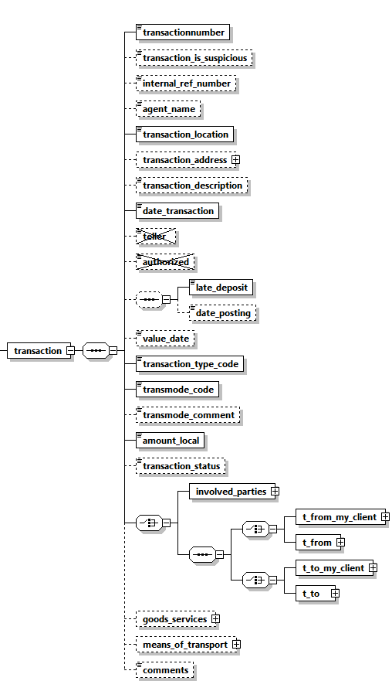

Figure 3: Overview node transaction

|  |  |  |  |  |  |  |  |  |
| --- | --- | --- | --- | --- | --- | --- | --- | --- |
| **Name** | | **#Schema**  **#App** | | **Description** | | **Length** | **Req.** | **Example** |
| **transactionnumber** | | Schema 5.0.1  App 5.1 | | Unique transaction number for bank transaction | | **100** | **Y** | 20084711 |
| Transaction is suspicious | | Schema 5.0.1  App 5.1 | | Boolean | |  | **N** |  |
| Internal_ref_number | | Schema 5.0.1  App 5.1 | | Reporting Entity internal transaction reference number | | 100 | N | WU_BRNCH01_0001 |
| agent name | | Schema 5.0.1  App 5.1 | | Hosts the agent name in money transfer agencies case when the report is done by main service provider | | 255 | N | WU Agent |
| **transaction_location** | |  | | Branch/Location where the transaction took place | | 255 | Y | Branch 001 |
| Transaction Address | | Schema 5.0.1  App 5.1 | | Address of transaction place | | Type “t_address” | N |  |
| transaction_ description | |  | | Free text field to describe the purpose of the transaction | | 4000 | N |  |
| **date_**  **transaction** | |  | | Date and time of the transaction | | DateTime | **Y** | 2006-03-25T11:55:00 |
| ~~teller~~ | |  | | Not in use | | ~~255~~ | ~~N~~ |  |
| ~~authorized~~ | |  | | Not in use | | ~~20~~ | ~~N~~ | ~~ID00033345~~ |
|  | | *late_deposit* and *date_posting* are both optional but when setting *date_posting,*  *late_deposit* becomes mandatory.  3 possible combinations  1. none of the nodes is set  2. only *late_deposit* is set  3. *late_deposit* AND *date_posting* are set | | | | | | |
| late_deposit | |  | | Late deposit indicator | | Boolean | N | True |
| date_  posting | |  | | Date of posting (if different from date of transaction) | | DateTime | N | 2006-03-24T19:55:00 |
| value_date | |  | | The actual date when the money will be credited (For example, Value date of a cheque) | | DateTime | N | 2006-03-27T00:00:00 |
| Transaction_Type | | Schema 5.0.1  App 5.1 | | answer the WHAT question while the current transaction_mode can be dedicated then to answer the HOW | | Enumeration | N | see 5.18 Transaction Type |
| **transmode_code** | |  | | How the transaction was conducted | | Enumeration | **Y** | See 5.6 Conduction Type |
| transmode_comment | |  | | Description if transmode_code is “O” (Other) | | 50 | N | - |
| **amount_**  **local** | |  | | The value of the transaction in local currency | | Decimal | **Y** |  |
| Transaction Status | | Schema 5.0.1  App 5.1 | | Describe if transaction was executed, on hold, blocked, ..etc. | | Enumeration | N | see 5.19 Transaction Status |
|  | | Transaction could be either a bi-party transaction with clear From and To sides, or a multi-party transaction with unlimited list of subjects (Persons, Accounts and Entities) where each has a role in the transaction rather than a clear from or to side. | | | | | | |
|  | | Bi-Party Transaction | | | | | | |
|  | | One of the nodes *t_from_my_client* or *t_from* should be provided. Both CANNOT be present together in a transaction, but one of them should be present. | | | | | |
|  | | **t_from_my_client** | | Specifies where the money came from. If the source is reporting bank’s client, then this node should be provided | Subnode | **Y**  (one of them) | See t_from_my_client | |
|  | | **t_from** | | Specifies where the money came from | Subnode | See 3.42 Node t_from | |
|  | | One of the nodes *t_to_my_client* or *t_to* should be provided. Both CANNOT be present together in a transaction, but one of them should be present. | | | | | |
|  | | **t_to_my_client** | | Specifies where the money went. If the destination is reporting bank’s client, then this node should be provided | Subnode | **Y**  (one of them) | See 3.51 Node t_to_my_client | |
|  | | **t_to** | | Specifies where the money went. | Subnode | See 3.52 Node t_to | |
|  | | Multi-Party Transaction | | | | | | |
|  | | This is a new node in schema 3.0. It covers transactions with multi-party involvement covering non-banking transactions. Car dealers for example can report such transactions where more than one subject bought/sold a car, while the car dealer is not reported as part of the transaction but only as the reporting entity. If the transaction is reported in this way, then at least one “Party” node should be reported. | | | | | |
|  | | **party** | | Describes the involved party details | Type “t_party” | **Y** | See 4.4 Type t_party | |
| Goods_  services | |  | | The goods/services linked to the transaction | | subnode | N | See 3.5 3.6 Subnode goods_services | |
| means_of_  transport | | Schema 5.0.1  App 5.2 | | capture customs related reports where subjects carry money cross borders as well as possible TBML reporting | | Subnode | **N** | 4.15 Means of Transportation Node | |
| Comments | |  | | Additional comments | | Type “comments_type”  Text 8000 |  |  | |

Table 3: Details node transaction

## 3.2.2 **Transaction Additional Info Type**

Describes additional information in virtual currency and mobile money transactions regarding the used device, related IP address, blockchain block number and virtual address if the involved party is a Virtual Wallet.

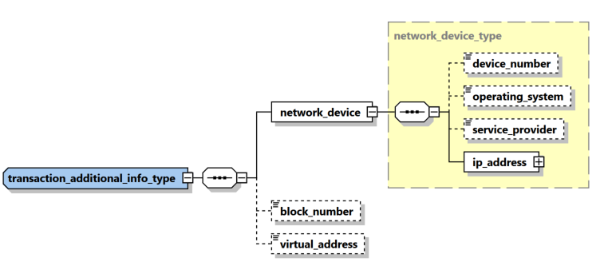

|  |  |  |  |  |  |
| --- | --- | --- | --- | --- | --- |
| **Name** | **#Schema**  **#App** | **Description** | **Length** | **Req.** | **Example** |
| device_number | Schema 5.0.1  App 5.1 | The number of device to send/receive the money in transaction context | 50 | N | 06501234567 |
| device_number | Schema 5.0.1  App 5.1 | The device operating system | Enumeration | N | iOS, Android, Windows, Mac OS, Linux… |
| service_provider | Schema 5.0.1  App 5.1 | The name of the service provider in case of mobile phone for example | 255 | N | Orange |
| **ip_address** | **Schema 5.0.1**  **App 5.1** | **Describes the details of the used “IP address”** | **Subnode** | **Y** | **See** 4.8.2 IP Address Type |
| Block_number | Schema 5.0.1  App 5.1 | blockchain block number | Decimal | N |  |
| virtual_address | Schema 5.0.1  App 5.1 | virtual address if the involved party is a Virtual Wallet | 255 | N |  |

## 3.3 Node Activity

Activity node was introduced first in schema 4.0 to represent an event where a list of subjects and goods are related directly to the report without the need of a transaction. In Schema 5, it was enhanced to include several new elements like set of “my client” PAE elements as well as country and “is suspected”. In addition, new schema supports since Application 5.0, a hybrid mode where set of one or many transactions can be followed by an activity node to allow reporting additional parties who are not involved directly in any of the reported transactions.

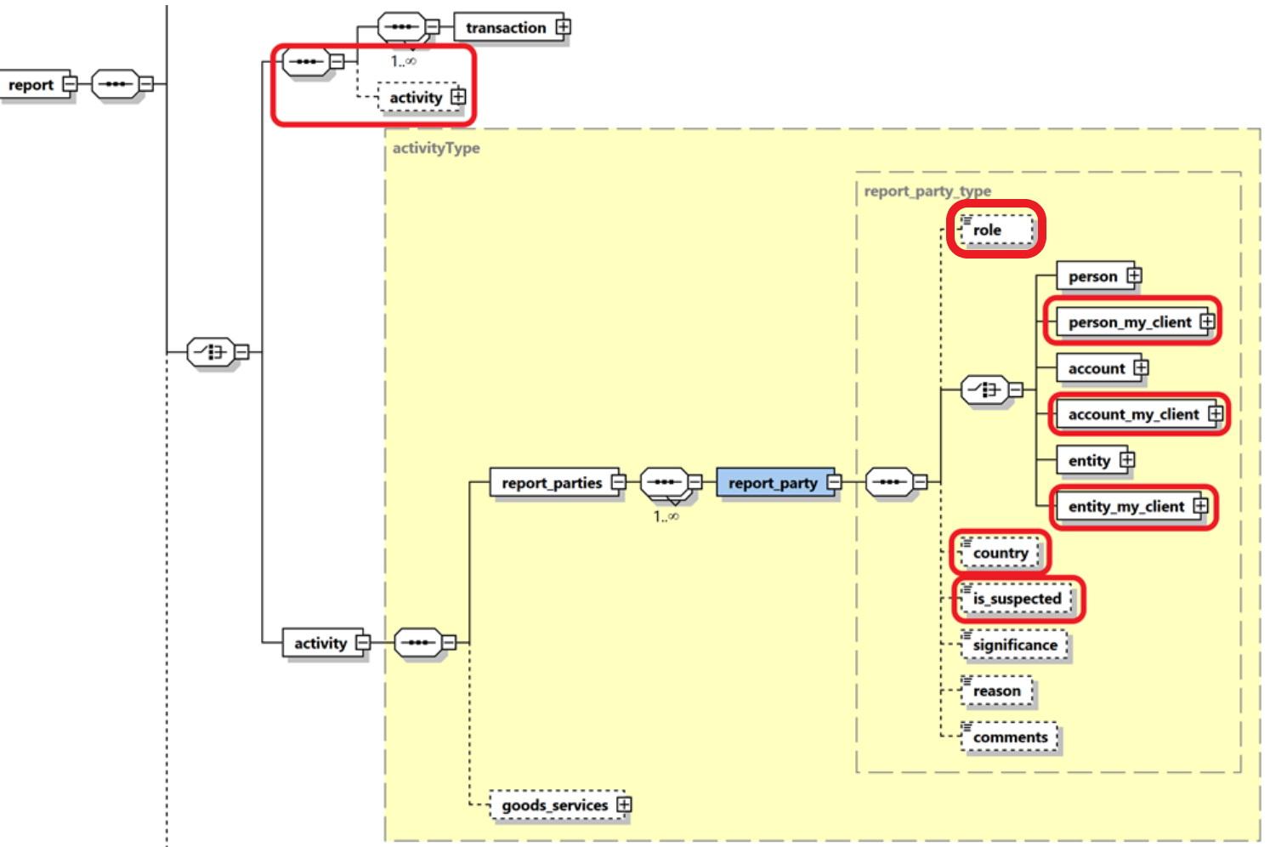

Figure 4: Overview node activity

|  |  |  |  |  |
| --- | --- | --- | --- | --- |
| **Name** | **Description** | **Length** | **Req.** | **Example** |
| **report_parties** | Represents a collection of involved subjects an involved subject with its details |  | **Y** |  |
| **report_party** | Represents a single involved subject with its details. At least one party should be included. | Type report_party_type | Y | See 4.9 Node report_party_type |
| goods_service | The standard goods_services node available in previous schemas | Type t_trans_item | N | - |

Table 4: Details node activity

## 3.4.1 Node t_from_my_client

This node should be provided if the source side of the transaction is a client of the reporting entity.

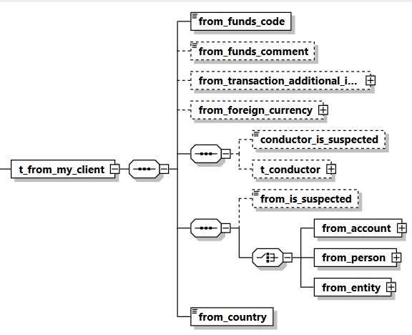

Figure 5: Overview node t_from_my_client

|  |  |  |  |  |  |
| --- | --- | --- | --- | --- | --- |
| **Name** | **#Schema**  **#App** | **Description** | **Length** | **Req.** | **Example** |
| **from_funds_**  **code** |  | Type of funds used in initiating transaction | Enumeration | **Y** | See 5.2 Funds type |
| from_funds_  comment |  | Description, if funds_code is “O” (Other). | 255 | N | - |
| From transaction Additional Information | Schema 5.0.1  App 5.1 | covers Virtual Currency and Mobile Money related transaction element | Subnode | N | See |
| from_foreign_  currency |  | If the transaction is conducted in foreign currency, then specify the foreign currency details. | type  t_foreign_currency | N | See 4.7 Type t_foreign_currency |
| conductor_is_  suspected | Schema 5.0.1  App 5.1 | Indicates if the conductor is a suspected party in this transaction | Boolean | N | True/False |
| t_conductor | Schema 5.0.1  App 5.1 | The person performing the transaction | type  t_conductor_my_client | N | See 4.31 Type t_person_my_client |
| **from_account** |  | Subnode that holds account information | type t_account_my_client | **Y**  (one of them only) | See 4.11 Type t_account_my_client |
| **from_person** |  | Subnode that holds “from person” information. | Type  t_person_my_client | See 4.31 Type t_person_my_client |
| **from_entity** |  | Subnode that holds “from entity” information. | Type t_entity_my_client | See 4.32 Type t_entity_my_client |
| **from_country** |  | Country where transaction was initiated. | Enumeration | **Y** | See 5.14 Country Codes |

Table 5: Details node t_from_my_client

## 3.4.2 Node t_from

This node should be provided if the source side of the transaction is NOT a client of the reporting entity.

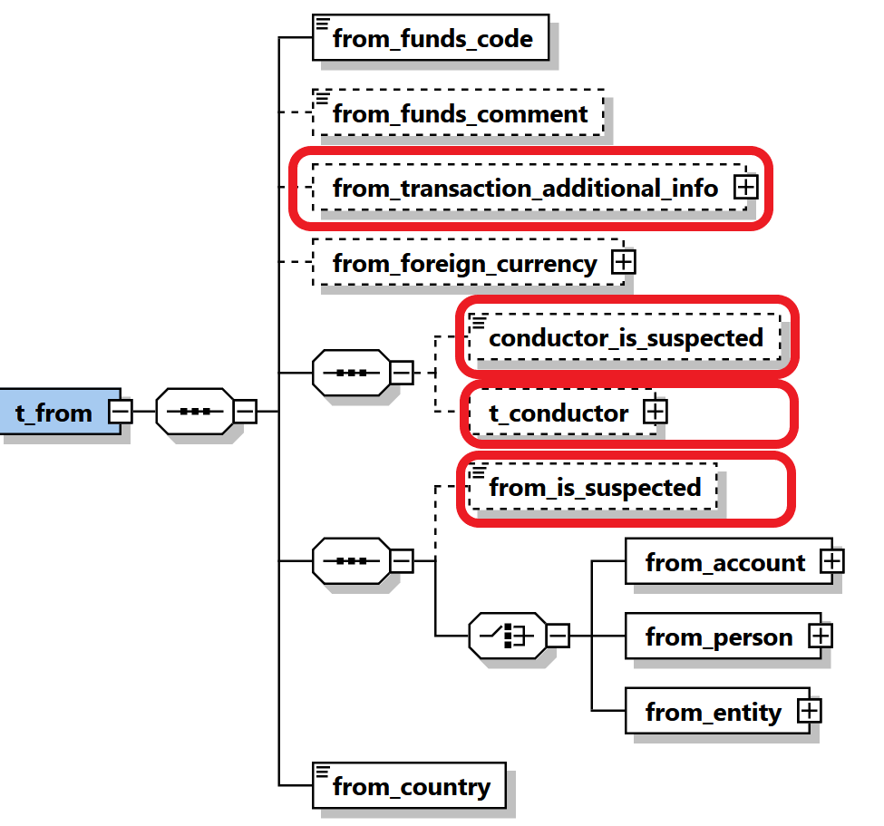

Figure 6: Overview node t_from

|  |  |  |  |  |  |
| --- | --- | --- | --- | --- | --- |
| **Name** | **#Schema**  **#App** | **Description** | **Length** | **Req.** | **Example** |
| **from_funds_**  **code** |  | Type of funds used in initiating transaction | Enumeration | **Y** | See 5.2 Funds type |
| from_funds_  comment |  | Description, if funds_code is “O” (Other). | 255 | N | - |
| From transaction Additional Information | Schema 5.0.1  App 5.1 | covers Virtual Currency and Mobile Money related transaction element | Subnode | N | Transaction Additional Info Type |
| from_foreign_  currency |  | If the transaction is conducted in foreign currency, then specify the foreign currency details. | type  t_foreign_currency | N | See 4.7 Type t_foreign_currency |
| conductor_is_  suspected | Schema 5.0.1  App 5.1 | Indicates if the conductor is a suspected party in this transaction | Boolean | N | True/False |
| t_conductor | Schema 5.0.1  App 5.1 | The person performing the transaction | type  t_conductor | N | See 4.31 Type t_person_my_client |
| From_is_  suspected | Schema 5.0.1  App 5.1 | Indicates if the from party is a suspected party in this transaction | Boolean | N | True/False |
| **from_account** |  | Subnode that holds account information | type t_account | **Y**  (one of them only) | See 4.11 Type t_account_my_client |
| **from_person** |  | Subnode that holds “from person” information. | Type  t_person | See 4.31 Type t_person_my_client |
| **from_entity** |  | Subnode that holds “from entity” information. | Type t_entity | See 4.32 Type t_entity_my_client |
| **from_country** |  | Country where transaction was initiated. | Enumeration | **Y** | See 5.14 Country Codes |

Table 6: Details node t_from

## 3.5.1 Node t_to_my_client

This node should be provided if the destination side of the transaction is a client of the reporting bank.

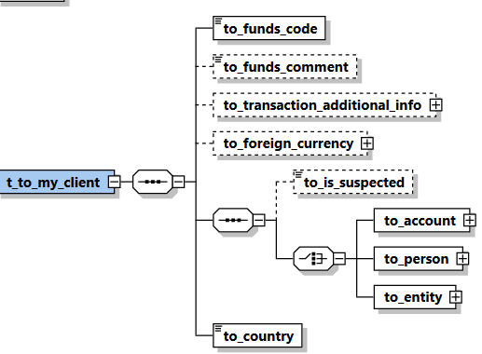

Figure 7: Overview node t_to_my_client

|  |  |  |  |  |  |
| --- | --- | --- | --- | --- | --- |
| **Name** | **#Schema**  **#App** | **Description** | **Length** | **Req.** | **Example** |
| **to_funds_code** |  | Disposition of funds | Enumeration | **Y** | See 5.2 Funds type |
| to_funds_comment |  | Description, if funds_code is “O” (Other) or policy number. | 255 | N | - |
| to_transaction Additional Information | Schema 5.0.1  App 5.1 | covers Virtual Currency and Mobile Money related transaction element | Subnode | N | Transaction Additional Info Type |
| to_foreign_  currency |  | If the transaction is conducted in foreign currency, then specify the foreign currency details. | type  t_foreign_currency | N | See 4.7 Type t_foreign_currency |
| to_is_  suspected | Schema 5.0.1  App 5.1 | Indicates if the “to” party is a suspected party in this transaction | Boolean | N | True/False |
| **to_account** |  | Subnode that holds account information | type t_account_my_client | **Y**  (one of them) | See *4.11 Type* t_account_my_client |
| **to_person** |  | Subnode that holds person information | type t_person_my_client | See 4.31 Type t_person_my_client |
| **to_entity** |  | Subnode that holds “to entity” information. | Type t_entity_my_client | See 4.32 Type t_entity_my_client |
| **to_country** |  | Target country of the transaction | Enumeration | **Y** | See 5.14 Country Codes |

Table 7: Details node t_to_my_client

## 3.5.2 Node t_to

Information about the transaction disposition(s) - i.e. where the money went.

*t_to* can either point to a person or to an account.

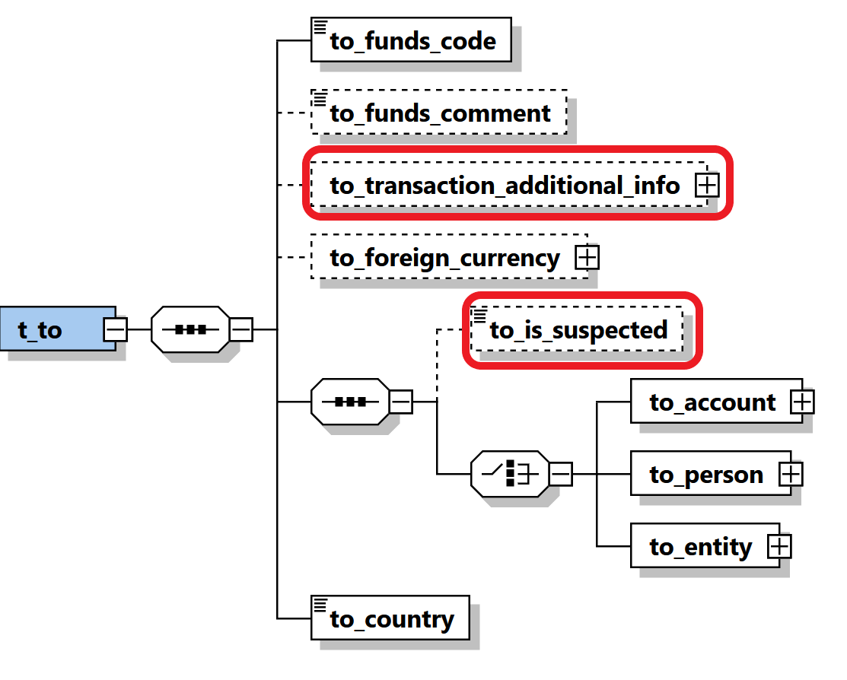

Figure 8: Overview node t_to

|  |  |  |  |  |  |
| --- | --- | --- | --- | --- | --- |
| **Name** | **#Schema**  **#App** | **Description** | **Length** | **Req.** | **Example** |
| **to_funds_code** |  | Disposition of funds | Enumeration | **Y** | See 5.2 Funds type |
| to_funds_comment |  | Description, if funds_code is “O” (Other) or policy number. | 255 | N | - |
| to_transaction Additional Information | Schema 5.0.1  App 5.1 | covers Virtual Currency and Mobile Money related transaction element | Subnode | N | Transaction Additional Info Type |
| to_foreign_  currency |  | If the transaction is conducted in foreign currency, then specify the foreign currency details. | type  t_foreign_currency | N | See 4.7 Type t_foreign_currency |
| to_is_  suspected | Schema 5.0.1  App 5.1 | Indicates if the “to” party is a suspected party in this transaction | Boolean | N | True/False |
| **to_account** |  | Subnode that holds account information | type t_account | **Y**  (one of them) | See *4.11* t_account_my_client |
| **to_person** |  | Subnode that holds person information | type t_person | See 4.31 t_person_my_client |
| **to_entity** |  | Subnode that holds “to entity” information. | Type t_entity | See 4.32 t_entity_my_client |
| **to_country** |  | Target country of the transaction | Enumeration | **Y** | See 5.14 Country Codes |

Table 8: Details node t_to

## 3.6.1 Node t_party

This type is used to represent Multi-Party transaction parties

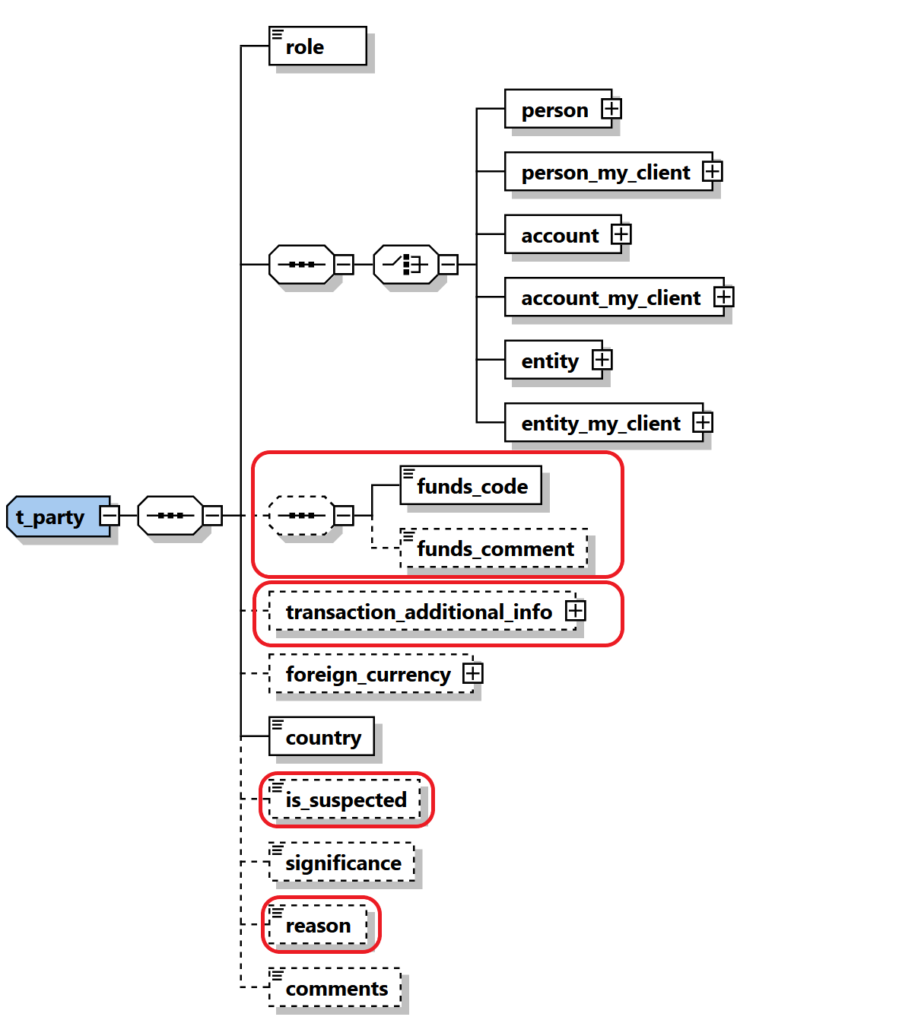

Figure 9: Overview type t_party

|  |  |  |  |  |  |  |
| --- | --- | --- | --- | --- | --- | --- |
| **Name** | | **#Schema**  **#App** | **Description** | **Length** | **Req.** | **Example** |
| **role** | |  | Subject role in the transaction | Enumeration | **Y** | Buyer, Seller,.. |
|  | Subject: One occurrence of the supported subject types must be included. | | | | | |
| Person | |  | Involved Person | Type “t_person” | **Y** | See 4.32 Type t_person |
| Person_my_client | |  | Involved Person | Type “t_person_  my_client” | **Y** | See 4.31 Type t_person_my_client |
| account | |  | Involved Account | Type “t_account” | **Y** | See *4.12 Type* t_account |
| account_  my_client | |  | Involved Account | Type “t_ account_my_client” | **Y** | See *4.11 Type* t_account_my_client |
| entity | |  | Involved Entity | Type “t_ entity” | **Y** | See 4.22 Type t_entity |
| entity_my_client | |  | Involved Entity | Type “t_ entity_my_client” | **Y** |  |
| funds_code | |  | Type of funds used in initiating transaction | Enumeration | N | See 5.2 Funds type |
| funds_comment | |  | Description, if funds_code is “O” (Other). | 255 | N | - |
| transaction Additional Information | | Schema 5.0.1  App 5.1 | covers Virtual Currency and Mobile Money related transaction element | Subnode | N | Transaction Additional Info Type |
| foreign_currency | |  | If the transaction is conducted in foreign currency, then specify the foreign currency details. | type  t_foreign_currency | N | See 4.7 Type t_foreign_currency |
| **country** | |  | Country of the transaction | Enumeration | **Y** | See 5.14 Country Codes |
| is_  suspected | | Schema 5.0.1  App 5.1 | Indicates if the “to” party is a suspected party in this transaction | Boolean | N | True/False |
| significance | |  | The significance of the subject in the transaction | Integer | N | 0-10 |
| Reason | | Schema 5.0.1  App 5.1 | Describe the reason why the party is included | 8000 | N |  |
| comments | |  | Generic comments | 8000 | N |  |

Table 9: Details type t_party

## 3.7 Subnode goods_services

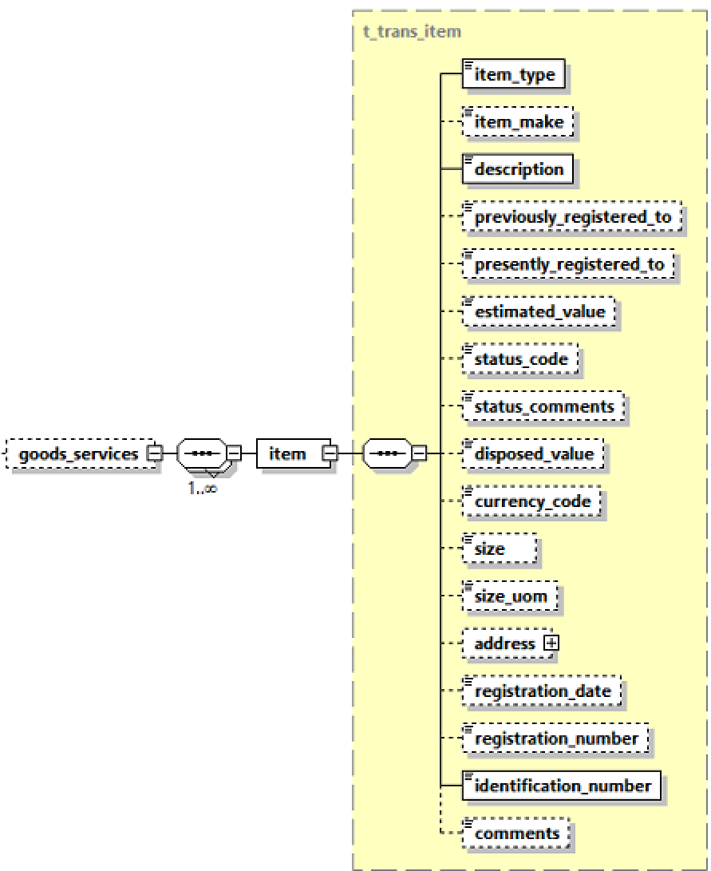

Figure 9: Overview subnode goods_services

|  |  |  |  |  |
| --- | --- | --- | --- | --- |
| **Name** | **Description** | **Length** | **Req.** | **Example** |
| **Item_type** | Lookup code describes the item type | Type “trans_item_type” | **Y** | C = Car  L = Land |
| Item_make | Item Maker | 255 | N | In case of Car for example, BMW |
| description | Description of item | 8000 | N | Apartment building |
| previously_registered_to | Name of previous owner | 500 | N | John Smith |
| presently_registered_to | Name of current owner | 500 | N | Jane Smith |
| **estimated_value** | **Estimated value of the property – Used Currency is the one specified in node *from_currency*** | **Decimal** | **Y** | 250000.00 |
| status_code | Status code | Enumeration | N | See 5.7 Transaction Item Status |
| status_comments | Status Comments | 500 | N |  |
| disposed_value | effective value for property transfer – Used Currency is the one specified in node *from_currency* | Decimal | N | 500000.00 |
| Currency_code | used to report service conducted in foreign currency | Enumeration | **N** | See 5.13 Currencies |
| size | Size of the property – in unit specified in node *size_uom* | Decimal | N | 150 |
| size_uom | Unit of measurement | 250 | N | Square meters |
| address | Address of the property | type t_address | N | *4.5 Type* t_address |
| registration_date | Official registration date | DateTime | N | 2001-12-17T09:30:47 |
| registration_number | Official registration number | 500 | N | Car VIN Number |
| **Identification_number** | **Any number that can identify the item** | **255** | **Y** | Car Plate Number |
| Comments | Additional comments | 8000 | N |  |

Table 9: Details subnode goods_services

# Description Of Common Types Used in the Schema

## *4.1.1 Type* t_account_my_client/t_account

The structure of these 2 types is exactly the same*,* it is introduced just to allow FICs to add more restrictions when the account is the hosted in the reporting entity in comparison to an account of another RE. i.e., some nodes which are not mandatory in *t_account* can be set mandatory in *t_account_my_client.*

The logic here is that whenever the involved account or person is the client of the reporting entity, more details may be demanded, and the reporting entity must have the information as part of the adherence to the “Know Your Customer” (KYC) philosophy of compliance.

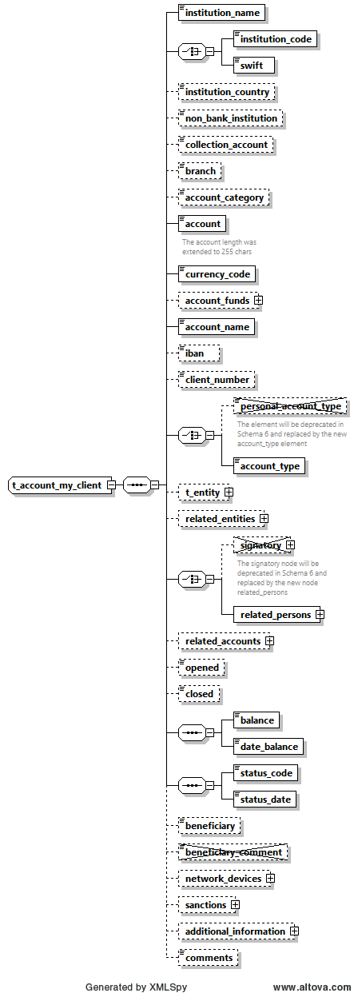

**Figure 10: Overview type t_account_my_client**/

|  |  |  |  |  |  |  |  |  |  |  |  |  |  |
| --- | --- | --- | --- | --- | --- | --- | --- | --- | --- | --- | --- | --- | --- |
| **Name** | | **#Schema**  **#App** | | | **Description** | | **Length** | | | **Req.** | | **Example** | |
| Instituation_name | |  | | | The name of the Bank | | 255 | | | Y | | Bank of … | |
| **institution_code** | |  | | | Institution code | | | 50 | | **Y**  (one of them) | | - | |
| **swift** | |  | | | SWIFT code according to ISO 9362 | | | 11 | | ATTBVI | |
| Institution Country | | Schema 5.0.1  App 5.1 | | | The country of the reported bank especially relevant for foreign banks | | Enumeration | | | N | | UN | |
| Non_banking_  institution | |  | | | Notification that an account is not opened in bank | | Boolean | | | N | | True/False | |
| Collection Account | | Schema 5.0.1  App 5.1 | | | Indicate that the reported account is a collection account and is not owned really by the reported subject | | Boolean | | | N | | True/False | |
| Branch | |  | | | Branch code or name | | 255 | | | N | | ABX12 | |
| Account Category | | Schema 5.0.1  App 5.1 | | | Allow different presentations of the Account element, e.g., Account, IBAN, Payment Card, Email, Mobile number as well as **Virtual Addresses** and **Wallets** | | Enumeration | | | N | | IBAN | |
| **Account** | | Schema 5.0.1  App 5.1 | | | Account number  Enlarged and can host now as well IBAN, Wallet, Virtual Address, etc. | | ~~50~~  255 | | | **Y** | | 31032027088 | |
| **currency_code** | |  | | | Currency the account is kept in | | Enumeration | | | **Y** | | See 5.13 Currencies | |
| Account Funds | | Schema 5.0.1  App 5.1 | | | allow capturing different funds for the same account. This will be implemented first to handle **Wallet** funds but can be extended later to host different currencies in one main account for example. | | SubNode | | | N | | See 4.1.6 Type Account Funds | |
| **account_name** | |  | | | This is a free text field used to “Label” the account, for example a saving book account with anonymous owner, or an Entity account dedicated to Invoices, etc. | | 255 | | | **Y** | | Private savings account | |
| iban | |  | | | LT601010012345678901 | | 34 | | | N | | LT601010012345678901 | |
|  | |  | | |  | |  | | |  | |  | |
| personal_account_type | | |  | | Account Type  Will be deprecated in the next schema | | Enumeration | | | N | | See 5.3 Account type | |
| account_type | | | Schema 5.0.1  App 5.1 | | Same as Account Type, jus better name since the type is the same for private of business accounts | | Enumeration | | | Y | | See 5.3 Account type | |
| t_entity | |  | | | Business entity owning the account | | type  t_entity | | | N | | See 4.22 Type t_entity | |
| related_entities | | Schema 5.0.1  App 5.1 | | | A new one to many relations to allow Reporting Entities to report several entities having some kind of relation to an account in addition to the current Entity owning the account node. | | Subnode | | | N | | See 4.1.5 Type Account Related Entity | |
| ~~signatory~~ | | |  | | ~~Person(s) with access to the account.~~ | | Not in use | | | N | |  | |
| related_persons | | | Schema 5.0.1  App 5.1 | | New Choice was introduced to allow deprecating the current root level Signatory node and replace it with cover node related_persons with multiple occurrences of single related_person element. | | Subnode | | | Y | | 4.1.3 Type Account Related Persons | |
| related_accounts | | Schema 5.0.1  App 5.1 | | | A new one to many relations to allow Reporting Entities to report several accounts as related to the main reported account | | SubNode | | | N | | 4.1.4 Type Account Related Accounts | |
| opened | |  | | | Date account opened | | DateTime | | | N | | 2003-01-25T00:00:00 | |
| closed | |  | | | Date account closed | | DateTime | | | N | | 2006-03-25T00:00:00 | |
| balance | |  | | | The account balance after the transaction was conducted. | | Decimal | | | N | | 5000.50 | |
| date_balance | |  | | | A date to specify the date of the reported balance. Application will show balance history | | DateTime | | | Y | |  | |
| status_code | |  | | | Account status when transaction was initiated | | Enumeration | | | Y | | 5.4 Account status type | |
| Status_date | | Schema 5.0.1  App 5.1 | | | A date to specify the date of the account status. Application will show balance history | | DateTime | | | Y | |  | |
| network_devices | | Schema 5.0.1  App 5.2 | | | Supports multi occurrence of “Network device” | | Subnode | | | N | | 4.9.1 Network Device Type | |
| beneficiary | |  | | | Ultimate beneficiary of the account. | | 50 | | | N | | Kalisa | |
| ~~beneficiary_~~  ~~comment~~ | |  | | | Not in use. | |  | | |  | |  | |
| sanctions | | Schema 5.0.1  App 5.2 | | | supports multi occurrence of “sanction list”. | | Subnode | | | N | | 4.13 Sanctions Node | |
| additional_  information | | Schema 5.0.1  App 5.2 | | | A new optional generic node for adding any unplanned extra information. See dedicated section. | | SubNode | | | N | | 4.12 Additional Information | |
| comments | |  | | | Generic comments elements | | 8000 | | | N | |  | |

Table 10: Details type t_account_my_client

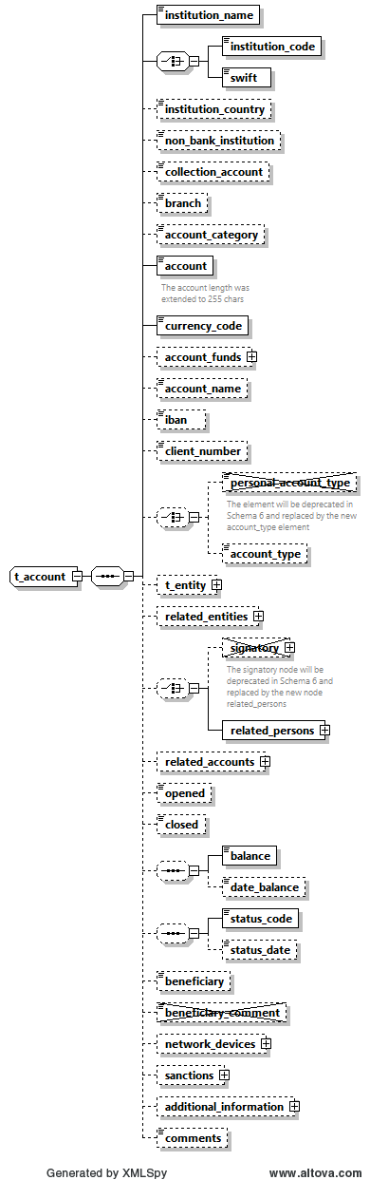

**Figure 10: Overview type t_account**

|  |  |  |  |  |  |  |  |  |  |  |  |  |  |
| --- | --- | --- | --- | --- | --- | --- | --- | --- | --- | --- | --- | --- | --- |
| **Name** | | **#Schema**  **#App** | | | **Description** | | **Length** | | | **Req.** | | **Example** | |
| Instituation_name | |  | | | The name of the Bank | | 255 | | | Y | | Bank of … | |
| **institution_code** | |  | | | Institution code | | | 50 | | **Y**  (one of them) | | - | |
| **swift** | |  | | | SWIFT code according to ISO 9362 | | | 11 | | ATTBVI | |
| Institution Country | | Schema 5.0.1  App 5.1 | | | The country of the reported bank especially relevant for foreign banks | | Enumeration | | | N | | UN | |
| Non_banking_  institution | |  | | | Notification that an account is not opened in bank | | Boolean | | | N | | True/False | |
| Collection Account | | Schema 5.0.1  App 5.1 | | | Indicate that the reported account is a collection account and is not owned really by the reported subject | | Boolean | | | N | | True/False | |
| Branch | |  | | | Branch code or name | | 255 | | | N | | ABX12 | |
| Account Category | | Schema 5.0.1  App 5.1 | | | Allow different presentations of the Account element, e.g., Account, IBAN, Payment Card, Email, Mobile number as well as **Virtual Addresses** and **Wallets** | | Enumeration | | | N | | IBAN | |
| **Account** | | Schema 5.0.1  App 5.1 | | | Account number  Enlarged and can host now as well IBAN, Wallet, Virtual Address, etc. | | ~~50~~  255 | | | **Y** | | 31032027088 | |
| **currency_code** | |  | | | Currency the account is kept in | | Enumeration | | | **Y** | | See 5.13 Currencies | |
| Account Funds | | Schema 5.0.1  App 5.1 | | | allow capturing different funds for the same account. This will be implemented first to handle **Wallet** funds but can be extended later to host different currencies in one main account for example. | | SubNode | | | N | | See 4.1.6 Type Account Funds | |
| account_name | |  | | | This is a free text field used to “Label” the account, for example a saving book account with anonymous owner, or an Entity account dedicated to Invoices, etc. | | 255 | | | N | | Private savings account | |
| iban | |  | | | LT601010012345678901 | | 34 | | | N | | LT601010012345678901 | |
|  | |  | | |  | |  | | |  | |  | |
| personal_account_type | | |  | | Account Type  Will be deprecated in the next schema | | Enumeration | | | N | | See 5.3 Account type | |
| account_type | | | Schema 5.0.1  App 5.1 | | Same as Account Type, jus better name since the type is the same for private of business accounts | | Enumeration | | | N | | See 5.3 Account type | |
| t_entity | |  | | | Business entity owning the account | | type  t_entity | | | N | | See 4.22 Type t_entity | |
| related_entities | | Schema 5.0.1  App 5.1 | | | A new one to many relations to allow Reporting Entities to report several entities having some kind of relation to an account in addition to the current Entity owning the account node. | | Subnode | | | N | | See 4.1.5 Type Account Related Entity | |
| signatory | | |  | | Person(s) with access to the account. | | Subnode (can repeated to specify multiple signatories). Note that the node t_person is of type t_person_my_client | | | N | | See 4.1.2 Type Signatory | |
| related_persons | | | Schema 5.0.1  App 5.1 | | New Choice was introduced to allow deprecating the current root level Signatory node and replace it with cover node related_persons with multiple occurrences of single related_person element. | | Subnode | | | N | | 4.1.3 Type Account Related Persons | |
| related_accounts | | Schema 5.0.1  App 5.1 | | | A new one to many relations to allow Reporting Entities to report several accounts as related to the main reported account | | SubNode | | | N | | 4.1.4 Type Account Related Accounts | |
| opened | |  | | | Date account opened | | DateTime | | | N | | 2003-01-25T00:00:00 | |
| closed | |  | | | Date account closed | | DateTime | | | N | | 2006-03-25T00:00:00 | |
| balance | |  | | | The account balance after the transaction was conducted. | | Decimal | | | N | | 5000.50 | |
| date_balance | |  | | | A date to specify the date of the reported balance. Application will show balance history | | DateTime | | | N | |  | |
| status_code | |  | | | Account status when transaction was initiated | | Enumeration | | | N | | 5.4 Account status type | |
| Status_date | | Schema 5.0.1  App 5.1 | | | A date to specify the date of the account status. Application will show balance history | | DateTime | | | N | |  | |
| network_devices | | Schema 5.0.1  App 5.2 | | | Supports multi occurrence of “Network device” | | Subnode | | | N | | 4.9.1 Network Device Type | |
| beneficiary | |  | | | Ultimate beneficiary of the account. | | 50 | | | N | | Kalisa | |
| ~~beneficiary_~~  ~~comment~~ | |  | | | Not in use. | |  | | |  | |  | |
| sanctions | | Schema 5.0.1  App 5.2 | | | supports multi occurrence of “sanction list”. | | Subnode | | | N | | 4.13 Sanctions Node | |
| additional_  information | | Schema 5.0.1  App 5.2 | | | A new optional generic node for adding any unplanned extra information. See dedicated section. | | SubNode | | | N | | 4.12 Additional Information | |
| comments | |  | | | Generic comments elements | | 8000 | | | N | |  | |

Table 11: Details type t_account

## *4.1.2 Type* Signatory(In our context this node is not active as it was replaced by Account related persons)

|  |  |  |  |  |  |
| --- | --- | --- | --- | --- | --- |
| is_primary | **Note in use** | Identifies the primary account holder. Only one signatory may be marked as *is_primary.* Has to be ‘true’ when node is set. | fixed = 1 | N |  |
| t_person | **Note in use** | Subnode holding detailed information about the signatory. Mandatory for signatories in the XML report. | type  t_person_my_client | Y | See 4.31 Type t_persony |
| role | **Note in use** | Subnode holding enumeration about the role of current signatory with the account. report. | type  “account_person_role_type” | N |  |

## *4.1.3 Type* Account Related Persons

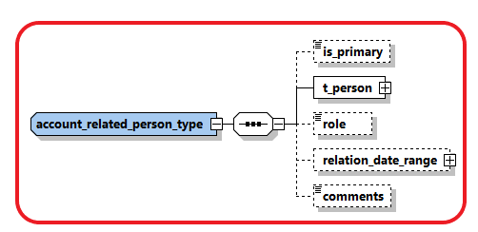

|  |  |  |  |  |  |
| --- | --- | --- | --- | --- | --- |
| is_primary |  | Identifies the primary account holder. Only one signatory may be marked as *is_primary.* Has to be ‘true’ when node is set. | fixed = 1 | N |  |
| t_person |  | Subnode holding detailed information about the signatory. Mandatory for signatories in the XML report. | type  t_person | Y | See 4.31 Type t_person |
| role |  | Subnode holding enumeration about the role of current signatory with the account. report. | type  “account_person_role_type” | N |  |
| relation_date_range | Schema 5.0.1  App 5.1 | Subnode to describe the date range relation | Type “relation_data_range_type” | N |  |
| comments |  | Generic Comments | 8000 | N |  |

## *4.1.4 Type* Account Related Accounts

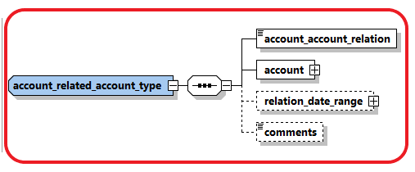

|  |  |  |  |  |  |
| --- | --- | --- | --- | --- | --- |
| account_account_  relation | Schema 5.0.1  App 5.1 | Describe the relation between the related two accounts | enumeration | Y |  |
| account |  | Subnode holding detailed information about the Related Account. | type  t_account | Y | See 4.31 Type t_account |
| relation_date_range |  | Subnode to describe the date range relation | Type “relation_data_range_type” | N |  |
| comments |  | Gneric Comments | 8000 | N |  |

## *4.1.5 Type* Account Related Entity

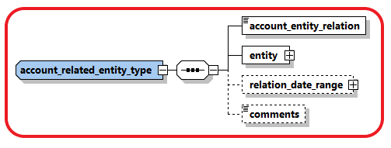

|  |  |  |  |  |  |
| --- | --- | --- | --- | --- | --- |
| account_entity_  relation | Schema 5.0.1  App 5.1 | Describe the relation between the account and related entity | enumeration | Y |  |
| entity |  | Subnode holding detailed information about the related entity. | type  t_entity | Y | See 4.31 Type t_entity |
| relation_date_range |  | Subnode to describe the date range relation | Type “relation_data_range_type” | N |  |
| comments |  | Generic Comments | 8000 | N |  |

## *4.1.6 Type* Account Funds

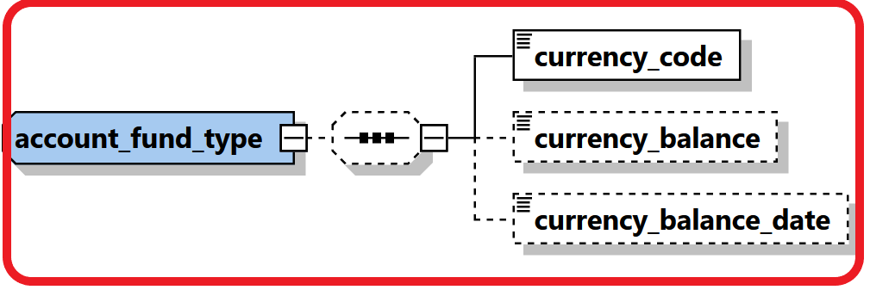

|  |  |  |  |  |  |
| --- | --- | --- | --- | --- | --- |
| currency_code | Schema 5.0.1  App 5.1 | Describe the currency of the funds | enumeration | Y |  |
| currency_balance | Schema 5.0.1  App 5.1 | Balance of the funds. | Decimal | N |  |
| currency_balance_date | Schema 5.0.1  App 5.1 | Balance of the funds. | DateTime” | N |  |

## 4.2.1 Type t_entity_my_client/t_entity

The structure of these 2 types is exactly the same*,* it is introduced just to allow more restrictions when the entity is hosted in the reporting entity in comparison to an entity which is the customer of another RE. i.e., some nodes which are not mandatory in *t_entity* can be set mandatory in *t_entity_my_client*.

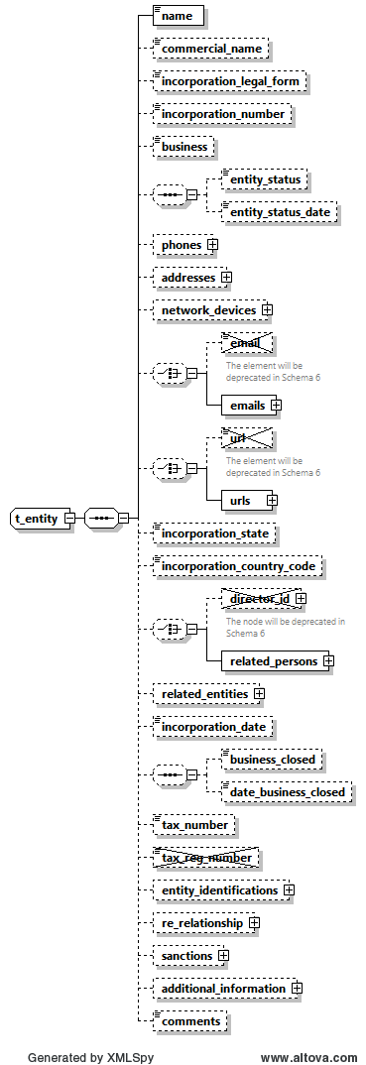

Figure 5: Overview type t_entity/

|  |  |  |  |  |  |  |  |  |  |  |  |  |  |
| --- | --- | --- | --- | --- | --- | --- | --- | --- | --- | --- | --- | --- | --- |
| **Name** | | **#Schema**  **#App** | | | **Description** | | **Length** | | **Req.** | | **Example** | | |
| **Name** | |  | | | Name of Entity | | 255 | | **Y** | | DoeComp | | |
| Commercial_name | |  | | | The “traded as” name of the entity | | 255 | | N | |  | | |
| **Incorporation_legal_form** | |  | | | The legal form of the entity | | Type “legal_form_type” | | **N** | | See 5.11  Ltd., GmbH, | | |
| **incorporation_**  **number** | |  | | | The registration number of the entity/"company" in the relevant authority (e.g. Chamber of Commerce) | | 50 | | **N** | | C845900 | | |
| Business | |  | | | Nature of business activities from NACE v.2 code list published by FIU-LV (provide a code or multiple semicolon-separated codes) | | Text 255 | | N | |  | | |
| Entity Status | | Schema 5.0.1  App 5.2 | | | describing the status of the entity | | Enumeration | | N | | ACTIVE | | |
| Entity Status Date | | Schema 5.0.1  App 5.2 | | | describing the date of entity status | | DateTime | | N | |  | | |
| Phones | |  | | | A Holder node for a 1..many Phones | |  | | N | |  | | |
| **Phone** | |  | | | One occurrence of phone node | | Type “t_phone” | | **N**  When “Phones” is provided | | See *4.6 Type* t_phone | | |
| Addresses | |  | | | A Holder node for a 1..many Addresses | |  | | N | |  | | |
| **Address** | |  | | | One occurrence of address node | | Type “t_address” | | **N**  When “Addresses” is provided | | *4.5 Type* t_address | | |
| network_devices | | Schema 5.0.1  App 5.2 | | | supports multi occurrence of “network device”. | | Subnode | | N | | See 4.8.1 Network Device Type | | |
| ~~Email~~ | | |  | | Not in use | | email_address (255) | | | N | | [test@mail.com](mailto:test@mail.com) | |
| emails | | | Schema 5.0.1  App 5.2 | | supports several emails for the reported entity in comparison with currently one email | | email_address (255) | | | N | |  | |
|  | | |  | |  | |  | | |  | |  | |
| ~~url~~ | | |  | | Not in use | | 255 | | | N | | [www.entity.com](http://www.entity.com) | |
| urls | | |  | | supports several urls for the reported entity in comparison with currently one url | | 255 | | | N | | [www.entity.com](http://www.entity.com) | |
| Incorporation_state | |  | | | State/Province | |  | | N | |  | | |
| **incorporation_**  **country_code** | |  | | | Country | | Enumeration | | **Y** | | See 5.14 Country Codes | | |
| **~~director_id~~** | |  | | | Not in use | | Not in use | | **N** | | See 4.31 Type t_person/t_person_my_client | | |
| related_persons | | Schema 5.0.1  App 5.2 | | | Parent node for multiple related_persons. Director_id will be deprecated in future schemas. | | subnode | | N | | See 4.2.2 Type Entity Related Persons | | |
| related_entities | | Schema 5.0.1  App 5.0 | | | Supports creating relations between different entities | | Subnode | | N | | See 4.2.3 Type Entity Related Entities | | |
| incorporation_date | |  | | | Incorporation registration date | | Date | | N | |  | | |
| business_closed | |  | | | Boolean to indicate if the company is closed down | | Boolean | | N | |  | | |
| date_business_  closed | |  | | | If entity is closed then specify close date if any. | | Date | | N | |  | | |
| tax_numebr | |  | | | The entity tax number | | 100 | | N | |  | | |
| ~~tax_registeration_~~  ~~number~~ | |  | | | Not in use | |  | |  | |  | | |
| entity_identifications | | Schema 5.0.1  App 5.2 | | | Similar to Person Identifications, a repeated sub node for Entity identification numbers was introduced. | | Subnode | | N | | See 4.2.4 Type Entity Identifications | | |
| business relationship | | Schema 5.0.1  App 5.2 | | | host the starting and dates of the relationship between the **Reporting Entity** and the Entity | | Subnode | | N | | 4.12 Business Relationship | | |
| sanctions | | Schema 5.0.1  App 5.2 | | | supports multi occurrence of “sanction list”. | | Subnode | | N | | 4.13 Sanctions Node | | |
| additional_  information | | Schema 5.0.1  App 5.2 | | | A new optional generic node for adding any unplanned extra information. See dedicated section. | | SubNode | | N | | 4.12 Additional Information | | |
| Comments | |  | | | Generic comments field | | 8000 | | N | |  | | |

Table 5: Details type t_entity

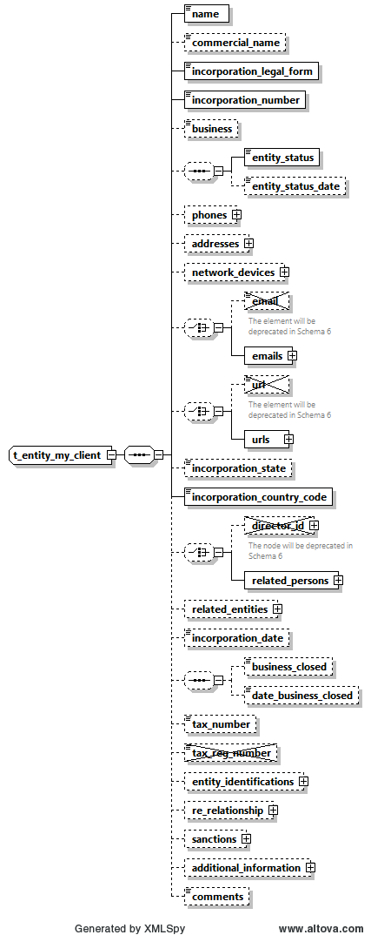

**Figure 6: Overview type t_entity My_Client**

|  |  |  |  |  |  |  |  |  |  |  |  |  |  |
| --- | --- | --- | --- | --- | --- | --- | --- | --- | --- | --- | --- | --- | --- |
| **Name** | | **#Schema**  **#App** | | | **Description** | | **Length** | | **Req.** | | **Example** | | |
| **Name** | |  | | | Name of Entity | | 255 | | **Y** | | DoeComp | | |
| Commercial_name | |  | | | The “traded as” name of the entity | | 255 | | N | |  | | |
| **Incorporation_legal_form** | |  | | | The legal form of the entity | | Type “legal_form_type” | | **Y** | | See 5.11  Ltd., GmbH, | | |
| **incorporation_**  **number** | |  | | | The registration number of the entity/"company" in the relevant authority (e.g. Chamber of Commerce) | | 50 | | **Y** | | C845900 | | |
| Business | |  | | | Nature of business activities from NACE v.2 code list published by FIU-LV (provide a code or multiple semicolon-separated codes) | | Text 255 | |  | |  | | |
| Entity Status | | Schema 5.0.1  App 5.2 | | | describing the status of the entity | | Enumeration | | N | | ACTIVE | | |
| Entity Status Date | | Schema 5.0.1  App 5.2 | | | describing the date of entity status | | DateTime | | N | |  | | |
| Phones | |  | | | A Holder node for a 1..many Phones | |  | | N | |  | | |
| **Phone** | |  | | | One occurrence of phone node | | Type “t_phone” | | **N**  When “Phones” is provided | | See *4.6 Type* t_phone | | |
| Addresses | |  | | | A Holder node for a 1..many Addresses | |  | | N | |  | | |
| **Address** | |  | | | One occurrence of address node | | Type “t_address” | | **N**  When “Addresses” is provided | | *4.5 Type* t_address | | |
| network_devices | | Schema 5.0.1  App 5.2 | | | supports multi occurrence of “network device”. | | Subnode | | N | | See 4.8.1 Network Device Type | | |
| ~~Email~~ | | |  | | Not in use | | ~~email_address (255)~~ | | | N | | [test@mail.com](mailto:test@mail.com) | |
| emails | | | Schema 5.0.1  App 5.2 | | supports several emails for the reported entity in comparison with currently one email | | email_address (255) | | | N | |  | |
|  | | |  | |  | |  | | |  | |  | |
| ~~url~~ | | |  | | Not in use | | 255 | | | N | | [www.entity.com](http://www.entity.com) | |
| urls | | |  | | supports several urls for the reported entity in comparison with currently one url | | 255 | | | N | | [www.entity.com](http://www.entity.com) | |
| Incorporation_state | |  | | | State/Province | |  | | N | |  | | |
| **incorporation_**  **country_code** | |  | | | Country | | Enumeration | | **Y** | | See 5.14 Country Codes | | |
| **~~director_id~~** | |  | | | Not in use | |  | | **N** | | See 4.31 Type t_person/t_person_my_client | | |
| related_persons | | Schema 5.0.1  App 5.2 | | | Parent node for multiple related_persons. Director_id will be deprecated in future schemas. | | subnode | | N | | See 4.2.2 Type Entity Related Persons | | |
| related_entities | | Schema 5.0.1  App 5.0 | | | Supports creating relations between different entities | | Subnode | | N | | See 4.2.3 Type Entity Related Entities | | |
| incorporation_date | |  | | | Incorporation registration date | | Date | | N | |  | | |
| business_closed | |  | | | Boolean to indicate if the company is closed down | | Boolean | | N | |  | | |
| date_business_  closed | |  | | | If entity is closed then specify close date if any. | | Date | | N | |  | | |
| tax_numebr | |  | | | The entity tax number | | 100 | | N | |  | | |
| ~~tax_registeration_~~  ~~number~~ | |  | | | Not in use | |  | |  | |  | | |
| entity_identifications | | Schema 5.0.1  App 5.2 | | | Similar to Person Identifications, a repeated sub node for Entity identification numbers was introduced. | | Subnode | | N | | See 4.2.4 Type Entity Identifications | | |
| business relationship | | Schema 5.0.1  App 5.2 | | | host the starting and dates of the relationship between the **Reporting Entity** and the Entity | | Subnode | | N | | 4.12 Business Relationship | | |
| sanctions | | Schema 5.0.1  App 5.2 | | | supports multi occurrence of “sanction list”. | | Subnode | | N | | 4.13 Sanctions Node | | |
| additional_  information | | Schema 5.0.1  App 5.2 | | | A new optional generic node for adding any unplanned extra information. See dedicated section. | | SubNode | | N | | 4.12 Additional Information | | |
| Comments | |  | | | Generic comments field | | 8000 | | N | |  | | |

Table 6: Details type t_entity My_Client

## *4.2.2 Type* Entity Related Persons

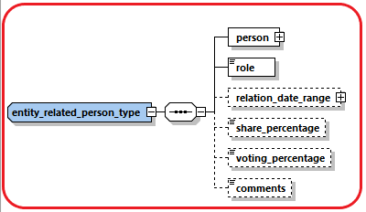

|  |  |  |  |  |  |
| --- | --- | --- | --- | --- | --- |
| person |  | Subnode holding detailed information about the signatory. | type  t_person | Y | See 4.31 Type t_person |
| role |  | Subnode holding enumeration about the role of current signatory in the entity | type  “entity_person_role_type” | N | 5.16 Entity Person Role Type |
| relation_date_range | Schema 5.0.1  App 5.2 | Subnode to describe the date range relation | Type “relation_data_range_type” | N |  |
| share_percentage | Schema 5.0.1  App 5.2 | Value of shares owned by the related person – if any. | Decimal  0>>100 | N |  |
| Voting_percentage | Schema 5.0.1  App 5.2 | Value of voting rights owned by the related person – if any. | Decimal  0>>100 | N |  |
| comments |  | Generic Comments | 8000 | N |  |

## 

## *.2.3 Type* Entity Related Entities

Introduced in goAML Release 5.0 to allow reporting relations between different entities. The relation type should describe always how the reported entity is related to the other related entities.

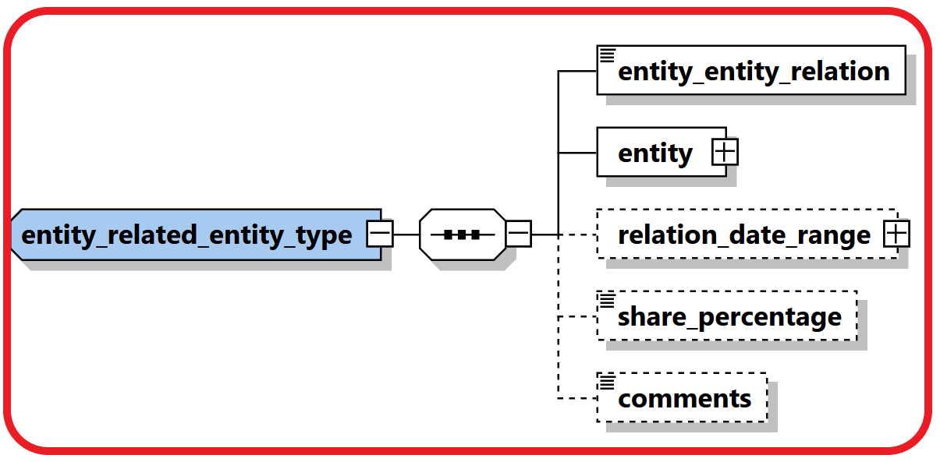

|  |  |  |  |  |  |
| --- | --- | --- | --- | --- | --- |
| entity_entity_  relation | Schema 5.0.1  App 5.0 | Describe the relation between the two and related entities. | enumeration | Y | 5.17 Entity-Entity Relation Type |
| entity |  | Subnode holding detailed information about the related entity. | type  t_entity | Y | See 4.31 Type t_entity |
| relation_date_range | Schema 5.0.1  App 5.0 | Subnode to describe the date range relation | Type “relation_data_range_type” | N |  |
| share_percentage | Schema 5.0.1  App 5.0 | Describes the percentage of shares held between the two entities, relation type determines who owns the shares. | Decimal  0>>100 | N |  |
| comments |  | Generic Comments | 8000 | N |  |

## *4.2.4* Entity Identifications

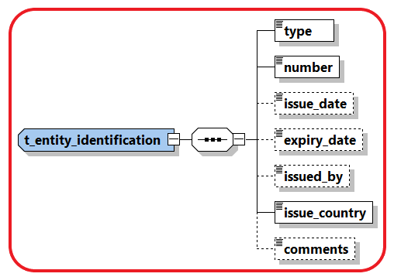

|  |  |  |  |  |
| --- | --- | --- | --- | --- |
| **Name** | **Description** | **Length** | **Req.** | **Example** |
| **type** | **Document type** | **Enumeration** | **Y** | **5.5 Identifier type** |
| **number** | **ID of the identification document** | **255** | **Y** | **AT08154711** |
| issue_date | Identification document issue date | DateTime | N | 2001-12-17T09:30:47 |
| expiry_date | Identification document expiry date | DateTime | N | 2012-01-01T00:00:00 |
| issued_by | Name of Authority issued the document | 255 | N | Interior Ministry |
| **issue_country** | **Country where the document was issued** | **Enumeration** | **Y** | **See 5.14 Country Codes** |
| comments | Generic comments field | 8000 | N |  |

## 4.3.1 Type t_person_my_client/t_person

The structure of these 2 types is exactly the same*,* it is introduced just to allow more restrictions when the person is a customer of the reporting entity in comparison to a person which is the customer of another reporting entity. i.e., some nodes which are not mandatory in *t_person* can be set mandatory in *t_person_my_client.*

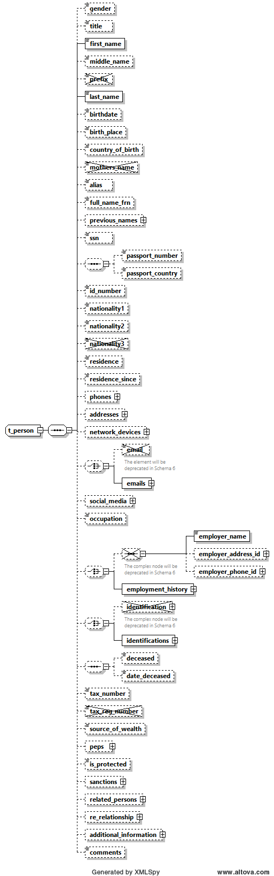

Figure 7: Overview type t_person

|  |  |  |  |  |  |  |  |  |  |  |  |  |  |  |  |  |  |  |  |  |  |
| --- | --- | --- | --- | --- | --- | --- | --- | --- | --- | --- | --- | --- | --- | --- | --- | --- | --- | --- | --- | --- | --- |
| **Name** | | | | **#Schema**  **#App** | | | | | **Description** | | | | **Length** | | | **Req.** | | **Example** | | | |
| gender | | | |  | | | | | Gender | | | | Enumeration | | | N | | M or F | | | |
| title | | | |  | | | | | Title | | | | 30 | | | N | | Dr. | | | |
| **first_name** | | | |  | | | | | First name | | | | 100 | | | **Y** | | Elias | | | |
| middle_name | | | |  | | | | | Middle name | | | | 100 | | | N | | X. | | | |
| ~~Prefix~~ | | | |  | | | | | Not in use | | | |  | | |  | |  | | | |
| **last_name** | | | |  | | | | | Last name | | | | 100 | | | **Y** | | Maschera | | | |
| **birthdate** | | | |  | | | | | Birth date | | | | DateTime | | | **N** | | 1953-01-25T00:00:00 | | | |
| birth_place | | | |  | | | | | Place of birth | | | | 255 | | | N | | Vienna | | | |
| country_of_birth | | | | Schema 5.0.1  App 5.2 | | | | | Country of Birth | | | | Enumeration | | | N | | UN | | | |
| ~~mothers_name~~ | | | |  | | | | | Not in use | | | |  | | |  | |  | | | |
| Alias | | | |  | | | | | Alias Name, Known as, ..etc. | | | | 100 | | | N | |  | | | |
| full_name_frn | | | | Schema 5.0.1  App 5.2 | | | | | Foreign language Full name. | | | | 255 | | | N | |  | | | |
| previous_names | | | | Schema 5.0.1  App 5.2 | | | | | multi-occurrence node which will allow reporting a list of previous names for the person. | | | | Subnode | | | N | | 4.3.2 Type Previous Names | | | |
| SSN | | | |  | | | | | Social Security Number/Identification number | | | |  | | | N | | National ID Number | | | |
| passport_number | | | |  | | | | | No. of passport | | | | 25 | | | N | | Passport num to be used as unification rule | | | |
| passport_country | | | |  | | | | | Passport issue country  (Can be reported only when there is a passport number) | | | | 25 | | | N | | Passport country to be used as unification rule | | | |
| id_ number | | | |  | | | | | Any additional identification number rather then ssn and passport | | | | 25 | | | N | | Additional identification number | | | |
| **Nationality1** | | | |  | | | | | Country of Nationality (1) | | | | Enumeration | | | **N** | | See 5.14 Country Codes | | | |
| Nationality2 | | | |  | | | | | Country of Nationality (2) | | | | Enumeration | | | N | | See 5.14 Country Codes | | | |
| ~~Nationality3~~ | | | |  | | | | | Not in use | | | |  | | |  | |  | | | |
| residence | | | |  | | | | | Country of residence | | | | Enumeration | | | N | | See 5.14 Country Codes | | | |
| residence_since | | | | Schema 5.0.1  App 5.2 | | | | | when the person has a resident status in the relevant country | | | | DateTime | | | N | |  | | | |
| Phones | | | |  | | | | | A Holder node for a 1..many Phones | | | |  | | | N | |  | | | |
| **Phone** | | | | |  | | | One occurrence of phone node | | | Type t_phone | | | **N** | | | | See *4.6 Type* t_phone | | |
| Addresses | | | |  | | | | | A Holder node for a 1..many Addresses | | | |  | | | N | |  | | | |
| **Address** | | | | |  | | | One occurrence of address node | | | Type t_address | | | **N** | | | | *4.5 Type* t_address | | |
| ~~network_devices~~ | | | | Schema 5.0.1  App 5.2 | | | | | Not in use | | | |  | | |  | |  | | | |
| Email | | | | |  | | | Email address | | | Type email_address  (255) | | | | | | N | [test@mail.com](mailto:test@mail.com) | | | |
| emails | | | | | Schema 5.0.1  App 5.2 | | | supports several emails for the reported person in comparison with currently fix 5 emails | | | email_address (255) | | | | | | N |  | | | |
| social_media | | | | Schema 5.0.1  App 5.2 | | | | | optional 1-many relations to report various social accounts | | | | Subnode | | | N | | 4.3.3 Type Social Account | | | |
| Occupation | | | |  | | | | | Occupation | | | | 255 | | | N | | Financial Analyst | | | |
| employer_name | | | | |  | | | Employer’s name | | | | | 255 | | | N | | FIC | | | |
| employer_address_id | | | | |  | | | Employer’s address | | | | | type t_address | | | N | | *4.5 Type* t_address | | | |
| employer_phone_id | | | | |  | | | Employer’s phone | | | | | type t_phone | | | N | | See 4.6 Type t_phone | | | |
| Employment History | | | | | Schema 5.0.1  App 5.2 | | | Supports many occurrences of employment information. Previous employment elements will be deprecated in future schemas | | | | | Subnode | | | N | | 4.3.4 Type Employment History | | | |
| identification | | |  | | | | Subnode(s) for identification documents | | | | | | subnode | | | N | | See 4.8 Type t_person_identification | | | |
| Identifications | | | Schema 5.0.1  App 5.2 | | | | Allows deprecating the current repeated root level Identification node with a parent cover node Identifications with many occurrences of single Identification element | | | | | | subnode | | | N | | 4.3.5 Type t_person_identification | | | |
| deceased | | | |  | | | | | A Boolean to indicated if person has passed away | | | | Boolean | | | N | |  | | | |
| deceased_date | | | |  | | | | | If deceased, then RE can report deceased date if known as well | | | | Date | | | N | |  | | | |
| tax_numebr | | | |  | | | | | The person tax number | | | | 100 | | | N | |  | | | |
| ~~tax_reg_numebr~~ | | | |  | | | | | Not in use | | | |  | | |  | |  | | | |
| source_of_wealth | | | |  | | | | | Free text description of the person source of wealth | | | | 255 | | | N | |  | | | |
| peps | | | | Schema 5.0.1  App 5.2 | | | | | REs will be able to indicate if the reported person is a Politically Exposed Person with few additional attributes | | | | Subnode | | | N | | 4.3.6 Type PEPS | | | |
| is_protected | | | | Schema 5.0.1  App 5.2 | | | | | can be used for example to avoid disseminating protected subjects – goAML will just maintain the field. FICs must decide on how to use | | | | Boolean | | | N | |  | | | |
| sanctions | | | | Schema 5.0.1  App 5.2 | | | | | supports multi occurrence of “sanction list”. | | | | Subnode | | | N | | 4.14 Sanctions Node | | | |
| related_persons | | | | Schema 5.0.1  App 5.2 | | | | | An optional multiple relation sub node between a reported person and his/her social network. | | | | Subnode | | | N | | 4.3.7 Type Person Related Persons | | | |
| business relationship | | | | Schema 5.0.1  App 5.2 | | | | | host the starting and dates of the relationship between the **Reporting Entity** and the Person | | | | Subnode | | | N | | 4.12 Business Relationship | | | |
| additional_  information | | | | Schema 5.0.1  App 5.2 | | | | | A new optional generic node for adding any unplanned extra information. See dedicated section. | | | | SubNode | | | N | | 4.13 Additional Information | | | |
| comments | | | |  | | | | | Generic comments field | | | | 8000 | | | N | |  | | | |

Table 7: Details type t_person

**Note**: While submitting the report either Passport Number or ID Number or both should be provided

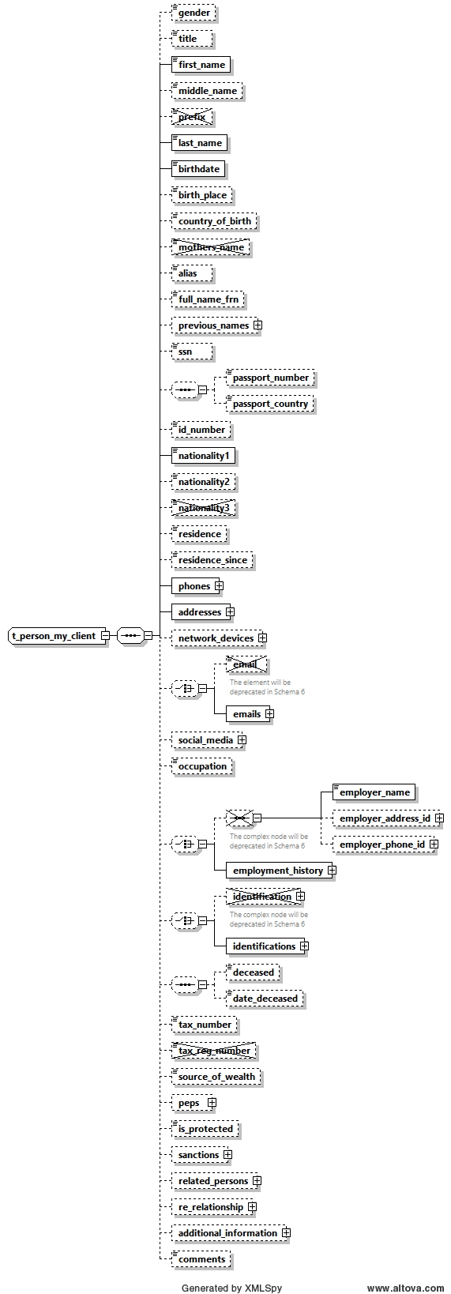

Figure 8: Overview type t_person_MyClient

|  |  |  |  |  |  |  |  |  |  |  |  |  |  |  |  |  |  |  |  |  |  |
| --- | --- | --- | --- | --- | --- | --- | --- | --- | --- | --- | --- | --- | --- | --- | --- | --- | --- | --- | --- | --- | --- |
| **Name** | | | | **#Schema**  **#App** | | | | | **Description** | | | | **Length** | | | **Req.** | | **Example** | | | |
| gender | | | |  | | | | | Gender | | | | Enumeration | | | N | | M or F | | | |
| title | | | |  | | | | | Title | | | | 30 | | | N | | Dr. | | | |
| **first_name** | | | |  | | | | | First name | | | | 100 | | | **Y** | | Elias | | | |
| middle_name | | | |  | | | | | Middle name | | | | 100 | | | N | | X. | | | |
| ~~Prefix~~ | | | |  | | | | | Not in use | | | |  | | |  | |  | | | |
| **last_name** | | | |  | | | | | Last name | | | | 100 | | | **Y** | | Maschera | | | |
| **birthdate** | | | |  | | | | | Birth date | | | | DateTime | | | **Y** | | 1953-01-25T00:00:00 | | | |
| birth_place | | | |  | | | | | Place of birth | | | | 255 | | | N | | Vienna | | | |
| country_of_birth | | | | Schema 5.0.1  App 5.2 | | | | | Country of Birth | | | | Enumeration | | | N | | UN | | | |
| ~~mothers_name~~ | | | |  | | | | | Not in use | | | |  | | |  | |  | | | |
| Alias | | | |  | | | | | Alias Name, Known as, ..etc. | | | | 100 | | | N | |  | | | |
| full_name_frn | | | | Schema 5.0.1  App 5.2 | | | | | Foreign language Full name. | | | | 255 | | | N | |  | | | |
| previous_names | | | | Schema 5.0.1  App 5.2 | | | | | multi-occurrence node which will allow reporting a list of previous names for the person. | | | | Subnode | | | N | | 4.3.2 Type Previous Names | | | |
| SSN | | | |  | | | | | Social Security Number | | | |  | | | N | | National ID Number | | | |
| passport_number | | | |  | | | | | No. of passport | | | | 25 | | | N | | Passport num to be used as unification rule | | | |
| passport_country | | | |  | | | | | Passport issue country  (Can be reported only when there is a passport number) | | | | 25 | | | N | | Passport country to be used as unification rule | | | |
| id_ number | | | |  | | | | | Any additional identification number rather then ssn and passport | | | | 25 | | | N | | Additional identification number | | | |
| **Nationality1** | | | |  | | | | | Country of Nationality (1) | | | | Enumeration | | | **Y** | | See 5.14 Country Codes | | | |
| Nationality2 | | | |  | | | | | Country of Nationality (2) | | | | Enumeration | | | N | | See 5.14 Country Codes | | | |
| ~~Nationality3~~ | | | |  | | | | | Not in use | | | |  | | |  | |  | | | |
| residence | | | |  | | | | | Country of residence | | | | Enumeration | | | N | | See 5.14 Country Codes | | | |
| residence_since | | | | Schema 5.0.1  App 5.2 | | | | | when the person has a resident status in the relevant country | | | | DateTime | | | N | |  | | | |
| Phones | | | |  | | | | | A Holder node for a 1..many Phones | | | |  | | | N | |  | | | |
| **Phone** | | | | |  | | | One occurrence of phone node | | | Type t_phone | | | **Y** | | | | See *4.6 Type* t_phone | | |
| Addresses | | | |  | | | | | A Holder node for a 1..many Addresses | | | |  | | | N | |  | | | |
| **Address** | | | | |  | | | One occurrence of address node | | | Type t_address | | | **Y** | | | | *4.5 Type* t_address | | |
| network_devices | | | | Schema 5.0.1  App 5.2 | | | | |  | | | |  | | |  | |  | | | |
| ~~Email~~ | | | | |  | | | Not in use | | | Type email_address  (255) | | | | | | N | [test@mail.com](mailto:test@mail.com) | | | |
| emails | | | | | Schema 5.0.1  App 5.2 | | | supports several emails for the reported person in comparison with currently fix 5 emails | | | email_address (255) | | | | | | N |  | | | |
| social_media | | | | Schema 5.0.1  App 5.2 | | | | | optional 1-many relations to report various social accounts | | | | Subnode | | | N | | 4.3.3 Type Social Account | | | |
| Occupation | | | |  | | | | | Occupation | | | | 255 | | | N | | Financial Analyst | | | |
| employer_name | | | | |  | | | Employer’s name | | | | | 255 | | | N | | FIC | | | |
| employer_address_id | | | | |  | | | Employer’s address | | | | | type t_address | | | N | | *4.5 Type* t_address | | | |
| employer_phone_id | | | | |  | | | Employer’s phone | | | | | type t_phone | | | N | | See 4.6 Type t_phone | | | |
| Employment History | | | | | Schema 5.0.1  App 5.2 | | | Supports many occurrences of employment information. Previous employment elements will be deprecated in future schemas | | | | | Subnode | | | N | | 4.3.4 Type Employment History | | | |
| ~~identification~~ | | |  | | | | Subnode(s) for identification documents | | | | | | subnode | | | N | | See 4.8 Type t_person_identification | | | |
| Identifications | | | Schema 5.0.1  App 5.2 | | | | Allows deprecating the current repeated root level Identification node with a parent cover node Identifications with many occurrences of single Identification element | | | | | | subnode | | | N | | 4.3.5 Type t_person_identification | | | |
| deceased | | | |  | | | | | A Boolean to indicated if person has passed away | | | | Boolean | | | N | |  | | | |
| deceased_date | | | |  | | | | | If deceased, then RE can report deceased date if known as well | | | | Date | | | N | |  | | | |
| tax_numebr | | | |  | | | | | The person tax number | | | | 100 | | | N | |  | | | |
| ~~tax_reg_numebr~~ | | | |  | | | | | Not in use | | | |  | | |  | |  | | | |
| source_of_wealth | | | |  | | | | | Free text description of the person source of wealth | | | | 255 | | | N | |  | | | |
| peps | | | | Schema 5.0.1  App 5.2 | | | | | REs will be able to indicate if the reported person is a Politically Exposed Person with few additional attributes | | | | Subnode | | | N | | 4.3.6 Type PEPS | | | |
| is_protected | | | | Schema 5.0.1  App 5.2 | | | | | can be used for example to avoid disseminating protected subjects – goAML will just maintain the field. FICs must decide on how to use | | | | Boolean | | | N | |  | | | |
| sanctions | | | | Schema 5.0.1  App 5.2 | | | | | supports multi occurrence of “sanction list”. | | | | Subnode | | | N | | 4.14 Sanctions Node | | | |
| related_persons | | | | Schema 5.0.1  App 5.2 | | | | | An optional multiple relation sub node between a reported person and his/her social network. | | | | Subnode | | | N | | 4.3.7 Type Person Related Persons | | | |
| business relationship | | | | Schema 5.0.1  App 5.2 | | | | | host the starting and dates of the relationship between the **Reporting Entity** and the Person | | | | Subnode | | | N | | 4.12 Business Relationship | | | |
| additional_  information | | | | Schema 5.0.1  App 5.2 | | | | | A new optional generic node for adding any unplanned extra information. See dedicated section. | | | | SubNode | | | N | | 4.13 Additional Information | | | |
| comments | | | |  | | | | | Generic comments field | | | | 8000 | | | N | |  | | | |

**Table 8: T_Person My_Client**

**Note**: While submitting the report either Passport Number or ID Number or both should be provided

## 4.3.2 Type Previous Names

It allows reporting a list of previous names for the person. Each Name contains First and Last Name in addition to a comments field to provide the context.

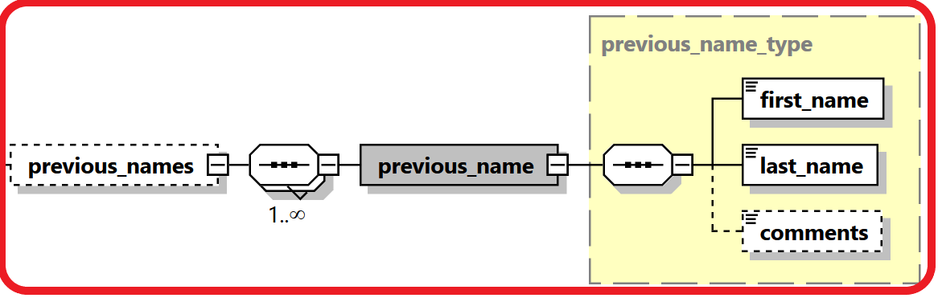

|  |  |  |  |  |  |
| --- | --- | --- | --- | --- | --- |
| Name | #Schema  #App | Description | Length | Req. | Example |
| First_name | Schema 5.0.1  App 5.2 | First Name | 100 | Y |  |
| last_name | Schema 5.0.1  App 5.2 | Last Name | 100 | Y |  |
| comments | Schema 5.0.1  App 5.2 | Generic Comments | Comments Type | N |  |

## 4.3.3 Type Social Account

REs can report social media accounts of the reported person.

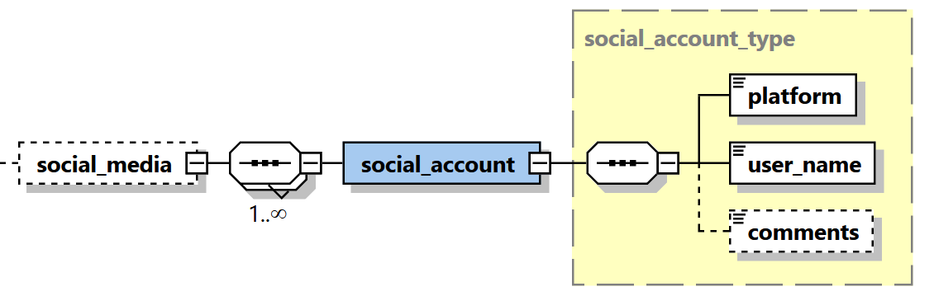

|  |  |  |  |  |  |
| --- | --- | --- | --- | --- | --- |
| **Name** | **#Schema**  **#App** | **Description** | **Length** | **Req.** | **Example** |
| platform | Schema 5.0.1  App 5.2 | Name of social media platform | 255 | Y |  |
| user_name | Schema 5.0.1  App 5.2 | User Name in that social media platform | 255 | Y |  |
| comments | Schema 5.0.1  App 5.2 | Description of the function held by the PEP. | Comments type | N |  |

## 

## 4.3.4 Type Employment History

Reporting entities can report many occurrences of employment information including employer name, business, identification, phones, addresses and employment date range.

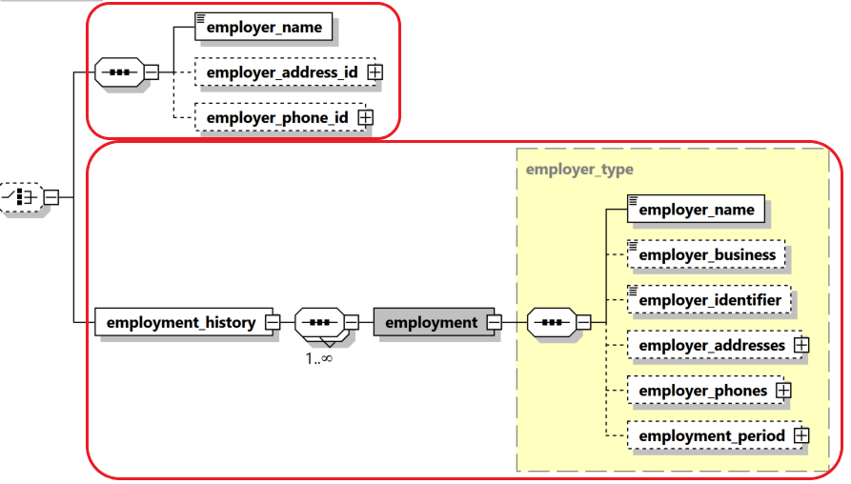

|  |  |  |  |  |  |
| --- | --- | --- | --- | --- | --- |
| **Name** | **#Schema**  **#App** | **Description** | **Length** | **Req.** | **Example** |
| employer_name | Schema 5.0.1  App 5.2 | Type of relation | Enumeration | N |  |
| Person | Schema 5.0.1  App 5.2 | Person node | Subnode | N | See 4.3.1 Type t_person_my_client/ t_person |
| relation_date_range | Schema 5.0.1  App 5.2 | The time frame of the relation between the two persons. | Subnode | N | 4.10 Relation Date Range Type |
| comments | Schema 5.0.1  App 5.2 | Description of the function held by the PEP. | Comments type | N |  |

## 4.3.5 Type t_person_identification

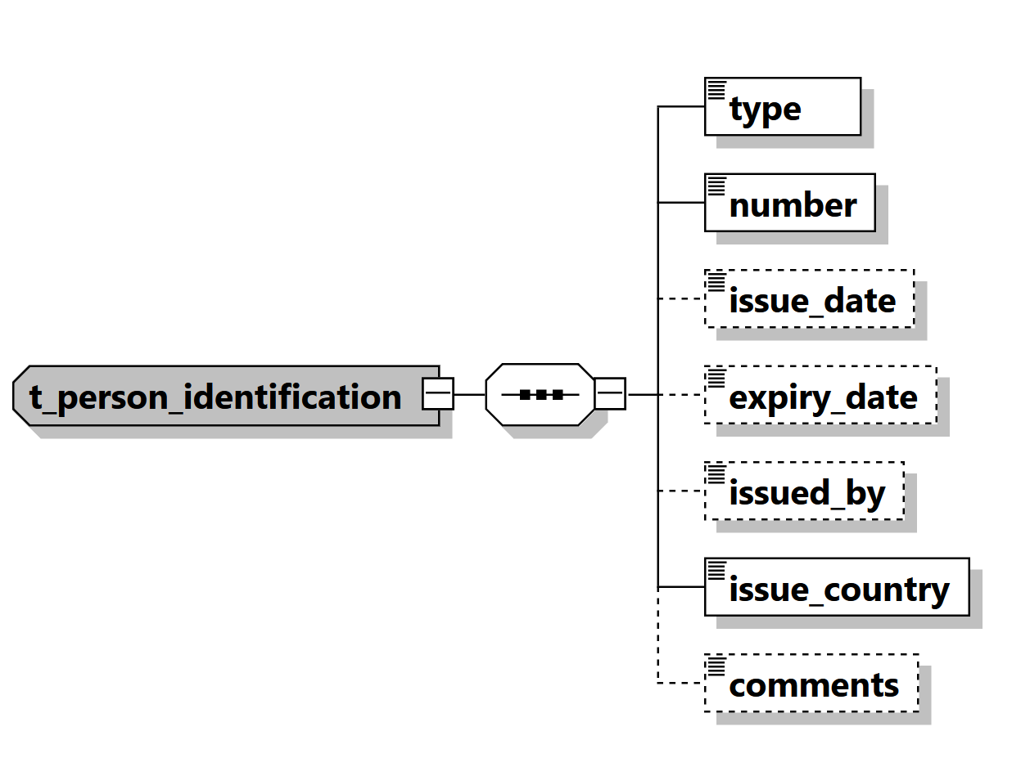

Figure 20: Overview type t_person_identification

|  |  |  |  |  |
| --- | --- | --- | --- | --- |
| **Name** | **Description** | **Length** | **Req.** | **Example** |
| **type** | Document type | Enumeration | **Y** | 5.5 Identifier type |
| **number** | ID of the identification document | 255 | **Y** | AT08154711 |
| issue_date | Identification document issue date | DateTime | N | 2001-12-17T09:30:47 |
| expiry_date | Identification document expiry date | DateTime | N | 2012-01-01T00:00:00 |
| issued_by | Name of Authority issued the document | 255 | N | Interior Ministry |
| **issue_country** | Country where the document was issued | Enumeration | **Y** | See 5.14 Country Codes |
| comments | Generic comments field | 8000 | N |  |

Table 20: Type t_person_identification

## 4.3.6 Type PEPS

Reporting entities can indicate if the reported person is/was a Politically Exposed Person with few additional attributes, like country, function name, function description, date range and general comments. Multiple occurrences of PEP info per person is supported as well.

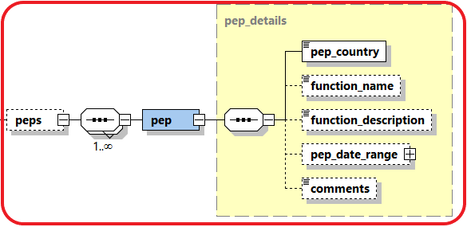

|  |  |  |  |  |  |
| --- | --- | --- | --- | --- | --- |
| **Name** | **#Schema**  **#App** | **Description** | **Length** | **Req.** | **Example** |
| pep_country | Schema 5.0.1  App 5.2 | Name of the related country | Enumeration | Y |  |
| function_name | Schema 5.0.1  App 5.2 | Name of the function held by the PEP. | 255 | N |  |
| function_description | Schema 5.0.1  App 5.2 | Description of the function held by the PEP. | Comments type | N |  |
| pep_date_range | Schema 5.0.1  App 5.2 | The time frame of the subject being PEP in this occurrence. | Subnode | N | 4.10 Relation Date Range Type |
| comments | Schema 5.0.1  App 5.2 | Generic Comments | Comments Type | N |  |

## 4.3.7 Type Person Related Persons

Reporting entities can report social network of the reported person

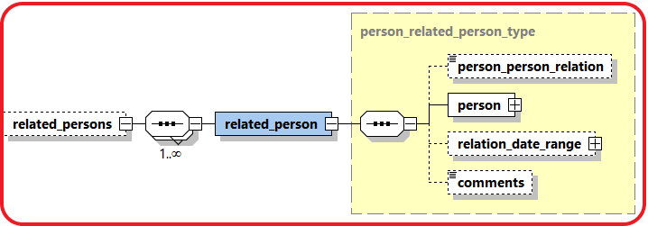

|  |  |  |  |  |  |
| --- | --- | --- | --- | --- | --- |
| **Name** | **#Schema**  **#App** | **Description** | **Length** | **Req.** | **Example** |
| person_person_  relation | Schema 5.0.1  App 5.2 | Type of relation | Enumeration | N | 5.23 Person-Person Relation Type |
| Person | Schema 5.0.1  App 5.2 | Person node | Subnode | N | 4.3.1 Type t_person_my_client/ t_person |
| relation_date_range | Schema 5.0.1  App 5.2 | The time frame of the relation between the two persons. | Subnode | N | 4.10 Relation Date Range Type |
| comments | Schema 5.0.1  App 5.2 | Description of the function held by the PEP. | Comments type | N |  |

## 4.4.1 Type t_person_registration_in_report

The structure of this type is similar to that of type *t_person,* but dedicated to the reporting person details.

## 4.4.2 Type t_conductor/t_conductor_my_client

The structure of these types is similar to that of type *t_person,* but dedicated to the conductor person details,

## 

## *4.5 Type* t_address

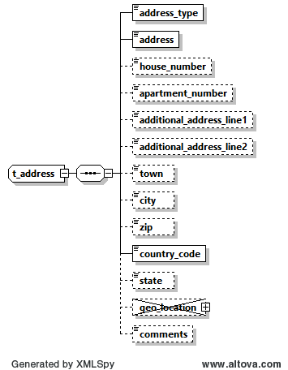

Figure 10: Overview type t_address

|  |  |  |  |  |  |  |
| --- | --- | --- | --- | --- | --- | --- |
| **Name** | **#Schema**  **#App** | | **Description** | **Length** | **Req.** | **Example** |
| **Address_type** |  | | The contact type of the address | Enumeration | **Y** | Private, Business,..  See 5.9 Contact Type |
| **Address** |  | |  | 100 | **Y** | - |
| house_number | Schema 5.0.1  App 5.2 | |  |  |  |  |
| apartment_number | Schema 5.0.1  App 5.2 | |  |  |  |  |
| additional_address_line1 | Schema 5.0.1  App 5.2 | | Additional Address line 1 | 100 | N |  |
| additional_address_line2 | Schema 5.0.1  App 5.2 | |  |  |  |  |
| Town |  | | Name of Town/district/as part of a City | 255 | N |  |
| **City** |  | | City/Province | 255 | **N** | - |
| Zip |  | | Zip Code | 10 | N | A-1220 |
| **country_code** |  | | Country | Enumeration | **Y** | See 5.14 Country Codes |
| State |  | | State | 255 | N |  |
| ~~geo_location~~ | ~~Schema 5.0.1~~  ~~App 5.2~~ | | Not in use | ~~Subnode~~ | ~~N~~ |  |
| ~~latitude~~ | | ~~Schema 5.0.1~~  ~~App 5.2~~ | ~~Address latitude~~ | ~~Decimal~~  ~~-90>>90~~ | ~~N~~ | ~~48.210033~~ |
| ~~longitude~~ | | ~~Schema 5.0.1~~  ~~App 5.2~~ | ~~Address longitude~~ | ~~Decimal~~  ~~-180>>180~~ | ~~N~~ | ~~16.363449~~ |
| ~~Plus Code~~ | | ~~Schema 5.0.1~~  ~~App 5.2~~ | ~~Address “Plus Code”~~ | ~~25~~ | ~~N~~ | ~~6CRP+R9~~ |
| ~~is_approx_location~~ | | ~~Schema 5.0.1~~  ~~App 5.2~~ | ~~Is the location accurate?~~ | ~~Boolean~~ | ~~N~~ | ~~True~~ |
| ~~error_distance_margin~~ | | ~~Schema 5.0.1~~  ~~App 5.2~~ | ~~Error margin~~ | ~~Decimal~~ | ~~N~~ | ~~500~~ |
| ~~Margin_uom~~ | | ~~Schema 5.0.1~~  ~~App 5.2~~ | ~~Unit of measurement for error~~ | ~~255~~ | ~~N~~ | ~~Meter~~ |
| comments |  | | Generic comments | 8000 | N |  |

able 10: Details type t_address

## 4.6 Type t_phone

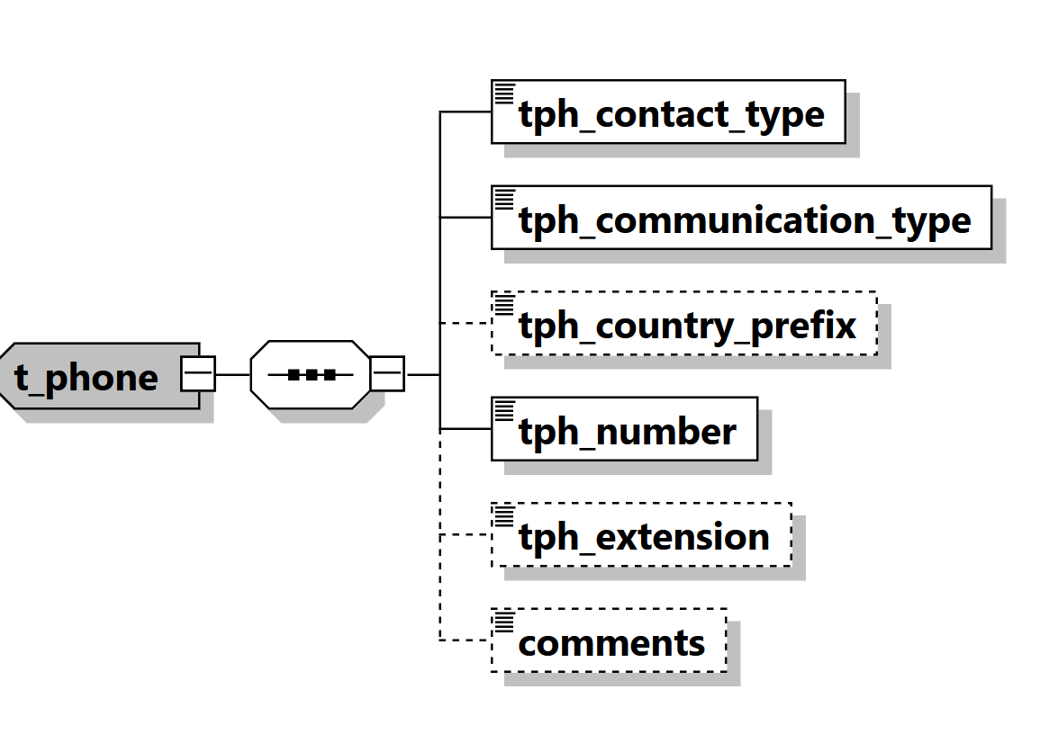

Figure 11: Overview type t_phone

|  |  |  |  |  |
| --- | --- | --- | --- | --- |
| **Name** | **Description** | **Length** | **Req.** | **Example** |
| **tph_contact_type** | The contact type of the Phone | Enumeration | **Y** | Private, Business,..  See 5.9 Contact Type |
| **tph_communication_type** | The comm.. type of the Phone | Enumeration | **Y** | Landline, mobile ,fax,..  5.10 Communication Type |
| tph_country_prefix | Country phone code | 4 | N | 0043 |
| **tph_number** | Phone number | 50 | **Y** | 6655778 |
| tph_extension | Phone’s extension | 10 | N | 7789 |
| comments | Generic comments | 8000 | N |  |

Table 11: Details type t_phone

## 4.7 Type t_foreign_currency

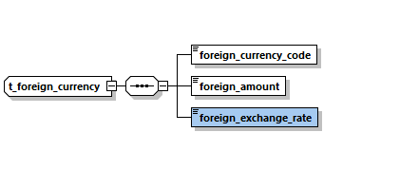

Figure 12: Overview type t_foreign_currency

|  |  |  |  |  |
| --- | --- | --- | --- | --- |
| **Name** | **Description** | **Length** | **Req.** | **Example** |
| **foreign_currency_code** | Currency Code according to ISO 4217 | Enumeration | **Y** | See 5.13 Currencies |
| **foreign_amount** | Transaction amount in foreign currency | Decimal | **Y** | 1300.50 |
| **foreign_exchange_rate** | Exchange rate which has been used for transaction  Default is set as optional in Schema 5.0.2 | Decimal | **Y** | 1.45 |

Table 12: Details type t_foreign_currency

## 4.8 Type report_party_type

Introduced in schema 4.0 and enhanced in Schema 5. Represents an involved subject in a report and its details.

Subject can be a Person, an Account or an Entity together with its my_client – Only one of them can be included per involved party.

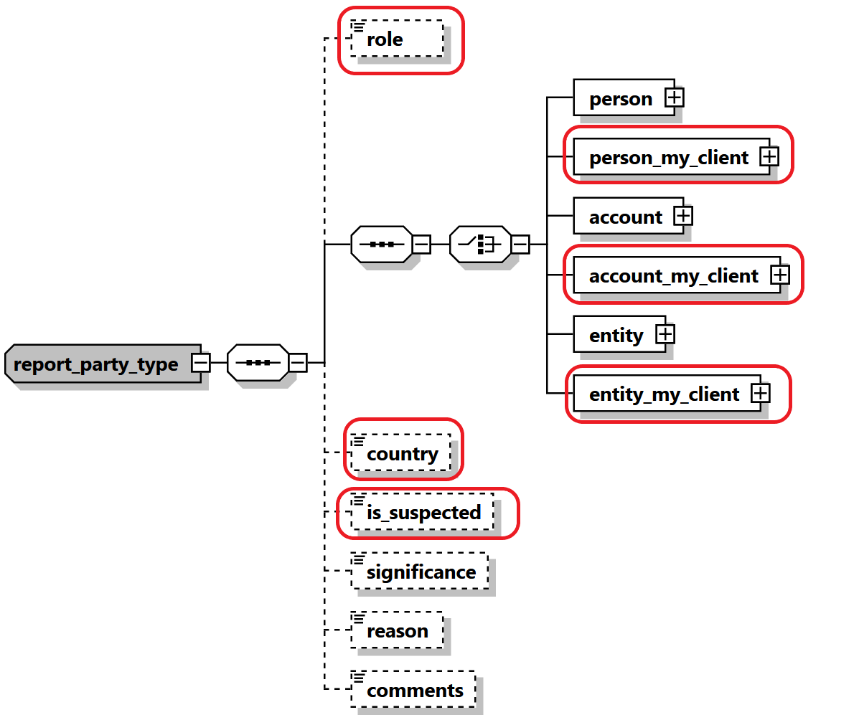

Figure 21: Overview type report_party_type

|  |  |  |  |  |  |  |  |  |  |  |  |  |
| --- | --- | --- | --- | --- | --- | --- | --- | --- | --- | --- | --- | --- |
| **Name** | | | **#Schema**  **#App** | | **Description** | | **Length** | **Req.** | | **Example** | | |
| Role | | | Schema 5.0.1  App 5.2 | | Role of Party in this activity | | Enumeration | N | | Conductor | | |
|  | | One of the following subject nodes must be included when activity node is used | | | | | | | | | | |
| **person** | | |  | | Represents an involved person node | | | t_person type | | **Y** |  |
| **person_my_client** | | | Schema 5.0.1  App 5.2 | | Represents an involved my_client person node | | | t_person_my_client type | | **Y** |  |
| **account** | | |  | | Represents an involved account | | | t_account type | | **Y** |  |
| **Account_my_client** | | | Schema 5.0.1  App 5.2 | | Represents an involved my_client account | | | t_account_my_client type | | **Y** |  |
| **entity** | | |  | | Represents an involved entity | | | t_entity type | | **Y** |  |
| **Entity_my_client** | | | Schema 5.0.1  App 5.2 | | Represents an involved my_client entity | | | t_entity_my_client type | | **Y** |  |
| country | | | Schema 5.0.1  App 5.2 | | The country of the reported party | | Enumeration | N | | UN | | |
| is_suspected | | | Schema 5.0.1  App 5.2 | | Indicates if the party is suspected or not. | | Boolean | N | | True/False | | |
| significance | | |  | | The significance of the subject in the report | | Integer | N | | 0 - 10 | | |
| reason | | |  | | Why the subject is involved in the current report | | 8000 | N | |  | | |
| comments | | |  | | Generic comments element | | 8000 | N | |  | | |

Table 21: Type report_party_type

## 4.9.1 Network Device Type

Describes additional information in virtual currency and mobile money transactions regarding the used device and related IP address. Allows Reporting Entities like ISP providers to report online connections of their clients if needed.

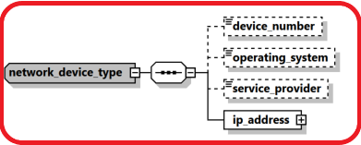

|  |  |  |  |  |  |
| --- | --- | --- | --- | --- | --- |
| **Name** | **#Schema**  **#App** | **Description** | **Length** | **Req.** | **Example** |
| device_number | Schema 5.0.1  App 5.1 | The number of device to send/receive the money in transaction context | 50 | N | 06501234567 |
| operating_system | Schema 5.0.1  App 5.1 | The device operating system | Enumeration | N | iOS, Android, Windows, Mac OS, Linux… |
| service_provider | Schema 5.0.1  App 5.1 | The name of the service provider in case of mobile phone for example | 255 | N | Orange |
| **ip_address** | **Schema 5.0.1**  **App 5.1** | **Describes the details of the used “IP address”** | **Subnode** | **Y** | **See** 4.8.2 IP Address Type |

## 4.9.2 IP Address Type

Introduced in schema 5.0.1, the type is used in goAML Application 5.1 to describe IP address details of the transaction party.

The type will be used in goAML Application 5.2 to allow Reporting Entities like ISP providers to report online connections of their clients if needed.

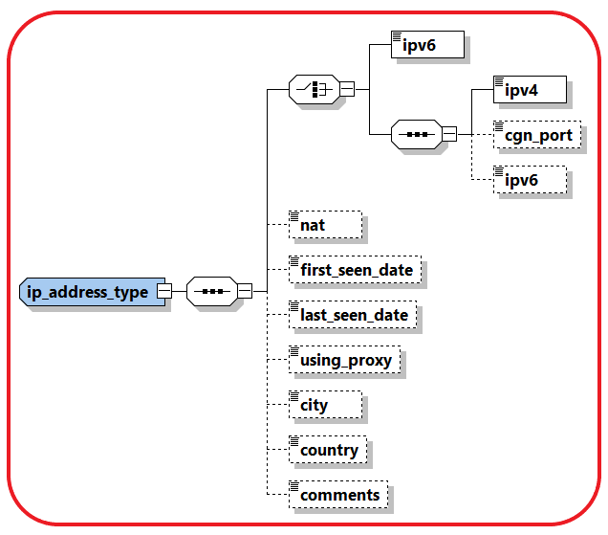

|  |  |  |  |  |  |  |  |  |  |  |  |  |  |  |  |
| --- | --- | --- | --- | --- | --- | --- | --- | --- | --- | --- | --- | --- | --- | --- | --- |
| **Name** | | | **#Schema**  **#App** | | **Description** | | | **Length** | | **Req.** | | | | **Example** | |
| Ipv6 | | | Schema 5.0.1  App 5.1 | | IP address in IPV6 format | | 45 | | | Y | *2001:0db8:85a3:0000:*  *0000:8a2e:0370:7334* | | | | |
| Ipv4 | | | Schema 5.0.1  App 5.1 | | IP address in IPV4 format | | 15 | | | Y | 172.31.255.255 | | | | |
| cgn_port | | | Schema 5.0.1  App 5.1 | | CGN Port | | Integer | | | | N | | 44 | |
| Ipv6 | | | Schema 5.0.1  App 5.1 | | IP address in IPV6 format, can be reported optionally if the main format is ipv4 | | 45 | | | | Y | | *2001:0db8:85a3:0000:*  *0000:8a2e:0370:7334* | |
| Nat | | | Schema 5.0.1  App 5.1 | | [network address translation](https://en.wikipedia.org/wiki/Network_address_translation) | | | 15 | | N | | | | 1.1.1.1 | |
| first_seen_date | | | Schema 5.0.1  App 5.1 | | First time IP address is reported | | | DateTime | | N | | | |  | |
| last_seen_date | | | Schema 5.0.1  App 5.1 | | Last time IP address is reported | | | DateTime | | N | | | |  | |
| using_proxy | | | Schema 5.0.1  App 5.1 | | A flag to indicate if Proxy was used | | | Boolean | | N | | | | True/False | |
| City | | | Schema 5.0.1  App 5.1 | | City name | | | 255 | | N | | | |  | |
| Country | | | Schema 5.0.1  App 5.1 | | Country code | | | Enum | | N | | | |  | |
| Comments | | | Schema 5.0.1  App 5.1 | | Generic Comments | | | 8000 | | N | | | |  | |

## 4.10 Relation Date Range Type

A new type describing relations date range was introduced and is used now with each relation between two nodes in goAML schema. The type is used gradually with each goAML release since 5.0 in combination with implementing the parent type. The Booleans are considered false by default if not reported.

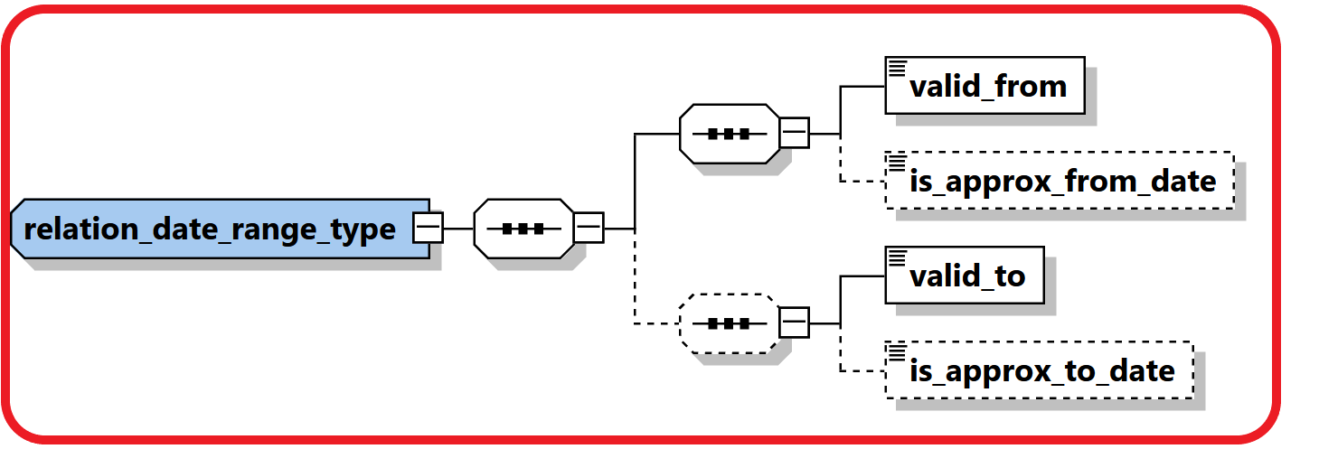

|  |  |  |  |  |  |
| --- | --- | --- | --- | --- | --- |
| **Name** | **#Schema**  **#App** | **Description** | **Length** | **Req.** | **Example** |
| valid_from | Schema 5.0.1  App 5.1 | Valid FROM date | DateTime | Y |  |
| is_approx_from_date | Schema 5.0.1  App 5.1 | Is the “Valid From Date” accurate? | Boolean | N |  |
| valid_to | Schema 5.0.1  App 5.1 | Valid TO Date | DateTime | Y |  |
| is_approx_to_date | Schema 5.0.1  App 5.1 | Is the “Valid To Date” accurate? | Boolean | N |  |

## 4.11 Comments Type

A new **comment_type** was introduced with max length of 8000 chars instead of 4000 as newer versions of SQL server supports longer length now. All elements like **Comments**, **Reason**, **Action** and **Description** elements all over the schema are defined now using the new type.

## 4.12 Business Relationship

A new subnode was introduced to describe the relation between the reported subjects and the reporting entity, including information regarding the relation type and timeframe. Person and Entities in goAML can have multiple relationships with different reporting entities.

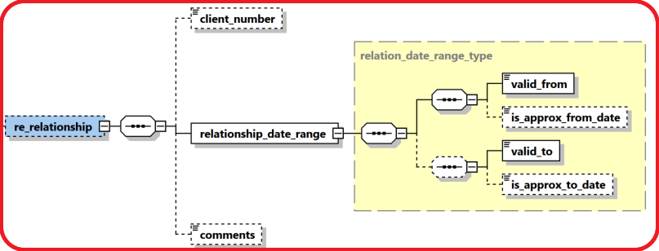

|  |  |  |  |  |  |
| --- | --- | --- | --- | --- | --- |
| **Name** | **#Schema**  **#App** | **Description** | **Length** | **Req.** | **Example** |
| client_number | Schema 5.0.1  App 5.2 | A reference number of the customer at the RE side | 255 | N |  |
| valid_from | Schema 5.0.1  App 5.2 | Valid FROM date | DateTime | Y |  |
| is_approx_from_date | Schema 5.0.1  App 5.2 | Is the “Valid From Date” accurate? | Boolean | N |  |
| valid_to | Schema 5.0.1  App 5.2 | Valid TO Date | DateTime | Y |  |
| is_approx_to_date | Schema 5.0.1  App 5.2 | Is the “Valid To Date” accurate? | Boolean | N |  |
| comments | Schema 5.0.1  App 5.2 | Generic Comments | Comments Type | N |  |

## 4.13 Additional Information

A new optional generic node for adding any number of unplanned extra information in a controlled way.

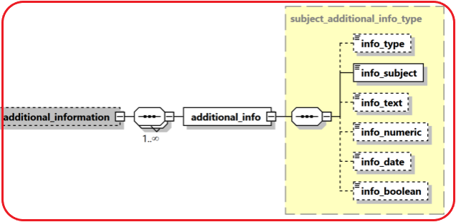

|  |  |  |  |  |  |
| --- | --- | --- | --- | --- | --- |
| **Name** | **#Schema**  **#App** | **Description** | **Length** | **Req.** | **Example** |
| info_type | Schema 5.0.1  App 5.2 | Type of the provided info | Enumeration | N |  |
| Subject | Schema 5.0.1  App 5.2 | Short description of the additional info | 255 | Y |  |
| Info_text | Schema 5.0.1  App 5.2 | A text value of the provided info | Comments type | N |  |
| Info_numeric | Schema 5.0.1  App 5.2 | A numeric value of the provided info | decimal | N |  |
| info_date | Schema 5.0.1  App 5.2 | A date value of the provided info | Date Time | N |  |
| Info_boolean | Schema 5.0.1  App 5.2 | A Boolean value of the provided info | Boolean | N |  |

## 4.14 Sanctions Node

New sanctions node was added which supports multi occurrence of “sanction list”. Each Sanction list contains several details about the list like providing source, list name, matching criteria, date of joining/exiting a list, .etc.

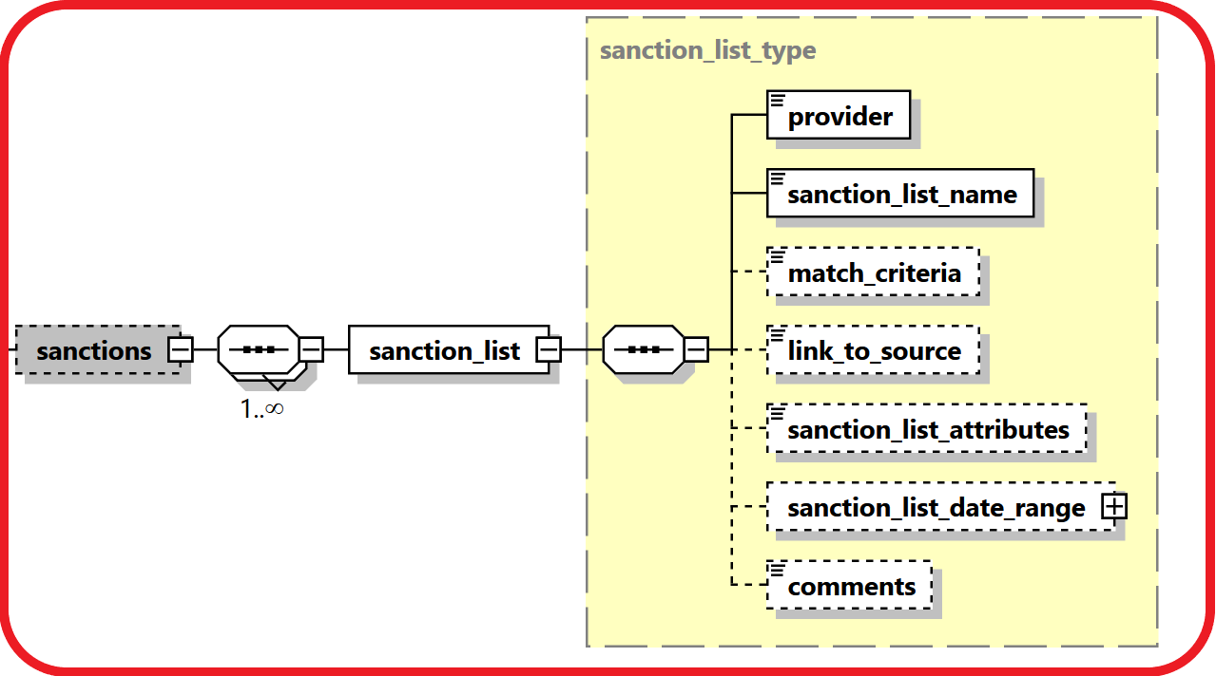

|  |  |  |  |  |  |
| --- | --- | --- | --- | --- | --- |
| **Name** | **#Schema**  **#App** | **Description** | **Length** | **Req.** | **Example** |
| Provider | Schema 5.0.1  App 5.2 | Name of the sanctions list provider | 255 | N |  |
| sanctions_list_name | Schema 5.0.1  App 5.2 | Name of the sanctions list | 255 | Y |  |
| match_criteria | Schema 5.0.1  App 5.2 | The criteria used by the RE to match the reported subject with the name in the list. | Comments type | N |  |
| link_to_source | Schema 5.0.1  App 5.2 | A link to the subject in the sanction list document | 255 | N |  |
| sanctions_list_attributes | Schema 5.0.1  App 5.2 | Any additional info regarding the subject provided in the sanction list document | Comments type | N |  |
| Sanctions_list_date_range | Schema 5.0.1  App 5.2 | The time frame of the subject existence in the list | Subnode | N | 4.10 Relation Date Range Type |
| comments | Schema 5.0.1  App 5.2 | Generic Comments | Comments Type | N |  |

## 4.15 Means of Transportation Node

A new complex node to capture customs related reports where subjects carry money cross borders as well as possible Trade Based Money Laundering reporting. The node supports multi routes per transaction with details regarding the reported point, transportation mode (Air, Sea, Road, Train, ..etc.), transportation type (Comm. Airline, Private Jet, Vessel, Cruise Ship, Car, Bus, ..etc.), then step direction, status, date, carrier details as well location details of each route.

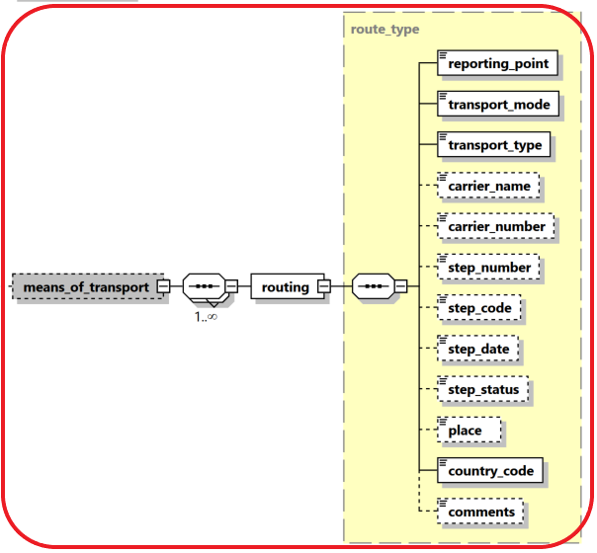

|  |  |  |  |  |  |
| --- | --- | --- | --- | --- | --- |
| **Name** | **#Schema**  **#App** | **Description** | **Length** | **Req.** | **Example** |
| reporting_point | Schema 5.0.1  App 5.2 | Is the report if from this route step? | Boolean | N |  |
| transport_mode | Schema 5.0.1  App 5.2 | Transportation mode | Enumeration | Y | Air, Sea, Road, Train, |
| transport_type | Schema 5.0.1  App 5.2 | Transportation Type | Enumeration | Y | Comm. Airline, Private Jet, Vessel, Cruise Ship, Car, Bus |
| carrier_name | Schema 5.0.1  App 5.2 | Name of Carrier | 255 | N | UN Airline |
| carrier_number | Schema 5.0.1  App 5.2 | Number of Carrier | 255 | N | UN123 |
| step_number | Schema 5.0.1  App 5.2 | The number of this step in the route | Integer | N |  |
| step_code | Schema 5.0.1  App 5.2 | The code of the step | Enumeration | N | Start, End, Transit,.. |
| step_date | Schema 5.0.1  App 5.2 | Date of the step | DateTime | N |  |
| step_status | Schema 5.0.1  App 5.2 | Status of the step | Enumeration | N | Conducted, Cancelled, .. |
| place | Schema 5.0.1  App 5.2 | Name of the Entry/Exit place | 255 | N | Name of Port, Airport, Border Cross, … |
| country_code | Schema 5.0.1  App 5.2 | Name of step country | Enumeration | Y |  |
| comments | Schema 5.0.1  App 5.2 | Generic Comments | Comments Type | N |  |

# Lookup Values

All schema lookups are defined as enumerations. goAML application includes an option to update the schema automatically with the lookup codes defined by the FIC in the “Lookup Master” screen. Reporting entities cannot submit reports with undefined lookup codes.

Most of the lookup enumerations mentioned below are just suggestions. Feel free to adjust them using “Lookup Master” screen.

## 5.1 Submission type

|  |  |
| --- | --- |
| **Value** | **Description** |
| E | Electronically |
| M | Manually |

Table 13: submission type

## 5.2 Funds type

* The following list is a suggestion. Actual codes defined by FIC in “Lookup Master” will be added automatically to the Schema by goAML client application.

|  |  |
| --- | --- |
| **Value** | **Description** |
| BDFT | Bank Draft |
| BGNT | Bank Guarantee |
| BEXH | Bill of Exchange |
| CASH | Cash |
| CSN | Casino Chips |
| CHQ | Cheque |
| CDT | Credit |
| CC | Credit Card |
| CE | Currency Exchange |
| DB | Debit card |
| DPT | Deposit |
| ETN | Electronic Fund |
| FSF | Funds in Safe |
| GMCHP | Gaming Chips |
| SEC | Government Securities |
| LIP | Life Insurance Policy |
| LP | Loan |
| MR | Money remittance |
| OT | Other |
| PM | Precious Metals |
| PPC | Prepaid Card |
| PN | Promissory Note |
| RE | Real estate |
| SC | Securities |
| SHR | Shares |
| TCHQ | Traveller's Cheque |
| - | UNKNOWN |
| VC | Virtual Currency |

Table 14: Funds type

## 5.3 Account type

*The following list is a suggestion. Actual codes defined by FIC in “Lookup Master” will be added automatically to the Schema by goAML client application.

|  |  |
| --- | --- |
| **Value** | **Description** |
| BUS | Business |
| CAP | Capital Payment Account |
| COM | Commodity Account |
| CCA | Credit Card Account |
| CUR | Current Account |
| CUS | Custody Account |
| DCA | Debit Card Account |
| DIG | Digital wallet |
| GAM | Gaming Account |
| GUR | Guarantee Account |
| INS | Insurance Policy |
| INV | Investment account |
| LON | Loan Account |
| MBLW | Mobile wallet |
| MRT | Mortgage Account |
| OTR | Other |
| OTH | Other Type of Account |
| PAY | Payment account |
| PMA | Precious Metal Account |
| SDB | Safe Deposit Box |
| SVA | Saving Deposit Account |
| SEC | Securities Account |
| TECH | Technical Account |
| DEP | Term Fixed Deposit Account |
| TST | Trust |
| - | Unknown |
| VCW | Virtual Currency Wallet |

Table 15: Account type

## 5.4 Account status type

*The following list is a suggestion. Actual codes defined by FIC in “Lookup Master” will be added automatically to the Schema by goAML client application.

|  |  |
| --- | --- |
| **Value** | **Description** |
| A | Active |
| B | Blocked |
| C | Closed |
| D | Dormant |
| F | Frozen/Suspended |
| N | New |
| OTH | Other |
| S | Seized |
| - | UNKNOWN |

Table 16: Account status type

## 5.5 Identifier type

*The following list is a suggestion. Actual codes defined by FIC in “Lookup Master” will be added automatically to the Schema by goAML client application.

|  |  |
| --- | --- |
| **Value** | **Description** |
| D | Driver''s Licence |
| F | Foreign Identity Card |
| N | National Identification Card |
| P | Passport |
| RF | Refugee ID |
| R | Residence Permit |
| URC | UNHCR Refugee card |
| - | UNKNOWN |

Table 17: Identifier type

## 5.6 Conduction/Transaction mode Type

*The following list is a suggestion. Actual codes defined by FIC in “Lookup Master” will be added automatically to the Schema by goAML client application.

|  |  |
| --- | --- |
| **Value** | **Description** |
| AD | Agent Deposit |
| ATM | ATM |
| K | Cash |
| CRIER | Courier |
| CDT | Credit |
| CRDTC | Credit Card |
| CEX | Currency Exchange |
| DEBTC | Debit Card |
| ET | Electronic Funds Transfer |
| FRX | Forex Exchange |
| BRNVH | In Branch/Office |
| INTR | Internet/Web portal |
| LYFI | Life Insurency Policy |
| MAP | Mobile App |
| MM | Mobile Money |
| MR | Money Remittance |
| ONLIN | Online Order |
| OTR | Other |
| - | UNKNOWN |
| VC | Virtual Currency |

Table 25: Conduction Type

## 5.7 Transaction Item Status

*The following list is a suggestion. Actual codes defined by FIC in “Lookup Master” will be added automatically to the Schema by goAML client application.

|  |  |
| --- | --- |
| **Value** | **Description** |
| A | Bought |
| G | Destroyed |
| F | Donated |
| E | Exchanged |
| D | Hired |
| C | Let |
| H | Other |
| B | Sold |
| - | UNKNOWN |

Table 26: Transaction Item Status

## 5.8 Report Code

|  |  |
| --- | --- |
| **Value** | **Description** |
| AIFZ | Additional Information File(AIF) |
| CTR | Cash Transaction Report(CTR) |
| CBCD | Crossborder Cash/BNIs Declaration |
| IRD | Incoming Request for Information Domestic(IRD) |
| IRI | Incoming Request for Information International(IRII) |
| ORD | Outgoing Request for Information Domestic(ORID) |
| ORI | Outgoing Request for Information International(ORII) |
| RAIF | Response to Additional info File(RAIF) |
| RORD | Response to Outgoing Request Domesic(RORD) |
| RORI | Response to Outgoing request International(RORI) |
| RIRD | Response to the Incoming Request for Info Domestic |
| RIRII | Response to the Incoming Request Info International |
| SAR | Suspicious Activity Report (SAR) |
| STR | Suspicious Transaction Report(STR) |
| TF | Terrorist Activity/Financing Transaction Report |
| WTR | Wire Transfer Report(WTR) |

Table 27: Report Code

## 5.9 Contact Type

*The following list is a suggestion. Actual codes defined by FIC in Lookup Master will be added automatically to the Schema by goAML client application.

|  |  |
| --- | --- |
| **Value** | **Description** |
| B | Business |
| OTR | Other |
| P | Private |
| - | UNKNOWN |

Table 28: Contact Type

## 5.10 Communication Type

*The following list is a suggestion. Actual codes defined by FIC in Lookup Master will be added automatically to the Schema by goAML client application.

|  |  |
| --- | --- |
| **Value** | **Description** |
| 1 | E-Mail |
| F | Fax |
| L | Landline Phone |
| M | Mobile Phone |
| OTR | Other |
| P | Pager |
| S | Satellite Phone |
| - | UNKNOWN |

Table 29: Communication Type

## 5.11 Entity Legal Form Type

* The following list is a suggestion. Actual codes defined by FIC in “Lookup Master” will be added automatically to the Schema by goAML client application.

|  |  |
| --- | --- |
| **Value** | **Description** |
| ASN | Association |
| CO | Charity Organization |
| CBF | Common Benefit Foundation |
| COO | Cooperative Society |
| FBO | Faith Based Organization |
| FML | Family Undertaking |
| FRN | Foreign Representative Office |
| FLP | Full Liability Partnership |
| RLG | Institution of Religious Organisation |
| INV | Investment Company |
| MBF | Mixed Benefit Foundation |
| MUC | Municipal Company |
| NGO | Non-Governmental Organization |
| NBO | Non-Profit Organization |
| PBF | Private Benefit Foundation |
| PLG | Private Limited by guarantee Company |
| PLSG | Private Limited by shares and Guarantee Company |
| PLS | Private Limited by shares Company |
| PLC | Public Limited Company |
| SPS | Sole Proprietorship |
| SOC | State-Owned Enterprise |
| ARB | Trade Union |
| TRUST | Trusts |
| - | Unknown |

!Unexpected End of Formula

Table 30: Legal Form Type

## 5.12 Transaction Item Type

* The following list is a suggestion. Actual codes defined by FIC in “Lookup Master” will be added automatically to the Schema by goAML client application.

|  |  |
| --- | --- |
| **Code** | **Name** |
| Cs | Consumer goods |
| E | Equipment |
| FRC | Foreign Currency |
| F | Furniture |
| G | Gold |
| IE | Industrial Equipment |
| INS | Insurance |
| IT | Intangible Asset |
| INT | Intellectual Property Rights |
| J | Jewellery |
| LND | Land |
| Art | Object of Art |
| OTR | Other |
| P | Property |
| RE | Real Estate |
| SE | Securities |
| SVS | Services |
| - | Unknown |
| V | Vehicle |
| W | Weapon |

Table 31: Transaction Item Type

## 5.13 Currencies

World Currencies (and their abbreviations) listed by ISO 4217

|  |  |
| --- | --- |
| **Value** | **Description** |
| XOX | 0x |
| AFN | Afghan afghani |
| DZD | Algerian Dinar |
| AOA | Angolan kwanza |
| ARS | Argentinean Nuevo Peso |
| AWG | Aruban Guilder |
| AUD | Australian Dollar |
| AZN | Azerbaijani manat |
| BSD | Bahamian Dollar |
| BHD | Bahraini Dinar |
| THB | Baht |
| PAB | Balboa |
| BBD | Barbados Dollar |
| BYR | Belarussian Rouble |
| BZD | Belize Dollar |
| BMD | Bermudian Dollar |
| XBT | Bitcoin |
| XAB | Bitcoin ABC |
| XTC | Bitcoin Cash |
| XTG | Bitcoin Gold |
| XBS | Bitcoin SV |
| BOB | Boliviano |
| BND | Brunei Dollar |
| BGN | Bulgarian lev |
| BIF | Burundi Franc |
| CAD | Canadian Dollar |
| KYD | Cayman Islands Dollar |
| CLP | Chilean Peso |
| XTS | Code reserved for testing purposes |
| COP | Colombian Peso |
| KMF | Comorian Franc |
| CDF | Congolese franc |
| BEC | Convertible Belgian Franc (no longer in use) |
| BAM | Convertible Mark |
| NIO | Cordoba oro |
| CRC | Costa Rican Colón |
| HRK | Croatian Kuna |
| CUP | Cuban Peso |
| CZK | Czech Koruna |
| GMD | Dalasi |
| DKK | Danish Krone |
| XDH | Dash |
| KPW | Democratic People's Republic of Korean Won |
| DJF | Djibouti Franc |
| STD | Dobra |
| DOP | Dominican Republic Peso |
| AMD | Dram |
| XCD | East Caribbean Dollar |
| EGP | Egyptian Pound |
| XES | EOS |
| ERN | Eritrean Nakfa |
| CVE | Escudo Caboverdiano |
| XET | Ethereum |
| XEC | Ethereum Classic |
| ETB | Ethiopian Birr |
| XTP | ETP |
| EUR | Euro (replacement name for the ECU) |
| XBA | European Composite Unit |
| XBB | European Monetary Unit |
| XBD | European Unit of Account 17 |
| XBC | European Unit of Account 9 |
| FKP | Falkland Pound |
| FJD | Fiji Dollar |
| BEL | Financial Belgian Franc (no longer in use) |
| HUF | Forint |
| XAF | Franc de la Communauté financière africaine |
| XPF | Franc des Comptoirs français du Pacifique |
| GHS | Ghanaian cedi |
| GIP | Gibraltar Pound |
| XAU | Gold |
| HTG | Gourde |
| PYG | Guarani |
| GNF | Guinean franc |
| GYD | Guyana Dollar |
| HKD | Hong Kong Dollar |
| UAH | Hryvna |
| ISK | Icelandic Króna |
| UKP | Incorrectly used for GBP |
| INR | Indian Rupee |
| XDR | International Monetary Fund Special Drawing Rights |
| XIT | IOTA |
| IRR | Iranian Rial |
| IQD | Iraqi Dinar |
| JMD | Jamaican Dollar |
| JOD | Jordanian Dinar |
| KES | Kenyan Shilling |
| PGK | Kina |
| LAK | Kip |
| EEK | Kroon |
| KWD | Kuwaiti Dinar |
| AOK | Kwanza |
| MMK | Kyat |
| KGS | Kyrgyzstani Som |
| GEL | Lari |
| LVL | Lats |
| LBP | Lebanese Pound |
| ALL | Lek |
| HNL | Lempira |
| SLL | Leone |
| LRD | Liberian Dollar |
| LYD | Libyan Dinar |
| SZL | Lilangeni |
| LTL | Litas |
| XLN | Litecoin |
| LSL | Loti |
| MKD | Macedonian Dinar |
| MGA | Malagasy ariary |
| MWK | Malawian Kwacha |
| LSM | Maloti |
| MTP | Maltese Pound, replaced by Maltese Lira |
| MUR | Mauritius Rupee |
| MXN | Mexican New Peso (replacement for Mexican Peso) |
| MDL | Moldavian Leu |
| XMR | Monero |
| MAD | Moroccan Dirham |
| MZN | Mozambican metical |
| NGN | Naira |
| NAD | Namibian Dollar |
| XNO | NEO |
| NPR | Nepalese Rupee |
| ANG | Netherlands Antilles Guilder |
| PEN | New Sol |
| CDZ | New Zaïre |
| NZD | New Zealand Dollar |
| PLN | New Zloty |
| BTN | Ngultrum |
| XXX | No currency |
| NOK | Norwegian Krone |
| OMR | Omani Rial |
| MRO | Ouguiya |
| TOP | Pa'anga |
| PKR | Pakistani Rupee |
| XPD | Palladium (one troy ounce) |
| MOP | Pataca |
| PHP | Philippines Peso |
| XPT | Platinum (one troy ounce) |
| GBP | Pound Sterling (United Kingdom Pound) |
| BWP | Pula |
| QAR | Qatari Riyal |
| GTQ | Quetzal |
| ZAR | Rand |
| BRL | Real |
| BUK | Replaced by MMK |
| KRW | Republic of Korean Won |
| KHR | Riel |
| MYR | Ringgit (also known as Malaysian Dollar) |
| XRP | Ripple |
| RON | Romanian new leu |
| MVR | Rufiyaa |
| IDR | Rupiah |
| RUB | Russian Federation Rouble (formerly RUR) |
| RWF | Rwandan Franc |
| XSA | Santiment |
| SAR | Saudi Riyal |
| RSD | Serbian dinar |
| SCR | Seychelles Rupee |
| ILS | Shekel |
| XAG | Silver (one troy ounce) |
| SGD | Singapore Dollar |
| PES | Sol (replaced by New Sol [PEN]) |
| SBD | Solomon Islands Dollar |
| SOS | Somali Shilling |
| SSP | South Sudanese Pound |
| LKR | Sri Lankan Rupee |
| SHP | St Helena Pound |
| XLM | Stellar Lumen |
| SDG | Sudanese pound |
| SRD | Surinamese dollar |
| SEK | Swedish Krona |
| CHF | Swiss Franc |
| GNS | Syli (also known as Guinea Franc) |
| SYP | Syrian Pound |
| TWD | Taiwan Dollar |
| TJS | Tajikistani somoni |
| BDT | Taka |
| WST | Tala |
| TZS | Tanzanian Shilling |
| KZT | Tenge |
| XOM | TetherUSD (Omni) |
| TPE | Timorian Escudo |
| TTD | Trinidad and Tobago Dollar |
| MNT | Tugrik |
| TND | Tunisian Dinar |
| TRY | Turkish lira |
| TMT | Turkmenistani manat |
| UGX | Ugandan shilling |
| XFU | UIC franc (special settlement currency) |
| COU | Unidad de Valor Real |
| CLF | Unidades de Fomento |
| AED | United Arab Emirates Dirham |
| USD | United States Dollar |
| USN | United States Dollar (Next day) |
| USS | United States Dollar (Same day) |
| - | UNKNOWN |
| UYU | Uruguayan New Peso |
| UYP | Uruguayan Peso, replaced by Uruguayan New Peso (UYU) |
| UZS | Uzbekistani Som |
| VUV | Vatu |
| VEF | Venezuelan bolívar fuerte |
| VND | Viet Nam Dông |
| XOF | West African Franc |
| CHW | WIR Bank (complementary currency) |
| CHE | WIR Bank (complementary currency) |
| YER | Yemeni Riyal |
| JPY | Yen |
| CNY | Yuan Renminbi |
| ZMW | Zambian Kwacha |
| ZMK | Zambian Kwacha (obsolete) |
| XZC | Zcash |

Table 32: Currency Codes

## 5.14 Country Codes

This list states the country names (official short names in English) in alphabetical order as given in ISO 3166-1 and the corresponding ISO 3166-1-alpha-2 code elements.

|  |  |
| --- | --- |
| **Value** | **Description** |
| AF | AFGHANISTAN |
| AX | ÅLAND ISLANDS |
| AL | ALBANIA |
| DZ | ALGERIA |
| AS | AMERICAN SAMOA |
| AD | ANDORRA |
| AO | ANGOLA |
| AI | ANGUILLA |
| AQ | ANTARCTICA_ENG |
| AG | ANTIGUA AND BARBUDA |
| AR | ARGENTINA |
| AM | ARMENIA |
| AW | ARUBA |
| AU | AUSTRALIA |
| AT | AUSTRIA |
| AZ | AZERBAIJAN |
| BS | BAHAMAS |
| BH | BAHRAIN |
| BD | BANGLADESH |
| BB | BARBADOS |
| BY | BELARUS |
| BE | BELGIUM |
| BZ | BELIZE |
| BJ | BENIN |
| BM | BERMUDA |
| BT | BHUTAN |
| BO | BOLIVIA |
| BQ | Bonaire, Saint Eustatius and Saba |
| BA | BOSNIA AND HERZEGOVINA |
| BW | BOTSWANA |
| BV | BOUVET ISLAND |
| BR | BRAZIL |
| IO | BRITISH INDIAN OCEAN TERRITORY |
| BN | BRUNEI DARUSSALAM |
| BG | BULGARIA |
| BF | BURKINA FASO |
| BI | BURUNDI |
| KH | CAMBODIA |
| CM | CAMEROON |
| CA | CANADA |
| CV | CAPE VERDE |
| KY | CAYMAN ISLANDS |
| CF | CENTRAL AFRICAN REPUBLIC |
| TD | CHAD |
| CL | CHILE |
| CN | CHINA |
| CX | CHRISTMAS ISLAND |
| CC | COCOS (KEELING) ISLANDS |
| CO | COLOMBIA |
| KM | COMOROS |
| CG | CONGO |
| CD | CONGO, THE DEMOCRATIC REPUBLIC OF THE |
| CK | COOK ISLANDS |
| CR | COSTA RICA |
| CI | COTE D'IVOIRE |
| HR | CROATIA |
| CU | CUBA |
| CW | Curaçao |
| CY | CYPRUS |
| CZ | CZECH REPUBLIC |
| DK | DENMARK |
| DJ | DJIBOUTI |
| DM | DOMINICA |
| DO | DOMINICAN REPUBLIC |
| EC | ECUADOR |
| EG | EGYPT |
| SV | EL SALVADOR |
| GQ | EQUATORIAL GUINEA |
| ER | ERITREA |
| EE | ESTONIA |
| ET | ETHIOPIA |
| FK | FALKLAND ISLANDS (MALVINAS) |
| FO | FAROE ISLANDS |
| FJ | FIJI |
| FI | FINLAND |
| FR | FRANCE |
| GF | FRENCH GUIANA |
| PF | FRENCH POLYNESIA |
| TF | FRENCH SOUTHERN TERRITORIES |
| GA | GABON |
| GM | GAMBIA |
| GE | GEORGIA |
| DE | GERMANY |
| GH | GHANA |
| GI | GIBRALTAR |
| GR | GREECE |
| GL | GREENLAND |
| GD | GRENADA |
| GP | GUADELOUPE |
| GU | GUAM |
| GT | GUATEMALA |
| GG | GUERNSEY |
| GN | GUINEA |
| GW | GUINEA-BISSAU |
| GY | GUYANA |
| HT | HAITI |
| HM | HEARD ISLAND AND MCDONALD ISLANDS |
| VA | HOLY SEE (VATICAN CITY STATE) |
| HN | HONDURAS |
| HK | HONG KONG |
| HU | HUNGARY |
| IS | ICELAND |
| IN | INDIA |
| ID | INDONESIA |
| IR | IRAN, ISLAMIC REPUBLIC OF |
| IQ | IRAQ |
| IE | IRELAND |
| IM | ISLE OF MAN |
| IL | ISRAEL |
| IT | ITALY |
| JM | JAMAICA |
| JP | JAPAN |
| JE | JERSEY |
| JO | JORDAN |
| KZ | KAZAKHSTAN |
| KE | KENYA |
| KI | KIRIBATI |
| KP | KOREA, DEMOCRATIC PEOPLE'S REPUBLIC OF |
| KR | KOREA, REPUBLIC OF |
| XK | KOSOVO |
| KS | KOSOVO (Old - KS) |
| KW | KUWAIT |
| KG | KYRGYZSTAN |
| LA | LAO PEOPLE'S DEMOCRATIC REPUBLIC |
| LV | LATVIA |
| LB | LEBANON |
| LS | LESOTHO |
| LR | LIBERIA |
| LY | LIBYAN ARAB JAMAHIRIYA |
| LI | LIECHTENSTEIN |
| LT | LITHUANIA |
| LU | LUXEMBOURG |
| MO | MACAO |
| MK | MACEDONIA, THE FORMER YUGOSLAV REPUBLIC OF |
| MG | MADAGASCAR |
| MW | MALAWI |
| MY | MALAYSIA |
| MV | MALDIVES |
| ML | MALI |
| MT | MALTA |
| MH | MARSHALL ISLANDS |
| MQ | MARTINIQUE |
| MR | MAURITANIA |
| MU | MAURITIUS |
| YT | MAYOTTE |
| MX | MEXICO |
| FM | MICRONESIA, FEDERATED STATES OF |
| MD | MOLDOVA, REPUBLIC OF |
| MC | MONACO |
| MN | MONGOLIA |
| ME | Montenegro |
| MS | MONTSERRAT |
| MA | MOROCCO |
| MZ | MOZAMBIQUE |
| MM | MYANMAR |
| NA | NAMIBIA |
| NR | NAURU |
| NP | NEPAL |
| NL | NETHERLANDS |
| AN | NETHERLANDS ANTILLES |
| NC | NEW CALEDONIA |
| NZ | NEW ZEALAND |
| NI | NICARAGUA |
| NE | NIGER |
| NG | NIGERIA |
| NU | NIUE |
| NF | NORFOLK ISLAND |
| MP | NORTHERN MARIANA ISLANDS |
| NO | NORWAY |
| OM | OMAN |
| PK | PAKISTAN |
| PW | PALAU |
| PS | PALESTINIAN TERRITORY, OCCUPIED |
| PA | PANAMA |
| PG | PAPUA NEW GUINEA |
| PY | PARAGUAY |
| PE | PERU |
| PH | PHILIPPINES |
| PN | PITCAIRN |
| PL | POLAND |
| PT | PORTUGAL |
| PR | PUERTO RICO |
| QA | QATAR |
| RE | REUNION |
| RO | ROMANIA |
| RU | RUSSIAN FEDERATION |
| RW | RWANDA |
| BL | SAINT BARTHÉLEMY |
| SH | SAINT HELENA |
| KN | SAINT KITTS AND NEVIS |
| LC | SAINT LUCIA |
| MF | SAINT MARTIN (FRENCH PART) |
| PM | SAINT PIERRE AND MIQUELON |
| VC | SAINT VINCENT AND THE GRENADINES |
| WS | SAMOA |
| SM | SAN MARINO |
| ST | SAO TOME AND PRINCIPE |
| SA | SAUDI ARABIA |
| SN | SENEGAL |
| RS | Serbia |
| SC | SEYCHELLES |
| SL | SIERRA LEONE |
| SG | SINGAPORE |
| SX | Sint Maarten (Dutch part) |
| SK | SLOVAKIA |
| SI | SLOVENIA |
| SB | SOLOMON ISLANDS |
| SO | SOMALIA |
| ZA | SOUTH AFRICA |
| GS | SOUTH GEORGIA AND THE SOUTH SANDWICH ISLANDS |
| SS | South Sudan |
| ES | SPAIN |
| LK | SRI LANKA |
| SD | SUDAN |
| SR | SURINAME |
| SJ | SVALBARD AND JAN MAYEN |
| SZ | SWAZILAND |
| SE | SWEDEN |
| CH | SWITZERLAND |
| SY | SYRIAN ARAB REPUBLIC |
| TW | TAIWAN, PROVINCE OF CHINA |
| TJ | TAJIKISTAN |
| TZ | TANZANIA, UNITED REPUBLIC OF |
| TH | THAILAND |
| TL | TIMOR-LESTE |
| TG | TOGO |
| TK | TOKELAU |
| TO | TONGA |
| TT | TRINIDAD AND TOBAGO |
| TN | TUNISIA |
| TR | TURKEY |
| TM | TURKMENISTAN |
| TC | TURKS AND CAICOS ISLANDS |
| TV | TUVALU |
| UG | UGANDA |
| UA | UKRAINE |
| AE | UNITED ARAB EMIRATES |
| GB | UNITED KINGDOM |
| US | UNITED STATES |
| UM | UNITED STATES MINOR OUTLYING ISLANDS |
| - | UNKNOWN |
| UY | URUGUAY |
| UZ | UZBEKISTAN |
| VU | VANUATU |
| VE | VENEZUELA |
| VN | VIET NAM |
| VG | VIRGIN ISLANDS, BRITISH |
| VI | VIRGIN ISLANDS, U.S. |
| WF | WALLIS AND FUTUNA |
| EH | WESTERN SAHARA |
| YE | YEMEN |
| ZM | ZAMBIA |
| ZW | ZIMBABWE |

Table 33: Country Codes

## 5.15 Account Person Role Type

* The following list is a suggestion. Actual codes defined by FIC in “Lookup Master” will be added automatically to the Schema by goAML client application.

|  |  |
| --- | --- |
| **Value** | **Description** |
| AH | Account Holder |
| BO | Beneficial Owner |
| BP | Business Provider |
| CCO | Card Owner |
| CNTP | Contact Person |
| CP | Contracting Party |
| GD | Guardian |
| INSBF | Insurance Beneficiary |
| OTH | Other |
| RUSE | Person with joint bank account rights |
| PA | Power of Attorney |
| RF | Receiver of Funds |
| SF | Sender of funds |
| SGN | Signatory |
| TRUST | Trustee |
| - | Unknown |

## 5.16 Entity Person Role Type

*The following list is a suggestion. Actual codes defined by FIC in “Lookup Master” will be added automatically to the Schema by goAML client application.

|  |  |
| --- | --- |
| **Value** | **Description** |
| ACC | Accountant |
| AUDT | Auditor |
| AUTH | Authorised Person |
| BO | Beneficial Owner |
| BOARD | Board Member |
| CEO | Chief Executive Officer |
| CFO | Chief Financial Officer |
| CONC | Concealed Beneficial Owner |
| DIR | Director |
| EMP | Employee |
| EO | Executive Officer |
| EXOF | Former Officer |
| EXOW | Former Owner |
| FOUND | Founder |
| GUR | Guarantor |
| HEAD | Head of Organisation |
| MGR | Manager |
| NOMN | Nominee |
| OFFC | Officer |
| OTH | Other |
| OWNR | Owner |
| ATN | Power of Attorney / Authorised Signatory |
| STL | Settlor |
| SHLD | Shareholder |
| TRES | Treasurer |
| TRSTE | Trustee |
| - | Unknown |

## 5.17 Entity-Entity Relation Type

*The following list is a suggestion. Actual codes defined by FIC in “Lookup Master” will be added automatically to the Schema by goAML client application.

|  |  |
| --- | --- |
| **Code** | **Name** |
| BP | Business Partners |
| CONT | Contractor |
| CP | Corporate Partnership |
| EMPY | Employee |
| EMPE | Employer |
| FA | Financial Advisory |
| LA | Legal Advisory |
| LE | Lenders and investors |
| OWN | Owner |
| SHDR | Share Holder |
| STKH | Stake Holder |
| SUB | Subsidiary |
| TRUST | Trustee |
| - | Unknown |

## 5.18 Transaction Type

*The following list is a suggestion. Actual codes defined by FIC in “Lookup Master” will be added automatically to the Schema by goAML client application.

|  |  |
| --- | --- |
| **Value** | **Description** |
| BORRW | Borrowing |
| CCTRN | Credit Card Transaction |
| CRDTN | Credit Turnover |
| CXCHG | Currency Exchange |
| DEBTN | Debit Turnover |
| SECDL | Delivery of Securities |
| DEPST | Deposit |
| EMTRN | Electronic Money (e-money) Transaction |
| XCHGD | Exchanging Denominations of Money |
| INHRT | Inheritance |
| INSPO | Insurance Payout |
| PRMTL | Precious Metals |
| PRCHS | Purchase |
| CHPPR | Purchase of gaming chips or lottery tickets |
| RTC | Remittance |
| REPYM | Repayment |
| SALE | Sale |
| STKCH | Stock Exchange Business |
| TRSFR | Transfer |
| - | Unknown |
| VCTRN | Virtual currency (e.g., cryptocurrency) transaction |
| WDRAW | Withdraw |

## 5.19 Transaction Status

*The following list is a suggestion. Actual codes defined by FIC in “Lookup Master” will be added automatically to the Schema by goAML client application.

|  |  |
| --- | --- |
| **Code** | **Name** |
| AUTHR | Authorized |
| BLOCK | Blocked |
| CNCLC | Cancelled by Client |
| EXECT | Executed |
| FREZD | Freezed |
| PENDG | Pending |
| RFUSD | Refused |
| SZURE | Seizured |
| - | UNKNOWN |

## 5.20 Account Category Type

*The following list is a suggestion. Actual codes defined by FIC in “Lookup Master” will be added automatically to the Schema by goAML client application.

|  |  |
| --- | --- |
| **Value** | **Description** |
| ACCNT | Account |
| EMAIL | Email |
| IBAN | IBAN |
| MOB | Mobile Number |
| OTH | Other |
| PYMCC | Payment Card |
| - | Unknown |
| VWALT | Virtual Wallet |

## 5.21 Account-Entity Relation Type

*The following list is a suggestion. Actual codes defined by FIC in “Lookup Master” will be added automatically to the Schema by goAML client application.

|  |  |
| --- | --- |
| **Value** | **Description** |
| ASM | Asset Manager |
| AIO | Authorised Information Officer |
| C | Contact |
| CD | Corporate Director |
| OTH | Other |
| OWN | Owner |
| SIGNS | Signatories |
| TRUST | Trustee |
| - | Unknown |

.

## 5.22 Account-Account Relation Type

*The following list is a suggestion. Actual codes defined by FIC in “Lookup Master” will be added automatically to the Schema by goAML client application.

|  |  |
| --- | --- |
| **Value** | **Description** |
| AS | Authorized Signatories |
| OTH | Other |
| OWN | Owner |
| SE | Same Owning Entity |
| - | Unknown |

## 5.23 Person-Person Relation Type

*The following list is a suggestion. Actual codes defined by FIC in “Lookup Master” will be added automatically to the Schema by goAML client application.

|  |  |
| --- | --- |
| **Value** | **Description** |
| C | Colleague |
| F | Friend |
| K | Kid |
| P | Parent |
| R | Relative |
| B | Sibling |
| S | Spouse |
| - | Unknown |

## 5.24 Operating Systems Type

*The following list is a suggestion. Actual codes defined by FIC in “Lookup Master” will be added automatically to the Schema by goAML client application.

.

|  |  |
| --- | --- |
| **Value** | **Description** |
| - | Unknown |
| Android | Android |
| Chrome OS | Chrome OS |
| iOS | iOS |
| Linux | Linux |
| MacOS | MacOS |
| Ubuntu | Ubuntu |
| Windows | Windows |