**Network topology diagram**:

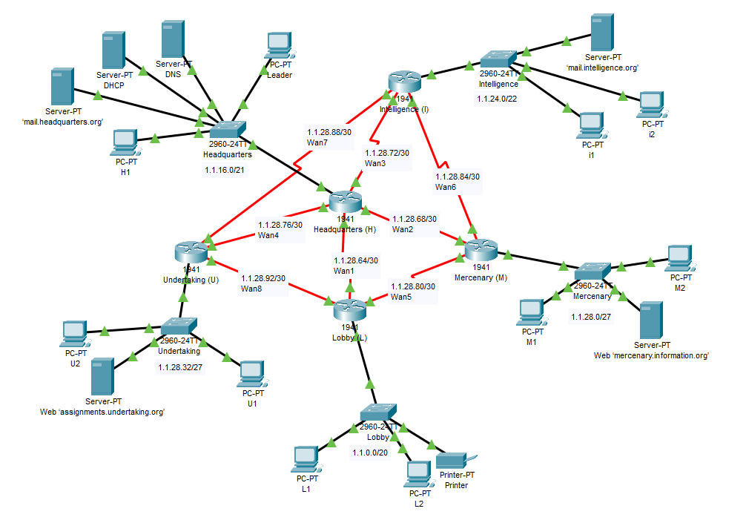

**VLSM tree:**

Main IP

1.1.0.0/16

1.1.0.0/20  
Lobby

. . . . . . . . . . . .

1.1.48.0/20

1.1.240.0/20

1.1.32.0/20

1.1.16.0/20

1.1.24.0/21

1.1.16.0/21  
Headquarters

1.1.28.0/22

1.1.24.0/22  
Intelligence

. . . . . . . . . . . .

1.1.31.224/27

1.1.28.96/27

1.1.28.0/27  
Mercenary

1.1.28.64/27

1.1.28.32/27  
Undertaking

1.1.28.92/30  
Wan8

1.1.28.88/30  
Wan7

1.1.28.84/30  
Wan6

1.1.28.80/30  
Wan5

1.1.28.76/30  
Wan4

1.1.28.72/30  
Wan3

1.1.28.68/30  
Wan2

1.1.28.64/30  
Wan1

**Router configuration commands:**

**Headquarters (H) :**

enable  
configure terminal  
hostname H

enable secret head

service password-encryption  
access-list 1 permit host 1.1.16.5 0.0.0.0

access-list 1 deny any  
line vty 0 4

access-class 1 in

password leader

login

transport input telnet

exit  
interface GigabitEthernet0/1

ip address 1.1.16.1 255.255.248.0  
no shutdown

exit

interface Serial0/0/0

ip address 1.1.28.65 255.255.255.252  
no shutdown

exit

interface Serial0/0/1

ip address 1.1.28.69 255.255.255.252  
no shutdown

exit

interface Serial0/1/0

ip address 1.1.28.73 255.255.255.252  
no shutdown

exit

interface Serial0/1/1

ip address 1.1.28.77 255.255.255.252  
no shutdown

exit

router rip

version 2  
network 1.1.28.64  
network 1.1.28.68

network 1.1.28.72

network 1.1.28.76

passive-interface GigabitEthernet0/1

no auto-summary

exit  
ip route 1.1.0.0 255.255.240.0 Serial0/0/0

ip route 1.1.24.0 255.255.252.0 Serial0/1/0

ip route 1.1.28.0 255.255.255.224 Serial0/0/1

ip route 1.1.28.32 255.255.255.224 Serial0/1/1  
end  
copy run start

**Lobby (L):**

enable  
configure terminal  
hostname L  
interface GigabitEthernet0/1

ip address 1.1.0.1 255.255.240.0

ip helper-address 1.1.16.2  
no shutdown  
exit

interface Serial0/0/0

ip address 1.1.28.66 255.255.255.252  
no shutdown

exit

interface Serial0/0/1

ip address 1.1.28.94 255.255.255.252

no shutdown

exit  
interface Serial0/1/0

ip address 1.1.28.81 255.255.255.252  
no shutdown  
exit  
ip route 1.1.28.32 255.255.255.224 Serial0/0/1 12

ip route 1.1.28.0 255.255.255.224 Serial0/1/0 12

ip route 1.1.24.0 255.255.252.0 Serial0/1/0 12

ip route 1.1.28.32 255.255.255.224 Serial0/0/0

ip route 1.1.28.0 255.255.255.224 Serial0/0/0

ip route 1.1.24.0 255.255.252.0 Serial0/0/0

ip route 1.1.16.0 255.255.248.0 Serial0/0/0  
router rip

version 2  
network 1.1.28.64  
network 1.1.28.80

network 1.1.28.92

passive-interface GigabitEthernet0/1

no auto-summary

exit

end  
copy run start

**Mercenary (M):**

enable  
configure terminal  
hostname M  
interface GigabitEthernet0/1

ip address 1.1.28.1 255.255.255.224

ip helper-address 1.1.16.2

no shutdown

exit

interface Serial0/0/1

ip address 1.1.28.70 255.255.255.252

no shutdown

exit

interface Serial0/1/0

ip address 1.1.28.82 255.255.255.252

no shutdown

exit

interface Serial0/1/1

ip address 1.1.28.85 255.255.255.252  
no shutdown

exit

router rip

version 2  
network 1.1.28.68  
network 1.1.28.80

network 1.1.28.84

passive-interface GigabitEthernet0/1

no auto-summary

exit  
ip route 1.1.24.0 255.255.252.0 Serial0/1/1 12

ip route 1.1.0.0 255.255.240.0 Serial0/1/0 12

ip route 1.1.28.32 255.255.255.224 Serial0/1/0 12

ip route 1.1.24.0 255.255.252.0 Serial0/0/1

ip route 1.1.0.0 255.255.240.0 Serial0/0/1

ip route 1.1.28.32 255.255.255.224 Serial0/0/1

ip route 1.1.16.0 255.255.248.0 Serial0/0/1  
end  
copy run start

**Intelligence (I):**

enable  
configure terminal  
hostname I

interface GigabitEthernet0/1

ip address 1.1.24.1 255.255.252.0

ip helper-address 1.1.16.2

no shutdown  
exit

interface Serial0/1/0

ip address 1.1.28.74 255.255.255.252

no shutdown  
exit

interface Serial0/1/1

ip address 1.1.28.86 255.255.255.252  
no shutdown

exit  
ip route 1.1.28.0 255.255.255.224 Serial0/1/1 12

ip route 1.1.28.32 255.255.255.224 Serial0/0/0 12

ip route 1.1.0.0 255.255.240.0 Serial0/1/1 12

ip route 1.1.28.0 255.255.255.224 Serial0/1/0

ip route 1.1.28.32 255.255.255.224 Serial0/1/0

ip route 1.1.0.0 255.255.240.0 Serial0/1/0

ip route 1.1.16.0 255.255.248.0 Serial0/1/0  
router rip

version 2

passive-interface GigabitEthernet0/1

no auto-summary  
network 1.1.28.72

network 1.1.28.84  
network 1.1.28.78

end

copy run start

**Undertaking (U):**  
enable  
configure terminal  
hostname U

interface GigabitEthernet0/1

ip address 1.1.28.33 255.255.255.224

ip helper-address 1.1.16.2

no shutdown

exit

interface Serial0/0/1

ip address 1.1.28.93 255.255.255.252

no shutdown

exit

interface Serial0/1/1

ip address 1.1.28.78 255.255.255.252

no shutdown

exit

interface Serial0/0/0

ip address 1.1.28.90 255.255.255.252

no shutdown

exit  
ip route 1.1.0.0 255.255.240.0 Serial0/0/1 12

ip route 1.1.24.0 255.255.252.0 Serial0/0/0 12

ip route 1.1.28.0 255.255.255.224 Serial0/0/1 12

ip route 1.1.0.0 255.255.240.0 Serial0/1/1

ip route 1.1.24.0 255.255.252.0 Serial0/1/1

ip route 1.1.28.0 255.255.255.224 Serial0/1/1

ip route 1.1.16.0 255.255.248.0 Serial0/1/1  
router rip  
version 2  
passive-interface GigabitEthernet0/1  
no auto-summary  
network 1.1.28.76

network 1.1.28.88

network 1.1.28.92  
end  
copy run start

**IP address table:**

|  |  |  |  |  |
| --- | --- | --- | --- | --- |
| **Device** | **Interface** | **IP Address** | **Subnet Mask** | **Default Gateway** |
| Router  Headquarters (H) | S0/0/0 | 1.1.28.65 | 255.255.255.252 | N/A |
| S0/0/1 | 1.1.28.69 | 255.255.255.252 |
| S0/1/0 | 1.1.28.73 | 255.255.255.252 |
| S0/1/1 | 1.1.28.77 | 255.255.255.252 |
| G0/1 | 1.1.16.1 | 255.255.248.0 |
| Router Lobby (L) | S0/0/0 | 1.1.28.66 | 255.255.255.252 | N/A |
| S0/0/1 | 1.1.28.94 | 255.255.255.252 |
| S0/1/0 | 1.1.28.81 | 255.255.255.252 |
| G0/1 | 1.1.0.1 | 255.255.240.0 |
| Router Mercenary (M) | s0/1/0 | 1.1.28.82 | 255.255.255.252 | N/A |
| S0/1/1 | 1.1.28.85 | 255.255.255.252 |
| S0/0/1 | 1.1.28.70 | 255.255.255.252 |
| G0/1 | 1.1.28.1 | 255.255.255.224 |
| Router Intelligence (I) | S0/0/0 | 1.1.28.89 | 255.255.255.252 | N/A |
| S0/1/0 | 1.1.28.74 | 255.255.255.252 |
| S0/1/1 | 1.1.28.86 | 255.255.255.252 |
| G0/1 | 1.1.24.1 | 255.255.252.0 |
| Router Undertaking (U) | S0/0/0 | 1.1.28.90 | 255.255.255.252 | N/A |
| S0/0/1 | 1.1.28.93 | 255.255.255.252 |
| S0/1/1 | 1.1.28.78 | 255.255.255.252 |
| G0/1 | 1.1.28.33 | 255.255.255.224 |
| Server DHCP | Fa0 | 1.1.16.2 | 255.255.248.0 | 1.1.16.1 |
| Server DNS | Fa0 | 1.1.16.3 | 255.255.248.0 | 1.1.16.1 |
| Server mail.headquarters.org | Fa0 | 1.1.16.4 | 255.255.248.0 | 1.1.16.1 |
| PC Leader | Fa0 | 1.1.16.5 | 255.255.248.0 | 1.1.16.1 |
| PC H1 | Fa0 | DHCP | 255.255.248.0 | 1.1.16.1 |
| Printer | Fa0 | 1.1.0.2 | 255.255.240.0 | 1.1.0.1 |
| PC L1 | Fa0 | DHCP | 255.255.240.0 | 1.1.0.1 |
| PC L2 | Fa0 | DHCP | 255.255.240.0 | 1.1.0.1 |
| Server Web mercenary.information.org | Fa0 | 1.1.28.2 | 255.255.255.224 | 1.1.28.1 |
| PC M1 | Fa0 | DHCP | 255.255.255.224 | 1.1.28.1 |
| PC M2 | Fa0 | DHCP | 255.255.255.224 | 1.1.28.1 |
| Server mail.intelligence.org | Fa0 | 1.1.24.2 | 255.255.252.0 | 1.1.24.1 |
| PC i1 | Fa0 | DHCP | 255.255.252.0 | 1.1.24.1 |
| PC i2 | Fa0 | DHCP | 255.255.252.0 | 1.1.24.1 |
| Server assignments.undertaking.org | Fa0 | 1.1.28.34 | 255.255.255.224 | 1.1.28.33 |
| PC U1 | Fa0 | DHCP | 255.255.255.224 | 1.1.28.33 |
| PC U2 | Fa0 | DHCP | 255.255.255.224 | 1.1.28.33 |