Light Report Test Coverage
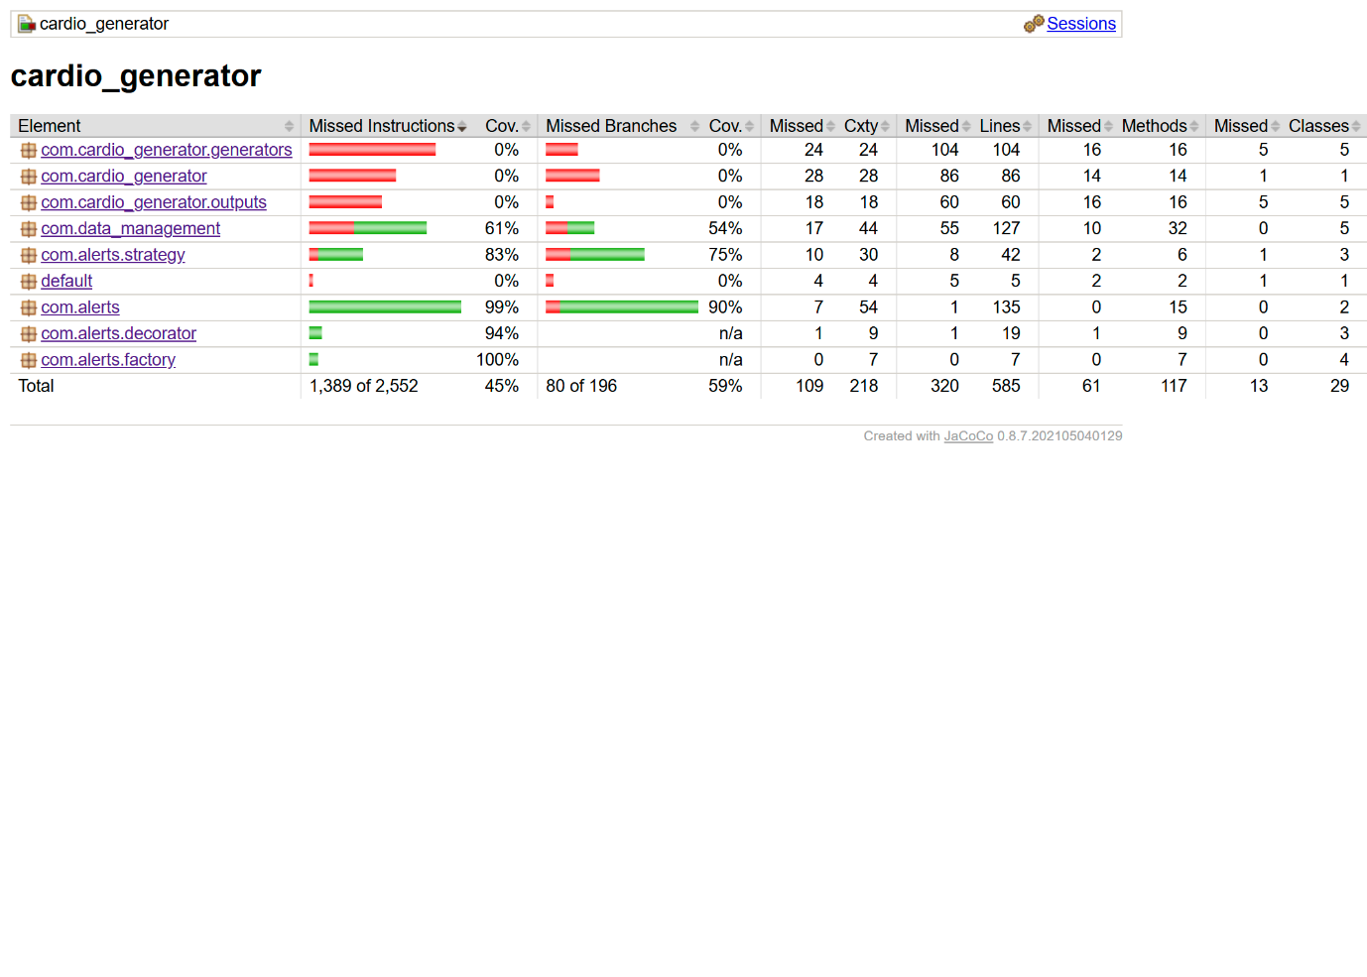

In total, the project received 45% instruction coverage and 59% branch coverage. It seems that alert-related packages have high coverage as most functionality was tested.
The com.alerts.factory package has full 100% coverage as all factory classes along with their createAlert() method were tested. Package com.alerts has 99% coverage. Low coverage (which is due to the triggerAlert print statement) comes from difficulty to test such statement within unit tests. Coverage in com.alerts.decorator and com.alerts.strategy packages equals to 94% and 83%, respectively. Low coverage in both packages is caused by some corner cases such as decorator combination and hard-to-cover aspects of trend detection algorithm.
Package com.data_management has 61% coverage. All major classes such as DataStorage, Patient, and FileDataReader were tested, while some of WebSocketClient methods were left out as they require establishing connection with a live server during tests.
Coverage for all com.cardio_generator packages equals to 0%. As can be inferred from the name, these classes are aimed at generating fake patient data, hence there was no point in testing them further since they were provided and unchanged during this project. Main class has zero coverage too as its main role is starting the application and passing execution to other classes.

