Hotel Reservation System

Architecture Notebook

Revision History

Date | Author | Description | Version
03/05/2021 | Irina Erofeeva  Ömer Denizoğlu  Durali Alagöz  M.Mert Dervişoğulları | First version | v 1.0
09/05/2021 | Irina Erofeeva  Ömer Denizoğlu  Durali Alagöz  M.Mert Dervişoğulları | Updated according to Iteration2 reviews. | v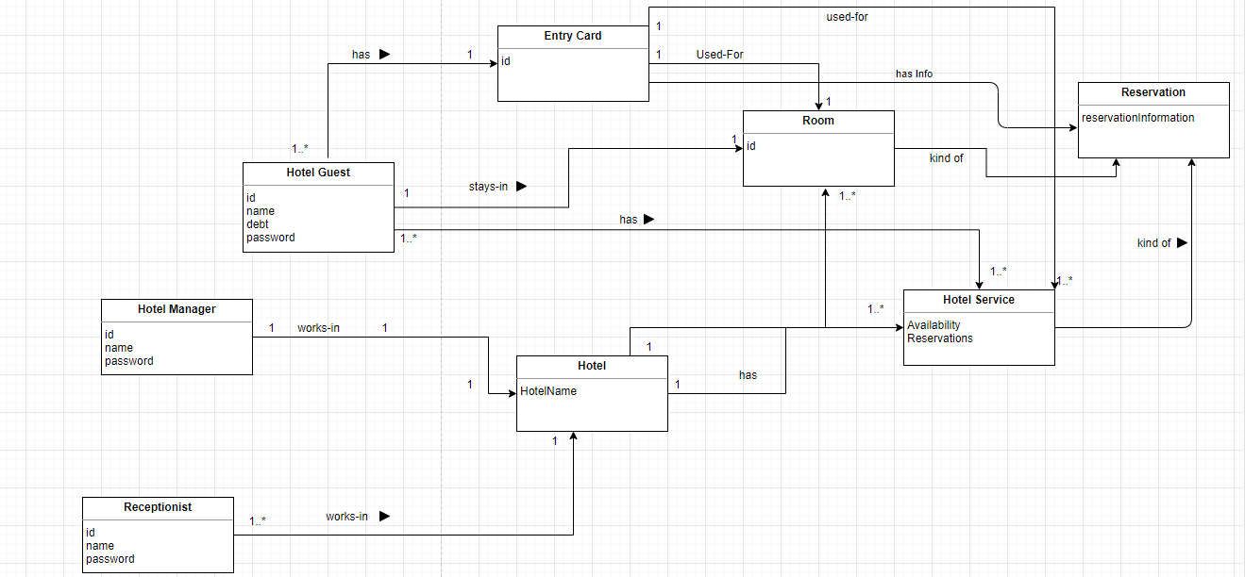 1.1

Table of Contents
1. Purpose 1
2. Architectural goals and philosophy 1
3. Assumptions and dependencies 1
4. Architecturally significant requirements 2
5. Decisions, constraints, and justifications 2
6. Architectural Mechanisms 2
6.1 Architectural Mechanism 1 2
7. Key abstractions 3
8. Layers or architectural framework 3
9. Architectural views 5
9.1 Logical: 5
9.2 Deployment: 6
9.3 Data 7
9.4 Use Case 7

Purpose
This document describes the philosophy, decisions, constraints, justifications, significant elements, and any other overarching aspects of the system that shape the design and implementation. This document is aiming to guide software developers already working on this project and newcomers who will work for this project.

Architectural goals and philosophy
- The architecture document must guide to simplicity, high performance and maintainability.
- All architecturally significant requirements must be considered while developing the architecture notebook.
- Reusing the existing components is a mandatory goal of architecture.
- System should be extendible without modifying or rewriting existing components.

Assumptions and dependencies
- Object Oriented Design and Analysis must be followed.
- Java programming language will be used as an object oriented language.
- The system will run on any machine that has Java Virtual Machine.
- The system will work with SQLite but it can also work with other Databases.

Architecturally significant requirements
- SWRS section 4. Hotel guests must interact with the system through kiosks in the lobby, touch screens in their rooms -> System should have a Graphical User Interface.
- SWRS section 2. In the later stage on the development the system must be adapted to mobile devices for the remote control.
- SWRS section 4.2.1. System must provide an interface in order to provide an access to the system for other services of the hotel.
- SWRS section 4.2.1. HRS should use different external systems for payment.
- Use Cases Specification Use Case1- Manage Accounts, Use Case2- Manage Reservation of Room, Use Case4- Manage Reservation of Other services, Use Case5- Make Payment in cash, Use Case7- Monitor Reservations are significant requirements.

Decisions, constraints, and justifications
- Each class must have only one responsibility to achieve SOLID principles.
- There should not be any logical operation in the UI layer to achieve model view separation.
- There must be low representational gap between Domain model and Design Model to achieve FURPS+ principles.
- Using magic numbers is not allowed to achieve easy understandable code.
- Using interfaces is mandatory to achieve low coupling.
- The unified process will be followed during the project to follow the architecture-centric method.

Architectural Mechanisms

Architectural Mechanism 1
Technical Memo
Issue: The significant external parts of the system can be changed. (Payment, Database…)
Solution Summary: If the external parts of the system are changed, the system must continue to work properly.
Factors
Robust recovery from remote database failure
Robust recovery from payment system failure

Solution
The system can continue to work with different databases or payment system using adapter design pattern.
Motivation
The hotel can work with different payment systems as time goes.
The database is used in the system may be insufficient as time goes.

Key abstractions
Figure 1 Domain Model

Layers or architectural framework
Layered Architecture will be used to achieve separation of concerns principle.
- UI Layer
The user will interact with this layer. There won’t be any logic operation in this layer. These layer elements will be in HRS.UI namespace.
- Application Logic Layer
All the logic operations about the requirement will be handled in this layer. These layer elements will be in HRS.APPLOGIC namespace.
- Technical Services Layer
All the technical services will be handled in this layer. These layer elements will be in HRS.SERVICES namespace.

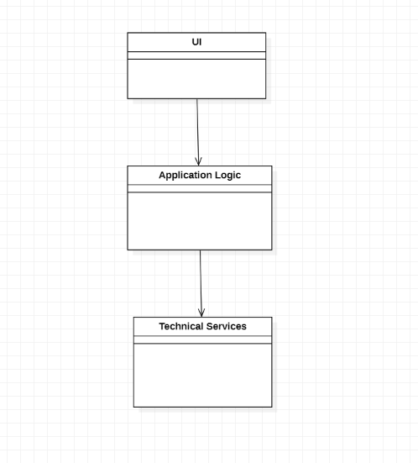
Figure 2 Layers

Architectural views

Logical:
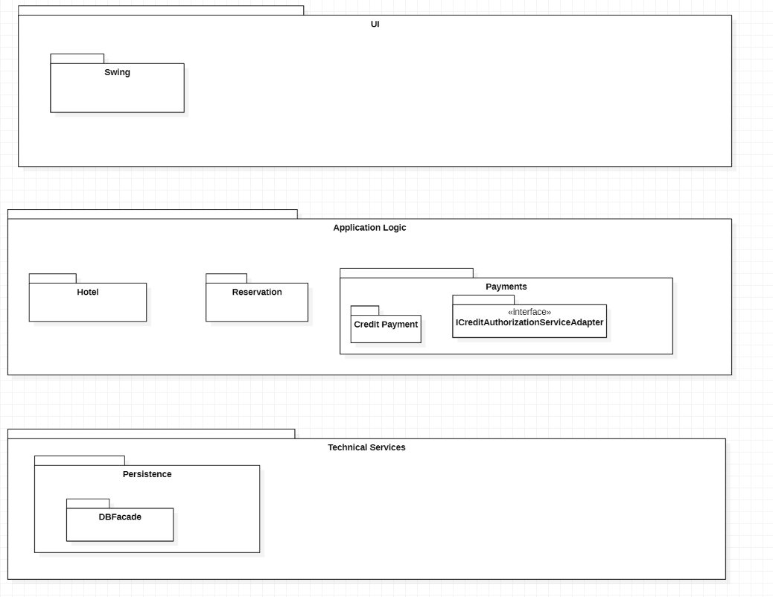
Figure 3 Logical View

Deployment:
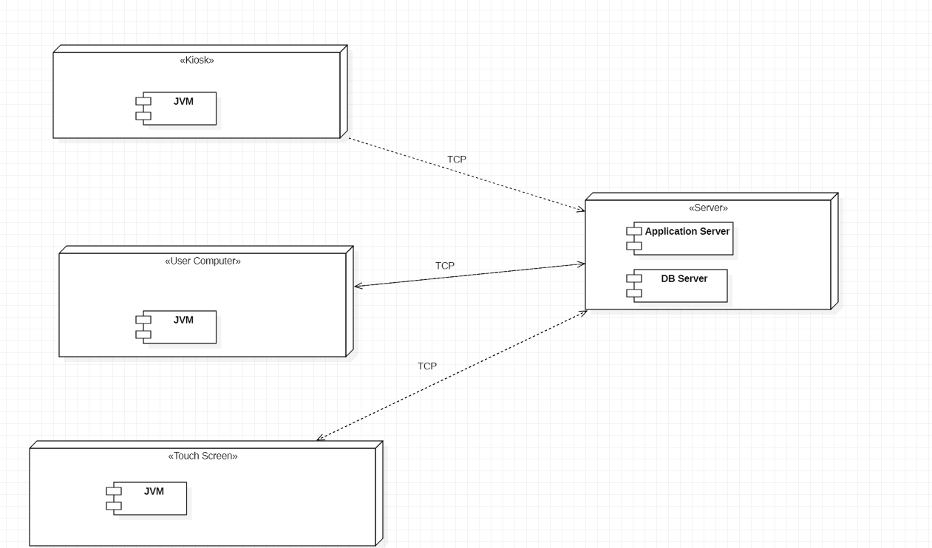
Figure 4 Deployment View

Data

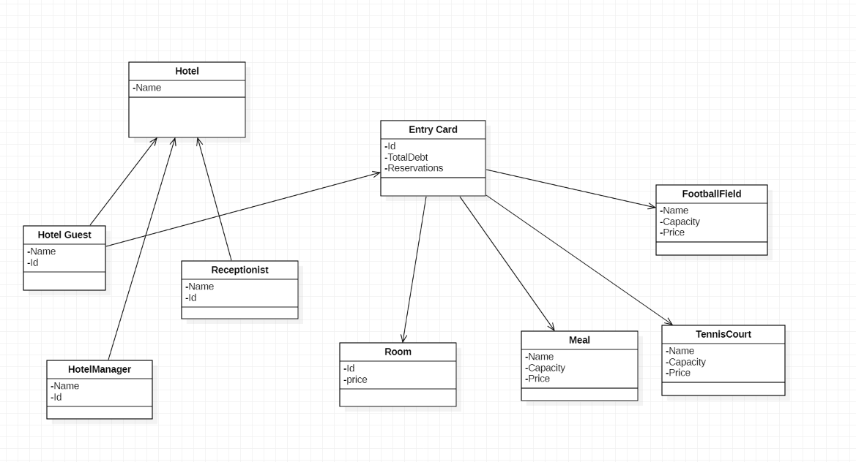
Figure 5 Data View

Use Case
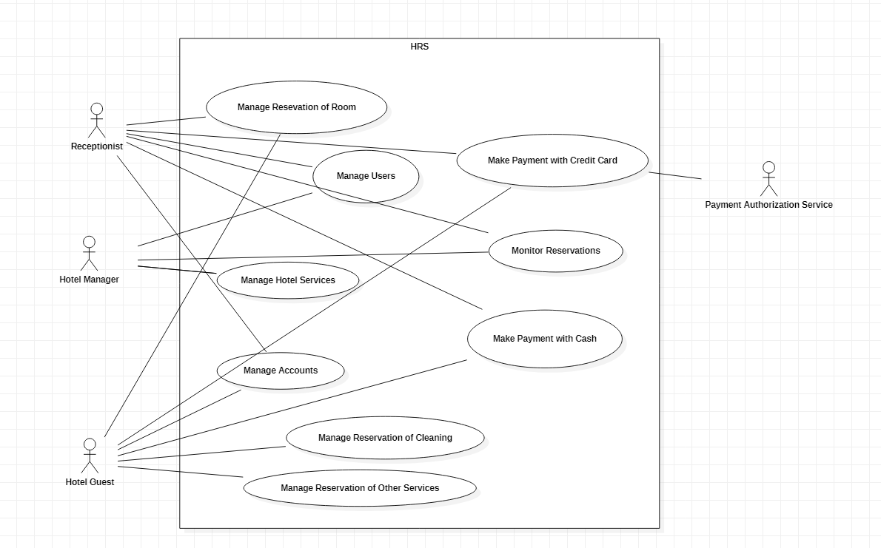
Figure 6 Use Case View

