Irina Chis

Evaluare 2

3.

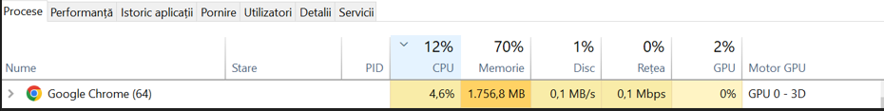

URL Azure DevOps: <https://myprojectirina.z6.web.core.windows.net/>