Weather analysis around the world for one day.

Weather is one of the things that are change constantly. Let’s make a data snap from 500 cities data from all over the world and analyze how weather looks like on that one day, 03/30/2018.

The criteria we are using are Latitude vs Max Temperature, Humidity, Wind Speed, and Cloudiness.

LATITUDE vs MAX TEMPERATURE

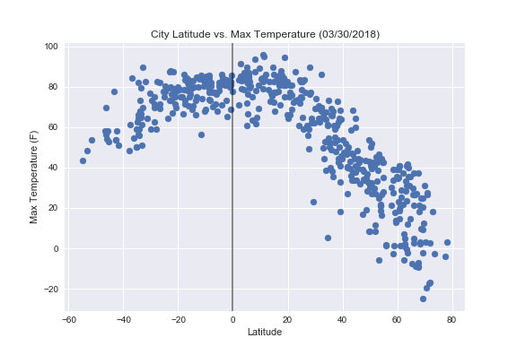

Most of the max temperatures (60-95deg F) are happen around the equator. The lowest temperatures belong to the northern parts of the world closer to the North Pole.

LATITUDE vs CLOUDINESS

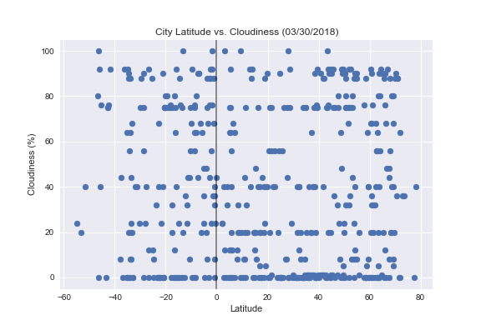

The cloudiness is pretty evenly spread out all over the world for this day.

LATITUDE vs HUMIDITY

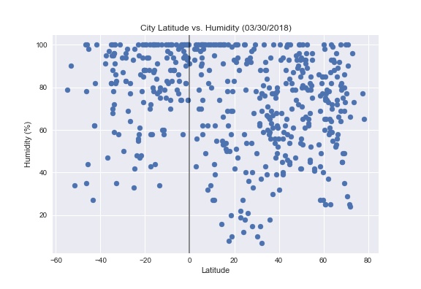

The evenly spread out cloudiness correlates with the pretty evenly spread out humidity, 30 – 100%, with the ‘dry’ area of 2 – 30% on the Lat 15 – 40 deg.

LATITUDE vs WIND SPEED

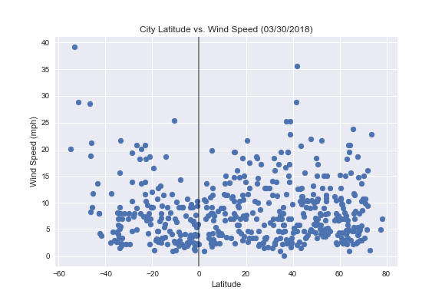

This day is relatively calm everywhere in terms of wind speed, mostly in range of 3 – 15 mph, with some areas of 25 – 40 mph.