Redwood Public Library
Planning Document
April 11th, 2026
Author: Iris Healy

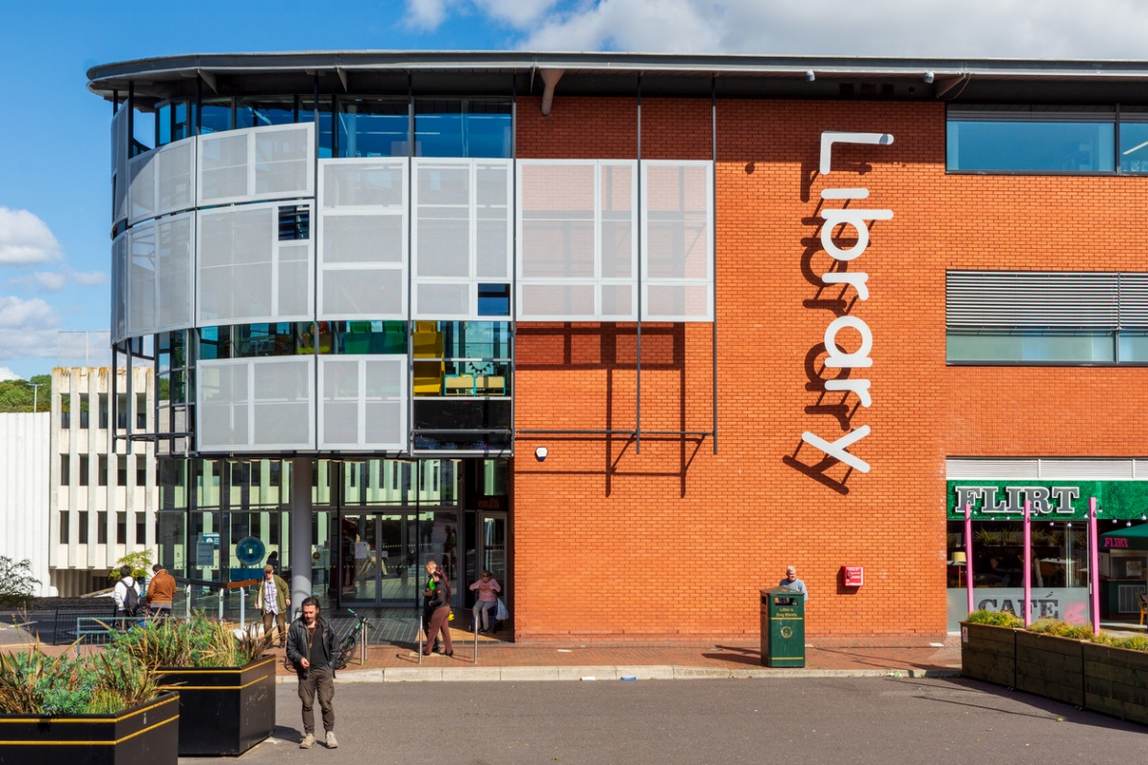
https://publiclibrariesonline.org/wp-content/uploads/2026/01/iStock-2237285800.jpg

2.1 Executive Summary
Redwood Public Library is looking to develop a new website for our users and librarians. The website will have features for library members to search through our catalog of books, and for our librarians to manage library operations and keep track of and add to our growing selection of books. We see this website as a necessary step in evolving our aging library system to meet our member access needs in the evolving technical world of 2026
2.2 User Stories
As a Library administrator. I want to be able to create new user accounts in the database to increase our library’s membership
As a Librarian . I want to be able to Add books to the library database to keep an up-to-date catalog of books
As a Librarian. I want to be able to Check out and Check in Books to and from users to track lent out books in the database
As a Librarian. I want to be able to view a list of Library members and the books that they have checked out
As a Library Member I want to be able to search books by Name, Genre Keywords, and Author to find books that would interest me
As a Library Member I want to be able to log into my account to see what books I have checked out to keep track of my due dates

2.3 Technical Elements
1. The Code Will be stored in a GitHub Repository
2. The Technical stack for the Redwood Public Library website will be as follows
GUI
RAZOR Page (HTML & CSS with C# elements)

Logic Layer
C#

ORM (Object Relational Mapping)
Entity Framework Core
(Maps C# Classes to Database Tables)

Foundation Layer
ADO.NET (Handles Database Queries)

Database Layer
MS SQL Server

3. The code will be commented clearly for future developers to be able to understand and add to the project
4. This Document and setup Instructions will be stored in the repository as a README
5. Public Variables will be used in the code to store database attributes of book entities such as Author, ISBN, Title to book objects within the code
6. Mathematical operators will be used within the code to total the monetary value of Books that a User has checked out when viewed by a Librarian
7. Boolean operators will be used within the code to put endcaps on loops once they have iterated through all items stored in a list as well as check if a book is available for lending by checking the bit value stored in the database
8. Conditional statements will be used throughout the code to check if a login matches a value stored in the database. It will also be used to check if a list contains no items so that the page can display an error to the user that their query did not return any values
9. Loops will be used throughout the code to iterate through lists of Book Objects for display to the user on the GUI Layer in tables
10. Lists will be used to store a collection of book objects returned by the database queries
11. Object oriented programming principles will be used throughout the code for Object Relational Mapping Relating C# classes such as Books and Users to their Database entities
12. The Website will have A GUI coded in HTML and CSS using C# Razor elements
13. The database for the library website will be coded in TSQL and run in MS SQL Server in a docker container
14. EF Core will be used to Map C# Books Objects to results returned from parameterized SELECT queries through ADO.NET. These results will then be displayed to the user using html tables
15. EF Core will be used to Bind User text inputs to SQL Insert Queries performed by ADO.NET to create new users and new books within the database when credentialed as a Library Administrator
2.4 Task List
Sprint 1 (Tue April 14th – Tue April 21st)
Task 1: Code The Redwood Library Database based on the Entity relationship diagram in TSQL and insert Seed Data into Entities
Task 2: Ensure Database connection with test queries
Task 3: Create Working Page models for Staff and User Logins
Sprint 2 (Tue April 21st – Tue April 28th)
Task 1: Add Search by Name, Author, and Search by genre functionality to member users
Task 2: Add Checked out books display for member users
Task 3: Add Display Checked out books by users for Librarian Users
Sprint 3 (Tue April 28th – Tue May 5th)
Task 1: Add Create new user functionality for Library Administrators
Task 2: Add new book functionality For Librarians
Task 3: Polish Base HTML Elements with CSS

2.5 Entity Relationship Planning and Diagram
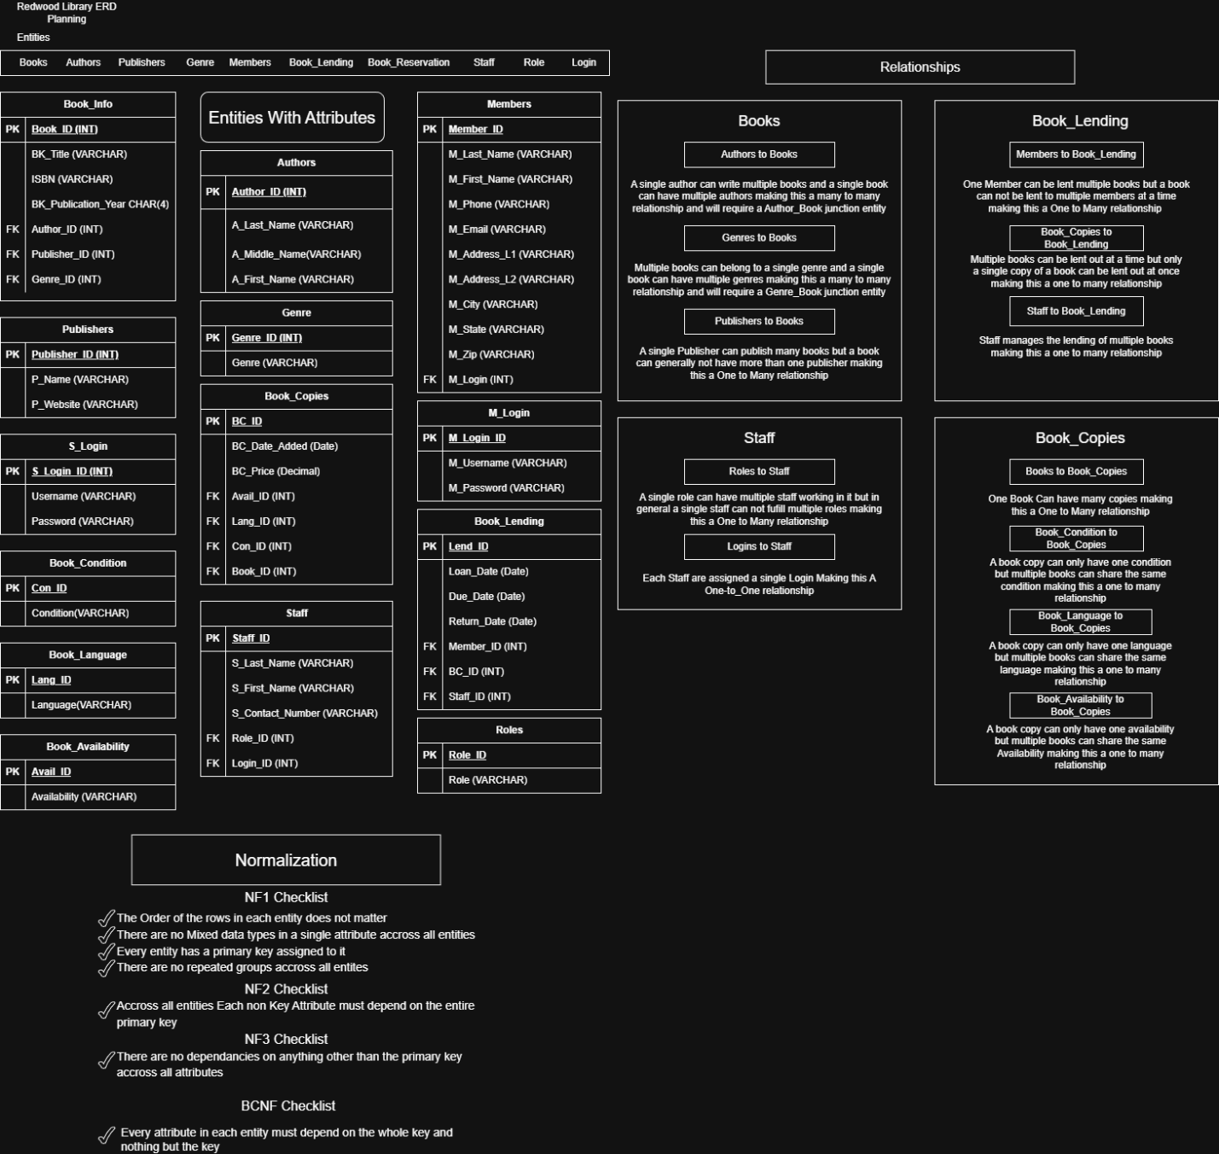

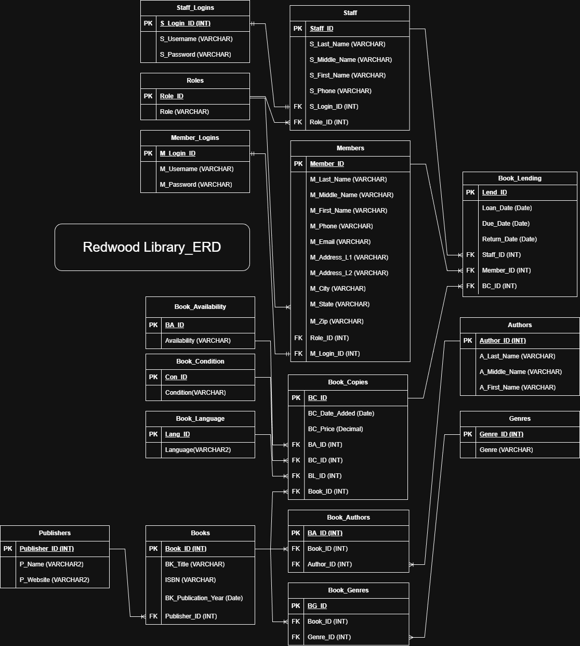

References
Lebens, M. (2026). Module 10 Lab. Retrieved from Module 10 Lab: https://minneapolis.learn.minnstate.edu/d2l/lms/dropbox/user/folder_submit_files.d2l?ou=7008324&isprv=0&db=15182090&cfql=1
Lebens, M. (2026). Module 10 Lab. Retrieved from Module 10 Lab: https://minneapolis.learn.minnstate.edu/d2l/lms/dropbox/user/folder_submit_files.d2l?ou=7008324&isprv=0&db=15182089&cfql=1
Lebens, M. (2026). Module 11 Lab. Retrieved from Module 11 Lab: https://minneapolis.learn.minnstate.edu/d2l/lms/dropbox/user/folder_submit_files.d2l?ou=7008324&isprv=0&db=15182099&cfql=1

