**同济大学计算机系**

**计算机组成原理实验报告**



**学 号 1954263**

**姓 名 宋子铭**

**专 业 计算机科学与技术**

**授课老师 郝泳涛**

1. 实验内容

将使用 Verilog HDL 语言实现 54 条 MIPS 指令的 CPU 的设计 和仿真，设计的 CPU 可以是单周期的，也可以是多周期。

我设计的是单周期CPU。

1. 设计思路和数据通路

**整体思路：**

该次实验，我先将各条指令理解清晰，分别找出其对应操作和所需部件并画出数据通路图，然后分析所有指令各部件的输入输出对应信号。依照整理的信号表格和各指令的数据通路，绘制总的数据通路。最后在vivado上编写并借助modelsim，mars汇编器进行调试，最后下板验证实验成功。

**2.1 54条指令数据通路**

1 add

格式：add rd, rs, rt

操作：取指令，rd←rs+rt, PC←NPC(PC+4)

所需部件：PC, NPC, IMEM, Regfile, ALU

部件之间数据输入输出关系：

|  |  |  |  |  |  |  |
| --- | --- | --- | --- | --- | --- | --- |
|  | PC | NPC | IMEM | Rgefile | ALU | |
|  |  |  |  | rd | A | B |
| add | NPC | PC | PC | ALU | rs | rt |

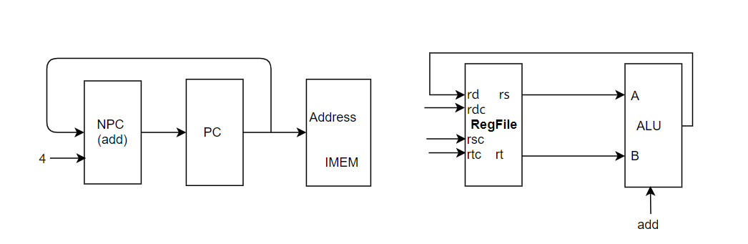

2 addu

格式：addu rd, rs, rt

操作：取指令，rd←rs+rt, PC←NPC(PC+4)

所需部件：PC, NPC, IMEM, Regfile, ALU

部件之间数据输入输出关系：

|  |  |  |  |  |  |  |
| --- | --- | --- | --- | --- | --- | --- |
|  | PC | NPC | IMEM | Rgefile | ALU | |
|  |  |  |  | rd | A | B |
| addu | NPC | PC | PC | ALU | rs | rt |

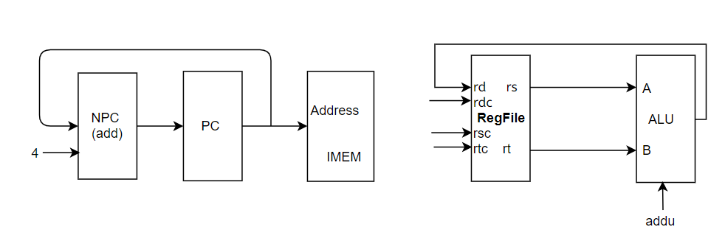

3 sub

格式：sub rd, rs, rt

操作：取指令，rd←rs-rt, PC←NPC(PC+4)

所需部件：PC, NPC, IMEM, Regfile, ALU

部件之间数据输入输出关系：

|  |  |  |  |  |  |  |
| --- | --- | --- | --- | --- | --- | --- |
|  | PC | NPC | IMEM | Rgefile | ALU | |
|  |  |  |  | rd | A | B |
| sub | NPC | PC | PC | ALU | rs | rt |

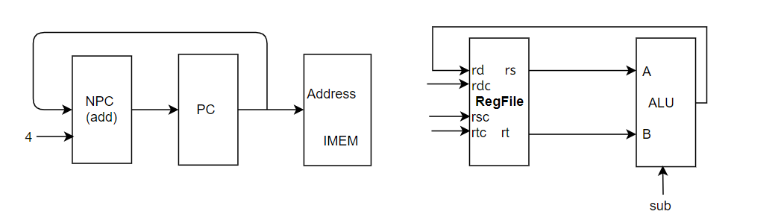

4 subu

格式：subu rd, rs, rt

操作：取指令，rd←rs-rt, PC←NPC(PC+4)

所需部件：PC, NPC, IMEM, Regfile, ALU

部件之间数据输入输出关系：

|  |  |  |  |  |  |  |
| --- | --- | --- | --- | --- | --- | --- |
|  | PC | NPC | IMEM | Rgefile | ALU | |
|  |  |  |  | rd | A | B |
| subu | NPC | PC | PC | ALU | rs | rt |

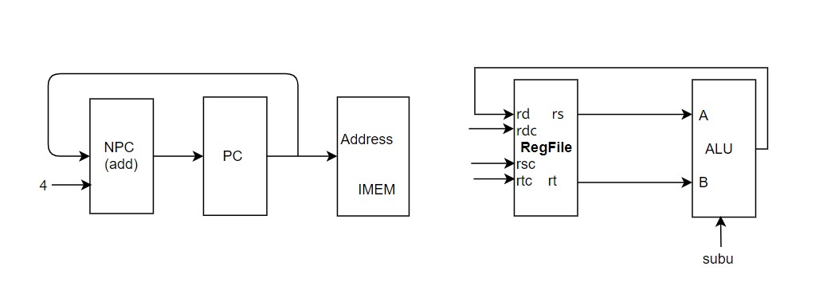

5 and

格式：and rd, rs, rt

操作：取指令，rd←rs&rt, PC←NPC(PC+4)

所需部件：PC, NPC, IMEM, Regfile, ALU

部件之间数据输入输出关系：

|  |  |  |  |  |  |  |
| --- | --- | --- | --- | --- | --- | --- |
|  | PC | NPC | IMEM | Rgefile | ALU | |
|  |  |  |  | rd | A | B |
| and | NPC | PC | PC | ALU | rs | rt |

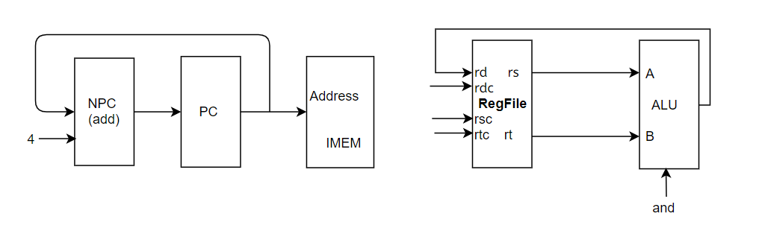

6 or

格式：or rd, rs, rt

操作：取指令，rd←rs|rt, PC←NPC(PC+4)

所需部件：PC, NPC, IMEM, Regfile, ALU

部件之间数据输入输出关系：

|  |  |  |  |  |  |  |
| --- | --- | --- | --- | --- | --- | --- |
|  | PC | NPC | IMEM | Rgefile | ALU | |
|  |  |  |  | rd | A | B |
| or | NPC | PC | PC | ALU | rs | rt |

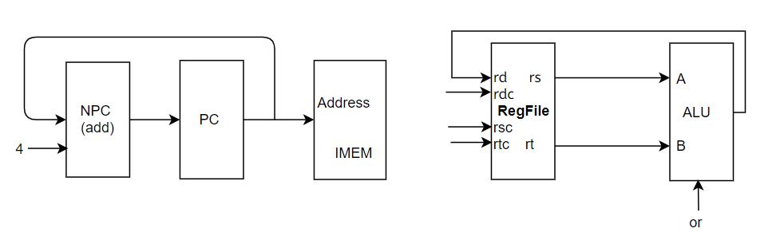

7 xor

格式：xor rd, rs, rt

操作：取指令，rd←rs^rt, PC←NPC(PC+4)

所需部件：PC, NPC, IMEM, Regfile, ALU

部件之间数据输入输出关系：

|  |  |  |  |  |  |  |
| --- | --- | --- | --- | --- | --- | --- |
|  | PC | NPC | IMEM | Rgefile | ALU | |
|  |  |  |  | rd | A | B |
| xor | NPC | PC | PC | ALU | rs | rt |

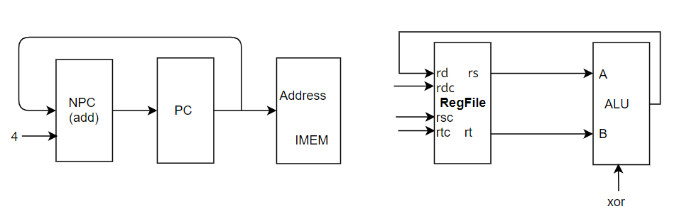

8 nor

格式：nor rd, rs, rt

操作：取指令，rd←~(rs|rt), PC←NPC(PC+4)

所需部件：PC, NPC, IMEM, Regfile, ALU

部件之间数据输入输出关系：

|  |  |  |  |  |  |  |
| --- | --- | --- | --- | --- | --- | --- |
|  | PC | NPC | IMEM | Rgefile | ALU | |
|  |  |  |  | rd | A | B |
| nor | NPC | PC | PC | ALU | rs | rt |

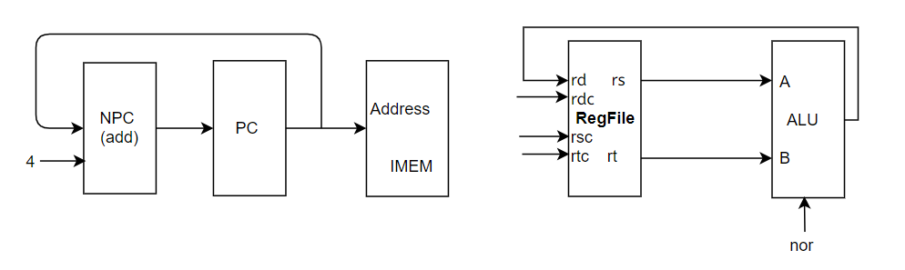

9 slt

格式：slt rd, rs, rt

操作：取指令，rd←rs<rt, PC←NPC(PC+4)

所需部件：PC, NPC, IMEM, Regfile, ALU

部件之间数据输入输出关系：

|  |  |  |  |  |  |  |
| --- | --- | --- | --- | --- | --- | --- |
|  | PC | NPC | IMEM | Rgefile | ALU | |
|  |  |  |  | rd | A | B |
| slt | NPC | PC | PC | ALU | rs | rt |

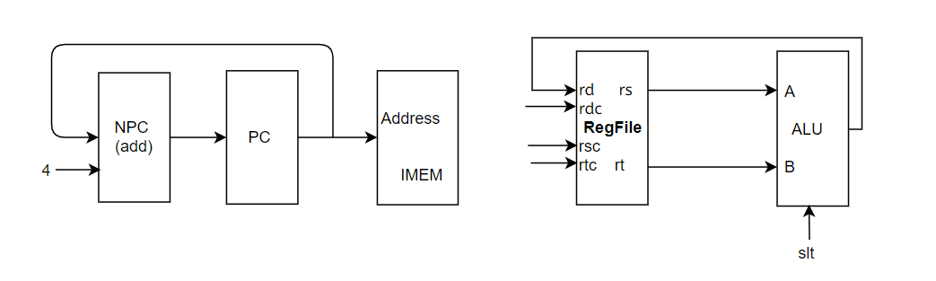

10 sltu

格式：sltu rd, rs, rt

操作：取指令，rd←rs<rt, PC←NPC(PC+4)

所需部件：PC, NPC, IMEM, Regfile, ALU

部件之间数据输入输出关系：

|  |  |  |  |  |  |  |
| --- | --- | --- | --- | --- | --- | --- |
|  | PC | NPC | IMEM | Rgefile | ALU | |
|  |  |  |  | rd | A | B |
| sltu | NPC | PC | PC | ALU | rs | rt |

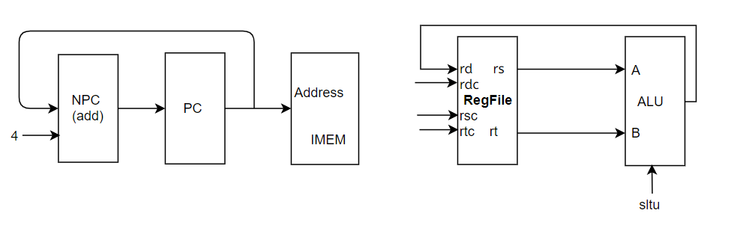

11 sll

格式：sll rd, rt, sa

操作：取指令，rd←rt<<sa, PC←NPC(PC+4)

所需部件：PC, NPC, IMEM, Regfile, ALU,Ext5

部件之间数据输入输出关系：

|  |  |  |  |  |  |  |  |
| --- | --- | --- | --- | --- | --- | --- | --- |
|  | PC | NPC | IMEM | Rgefile | ALU | | Ext5 |
|  |  |  |  | rd | A | B |  |
| sll | NPC | PC | PC | ALU | Ext5 | rt | sa(IM[10:6]) |

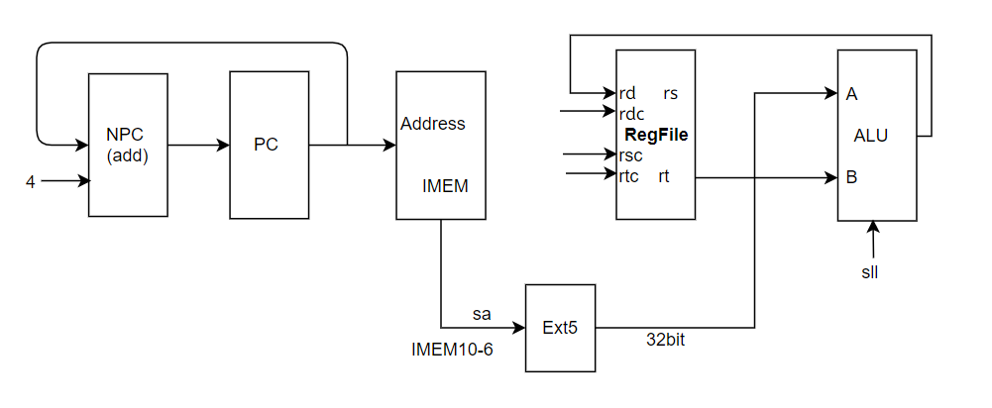

12 srl

格式：srl rd, rt, sa

操作：取指令，rd←rt>>sa(逻辑), PC←NPC(PC+4)

所需部件：PC, NPC, IMEM, Regfile, ALU,Ext5

部件之间数据输入输出关系：

|  |  |  |  |  |  |  |  |
| --- | --- | --- | --- | --- | --- | --- | --- |
|  | PC | NPC | IMEM | Rgefile | ALU | | Ext5 |
|  |  |  |  | rd | A | B |  |
| srl | NPC | PC | PC | ALU | Ext5 | rt | sa(IM[10:6]) |

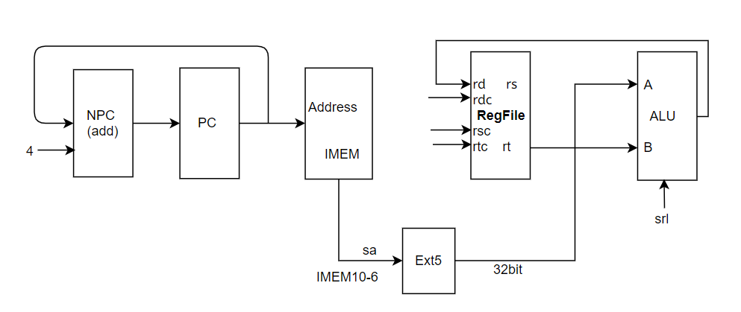

13 sra

格式：sra rd, rt, sa

操作：取指令，rd←rt>>sa(算数), PC←NPC(PC+4)

所需部件：PC, NPC, IMEM, Regfile, ALU,Ext5

部件之间数据输入输出关系：

|  |  |  |  |  |  |  |  |
| --- | --- | --- | --- | --- | --- | --- | --- |
|  | PC | NPC | IMEM | Rgefile | ALU | | Ext5 |
|  |  |  |  | rd | A | B |  |
| srl | NPC | PC | PC | ALU | Ext5 | rt | sa(IM[10:6]) |

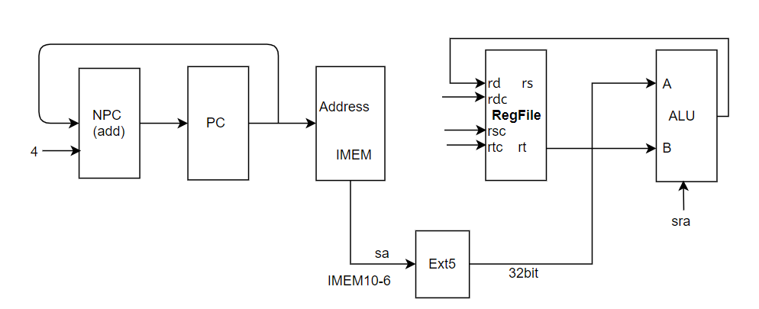

14 sllv

格式：sllv rd, rs, rt

操作：取指令，rd←rs<<rt, PC←NPC(PC+4)

所需部件：PC, NPC, IMEM, Regfile, ALU

部件之间数据输入输出关系：

|  |  |  |  |  |  |  |
| --- | --- | --- | --- | --- | --- | --- |
|  | PC | NPC | IMEM | Rgefile | ALU | |
|  |  |  |  | rd | A | B |
| sllv | NPC | PC | PC | ALU | rs | rt |

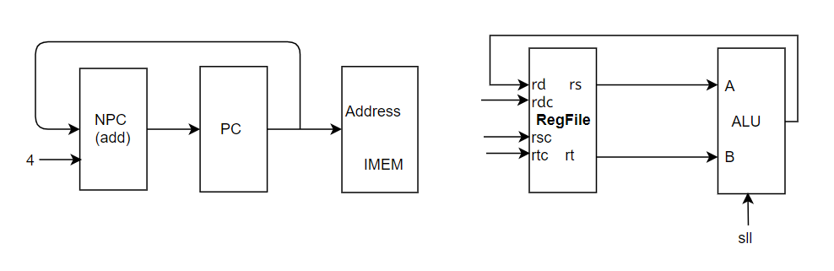

15 srlv

格式：srlv rd, rs, rt

操作：取指令，rd←rs>>rt(逻辑), PC←NPC(PC+4)

所需部件：PC, NPC, IMEM, Regfile, ALU

部件之间数据输入输出关系：

|  |  |  |  |  |  |  |
| --- | --- | --- | --- | --- | --- | --- |
|  | PC | NPC | IMEM | Rgefile | ALU | |
|  |  |  |  | rd | A | B |
| srlv | NPC | PC | PC | ALU | rs | rt |

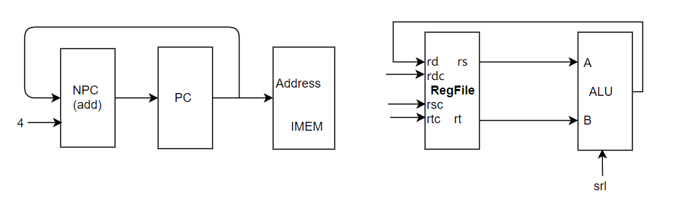

16 srav

格式：srav rd, rs, rt

操作：取指令，rd←rs>>rt(算数), PC←NPC(PC+4)

所需部件：PC, NPC, IMEM, Regfile, ALU

部件之间数据输入输出关系：

|  |  |  |  |  |  |  |
| --- | --- | --- | --- | --- | --- | --- |
|  | PC | NPC | IMEM | Rgefile | ALU | |
|  |  |  |  | rd | A | B |
| srav | NPC | PC | PC | ALU | rs | rt |

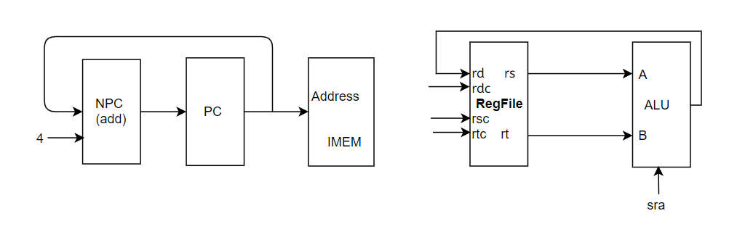

17 jr

格式：jr rs

操作：取指令，PC←rs, PC←NPC(PC+4)

所需部件：PC, NPC, IMEM, Regfile,MUX

部件之间数据输入输出关系：

|  |  |  |  |  |
| --- | --- | --- | --- | --- |
|  | PC | NPC | IMEM | Rgefile |
|  |  |  |  | Rd |
| jr | rs | PC | PC |  |

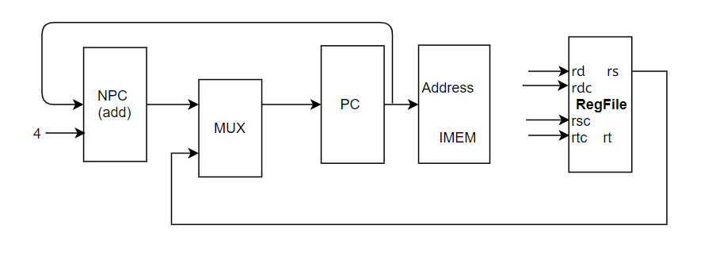

18 addi

格式：addi rt, rs, imm16

操作：取指令、rt←rs+imm16(sign_extend) 、PC←NPC(PC+4)

所需部件：PC、NPC、IMEM、Regfile、ALU、Ext16

部件之间数据输入输出关系：

|  |  |  |  |  |  |  |  |
| --- | --- | --- | --- | --- | --- | --- | --- |
|  | PC | NPC | IMEM | Rgefile | ALU | | Ext16 |
|  |  |  |  | Rd | A | B |  |
| addi | NPC | PC | PC | ALU | rs | Ext16 | imm16 |

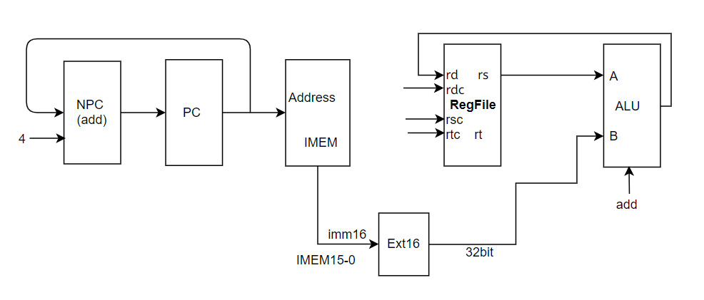

19 addiu

格式：addiu rt, rs, imm16

操作：取指令、rt←rs+imm16(sign_extend) 、PC←NPC(PC+4)

所需部件：PC、NPC、IMEM、Regfile、ALU、Ext16

部件之间数据输入输出关系：

|  |  |  |  |  |  |  |  |
| --- | --- | --- | --- | --- | --- | --- | --- |
|  | PC | NPC | IMEM | Rgefile | ALU | | Ext16 |
|  |  |  |  | Rd | A | B |  |
| addiu | NPC | PC | PC | ALU | rs | Ext16 | imm16 |

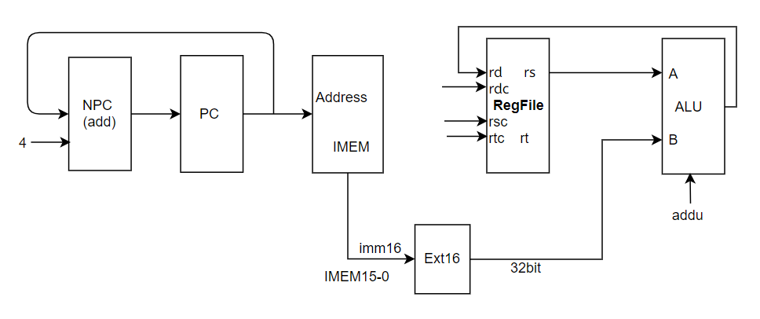

20 andi

格式：andi rt, rs, imm16

操作：取指令、rt←rs&imm16(zero_extend) 、PC←NPC(PC+4)

所需部件：PC、NPC、IMEM、Regfile、ALU、Ext16

部件之间数据输入输出关系：

|  |  |  |  |  |  |  |  |
| --- | --- | --- | --- | --- | --- | --- | --- |
|  | PC | NPC | IMEM | Rgefile | ALU | | Ext16 |
|  |  |  |  | Rd | A | B |  |
| andi | NPC | PC | PC | ALU | rs | Ext16 | imm16 |

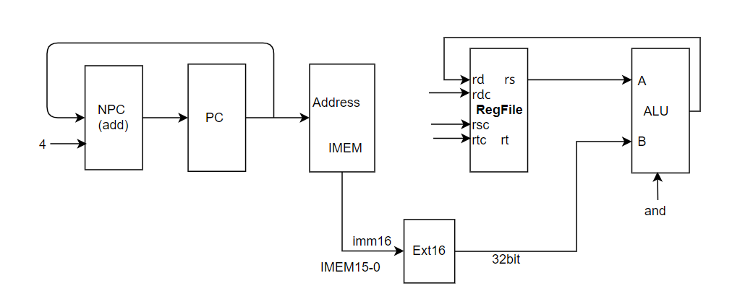

21 ori

格式：ori rt, rs, imm16

操作：取指令、rt←rs|imm16(zero_extend) 、PC←NPC(PC+4)

所需部件：PC、NPC、IMEM、Regfile、ALU、Ext16

部件之间数据输入输出关系：

|  |  |  |  |  |  |  |  |
| --- | --- | --- | --- | --- | --- | --- | --- |
|  | PC | NPC | IMEM | Rgefile | ALU | | Ext16 |
|  |  |  |  | Rd | A | B |  |
| ori | NPC | PC | PC | ALU | rs | Ext16 | imm16 |

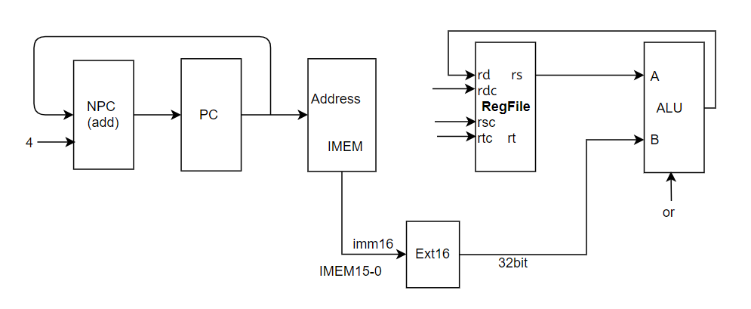

22 xori

格式：xori rt, rs, imm16

操作：取指令、rt←rs^imm16(zero_extend) 、PC←NPC(PC+4)

所需部件：PC、NPC、IMEM、Regfile、ALU、Ext16

部件之间数据输入输出关系：

|  |  |  |  |  |  |  |  |
| --- | --- | --- | --- | --- | --- | --- | --- |
|  | PC | NPC | IMEM | Rgefile | ALU | | Ext16 |
|  |  |  |  | Rd | A | B |  |
| xori | NPC | PC | PC | ALU | rs | Ext16 | imm16 |

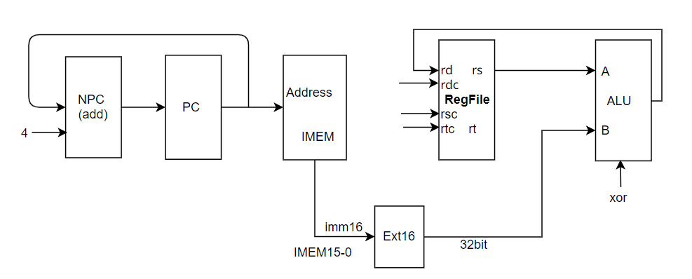

23 lw

格式：lw rt, offset(base)

操作：取指令、rt←[rs+Sign_ext_offset] 、PC←NPC(PC+4)

所需部件：PC、NPC、IMEM、Regfile、ALU、Ext16、DMEM

部件之间数据输入输出关系：

|  |  |  |  |  |  |  |  |  |  |  |
| --- | --- | --- | --- | --- | --- | --- | --- | --- | --- | --- |
|  | PC | NPC | IMEM | Rgefile | ALU | | Ext16 | DMEM | | |
|  |  |  |  | Rd | A | B |  | Addr | | Data |
| lw | NPC | PC | PC | DMEM(Data) | rs | Ext16 | offset | ALU |  | |

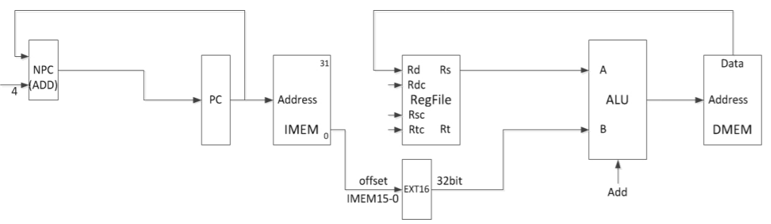

24 sw

格式：sw rt, offset(base)

操作：取指令、[base+Sign_ext_offset]←rt, PC←NPC(PC+4)

所需部件：PC、NPC、IMEM、Regfile、ALU、Ext16、DMEM

部件之间数据输入输出关系：

|  |  |  |  |  |  |  |  |  |  |  |
| --- | --- | --- | --- | --- | --- | --- | --- | --- | --- | --- |
|  | PC | NPC | IMEM | Rgefile | ALU | | Ext16 | DMEM | | |
|  |  |  |  | Rd | A | B |  | Addr | | Data |
| sw | NPC | PC | PC |  | rs | Ext16 | offset | ALU | rt | |

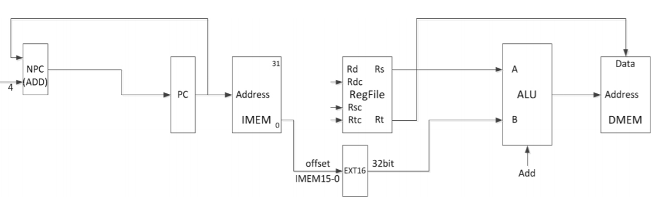

25 beq

格式：beq rs,rt,offset

操作：取指令、rs=rt,PC←NPC+Sign_ext(offset||02) 否则PC←NPC(PC+4)

所需部件：PC、NPC、IMEM、Regfile、ALU、Ext18、ADD

部件之间数据输入输出关系：

|  |  |  |  |  |  |  |  |  |  |  |
| --- | --- | --- | --- | --- | --- | --- | --- | --- | --- | --- |
|  | PC | NPC | IMEM | Rgefile | ALU | | Ext18 | ADD | | |
|  |  |  |  | Rd | A | B |  | A | | B |
| beq | ADD | PC | PC |  | rs | rt | offset | NPC | Ext18 | |

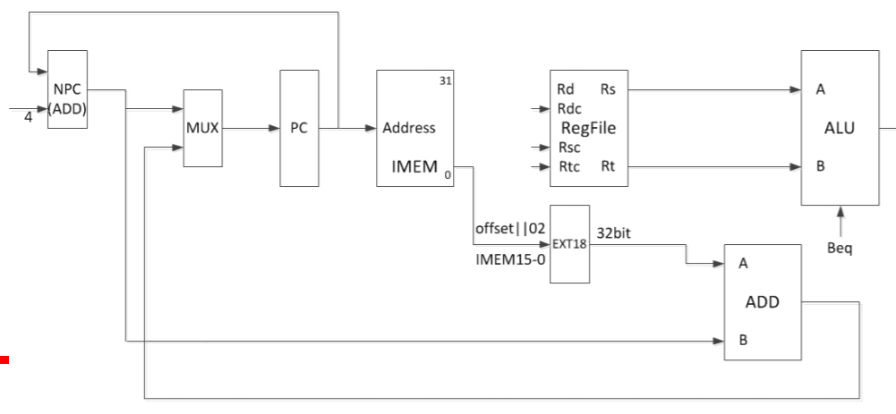

26 bne

格式：bne rs,rt,offset

操作：取指令、rs≠rt,PC←NPC+Sign_ext(offset||02 ) 否则PC←NPC(PC+4)

所需部件：PC、NPC、IMEM、Regfile、ALU、Ext18、ADD

部件之间数据输入输出关系：

|  |  |  |  |  |  |  |  |  |  |  |
| --- | --- | --- | --- | --- | --- | --- | --- | --- | --- | --- |
|  | PC | NPC | IMEM | Rgefile | ALU | | Ext18 | ADD | | |
|  |  |  |  | Rd | A | B |  | A | | B |
| bne | ADD | PC | PC |  | rs | rt | offset | NPC | Ext18 | |

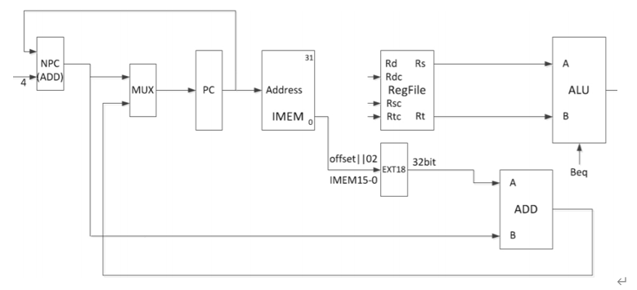

bne

27 slti

格式：slti rt, rs, imm16

操作：取指令、rt←rs<imm16(sign_extend) 、PC←NPC(PC+4)

所需部件：PC、NPC、IMEM、Regfile、ALU、Ext16

部件之间数据输入输出关系：

|  |  |  |  |  |  |  |  |
| --- | --- | --- | --- | --- | --- | --- | --- |
|  | PC | NPC | IMEM | Rgefile | ALU | | Ext16 |
|  |  |  |  | Rd | A | B |  |
| slti | NPC | PC | PC | ALU | rs | Ext16 | imm16 |

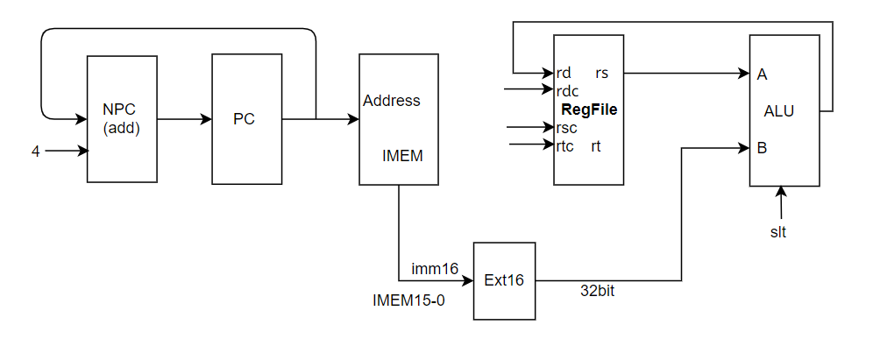

28 sltiu

格式：sltiu rt, rs, imm16

操作：取指令、rt←rs<imm16(sign_extend) 、PC←NPC(PC+4)

所需部件：PC、NPC、IMEM、Regfile、ALU、Ext16

部件之间数据输入输出关系：

|  |  |  |  |  |  |  |  |
| --- | --- | --- | --- | --- | --- | --- | --- |
|  | PC | NPC | IMEM | Rgefile | ALU | | Ext16 |
|  |  |  |  | Rd | A | B |  |
| sltiu | NPC | PC | PC | ALU | rs | Ext16 | imm16 |

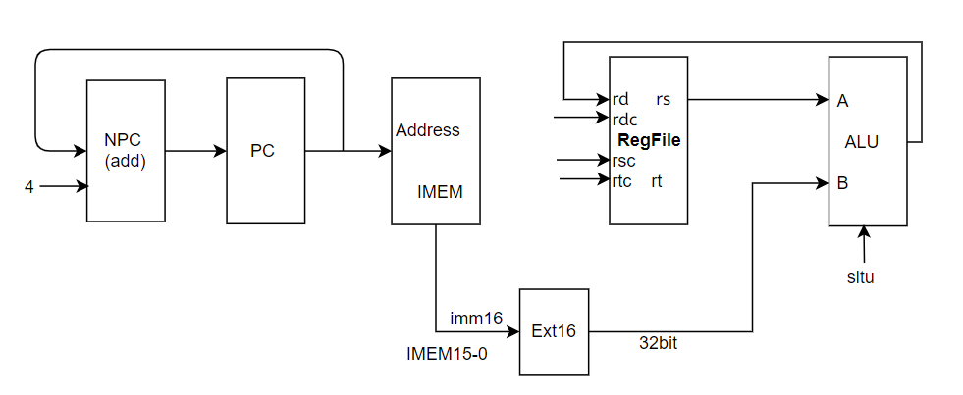

29 lui

格式：lui rt, rs, imm16

操作：取指令、rt←imm16||016 、PC←NPC(PC+4)

所需部件：PC、NPC、IMEM、Regfile、ALU、Ext16

部件之间数据输入输出关系：

|  |  |  |  |  |  |  |  |
| --- | --- | --- | --- | --- | --- | --- | --- |
|  | PC | NPC | IMEM | Rgefile | ALU | | Ext16 |
|  |  |  |  | Rd | A | B |  |
| lui | NPC | PC | PC | ALU | rs | Ext16 | imm16 |

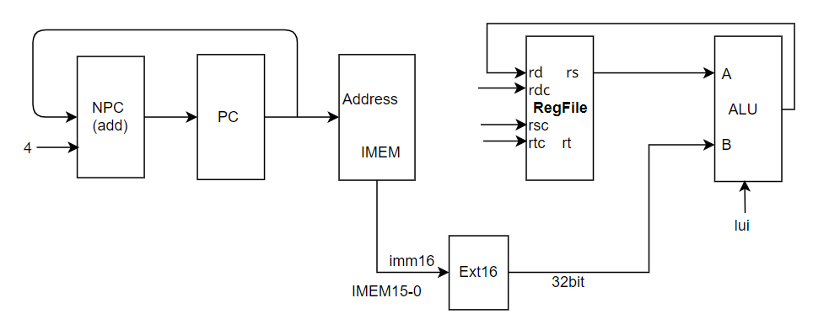

30 j

格式：j target

操作：取指令、PC←PC31-28||instr_index||02 ，PC←NPC(PC+4)

所需部件：PC、NPC、IMEM、||

部件之间数据输入输出关系：

|  |  |  |  |  |  |
| --- | --- | --- | --- | --- | --- |
|  | PC | NPC | IMEM | || | |
|  |  |  |  | A | B |
| j | || | PC | PC | PC31-28 | IMEM 25-0||02 |

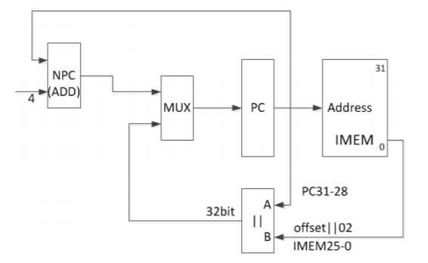

31 jal

格式：jal target

操作：取指令、PC←PC31-28||instr_index||02 ，PC←NPC(PC+4)，rd←PC+8

所需部件：PC、NPC、IMEM、||、ALU、

部件之间数据输入输出关系：

|  |  |  |  |  |  |  |  |
| --- | --- | --- | --- | --- | --- | --- | --- |
|  | PC | NPC | IMEM | || | | ALU | |
|  |  |  |  | A | B | A | B |
| jal | || | PC | PC | PC31-28 | IMEM 25-0||02 | PC | 8 |

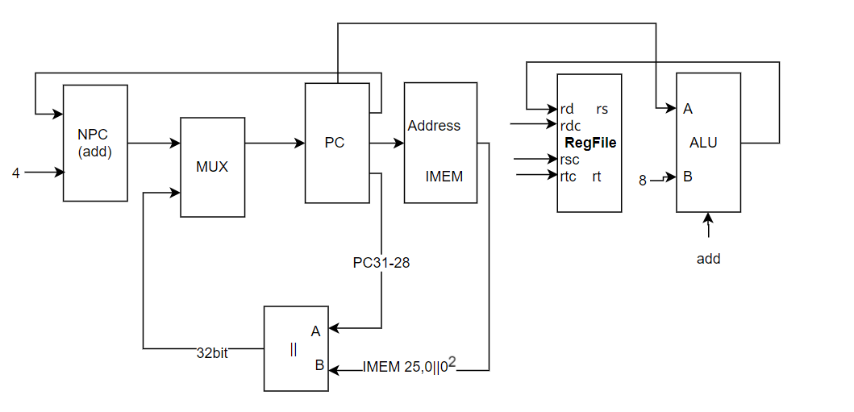

32 clz

格式：clz rd, rs

操作：取指令、rd ←count_leading_zeros (rs), PC←NPC(PC+4)

所需部件：PC、NPC、ALU、IMEM、Regfile

部件之间数据输入输出关系：

|  |  |  |  |  |
| --- | --- | --- | --- | --- |
|  | PC | NPC | IMEM | Rgefile |
|  |  |  |  | Rd |
| clz | NPC | PC | PC | count_leading_zeros (rs) |

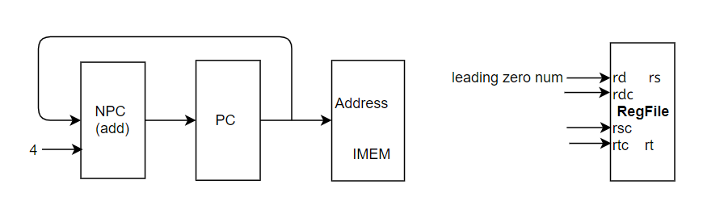

33 divu

格式：divu rs, rt

操作：取指令、(HI，LO)←(unsign)rs/rt, PC←NPC(PC+4)

所需部件：PC、NPC、DIVU、IMEM、Regfile、HI、LO

部件之间数据输入输出关系：

|  |  |  |  |  |  |  |  |
| --- | --- | --- | --- | --- | --- | --- | --- |
|  | PC | NPC | IMEM | DIVU | | HI | LO |
|  |  |  |  | dividend | divisor |  |  |
| divu | NPC | PC | PC | rs | rt | r | q |

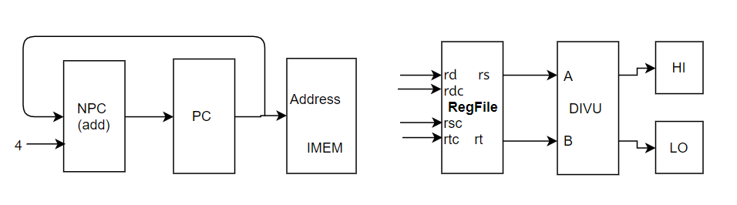

34 eret

格式：eret

操作：取指令、PC←EPC，PC←NPC(PC+4)

所需部件：PC、NPC、CP0、IMEM

部件之间数据输入输出关系：

|  |  |  |  |  |
| --- | --- | --- | --- | --- |
|  | PC | NPC | IMEM | CP0 |
|  |  |  |  | eret |
| eret | EPC | PC | PC | 1 |

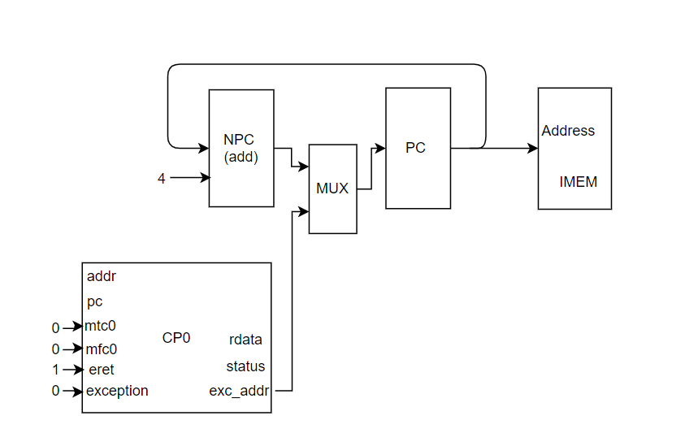

35 jalr

格式：jalr rd rs

jalr rs (rd = 31 implied)

操作：取指令、rd ← PC+8 , PC ← rs，PC←NPC(PC+4)

所需部件：PC、NPC、IMEM、Regfile

部件之间数据输入输出关系：

|  |  |  |  |  |  |  |
| --- | --- | --- | --- | --- | --- | --- |
|  | PC | NPC | IMEM | Regfile | ALU | |
|  |  |  |  | rd | A | B |
| jalr | NPC | PC | PC | ALU.r | PC | 8 |

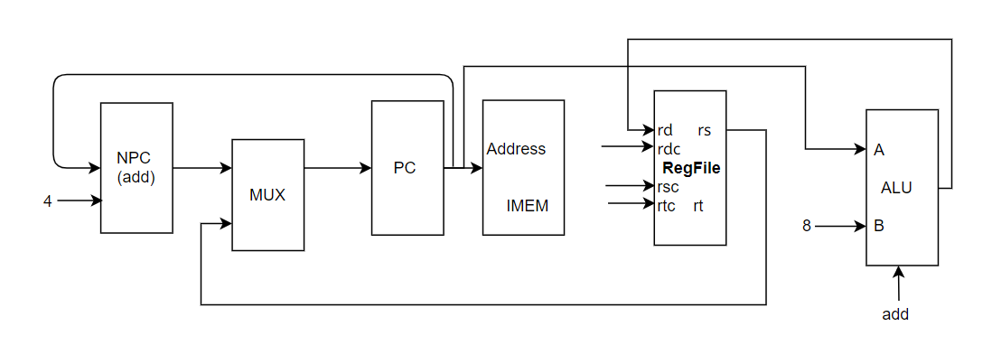

36 lb

格式：lb rt,offset(base)

操作：取指令、rt←memory[base+offset]，PC←NPC(PC+4)

所需部件：PC、NPC、IMEM、Regfile、ALU、sExt16、DMEM

部件之间数据输入输出关系：

|  |  |  |  |  |  |  |  |  |
| --- | --- | --- | --- | --- | --- | --- | --- | --- |
|  | PC | NPC | IMEM | Regfile | ALU | | DMEM | Ext16 |
|  |  |  |  | rd | A | B | Addr |  |
| lb | NPC | PC | PC | DMEM.data | rs(base) | sExt16 | ALU.r | offset  (IMEM15-0) |

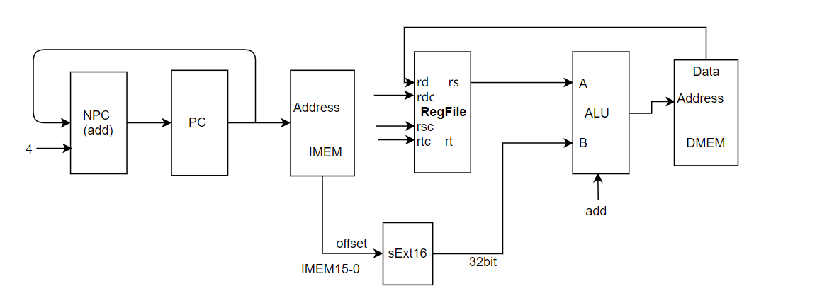

37 lbu

格式：lbu rt,offset(base)

操作：取指令、rt←memory[base+offset]，PC←NPC(PC+4)

所需部件：PC、NPC、IMEM、Regfile、ALU、sExt16、DMEM

部件之间数据输入输出关系：

|  |  |  |  |  |  |  |  |  |
| --- | --- | --- | --- | --- | --- | --- | --- | --- |
|  | PC | NPC | IMEM | Regfile | ALU | | DMEM | Ext16 |
|  |  |  |  | rd | A | B | Addr |  |
| lbu | NPC | PC | PC | DMEM.data | rs(base) | sExt16 | ALU.r | offset  (IMEM15-0) |



38 lhu

格式：lhu rt,offset(base)

操作：取指令、rt←memory[base+offset]，PC←NPC(PC+4)

所需部件：PC、NPC、IMEM、Regfile、ALU、sExt16、DMEM

部件之间数据输入输出关系：

|  |  |  |  |  |  |  |  |  |
| --- | --- | --- | --- | --- | --- | --- | --- | --- |
|  | PC | NPC | IMEM | Regfile | ALU | | DMEM | Ext16 |
|  |  |  |  | rd | A | B | Addr |  |
| lhu | NPC | PC | PC | DMEM.data | rs(base) | sExt16 | ALU.r | offset  (IMEM15-0) |



39 sb

格式：sb rt,offset(base)

操作：取指令、memory[base+offset]←rt，PC←NPC(PC+4)

所需部件：PC、NPC、IMEM、Regfile、ALU、sExt16、DMEM

部件之间数据输入输出关系：

|  |  |  |  |  |  |  |  |  |  |
| --- | --- | --- | --- | --- | --- | --- | --- | --- | --- |
|  | PC | NPC | IMEM | Regfile | ALU | | DMEM | | Ext16 |
|  |  |  |  | rt | A | B | Addr | data |  |
| sb | NPC | PC | PC | DMEM.data | rs(base) | sExt16 | ALU.r | RF.rt | offset  (IMEM15-0) |

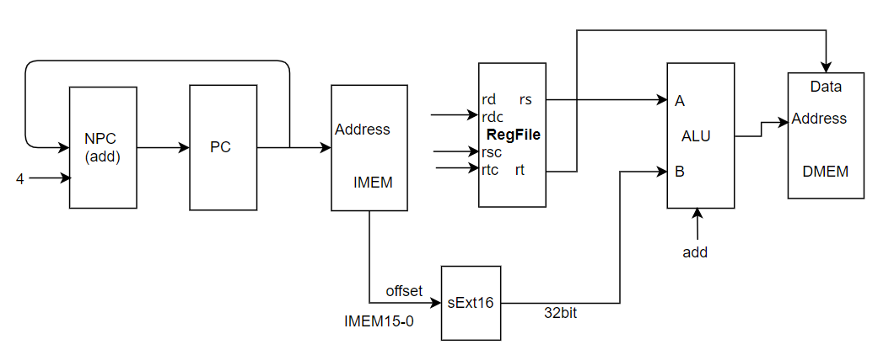

40 sh

格式：sh rt,offset(base)

操作：取指令、memory[base+offset]←rt，PC←NPC(PC+4)

所需部件：PC、NPC、IMEM、Regfile、ALU、sExt16、DMEM

部件之间数据输入输出关系：

|  |  |  |  |  |  |  |  |  |  |
| --- | --- | --- | --- | --- | --- | --- | --- | --- | --- |
|  | PC | NPC | IMEM | Regfile | ALU | | DMEM | | Ext16 |
|  |  |  |  | rt | A | B | Addr | data |  |
| sh | NPC | PC | PC | DMEM.data | rs(base) | sExt16 | ALU.r | RF.rt | offset  (IMEM15-0) |



41 lh

格式：lh rt,offset(base)

操作：取指令、rt←memory[base+offset]，PC←NPC(PC+4)

所需部件：PC、NPC、IMEM、Regfile、ALU、uExt16、DMEM

部件之间数据输入输出关系：

|  |  |  |  |  |  |  |  |  |
| --- | --- | --- | --- | --- | --- | --- | --- | --- |
|  | PC | NPC | IMEM | Regfile | ALU | | DMEM | Ext16 |
|  |  |  |  | rd | A | B | Addr |  |
| lh | NPC | PC | PC | DMEM.data | rs(base) | uExt16 | ALU.r | offset  (IMEM15-0) |



42 mfc0

格式：mfc0 rt, rd

操作：取指令、rt←CP0 rd，PC←NPC(PC+4)

所需部件：PC、NPC、CP0、IMEM、Regfile

部件之间数据输入输出关系：

|  |  |  |  |  |  |  |
| --- | --- | --- | --- | --- | --- | --- |
|  | PC | NPC | IMEM | CP0 | | Regfile |
|  |  |  |  | mfc0 | addr(Rd) | rd |
| mfc0 | NPC | PC | PC | 1 | IMEM 15-11 | CP0.rdata |

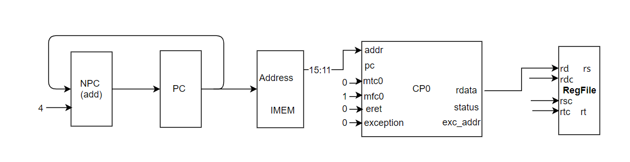

43 mfhi

格式：mfhi rd

操作：取指令、rd← HI，PC←NPC(PC+4)

所需部件：PC、NPC、HI、IMEM、Regfile

部件之间数据输入输出关系：

|  |  |  |  |  |
| --- | --- | --- | --- | --- |
|  | PC | NPC | IMEM | Regfile |
|  |  |  |  | rd |
| mfhi | NPC | PC | PC | HI |

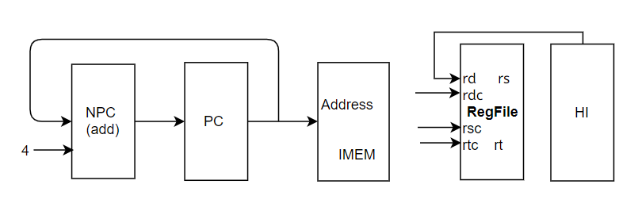

44 mflo

格式：mflo rd

操作：取指令、rd← LO，PC←NPC(PC+4)

所需部件：PC、NPC、LO、IMEM、Regfile

部件之间数据输入输出关系：

|  |  |  |  |  |
| --- | --- | --- | --- | --- |
|  | PC | NPC | IMEM | Regfile |
|  |  |  |  | rd |
| mflo | NPC | PC | PC | LO |

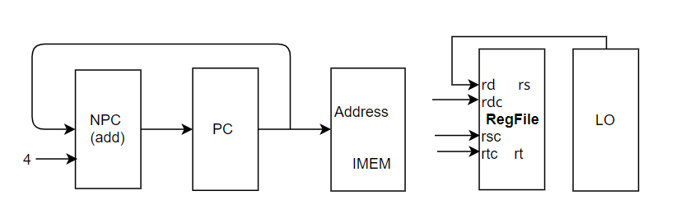

45 mtc0

格式：mtc0 rt, rd

操作：取指令、CP0 rd←rt，PC←NPC(PC+4)

所需部件：PC、NPC、CP0、IMEM、Regfile

部件之间数据输入输出关系：

|  |  |  |  |  |  |  |
| --- | --- | --- | --- | --- | --- | --- |
|  | PC | NPC | IMEM | CP0 | | |
|  |  |  |  | mtc0 | addr(Rd) | wdata |
| mtc0 | NPC | PC | PC | 1 | IMEM 15-11 | RF.rt |

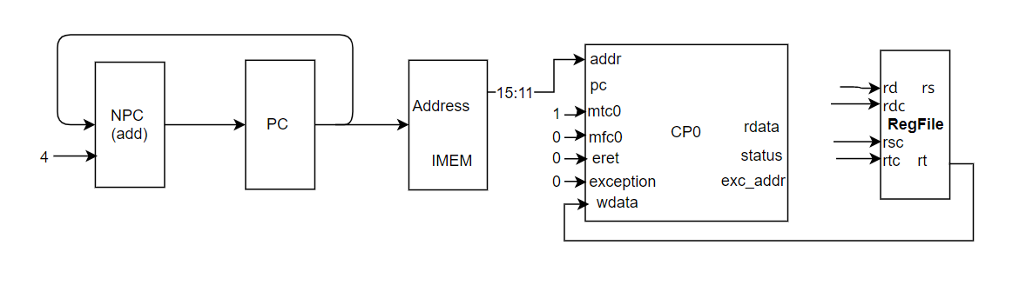

46 mthi

格式：mthi rd

操作：取指令、HI←rs，PC←NPC(PC+4)

所需部件：PC、NPC、HI、IMEM、Regfile

部件之间数据输入输出关系：

|  |  |  |  |  |
| --- | --- | --- | --- | --- |
|  | PC | NPC | IMEM | HI |
| mthi | NPC | PC | PC | RF.rs |

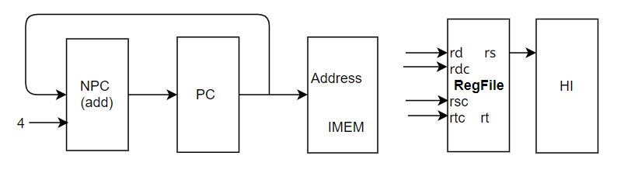

47 mtlo

格式：mtlo rd

操作：取指令、LO←rs，PC←NPC(PC+4)

所需部件：PC、NPC、LO、IMEM、Regfile

部件之间数据输入输出关系：

|  |  |  |  |  |
| --- | --- | --- | --- | --- |
|  | PC | NPC | IMEM | LO |
| mtlo | NPC | PC | PC | RF.rs |

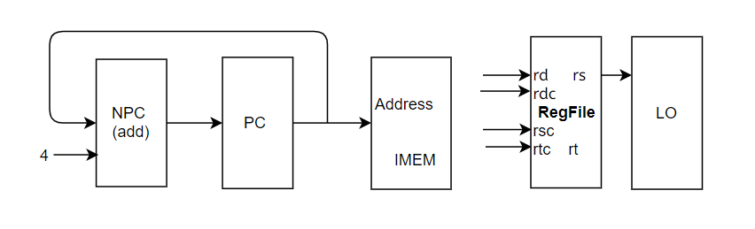

48 mul

格式：mul rd, rs, rt

操作：取指令、rd←(sign)rs*rt, PC←NPC(PC+4)

所需部件：PC、NPC、MULT、IMEM、Regfile

部件之间数据输入输出关系：

|  |  |  |  |  |  |  |
| --- | --- | --- | --- | --- | --- | --- |
|  | PC | NPC | IMEM | MULT | | Regfile |
|  |  |  |  | a | b | rd |
| div | NPC | PC | PC | rs | rt | z(lo) |

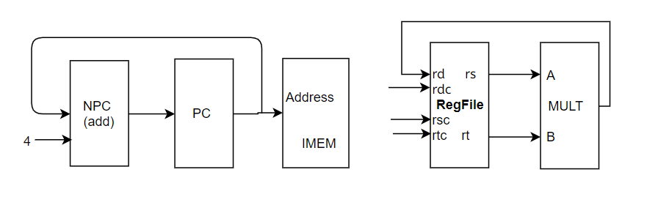

49 multu

格式：multu rs, rt

操作：取指令、(HI，LO)←(unsign)rs*rt, PC←NPC(PC+4)

所需部件：PC、NPC、MULTU、IMEM、Regfile、HI、LO

部件之间数据输入输出关系：

|  |  |  |  |  |  |  |  |
| --- | --- | --- | --- | --- | --- | --- | --- |
|  | PC | NPC | IMEM | MULTU | | HI | LO |
|  |  |  |  | a | b |  |  |
| multu | NPC | PC | PC | rs | rt | z(hi) | z(lo) |

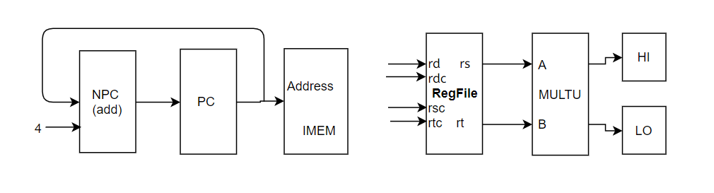

50 syscall

格式：syscall

操作：取指令、EPC←PC，cause← 01000，status<<5，PC←NPC(PC+4)

所需部件：PC、NPC、CP0、IMEM

部件之间数据输入输出关系：

|  |  |  |  |  |  |  |
| --- | --- | --- | --- | --- | --- | --- |
|  | PC | NPC | IMEM | CP0 | | |
|  |  |  |  | exception | cause | EPC |
| syscall | NPC | PC | PC | 1 | 01000 | PC |

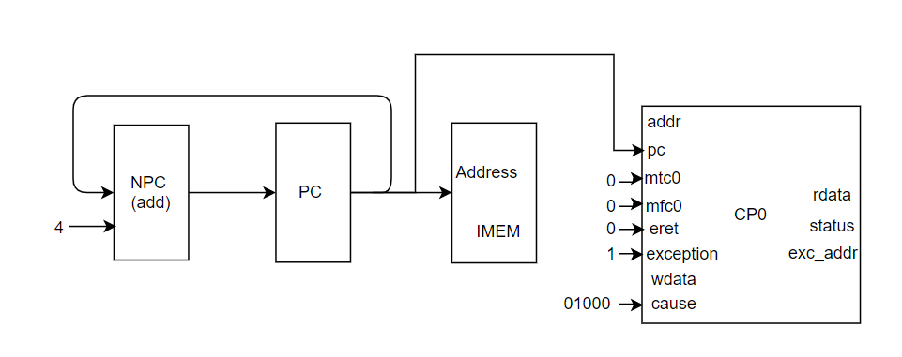

51 teq

格式：teq rs, rt

操作：取指令、rs-rt，EPC←PC , cause← 01101，status<<5，PC←NPC(PC+4)

所需部件：PC、NPC、CP0、IMEM、Regfile、ALU

部件之间数据输入输出关系：

|  |  |  |  |  |  |  |  |  |
| --- | --- | --- | --- | --- | --- | --- | --- | --- |
|  | PC | NPC | IMEM | CP0 | | | ALU | |
|  |  |  |  | exception | cause | EPC | A | B |
| teq | NPC | PC | PC | 1 | 01101 | PC | rs | rt |

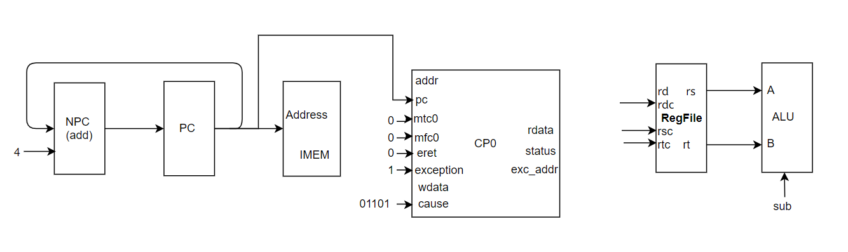

52 bgez

格式：bgez rs,offset

操作：取指令、if(rs>=0)PC←PC+Sign_ext(offset||02)

else PC←NPC(PC+4)

所需部件：PC、NPC、IMEM、sExt18

部件之间数据输入输出关系：

|  |  |  |  |  |  |  |
| --- | --- | --- | --- | --- | --- | --- |
|  | PC | NPC | IMEM | sExt18 | ALU | |
|  |  |  |  |  | A | B |
| bgez | ALU.r | PC | PC | offset||02 | rs | 0 |

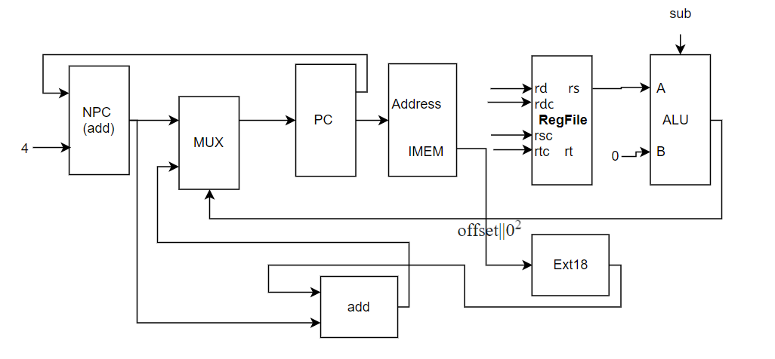

53 break

格式：break

操作：取指令、EPC←PC , cause← 01001，status<<5，PC←NPC(PC+4)

所需部件：PC、NPC、CP0、IMEM

部件之间数据输入输出关系：

|  |  |  |  |  |  |  |
| --- | --- | --- | --- | --- | --- | --- |
|  | PC | NPC | IMEM | CP0 | | |
|  |  |  |  | exception | cause | EPC |
| break | NPC | PC | PC | 1 | 01001 | PC |

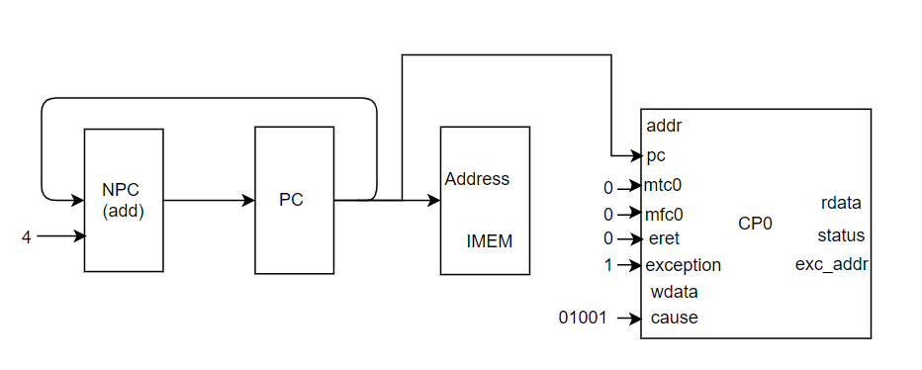

54 div

格式：div rs, rt

操作：取指令、(HI，LO)←(sign)rs/rt, PC←NPC(PC+4)

所需部件：PC、NPC、DIV、IMEM、Regfile、HI、LO

部件之间数据输入输出关系：

|  |  |  |  |  |  |  |  |
| --- | --- | --- | --- | --- | --- | --- | --- |
|  | PC | NPC | IMEM | DIV | | HI | LO |
|  |  |  |  | dividend | divisor |  |  |
| div | NPC | PC | PC | rs | rt | r | q |

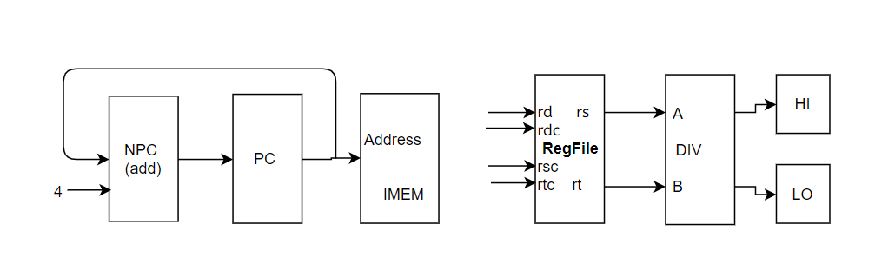

**2.2输入输出关系表**

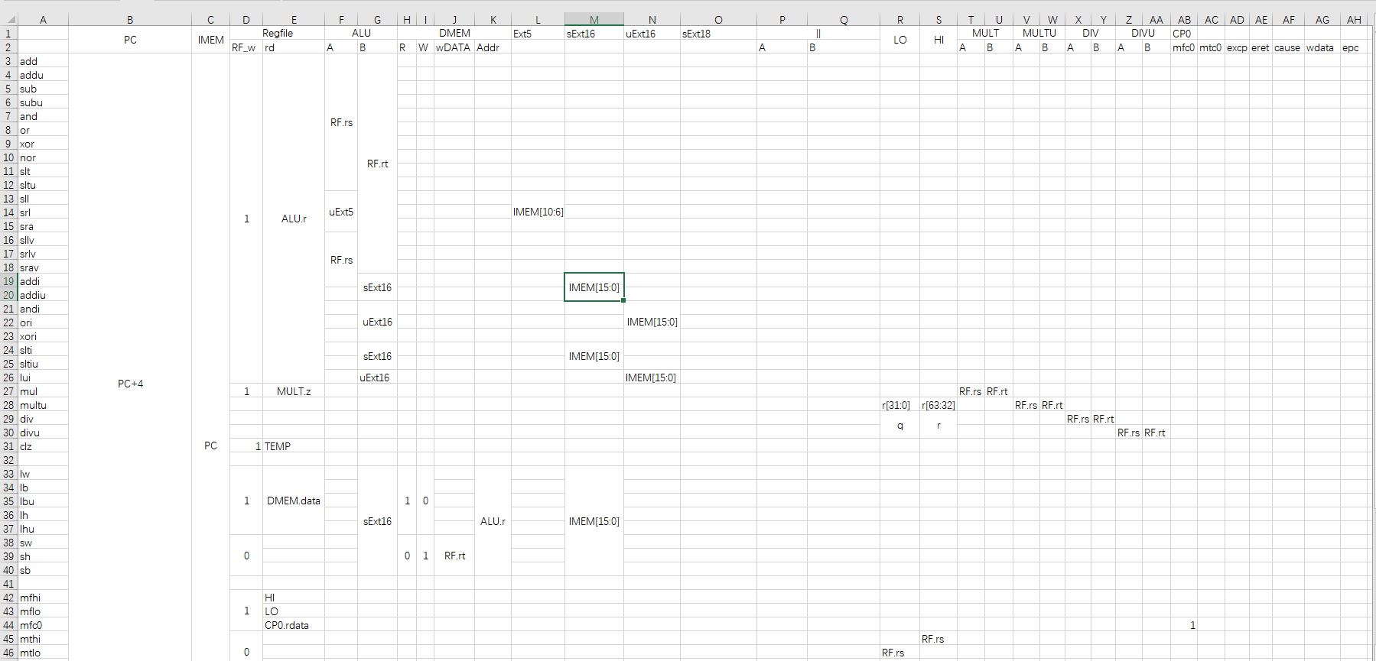

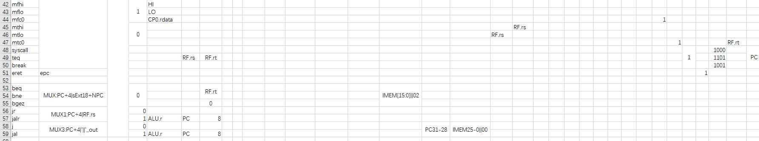

**2.3总数据通路图**

1. 模块建模

**3.1运算器模块，组合逻辑进行各类运算**

`define ALU_addu 4'b0000

`define ALU_add 4'b0010

`define ALU_subu 4'b0001

`define ALU_sub 4'b0011

`define ALU_and 4'b0100

`define ALU_or 4'b0101

`define ALU_xor 4'b0110

`define ALU_nor 4'b0111

`define ALU_lui 4'b1000

`define ALU_slt 4'b1011

`define ALU_sltu 4'b1010

`define ALU_sra 4'b1100

`define ALU_sll 4'b1110

`define ALU_srl 4'b1101

module alu(

input [31:0] a,

input [31:0] b,

input [3:0] aluc, //control

output[31:0] r, //result

output zero,

output carry,

output negative,

output overflow

);

reg [32:0] result;

wire signed [31:0] sa=a,sb=b;

always@(*)begin

case(aluc)

`ALU_addu:

result = a+b;

`ALU_add:

result = sa+sb;

`ALU_subu:

result = a-b;

`ALU_sub:

result = sa-sb;

`ALU_and:

result = a&b;

`ALU_or:

result = a|b;

`ALU_xor:

result = a^b;

`ALU_nor:

result = ~(a|b);

`ALU_lui:

result = {b[15:0], 16'b0};

`ALU_slt:

result = sa<sb? 1:0;

`ALU_sltu:

result = a<b? 1:0;

`ALU_sra: begin

if (a==0)

{result[31:0],result[32]} = {b,1'b0};

else

{result[31:0],result[32]} = sb>>>(a-1);

end

`ALU_srl: begin

if(a==0)

{result[31:0],result[32]} = {b,1'b0};

else

{result[31:0],result[32]} = b>>(a-1);

end

`ALU_sll:

result = b<<a;

default:

result = a+b;

endcase

end

assign r = result[31:0];

assign carry = result[32];

assign zero = (r==32'b0) ?1'b1:1'b0;

assign negative = result[31];

assign overflow = result[32];

endmodule

**3.2 CPU模块，调用控制器、运算器，程序计数器，寄存器，实现31条指令。**

module cpu(

input clk,

input reset,

input [31:0]inst,

input [31:0] dm_data,

output [31:0] Rt,

output [31:0] alu_r,

output [31:0] pc,

output dm_ena,

output dm_w,

output dm_r

);

wire [31:0] sExt18;

wire [31:0] sExt16,uExt16;

wire [8:0] MUX_OUT;

wire [31:0] PC,NPC,PC_TMP;

wire [31:0] PC_IN;

wire [3:0] ALUC;//alu control

wire ZF,CF,NF,OF;

wire [31:0] ALU_a,ALU_b,ALU_b_TMP;

wire RF_W; //regfiles write

wire [4:0] Rdc,Rsc,Rtc;

wire [31:0] Rs; //Rs

wire [31:0] RF_WD;

assign sExt18 = {{14{inst[15]}},{inst[15:0],2'h0}};

assign sExt16 = {{16{inst[15]}},inst[15:0]};//

assign uExt16 = {16'h0,inst[15:0]};

assign pc = PC;

assign NPC = PC + 4;

assign PC_TMP = MUX_OUT[2]? sExt18 + NPC : NPC;

assign PC_IN = MUX_OUT[1]? Rs : (MUX_OUT[0]? {PC[31:28],inst[25:0],2'b00} : PC_TMP);

assign ALU_a = MUX_OUT[4]? PC : (MUX_OUT[3]? {27'b0,inst[10:6]}: Rs);

assign ALU_b_TMP = (MUX_OUT[5]||MUX_OUT[6])? (MUX_OUT[5]? sExt16 : uExt16): Rt;

assign ALU_b = MUX_OUT[4]? 32'h4 : ALU_b_TMP;//*

assign Rsc = inst[25:21];

assign Rtc = inst[20:16];

assign Rdc = MUX_OUT[8]? inst[20:16] :(MUX_OUT[4]? 5'd31:inst[15:11]);

assign RF_WD = MUX_OUT[7]? dm_data : alu_r ;

pcreg pc_uut(

.clk(clk), .reset(reset),.ena(1'b1),

.pc_in(PC_IN),.pc_out(PC)

);

regfile cpu_ref(

.clk(clk),.rst(reset),.ena(1'b1),.we(RF_W),

.raddr1(Rsc),.rdata1(Rs),

.raddr2(Rtc),.rdata2(Rt),

.waddr(Rdc),.wdata(RF_WD)

);

alu alu_uut(

.a(ALU_a),.b(ALU_b),.aluc(ALUC),

.r(alu_r),

.zero(ZF),.carry(CF),.negative(NF),.overflow(OF)

);

cu cu_uut(

.inst(inst),.zf(ZF),.aluc(ALUC),

.mux(MUX_OUT),.rf_we(RF_W),

.dm_ena(dm_ena),.dm_w(dm_w),.dm_r(dm_r)

);

endmodule

**3.3 控制器模块，实现对CPU中各控制信号的选择控制**

module cu(

input [31:0]inst,

output [8:0]mux,

input zf,

output [3:0] aluc,

output rf_we,

output dm_ena,

output dm_w,

output dm_r

);

wire add_op, addu_op, sub_op, subu_op, and_op, or_op, xor_op, nor_op;

wire slt_op, sltu_op, sll_op, srl_op, sra_op, sllv_op, srlv_op, srav_op, jr_op;

assign add_op = (inst[31:26]==6'b000000&&inst[5:0]==6'b100000)?1'b1:1'b0;

assign addu_op = (inst[31:26]==6'b000000&&inst[5:0]==6'b100001)?1'b1:1'b0;

assign sub_op = (inst[31:26]==6'b000000&&inst[5:0]==6'b100010)?1'b1:1'b0;

assign subu_op = (inst[31:26]==6'b000000&&inst[5:0]==6'b100011)?1'b1:1'b0;

assign and_op = (inst[31:26]==6'b000000&&inst[5:0]==6'b100100)?1'b1:1'b0;

assign or_op = (inst[31:26]==6'b000000&&inst[5:0]==6'b100101)?1'b1:1'b0;

assign xor_op = (inst[31:26]==6'b000000&&inst[5:0]==6'b100110)?1'b1:1'b0;

assign nor_op = (inst[31:26]==6'b000000&&inst[5:0]==6'b100111)?1'b1:1'b0;

assign slt_op = (inst[31:26]==6'b000000&&inst[5:0]==6'b101010)?1'b1:1'b0;

assign sltu_op = (inst[31:26]==6'b000000&&inst[5:0]==6'b101011)?1'b1:1'b0;

assign sll_op = (inst[31:26]==6'b000000&&inst[5:0]==6'b000000)?1'b1:1'b0;

assign srl_op = (inst[31:26]==6'b000000&&inst[5:0]==6'b000010)?1'b1:1'b0;

assign sra_op = (inst[31:26]==6'b000000&&inst[5:0]==6'b000011)?1'b1:1'b0;

assign sllv_op = (inst[31:26]==6'b000000&&inst[5:0]==6'b000100)?1'b1:1'b0;

assign srlv_op = (inst[31:26]==6'b000000&&inst[5:0]==6'b000110)?1'b1:1'b0;

assign srav_op = (inst[31:26]==6'b000000&&inst[5:0]==6'b000111)?1'b1:1'b0;

assign jr_op = (inst[31:26]==6'b000000&&inst[5:0]==6'b001000)?1'b1:1'b0;

wire addi_op, addiu_op, andi_op, ori_op, xori_op;

wire lw_op, sw_op, beq_op, bne_op,slti_op, sltiu_op, lui_op;

assign addi_op = (inst[31:26]==6'b001000)?1'b1:1'b0;

assign addiu_op = (inst[31:26]==6'b001001)?1'b1:1'b0;

assign andi_op = (inst[31:26]==6'b001100)?1'b1:1'b0;

assign ori_op = (inst[31:26]==6'b001101)?1'b1:1'b0;

assign xori_op = (inst[31:26]==6'b001110)?1'b1:1'b0;

assign lw_op = (inst[31:26]==6'b100011)?1'b1:1'b0;

assign sw_op = (inst[31:26]==6'b101011)?1'b1:1'b0;

assign beq_op = (inst[31:26]==6'b000100)?1'b1:1'b0;

assign bne_op = (inst[31:26]==6'b000101)?1'b1:1'b0;

assign slti_op = (inst[31:26]==6'b001010)?1'b1:1'b0;

assign sltiu_op = (inst[31:26]==6'b001011)?1'b1:1'b0;

assign lui_op = (inst[31:26]==6'b001111)?1'b1:1'b0;

wire j_op, jal_op;

assign j_op = (inst[31:26]==6'b000010)?1'b1:1'b0;

assign jal_op = (inst[31:26]==6'b000011)?1'b1:1'b0;

/*------------------------------PC-----------------------------*/

assign mux[0]=jal_op||j_op;// 1 is jal | j "||", 0 is others

assign mux[1]=jr_op;//1 is jr

assign mux[2]=(beq_op & zf)||( bne_op & !zf);// 0 is pc+4, 1 is ext18 + npc

/*------------------------------ALU-----------------------------*/

assign aluc[3] = slt_op || sltu_op || sllv_op || srlv_op || srav_op || sll_op || srl_op || sra_op || slti_op || sltiu_op || lui_op ;

assign aluc[2] = and_op || or_op || xor_op || nor_op || sllv_op || srlv_op || srav_op || sll_op || srl_op || sra_op || andi_op || ori_op || xori_op ;

assign aluc[1] = add_op || sub_op || xor_op || nor_op || slt_op || sltu_op || sllv_op || sll_op || addi_op || xori_op || slti_op || sltiu_op ;

assign aluc[0] = sub_op || subu_op || or_op || nor_op || slt_op || srlv_op || srl_op || ori_op || slti_op || beq_op || bne_op ;

//select aluc_a;

assign mux[3]= sll_op || srl_op || sra_op;// 1 is sll | srl | sra, 0 is others

assign mux[4]= jal_op;//1 is jal ,0 is !(sll | srl | sra | jal)

//select aluc_b;

assign mux[5]= addi_op || addiu_op || sw_op || lw_op ||slti_op || sltiu_op ;//1 is sExt16

//assign mux[5]= addi_op || addiu_op || lw_op ||slti_op || sltiu_op ;//1 is sExt16

assign mux[6]= andi_op || ori_op || xori_op || lui_op;//1 is uExt16

//assign mux[6]= andi_op || ori_op || xori_op || lui_op || sw_op;//1 is uExt16

/*------------------------------RegFile-----------------------------*/

assign mux[7]= lw_op;//1 is lw ,0 is others

assign mux[8]= addi_op || addiu_op || lw_op || slti_op || sltiu_op || andi_op || ori_op || xori_op || lui_op;

assign rf_we = !(jr_op || beq_op || bne_op|| sw_op || j_op );

/*------------------------------DMEM-----------------------------*/

assign dm_ena = lw_op || sw_op;

assign dm_w = sw_op;

assign dm_r = lw_op;

endmodule

**3.4 数据寄存器模块**

module dmem(

input clk,

input dm_ena,

input dm_w, //write

input dm_r, //read

input [9:0] addr,

input [31:0] dm_in,

output [31:0] dm_out

);

reg [31:0] dmem_reg[1023:0];

assign dm_out=dm_ena? (dm_r? dmem_reg[addr]: 32'h00000000):32'hz;

always@(posedge clk or negedge dm_ena)

if(dm_ena && dm_w)

dmem_reg[addr]<=dm_in;

else;

endmodule

**3.5 程序计数器模块**

module pcreg(

input clk,

input reset,

input ena,

input [31:0]pc_in,

output [31:0]pc_out

);

reg [31:0] pc_reg;

always @(negedge clk or posedge reset)

if(reset)

pc_reg <= 32'h00400000;

else

pc_reg <= pc_in;

assign pc_out = ena? pc_reg : 32'hz;

endmodule

**3.6寄存器模块**

module regfile(

input clk,

input rst,

input ena,

input we,

input [4:0] raddr1,

input [4:0] raddr2,

input [4:0] waddr,

input [31:0] wdata,

output [31:0] rdata1,

output [31:0] rdata2

);

reg [31:0]array_reg[31:0];

integer i=0;

assign rdata1 = ena?array_reg[raddr1]:32'bz;

assign rdata2 = ena?array_reg[raddr2]:32'bz;

always @(posedge clk or posedge rst)

begin

if(rst==1'b1)

for(i=0;i<32;i=i+1)

array_reg[i] <= 32'b0;

else if ((ena&we)&& (waddr != 0))

array_reg[waddr] <= wdata;

else;

end

endmodule

**3.6顶层模块，调用cpu、指令寄存器、数据寄存器，实现哈佛结构**

module sccomp_dataflow(

input clk,

input reset,

output [31:0] inst,

output [31:0] pc

);

wire [31:0] imm;

wire [31:0]im_addr;

wire [31:0] Rt;

wire [31:0] alu_r;

wire [31:0]dm_addr;

wire dm_ena;

wire dm_w;

wire dm_r;

wire [31:0] dm_data;

assign inst = imm;

assign im_addr = pc- 32'h00400000;

assign dm_addr = alu_r-32'h10010000;

//imem imem(im_addr[12:2],imm);

pretest_imem imem(1'b1,im_addr[11:2],imm);

cpu sccpu (clk,reset,imm,dm_data, //input

Rt,alu_r,pc,dm_ena,dm_w,dm_r); //output

dmem dmem_uut (clk,dm_ena,dm_w,dm_r,

dm_addr[11:2],Rt,dm_data);

endmodule

1. 测试模块建模

**4.1用mars中得到的指令初始化得到的指令存储器模块**

module pretest_imem(

input im_r, //read ena

input [9:0] addr,

output reg [31:0] data_out

);

reg [31:0]mem [1023:0];

initial

begin

//文件名与路径可修改

$readmemh("C:/Users/1234/Desktop/test/random/random_code",mem);

end

always @ (*)

if(!im_r)

data_out <= 32'hz;

else

data_out <= mem[addr];

endmodule

4.2 cpu测试模块

调用顶层module sccomp_dataflow，将结果输入至文件

`timescale 1ns / 1ps

module cpu_tb;

reg clk;

reg rst;

wire [31:0]inst;

wire [31:0]pc;

sccomp_dataflow uut(clk,rst,inst,pc);

integer file_output;

integer counter = 0;

initial begin

file_output = $fopen("C:/Users/1234/Desktop/test/random/random_my_result.txt");

clk=0;

rst=1;

//wait 100ns for global reset to finish

#50

rst = 0;

end

always #3 clk=~clk;

always @(posedge clk)

begin

if(rst==0)

begin

if(counter == 500)

$fclose(file_output);

else begin

counter=counter+1;

$fdisplay(file_output, "pc: %h", pc);

$fdisplay(file_output, "instr: %h", inst);

$fdisplay(file_output,"regfile0: %h",cpu_tb.uut.sccpu.cpu_ref.array_reg[0]);

$fdisplay(file_output,"regfile1: %h",cpu_tb.uut.sccpu.cpu_ref.array_reg[1]);

$fdisplay(file_output,"regfile2: %h",cpu_tb.uut.sccpu.cpu_ref.array_reg[2]);

$fdisplay(file_output,"regfile3: %h",cpu_tb.uut.sccpu.cpu_ref.array_reg[3]);

$fdisplay(file_output,"regfile4: %h",cpu_tb.uut.sccpu.cpu_ref.array_reg[4]);

$fdisplay(file_output,"regfile5: %h",cpu_tb.uut.sccpu.cpu_ref.array_reg[5]);

$fdisplay(file_output,"regfile6: %h",cpu_tb.uut.sccpu.cpu_ref.array_reg[6]);

$fdisplay(file_output,"regfile7: %h",cpu_tb.uut.sccpu.cpu_ref.array_reg[7]);

$fdisplay(file_output,"regfile8: %h",cpu_tb.uut.sccpu.cpu_ref.array_reg[8]);

$fdisplay(file_output,"regfile9: %h",cpu_tb.uut.sccpu.cpu_ref.array_reg[9]);

$fdisplay(file_output,"regfile10: %h",cpu_tb.uut.sccpu.cpu_ref.array_reg[10]);

$fdisplay(file_output,"regfile11: %h",cpu_tb.uut.sccpu.cpu_ref.array_reg[11]);

$fdisplay(file_output,"regfile12: %h",cpu_tb.uut.sccpu.cpu_ref.array_reg[12]);

$fdisplay(file_output,"regfile13: %h",cpu_tb.uut.sccpu.cpu_ref.array_reg[13]);

$fdisplay(file_output,"regfile14: %h",cpu_tb.uut.sccpu.cpu_ref.array_reg[14]);

$fdisplay(file_output,"regfile15: %h",cpu_tb.uut.sccpu.cpu_ref.array_reg[15]);

$fdisplay(file_output,"regfile16: %h",cpu_tb.uut.sccpu.cpu_ref.array_reg[16]);

$fdisplay(file_output,"regfile17: %h",cpu_tb.uut.sccpu.cpu_ref.array_reg[17]);

$fdisplay(file_output,"regfile18: %h",cpu_tb.uut.sccpu.cpu_ref.array_reg[18]);

$fdisplay(file_output,"regfile19: %h",cpu_tb.uut.sccpu.cpu_ref.array_reg[19]);

$fdisplay(file_output,"regfile20: %h",cpu_tb.uut.sccpu.cpu_ref.array_reg[20]);

$fdisplay(file_output,"regfile21: %h",cpu_tb.uut.sccpu.cpu_ref.array_reg[21]);

$fdisplay(file_output,"regfile22: %h",cpu_tb.uut.sccpu.cpu_ref.array_reg[22]);

$fdisplay(file_output,"regfile23: %h",cpu_tb.uut.sccpu.cpu_ref.array_reg[23]);

$fdisplay(file_output,"regfile24: %h",cpu_tb.uut.sccpu.cpu_ref.array_reg[24]);

$fdisplay(file_output,"regfile25: %h",cpu_tb.uut.sccpu.cpu_ref.array_reg[25]);

$fdisplay(file_output,"regfile26: %h",cpu_tb.uut.sccpu.cpu_ref.array_reg[26]);

$fdisplay(file_output,"regfile27: %h",cpu_tb.uut.sccpu.cpu_ref.array_reg[27]);

$fdisplay(file_output,"regfile28: %h",cpu_tb.uut.sccpu.cpu_ref.array_reg[28]);

$fdisplay(file_output,"regfile29: %h",cpu_tb.uut.sccpu.cpu_ref.array_reg[29]);

$fdisplay(file_output,"regfile30: %h",cpu_tb.uut.sccpu.cpu_ref.array_reg[30]);

$fdisplay(file_output,"regfile31: %h",cpu_tb.uut.sccpu.cpu_ref.array_reg[31]);

// $fdisplay(file_output,"we: %h",cpu_tb.uut.sccpu.cpu_ref.we);

// $fdisplay(file_output,"wdata: %h",cpu_tb.uut.sccpu.cpu_ref.wdata);

// $fdisplay(file_output,"waddr: %h",cpu_tb.uut.sccpu.cpu_ref.waddr);

end

end

end

endmodule

1. 实验结果

1.前仿真测试

与Mars4_5.jr生成的result.txt文件进行一一比对，31个文件不超出标准输出的部分文本对比无误。

以addiu为例。modelsim下针对_1_addi.txt转换得到的16进制文件的实验结果：

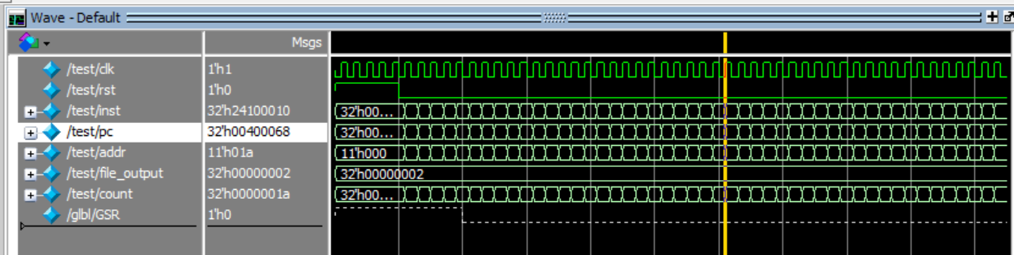

不超出标准输出的部分文本对比无误

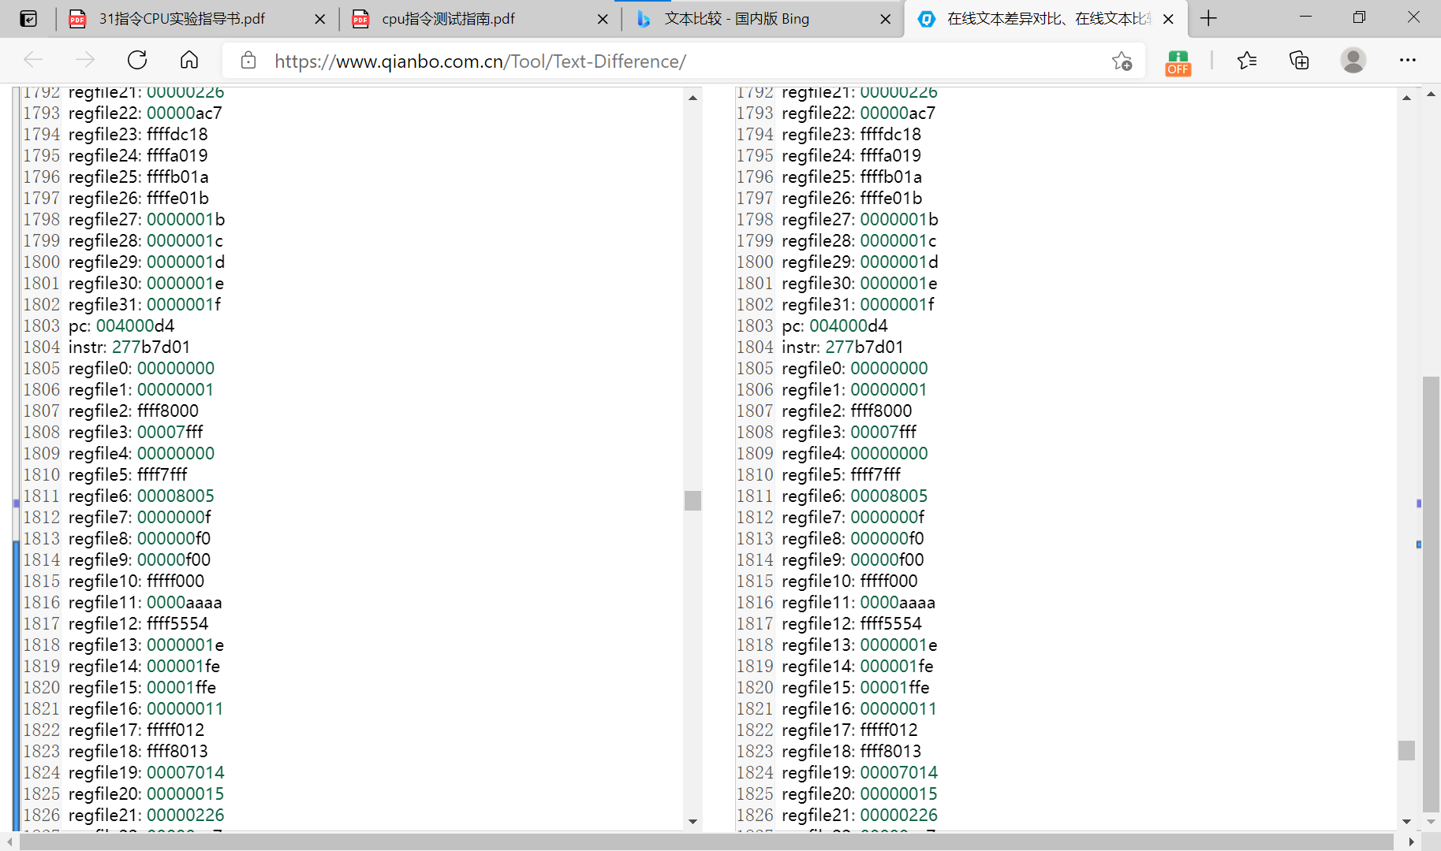

新建了测试边界的汇编程序，以addi的边界为例，实验所设计的cpu与Mars4_5.jr生成的result.txt结果一致。

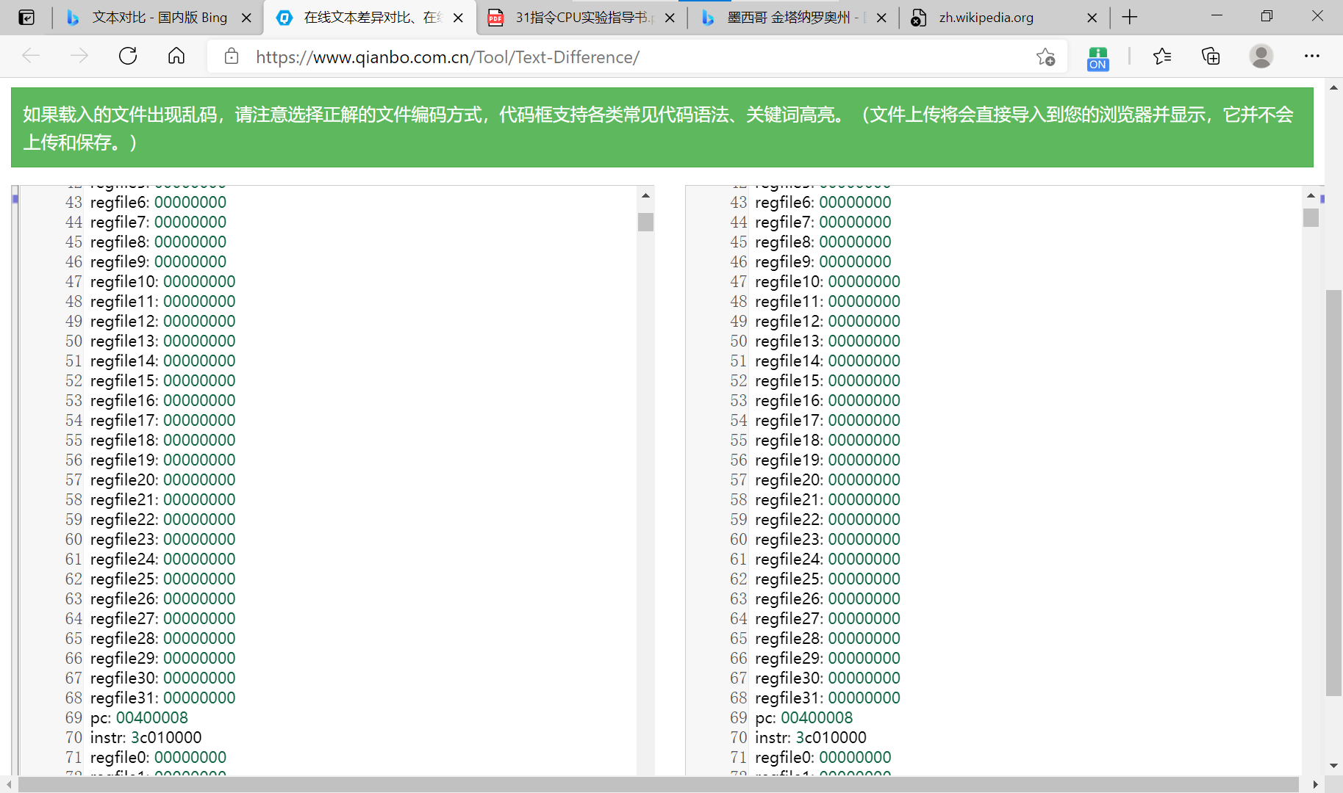

我自己编了几组数据进行测试，运行结果均正确，cpu能够通过随机数据测试。

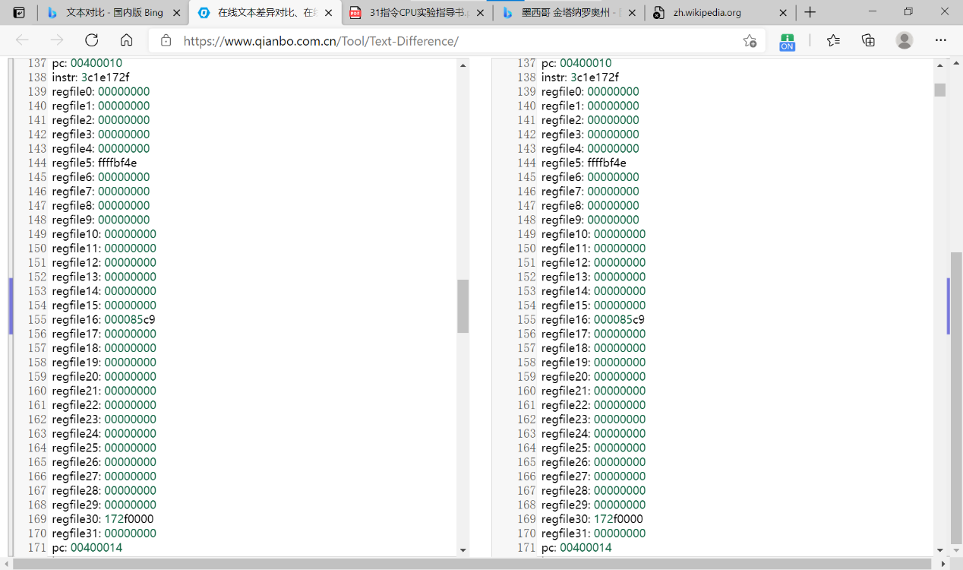

但因网站测试需要在时序上略有调整

2.后仿真测试

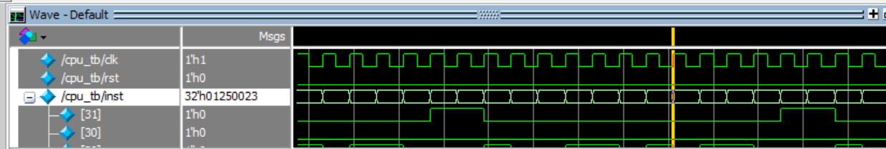

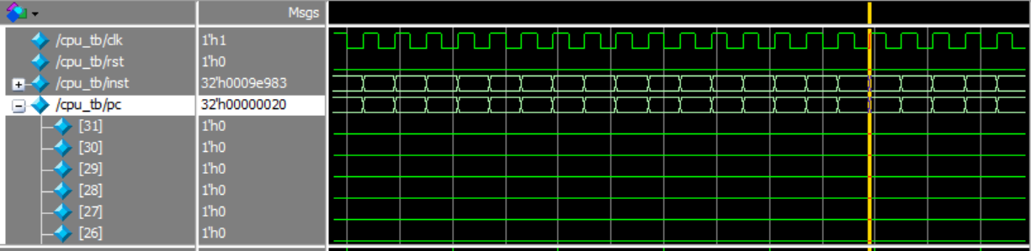

结果通过

3.下板

显示pc结果：

结果显示，下板成功