### 1. ****Opening: A Good Morning for ㄚㄚ****

* The story begins with ㄚㄚ waking up early in the morning, stretching, and getting ready for the day. She happily puts on her clothes and packs her backpack.
* **Lesson**: Start your day with a positive attitude and be prepared for the challenges ahead.

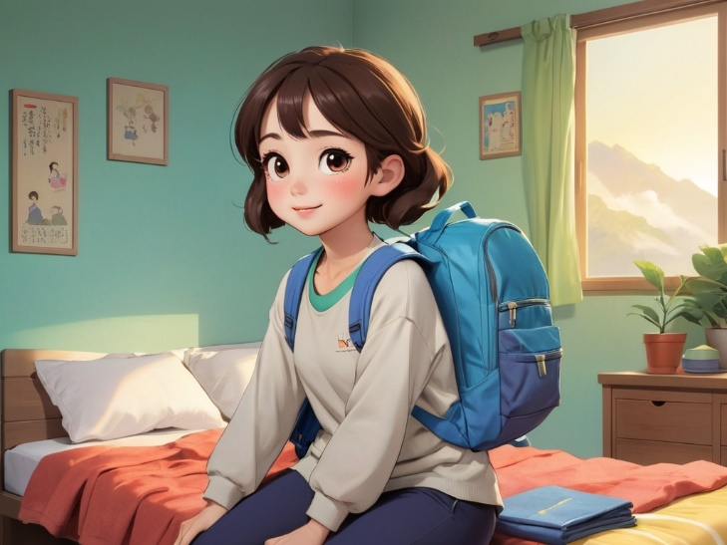

Image1

### 2. ****Exploring the New World: Discovering the Beautiful Garden****

* ㄚㄚ steps outside and finds a beautiful garden with all kinds of flowers and small animals. She decides to explore it.
* **Lesson**: Learn to appreciate the beauty around you and respect nature.

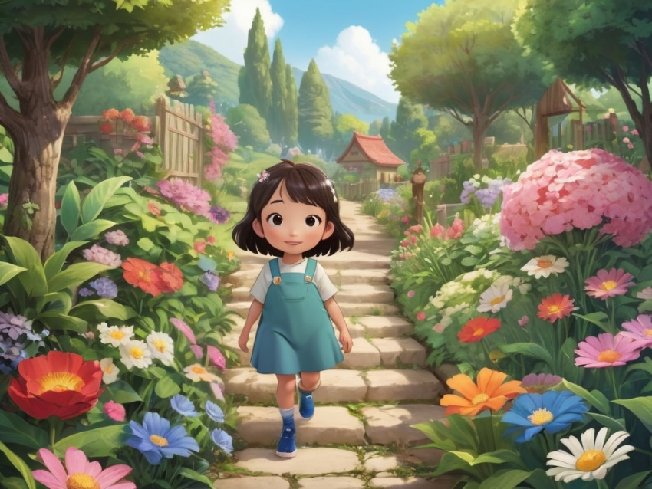

Image2

### 3. ****Helping a Small Animal: Saving a Lost Bunny****

* ㄚㄚ finds a lost bunny that looks scared. She helps the bunny find its way home and gives it some comfort.
* **Lesson**: Learn to help others, especially those who need assistance, such as animals and friends.

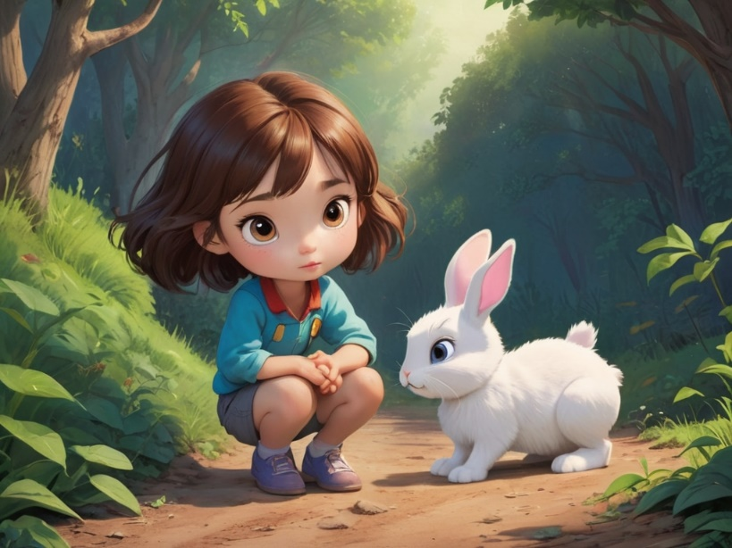

Image3

### 4. ****Learning to Share: Playing with Friends****

* ㄚㄚ meets a group of children, and they play games together. ㄚㄚ learns how to share toys and food, and everyone has fun.
* **Lesson**: Sharing makes playtime more enjoyable and strengthens friendships.

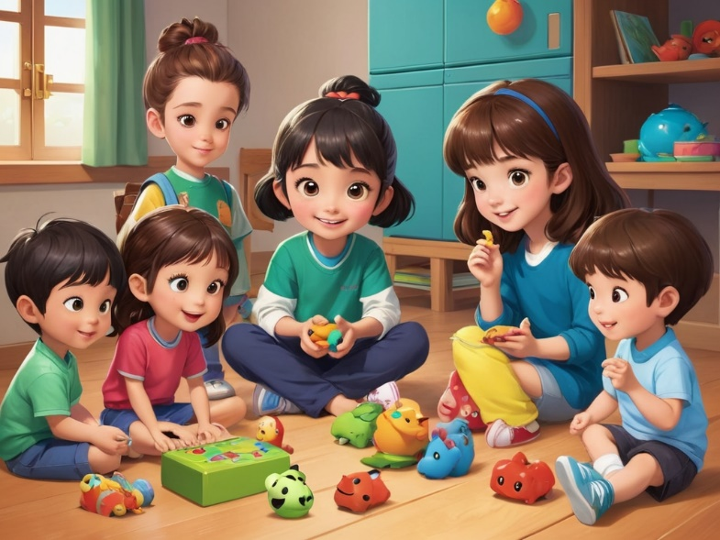

Image4

### 5. ****Solving Problems: Fixing a Broken Toy****

* ㄚㄚ's toy breaks, so she decides to try and fix it herself. After some effort, she successfully repairs the toy.
* **Lesson**: When faced with problems, don’t give up. Trying different solutions will lead to success.

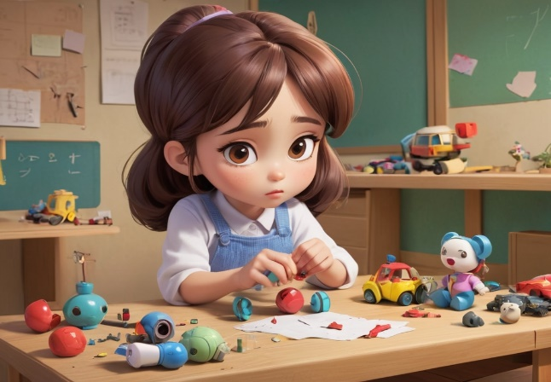

Image5

### 6. ****The Power of Friendship: Helping a Friend with Homework****

* ㄚㄚ sees her friend struggling with homework and patiently helps them work through the problems.
* **Lesson**: Helping friends builds trust and makes friendships stronger.

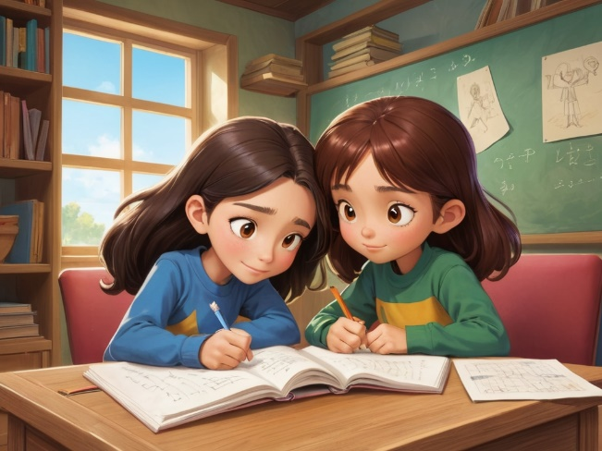

Image6

### 7. ****Learning Perseverance: Practicing Riding a Bike****

* ㄚㄚ tries to learn how to ride a bike. Although she falls a few times, she doesn’t give up and eventually learns how to ride steadily.
* **Lesson**: Learning new skills takes patience and perseverance. Failure is part of the learning process.

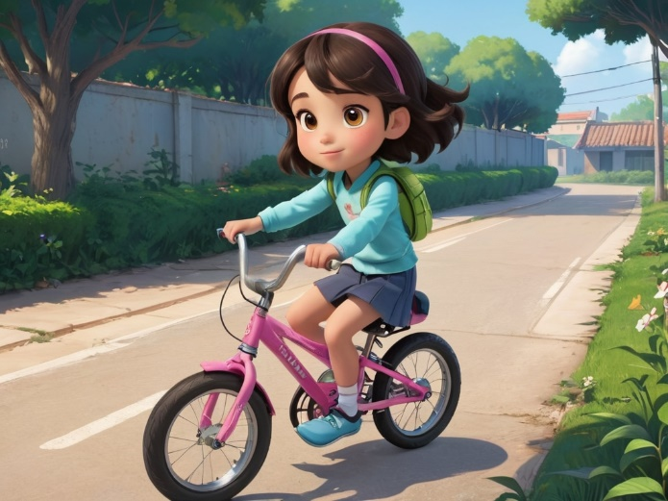

Image7

### 8. ****Gratitude: Thanking Mom for Her Help****

* After the day ends, ㄚㄚ thanks her mom for preparing a delicious dinner.
* **Lesson**: Gratitude is an important value, and we should always appreciate the people around us.

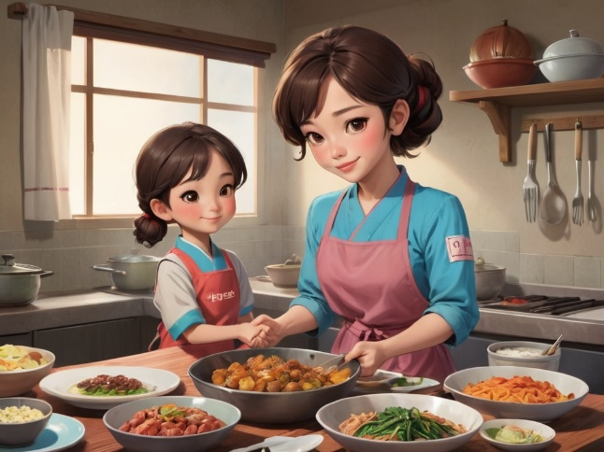

Image8

### 9. ****Helping the Community: Picking Up Trash in the Park****

* ㄚㄚ notices some trash in the park and decides to pick it up and throw it in the trash can to keep the environment clean.
* **Lesson**: Everyone should care about their surroundings and help maintain cleanliness in public spaces.

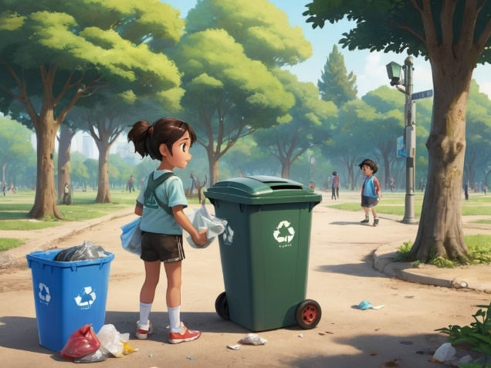

Image9

### 10. ****Ending: A Happy Bedtime Story****

* The day comes to a close, and ㄚㄚ listens to a bedtime story with her mom and dad. She feels happy and content about the day’s adventures and looks forward to tomorrow.
* **Lesson**: Reflect on the day and be thankful for the experiences, while also cultivating good bedtime habits.



Image10