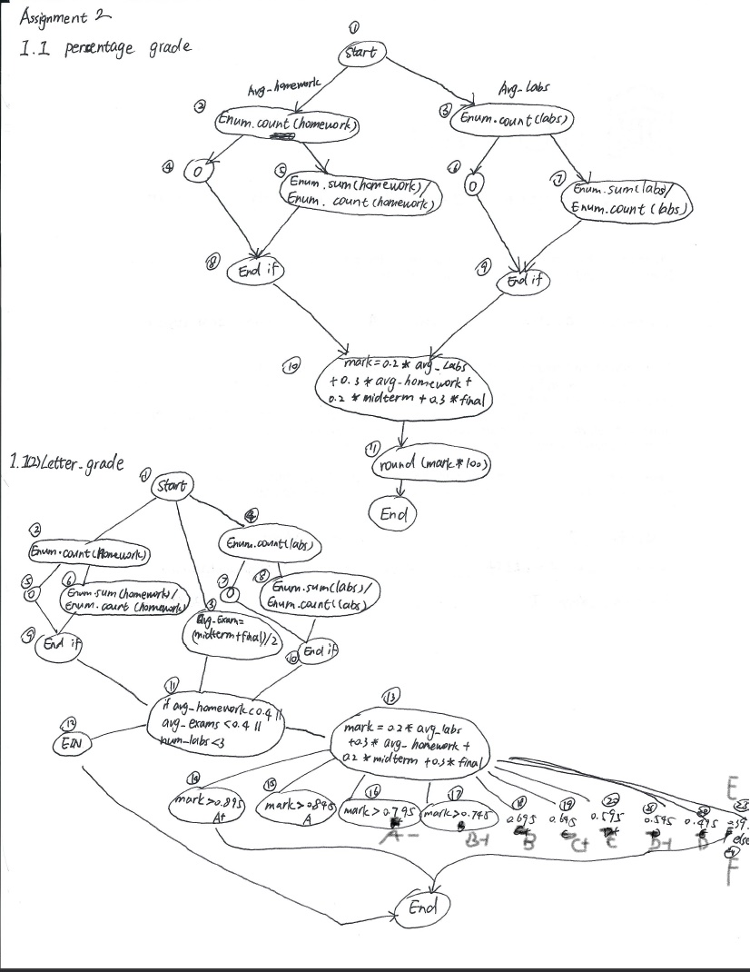

Numeric grade

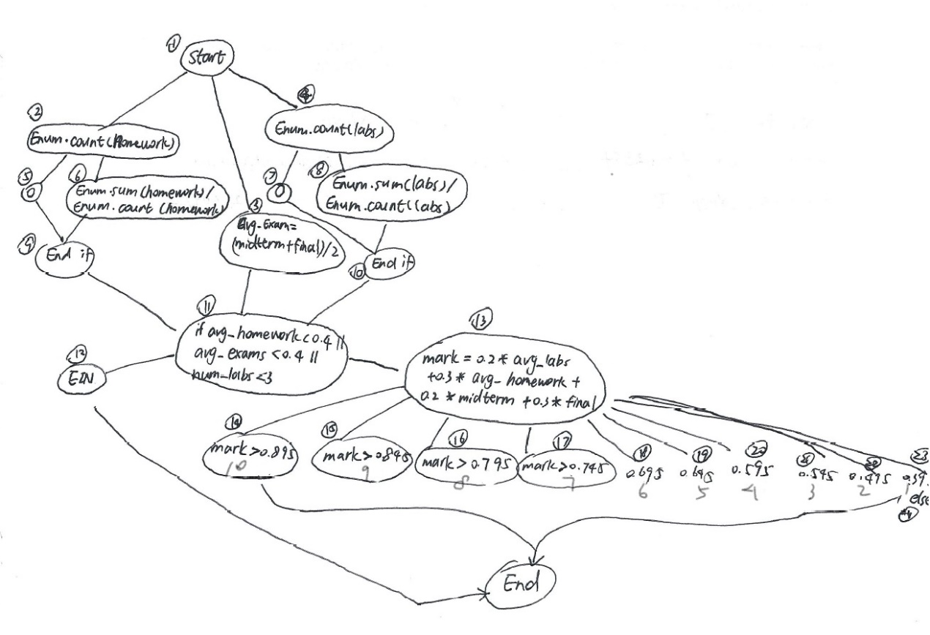

Letter grade

|  |  |  |  |  |
| --- | --- | --- | --- | --- |
| Test Case Number | Test Data | Expected results | Conditions Covered | Branches Covered |
| 1 | homework=0  labs=0 | EIN | Homework and labs are 0 | 2,5,9,11,12  4,7,10,11,12 |
| 2 | homework=0.4  labs=0.4 | F | 2,4,11,13,24 | 2,6,9,11,13,24  4,8,10,11,13,24 |
| 3 | homework=0.45  labs=0.45 | E | 2,4,11,13, | 2,6,9,11,13,23  4,8,10,11,13,23 |
| 4 | homework=0.5  labs=0.5 | D | 2,4,11,13, | 2,6,9,11,13,22  4,8,10,11,13,22 |
| 5 | homework=0.55  labs=0.55 | D+ | 2,4,11,13, | 2,6,9,11,13,21  4,8,10,11,13,21 |
| 6 | homework=0.6  labs=0.6 | C | 2,4,11,13, | 2,6,9,11,13,20  4,8,10,11,13,20 |
| 7 | homework=0.65  labs=0.65 | C+ | 2,4,11,13, | 2,6,9,11,13,19  4,8,10,11,13,19 |
| 8 | homework=0.7  labs=0.7 | B | 2,4,11,13, | 2,6,9,11,13,18  4,8,10,11,13,18 |
| 9 | homework=0.75  labs=0.75 | B+ | 2,4,11,13, | 2,6,9,11,13,17  4,8,10,11,13,17 |
| 10 | homework=0.8  labs=0.8 | A- | 2,4,11,13, | 2,6,9,11,13,16  4,8,10,11,13,16 |
| 11 | homework=0.85  labs=0.85 | A | 2,4,11,13, | 2,6,9,11,13,15  4,8,10,11,13,15 |
| 12 | homework=1  labs=1 | A+ | 2,4,11,13, | 2,6,9,11,13,14  4,8,10,11,13,14 |

Numeric grade

|  |  |  |  |  |
| --- | --- | --- | --- | --- |
| Test Case Number | Test Data | Expected results | Conditions Covered | Branches Covered |
| 1 | homework=0  labs=0 | EIN | Homework and labs are 0 | 2,5,9,11,12  4,7,10,11,12 |
| 2 | homework=0.4  labs=0.4 | 0 | 2,4,11,13,24 | 2,6,9,11,13,24  4,8,10,11,13,24 |
| 3 | homework=0.45  labs=0.45 | 1 | 2,4,11,13, | 2,6,9,11,13,23  4,8,10,11,13,23 |
| 4 | homework=0.5  labs=0.5 | 2 | 2,4,11,13, | 2,6,9,11,13,22  4,8,10,11,13,22 |
| 5 | homework=0.55  labs=0.55 | 3 | 2,4,11,13, | 2,6,9,11,13,21  4,8,10,11,13,21 |
| 6 | homework=0.6  labs=0.6 | 4 | 2,4,11,13, | 2,6,9,11,13,20  4,8,10,11,13,20 |
| 7 | homework=0.65  labs=0.65 | 5 | 2,4,11,13, | 2,6,9,11,13,19  4,8,10,11,13,19 |
| 8 | homework=0.7  labs=0.7 | 6 | 2,4,11,13, | 2,6,9,11,13,18  4,8,10,11,13,18 |
| 9 | homework=0.75  labs=0.75 | 7 | 2,4,11,13, | 2,6,9,11,13,17  4,8,10,11,13,17 |
| 10 | homework=0.8  labs=0.8 | 8 | 2,4,11,13, | 2,6,9,11,13,16  4,8,10,11,13,16 |
| 11 | homework=0.85  labs=0.85 | 9 | 2,4,11,13, | 2,6,9,11,13,15  4,8,10,11,13,15 |
| 12 | homework=1  labs=1 | 10 | 2,4,11,13, | 2,6,9,11,13,14  4,8,10,11,13,14 |