# **טכנולוגיות אינטרנט מתקדמות - 61776 (WEB)**

**הגשת פרויקט**

**<Quizzes> < B31><**16**>**

|  |  |
| --- | --- |
| **שם חבר.ת הצוות** | **תז** |
| אופיר עוזיאל | 313594699 |
| יניב בליצמן | 318261443 |
| אדם כיאל | 211584271 |
| איריס קנטר | 211566484 |

פרויקט זה הוא יישום חידון המאפשר למשתמשים ליצור ולשחק בחידונים. האפליקציה בנויה עם פרונטאנד React ובקאנד- Node.js/Express , כאשר MongoDB הוא מסד הנתונים לאחסון החידונים.

פונקציות מפתח

1. אימות משתמש:

האפליקציה כוללת מערכת התחברות פשוטה בה משתמשים יכולים להזין את שמם כדי להיכנס ולגשת לתפריט הראשי.

2. יצירת חידון:

משתמשים יכולים ליצור חידונים מותאמים אישית על ידי בחירת הקושי, הקטגוריה ומספר השאלות. לאחר מכן נשמרות השאלות שנבחרו במסד הנתונים, ומזהה חידון ייחודי נוצר לשיתוף.

3. יצירת חידונים אוטומטית:

- משתמשים יכולים ליצור חידונים על סמך קטגוריות מוגדרות מראש ורמות קושי. החידונים שנוצרו מאוחסנים במסד הנתונים, ומזהה חידון ניתן לשיתוף.

4. מענה על חידונים:

- משתמשים יכולים לענות על החידונים על ידי הזנת מזהה החידון. שאלות החידון נלקחות מהמסד נתונים, המשתמשים יכולים לענות על כל שאלה, כאשר האפליקציה עוקבת ומציגה את הניקוד שלהם.

5. סיכום חידון:

- לאחר השלמת חידון, מוצג למשתמשים סיכום של הביצועים שלהם, כולל הניקוד ומשוב מפורט על התשובות שלהם.

קישור לתיקיית גיט ציבורי: <https://github.com/OfirBraude/G16_Final>

קישור לאתר: <https://g16-client.onrender.com/>

קישור ל -:MTW <https://www.morethanwallet.com/app/880>

מהנדס מערכת -אופיר עוזיאל.

|  |  |  |
| --- | --- | --- |
| **שם חבר הצוות** | **משימות שהוקצו** | **משימות שהושלמו** |
| יניב בליצמן | תיק מתכנת | הושלם |
| אדם כיאל | תיק מתכנת | הושלם |
| אופיר עוזיאל | עדכון Usecase ותיק משתמש | הושלם |
| איריס קנטר | עדכון Usecase ותיק משתמש | הושלם |

**functional requirements:**

1.The system allows creating quizzes with multiple-choice questions.

2.The system shows the result of answering correctly in green and incorrect answers in red.

3.Automatic grading for multiple-choice questions. The system calculates the number of correct answers and displays the user's score at the end.

4.The system randomizes the order of questions.

5.The system provides an option to manually create a quiz.

6. The system provides an option to automatically generate a quiz.

**Non-functional requirement:**

1.Accessibility:The online quiz system includes features like adjustable color contrast settings. This ensures that students with visual impairments can navigate and use the system effectively.

2.Adaptability:The system supports customization for the quiz questions.

3.Backup:The system provides automatic backups of all data.

4.Boot Up Time:The system is optimized to boot up and become fully operational within 30 sec to 2 min(only in the first DB access). This quick startup ensures minimal downtime and faster access for users.

5.User-Friendliness:The system features an intuitive, easy-to-navigate interface.

הציגו ארכיטקטורה מעודכנת של האתר (תרשים הכולל את האלמנטים המרכזיים).

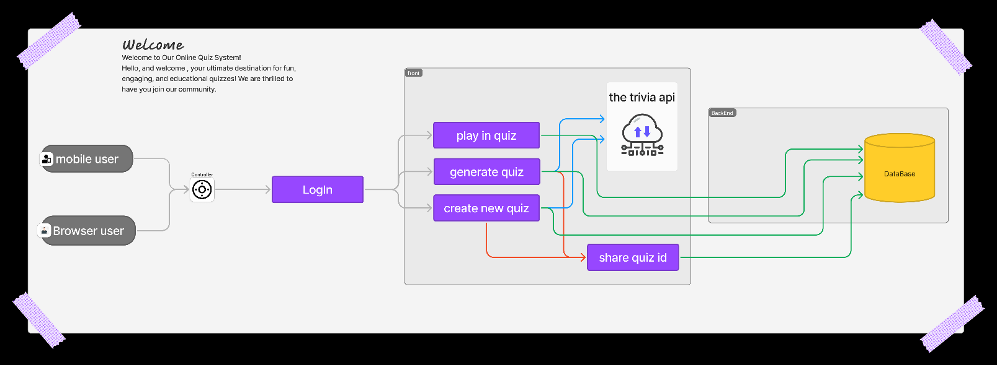

3. הציגו דיאגרמת use case המתארת את השימוש באתר.

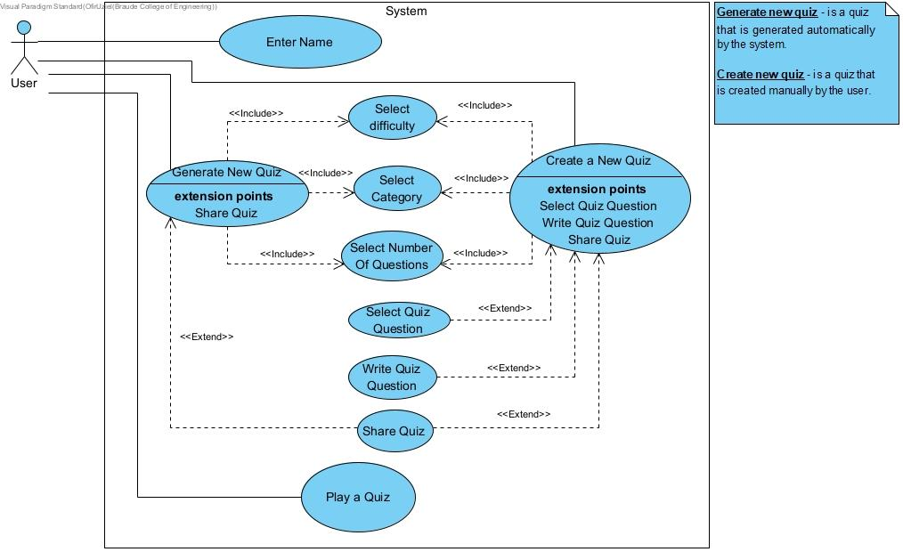

**תיק מתכנת**

**Client side:**

1. Component Documentation

**Component: `ReturnToMainMenuButton`**

JSX: ReturnToMainMenuButton.jsx

Purpose: This component renders a button that allows users to navigate back to the main menu. It is styled using a CSS module.

Key Functionality:

* The button uses React Router's `Link` component to navigate to the home route.
* The button is styled through an imported CSS module to ensure consistent appearance across the application.

CSS: ReturnToMainMenuButton.module.css

Purpose: Provides styling for the `ReturnToMainMenuButton` component.

Key Styles:

* Defines padding, background color, text color, border-radius, and hover effects for the button to ensure it stands out as an interactive element.

**Component: `QuizDisplay`**

JSX: QuizDisplay.jsx

Purpose: This component displays a quiz question along with multiple-choice options. Users can select an answer and submit it.

Key Functionality:

* The component takes in props for the question, options, selected answer, and event handlers for answer selection and form submission.
* It renders the quiz question and maps through the options to display each one as a clickable list item.
* The selected answer is highlighted, and the submit button is disabled until an answer is selected.

CSS: QuizDisplay.module.css

Purpose: Provides styling for the `QuizDisplay` component.

Key Styles:

* Styles the container, question text, answer options, and submit button.
* Includes responsive design elements and hover effects to enhance user interaction.

**Component: `Login`**

JSX: Login.jsx

Purpose: Handles user authentication by allowing users to enter their name and log in.

Key Functionality:

* Uses a custom hook (`useLogin`) to manage the state of the login form, including the entered name.
* On form submission, the entered name is passed to a function to handle the login process.

JS: useLogin.js

Purpose: Custom hook to manage the login state and logic.

Key Functionality:

* Manages the state for the user's name and handles changes and form submission.
* Calls the `onLogin` function with the user's name upon successful form submission.

CSS: Login.module.css

Purpose: Provides styling for the `Login` component.

Key Styles:

* Styles the login container, form, input fields, and submit button.
* Ensures that the design is responsive and visually appealing in both light and dark modes.

**Component: `MainMenu`**

JSX: MainMenu.jsx

Purpose: Acts as the central navigation point in the application, providing options to navigate to different sections like playing, generating, or creating quizzes.

Key Functionality:

* Uses a custom hook (`useMainMenu`) to manage navigation based on the button clicked.
* Dynamically displays a welcome message with the user's name and presents buttons for various actions.

JS: useMainMenu.js

* Purpose: Custom hook to manage navigation from the main menu.

Key Functionality:

* Provides a function (`handleNavigation`) that programmatically navigates to different routes within the application using React Router's `useNavigate`.

CSS: MainMenu.module.css

Purpose: Provides styling for the `MainMenu` component.

Key Styles:

* Styles the main menu container, options form, buttons, and headings.
* Includes responsive design elements and hover effects for interactive buttons.

**Component: `Header`**

JSX: Header.jsx

Purpose: Renders the application's header, containing a main menu button on the left and a theme toggle button on the right.

Key Functionality:

* The header is fixed at the top of the page and includes a button to toggle between light and dark modes.
* The theme toggle button text dynamically changes based on the current theme.

CSS: Header.module.css

Purpose: Provides styling for the `Header` component.

Key Styles:

* Styles the header container, buttons, and ensures the layout is responsive.
* - Includes hover effects for buttons and media queries for better usability on different screen sizes.

**Component: `QuizSummary`**

JSX: QuizSummary.jsx

Purpose: Displays the quiz results, including the user's score and a summary of their answers.

Key Functionality:

* Uses a custom hook (`useQuizSummary`) to retrieve quiz data and handle navigation back to the home page.
* Renders a detailed summary of each question, showing whether the user's answer was correct or incorrect.

JS: useQuizSummary.js

Purpose: Custom hook to manage the quiz summary logic, including navigation and data retrieval.

Key Functionality:

* Retrieves quiz questions, user answers, and the score from the location state.
* Provides a function to navigate back to the home page.

CSS: QuizSummary.module.css

Purpose: Provides styling for the `QuizSummary` component.

Key Styles:

* Styles the summary container, score text, question items, and navigation buttons.
* Includes specific styles for correct and incorrect answers to visually differentiate them.

**Component: `EnterQuizId`**

JSX: EnterQuizId.jsx

Purpose: Allows users to enter a quiz ID to start a quiz, handling validation and error handling.

Key Functionality:

* Uses a custom hook (`useFetchQuiz`) to fetch the quiz data based on the entered ID.
* If the quiz is found, the user is navigated to the quiz play screen; otherwise, an error message is shown.

JS: useFetchQuiz.js

Purpose: Custom hook to fetch quiz data based on the provided quiz ID.

Key Functionality:

* Sends a GET request to the backend API to retrieve quiz data by ID.
* Manages loading and error states, providing feedback to the user if the quiz is not found or if an error occurs.

CSS: EnterQuizId.module.css

Purpose: Provides styling for the `EnterQuizId` component.

Key Styles:

* Styles the container, form, input fields, and submit button.
* Includes responsive design and transitions for interactive elements.

**Component: `PlayQuiz`**

JSX: PlayQuiz.jsx

Purpose: Enables users to play a quiz fetched from the backend, displaying each question one at a time and calculating the final score.

Key Functionality:

* Uses a custom hook (`useQuiz`) to fetch quiz questions and manage state for playing the quiz.
* Handles user interactions, such as selecting answers and moving to the next question, while calculating the score in real-time.

JS: useQuiz.js

Purpose: Custom hook to fetch quiz data and manage the state for playing the quiz.

Key Functionality:

* Fetches quiz data from the backend and shuffles the answer options to ensure randomness.
* Manages user interactions, score calculation, and navigation to the quiz summary screen after the quiz is completed.

CSS: PlayQuiz.module.css

Purpose: Provides styling for the `PlayQuiz` component.

Key Styles:

* Styles the quiz container, question text, answer options, and navigation buttons.
* Includes responsive design and hover effects for a better user experience.

**Component: `CreateQuiz`**

JSX: CreateQuiz.jsx

Purpose: Allows users to create a custom quiz by selecting difficulty, category, and the number of questions. The selected questions are saved to the backend, and a Quiz ID is generated.

Key Functionality:

* Uses a custom hook (`useCreateQuiz`) to manage the state of quiz creation, including fetching categories and questions, and saving the quiz.
* The component provides a step-by-step interface for creating the quiz and generates a unique Quiz ID for sharing.

JS: useCreateQuiz.js

Purpose: Custom hook to handle the state and logic for creating a quiz.

Key Functionality:

* Manages the state for quiz difficulty, category, number of questions, and selected questions.
* Fetches categories and questions from The Trivia API, and saves the created quiz to the backend.
* Provides functions to handle question selection, form submission, and copying the generated Quiz ID.

CSS: CreateQuiz.module.css

Purpose: Provides styling for the `CreateQuiz` component.

Key Styles:

* Styles the form container, input fields, buttons, and question list.
* Includes responsive design and hover effects, as well as loading indicators for better user feedback.

**Component: `GenerateQuiz`**

JSX: GenerateQuiz.jsx

Purpose: Allows users to generate a quiz by selecting difficulty, category, and the number of questions. The generated quiz is saved on the backend, and a shareable Quiz ID is provided.

Key Functionality:

* Uses a custom hook (`useGenerateQuiz`) to manage the state of quiz generation, including fetching categories and questions, and saving the quiz.
* Provides a simple interface for generating the quiz and copying the Quiz ID.

JS: useGenerateQuiz.js

Purpose: Custom hook to handle the state and logic for generating a quiz.

Key Functionality:

* Manages the state for quiz difficulty, category, number of questions, and the generated quiz.
* Fetches categories from The Trivia API and generates a quiz based on user selections.
* Provides functions for submitting the form, handling errors, and copying the Quiz ID.

CSS: GenerateQuiz.module.css

Purpose: Provides styling for the `GenerateQuiz` component.

Key Styles:

* Styles the form container, input fields, buttons, and generated quiz display.
* Includes responsive design, loading indicators, and animations to enhance user experience.

**Server-Side Components**

**File: `server.js`**

Purpose:

* The main entry point for the server-side application, responsible for setting up the Express server, configuring middleware, and establishing a connection to the MongoDB database.

Key Functionality:

Express Server Setup:

* Creates an Express application and configures it to listen on a specified port (default: 5000).
* Configures middleware to handle JSON requests and manage Cross-Origin Resource Sharing (CORS) to allow requests from the frontend.

MongoDB Connection:

* Connects to a MongoDB database using the connection string from environment variables (`MONGO_URI`).
* Logs the connection status to the console.

Routes:

* Sets up the main API routes by importing and using the `quizRoutes` module to handle quiz-related operations.

Default Route:

* Defines a basic route (`/`) to ensure the server is running.

**File: `quizRoutes.js`**

Purpose:

* Defines and handles the API routes related to quizzes, including creating new quizzes, retrieving quizzes by ID, and optionally retrieving all quizzes.

Key Functionality:

* Creating a New Quiz (`POST /api/quizzes/create`):

1. Generates a unique quiz ID using the `uuid` library.
2. Validates the request to ensure that the `questions` array is provided.
3. Saves the quiz to the MongoDB database using the `Quiz` model.
4. Responds with the generated quiz ID or an error if the creation fails.

* Retrieving a Quiz by ID (`GET /api/quizzes/:quizId`):

1. Fetches a quiz from the database based on the provided `quizId`.
2. Responds with the quiz data if found, or an error if not found.

File: `Quiz.js`

Purpose:

* Defines the Mongoose schema and model for quizzes, specifying the structure of quiz documents stored in the MongoDB database.

Key Functionality:

* Mongoose Schema:

1. `quizId`: A unique identifier for each quiz, stored as a string and required.
2. `questions`: An array of objects, each representing a question with the following fields:
3. `question`: The text of the question.
4. `correctAnswer`: The correct answer for the question.
5. `incorrectAnswers`: An array of incorrect answers.
6. `createdAt`: A timestamp indicating when the quiz was created, with a default value of the current date and time.

* Mongoose Model:

1. Exports the `Quiz` model, which allows the application to interact with the `quizzes` collection in MongoDB.

2. APIs, Database, and Environment Setup

**APIs Used:**

* Backend API:

Purpose: The server-side API handles all quiz-related operations, including creating and retrieving quizzes.

* Endpoint Examples:

1. `POST /api/quizzes/create`: Creates a new quiz and stores it in the database.
2. `GET /api/quizzes/:quizId`: Retrieves a quiz by its unique ID.
3. `GET /api/quizzes`: Optionally retrieves all quizzes stored in the database.

* The Trivia API:

Purpose: Fetching quiz categories and questions for creating or generating quizzes.

Endpoint Examples:

1. `https://the-trivia-api.com/api/categories` - Fetches available categories.
2. `https://the-trivia-api.com/api/questions` - Fetches quiz questions based on selected parameters.

* Backend API:

Purpose: Interacting with the backend for storing and retrieving quizzes.

Endpoint Examples:

1. `/api/quizzes/create` - Saves a new quiz and generates a Quiz ID.
2. `/api/quizzes/{quizId}` - Retrieves a quiz based on the Quiz ID.

Database:

* MongoDB:

Purpose: Storing quiz data, including questions, answers, and user scores.

Link to DB: MongoDB is hosted on a cloud service like MongoDB Atlas, accessible via the backend API. The exact connection string would be set in the environment variables (e.g., `MONGO_URI`).

Environment Setup:

* Vite:

Purpose: A fast build tool and development server. Used for managing environment variables and optimizing the development experience.

Special Environment Variables:

1. `VITE_API_URL`: The base URL for the backend API.

Installation:

1. Installed via npm as part of the development dependencies (`npm install vite`).

* Node.js and Express:

Purpose: Used to build the backend API that interacts with the MongoDB database.

Installation:

1. Installed via npm (`npm install express mongoose`).

פרומפטים שהשתמשנו בהם עם CHATGPT:

1. Can you suggest animations or transitions to make the quiz more interactive?
2. How can I implement a custom theme for the entire application?
3. The frontend is not displaying the quiz questions correctly. How can I fix this?
4. I'm getting an error when trying to fetch a quiz by ID. Can you help me debug it?
5. How do I configure environment variables for different environments in this project?

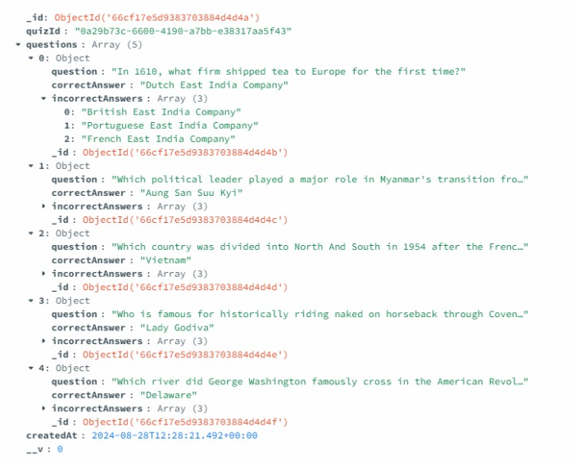Example of quiz in the DB:

**תיק למשתמש**

בשלב הראשון נכניס את השם שלנו ונלחץ login :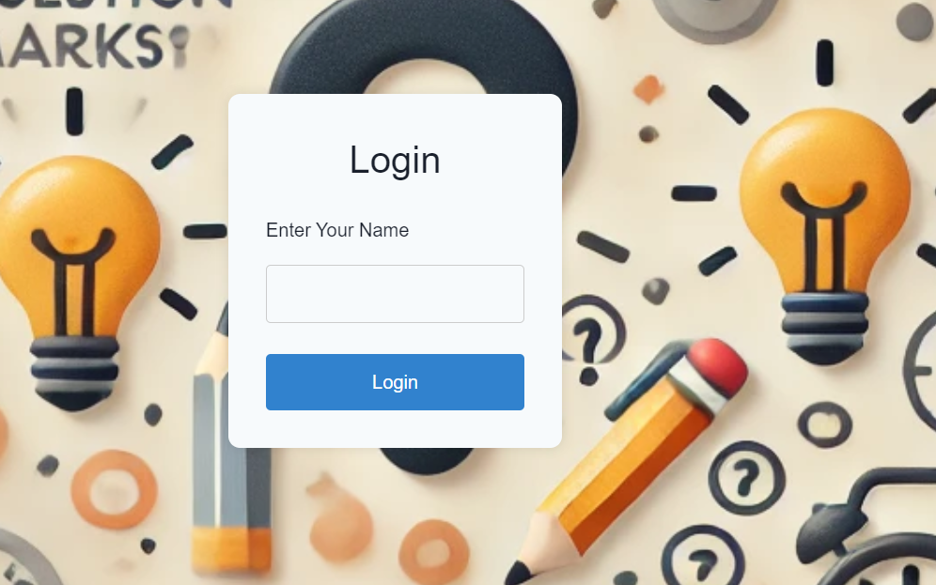

_________________________________________________________________________

בשלב השני נבחר את אחת מ שלושת אופציות:

1) לשחק בקוויז (לא ניתן לבחור באופציה הזאת בהתחלה נבחר בה רק אחרי שיצרנו QUIZ (רק אחרי generate quiz או create quiz))

2) לתת למחשב את האופציה ליצור לנו את השאלות בצורה אוטומטית,

3) לבחור את השאלות שאנחנו רוצים מהשאלות שמציע המחשב.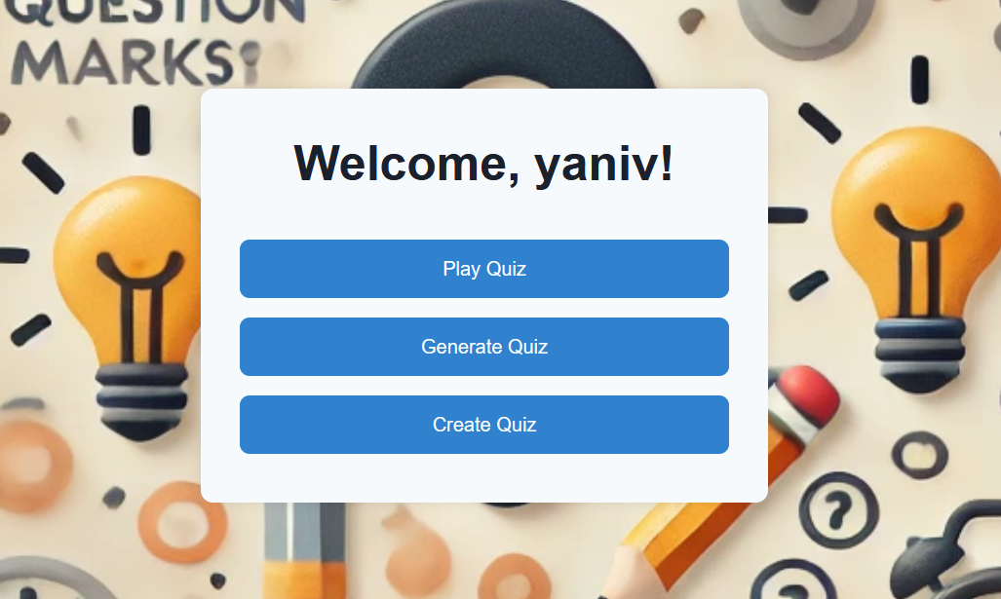

_________________________________________________________________________

בלחיצה על generate נקבל את המסך הבא:

* נבחר את רמת השאלות
* קטגוריה שאנחנו מעוניינים
* כמות השאלות
* נלחץ על generate Quiz

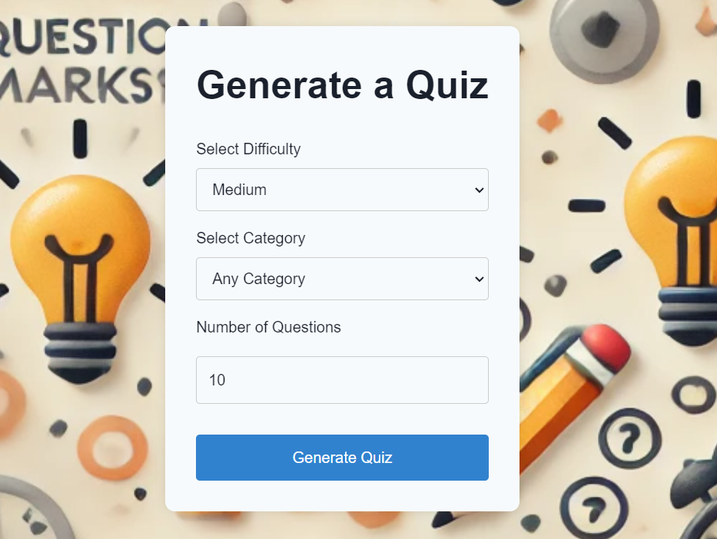

_________________________________________________________________________

* שלב הבא אנחנו נקבל חלון עם השאלות שהQUIZ אוטומטית יצר עבורנו .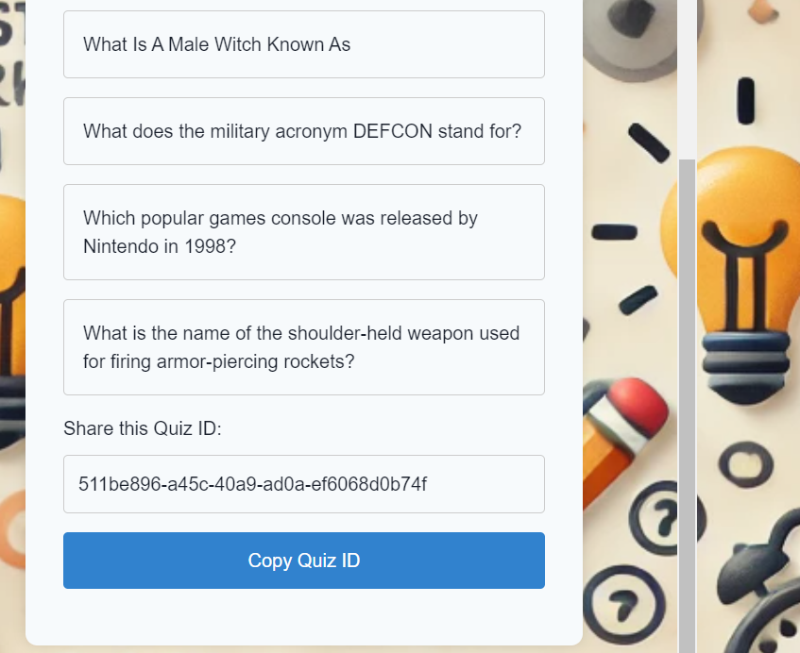
* נלחץ על copy quiz id
* נלחץ על הכפתור Main menu שנמצא בבר למעלה.

הסבר על הבר שנמצא למעלה:



Main menu- (מחזיר אותנו למסך הראשי (שלב 2

Switch to DarkMode- משנה את הצבעים באתר מבהירים לכהים

_________________________________________________________________________

* כדי לשחק בquiz שיצרנו נלחץ על כפתור הplayQuiz
* נדביק לשם את הלינק בquiz id ונלחץ על start quiz

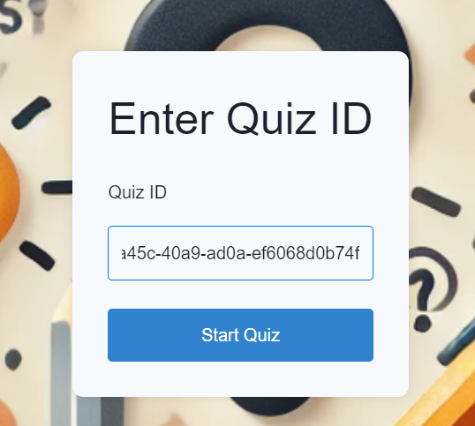

* נענה על הquiz ולבסוף נקבל את התוצאות שבהם יהיה מופרט איזה מהשאלות ענינו נכון והיכן טעינו ומה הייתה התשובה הנכונה.

_________________________________________________________________________

נסביר על create quiz:

* נלחץ על create a quiz
* נבחר את רמת הקושי , את הקטגוריה, כמות השאלות
* נלחץ Fetch questions

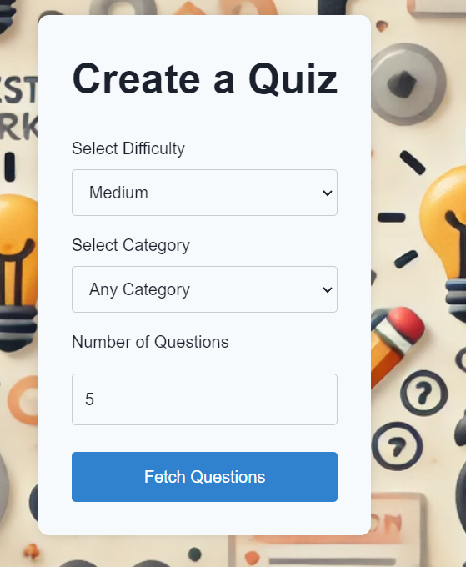

_________________________________________________________________________

נקבל את רשימת השאלות

נבחר את השאלות שאנחנו מעוניינים בהם

שאלה שנבחרה תסומן בכחול , נשים לב שלא נוכל לבחור יותר שאלות או פחות מאשר כמות השאלות הגדרנו במסך הקודם במסך הקודם.

איך נדע שהגענו לכמות הנכונה?- לא נוכל יותר לסמן שאלות חדשות בכחול.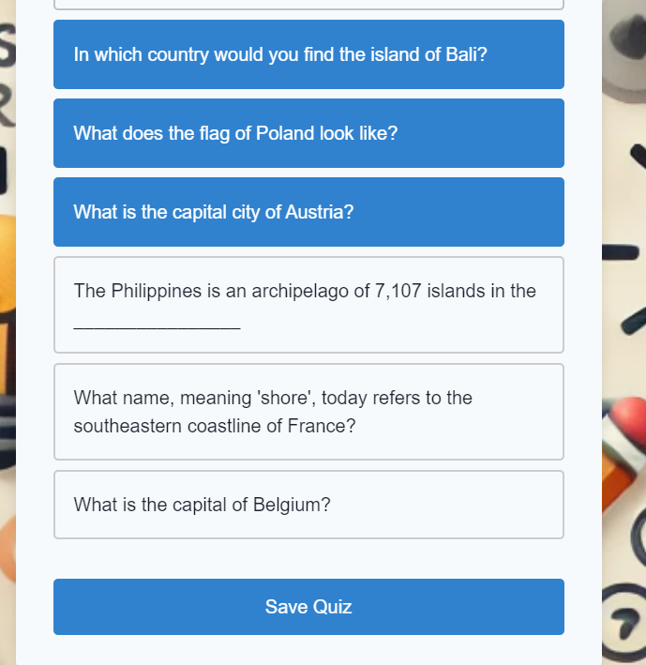

שלב הבא נלחץ על save

* נקבל קישור שאותו נכניס play quiz ונוכל לשחק בquiz.

