Credit Risk Assessment
Description: The business of banks is making loans. Assessing the credit worthiness of an applicant is of crucial importance. You have to develop a system to help a loan officer decide whether the credit of a customer is good, or bad. A bank's business rules regarding loans must consider two opposing factors. On the one hand, a bank wants to make as many loans as possible. Interest on these loans is the banks profit source. On the other hand, a bank cannot afford to make too many bad loans. Too many bad loans could lead to the collapse of the bank. The bank's loan policy must involve a compromise: not too strict, and not too lenient.
To do the assignment, you first and foremost need some knowledge about the world of credit. You can acquire such knowledge in a number of ways.
1. Knowledge Engineering. Find a loan officer who is willing to talk. Interview her and try to represent her knowledge in the form of production rules.
2. Books. Find some training manuals for loan officers or perhaps a suitable textbook on finance. Translate this knowledge from text form to production rule form.
3. Common sense. Imagine yourself as a loan officer and make up reasonable rules which can be used to judge the credit worthiness of a loan applicant.
4. Case histories. Find records of actual cases where competent loan officers correctly judged when, and when not to, approve a loan application.
The German Credit Data:
Actual historical credit data is not always easy to come by because of confidentiality rules. Here is one such dataset, consisting of 1000 actual cases collected in Germany. credit dataset (original) Excel spreadsheet version of the German credit data (Down load from web).
In spite of the fact that the data is German, you should probably make use of it for this assignment. (Unless you really can consult a real loan officer !)
A few notes on the German dataset
• DM stands for Deutsche Mark, the unit of currency, worth about 90 cents Canadian (but looks and acts like a quarter).
• Owns_telephone. German phone rates are much higher than in Canada so fewer people own telephones.
• Foreign_worker. There are millions of these in Germany (many from Turrkey). It is very hard to get German citizenship if you were not born of German parents.
• There are 20 attributes used in judging a loan applicant. The goal is the classify the applicant into one of two categories, good or bad.
Write a procedure to run WEKA data mining tool.
Procedure:
- To run WEKA find c://WEKA//WEKA-3.4/weka.jar, Double click on weka.jar.
- Explorer:
- Click on “explorer” button to bring up the explorer window.
- Make sure the “preprocess” tab is highlighted.
- Open a new file by clicking on “Open New file” and choosing a file with “.arff” extension from the “Data” directory.
- Attributes appear in the window below.
- Click on the attributes to see the visualization on the right.
- Click “visualize all” to see them all.
- Experimenter:
- Experimenter is for comparing results.
- Under the “set up” tab click “New”.
- Click on “Add New” under “Data” frame. Choose a couple of arff format files from “Data” directory one at a time.
- Click on “Add New” under “Algorithm” frame. Choose several algorithms, one at a time by clicking “OK” in the window and “Add New”.
- Under the “Run” tab click “Start”.
- Wait for WEKA to finish.
- Under “Analyses” tab click on “Experiment” to see results.
- Simple CLI:
- It is to run weka and algorithms from command-line.
- Knowledge flow:-
It defines the flow of data from component to component and save the layout using GUI.

1. List all the categorical (or nominal) attributes and the real-valued attributes seperately.
Procedure:-
- Insert the data into the excel sheet and save the file is “.arff”.
- Click on weka executable jar file.
- A window can open that window contains the buttons that are “Explorer, Experimenter, Knowledge flow, simple CLI”.
- Click the “Explorer” button.
- Open a new window and click the “preprocess” tab and open a “german.arff” file.
- You can see the list of categorical and nominal attributes can be displayed.
Output:-
Title: German Credit data
Number of Instances: 1000
The categorical attributes are 13 that are as follows.
For algorithms that need numerical attributes, Strathclyde University produced the file "german.data-numeric". This file has been edited and several indicator variables added to make it suitable for algorithms which cannot cope with categorical variables. Several attributes that are ordered categorical (such as attribute 17) have been coded as integer. This was the form used by StatLog.
6. Number of Attributes german: 20 (7 numerical, 13 categorical)
Number of Attributes german.numer: 24 (24 numerical)
7. Attribute description for german
Attribute 1: (qualitative)
Status of existing checking account
A11: < 0 DM
A12: 0 <= ... < 200 DM
A13: ... >= 200 DM / salary assignments for at least 1 year
A14: no checking account
Attribute 2: (numerical)
Duration in month
Attribute 3: (qualitative)
Credit history
A30: no credits taken/ all credits paid back duly
A31: all credits at this bank paid back duly
A32: existing credits paid back duly till now
A33: delay in paying off in the past
A34: critical account/ other credits existing (not at this bank)
Attribute 4: (qualitative)
Purpose
A40: car (new)
A41: car (used)
A42: furniture/equipment
A43: radio/television
A44: domestic appliances
A45: repairs
A46: education
A47: (vacation - does not exist?)
A48: retraining
A49: business
A410: others
Attribute 5: (numerical)
Credit amount
Attibute 6: (qualitative)
Savings account/bonds
A61: ... < 100 DM
A62: 100 <= ... < 500 DM
A63: 500 <= ... < 1000 DM
A64: .. >= 1000 DM
A65: unknown/ no savings account
Attribute 7: (qualitative)
Present employment since
A71: unemployed
A72: ... < 1 year
A73: 1 <= ... < 4 years
A74: 4 <= ... < 7 years
A75: .. >= 7 years
Attribute 8: (numerical)
Installment rate in percentage of disposable income
Attribute 9: (qualitative)
Personal status and sex
A91: male : divorced/separated
A92: female: divorced/separated/married
A93: male : single
A94: male : married/widowed
A95: female : single
Attribute 10: (qualitative)
Other debtors / guarantors
A101: none
A102: co-applicant
A103: guarantor
Attribute 11: (numerical)
Present residence since
Attribute 12: (qualitative)
Property
A121: real estate
A122: if not A121: building society savings agreement/ life insurance
A123: if not A121/ A122: car or other, not in attribute 6
A124: unknown / no property
Attribute 13: (numerical)
Age in years
Attribute 14: (qualitative)
Other installment plans
A141: bank
A142: stores
A143: none
Attribute 15: (qualitative)
Housing
A151: rent
A152: own
A153: for free
Attribute 16: (numerical)
Number of existing credits at this bank
Attribute 17: (qualitative)
Job
A171: unemployed/ unskilled- non-resident
A172: unskilled - resident
A173: skilled employee / official
A174: management/ self-employed/ highly qualified employee/ officer
Attribute 18: (numerical)
Number of people being liable to provide maintenance for
Attribute 19: (qualitative)
Telephone
A191: none
A192: yes, registered under the customer’s name
Attribute 20: (qualitative)
Foreign worker
A201: yes
A202: no

2. What attributes do you think might be crucial in making the credit assessement ? Come up with some simple rules in plain English using your selected attributes.
Procedure:
- Insert the data into the excel sheet and save the file is “.arff”.
- Click on weka executable jar file.
- A window can open that window contains the buttons that are ”Explorer” Experimenter, Knowledge flow, simple CLI”.
- Click the “Explorer” button.
- Open a new window and click the “preprocess” tab and open a “german.arff” file.
- Choose the credit history has the crucial attributes are 293.
Output:-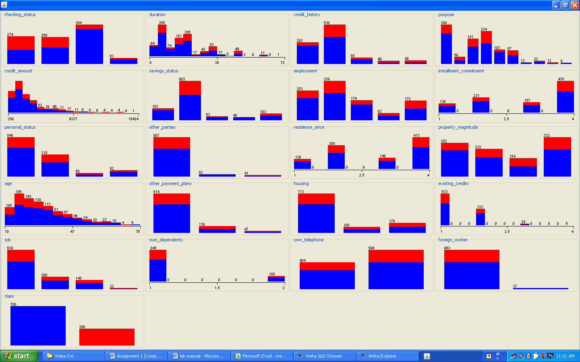

The crucial attribute in making credit assessment are:

- CHECKING
- FOREIGN
- OTHER
- HOUSING
- HISTORY
- DURATION

Simple Rules for credit assessment:

- If an applicant is foreign worker other is none i.e., if an applicant is not having any other credits and checking status is no then the applicant is treated as good
- If an applicant is foreign worker and then checking status is none then also an applicant is treated as good
- If other is none and checking status is none then also an applicant is treated as GOOD.
- If OTHER is none and house is own then also an applicant is treated as GOOD.
- If CHECKING is none then only we can treat an applicant as GOOD.
- If HISTORY is critical or other existing and OTHER is none then also the applicant is treated as GOOD.
- If DURATION is less and HISTORY is critical or other existing then also an applicant is treated as GOOD.

3. One type of model that you can create is a Decision Tree - train a Decision Tree using the complete dataset as the training data. Report the model obtained after training.
Procedure:
- Insert the data into the excel sheet and save the file is “.arff”.
- Click on weka executable jar file.
- A window can open that window contains the buttons that are ”Explorer”, Experimenter, Knowledge flow, simple CLI”.
- Click the “Explorer” button.
- A new window is open and click the “preprocess” tab and open a “german.arff ” file.
- Next click the “classify” menu on the top.
- Click the “choose” and list of “trees and rules” can be displayed.
- Select the “trees” under click the “J48”. And click “start”.
- Result list can be displayed and right click on “J48” and choose and select the “visualize tree”. See the decision tree.
Output:-
=== Run information ===

Scheme: weka.classifiers.trees.J48 -C 0.25 -M 2
Relation: german_credit
Instances: 1000
Attributes: 21
checking_status
duration
credit_history
purpose
credit_amount
savings_status
employment
installment_commitment
personal_status
other_parties
residence_since
property_magnitude
age
other_payment_plans
housing
existing_credits
job
num_dependents
own_telephone
foreign_worker
class
Test mode: evaluate on training data
=== Classifier model (full training set) ===
J48 pruned tree
------------------
checking_status = <0
| foreign_worker = yes
| | duration <= 11
| | | existing_credits <= 1
| | | | property_magnitude = real estate: good (8.0/1.0)
| | | | property_magnitude = life insurance
| | | | | own_telephone = none: bad (2.0)
| | | | | own_telephone = yes: good (4.0)
| | | | property_magnitude = car: good (2.0/1.0)
| | | | property_magnitude = no known property: bad (3.0)
| | | existing_credits > 1: good (14.0)
| | duration > 11
| | | job = unemp/unskilled non res: bad (5.0/1.0)
| | | job = unskilled resident
| | | | purpose = new car
| | | | | own_telephone = none: bad (10.0/2.0)
| | | | | own_telephone = yes: good (2.0)
| | | | purpose = used car: bad (1.0)
| | | | purpose = furniture/equipment
| | | | | employment = unemployed: good (0.0)
| | | | | employment = <1: bad (3.0)
| | | | | employment = 1<=X<4: good (4.0)
| | | | | employment = 4<=X<7: good (1.0)
| | | | | employment = >=7: good (2.0)
| | | | purpose = radio/tv
| | | | | existing_credits <= 1: bad (10.0/3.0)
| | | | | existing_credits > 1: good (2.0)
| | | | purpose = domestic appliance: bad (1.0)
| | | | purpose = repairs: bad (1.0)
| | | | purpose = education: bad (1.0)
| | | | purpose = vacation: bad (0.0)
| | | | purpose = retraining: good (1.0)
| | | | purpose = business: good (3.0)
| | | | purpose = other: good (1.0)
| | | job = skilled
| | | | other_parties = none
| | | | | duration <= 30
| | | | | | savings_status = <100
| | | | | | | credit_history = no credits/all paid: bad (8.0/1.0)
| | | | | | | credit_history = all paid: bad (6.0)
| | | | | | | credit_history = existing paid
| | | | | | | | own_telephone = none
| | | | | | | | | existing_credits <= 1
| | | | | | | | | | property_magnitude = real estate
| | | | | | | | | | | age <= 26: bad (5.0)
| | | | | | | | | | | age > 26: good (2.0)
| | | | | | | | | | property_magnitude = life insurance: bad (7.0/2.0)
| | | | | | | | | | property_magnitude = car
| | | | | | | | | | | credit_amount <= 1386: bad (3.0)
| | | | | | | | | | | credit_amount > 1386: good (11.0/1.0)
| | | | | | | | | | property_magnitude = no known property: good (2.0)
| | | | | | | | | existing_credits > 1: bad (3.0)
| | | | | | | | own_telephone = yes: bad (5.0)
| | | | | | | credit_history = delayed previously: bad (4.0)
| | | | | | | credit_history = critical/other existing credit: good (14.0/4.0)
| | | | | | savings_status = 100<=X<500
| | | | | | | credit_history = no credits/all paid: good (0.0)
| | | | | | | credit_history = all paid: good (1.0)
| | | | | | | credit_history = existing paid: bad (3.0)
| | | | | | | credit_history = delayed previously: good (0.0)
| | | | | | | credit_history = critical/other existing credit: good (2.0)
| | | | | | savings_status = 500<=X<1000: good (4.0/1.0)
| | | | | | savings_status = >=1000: good (4.0)
| | | | | | savings_status = no known savings
| | | | | | | existing_credits <= 1
| | | | | | | | own_telephone = none: bad (9.0/1.0)
| | | | | | | | own_telephone = yes: good (4.0/1.0)
| | | | | | | existing_credits > 1: good (2.0)
| | | | | duration > 30: bad (30.0/3.0)
| | | | other_parties = co applicant: bad (7.0/1.0)
| | | | other_parties = guarantor: good (12.0/3.0)
| | | job = high qualif/self emp/mgmt: good (30.0/8.0)
| foreign_worker = no: good (15.0/2.0)
checking_status = 0<=X<200
| credit_amount <= 9857
| | savings_status = <100
| | | other_parties = none
| | | | duration <= 42
| | | | | personal_status = male div/sep: bad (8.0/2.0)
| | | | | personal_status = female div/dep/mar
| | | | | | purpose = new car: bad (5.0/1.0)
| | | | | | purpose = used car: bad (1.0)
| | | | | | purpose = furniture/equipment
| | | | | | | duration <= 10: bad (3.0)
| | | | | | | duration > 10
| | | | | | | | duration <= 21: good (6.0/1.0)
| | | | | | | | duration > 21: bad (2.0)
| | | | | | purpose = radio/tv: good (8.0/2.0)
| | | | | | purpose = domestic appliance: good (0.0)
| | | | | | purpose = repairs: good (1.0)
| | | | | | purpose = education: good (4.0/2.0)
| | | | | | purpose = vacation: good (0.0)
| | | | | | purpose = retraining: good (0.0)
| | | | | | purpose = business
| | | | | | | residence_since <= 2: good (3.0)
| | | | | | | residence_since > 2: bad (2.0)
| | | | | | purpose = other: good (0.0)
| | | | | personal_status = male single: good (52.0/15.0)
| | | | | personal_status = male mar/wid
| | | | | | duration <= 10: good (6.0)
| | | | | | duration > 10: bad (10.0/3.0)
| | | | | personal_status = female single: good (0.0)
| | | | duration > 42: bad (7.0)
| | | other_parties = co applicant: good (2.0)
| | | other_parties = guarantor
| | | | purpose = new car: bad (2.0)
| | | | purpose = used car: good (0.0)
| | | | purpose = furniture/equipment: good (0.0)
| | | | purpose = radio/tv: good (18.0/1.0)
| | | | purpose = domestic appliance: good (0.0)
| | | | purpose = repairs: good (0.0)
| | | | purpose = education: good (0.0)
| | | | purpose = vacation: good (0.0)
| | | | purpose = retraining: good (0.0)
| | | | purpose = business: good (0.0)
| | | | purpose = other: good (0.0)
| | savings_status = 100<=X<500
| | | purpose = new car: bad (15.0/5.0)
| | | purpose = used car: good (3.0)
| | | purpose = furniture/equipment: bad (4.0/1.0)
| | | purpose = radio/tv: bad (8.0/2.0)
| | | purpose = domestic appliance: good (0.0)
| | | purpose = repairs: good (2.0)
| | | purpose = education: good (0.0)
| | | purpose = vacation: good (0.0)
| | | purpose = retraining: good (0.0)
| | | purpose = business
| | | | housing = rent
| | | | | existing_credits <= 1: good (2.0)
| | | | | existing_credits > 1: bad (2.0)
| | | | housing = own: good (6.0)
| | | | housing = for free: bad (1.0)
| | | purpose = other: good (1.0)
| | savings_status = 500<=X<1000: good (11.0/3.0)
| | savings_status = >=1000: good (13.0/3.0)
| | savings_status = no known savings: good (41.0/5.0)
| credit_amount > 9857: bad (20.0/3.0)
checking_status = >=200: good (63.0/14.0)
checking_status = no checking: good (394.0/46.0)

Number of Leaves: 103
Size of the tree: 140
Time taken to build model: 0.27 seconds
=== Evaluation on training set ===
=== Summary ===

Correctly Classified Instances 855 85.5 %
Incorrectly Classified Instances 145 14.5 %
Kappa statistic 0.6251
Mean absolute error 0.2312
Root mean squared error 0.34
Relative absolute error 55.0377 %
Root relative squared error 74.2015 %
Coverage of cases (0.95 level) 100 %
Mean rel. region size (0.95 level) 93.3 %
Total Number of Instances 1000

=== Detailed Accuracy By Class ===

TP Rate FP Rate Precision Recall F-Measure ROC Area Class
0.956 0.38 0.854 0.956 0.902 0.857 good
0.62 0.044 0.857 0.62 0.72 0.857 bad
Weighted Avg. 0.855 0.279 0.855 0.855 0.847 0.857

=== Confusion Matrix ===
a b <-- classified as
669 31 | a = good
114 186 | b = bad

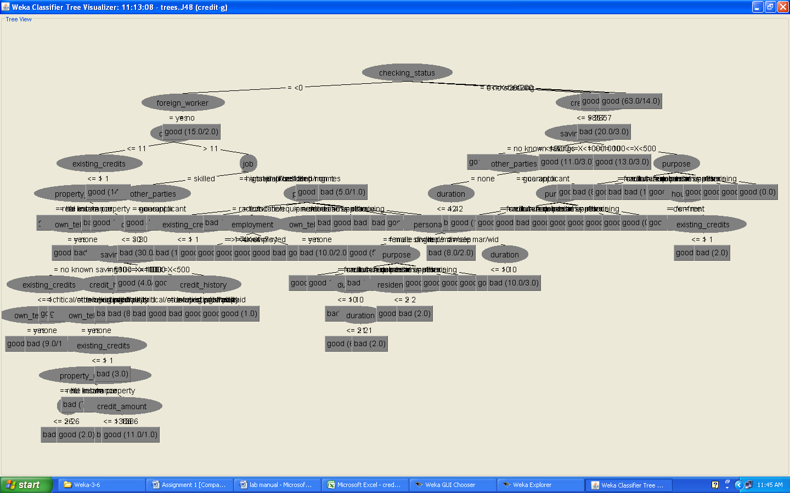

4. Suppose you use your above model trained on the complete dataset, and classify credit good/bad for each of the examples in the dataset. What % of examples can you classify correctly ? (This is also called testing on the training set) Why do you think you cannot get 100 % training accuracy ?
Procedure:-
- Insert the data into the excel sheet and save the file is “.arff”.
- Click on weka executable jar file.
- A window can open that window contains the for buttons that are ”Explorer”, Experimenter, Knowledge flow, simple CLI”.
- Click the “Explorer” button.
- Open a new window and click the “preprocess” tab and open a “german.arff” file.
- Next click the “classify” menu on the top.
- Click the “choose” and list of “trees and rules” can be displayed.
- Select the “trees” under click the “J48”. And choose the radio button is “using training dataset”. And click “start”. See the correctly classified instances.
Output:-
=== Run information ===
Scheme: weka.classifiers.trees.J48 -C 0.25 -M 2
Relation: credit-g-weka.filters.unsupervised.attribute.Remove-R3
Instances: 1000
Attributes: 20
checking_status
duration
purpose
credit_amount
savings_status
employment
installment_commitment
personal_status
other_parties
residence_since
property_magnitude
age
other_payment_plans
housing
existing_credits
job
num_dependents
own_telephone
foreign_worker
class
Test mode: evaluate on training data
=== Classifier model (full training set) ===
J48 pruned tree
------------------
checking_status = <0
| foreign_worker = yes
| | duration <= 11
| | | existing_credits <= 1
| | | | property_magnitude = real estate: good (8.0/1.0)
| | | | property_magnitude = life insurance
| | | | | own_telephone = yes: good (4.0)
| | | | | own_telephone = none: bad (2.0)
| | | | property_magnitude = no known property: bad (3.0)
| | | | property_magnitude = car: good (2.0/1.0)
| | | existing_credits > 1: good (14.0)
| | duration > 11
| | | job = skilled
| | | | other_parties = none
| | | | | savings_status = no known savings
| | | | | | existing_credits <= 1
| | | | | | | own_telephone = yes: good (4.0/1.0)
| | | | | | | own_telephone = none: bad (10.0/1.0)
| | | | | | existing_credits > 1: good (2.0)
| | | | | savings_status = <100: bad (98.0/30.0)
| | | | | savings_status = 500<=X<1000: good (5.0/2.0)
| | | | | savings_status = >=1000: good (4.0)
| | | | | savings_status = 100<=X<500
| | | | | | property_magnitude = real estate: good (1.0)
| | | | | | property_magnitude = life insurance: bad (3.0)
| | | | | | property_magnitude = no known property: good (0.0)
| | | | | | property_magnitude = car: good (2.0)
| | | | other_parties = guarantor
| | | | | duration <= 45: good (10.0/1.0)
| | | | | duration > 45: bad (2.0)
| | | | other_parties = co applicant: bad (7.0/1.0)
| | | job = unskilled resident
| | | | purpose = radio/tv
| | | | | existing_credits <= 1: bad (10.0/3.0)
| | | | | existing_credits > 1: good (2.0)
| | | | purpose = education: bad (1.0)
| | | | purpose = furniture/equipment
| | | | | employment = >=7: good (2.0)
| | | | | employment = 1<=X<4: good (4.0)
| | | | | employment = 4<=X<7: good (1.0)
| | | | | employment = unemployed: good (0.0)
| | | | | employment = <1: bad (3.0)
| | | | purpose = new car
| | | | | own_telephone = yes: good (2.0)
| | | | | own_telephone = none: bad (10.0/2.0)
| | | | purpose = used car: bad (1.0)
| | | | purpose = business: good (3.0)
| | | | purpose = domestic appliance: bad (1.0)
| | | | purpose = repairs: bad (1.0)
| | | | purpose = other: good (1.0)
| | | | purpose = retraining: good (1.0)
| | | job = high qualif/self emp/mgmt: good (30.0/8.0)
| | | job = unemp/unskilled non res: bad (5.0/1.0)
| foreign_worker = no: good (15.0/2.0)
checking_status = 0<=X<200
| credit_amount <= 9857
| | savings_status = no known savings: good (41.0/5.0)
| | savings_status = <100
| | | other_parties = none
| | | | duration <= 42
| | | | | personal_status = male single: good (52.0/15.0)
| | | | | personal_status = female div/dep/mar
| | | | | | purpose = radio/tv: good (8.0/2.0)
| | | | | | purpose = education: good (4.0/2.0)
| | | | | | purpose = furniture/equipment
| | | | | | | duration <= 10: bad (3.0)
| | | | | | | duration > 10
| | | | | | | | duration <= 21: good (6.0/1.0)
| | | | | | | | duration > 21: bad (2.0)
| | | | | | purpose = new car: bad (5.0/1.0)
| | | | | | purpose = used car: bad (1.0)
| | | | | | purpose = business
| | | | | | | residence_since <= 2: good (3.0)
| | | | | | | residence_since > 2: bad (2.0)
| | | | | | purpose = domestic appliance: good (0.0)
| | | | | | purpose = repairs: good (1.0)
| | | | | | purpose = other: good (0.0)
| | | | | | purpose = retraining: good (0.0)
| | | | | personal_status = male div/sep: bad (8.0/2.0)
| | | | | personal_status = male mar/wid
| | | | | | duration <= 10: good (6.0)
| | | | | | duration > 10: bad (10.0/3.0)
| | | | duration > 42: bad (7.0)
| | | other_parties = guarantor
| | | | purpose = radio/tv: good (18.0/1.0)
| | | | purpose = education: good (0.0)
| | | | purpose = furniture/equipment: good (0.0)
| | | | purpose = new car: bad (2.0)
| | | | purpose = used car: good (0.0)
| | | | purpose = business: good (0.0)
| | | | purpose = domestic appliance: good (0.0)
| | | | purpose = repairs: good (0.0)
| | | | purpose = other: good (0.0)
| | | | purpose = retraining: good (0.0)
| | | other_parties = co applicant: good (2.0)
| | savings_status = 500<=X<1000: good (11.0/3.0)
| | savings_status = >=1000
| | | duration <= 10: bad (2.0)
| | | duration > 10: good (11.0/1.0)
| | savings_status = 100<=X<500
| | | purpose = radio/tv: bad (8.0/2.0)
| | | purpose = education: good (0.0)
| | | purpose = furniture/equipment: bad (4.0/1.0)
| | | purpose = new car: bad (15.0/5.0)
| | | purpose = used car: good (3.0)
| | | purpose = business
| | | | housing = own: good (6.0)
| | | | housing = for free: bad (1.0)
| | | | housing = rent
| | | | | existing_credits <= 1: good (2.0)
| | | | | existing_credits > 1: bad (2.0)
| | | purpose = domestic appliance: good (0.0)
| | | purpose = repairs: good (2.0)
| | | purpose = other: good (1.0)
| | | purpose = retraining: good (0.0)
| credit_amount > 9857: bad (20.0/3.0)
checking_status = no checking: good (394.0/46.0)
checking_status = >=200: good (63.0/14.0)
Number of Leaves: 87
Size of the tree: 119
Time taken to build model: 0.02 seconds
=== Evaluation on training set ===
=== Summary ===
Correctly Classified Instances 839 83.9 %
Incorrectly Classified Instances 161 16.1 %
Kappa statistic 0.5971
Mean absolute error 0.2508
Root mean squared error 0.3541
Relative absolute error 59.6831 %
Root relative squared error 77.2695 %
Total Number of Instances 1000
=== Detailed Accuracy By Class ===

TP Rate FP Rate Precision Recall F-Measure ROC Area Class
0.921 0.353 0.859 0.921 0.889 0.848 good
0.647 0.079 0.779 0.647 0.707 0.848 bad
Weighted Avg. 0.839 0.271 0.835 0.839 0.834 0.848
=== Confusion Matrix ===
a b <-- classified as
645 55 | a = good
106 194 | b = bad

5. Is testing on the training set as you did above a good idea ? Why orWhy not ?
Description:-
- Performance on the training set is definitely not a good indicator of performance on an independent test data.
- For classification problem it is naturally to measures a classifiers performance in terms of the error rate. The classifier predicts the class of each instance if it is correct that is counted as a success if not it is an error.
- The error rate on the training data is called the “resubstitution error”, because it is calculated by resubstituting the training instances into a classifier that was constructed for them.
- None of the data may be used to determine an estimate of the future error rate. In such situations uses the training data, validation data, and test data.
- The training data is used by one or more learning methods to come up with classifiers.
- Of course, what are interested in is the likely future performance on new data, not the past performance on old data. We already know the classification of each instance in the training set, which after all is why we can use it for training.
- Data are randomly partitioned into two independent sets, a training set and test set.
Typically two-third of the data is allocated to the training set, and the remaining one-third allocated to the test set

6. One approach for solving the problem encountered in the previous question is using cross-validation? Describe what is cross-validation briefly. Train a Decistion Tree again using cross-validation and report your results. Does your accuracy increase/decrease ? Why ? (10 marks)
Procedure:-
- Insert the data into the excel sheet and save the file is “.arff”.
- Click on weka executable jar file.
- A window can open that window contains the buttons that are”Explorer”, Experimenter, Knowledge flow, simple CLI”.
- Click the “Explorer” button.
- A new window is open and click the “preprocess” tab and open a “german.arff ” file.
- Next click the “classify” menu on the top.
- Click the “choose” and list of “trees and rules” can be displayed.
- Select the “trees” under click the “J48”. And check the radio button is cross-validation. And click “start”. See the correctly classified instances.
In cross-validation you decided on a fixed number of folds or partitions of the data. Two-third for training and one-third for testing and repeat procedure three times so that in the end, every instance has been used exactly once for testing is called stratified cross-fold validation.In training dataset compared with cross-validation the accuracy is decreases.
Output:-
=== Run information ===
Scheme: weka.classifiers.trees.J48 -C 0.25 -M 2
Relation: credit-g-weka.filters.unsupervised.attribute.Remove-R3
Instances: 1000
Attributes: 20
checking_status
duration
purpose
credit_amount
savings_status
employment
installment_commitment
personal_status
other_parties
residence_since
property_magnitude
age
other_payment_plans
housing
existing_credits
job
num_dependents
own_telephone
foreign_worker
class
Test mode: 10-fold cross-validation
=== Classifier model (full training set) ===
J48 pruned tree
------------------
checking_status = <0
| foreign_worker = yes
| | duration <= 11
| | | existing_credits <= 1
| | | | property_magnitude = real estate: good (8.0/1.0)
| | | | property_magnitude = life insurance
| | | | | own_telephone = yes: good (4.0)
| | | | | own_telephone = none: bad (2.0)
| | | | property_magnitude = no known property: bad (3.0)
| | | | property_magnitude = car: good (2.0/1.0)
| | | existing_credits > 1: good (14.0)
| | duration > 11
| | | job = skilled
| | | | other_parties = none
| | | | | savings_status = no known savings
| | | | | | existing_credits <= 1
| | | | | | | own_telephone = yes: good (4.0/1.0)
| | | | | | | own_telephone = none: bad (10.0/1.0)
| | | | | | existing_credits > 1: good (2.0)
| | | | | savings_status = <100: bad (98.0/30.0)
| | | | | savings_status = 500<=X<1000: good (5.0/2.0)
| | | | | savings_status = >=1000: good (4.0)
| | | | | savings_status = 100<=X<500
| | | | | | property_magnitude = real estate: good (1.0)
| | | | | | property_magnitude = life insurance: bad (3.0)
| | | | | | property_magnitude = no known property: good (0.0)
| | | | | | property_magnitude = car: good (2.0)
| | | | other_parties = guarantor
| | | | | duration <= 45: good (10.0/1.0)
| | | | | duration > 45: bad (2.0)
| | | | other_parties = co applicant: bad (7.0/1.0)
| | | job = unskilled resident
| | | | purpose = radio/tv
| | | | | existing_credits <= 1: bad (10.0/3.0)
| | | | | existing_credits > 1: good (2.0)
| | | | purpose = education: bad (1.0)
| | | | purpose = furniture/equipment
| | | | | employment = >=7: good (2.0)
| | | | | employment = 1<=X<4: good (4.0)
| | | | | employment = 4<=X<7: good (1.0)
| | | | | employment = unemployed: good (0.0)
| | | | | employment = <1: bad (3.0)
| | | | purpose = new car
| | | | | own_telephone = yes: good (2.0)
| | | | | own_telephone = none: bad (10.0/2.0)
| | | | purpose = used car: bad (1.0)
| | | | purpose = business: good (3.0)
| | | | purpose = domestic appliance: bad (1.0)
| | | | purpose = repairs: bad (1.0)
| | | | purpose = other: good (1.0)
| | | | purpose = retraining: good (1.0)
| | | job = high qualif/self emp/mgmt: good (30.0/8.0)
| | | job = unemp/unskilled non res: bad (5.0/1.0)
| foreign_worker = no: good (15.0/2.0)
checking_status = 0<=X<200
| credit_amount <= 9857
| | savings_status = no known savings: good (41.0/5.0)
| | savings_status = <100
| | | other_parties = none
| | | | duration <= 42
| | | | | personal_status = male single: good (52.0/15.0)
| | | | | personal_status = female div/dep/mar
| | | | | | purpose = radio/tv: good (8.0/2.0)
| | | | | | purpose = education: good (4.0/2.0)
| | | | | | purpose = furniture/equipment
| | | | | | | duration <= 10: bad (3.0)
| | | | | | | duration > 10
| | | | | | | | duration <= 21: good (6.0/1.0)
| | | | | | | | duration > 21: bad (2.0)
| | | | | | purpose = new car: bad (5.0/1.0)
| | | | | | purpose = used car: bad (1.0)
| | | | | | purpose = business
| | | | | | | residence_since <= 2: good (3.0)
| | | | | | | residence_since > 2: bad (2.0)
| | | | | | purpose = domestic appliance: good (0.0)
| | | | | | purpose = repairs: good (1.0)
| | | | | | purpose = other: good (0.0)
| | | | | | purpose = retraining: good (0.0)
| | | | | personal_status = male div/sep: bad (8.0/2.0)
| | | | | personal_status = male mar/wid
| | | | | | duration <= 10: good (6.0)
| | | | | | duration > 10: bad (10.0/3.0)
| | | | duration > 42: bad (7.0)
| | | other_parties = guarantor
| | | | purpose = radio/tv: good (18.0/1.0)
| | | | purpose = education: good (0.0)
| | | | purpose = furniture/equipment: good (0.0)
| | | | purpose = new car: bad (2.0)
| | | | purpose = used car: good (0.0)
| | | | purpose = business: good (0.0)
| | | | purpose = domestic appliance: good (0.0)
| | | | purpose = repairs: good (0.0)
| | | | purpose = other: good (0.0)
| | | | purpose = retraining: good (0.0)
| | | other_parties = co applicant: good (2.0)
| | savings_status = 500<=X<1000: good (11.0/3.0)
| | savings_status = >=1000
| | | duration <= 10: bad (2.0)
| | | duration > 10: good (11.0/1.0)
| | savings_status = 100<=X<500
| | | purpose = radio/tv: bad (8.0/2.0)
| | | purpose = education: good (0.0)
| | | purpose = furniture/equipment: bad (4.0/1.0)
| | | purpose = new car: bad (15.0/5.0)
| | | purpose = used car: good (3.0)
| | | purpose = business
| | | | housing = own: good (6.0)
| | | | housing = for free: bad (1.0)
| | | | housing = rent
| | | | | existing_credits <= 1: good (2.0)
| | | | | existing_credits > 1: bad (2.0)
| | | purpose = domestic appliance: good (0.0)
| | | purpose = repairs: good (2.0)
| | | purpose = other: good (1.0)
| | | purpose = retraining: good (0.0)
| credit_amount > 9857: bad (20.0/3.0)
checking_status = no checking: good (394.0/46.0)
checking_status = >=200: good (63.0/14.0)

Number of Leaves: 87

Size of the tree: 119
Time taken to build model: 0.02 seconds
=== Stratified cross-validation ===
=== Summary ===
Correctly Classified Instances 703 70.3 %
Incorrectly Classified Instances 297 29.7 %
Kappa statistic 0.2508
Mean absolute error 0.3518
Root mean squared error 0.4836
Relative absolute error 83.722 %
Root relative squared error 105.5281 %
Total Number of Instances 1000
=== Detailed Accuracy By Class ===
TP Rate FP Rate Precision Recall F-Measure ROC Area Class
0.83 0.593 0.765 0.83 0.796 0.634 good
0.407 0.17 0.506 0.407 0.451 0.634 bad
Weighted Avg. 0.703 0.466 0.688 0.703 0.693 0.634
=== Confusion Matrix ===
a b <-- classified as
581 119 | a = good
178 122 | b = bad
The accuracy is decreases compared with the use training dataset.

7. Check to see if the data shows a bias against "foreign workers" (attribute 20),or "personal-status" (attribute 9). One way to do this (perhaps rather simple minded) is to remove these attributes from the dataset and see if the decision tree created in those cases is significantly different from the full dataset case which you have already done. To remove an attribute you can use the preprocess tab in Weka's GUI Explorer. Did removing these attributes have any significant effect? Discuss.

Procedure:-
- Insert the data into the excel sheet and save the file is “.arff”.
- Click on weka executable jar file.
- A window can open that window contains the buttons that are ”Explorer”, Experimenter, Knowledge flow, simple CLI”.
- Click the “Explorer” button. Open a new window and click the “preprocess” tab and open a “german.arff” file.
- Next we can remove the foreign workers and personal-status attributes.
- Next click the “classify” menu on the top.
- Click the “choose” and list of “trees and rules” can be displayed.
- Select the “trees” under click the “J48”. And next right click on j48tree and click the “visualize tree”
OUTPUT:

=== Run information ===

Scheme: weka.classifiers.trees.J48 -C 0.25 -M 2
Relation: german_credit-weka.filters.unsupervised.attribute.Remove-R9,20
Instances: 1000
Attributes: 19
checking_status
duration
credit_history
purpose
credit_amount
savings_status
employment
installment_commitment
other_parties
residence_since
property_magnitude
age
other_payment_plans
housing
existing_credits
job
num_dependents
own_telephone
class
Test mode: evaluate on training data
=== Classifier model (full training set) ===
J48 pruned tree
------------------
checking_status = <0
| duration <= 11
| | existing_credits <= 1
| | | property_magnitude = real estate: good (9.0/1.0)
| | | property_magnitude = life insurance
| | | | own_telephone = none: bad (2.0)
| | | | own_telephone = yes: good (4.0)
| | | property_magnitude = car: good (2.0/1.0)
| | | property_magnitude = no known property: bad (3.0)
| | existing_credits > 1: good (19.0)
| duration > 11
| | job = unemp/unskilled non res: bad (5.0/1.0)
| | job = unskilled resident
| | | property_magnitude = real estate
| | | | existing_credits <= 1
| | | | | num_dependents <= 1
| | | | | | installment_commitment <= 2: good (3.0)
| | | | | | installment_commitment > 2: bad (10.0/4.0)
| | | | | num_dependents > 1: bad (2.0)
| | | | existing_credits > 1: good (3.0)
| | | property_magnitude = life insurance
| | | | duration <= 18: good (9.0)
| | | | duration > 18: bad (3.0/1.0)
| | | property_magnitude = car: bad (12.0/5.0)
| | | property_magnitude = no known property: bad (5.0)
| | job = skilled
| | | other_parties = none
| | | | duration <= 30
| | | | | savings_status = <100
| | | | | | credit_history = no credits/all paid: bad (8.0/1.0)
| | | | | | credit_history = all paid: bad (6.0)
| | | | | | credit_history = existing paid
| | | | | | | own_telephone = none
| | | | | | | | employment = unemployed: good (3.0/1.0)
| | | | | | | | employment = <1
| | | | | | | | | property_magnitude = real estate: good (2.0)
| | | | | | | | | property_magnitude = life insurance: bad (4.0)
| | | | | | | | | property_magnitude = car: good (3.0)
| | | | | | | | | property_magnitude = no known property: good (1.0)
| | | | | | | | employment = 1<=X<4
| | | | | | | | | age <= 26: bad (7.0/1.0)
| | | | | | | | | age > 26: good (7.0/1.0)
| | | | | | | | employment = 4<=X<7: bad (5.0)
| | | | | | | | employment = >=7: good (2.0)
| | | | | | | own_telephone = yes: bad (5.0)
| | | | | | credit_history = delayed previously: bad (4.0)
| | | | | | credit_history = critical/other existing credit: good (14.0/4.0)
| | | | | savings_status = 100<=X<500
| | | | | | credit_history = no credits/all paid: good (0.0)
| | | | | | credit_history = all paid: good (1.0)
| | | | | | credit_history = existing paid: bad (3.0)
| | | | | | credit_history = delayed previously: good (0.0)
| | | | | | credit_history = critical/other existing credit: good (2.0)
| | | | | savings_status = 500<=X<1000: good (4.0/1.0)
| | | | | savings_status = >=1000: good (4.0)
| | | | | savings_status = no known savings
| | | | | | own_telephone = none
| | | | | | | installment_commitment <= 3: good (3.0/1.0)
| | | | | | | installment_commitment > 3: bad (7.0)
| | | | | | own_telephone = yes: good (6.0/1.0)
| | | | duration > 30: bad (30.0/3.0)
| | | other_parties = co applicant: bad (7.0/1.0)
| | | other_parties = guarantor: good (14.0/4.0)
| | job = high qualif/self emp/mgmt: good (31.0/9.0)
checking_status = 0<=X<200
| credit_amount <= 9857
| | savings_status = <100
| | | duration <= 42
| | | | purpose = new car
| | | | | employment = unemployed
| | | | | | installment_commitment <= 3: good (2.0)
| | | | | | installment_commitment > 3: bad (3.0)
| | | | | employment = <1: bad (7.0/2.0)
| | | | | employment = 1<=X<4: good (5.0/2.0)
| | | | | employment = 4<=X<7: good (5.0/1.0)
| | | | | employment = >=7: bad (5.0)
| | | | purpose = used car
| | | | | residence_since <= 3: good (6.0)
| | | | | residence_since > 3: bad (3.0/1.0)
| | | | purpose = furniture/equipment
| | | | | other_payment_plans = bank: good (2.0/1.0)
| | | | | other_payment_plans = stores: good (2.0)
| | | | | other_payment_plans = none
| | | | | | housing = rent: good (5.0/1.0)
| | | | | | housing = own: bad (14.0/5.0)
| | | | | | housing = for free: bad (0.0)
| | | | purpose = radio/tv: good (45.0/8.0)
| | | | purpose = domestic appliance: good (1.0)
| | | | purpose = repairs
| | | | | installment_commitment <= 3: good (3.0)
| | | | | installment_commitment > 3: bad (3.0/1.0)
| | | | purpose = education
| | | | | age <= 33: good (2.0)
| | | | | age > 33: bad (3.0/1.0)
| | | | purpose = vacation: good (0.0)
| | | | purpose = retraining: good (1.0)
| | | | purpose = business
| | | | | residence_since <= 3: good (10.0/2.0)
| | | | | residence_since > 3: bad (5.0)
| | | | purpose = other: good (1.0)
| | | duration > 42: bad (7.0)
| | savings_status = 100<=X<500
| | | purpose = new car
| | | | property_magnitude = real estate: bad (0.0)
| | | | property_magnitude = life insurance: bad (6.0)
| | | | property_magnitude = car
| | | | | residence_since <= 2: good (3.0)
| | | | | residence_since > 2: bad (4.0/1.0)
| | | | property_magnitude = no known property: good (2.0/1.0)
| | | purpose = used car: good (3.0)
| | | purpose = furniture/equipment: bad (4.0/1.0)
| | | purpose = radio/tv: bad (8.0/2.0)
| | | purpose = domestic appliance: good (0.0)
| | | purpose = repairs: good (2.0)
| | | purpose = education: good (0.0)
| | | purpose = vacation: good (0.0)
| | | purpose = retraining: good (0.0)
| | | purpose = business
| | | | housing = rent
| | | | | existing_credits <= 1: good (2.0)
| | | | | existing_credits > 1: bad (2.0)
| | | | housing = own: good (6.0)
| | | | housing = for free: bad (1.0)
| | | purpose = other: good (1.0)
| | savings_status = 500<=X<1000: good (11.0/3.0)
| | savings_status = >=1000: good (13.0/3.0)
| | savings_status = no known savings: good (41.0/5.0)
| credit_amount > 9857: bad (20.0/3.0)
checking_status = >=200
| property_magnitude = real estate
| | installment_commitment <= 3: good (15.0/3.0)
| | installment_commitment > 3: bad (6.0/1.0)
| property_magnitude = life insurance: good (12.0)
| property_magnitude = car: good (21.0/3.0)
| property_magnitude = no known property
| | num_dependents <= 1: good (7.0/1.0)
| | num_dependents > 1: bad (2.0)
checking_status = no checking: good (394.0/46.0)
Number of Leaves: 97
Size of the tree: 139
Time taken to build model: 0.22 seconds

=== Evaluation on training set ===
=== Summary ===

Correctly Classified Instances 861 86.1 %
Incorrectly Classified Instances 139 13.9 %
Kappa statistic 0.6458
Mean absolute error 0.2194
Root mean squared error 0.3312
Relative absolute error 52.208 %
Root relative squared error 72.2688 %
Coverage of cases (0.95 level) 100 %
Mean rel. region size (0.95 level) 91.15 %
Total Number of Instances 1000

=== Detailed Accuracy By Class ===

TP Rate FP Rate Precision Recall F-Measure ROC Area Class
0.95 0.347 0.865 0.95 0.905 0.869 good
0.653 0.05 0.848 0.653 0.738 0.869 bad
Weighted Avg. 0.861 0.258 0.86 0.861 0.855 0.869

===confusion matrix ===
a b <-- classified as
665 35 | a = good
104 196 | b = bad

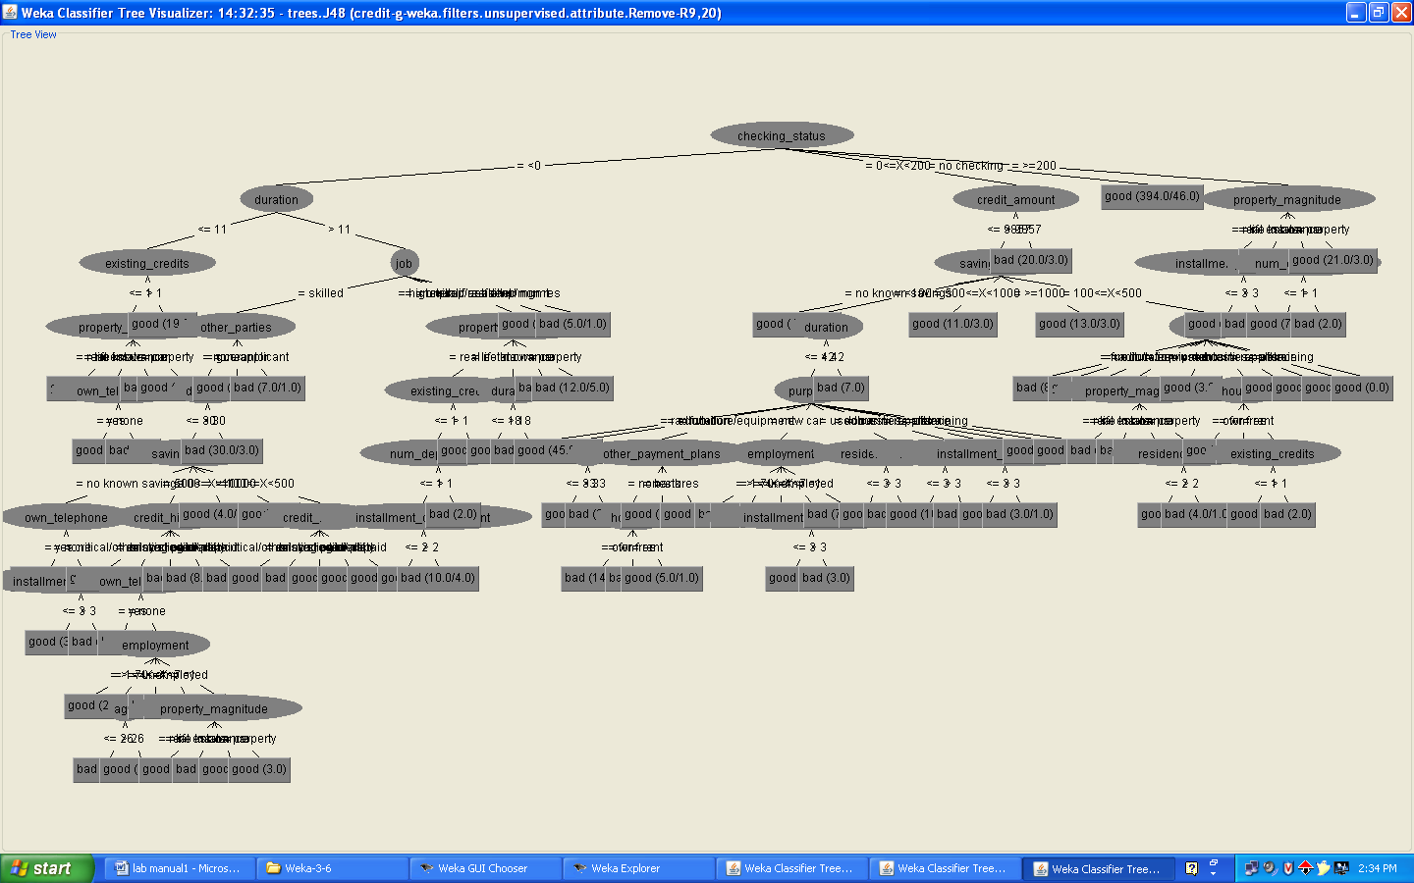

8. Another question might be, do you really need to input so many attributes to get good results? Maybe only a few would do. For example, you could try just having attributes 2, 3, 5, 7, 10, 17 (and 21, the class attribute (naturally)). Try out some combinations. (You had removed two attributes in problem 7. Remember to reload the arff data file to get all the attributes initially before you start selecting the ones you want.)
Procedure:
- Insert the data into the excel sheet and save the file is “.arff”.
- Click on weka executable jar file.
- A window can open that window contains the buttons that are “Explorer”, Experimenter, Knowledge flow, simple CLI”.
- Click the “Explorer” button.
- Open a new window and click the “preprocess” tab and open a “german.arff” file.
- Choose “visualize all” button and see the result.

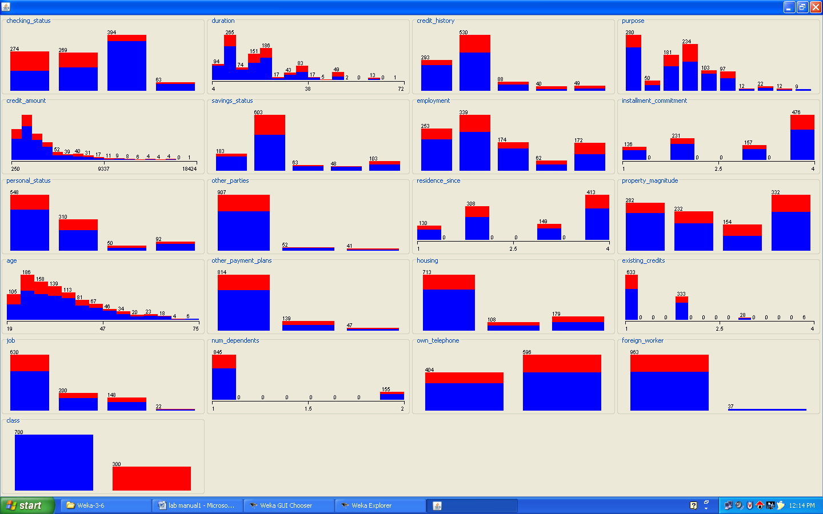

9. Sometimes, the cost of rejecting an applicant who actually has a good credit (case 1) might be higher than accepting an applicant who has bad credit (case 2). Instead of counting the misclassifcations equally in both cases, give a higher cost to the first case (say cost 5) and lower cost to the second case. You can do this by using a cost matrix in Weka. Train your Decision Tree again and report the Decision Tree and cross-validation results. Are they significantly different from results obtained in problem 6 (using equal cost)?
Procedure:
- Insert the data into the excel sheet and save the file is “.arff”.
- Click on weka executable jar file.
- A window can open that window contains the buttons that are “Explorer”, Experimenter, Knowledge flow, simple CLI”.
- Click the “Explorer” button.
- Open a new window and click the “preprocess” tab and open a “german.arff” file.
- Next click the “classify” menu on the top.
- Click the “choose” and list of “trees and rules” can be displayed.
- Select the “trees” under click the “J48”. And choose the radio button is “using training dataset”. And click “start”. See the correctly classified instances.
- Choose on result list and right click that one and click visualize “cost curve” is good can select.
Output:-
Using cross-validation dataset results
=== Run information ===
Scheme: weka.classifiers.trees.J48 -C 0.25 -M 2
Relation: credit-g-weka.filters.unsupervised.attribute.Remove-R9,20
Instances: 1000
Attributes: 19
checking_status
duration
credit_history
purpose
credit_amount
savings_status
employment
installment_commitment
other_parties
residence_since
property_magnitude
age
other_payment_plans
housing
existing_credits
job
num_dependents
own_telephone
class
Test mode: 10-fold cross-validation
=== Classifier model (full training set) ===
J48 pruned tree
------------------
checking_status = <0
| duration <= 11
| | existing_credits <= 1
| | | property_magnitude = real estate: good (9.0/1.0)
| | | property_magnitude = life insurance
| | | | own_telephone = yes: good (4.0)
| | | | own_telephone = none: bad (2.0)
| | | property_magnitude = no known property: bad (3.0)
| | | property_magnitude = car: good (2.0/1.0)
| | existing_credits > 1: good (19.0)
| duration > 11
| | job = skilled
| | | other_parties = none
| | | | duration <= 30
| | | | | savings_status = no known savings
| | | | | | own_telephone = yes: good (6.0/1.0)
| | | | | | own_telephone = none
| | | | | | | installment_commitment <= 3: good (3.0/1.0)
| | | | | | | installment_commitment > 3: bad (7.0)
| | | | | savings_status = <100
| | | | | | credit_history = critical/other existing credit: good (14.0/4.0)
| | | | | | credit_history = existing paid
| | | | | | | own_telephone = yes: bad (5.0)
| | | | | | | own_telephone = none
| | | | | | | | employment = >=7: good (2.0)
| | | | | | | | employment = 1<=X<4
| | | | | | | | | age <= 26: bad (7.0/1.0)
| | | | | | | | | age > 26: good (7.0/1.0)
| | | | | | | | employment = 4<=X<7: bad (5.0)
| | | | | | | | employment = unemployed: good (3.0/1.0)
| | | | | | | | employment = <1
| | | | | | | | | property_magnitude = real estate: good (2.0)
| | | | | | | | | property_magnitude = life insurance: bad (4.0)
| | | | | | | | | property_magnitude = no known property: good (1.0)
| | | | | | | | | property_magnitude = car: good (3.0)
| | | | | | credit_history = delayed previously: bad (4.0)
| | | | | | credit_history = no credits/all paid: bad (8.0/1.0)
| | | | | | credit_history = all paid: bad (6.0)
| | | | | savings_status = 500<=X<1000: good (4.0/1.0)
| | | | | savings_status = >=1000: good (4.0)
| | | | | savings_status = 100<=X<500
| | | | | | credit_history = critical/other existing credit: good (2.0)
| | | | | | credit_history = existing paid: bad (3.0)
| | | | | | credit_history = delayed previously: good (0.0)
| | | | | | credit_history = no credits/all paid: good (0.0)
| | | | | | credit_history = all paid: good (1.0)
| | | | duration > 30: bad (30.0/3.0)
| | | other_parties = guarantor: good (14.0/4.0)
| | | other_parties = co applicant: bad (7.0/1.0)
| | job = unskilled resident
| | | property_magnitude = real estate
| | | | existing_credits <= 1
| | | | | num_dependents <= 1
| | | | | | installment_commitment <= 2: good (3.0)
| | | | | | installment_commitment > 2: bad (10.0/4.0)
| | | | | num_dependents > 1: bad (2.0)
| | | | existing_credits > 1: good (3.0)
| | | property_magnitude = life insurance
| | | | duration <= 18: good (9.0)
| | | | duration > 18: bad (3.0/1.0)
| | | property_magnitude = no known property: bad (5.0)
| | | property_magnitude = car: bad (12.0/5.0)
| | job = high qualif/self emp/mgmt: good (31.0/9.0)
| | job = unemp/unskilled non res: bad (5.0/1.0)
checking_status = 0<=X<200
| credit_amount <= 9857
| | savings_status = no known savings: good (41.0/5.0)
| | savings_status = <100
| | | duration <= 42
| | | | purpose = radio/tv: good (45.0/8.0)
| | | | purpose = education
| | | | | age <= 33: good (2.0)
| | | | | age > 33: bad (3.0/1.0)
| | | | purpose = furniture/equipment
| | | | | other_payment_plans = none
| | | | | | housing = own: bad (14.0/5.0)
| | | | | | housing = for free: bad (0.0)
| | | | | | housing = rent: good (5.0/1.0)
| | | | | other_payment_plans = bank: good (2.0/1.0)
| | | | | other_payment_plans = stores: good (2.0)
| | | | purpose = new car
| | | | | employment = >=7: bad (5.0)
| | | | | employment = 1<=X<4: good (5.0/2.0)
| | | | | employment = 4<=X<7: good (5.0/1.0)
| | | | | employment = unemployed
| | | | | | installment_commitment <= 3: good (2.0)
| | | | | | installment_commitment > 3: bad (3.0)
| | | | | employment = <1: bad (7.0/2.0)
| | | | purpose = used car
| | | | | residence_since <= 3: good (6.0)
| | | | | residence_since > 3: bad (3.0/1.0)
| | | | purpose = business
| | | | | residence_since <= 3: good (10.0/2.0)
| | | | | residence_since > 3: bad (5.0)
| | | | purpose = domestic appliance: good (1.0)
| | | | purpose = repairs
| | | | | installment_commitment <= 3: good (3.0)
| | | | | installment_commitment > 3: bad (3.0/1.0)
| | | | purpose = other: good (1.0)
| | | | purpose = retraining: good (1.0)
| | | duration > 42: bad (7.0)
| | savings_status = 500<=X<1000: good (11.0/3.0)
| | savings_status = >=1000: good (13.0/3.0)
| | savings_status = 100<=X<500
| | | purpose = radio/tv: bad (8.0/2.0)
| | | purpose = education: good (0.0)
| | | purpose = furniture/equipment: bad (4.0/1.0)
| | | purpose = new car
| | | | property_magnitude = real estate: bad (0.0)
| | | | property_magnitude = life insurance: bad (6.0)
| | | | property_magnitude = no known property: good (2.0/1.0)
| | | | property_magnitude = car
| | | | | residence_since <= 2: good (3.0)
| | | | | residence_since > 2: bad (4.0/1.0)
| | | purpose = used car: good (3.0)
| | | purpose = business
| | | | housing = own: good (6.0)
| | | | housing = for free: bad (1.0)
| | | | housing = rent
| | | | | existing_credits <= 1: good (2.0)
| | | | | existing_credits > 1: bad (2.0)
| | | purpose = domestic appliance: good (0.0)
| | | purpose = repairs: good (2.0)
| | | purpose = other: good (1.0)
| | | purpose = retraining: good (0.0)
| credit_amount > 9857: bad (20.0/3.0)
checking_status = no checking: good (394.0/46.0)
checking_status = >=200
| property_magnitude = real estate
| | installment_commitment <= 3: good (15.0/3.0)
| | installment_commitment > 3: bad (6.0/1.0)
| property_magnitude = life insurance: good (12.0)
| property_magnitude = no known property
| | num_dependents <= 1: good (7.0/1.0)
| | num_dependents > 1: bad (2.0)
| property_magnitude = car: good (21.0/3.0)
Number of Leaves: 95
Size of the tree: 137
Time taken to build model: 0.03 seconds
=== Stratified cross-validation ===
=== Summary ===
Correctly Classified Instances 716 71.6 %
Incorrectly Classified Instances 284 28.4 %
Kappa statistic 0.2843
Mean absolute error 0.3328
Root mean squared error 0.477
Relative absolute error 79.2118 %
Root relative squared error 104.0916 %
Total Number of Instances 1000

=== Detailed Accuracy By Class ===
TP Rate FP Rate Precision Recall F-Measure ROC Area Class
0.839 0.57 0.774 0.839 0.805 0.66 good
0.43 0.161 0.533 0.43 0.476 0.66 bad
Weighted Avg. 0.716 0.447 0.702 0.716 0.706 0.66
=== Confusion Matrix ===
a b <-- classified as
587 113 | a = good
171 129 | b = bad
Cost curve:-
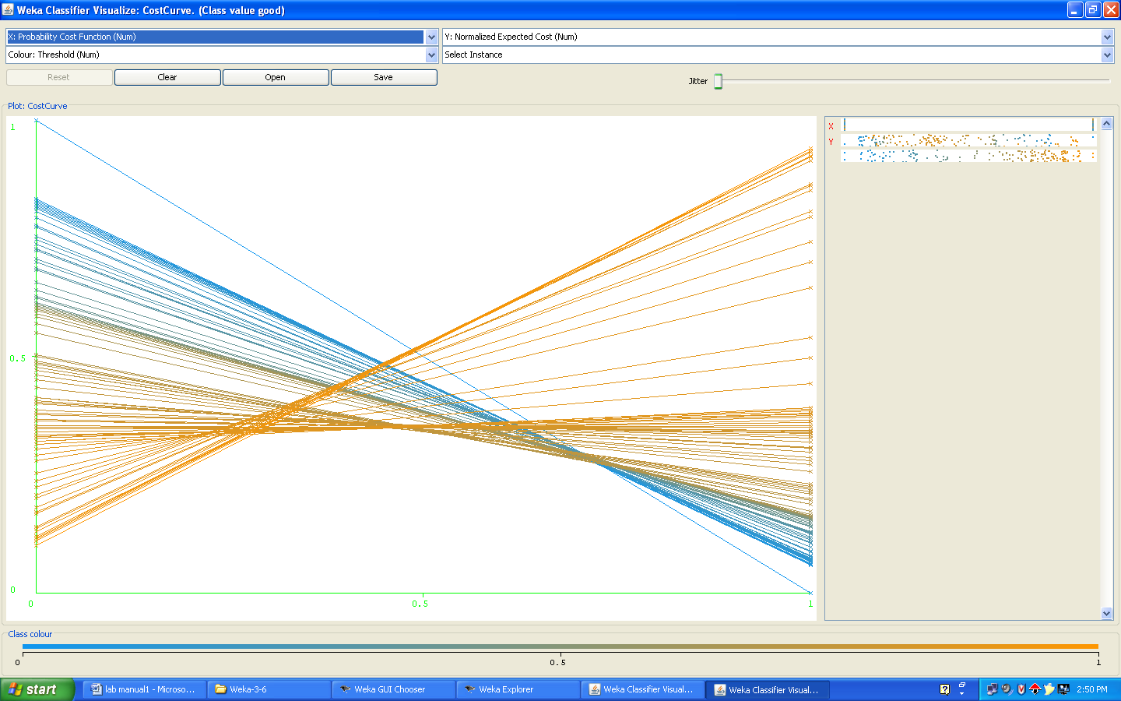

Using training dataset results
=== Run information ===
Scheme: weka.classifiers.trees.J48 -C 0.25 -M 2
Relation: credit-g-weka.filters.unsupervised.attribute.Remove-R9,20
Instances: 1000
Attributes: 19
checking_status
duration
credit_history
purpose
credit_amount
savings_status
employment
installment_commitment
other_parties
residence_since
property_magnitude
age
other_payment_plans
housing
existing_credits
job
num_dependents
own_telephone
class
Test mode: evaluate on training data
=== Classifier model (full training set) ===
J48 pruned tree
------------------
checking_status = <0
| duration <= 11
| | existing_credits <= 1
| | | property_magnitude = real estate: good (9.0/1.0)
| | | property_magnitude = life insurance
| | | | own_telephone = yes: good (4.0)
| | | | own_telephone = none: bad (2.0)
| | | property_magnitude = no known property: bad (3.0)
| | | property_magnitude = car: good (2.0/1.0)
| | existing_credits > 1: good (19.0)
| duration > 11
| | job = skilled
| | | other_parties = none
| | | | duration <= 30
| | | | | savings_status = no known savings
| | | | | | own_telephone = yes: good (6.0/1.0)
| | | | | | own_telephone = none
| | | | | | | installment_commitment <= 3: good (3.0/1.0)
| | | | | | | installment_commitment > 3: bad (7.0)
| | | | | savings_status = <100
| | | | | | credit_history = critical/other existing credit: good (14.0/4.0)
| | | | | | credit_history = existing paid
| | | | | | | own_telephone = yes: bad (5.0)
| | | | | | | own_telephone = none
| | | | | | | | employment = >=7: good (2.0)
| | | | | | | | employment = 1<=X<4
| | | | | | | | | age <= 26: bad (7.0/1.0)
| | | | | | | | | age > 26: good (7.0/1.0)
| | | | | | | | employment = 4<=X<7: bad (5.0)
| | | | | | | | employment = unemployed: good (3.0/1.0)
| | | | | | | | employment = <1
| | | | | | | | | property_magnitude = real estate: good (2.0)
| | | | | | | | | property_magnitude = life insurance: bad (4.0)
| | | | | | | | | property_magnitude = no known property: good (1.0)
| | | | | | | | | property_magnitude = car: good (3.0)
| | | | | | credit_history = delayed previously: bad (4.0)
| | | | | | credit_history = no credits/all paid: bad (8.0/1.0)
| | | | | | credit_history = all paid: bad (6.0)
| | | | | savings_status = 500<=X<1000: good (4.0/1.0)
| | | | | savings_status = >=1000: good (4.0)
| | | | | savings_status = 100<=X<500
| | | | | | credit_history = critical/other existing credit: good (2.0)
| | | | | | credit_history = existing paid: bad (3.0)
| | | | | | credit_history = delayed previously: good (0.0)
| | | | | | credit_history = no credits/all paid: good (0.0)
| | | | | | credit_history = all paid: good (1.0)
| | | | duration > 30: bad (30.0/3.0)
| | | other_parties = guarantor: good (14.0/4.0)
| | | other_parties = co applicant: bad (7.0/1.0)
| | job = unskilled resident
| | | property_magnitude = real estate
| | | | existing_credits <= 1
| | | | | num_dependents <= 1
| | | | | | installment_commitment <= 2: good (3.0)
| | | | | | installment_commitment > 2: bad (10.0/4.0)
| | | | | num_dependents > 1: bad (2.0)
| | | | existing_credits > 1: good (3.0)
| | | property_magnitude = life insurance
| | | | duration <= 18: good (9.0)
| | | | duration > 18: bad (3.0/1.0)
| | | property_magnitude = no known property: bad (5.0)
| | | property_magnitude = car: bad (12.0/5.0)
| | job = high qualif/self emp/mgmt: good (31.0/9.0)
| | job = unemp/unskilled non res: bad (5.0/1.0)
checking_status = 0<=X<200
| credit_amount <= 9857
| | savings_status = no known savings: good (41.0/5.0)
| | savings_status = <100
| | | duration <= 42
| | | | purpose = radio/tv: good (45.0/8.0)
| | | | purpose = education
| | | | | age <= 33: good (2.0)
| | | | | age > 33: bad (3.0/1.0)
| | | | purpose = furniture/equipment
| | | | | other_payment_plans = none
| | | | | | housing = own: bad (14.0/5.0)
| | | | | | housing = for free: bad (0.0)
| | | | | | housing = rent: good (5.0/1.0)
| | | | | other_payment_plans = bank: good (2.0/1.0)
| | | | | other_payment_plans = stores: good (2.0)
| | | | purpose = new car
| | | | | employment = >=7: bad (5.0)
| | | | | employment = 1<=X<4: good (5.0/2.0)
| | | | | employment = 4<=X<7: good (5.0/1.0)
| | | | | employment = unemployed
| | | | | | installment_commitment <= 3: good (2.0)
| | | | | | installment_commitment > 3: bad (3.0)
| | | | | employment = <1: bad (7.0/2.0)
| | | | purpose = used car
| | | | | residence_since <= 3: good (6.0)
| | | | | residence_since > 3: bad (3.0/1.0)
| | | | purpose = business
| | | | | residence_since <= 3: good (10.0/2.0)
| | | | | residence_since > 3: bad (5.0)
| | | | purpose = domestic appliance: good (1.0)
| | | | purpose = repairs
| | | | | installment_commitment <= 3: good (3.0)
| | | | | installment_commitment > 3: bad (3.0/1.0)
| | | | purpose = other: good (1.0)
| | | | purpose = retraining: good (1.0)
| | | duration > 42: bad (7.0)
| | savings_status = 500<=X<1000: good (11.0/3.0)
| | savings_status = >=1000: good (13.0/3.0)
| | savings_status = 100<=X<500
| | | purpose = radio/tv: bad (8.0/2.0)
| | | purpose = education: good (0.0)
| | | purpose = furniture/equipment: bad (4.0/1.0)
| | | purpose = new car
| | | | property_magnitude = real estate: bad (0.0)
| | | | property_magnitude = life insurance: bad (6.0)
| | | | property_magnitude = no known property: good (2.0/1.0)
| | | | property_magnitude = car
| | | | | residence_since <= 2: good (3.0)
| | | | | residence_since > 2: bad (4.0/1.0)
| | | purpose = used car: good (3.0)
| | | purpose = business
| | | | housing = own: good (6.0)
| | | | housing = for free: bad (1.0)
| | | | housing = rent
| | | | | existing_credits <= 1: good (2.0)
| | | | | existing_credits > 1: bad (2.0)
| | | purpose = domestic appliance: good (0.0)
| | | purpose = repairs: good (2.0)
| | | purpose = other: good (1.0)
| | | purpose = retraining: good (0.0)
| credit_amount > 9857: bad (20.0/3.0)
checking_status = no checking: good (394.0/46.0)
checking_status = >=200
| property_magnitude = real estate
| | installment_commitment <= 3: good (15.0/3.0)
| | installment_commitment > 3: bad (6.0/1.0)
| property_magnitude = life insurance: good (12.0)
| property_magnitude = no known property
| | num_dependents <= 1: good (7.0/1.0)
| | num_dependents > 1: bad (2.0)
| property_magnitude = car: good (21.0/3.0)
Number of Leaves: 95
Size of the tree: 137
Time taken to build model: 0.02 seconds
=== Evaluation on training set ===
=== Summary ===

Correctly Classified Instances 861 86.1 %
Incorrectly Classified Instances 139 13.9 %
Kappa statistic 0.6458
Mean absolute error 0.2194
Root mean squared error 0.3312
Relative absolute error 52.208 %
Root relative squared error 72.2688 %
Total Number of Instances 1000

=== Detailed Accuracy By Class ===

TP Rate FP Rate Precision Recall F-Measure ROC Area Class
0.95 0.347 0.865 0.95 0.905 0.869 good
0.653 0.05 0.848 0.653 0.738 0.869 bad
Weighted Avg. 0.861 0.258 0.86 0.861 0.855 0.869
=== Confusion Matrix ===
a b <-- classified as
665 35 | a = good
104 196 | b = bad

Cost curve:

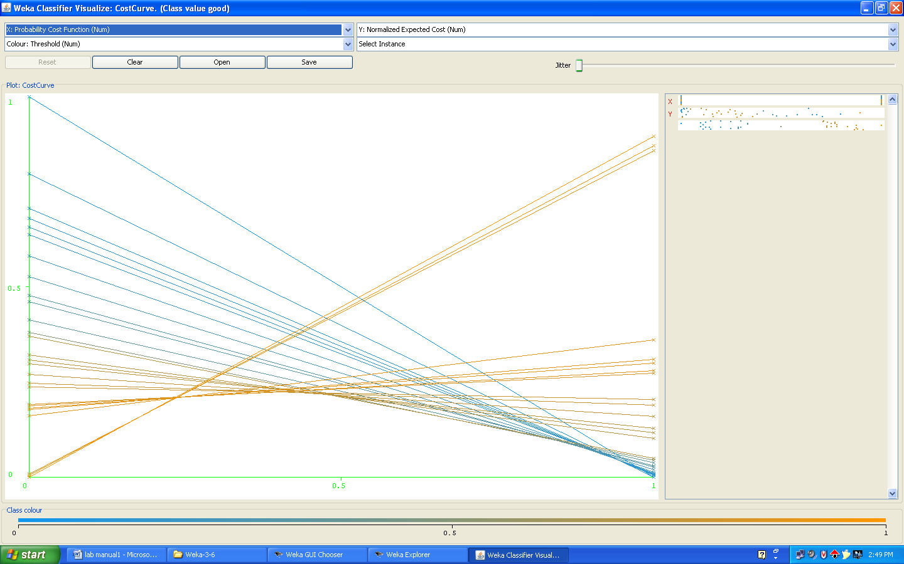

10. Do you think it is a good idea to prefer simple decision trees instead of having long complex decision trees ? How does the complexity of a Decision Tree relate to the bias of the model ?
Do you think it is a good idea to prefer simple decision tree instead of having long complex decision trees? How does the complexity of a decision tree relate to the bias of the model?
Description:
- The computational complexity of the decision tree induction is O (n) stands for a quantity that grows at most linearly with n, O (n2) grows at most quadratic ally with n.
- Suppose the training data contains n instances and m attributes. We need to make some assumption about the size of the tree, and we will assume that its depth is on the order of log n, that is O (log n).
- The computational cost of building the tree in the first place is O (mn log n).
- Because there are log n different depths in the tree, the amount of work for this on attribute is O (n log n) at each node all attributes are considered so the total amount of work is O (mn log n).
- The initial sort takes O (n log n) operations for each of up to m attributes thus the preceding complexity figure is unchanged.
- The complexity of sub-tree replacement is O (n).
- Finally sub-tree lifting has a basic complexity equal to sub-tree replacement. But there is an added cost because instances need to be reclassified during the lifting operation. During the whole process each instance may have to be reclassified at every node between its leaf and the root, i.e, as many as O (log n) times. That makes the total number of reclassification O (n log n).
- And reclassification is not a single operation one that occurs near the root will take O (log n) operations, and one of the average depth will take half of this. Thus the total complexity of sub-tree is as follows.
- O (n (log n) 2)\ taking into account all these operations, the full complexity of decision tree induction is O (mn log n) + O (n (log n) 2).

11. You can make your Decision Trees simpler by pruning the nodes. One approach is to use Reduced Error Pruning -Explain this idea briefly. Try reduced error pruning for training your Decision Trees using cross-validation and report the Decision Tree you obtain?Also,repor your accuracy using the pruned model. Does your accuracy increase ?
Description:
We need to estimate the error at internal nodes as well as at leaf nodes. If we had such an estimate, it would be clear whether to replace, or raise, a particular sub-tree simply by comparing the estimated error of the sub-tree with that of its proposed replacement. Before estimating the error for sub-tree proposed for raising.
One Way of coming up with an error estimate is the standard verification technique is hold back some of the data originally given and use it as an independent test set to estimate the error at each node. This is called reduced-error pruning.
Procedure:-
- Insert the data into the excel sheet and save the file is “.arff”.
- Click on weka executable jar file.
- A window can open that window contains the buttons that are “Explorer”, Experimenter, Knowledge flow, simple CLI”.
- Click the “Explorer” button.
- Open a new window and click the “preprocess” tab and open a “german.arff” file.
- Next click the “classify” menu on the top.
- Click the “choose” and list of “trees and rules” can be displayed.
- Select the “trees” under click the “J48”. And choose the radio button is “using training dataset”. And click “start”. See the correctly classified instances.
Output:-
=== Evaluation on training set === =====detailed accuracy by class=====
TP Rate FP Rate Precision Recall F-Measure ROC Area Class
0.956 0.38 0.854 0.956 0.902 0.857 good
0.62 0.044 0.857 0.62 0.72 0.857 bad
Weighted Avg. 0.855 0.279 0.855 0.855 0.847 0.857
=== Stratified cross-validation ===
=== Detailed Accuracy By Class ===
TP Rate FP Rate Precision Recall F-Measure ROC Area Class
0.843 0.61 0.763 0.843 0.801 0.641 good
0.39 0.157 0.515 0.39 0.444 0.641 bad
Weighted Avg. 0.707 0.474 0.689 0.707 0.694 0.641
12. (Extra Credit): How can you convert a Decision Trees into "if-then-else rules". Make up your own small Decision Tree consisting of 2-3 levels and convert it into a set of rules. There also exist different classifiers that output the model in the form of rules - one such classifier in Weka is rules.PART, train this model and report the set of rules obtained. Sometimes just one attribute can be good enough in making the decision, yes, just one ! Can you predict what attribute that might be in this dataset ? OneR classifier uses a single attribute to make decisions (it chooses the attribute based on minimum error). Report the rule obtained by training a one R classifier. Rank the performance of j48, PART and oneR.
Procedure:
- Insert the data into the excel sheet and save the file is “.arff”.
- Click on weka executable jar file.
- A window can open that window contains the buttons that are “Explorer”, Experimenter, Knowledge flow, simple CLI”.
- Click the “Explorer” button.
- Open a new window and click the “preprocess” tab and open a “german.arff” file.
- Next click the “classify” menu on the top.
- Click the “choose” and list of “trees and rules” can be displayed.
- Select the “rules” under click the “PART and OneR”. And choose the radio button is “using training dataset”. And click “start”. See the correctly classified instances.
Output:-
PART Rule
=== Run information ===
Scheme: weka.classifiers.rules.PART -M 2 -C 0.25 -Q 1
Relation: credit-g
Instances: 1000
Attributes: 21
checking_status
duration
credit_history
purpose
credit_amount
savings_status
employment
installment_commitment
personal_status
other_parties
residence_since
property_magnitude
age
other_payment_plans
housing
existing_credits
job
num_dependents
own_telephone
foreign_worker
class
Test mode: evaluate on training data
=== Classifier model (full training set) ===
PART decision list
------------------
checking_status = no checking AND
other_payment_plans = none AND
credit_history = critical/other existing credit: good (134.0/3.0)
checking_status = no checking AND
existing_credits <= 1 AND
other_payment_plans = none AND
purpose = radio/tv: good (49.0/2.0)
checking_status = no checking AND
foreign_worker = yes AND
employment = 4<=X<7: good (35.0/2.0)
foreign_worker = no AND
personal_status = male single: good (21.0)
checking_status = no checking AND
purpose = used car AND
other_payment_plans = none: good (23.0)
duration <= 15 AND
other_parties = guarantor: good (22.0/1.0)
duration <= 11 AND
credit_history = critical/other existing credit: good (29.0/3.0)
checking_status = >=200 AND
num_dependents <= 1 AND
property_magnitude = car: good (20.0/3.0)
checking_status = no checking AND
property_magnitude = real estate AND
other_payment_plans = none AND
age > 23: good (25.0)
savings_status = >=1000 AND
property_magnitude = real estate: good (10.0)
savings_status = 500<=X<1000 AND
employment = >=7: good (13.0/1.0)
credit_history = no credits/all paid AND
housing = rent: bad (9.0)
savings_status = no known savings AND
checking_status = 0<=X<200 AND
existing_credits > 1: good (9.0)
checking_status = >=200 AND
num_dependents <= 1 AND
property_magnitude = life insurance: good (9.0)
installment_commitment <= 2 AND
other_parties = co applicant AND
existing_credits > 1: bad (5.0)
installment_commitment <= 2 AND
credit_history = delayed previously AND
existing_credits > 1 AND
residence_since > 1: good (14.0/3.0)
installment_commitment <= 2 AND
credit_history = delayed previously AND
existing_credits <= 1: good (9.0)
duration > 30 AND
savings_status = 100<=X<500: bad (13.0/3.0)
credit_history = all paid AND
other_parties = none AND
other_payment_plans = bank: bad (16.0/5.0)
duration > 30 AND
savings_status = no known savings AND
num_dependents > 1: good (5.0)
duration > 30 AND
credit_history = delayed previously: bad (9.0)
duration > 42 AND
savings_status = <100 AND
residence_since > 1: bad (28.0/3.0)
purpose = used car AND
credit_amount <= 8133 AND
existing_credits > 1: good (11.0)
purpose = used car AND
credit_amount > 8133: bad (8.0/1.0)
purpose = used car AND
employment = 1<=X<4: good (7.0)
purpose = used car: good (16.0/3.0)
purpose = furniture/equipment AND
other_payment_plans = stores: good (8.0)
credit_history = all paid AND
other_parties = none AND
other_payment_plans = none: bad (10.0)
purpose = business AND
residence_since <= 1: good (9.0)
other_payment_plans = stores AND
purpose = radio/tv AND
personal_status = male single: bad (6.0/1.0)
purpose = radio/tv AND
employment = >=7 AND
num_dependents <= 1: good (20.0/1.0)
installment_commitment <= 3 AND
purpose = furniture/equipment AND
other_parties = none AND
own_telephone = yes: good (19.0/3.0)
checking_status = no checking AND
savings_status = no known savings AND
personal_status = male single: good (11.0/1.0)
checking_status = 0<=X<200 AND
employment = 4<=X<7 AND
personal_status = male single AND
residence_since > 2: good (9.0)
purpose = other: good (5.0/1.0)
installment_commitment <= 2 AND
foreign_worker = yes AND
credit_history = existing paid AND
residence_since > 1 AND
other_parties = none AND
other_payment_plans = none AND
housing = rent AND
installment_commitment <= 1: good (9.0)
housing = rent AND
other_payment_plans = none AND
purpose = new car: bad (13.0/2.0)
other_payment_plans = stores AND
property_magnitude = life insurance: bad (4.0/1.0)
other_payment_plans = bank AND
other_parties = none AND
housing = rent: bad (7.0/1.0)
installment_commitment > 3 AND
existing_credits <= 1 AND
savings_status = <100 AND
credit_history = existing paid AND
purpose = new car: bad (17.0/5.0)
checking_status = >=200 AND
job = skilled AND
credit_amount > 1283: good (5.0)
checking_status = >=200: bad (9.0/1.0)
duration <= 15 AND
property_magnitude = real estate AND
num_dependents <= 1 AND
other_payment_plans = none AND
foreign_worker = yes AND
existing_credits <= 1: good (22.0/5.0)
num_dependents > 1 AND
own_telephone = yes: good (14.0/2.0)
purpose = repairs AND
property_magnitude = car: good (5.0/1.0)
purpose = education AND
checking_status = <0: bad (9.0/1.0)
purpose = repairs: bad (7.0/1.0)
purpose = education AND
checking_status = 0<=X<200: good (5.0)
purpose = education AND
personal_status = male single: bad (3.0)
purpose = business AND
age > 27: bad (14.0/3.0)
purpose = new car AND
other_payment_plans = bank: bad (13.0/2.0)
purpose = radio/tv AND
foreign_worker = yes AND
other_parties = guarantor AND
existing_credits <= 1: good (5.0/1.0)
purpose = radio/tv AND
other_parties = none AND
foreign_worker = yes AND
other_payment_plans = bank AND
num_dependents <= 1: good (6.0/1.0)
purpose = radio/tv AND
foreign_worker = yes AND
other_parties = none AND
other_payment_plans = none AND
checking_status = <0 AND
credit_history = existing paid AND
savings_status = <100 AND
job = skilled: bad (9.0/1.0)
purpose = radio/tv AND
other_parties = none AND
foreign_worker = yes AND
other_payment_plans = none AND
credit_history = existing paid AND
savings_status = <100 AND
credit_amount > 2051: good (6.0)
purpose = business: good (5.0)
housing = for free AND
other_payment_plans = none AND
residence_since > 2: good (12.0/3.0)
purpose = new car AND
other_parties = none AND
housing = own AND
num_dependents <= 1 AND
savings_status = <100 AND
checking_status = <0 AND
property_magnitude = car: bad (6.0/1.0)
purpose = radio/tv AND
foreign_worker = yes AND
other_parties = none AND
other_payment_plans = none AND
existing_credits > 1 AND
credit_amount <= 2225: good (4.0)
purpose = radio/tv AND
foreign_worker = yes AND
other_parties = none AND
job = unskilled resident: bad (6.0)
purpose = furniture/equipment AND
other_parties = co applicant AND
duration > 15: bad (4.0)
employment = unemployed AND
residence_since <= 2: bad (9.0)
purpose = new car AND
other_parties = none AND
property_magnitude = car AND
installment_commitment <= 2: good (5.0)
purpose = furniture/equipment AND
other_parties = none AND
savings_status = <100 AND
num_dependents <= 1 AND
own_telephone = yes: bad (5.0/1.0)
purpose = furniture/equipment AND
own_telephone = none AND
other_parties = none AND
duration > 27: bad (9.0/1.0)
purpose = furniture/equipment AND
other_parties = none AND
personal_status = male single AND
residence_since > 3: good (6.0)
purpose = furniture/equipment AND
other_parties = none AND
personal_status = female div/dep/mar AND
job = skilled AND
employment = 1<=X<4: bad (6.0/2.0)
purpose = furniture/equipment AND
savings_status = <100 AND
housing = own AND
other_parties = none AND
personal_status = male single: bad (5.0/1.0)
purpose = furniture/equipment: good (25.0/5.0)
other_parties = none AND
purpose = radio/tv AND
foreign_worker = yes AND
personal_status = male mar/wid: bad (5.0)
other_parties = none AND
purpose = radio/tv AND
other_payment_plans = none AND
own_telephone = none: good (8.0/1.0)
purpose = new car AND
other_parties = none AND
num_dependents <= 1 AND
credit_history = existing paid AND
own_telephone = yes AND
age > 29: good (5.0/1.0)
credit_history = delayed previously AND
age <= 45: good (4.0)
other_payment_plans = none AND
other_parties = none AND
housing = own AND
personal_status = female div/dep/mar AND
installment_commitment > 1: bad (10.0)
other_parties = none AND
housing = own AND
purpose = radio/tv AND
existing_credits <= 1: good (4.0)
housing = own AND
other_parties = none AND
purpose = new car AND
installment_commitment > 3 AND
savings_status = <100: bad (7.0/2.0)
checking_status = <0: bad (10.0/2.0)
: good (12.0/3.0)
Number of Rules: 78
Time taken to build model: 0.13 seconds
=== Evaluation on training set ===
=== Summary ===
Correctly Classified Instances 909 90.9 %
Incorrectly Classified Instances 91 9.1 %
Kappa statistic 0.7815
Mean absolute error 0.1485
Root mean squared error 0.2725
Relative absolute error 35.3384 %
Root relative squared error 59.4574 %
Total Number of Instances 1000
=== Detailed Accuracy By Class ===
TP Rate FP Rate Precision Recall F-Measure ROC Area Class
0.941 0.167 0.929 0.941 0.935 0.949 good
0.833 0.059 0.859 0.833 0.846 0.949 bad
Weighted Avg. 0.909 0.134 0.908 0.909 0.909 0.949
=== Confusion Matrix ===
a b <-- classified as
659 41 | a = good
50 250 | b = bad
One Rule
=== Run information ===
Scheme: weka.classifiers.rules.OneR -B 6
Relation: credit-g
Instances: 1000
Attributes: 21
checking_status
duration
credit_history
purpose
credit_amount
savings_status
employment
installment_commitment
personal_status
other_parties
residence_since
property_magnitude
age
other_payment_plans
housing
existing_credits
job
num_dependents
own_telephone
foreign_worker
class
Test mode: evaluate on training data
=== Classifier model (full training set) ===
Credit_ amount:
< 883.0 -> good
< 922.0 -> bad
< 938.0 -> good
< 979.5 -> bad
< 1206.5-> good
< 1223.5-> bad
< 1267.5-> good
< 1286.0-> bad
< 1821.5-> good
< 1865.5-> bad
< 3913.5-> good
< 3969.0-> bad
< 4049.5-> good
< 4329.5-> bad
< 4726.0-> good
< 5024.0-> bad
< 6322.5-> good
< 6564.0-> bad
< 6750.0-> good
< 6917.5-> bad
< 7760.5-> good
< 8109.5-> bad
< 9340.5-> good
< 10331.5-> bad
< 11191.0-> good
>= 11191.0-> bad
(742/1000 instances correct)
Time taken to build model: 0.02 seconds
=== Evaluation on training set ===
=== Summary ===
Correctly Classified Instances 742 74.2 %
Incorrectly Classified Instances 258 25.8 %
Kappa statistic 0.2896
Mean absolute error 0.258
Root mean squared error 0.5079
Relative absolute error 61.4052 %
Root relative squared error 110.8409 %
Total Number of Instances 1000
=== Detailed Accuracy By Class ===
TP Rate FP Rate Precision Recall F-Measure ROC Area Class
0.917 0.667 0.762 0.917 0.833 0.625 good
0.333 0.083 0.633 0.333 0.437 0.625 bad
Weighted Avg. 0.742 0.492 0.724 0.742 0.714 0.625
=== Confusion Matrix ===
a b <-- classified as
642 58 | a = good
200 100 | b = bad
Rank of the j48, PART, OneR is
Correctly classified instances in PART is: 90.9%
Correctly classified instances in j48 is: 83.3%
Correctly classified instances in OneR is: 74.2%
***** ========*******

