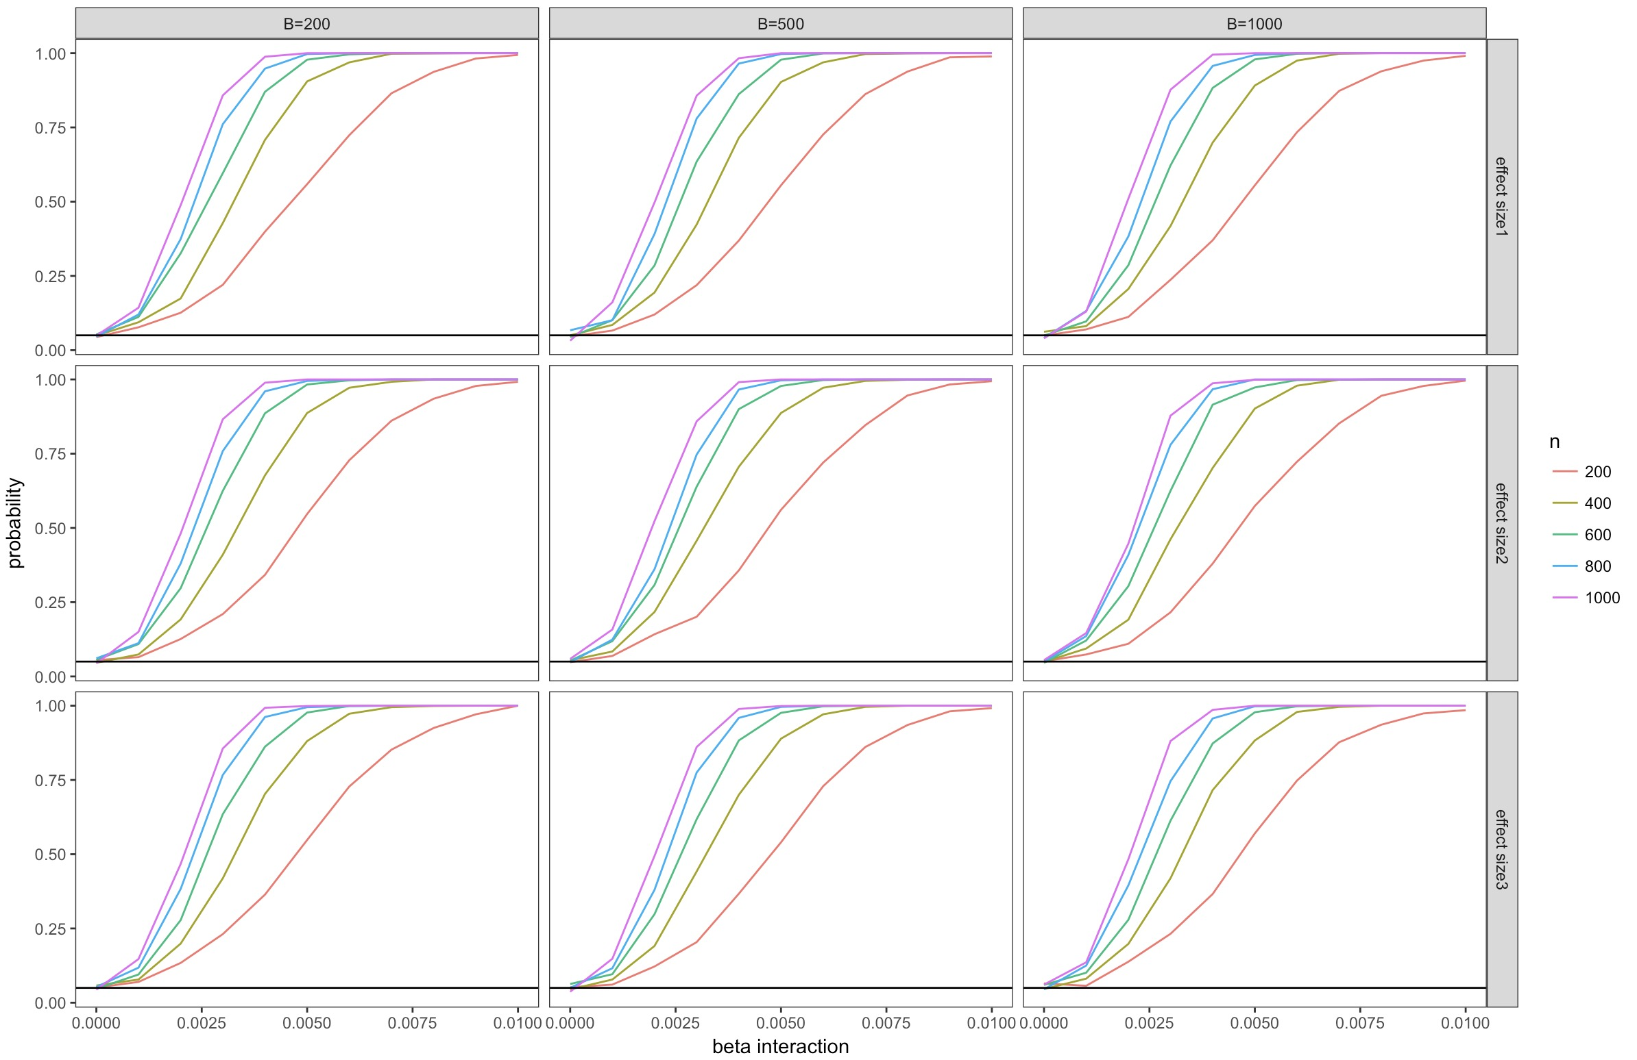

Figure1: Estimated $\hat{P}(p<0.05)$ (y-axis) as a function of Interaction Strength $δ∈[0, 0.01]$ (x-axis). **Effect size1**: coefficients for X1 $∈[20, 50]$, coefficients for X2 $∈[10, 30]$; **Effect size2**: coefficients for X1 $∈[50,80]$, coefficients for X2 $∈[40, 60]$; **Effect size3**: coefficients for X1 $∈[100, 130]$, coefficients for X2 $∈[90, 110]$.

Horizontal line marks the test’s significance level (0.05). When $δ=0$, $\hat{P}$ should be around this line.