Note : If using a laptop make sure it is connected to mains electricity before you begin.

1. When you receive the disk insert it in the cd drive. Click on My Computer in your START menu.

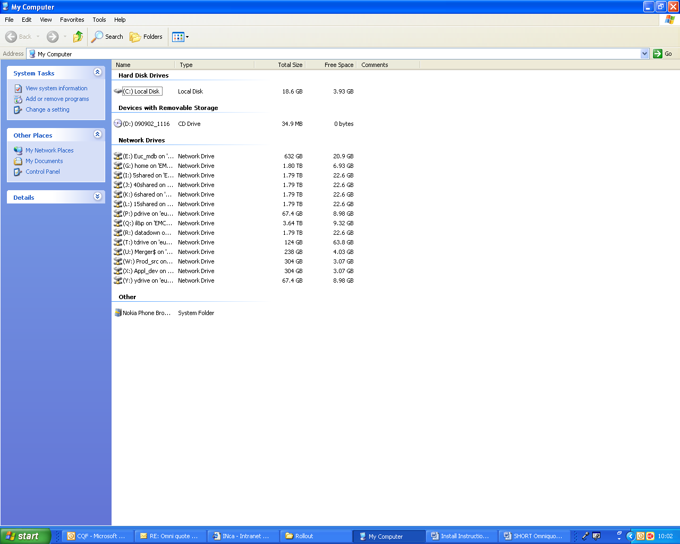

Click on the CD drive.

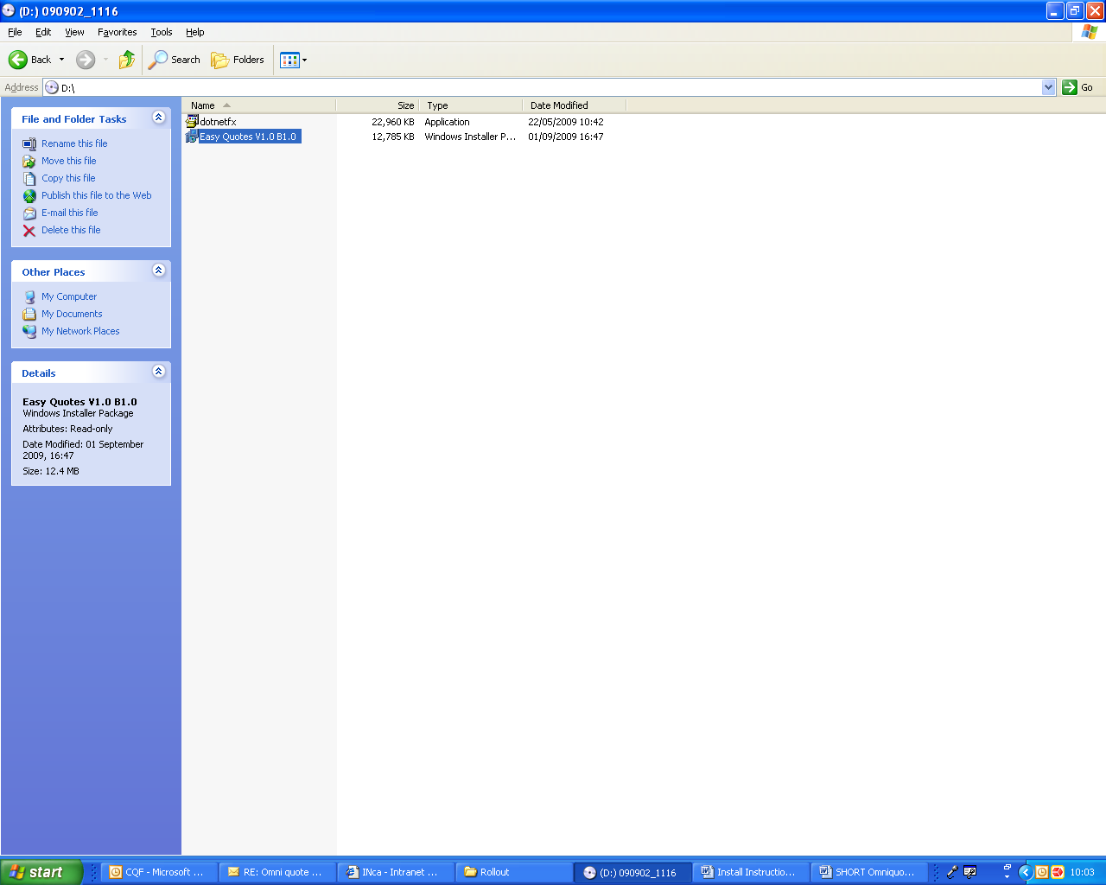
2. Click on Easy Quotes. (If you get an error message about .NET framework, see note at the end of this document on missing software)

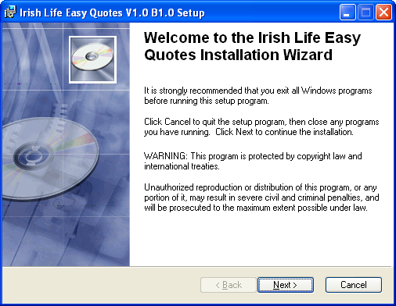
3. The installation process will start. Click Next
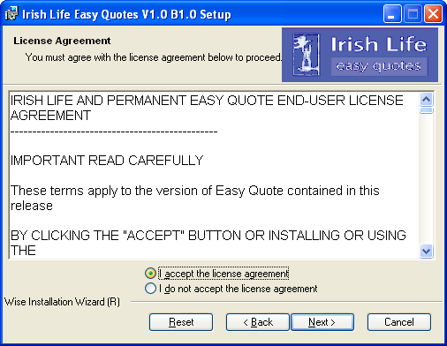
4. Accept the agreement and click Next

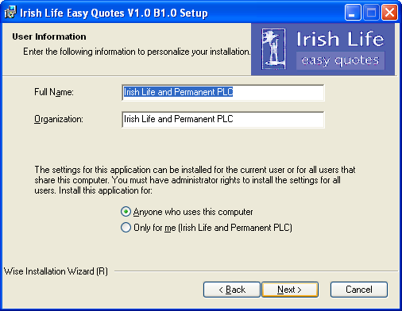
5. Click Next
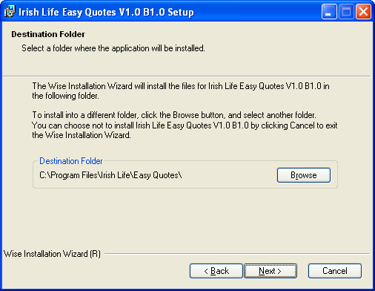
6. Click Next

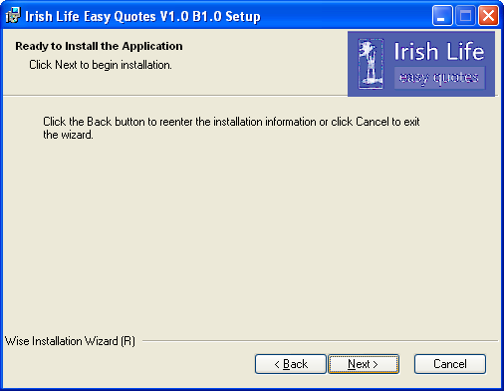
7. Click Next

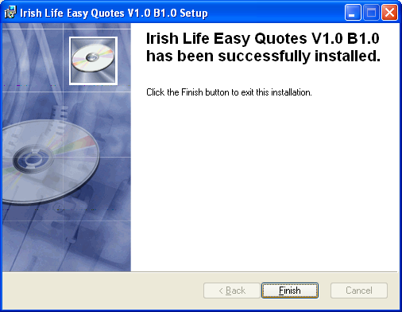
8. The install will run. Click Finish. You are now installed. To run easy quote click on the Easy quote icon on your desk top.
The first time you use the system you will be prompted for your user code and password. These can be found either printed on your CD or have been notified to you by email. If you do not have your user id and password please contact the Irish Life helpdesk on 1890 924 946.

Note: if you are missing .NET Framework you will get the following message after step 2 above.

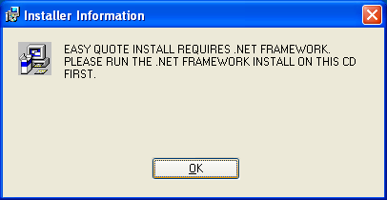

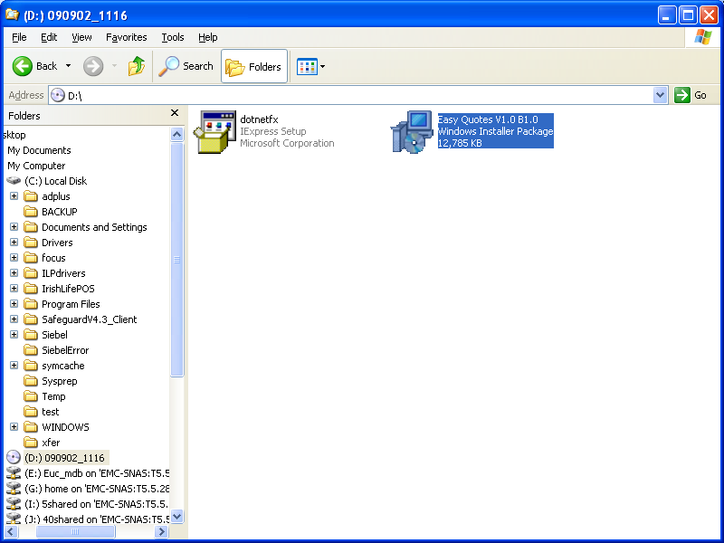

Go to you My Computer view and click on the dotnetfx install.
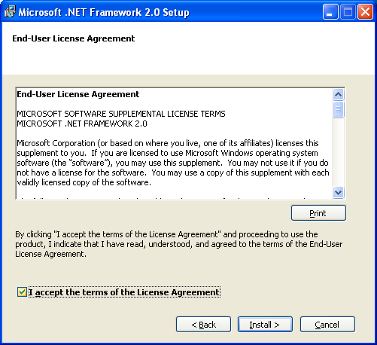
Accept the agreement. This install will take about 3 minutes, be patient.
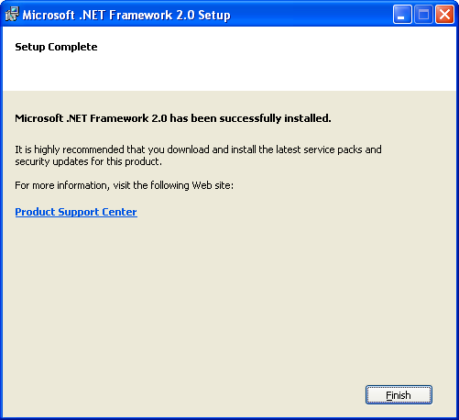

Once the install is complete. Click on Finish and then go back to step 1 above and run the Quotes install again.

