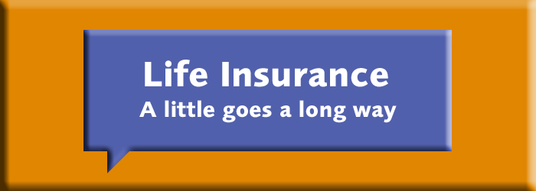

Dear <John>

We insure our cars, our holidays and sometimes even the family dog, but the very thing we may forget to insure is the most important of all – ourselves and our families. In fact based on recent research, the top ranking concern for people at the moment is the death or sudden illness of ones self or a partner (Source: IReach, April 2012).

When it comes to buying our mobile phone, broadband and daily cup of coffee, we often buy these automatically. Take a look below to see how much we might spend every month on these things.
Would you spend this much on protecting your most valuable asset – your family?

Protecting your family is very affordable. The life cover cost below is based on the Life Term Cover plan from Irish Life with €150,000 of cover over a 20 year term for a non-smoking male aged 40 and includes the 1% government levy. The cost of life insurance depends on your age, health, amount of cover, gender and product type. You must keep up your monthly payments to stay on cover

ITEM | COST PER MONTH
Health Cost | €81.40
Daily Coffee | €66.73
Satellite/Digital TV | €33.00
Mobile Phone | €39.66
Broadband | €30.00
Life Insurance + peace of mind | €22.34

The costs shown in the table above were correct in April 2012. The life cover cost is based on no indexation and no conversion. The price shown for satellite TV is for UPC Digital Select Extra package. The price shown for broadband is the average of Imagine and Eircom’s comparative packages. The cost of coffee is based on an average price of €2.30 a day. Health cover is based on the average of VHI Health Plus Extra (Plan B Option), Aviva level 2 Family Health with day-to-day and QUINN-healthcare Essential Health. The cost shown for mobile phone is based on the average of Vodafone, Meteor and 3 Mobile’s equivalent pay-monthly plans.

Why not take the life insurance challenge to see just how affordable life insurance will be for you?

Click here to take the life insurance challenge - How much would €100,000 cover cost you?
Isn’t it surprising that the cost of life insurance can be just a fraction of some of your other monthly outgoings.

If you would like to run through your finances in more detail with a protection review feel free to give me a call on <mob number>. Alternatively ill call you over the coming weeks.

Kind Regards

Broker Name

Irish Life Assurance plc is regulated by the Central Bank of Ireland.

