Step by step guide to downloading apps for your Smartphone.

Apple iPhone

- Go to iTunes and create a new account.

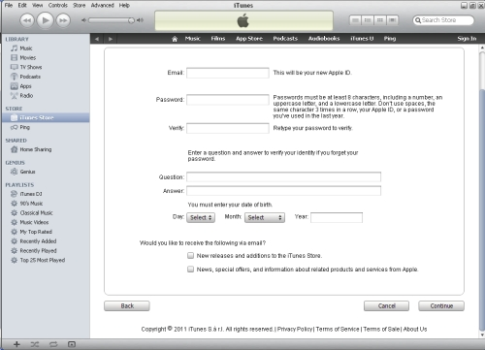

- From your iPhone, click on the App store button

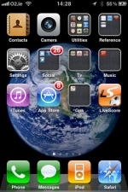
Click on the App store button

- Hit search, type in the name of the app you want and hit the blue search button


Type the name of the app and hit blue search button

- Select the app you want and tap the Free button


Tap the Free button to install App

- Type in the username and password you chose when you registered in Step 1 above and hit ok

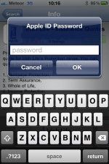

Android Market

- Open up the Android Market

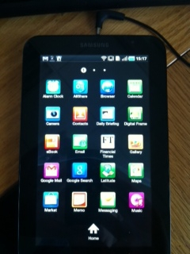
Click on Market icon to open up the Android Market

- Tap the magnifying glass and type in the name of the app you want to install

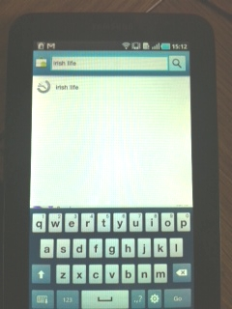
Type in name of app and hit magnifying glass

- Tap the app that you want on the search results screen

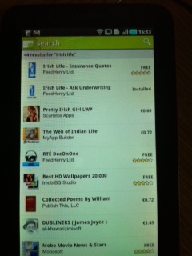
Tap on app you want to install

- Tap the install button and app will then install on your device

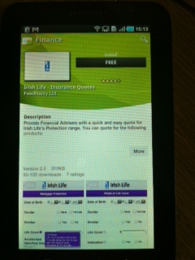
Press install button to download app

Windows Phone

- Open up Windows Marketplace

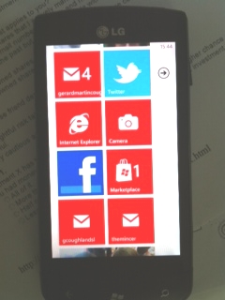
Open up Windows Marketplace

- Type in name of App and press magnifying glass button

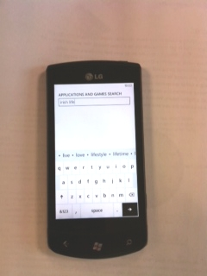
Press the magnifying glass button

- Tap on the name of the app in search results screen

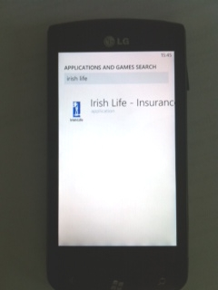
Tap on the name of the app

- Click install

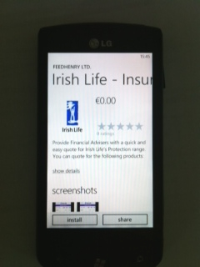
Click Install

