In the Word document click on tools and select options –

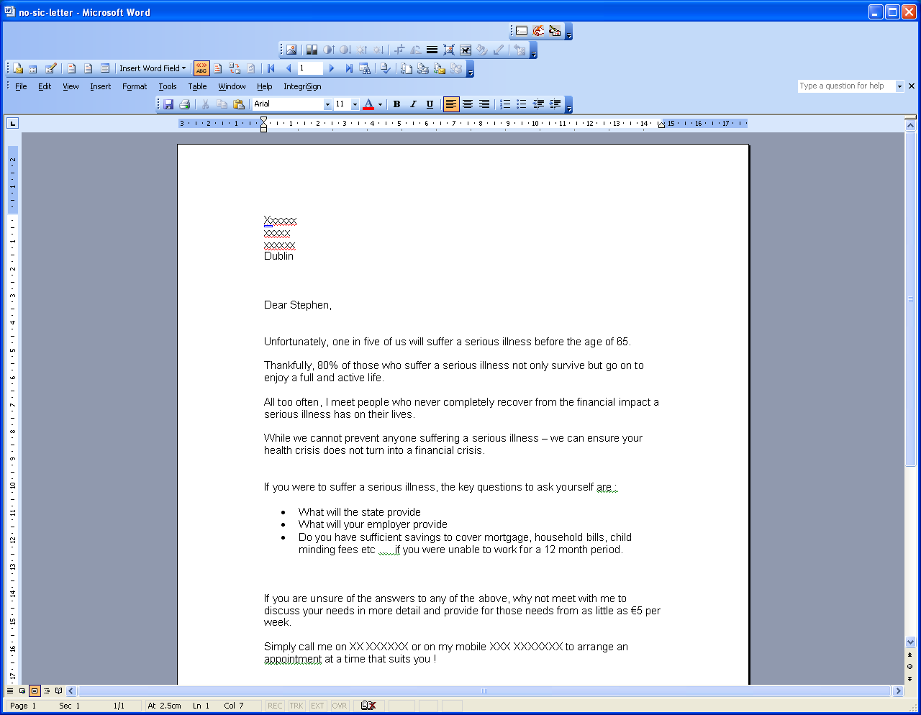

Now click on Security – near top left – then click on Macro Security – bottom right

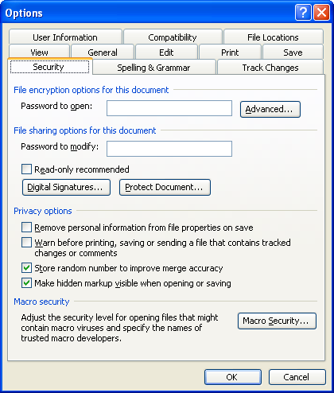
Now ensure that last option is selected and then OK .