How to use Git in linux.

1. SSH KEY set

1)Create keys:

$ ssh-keygen -C 'your@email.address' -t rsa

#better use your email address in github.com

#If you did not set up the ssh keys before, type enter till the end. It will create a folder called .ssh in the directory you execute the command. We will use the pub key called id_rsa.pub in the .ssh folder in next step.

#If not, follow the command to give the key a good name. It will create a pair of keys with the name in your keys folder. The pub one is what we need.

2)add ssh key to github

a. $ cat yourpubkey.pub, copy all the content.

b. log into your github. Click your profie in the right, choose setting, then choose ssh and GPG keys, click the green button called New SSH key. Then past what you copy the step above. Save.

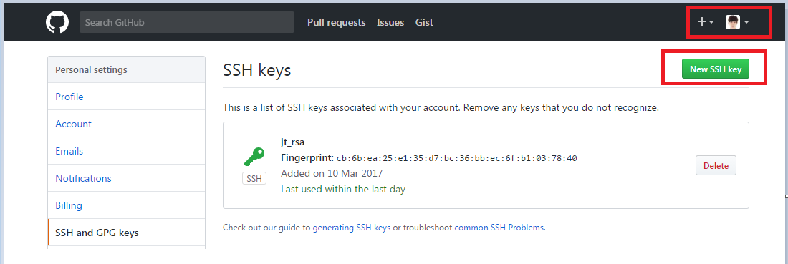

3) test ssh key

$ SSH -v [git@github.com](mailto:git@github.com)

1. Clone from github

$ git clone <https://github.com/MKR-GDC/MSDEV-BDPOC.git>

Then you will get the same folder with all the things from github in the current path.

1. Upload code
2. Copy the file to the mirror clone location of where you want to upload. Then be sure you’re in the path where you copy the file to.
3. $ git add yourfilename #add your file

$ git commit –m ‘your comment’ # add comment

$ git remote –v #check your remote link’s name(always origin)

$ git push origin master #origin is your push link name.