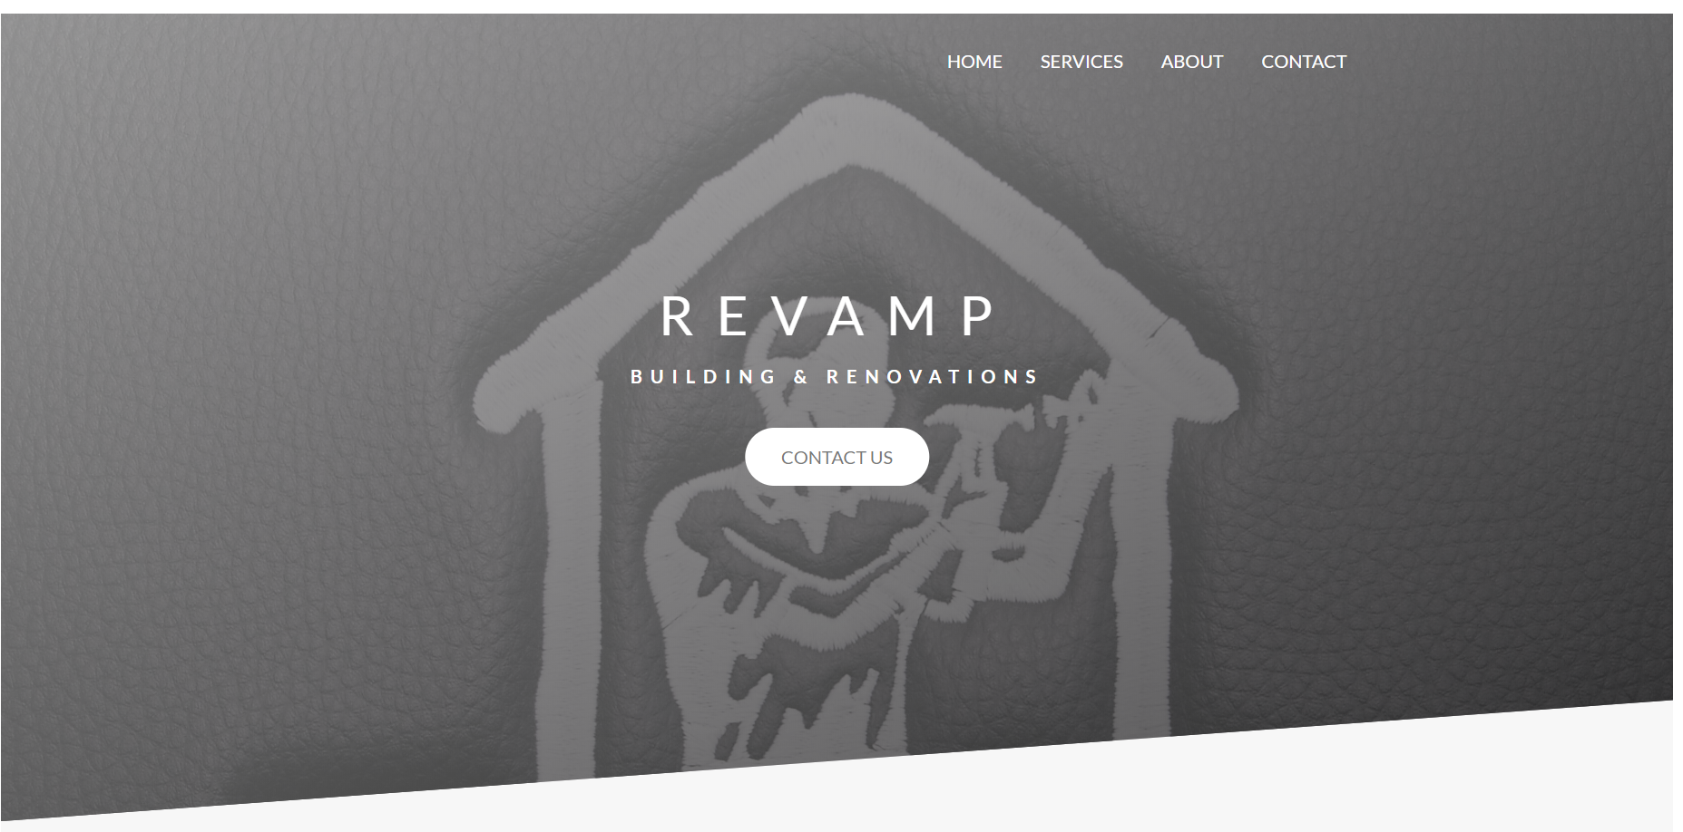

**Final Report**

**Introduction**

For this Web Design project, I have designed and developed a site for a small building and renovation business – Revamp – located in Co. Kildare. The reason for this choice was that the owner of Revamp approached me and asked me to design and develop a modern website for his business.

Revamp’s website (recently taken down) was developed in 2006. Little or no changes had been made in the intervening years which meant the site was no longer fit for purpose. The two main issues were:

* Lack of responsiveness. In 2006, the vast majority of people accessed websites on laptops and desktops (according to statista.com, less than 1% of sites were accessed through phones in 2009, by 2018 that figure had risen to 52%). Whilst the Revamp site continued to be readable in 2018 for those on larger screens, it was unreadable and therefore unusable for a majority of users who wished to access it on their phone. By implementing a CSS grid system along with the use of Media Queries, the new site is equally user-friendly whether one is on a desktop or a smart phone.
* A change in design methods and tastes: In 2006, CSS was still a relatively new technology. This new found ability to style web pages seems to have gone completely to many web designers’ heads leading to a visual assault of clashing colours and gaudy effects. The old Revamp site suffered greatly from this. Not ideal if you’re trying to convince someone to hire you to remodel or redecorate your home! As well as a change in tastes to more subtle styles and colours, the power of CSS has also increased dramatically, leading to almost endless possibilities in terms of effects and animations. Several of these have been included in the new site – such as photographs that animate and cards that rotate on hover to reveal more information on the back.

**Research**

In order to deliver the best possible project to this customer, I decided to adopt a three-prong approach to my research. I talked with Revamp’s owner to get his views and suggestions for the new site; I interviewed a small number of potential customers to find out what they would expect in a website for a builder; and lastly I looked at other websites (both in the construction and in other industries for ideas).

* Revamp owner’s input:

The old site reflected the fact that Revamp initially focused on building extensions to houses and installing decking in back gardens (apparently building decks was a very lucrative business during the Celtic Tiger!). Over the years though, the focus has changed and now the main part of the business is installing bathrooms. Revamp wanted this emphasised on the new site (whilst still mentioning its other services such as extensions, decks etc.).

The original site also used only a very small number of images and these were tucked away on secondary pages. The owner wanted images of nicely renovated bathrooms displayed prominently on the home page.

The owner also wanted the new site to be responsive.

* Customer’s persona:

Interestingly, Revamp’s owner revealed that the vast majority of his customers – i.e. the person who actually hires him and oversees his work – are female. They may be living alone or with a partner, but the customer ultimately making the decisions is almost always a woman. Typically, they are between 35 and 60 years old and own their own house or apartment. For bathrooms, their budgets are usually around €5,000. The survey I carried out (see Appendix A) reflected this demographic.

The surveys resulted in the creation of a primary persona of a typical customer: Karen is 46 years old and lives with her husband John and their three children in a 4-bedroomed semi-detached house in Naas. Both Karen and John work fulltime as teachers. With the economy picking up, they now feel they have the financial resources to renovate their bathroom, which is almost 20 years old. They plan to spend about €5000 on a new bathroom, but might increase this to €6000 for a particularly nice option. John has left the bathroom renovation project entirely in the hands of Karen.

In terms of a website for a building contractor, Karen wants a site that is easy to navigate and it must be accessible on a phone as she rarely uses a laptop or desktop. Rather than mountains of text describing the services offered (a characteristic of the old Revamp site), she wants to see nice clear photos of bathrooms so that she can judge the quality of Revamp’s work and also possibly get inspiration for her own renovations. She would also like to see evidence of other customers’ satisfaction as well as evidence that Revamp is a legitimate company (i.e. fully insured, all work guaranteed, registered for tax etc.). Lastly, she wants a simple process to get in contact with the company through either a contact form or a phone number.

* Other sites: In search of inspiration for the new Revamp site, I visited many other websites. Some of them were for other building contractors (e.g. placelift.ie and nuhaus.ie), others had nothing to do with construction (e.g. apple, Airbnb, blueapron.com etc) but I thought they might offer some design inspiration. The conclusions I reached from this research was that many of the best sites tended to have scrolling home pages that were muted in colour, effectively used large amounts of whitespace, and a good mixture of images (e.g. some as background) to complement text. There is also a tendency for the home page to be divided into sections where users scroll down the page. All of the above I attempted to incorporate into my project site.

**Design**

With the research phase completed, I could then move onto the design phase. The research led me to decide that the centrepiece of the site would be the home page. I wanted the user to be greeted with a page that had a professional and elegant feel. I didn’t want their initial experience to be cluttered with too much going on. I decided to begin the home page with the Revamp name animated against a backdrop of an image of the Revamp logo. Below that is a simple call to action button. At the top of the page is a navigation bar. That’s it – the user can take all this in in a moment and, at their leisure, can then begin to scroll down to the bathroom and other sections.

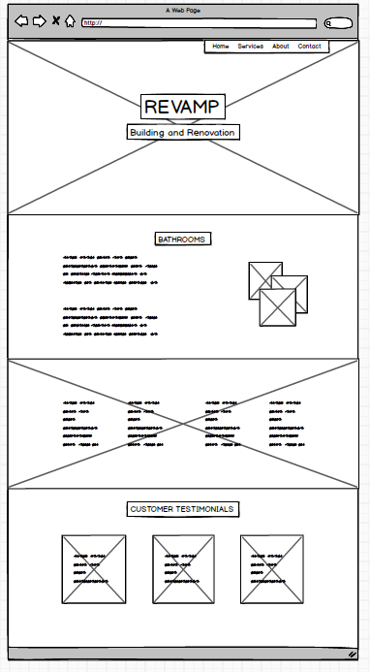

In comparison to the home page, the other three pages of the site are quite simple. This was deliberate as the feedback from the persona interviews was that users value simplicity. They want a contact form to be simple to find and simple to use. The pages on my project’s site are both.

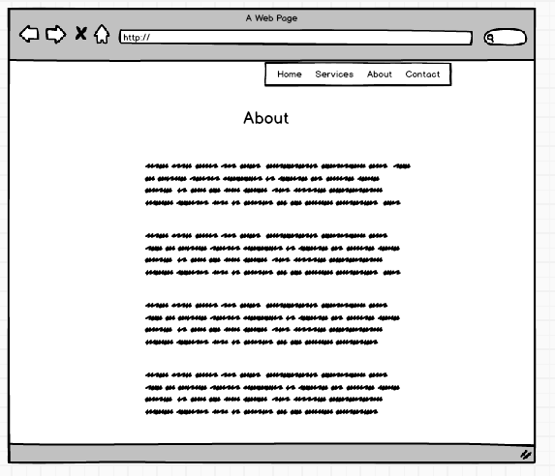

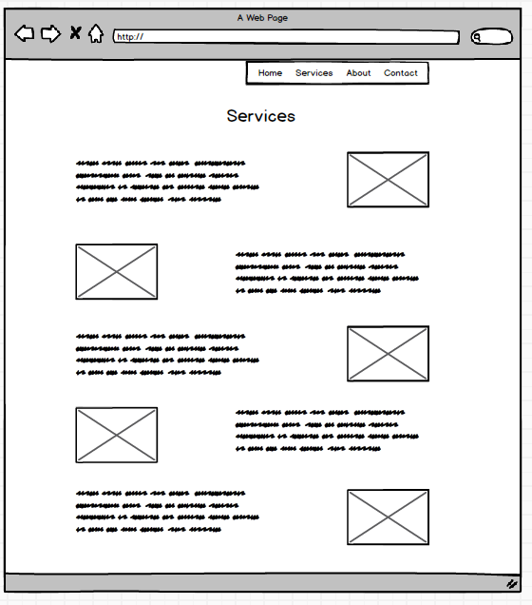

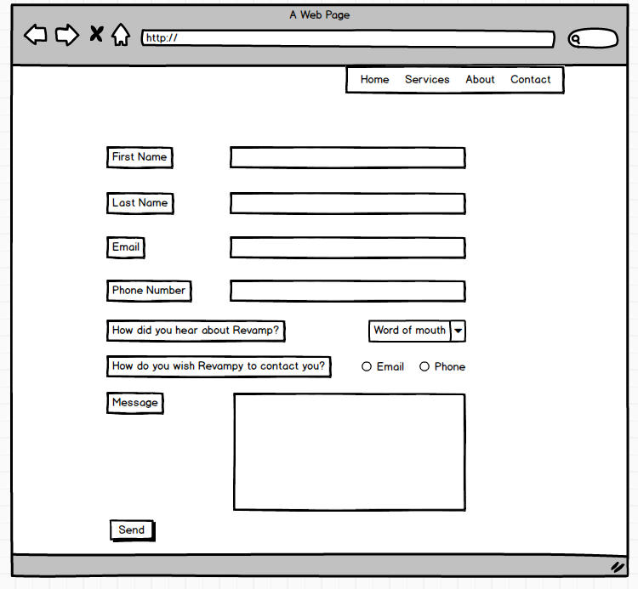

**Development**

In order to manage and keep the project on track, I used a Gantt chart (below) to divide up the various tasks and assign them each a duration so that I would have a better idea as to how the project was progressing. I decided to break the project down into four main sections: Research, Design, Development and Testing (each of which had their own sub tasks further broken down by duration). This resulted in a final estimation of 11 days for the project.

As I was doing this project on my own, there was no need to assign tasks to different team members. Nor was there any need for team meetings!

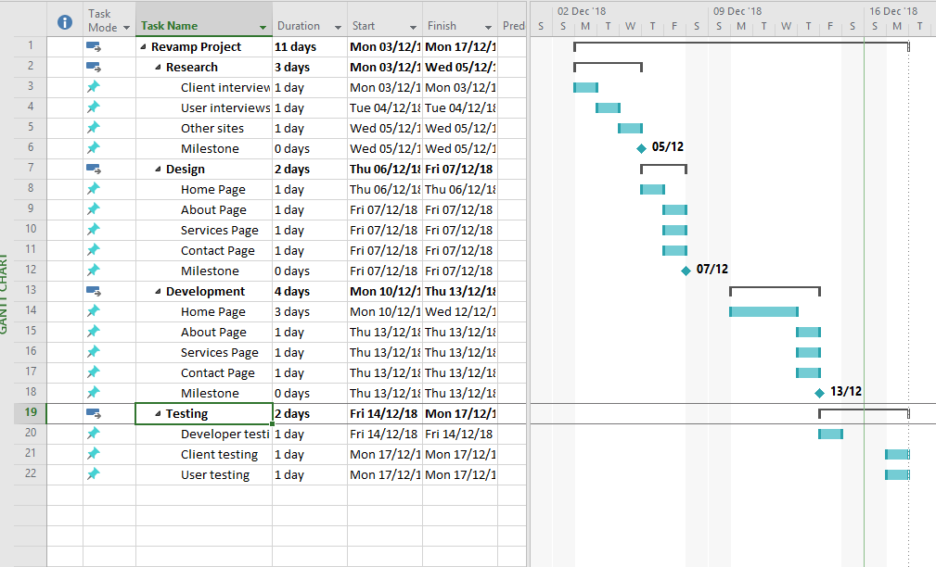

**Usability Testing**

As recommended, I used the Think Aloud Protocol for usability testing. More specifically, I went back to my original four interviewees as well as Revamp’s owner and asked them to use the new site whilst I observed them. I asked them to speak aloud their thoughts and suggestions as they navigated the various pages. I found this to be extremely useful and received some excellent feedback which I then implemented in the final design.

One issue that a couple of the users mentioned was that they felt that it wasn’t immediately obvious on loading the home page that a user could/should scroll down the page to see more information. For them, it appeared as if the darkened background image with the navigation bar and Revamp name superimposed was the entire home page! I modified the viewport height of the background image to 95% from 100% so as to give users the indication that there is more below that top section.

The original colour scheme for the site was a light green colour. When I gave the users the option of the grey colour, they all preferred that and so I changed the colour scheme (very easy to do using SASS variables).

The users all commented on how ‘clean’ and ‘sharp’ the site looked. They really liked the use of CSS animations especially the effects used to transform the photos and the effects used to rotate the customer testimonial cards. Several mentioned how ‘uncluttered’ the site appeared.

Several of the users thought that the site appearance could be improved on mobile devices – there was particularly an issue involving the padding between sections which needed to be reduced on smaller screen sizes.

A couple of the users commented that the contact form could be simpler. They didn’t want to have to fill out eight fields before submitting the form. Whilst this was a necessary criteria for the project, the real site will indeed have fewer fields.

Overall though, the feedback from the users and the owner was very positive and only relatively minor adjustments had to be made before the website is ready for full deployment.

**Appendix A**

The following survey was administered to four potential customers. From the data received, a primary persona was created (“Karen”) which is discussed in the Research section of the final report.

Q1. The person(s) most likely to choose a tradesperson for my home is:

* Male - Female - Both

Q2. Do you own your own home?

Q3. How many bedrooms in your home?

Q4. The age of the person choosing the tradesperson is:

20 – 39 40 – 59 60 +

Q5. If you were renovating your bathroom, how much would you be willing to spend?

Q6. When choosing a tradesperson, rank the following factors in order of importance (1 being the most important)

1. Cost
2. Reputation
3. Availability
4. Easy to deal with
5. Insured / taxed / work guaranteed
6. Other (please specify)

Q7. If you were looking for a tradesperson on the internet, which device are you most likely to use?

1. Mobile phone
2. Tablet
3. Laptop
4. Desktop

Q8. If you were looking at a tradesperson’s website, what would be the most important factors?

1. How easy to navigate the site
2. Lots of text information about the various services offered
3. Lots of phots of examples of previous work
4. Other customer testimonials
5. Easy means of contact
6. Information about prices
7. Other (Please specify)