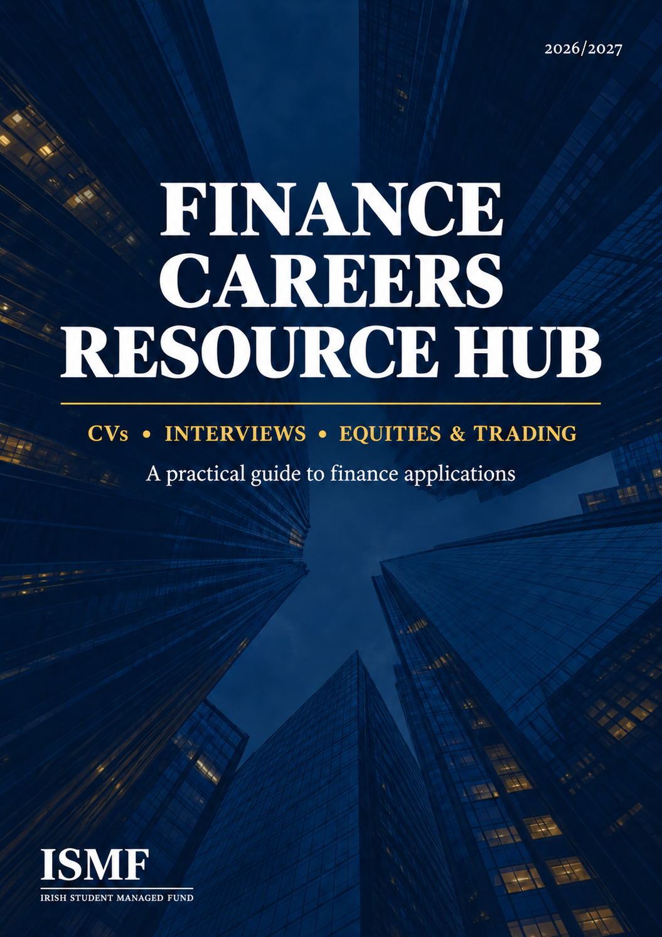
SECTION 01 · THE FINANCE CV
The Finance CV
Breaking into finance can feel overwhelming - countless firms, roles and opinions on what makes a strong candidate. The principles, though, are consistent: build a strong profile, then present it clearly.
Your CV exists to answer one question:
“Why should this candidate progress to the next stage?”
Recruiters may spend only seconds on a first pass, so specifics and numbers do the work adjectives can't. Aim for one page - at this stage you haven't done enough to justify more, and a second page usually means you're either padding or not using your space efficiently.
YOUR CV NEEDS TO BE  • Specific, not descriptive  • Evidence-based and quantified  • Professionally formatted |  | AND ALWAYS  • Tailored to the role  • Free of errors  • Genuinely yours

Recommended Structure
Five sections, in this order. Cut anything that doesn't earn its place.
1. Header — Name, phone, email, LinkedIn, location.
2. Education — Institution, degree, location, expected graduation date, current or expected grade (state a First as “expected” until confirmed), and relevant modules if your grade is strong.

EXAMPLE
University College Cork — BSc Finance
Cork, Ireland | Expected 2029
First Class Honours (expected) / XX.X% average
Relevant modules: Financial Accounting, Corporate Finance, Economics, Financial Markets

3. Professional Experience — Most recent role first: company, position, location, dates. Use 3-4 bullets per role, each following Action + What you did + Result, and lead every bullet with a strong verb.

WEAK  “Assisted customers and handled transactions.” |  | BETTER  “Managed customer transactions in a fast-paced environment while maintaining accuracy and delivering efficient service to 500 customers a day.”

SECTION 01 · THE FINANCE CV
4. Leadership, Extracurriculars & Projects — Especially important for students: finance societies, investment clubs, student-managed funds, case competitions, committee positions, sports teams, charity fundraising, or personal/group projects you led. Show responsibility and contribution, not just membership.

WEAK  “Member of Finance Society.” |  | BETTER  “Selected for the Investment Society committee, helping organise 50 industry events and coordinate engagement with 10 finance professionals.”

5. Skills & Interests — Technical skills and languages, relevant certifications, and genuine interests you could discuss confidently. Add soft skills only for a cover letter, or where a job description specifically asks for them.

• Technical: Excel, PowerPoint, Python, etc.  • Languages: English, French, Spanish, etc. |  | • Certifications: relevant finance or technical qualifications  • Interests: only what you can discuss confidently
If you list Excel, be ready to discuss what you can actually do with it - anything on your CV can become an interview question.
The 10-Second CV Test
Ask someone to look at your CV for ten seconds, then ask: “What do you remember about me?” If the answer is unclear, the CV needs work. A recruiter should be able to quickly identify your university, degree and academic performance, your most relevant experience, your leadership involvement, and your technical skills.
SECTION 02 · CV DO'S & DON'TS
Finance CV Do’s & Don’ts
Content beats decoration. The strongest finance CVs are specific, tailored, evidence-based and error-free.
DO  Be specific, not descriptive — “Owned 3 recurring reports across 6+ markets” beats “managed workflows.” Concrete nouns and numbers are what catch a recruiter's eye.  Quantify wherever honest — Volume, scope, percentages, people, hours, revenue - even a rough number is more convincing than a claim.  Lead with a strong verb — Analysed, evaluated, led, developed, built, negotiated, delivered, coordinated, researched, improved.  Tailor every application — Reorder or cut experience to match what the role actually asks for - a hospitality CV and a finance CV shouldn't read the same.  Keep it to one page — Every line should earn its place.  Keep formatting simple and aligned — Clean, consistent fonts and clear headings read well on screen, in print, and to an ATS.  Proofread thoroughly — Spelling, grammar, dates, capitalisation, company names, degree title, contact details, file name. |  | DON’T  Use soft-trait headers — “Reliability” or “Efficiency” as a bullet header reads as self-assessment. Let the specifics prove it instead.  Use a generic objective or photo — A personal statement or profile photo adds nothing and takes up space that could work harder for you.  Write in paragraphs — Recruiters want information fast - use concise bullet points.  Exaggerate — Never claim modelling expertise, advanced Excel, or experience you can't defend in an interview.  Over-design — Avoid heavy graphics, logos, skill bars, excessive colour or icons.  Use ALL-CAPS headers or jargon — Clean, simple structure reads better than anything trying to look “corporate.”  Include irrelevant personal details — Age, date of birth, marital status, or nationality (unless relevant). You can include your address but this is not necessary.
Send a different, tailored CV to every application - never the same one on repeat.
CONTENT BEATS DECORATION.
SECTION 03 · FINANCE INTERVIEW GUIDE
Finance Interview Guide
Getting the interview is only half the process. The goal isn't to memorise hundreds of answers - it's to prepare enough that you can communicate naturally under pressure. Most finance interviews test four areas:
FIT / MOTIVATION  Who are you?  COMMERCIAL AWARENESS  Do you understand markets and business? |  | TECHNICAL  Do you understand the fundamentals the role requires?  COMPETENCY  Can you demonstrate the relevant behaviours and skills?

Two Kinds of Question

• Subtext questions (“tell me about a time you…”) test how you think - the reasoning behind your actions matters more than the story itself.
• Direct questions (“what's your experience with X”) want a literal, specific answer - don't wrap it in a story.

Common Fit Questions
• Tell me about yourself / walk me through your CV  • Why finance? Why this division?  • Why this firm? |  | • Strengths, and a weakness you're working on  • A time you showed leadership or teamwork  • A failure or a difficult situation

SECTION 03 · FINANCE INTERVIEW GUIDE
“TELL ME ABOUT YOURSELF”  Structure it, don't recite it chronologically. Aim for 60-90 seconds - it should sound like a coherent story, not a list of achievements.  “WHY THIS FIRM?”  Don't just say “great reputation.” Research the firm and connect what you find to your own interests and experience. |  | “WHY FINANCE?”  Avoid “I like numbers and think finance is interesting.” Structure it instead: what interests you → what you've done about it. Make the answer authentic to you.

Competency Questions — STAR, Kept Tight
• S – Situation: what was happening?  • T – Task: what needed to be achieved? |  | • A – Action: what did you personally do?  • R – Result: what happened?
Action and Result are what's actually being listened for - don't spend 80% of the answer on Situation.

Build Your Story Bank
Prepare at least one strong example for each of the following before you walk in. Examples don't need to be finance-related - university, sport, part-time work and volunteering all count.
• Leadership  • Teamwork |  | • Problem-solving  • Failure

How to Prepare
• Practise answers out loud, not just in your head - what sounds clean internally often rambles out loud.
• It's fine to say something is “still developing.” Honesty reads as credibility; confident bluffing falls apart under follow-up questions.
• Research the specific company, not generic prep - one concrete, current detail gives you a real answer to “why here,” not a generic one.
• Know what's happening in the market - it shows genuine interest and gives you talking points beyond the textbook.
• Know your CV inside out - be ready to explain any line of it immediately.
• If you don't know a technical answer, don't invent one - demonstrating logical thinking is often more valuable than confidently giving incorrect information.
SECTION 04 · COMMERCIAL AWARENESS
Commercial Awareness
You don't need to know everything happening in the world - you need to be able to discuss a small number of developments intelligently.

That is the difference between knowing a headline and understanding it.

Pick a small number of current stories you can genuinely go deep on - what's happening, why it matters, and who it affects. Anything you raise can become a follow-up question, so depth on a few topics beats breadth.

SECTION 05 · INTERVIEW DAY CHECKLIST
Interview Day Checklist
A practical, printable checklist to work through before you walk into (or log into) the interview.
☐ Research the firm  ☐ Research the division  ☐ Review your CV  ☐ Prepare your “Why Finance?” answer  ☐ Prepare your “Why Firm?” answer  ☐ Prepare competency examples |  | ☐ Review technical fundamentals  ☐ Test your technology if virtual  ☐ Know the interview location / time  ☐ Dress appropriately  ☐ Get enough sleep

SECTION 06 · QUESTIONS TO ASK INTERVIEWERS
Questions to Ask Interviewers
Avoid questions the firm's website already answers. The best questions are specific, thoughtful and conversational.
01
What distinguishes analysts who perform particularly well on this team?

02
What has surprised you most since joining the firm?

03
How has the team's work changed over the past few years?

04
What makes this team different from its competitors?

05
What do candidates often misunderstand about this role?

A thoughtful closing question is one of the most memorable parts of an interview - use it well.

SECTION 07 · ROADMAP & FINAL CHECKLIST
Finance Recruitment Roadmap
Treat recruitment as a process, not a single application.

APPLICATIONS | ASSESMENTS | INTERVIEWS | OFFER
1. Research — identify firms and roles that genuinely interest you.
2. Prepare — build a strong CV and application; speak to alumni, society speakers and professionals.
3. Apply — track every application.
4. Prepare for assessments — numerical, logical, situational judgement.
5. Interview — prepare both fit and technical content.
6. Review — how did the interview go, and how can it improve next time?

Final Application Checklist
A three-part check before you submit anything.
CV  ☐ One page  ☐ Relevant content  ☐ Clear, consistent formatting  ☐ Quantified achievements  ☐ No spelling errors  ☐ Correct dates & company names |  | APPLICATION  ☐ Firm and role researched  ☐ Motivation is specific  ☐ No generic statements  ☐ Reviewed before submission  INTERVIEW  ☐ Why Finance / Why Firm / Why Role prepared  ☐ STAR examples prepared  ☐ Questions prepared
You don't need to be the most experienced student in the applicant pool. You need to demonstrate curiosity, preparation, analytical ability, communication, and consistency.
SECTION 08 · EQUITIES & TRADING
Equities & Trading
Role-specific guidance for students targeting trading and equity research - what these interviews test beyond the general process above.

Trading
• What they're really assessing: drive, initiative, genuine interest and willingness to learn - valued far more than existing knowledge.
• Know the firm before you walk in - its history and what it actually does day to day. This alone signals interest and drive.
• You are not expected to know everything. Trading spans many markets that don't transfer neatly between one another, and recruiters know this - your initiative matters more than your existing knowledge base.
• A desk is bigger than the trader. Research, modelling, analytics, forecasting, portfolio optimisation, risk and settlements all sit around the trading seat - experience in any of these builds a stronger, more rounded trader.
• For entry-level roles, shift your CV out of “college / part-time job” mode and into a corporate, career-ready one.
• Independent projects count. A markets blog, a trading algorithm, or similar self-directed work shows the initiative recruiters look for and helps you stand out.
SECTION 08 · EQUITIES & TRADING
Equity Research

Market Interviews
• Expect far more market discussion than in a typical interview.
• Don't memorise answers word-for-word - spend prep time genuinely understanding market themes.
• Be ready for “What's happening in markets today?” and to go several layers deep on anything you raise - mention rates, and expect a follow-up on Fed policy and which asset classes it affects.
• Stay on topic and avoid tangents. Genuine interest makes this section noticeably easier.

Technical Interview
• Expect a maths or numerical assessment for analytical roles - common topics include probabilities, fractions, discount rates, annuities and terminal value.
• Use firm-specific practice tests where available; many banks test similar concepts, so independent practice still transfers.
• AI tools and online resources can generate additional practice questions.

Behavioural Questions
• Trading and research firms know you'll be wrong often - prepare an example of getting something wrong and responding well.
• Don't be afraid to discuss a genuine setback; they're testing resilience, self-awareness, and whether you learn from mistakes.

Mental Maths & Estimation
• Expect estimation (“black box”) questions - the interviewer isn't looking for the exact answer, but for how you approach an unfamiliar problem.
• Start with a reasonable confidence interval, break the problem into logical components, and talk through your assumptions out loud.
• Example: Spotify subscribers → population → device access → music listeners → Spotify's market share. Refine your range as new information is given - the thought process matters more than the final number.

Buy-Side vs. Sell-Side Research

BUY-SIDE  Supports a firm's own investment decisions. At a trading firm such as SIG, it's ultimately used to trade on - often over a short horizon, sometimes just days. Coverage tends to be narrower but considerably deeper. |  | SELL-SIDE  Produced for institutional clients, and can also support a firm's wider investment banking and trading businesses. Clients use it to inform decisions and gauge market consensus.

Buy-side investors often read sell-side research specifically for that consensus view, then decide whether to position with it or against it.

Sample Morgan Stanley CV Template
[NAME]
[Primary address]
[phone no.] | [email address]

EDUCATION
Imperial College Business School London, United Kingdom
M.Sc. in Financial Engineering and Risk Management Expected September 2016
- Relevant Coursework: [Most relevant modules for role, no more than two lines]
- Awards:

University College Dublin Dublin, Ireland
B.Sc.in Economics and Finance, Mathematics and Statistics Stream Graduated September 2015
- Honours: [First/Second] Class Honours GPA: X / 4.2
- Relevant Coursework: Financial Economics, Econometrics, Differential Equations, Geometry, Financial Mathematics, Stochastic Models and Corporate Finance
- Awards: UCD Entrance Scholar

[School Name] [County], Ireland
- Leaving Certificate X/625 points (top X%).
- A1 grades in …
- Awards:

WORK EXPERIENCE
[Company Name] [City], [State/Country]
[Position Title], [Group Name] [Start Date] – [End Date]

[Company Name] [City], [State/Country]
[Position Title], [Group Name] [Start Date] – [End Date]

[Company Name] [City], [State/Country]
[Position Title], [Group Name] [Start Date] – [End Date]

ADDITIONAL SKILLS AND ACHIEVEMENTS
IT Skills:
- Experienced in the use of ….

Sporting Achievements:

Other Achievements:

ISMF
ISMF · FINANCE CAREERS RESOURCE HUB

RESEARCH
THOROUGHLY.
BUILD
PROGRESSIVELY.
PREPARE
DELIBERATELY.

ISMF Finance Careers Resource Hub
CV → Applications → Interviews → Offers.
Use this guide as a starting point, then seek feedback from peers,
alumni, careers staff and industry professionals.

