A Website Framework for Adults with Intellectual Disabilities to aid literacy and skills retention.

Semester 1 Status Report

Karen McCarthy

20004879

Supervisor: David Power

BSc(Hons) in Information Technology

Introduction 3

Project Description 4

Goals of the project 7

Intended Audience 7

Research 9

Existing Systems 12

User Requirements 14

Interviews 15

Methodology 17

Risk Analysis 19

Functional Requirements 19

User Access & Authentication 19

Learning/Game Modules 22

Non-Functional Requirements 25

Accessibility 25

Design 29

Interface Wireframes 30

Software & Tools 31

Live Technological Prototype 31

Conclusion 32

Schedule 32

Weekly Activities 33

**Table of Figures**

Figure 1: Internet use in Ireland, in the last 3 months and every day or almost every day by statistical indicator and Age Group (CSO, 2017). 5

Figure 2: Future day service requirements of individuals aged 16–19 years in an education setting, NIDD 2016–2020 (Carew and Doyle, 2016). 8

Figure 3: Timeline of changes that affect disability inclusion from 1800 to present (Department of Education and Science Ireland, 2004). 11

Figure 4: Example of google chat conversation 15

Figure 5: Evolutionary Prototyping (Teach-ICT, 2016). 18

Figure 6: Rix wiki login screen (Rix Wiki, no date). 21

Figure 7: VisualCaptcha (nd) Figure 8: Brandom, R. (2014) 21

Figure 9: Use case for New User and Registered Member. 22

Figure 10: Use case for Forum Member and Administrator. 24

Figure 11: Example of Easy-To-Read Text. (Inclusion Europe, 2009) 27

Figure 12: Point (Widgit Software, 2017). 27

Figure 13: Interface screen shots 30

**Table of Tables**

Table 1: : Terminology Inconsistencies across countries (SESS, 2016). 8

Table 2: P - Poor, G - Good, Excellent (Dennis, Wixom, and Tegarden, 2012). 18

Table 3: Risk Analysis 20

Table 4: W3C principles. (W3C, 2016) 27

Introduction

Online learning options for adults with intellectual disabilities (I.D.) are limited. This study hopes to contribute to a gap in the literature available and suggest a solution to the problem. The paper explores the unique requirements needed by adults with I.D. and how they differ from ‘normal’ adults. Individuals with Down syndrome have achieved literacy levels that have surpassed expectation, thus recognising that literacy levels need to be maintained for lifelong learning (Morgan, Cuskelly and Moni, 2011).

The aim of this project is to research relevant literature and existing resources, where technology is used for communication, education, skills retention and entertainment in relation to adults with ID. This will lead to the design and development of a working prototype, which will be used as a testbed, to provide valuable feedback for future iterations. Finally, it is proposed to develop a framework for developers / educators who wish to develop an online learning platform to facilitate adults with literacy and learning difficulties or intellectual disabilities.

Project Description

In Ireland, using technology for special needs isn’t very commonplace as can be seen by this excited tweeter while at the Special Needs Toy and Equipment Exhibition 2016 in Kildare, “*We have a new exhibitor! For the first time we have a technology company!!!!*” (SN Toy Exhibition, 2016). Funding for proprietary software, assistive technology and specialised software is limited. To address this, the Disability Federation of Ireland’s vision for Assistive Technology (AT) is “*A society where everyone with a disability or disabling condition, and older people, has access to affordable, up to date and appropriate technology that suits their needs*.” (Dolan, 2016) They also envisage developing a loan library for different ATs, which is commendable but in the meantime many people are without access to ATs.

In the article ‘Current perspective regarding adults with intellectual and developmental disabilities accessing computer technology’ Hoppestad concluded that after formal schooling there appeared to be insufficient interest in supporting adults using computers (Hoppestad, 2012).

According to the Annual Report of the National Intellectual Disability Database Committee 2015, most individuals with ID live with family or carers at home (Carew and Doyle, 2016). The ability to communicate and learn independently is increasingly important as demographics are changing, and these adults often live with and depend on elderly parents. Families may not have the time and expertise needed to support people with intellectual disability to access the internet and for some it may be viewed as unsuitable (Chadwick, Wesson, and Fullwood, 2013).

As can be seen in Figure: 1 (CSO, 2017), 59% of people in Ireland, 45-59 years of age have used the Internet every day or almost every day and 24% did not use the internet in the last 3 months. Among adults aged 60-74 years of age only 32% used the internet every day or almost every day. These figures show that older adults use the internet less so parents of adults with intellectual disabilities may lack the skills and knowledge to advise their adult children on internet and mobile phone use.

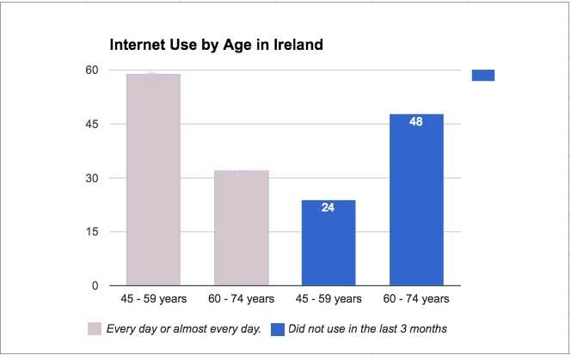

Figure : Internet use in Ireland, in the last 3 months and every day or almost every day by statistical indicator and Age Group (CSO, 2017).

Some adults with special needs can be more vulnerable socially online, and “*barriers that stop people with intellectual disability from successfully accessing social media were identified as being: safeguarding concerns, difficulties caused by literacy and communication skills, cyber-language, cyber-etiquette, and accessibility*” (Caton and Chapman, 2016).

These concerns may prevent adults with I.D. having independent access to the internet through mobile devices. There are thousands of mobile apps for learning but since mobile device accessibility maybe a problem, this project concentrates on a framework that will be delivered through a responsive website; developing an app may come later.

A 2013 study, found that “*when digital games were compared to other instruction conditions without digital games, there was a moderate to strong effect in favor of digital games in terms of broad cognitive competencies*” (Clark, Tanner-Smith, and Killingsworth, 2013). Also, Nature, the International weekly journal of science, claimed to “*provide the first evidence, to our knowledge, of how a custom-designed video game can be used to assess cognitive abilities across the lifespan, evaluate underlying neural mechanisms, and serve as a powerful tool for cognitive enhancement*” (Anguera et al., 2013). Practice by doing helps to retain 75% of information according to the learning pyramid (Peak Performance Centre, no date) so game based learning will be incorporated into the website to provide the opportunity for repetition and rehearsal. People with I.D. have poor retention of knowledge and limited attention-span, as “*repetition and rehearsal of information enhance a process called consolidation, the process by which memories are moved from temporary storage in the hippocampus*” (Richards, R.G., 2017). Interactive game based learning will benefit these adults and help to maintain education and life skill levels through practice and play. Repetition and rehearsal alone are not enough as it may become tedious, “*the brain can go into a pattern similar to the screen saver mode on your computer monitor*” (Richards, R.G., 2017). Game based learning gives students a goal to achieve or a score to beat; giving positive feedback throughout improves self-esteem and the feeling accomplishment.

The Irish LongituDinal Study on Ageing” *(TILDA), dealing with people over 50 years of age and living in Ireland recently released figures that show that between 2010 and 2013, the prevalence of dementia among people with Down syndrome who are part of the study had almost doubled from 15.8% to 29.9%”* (RTÉ Commercial Enterprises Ltd, 2015).

One of the National Dementia Strategy actions is “*to examine the issues arising regarding the assessment of those with Down Syndrome and other types of intellectual disability given the early age of onset of dementia for these groups and the value of establishing a reliable baseline*” (Dept. of Health, 2014). A new study launched in 2015, “*The BEADS study (Brain Exercises for Adults with Down syndrome) will investigate the feasibility of using existing brain training games with a cohort of older adults with Down syndrome without dementia*” (Trinity News, 2015) by researchers at Trinity College Dublin.

Ireland’s population of those with I.D. over the age of 35 years is increasing and vulnerable to dementia as reported by (Head, E. et al, 2014) and according to (Huntsman, M., 2014) those vulnerable to dementia could benefit from brain training games.

Social learning and interaction will be catered for through the inclusion of a forum as “*The importance of communication is crucial. Anne McDonald (Crossley & McDonald 1982) has said, ‘Communication falls into the same category as food, drink and shelter: - it is essential for life, and without it life becomes worthless’*  ”(Gates, 2002). Online communication helps form relationships, access information and reduce isolation and loneliness.

This framework will be designed for adults with I. D’s self-development independent of an organisation, although it can also be used within a class environment.

Goals of the project

This project aims to discover the information available concerning online websites for adults who have learning or intellectual disabilities as per the target audience, with the intention of building a framework of a website to incorporate activities that help them learn, have fun and keep their brains agile.

**Objectives**

1. Research literature and existing resources available for adults with ID.
2. Develop and test the prototype.
3. Implement changes and retest.
4. Analyse user reactions to the prototype.
5. Propose a suitable framework for the development of an IT based learning system for adults with ID.

Intended Audience

Researching the intended audience has been hampered by the different definitions and classifications across countries, policies implemented, and various government acts concerning people with learning disabilities.

Once called a Cretin, Imbecile, Idiot, Moron, uneducable, mentally retarded, and mentally handicapped, the terms used to describe people who were seen as other than ‘normal’ have changed and are still changing. The World Health Organisation’s (WHO) strategic plan and classification system aims to standardise these terms. Nowadays, the most commonly used terms are ‘Intellectual disability’(I.D.), ‘learning disability’(L.D.) or ‘learning difficulty’. Some argue the difference between I.D. and L.D., for example (Cunningham, 2015) describes I.D. as being below-average IQ, whereas I.D. describes a weakness in certain academic skills, however as Table: 1 demonstrates it also depends which country you are in.

“*Learning disabilities, in the form of intellectual disability and learning disorders, are one of the most common forms of disability in the United Kingdom (UK) and Ireland; however, there is a lack of terminological consistency in respect to these conditions, which affects the description, diagnosis, treatment and prevalence figures of these conditions.*” (Department of Social Protection, 2010).

|  |  |  |  |
| --- | --- | --- | --- |
| UK | Aus/NZ | US/Canada | Ireland |
| **LD-learning difficulties** | **I.D.-Intellectual disability** | **mental retarded/retardation** | **GLD-general learning disabilities** |
| Moderate L.D. | Moderate/Mild I.D. | mild or educable | Mild GLD |
| Severe L.D. | moderate I.D. | moderate/severe or trainable | moderate to severe GLD |
| Profound & multiple L.D. | severe I.D. | severe to profound | Profound GLD |

Table : Terminology Inconsistencies across countries (SESS, 2016).

Levels of Intellectual Disability are described as Mild, Moderate, Severe, and Profound. There are in 9,130 registered with mild disability in Ireland, also as per the HRB report by (Carew and Doyle, 2016) young people (aged 16–19 years) who were in an education setting in 2015 are in need of additional services through various pathways, Figure 2, of the 784 young people, 32.7% require rehabilitative training, 23.5% require vocational training and 142 18.1% require activation programmes in the next 5 years 2016–2020. Having a website that provides for independent learning, can help skills retention within each of these pathways.

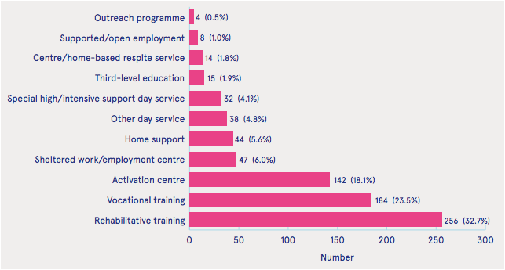

Figure : Future day service requirements of individuals aged 16–19 years in an education setting, NIDD 2016–2020 (Carew and Doyle, 2016).

About 15% of the world’s population have a disability, that’s more than 1,000 million people (World Health Organization, 2015). The National Intellectual Disability Database (NIDD) 2015 Annual report by HRB (Health Research Board) shows 28,108 people registered with I.D. in Ireland. Of those registered, 17,872 are over 19 years of age and 32.5% have mild disability, so there are approx. 5,800 adults with mild disabilities.

This project focuses primarily on the needs of Down syndrome adults within Ireland with a mild to moderate disability but it may also suit a wider audience including people with other disabilities, and literacy needs around the world. “*Down syndrome is a genetic condition that influences development throughout life. It is one of the most common causes of intellectual disability*” (Syndrome Education International, 2017). Similarities within this target group are the love of music and pop culture, the risk of being easily led, resistance to change, accomplishments driven and reward oriented.

Research

This research aims to discover the information available concerning online websites for adults who have learning disabilities.

Objectives.

* Review books, online resources, reports, initiatives and interview key personnel, within Ireland and the wider community.
* Analyse the information to ascertain the lack of facilities for adults with intellectual disabilities and show relevancy for this project.
* Identify the gaps in research and suggest a framework of significance to adults with intellectual disabilities.

## Literature Review

People with intellectual disabilities were largely seen as people who were demonised and families struggled to cope. An eighteenth-century exception was the visionary, pioneer of special education, David Manson. He encouraged children to learn in a playful manner and forbid corporal punishment. The school he established in Belfast attracted many children with severe literacy difficulties (Walsh, 2016). The nineteenth century saw the setting up of a range of institutions including county lunatic asylums and workhouse, where overcrowding and abuse was common (Walsh, 2016). Meanwhile in France alternative means of coping with ‘lunatics’ were investigated. The world’s first school for idiots was opened in Paris by Sequin, reports of his work begun to appear in English in 1845 (Rose, 2008). The Statistical and Social Inquiry Society of Ireland and Dr. Stewart built on Sequin’s ideas in 1867 and after a fundraising raising campaign Dr. Stewart’s private asylum became known as the Stewart’s Institute and instead of custodial care, it focused on education and training (Walsh, 2016) and it is still in operation today.

The first state recognised special school was St. Vincent’s Home for Mentally Defective Children in 1947 (Walsh, 2016) and by the 1970s voluntary initiatives set up over one hundred specialised schools. In 1961 Namhi (National Association of Mentally Handicapped in Ireland) was founded to represent people with intellectual disabilities. The 80’s and 90’s brought more changes, the Education Act (1981) recommended that the term “*‘special education need’ refer to any child or young person experiencing difficulties in learning for whatever reason*” (Walsh, 2016). Also in 1981, the United Nations proclaimed it as the International Year of the Disabled Person (IYDP) calling a plan of action and 1983-1993 the Decade of Disabled Persons to provide time for plans to be implemented. The publication ‘Disability, Handicap & Society’ journals began in 1986, they dropped the word ‘Handicapped in 1994 and it became ‘Disability and Society’. Also, that year, there was a World Conference on Special Needs Education: Access and Quality adopted the Salamanca Statement and Framework of Action towards an Inclusive Education policy. In Ireland the Education Act, 1998 made provisions for persons with disability or special education needs in schools and the Employability Act outlawed discrimination on 9 grounds including disabilities. The National Disability Authority Act in 1999 established the National Disability Authority “*the independent state body providing expert advice on disability policy and practice to the government and the public sector, and promoting Universal Design in Ireland*” (National Disability Authority, 2014).

21st century legislation continued to improve conditions, the Equal Status Act (2000), the Equality Act (2004), the Education (Welfare) Act (2000), the Data Protection Acts (1988 and 2003), the Education for Persons with Special Educational Needs Act (2004) and the Disability Act (2005). Under the Education for Persons with Special Needs (EPSEN) Act, the National Council for Special Education (NCSE, 2014) was setup to improve the delivery of education services to persons with special educational needs arising from disabilities, with emphasis on children.

The Special Education Support Services (SESS) was established “*to enhance the quality of learning and teaching in relation to special educational provision*” (SESS, 2017). Figure 3 summarises a timeline of these changes.

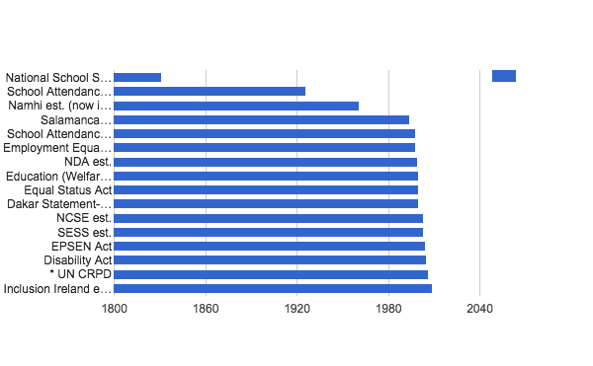

Figure : Timeline of changes that affect disability inclusion from 1800 to present (Department of Education and Science Ireland, 2004).

In 2009 Namhi (National Associated for Mentally Handicapped of Ireland) first established in 1961, changed its name to ‘Inclusion Ireland’ when the term ‘handicapped’ was replace by ‘intellectual disabilities’ as the official term used by the state (Inclusion Ireland, 2006).

Inclusion Ireland has campaigned for the ratification of the United Nations Convention on the Rights of Persons with Disabilities (CRPD) along with other improvement in services for people with intellectual disabilities. The CRPD is the first comprehensive human rights treaty of the 21st century, it was signed by Ireland in 2007, nearly 10 years later 96% of states have ratified it but Ireland hasn’t ratified it yet. Legislation is slowly improving conditions and education for people with I.D. with its main focus on providing services through schools and for children rather than adults with intellectual disabilities (Inclusion Ireland, 2016).

Existing Systems

Assistive Technology described as “*Any product (including devices, equipment, instruments and software) especially produced or generally available, used by or for persons with a disability*” (ISO 9999:2011, 2011) needs to be purchased, and according to Jackson, Ireland’s AT infrastructure is underdeveloped in comparison with other countries (Jackson, 2016).

Outside of educational and training institutions the price of purchasing assistive technology and specialised software is a barrier individual uptake, “*computer technology has the potential to act as an equalizer by freeing many students from their disabilities, the barriers of inadequate training and cost must first be overcome before more widespread use can become a reality*” (Hasselbring and Glaser, CHW, 2000). Clicker 7 is a well-known literacy tool kit created by Crick Software and sells for £199.99 (Crick Software Ltd, 2017). Clicker provides word processing, planning tools, audio note taking, predictive text and more, although it is designed with children’s education in mind.

In researching the opportunities for adults with I.D. to access online learning for skills acquisition and retention, it was found that online learning websites available for adults are plentiful, for example, Udemy.com, alison.com and Udacity.com. Online learning options for adults are generally geared towards adults who have completed primary or secondary education. 2011 census revealed that 16% of people with disabilities aged 15-49 had only completed primary level or less, and 22% didn’t progress after lower secondary (Disability Federation of Ireland, 2015).

There is an extensive range of learning websites for children, for example. abcya.com and even websites for children with I.D. for example, do2learn.com and even more curated on Checkthemap.org: www.checkthemap.org/links/fun_sites/. The tasks and simplicity of some sites designed for children are generally suitable for adults with ID however the content and design is often too childish in nature (Hegarty and Aspinall, 2006) and maybe demeaning to those adults.

Alternatively, the online websites for adult literacy have improved but availability is still low, for example: NALA and writeon.ie. These have a few online modules however the terminology is sometimes complex and the features often lack accessibility.

With all these sites, some elements may be suitable but there is no one website that specialises in providing a service for adults with intellectual disabilities.

There are a variety of free third party accessibility tools for example the Universal Design for learning kit curated on the UdlTechtool Kit wiki, reading aids like naturalreaders.com or google extensions for screen reading and even rewordify.com for rephrasing complex text. However, while these are all excellent resources it means navigating to different sites, and using these accessibility tools in conjunction with other websites. A website with built in added accessibility options would be preferable.

Two projects that have similar aspects to the framework proposed in this paper are ‘Accessible information: Advocating the use of technology for individuals with intellectual disability on their path to Individualised services’ by Michelle Moloney, and Web Fun Central by Assadour Kirijian and Matthew Myers. Moloney’s research investigated “*the viability of developing an internal web based learning and communication tool for people with an ID*”. It was tested on residents within a care-giving facility, it provided valuable insight into design although it’s framework concentrated on news and events rather than learning modules. ‘Web Fun Central: Online learning tools for individuals with Down syndrome’ was developed by New Media Inc. A.K.A. Assadour Kirijian and Matthew Myers. These “*online tools were created to help individuals with Down syndrome learn and practice the basic skills required to use the Internet, allowing them to take better advantage of the entertainment and educational benefits that the Internet can provide*.” Web Fun Central concentrated on three modules: 1) How to use web links, 2) How to use pull down menus and 3) How to use the browser back button. The project was built in Flash and unfortunately, Web fun central’s website is not live and the last capture on wayback machine was in 2006.

Accessibility requirements for people with intellectual disability can vary greatly in developmental growth, reading age, and motor skills. The visual design and skill level needs to relate to the individuals with Down syndrome. Incidences of visual defects are higher in people with Down syndrome (Perez-Carpinell, de Fez and Climent, 1994), so colour blindness needs to be taken into consideration, in particular the difficulty some have to distinguish green form red and yellow from blue. In Lazar’s study 93.2% of respondents used the mouse, and 85.6% use keyboard, they were not using AT. Whilst typing they used the ‘hunt and peck’ method rather than touch typing. Results also proved that whilst alphanumeric passwords were frequently forgotten the test group were very observant of visual cues, even indicators for battery power etc. People with down syndrome were better at getting graphical passwords in the correct order than neurotypical users. Other noticeable results were the need to remind user not to use their real name and to check if cap locks were on. When using subtitles, it is best to use both lower and upper case letters, similar to Transport Typeface used for road signs for better word recognition. (Lazar, 2017)

User Requirements

There were several steps to identifying user requirements. Firstly, through studying documentation. In researching reports and findings provided background knowledge of the intended users. The next step was to list the stakeholders and experts in the field and interview them. After the interviews with subject matter experts, facilitators and parents, questions were revised to extrapolated more information.

A focus group helped to research similar products e.g. writeon.com and abyc.com and had an active discussion giving feedback about their views. Direct observations identified the type of activity users repeated and favoured, while through indirect observations the groups literacy levels and social chats, for example Figure 4, were reviewed for understanding. It was found that the actual communication was more important than what was being communicated. Common spelling errors were discovered, for example ‘hulle’, ‘holll’ and ‘holle’ were all used for the word ‘hello’. The option of predictive text would reduce these errors.

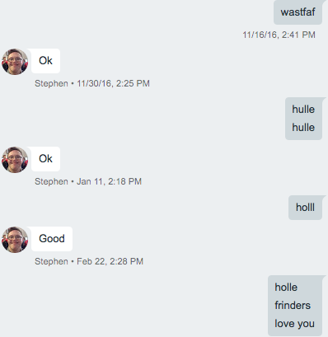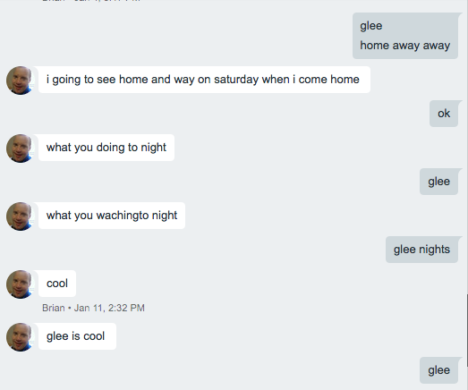

Figure : Example of google chat conversation

Interviews

**Tracy Boland, pathfinder’s co-ordinator.**

Pathfinders is a community based day service for adults with an Intellectual disability. It is part of the Brothers of Charity South East Services. The Brothers of Charity Services in Ireland provide a variety of services and supports to approximately 6,500 people with an intellectual disability or autism, and their families, throughout Counties Clare, Cork, Galway, Kerry, Limerick, Roscommon, Tipperary, and Waterford. (Brothersofcharity.ie, 2017)

Pathfinders deal with mostly those with mild to moderate intellectual disability. Their members and those born with genetic conditions rather than people with acquired brain injuries. Members attend various classes, for example cooking, drama and dance, exercise, literacy and computers. Members IQ is under 70, moderate IQ is lower at 35 - 49. They have one computer which members can book time on, some members have mobile phones but phones with larger interfaces for example Doro phones are more popular than smartphones (Boland, 2016).

**Tony McSweeney, parent of Brian McSweeney, an adult with Down syndrome.**

Brian loves dancing and is a recipient of the Arts & Disability Ireland Connect Mentorship Award for 2016. He loves watching dance videos on YouTube and watching videos of himself dancing. He likes writing scripts and participating in dramas and plays.

Brian age 28 and has a reading age of 9 (level 4). He achieved a Certificate in Literacy and Technology as part of the Latch-on program (Literacy And Technology Hands ON). Latch-On was developed in Queensland for people with mild to moderate ID and is delivered by Down Syndrome Ireland but class sizes are limited. Brian also did an Independent Living course.

Tony’s top tip when it comes to facilitating people with ID in education is to keep it simple, progress slowly and use plenty of repetition. Even though Brian has attained a level of literacy, retaining it depends on constant practice.

Brian thinks that text is amazing, he loves texting his girlfriend, words sometimes maybe misspelled but it’s like they have their own language and the most important aspect of communication is that they understand each other.

Having a mobile gives Brian great independence but his activity is monitored by his parents as once, for example, he accidentally uploaded a video of friends to YouTube that could be viewed publicly. Brian is not encouraged by his parents to join Facebook due to security and safety risks (McSweeney, 2016).

**About teaching adults with special needs from Pathfinders Waterford**

This research is motivated by experiencing first how the Brothers of Charity Pathfinders group interact with the internet during computer class from 2013 to 2016. These are adults between 25 - 50 of mixed gender, most have Down syndrome. Andrea Galgey described their experiences. After using Microsoft programs such as MS Paint, Word and PowerPoint they were eager to use the internet. Initially they used Gmail which was monitored weekly to ensure safety, they went on to use many google products: google chat, google docs and google slides, all accessible through the google app launcher. Then the group signed up to a few online websites that had google account sign-in or really simple registration processes. Over the 3 years it has been difficult to find resources for entertainment, communication and learning appropriate to their needs that is simple to understand yet not infantile in terminology and design. Their favourite web pages are often on different sites and the group find it hard to remember the website names or navigate them. Of the ten students in class only one is allowed to have a Facebook account for security reasons so access to social networks is restricted. (Gagley, 2016).

These interviews reinforce the need to have a website where individuals can learn and practice their skills. Interfaces must be uncluttered, easy to use, with plain text and clear visible indicators to describe the available actions. Due to their familiarity with google suite, a google login option maybe be preferable. Further observations and feedback of the target audience needs to be considered during interface design. Usability testing of the prototype will be carried out with the Pathfinders group.

Methodology

After considering the requirements, technology, complexity, reliability, time frame and scheduling factors, the waterfall, parallel and phased methods were not adequate for the project's needs. When comparing eXtreme Programming with the Throwaway prototyping it rated poor on unfamiliar technology and complex systems, therefore, the Throwaway prototyping methodology seemed a better fit, Table 5.

|  |  |  |  |  |  |  |
| --- | --- | --- | --- | --- | --- | --- |
| **Useful for** | **Waterfall** | **Parallel** | **Phased** | **Prototyping** | **RAD-**  **Throwaway Prototyping** | **Agile-**  **Extreme** |
| Unclear user req. | P | P | G | E | E | E |
| Unfamiliar tech | P | P | G | P | E | P |
| Complexity | G | G | G | P | E | P |
| Reliability | G | G | G | P | E | G |
| Short time | P | G | E | E | G | E |
| Schedule visibility | P | P | E | E | G | G |

Table : P - Poor, G - Good, Excellent (Dennis, Wixom, and Tegarden, 2012).

On researching further found that the evolutionary prototyping methodology would be ideal as in theory the outcome wouldn’t be a finished product.

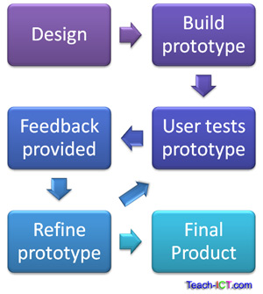

Figure : Evolutionary Prototyping (Teach-ICT, 2016).

The evolutionary prototyping methodology is suitable for projects where requirements are uncertain; as the target audience for this project hasn’t experienced a similar website that is the case, however the evolutionary prototyping model, Figure 5, allows for frequent testing, which is an advantage as testers are available and willing to participate.

# System Requirements

This framework suggests a browser user interface (BUI) that can run on any browser on the world-wide web which is inherently an independent platform. The website can be accessed through any internet enabled device. It will be tested on the latest versions chrome, Firefox, safari and internet explorer. It will be available almost 24/7, updates and maintenance will be performed at times of low to zero traffic as tracked with google analytics. Graphics will be optimised to reduce delay in loading. Scalability is necessary as more modules need to be incorporate to improve user experience and choice. The system also needs to provide feedback in a timely manner to users. The system will operate on a local host initially, the prototype will be live to facilitate testing.

Risk Analysis

Risk analysis to ascertain problems that may occur during the development of the project, Table 8.

|  |  |  |
| --- | --- | --- |
| **Risk** | **Description** | **Contingencies** |
| Requirements | Changes to requirements  Time | Re-visit  Review schedule |
| Skills | Required skills are rusty due to the lapse in education and changing technologies. | Use online resources to upskill and practice skills needed. |
| Technological | Software may not work  Hardware may malfunction | Use GitHub for revisions  Keep softcopy  Have access to a second PC |

Table : Risk Analysis

Functional Requirements

User Access & Authentication

Users will need to register on the website to use the forum and have their progress saved. The common terms to prompt users to create online accounts are: Register, Sign Up, Create Account, Create New Account, Create Profile and Join. Registered users access terms are: ‘Log In’, ‘Log On’, ‘Sign In’, ‘Enter’, ‘Let Me In’ and for exiting the restricted area: ‘log out’, ‘log off’, ‘sign out’ or ‘exit’. The word register is official sounding and log in may come across as a bit technical, using Signup and Sign In may confuse users as they are similar and takes longer to identify which is which (Munroe, 2010) so Sign Up and Log In are usually preferred. When a user registers with the website, they will become a member and part of a community facilitated by the forum so it was decided to use the term ‘Join’ to become a member and ‘Sign In’ to access the member area.

This site is designed for adults but will not have any content deemed unsuitable for any age group, so access will be open to anyone. Registration will involve providing email address, username, password and either a captcha or a no captcha.

For simplicity, the low security password has one limitation, it must be at least 5 characters in length. Since “*Users should use and reuse weak passwords for websites which don't hold valuable information*” (Hern, 2014), and the only information that will be retained is the users progress and forum postings, there is a low security risk.

People with ID find alphanumeric passwords hard to remember so as an alternative to aid retention there will be a picture password option, similar to Figure: 6, Rix Wiki login screen. The user will be required to choose three images in a certain order Lazar’s research found that people with Down Syndrome are even better at remembering the order of images than other people. (Lazar, 2017)

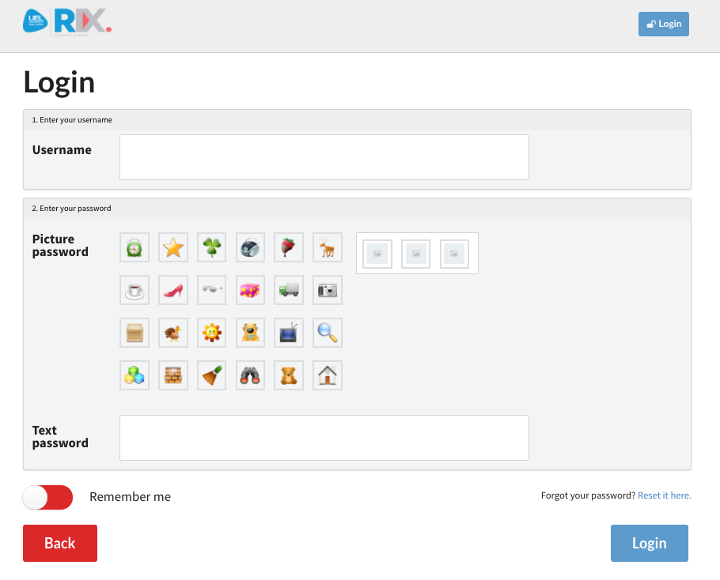

Figure : Rix wiki login screen (Rix Wiki, no date).

To captcha or not to captcha; in 2013 after many accessibility issues were highlighted, a campaign began in Australia to ‘kill Captcha’ (ACCAN, 2013). Alternatives to the Turing Test included the use of pictures, for example, visual captcha Figure: 7. In 2014 Google launched its solution, the [No-CAPTCHA](http://googleonlinesecurity.blogspot.com/2014/12/are-you-robot-introducing-no-captcha.html), Figure 8, The “*new approach built on a new API, ... adopted by Snapchat, WordPress and Humble Bundle, among other partners*.” The No-Captcha and Visual Captcha will be tested as part of the prototype to ascertain which is favourable.

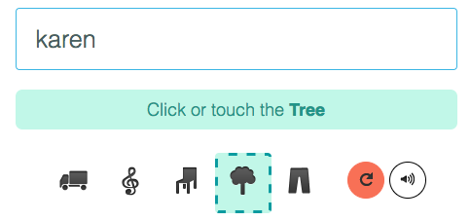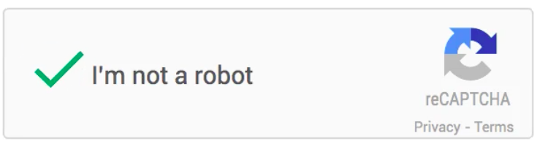

Figure : VisualCaptcha (nd) Figure : Brandom, R. (2014)

Finally, the website will incorporate Google's OAuth 2.0 APIs which can be used for authentication and authorization. Not having to remember individual usernames and passwords makes the web easier to use.

Figure 9, the Use Case diagram shows the actions a new unregistered user can take as opposed to a registered user. An unregistered user can view and play modules although their progress won’t be recorded and they won’t be able to access the forum. They have the option to register and then become a registered user or member, with the extra privileges.

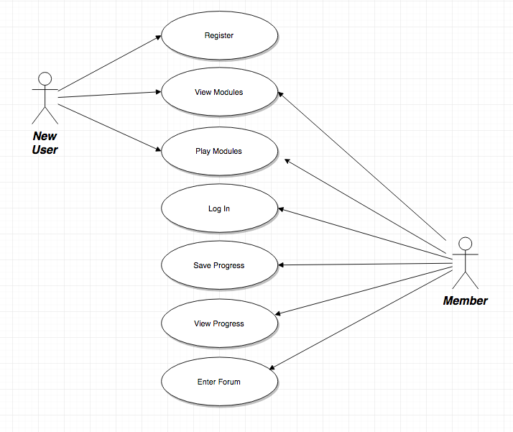

Figure : Use case for New User and Registered Member.

Learning/Game Modules

Modules will be categorised by one of three headings: Letters, Numbers and Skills. The beginner modules will concentrate on mouse and keyboard skills and low levels of literacy and numeracy gradually getting more challenging. The Letters section will include letter identification, drawing and matching and progress to word identification, matching, reading and typing customised word banks. The numbers section will include identification of numbers, counting to ten, logical problems and simple addition progressing to double digits and money games. The skills will focus on cognitive abilities, spacial awareness, auditory and linguistic exercises and creativity games. The modules are built for solitary use, additional updates may include a social multiplayer game with challenge.

The system will track and store the user's progress with options to go back or restart, the sequence won’t need to be linear. Earlier modules can be repeated at any stage to facilitate rehearsal and user satisfaction. As memory retention will be problem, the website needs to incorporate retention strategies and (Richards, R.G. and WETA, 2008) a progressive, step-wise, learning approach will be developed, with visual cues to provide direct, immediate feedback and encouragement. Immediate feedback enables people to make a connection between behaviour and response. When a user returns to the site after 24 hours, the system will prompt the user to repeat the last module that was completed before giving the option to advance.

### The Forum

The forum will consist of two types of users: members and admins. When entering the forum, users will be reminded not to share personal information and given a few brief safety tips. All members and administrators can post messages, but members messages need to be approved by the administration.

Posting options will include predictive text helper, symbol chat and emoji. When a member types a message for posting, there will be a visual que to preview the message or to use audio to playback the message back before the choosing to edit or send it.

Members can also report a message if they believe it to breach the forum rules.

The administrator will display response times and schedule times for live assistance. Figure 10, the Use case diagram shows how an actor can interact with the system, in this case it describes the actions of the systems two actors; a forum member and the forum administrator.

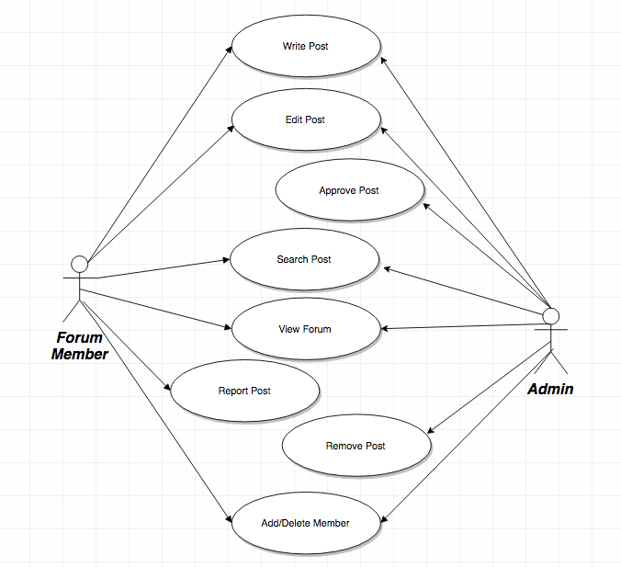

Figure : Use case for Forum Member and Administrator.

The system will limit access to authorised users. The database must be able to store and update account details, users progress and forum posts. When user account data is entered into the system, an email must be sent to confirm details, only then will the module progress is saved, or the user permitted to access the forum. An email must also be sent to a user if their forum post has been deleted due to unsuitability.

Non-Functional Requirements

It is essential that the system performs well and provides prompt feedback. The number of active windows should be limited with tasks requiring to be completed asynchronously. Any alerts and feedback pop over windows need to have an obviously visual cue requiring confirmation to close. As new modules are added or changed the performance must not suffer, regular maintenance and testing is required to ensure adequate effectiveness and quality while preserving scalability. Additional monitoring is required to ensure efficient capacity. The database must be backup for easy restoration in case of system failure. The design and content needs to be consistent throughout to aid usability.

Accessibility

User centred design for inclusion and accessibility can be challenging as people with intellectual difficulties are diverse in their needs. “*Persons with learning disabilities often have trouble processing language and numbers, deciphering auditory input, and with spatial orientation*” (NCDAE, 2017). Accessibility needs to be incorporated into both the functional learning aspect and content as well as the operational actions, interfacing needs to be transparent.

W3C’s web accessibility initiative (WAI) aims “*to lead the Web to its full potential to be accessible, enabling people with disabilities to participate equally on the Web.*” W3C (2016)

Their quick reference guidelines include 4 principles, Figure: 14

|  |  |
| --- | --- |
| Principle | Description |
| 1 - Perceivable | * Text Alternatives for non-text content, compatible with assistive technology. * Alternative descriptions/instructions for time-based media: closed captions, subtitles, screenplay, transcripts, description of video-based content, sign-language, labelling * Adaptable: content can be displayed differently without changing meaning and structure, magnifying etc. * Distinguishable: Use of colour, contrasts, images, resizing, audio levels. |
| 2 - Operable | * Keyboard Accessibility, for mouse alternatives. * Allow enough time to read and use content * Avoid seizures * Navigable |
| 3 - Understandable | * Readable * Make content appear and operate in predictable ways. * Input Assistance, help users avoid and correct mistakes. |
| 4 - Robust | * Maximise Compatibility |

Table : W3C principles. (W3C, 2016)

**Navigation** needs to be easy to follow with paths clearly labelled and consistent throughout. It also needs to include ways to backtrack or restart, “*the use of breadcrumbs, can be particularly beneficial for people with cognitive problems, since it appears to provide ongoing confirmation of navigational choices and reinforcement of the overall task objective*” (Hudson, 2004). Clickable areas need to be obvious, enlarged and underlined, highlighted on mouseover for easy to read. No hidden clickables (Facebook - hover over to appear).

**Text** will be written in plain language, in short sentence, not longer than one line. Bulleted information will be used where appropriate. Information will be displayed in sushi style, one bite sized chunk for each point. Consistent terminology will be used throughout with meaningful headings.

A project called ‘Pathways to adult education for people with intellectual disabilities’ met to establish standards to make information easy for people with intellectual disabilities to understand. Font size is recommended to be equivalent to Arial size 14, these standards are published on easy-to-read.eu and will be taken into consideration when preparing content.

Text is easier to read in short sentences indent from the right as seen in Figure 11.

|  |
| --- |
| “*The aim of this project is*  *to make lifelong learning programmes easier*  *for people with intellectual disabilities to take part in*.” |

Figure : Example of Easy-To-Read Text. (Inclusion Europe, 2009)

Information and instructions will be easily accessible to be repeated when needed in the form of hints and recaps. Text will be organised to consider the reading order of assistive technology as well as for visual impact.

Widgit have a range of symbols that can be used in print and online. ‘Point’, Figure 12 is available for websites at £282 per year, if you hover over a word a symbol will pop up to give a visual representation of the word. Their website does state that “*If only a few symbols are needed and acknowledgement is given then licensing is often free or very low-cost*” (Widgit, 2017). This technology will not initially be included but maybe an option for future updates.

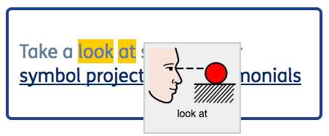

Figure : Point (Widgit Software, 2017).

**Easy to Read Fonts**

There are many specialised fonts, some free to use, for example OpenDyslexic and some require a fee. “*Some dyslexic people have expressed strong feelings about typefaces, but there is no agreement apart from saying it should be sans serif*” (B.D.A. New Technologies Committee, 2005). Arial font has become popular but maybe since fonts are in alphabetical order in MS Word and it is first in the list. “*Most people find a sans-serif style such as Arial or Verdana more comfortable. Others find a monospaced font such as Courier easier to read*” (BBC, 2014), although headings and navigation or any enlarged text can have more style and should clearly stand out.

Visually, a high contrast is needed between text and background; black on white, cream or yellow is best. Kirijian and Myers’ study found that words accentuated using colour and scale worked well, words stylized with highlighted graphical elements scored very highly however font drop shadows, obscured outlines and fanciful fonts made the text difficult to read (Kirijian and Myers, 2007)

Other characteristics of a good easy-to-read font include:

* A large x-height, good ascenders and descenders,
* Wide letter spacing & overall proportions
* Medium weight with very open counters
* b and d; p and q distinguished, not mirror images.
* Different forms for capital I, lowercase l and digit 1.
* Letter-spacing, e.g. r, n together rn should not look like m.

**User customisation**

The user will benefit from controlling certain visuals, for example text size, line height and spacing, contrast, background colour, or invert colour. These options can be done with CSS.

Page customisation can be done on the client side or the server side. Client side switching is instantaneous but there are some drawbacks: older browsers may not support JavaScript; internet security systems may block it. Server side option is more reliable according to (Hudson, 2004) but maybe slower as the page will have to reload to apply changes.

Alternatively, third party tools can be utilised. Browsealoud software “*adds speech, reading, and translation to websites facilitating access and participation for people with Dyslexia, Low Literacy, English as a Second Language, and those with mild visual impairment*” (Text Help, no date). A free trial is available for 30 days.

AudioEye offer free web personalisation assistive tools with their ‘Ally Toolbar’, this benefit “*aging populations and individuals who have vision, hearing, motor and intellectual (cognitive) disabilities, those who are color blind, dyslexic, are learning to read, learning a second language, or may prefer listening instead of reading.*” (AudioEye | Digital Accessibility Compliance & Personalization Platform, 2017)

Browser accessibility plugins are also available to invert backgrounds, change font size or contrasts. Some accessibility features will be added to this project, in addition to an accessibility guide in the help section. The accessibility guide will provide links to alternative accessibility options to maximise user choices and educate them about the tools that can be used with across all websites.

Design

The overall design of the website needs to be minimalistic and uncluttered, only essential elements should be displayed on each screen.

Site map

Interface Wireframes

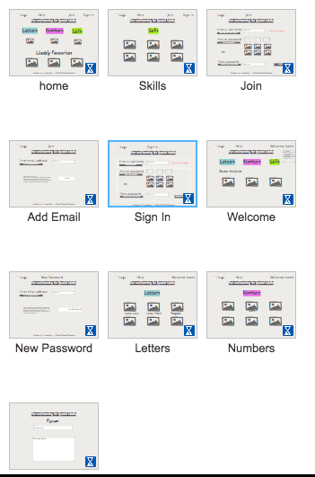

Figure : Interface screen shots

Software & Tools

* Draw.io is a free online diagram software for making flowcharts, process diagrams, org charts, UML, ER and network diagrams.
* Adobe Photoshop, Illustrator, Dreamweaver (stopped working on Mac!)
* GitHub for documentation and revisions
* NinjaMock.com for creating and sharing wireframes
* MEAN Stack - (MongoDB, Express.js, Angular.js, Node.js) is an opinionated fullstack JavaScript framework that simplifies web application development.
  + MongoDB will store my application
  + Express.js is a web application framework for node that provides more robust features to the application
  + Angular.js is a client side JavaScript framework that allows for an expanded html library
  + Node.js is the framework for fast, scalable network applications.
* HTML & CSS
* Vision simulator tools
* Accessibility validation tools

Live Technological Prototype

(This is how I will test my prototype….)

* Testing - make it fun for users
  + Observations- watch what they like and repeat
  + Verbal Feedback
  + Online Questionnaire

**Testing Tools**

Check accessibility: http://wave.webaim.org/

Colour contrast check: https://snook.ca

Web Accessibility Evaluation Tools List www.w3.org/WAI/ER/tools/

readability tests

W3c - WA 14 guidelines validity check

Use GA event tracking to see if people use the accessibility options.

Colour Vision Simulators: Chromatic Vision Simulator, no coffee chrome extension, or

Use Photoshop to simulate colour vision problems. Convert designs to grayscale by going to Select View → Image → Adjustments → Grayscale.

Simulate colour blindness conditions by going to Select View → Proof Setup → Colour Blindness and choosing protanopia type or deuteranopia type. Adobe provides [soft-proofs for colour blindness](http://help.adobe.com/en_US/creativesuite/cs/using/WS3F71DA01-0962-4b2e-B7FD-C956F8659BB3.html#WS473A333A-7F61-4aba-8F67-5553208E349C) (O’Connor, 2014)

Conclusion

This is my conclusion on stage 1 of the project….

WebFun Central & Michelle Moloney's projects came close, none of which are live.

Schedule

Learn MEAN stack - 6 weeks

# 

# 

Weekly Activities

|  |  |  |
| --- | --- | --- |
| **Week** | **Date** | **Activities Completed** |
| 1 | 7/9 | Began brainstorming  Submitted Proposal to Supervisor  Began revising HTML, CSS, JS and SQL on khan academy and udemy. |
| 2 | 14/9 | Attended project induction day.  Discovered the proposal was due in that day, but can be sent in afterwards.  Enrolled in Moodle. |
| 3 | 21/9 | Paid my Fees - I’m committed. Scary as hell, memories of constant struggle flood back. Hope it’s better this time round. |
| 4 | 28/9 | Got sample proposal from Moodle and submitted mine. It’s quite a poor proposal, I need to flesh it out a bit. I’m not sure exactly what technologies I need or how to go about putting this together.  Continued with online learning review of basic coding. It’s easy to follow lessons, but I’m still not confident of creating something from scratch. |
| 5 | 5/10 | Received an email David Power is my supervisor. |
| 6 | 12/10 | **First Meeting with Supervisor**  Need to re-write proposal to add more detail  I looked at code examples of typing games. |
| 7 | 19/10 | Researched availability of online learning / gamification for adults with special needs.  Redo Project proposal for research. After sending it, I didn’t want to do an only research project - trying to word / phrase things are annoying!!  **Meeting with Supervisor**  Reviewed project again. Change to 50/50 research/project.  Create an online learning platform, with login that records progress.  GUI - choose appropriate font, colours, graphics  Explain and justify all decisions.  Identify components needed, then identify technologies that will be used to create them. |
| 8 | 26/10 | Cancelled Meeting with supervisor - sick.  Khan Academy, Download Mongo, Research GUI for special needs  Research educational websites, and alternatives for people with special needs (none for adults!). Research brain training apps/websites |
| 9 | 2/11 | Funeral/Mid-term, no meeting/ |
| 10 | 9/11 | **Meeting with Supervisor**  Submit Revised Proposal, Research Methodologies & Frameworks  Start Semester 1 report |
| 11 | 16/11 | I'm going through the 3 books, some e-books and bits from 3 theses from the WIT library last week.  I also did a course on GitHub and am considering using mean stack - MongoDB, Express.js, AngularJS, and Node.js. Would this be a good option for the prototype? I've complete and one lesson www.youtube.com/watch?v=Jh0er2pRcq8  I met with the Tony Mac Sweeney (Dad of adult with Down syndrome Waterford yesterday, for an informal interview and got a lead to follow up. |
| 12 | 22/11 | Researched from sources: Centre on Technology & Disability, National Centre on Disability and Education, National Council for Special Education, online library, science direct, NCSE research section. Sign up to and downloaded resources: AAC & AT |
| 13 | 30/11 | Met with Caroline ? literacy teacher to Brothers of Charity group & discussed IQ levels. Emailed them with questions. Created questionnaire for Pathfinders group. Worked on Report - sorted references, completed intro and description. Changed the title, removing ‘special education’ as education refers to structured learning with a mediator/teacher. This website is primarily for self-development.  A Website Framework for Adults with I.D.in Literacy |
| 14 | 7/12 | Adult Ed literacy contact: 051854444..Ana Murphy |
|  | 11/12 | D-Day - Submit Semester 1 Status Report |
|  |  | Deferred due to mitigating circumstances |
|  | 9th-13t | Presentation - deferred |
|  | 17/1 | More research online. |
|  | 2/2 | Add references from refme to the report, gdrive wouldn’t save. I looked for a fix. Copied to a new doc, downloaded and tried to open with Mac Word. All programs on Mac have limited access since the last o/s update, including the adobe suite. Java won’t work with Sierra OS. |
|  | 3/2 | PC with Windows 7 O/S not activated so programs have limited functionality. Tried again with gdrive on safari, then opened it in chrome - works this time. Found discussions giving file size of revisions or word count a factor in the error message. |
|  | 5/2 | sketch UML diagrams and created a use case diagrams with draw.io |
|  | 6/2 | Worked on accessibility section |
|  | 14/2 | 2 hours, Reread information on accessibility to identify key points. |
|  | 15/2 | 3 hours. Read research and edited up to Functional Requirements, edited use case diagrams. |
|  | 16/2 | Edited up to Sys Req.& edited refs. My references are organised on Refme.com which has been sold and will merge with citeforme.com on 28th Feb. To maintain access to my free account I have to wait until the change takes place. |
|  | 17/2 | 2 + 1 hour: Edited system requirements, researched captcha options and captchas alternatives. Edited up to forum in sys requirements. |
|  | 20/2 | Edited & backed up references as refme will be taken over by citethisforme at the end of the month. |
|  | 21/2 | Up to accessibility done. |
|  | 26/2 | Researched way too much on accessibility, need to focus on specific requirements. |
|  | 27/2 | Finished accessibility |
|  | 12/3 | Fixed use case and internet use by age chart. I couldn’t change column colour in google spreadsheets, couldn’t change horizontal axis in mac excel. Took chart from google spreadsheets and changed colour with Photoshop |
|  | 13/3 | Fixed other issues highlighted from last week's supervisor meeting. |
|  | 26/3 | Redid lesson 2 on MEAN – front end of chirp app |
|  | 27/3 | Bought MS suite, separated references and bibliography |

## References

Anguera, J. et al (2013). Video game training enhances cognitive control in older adults. *Nature*, [online] 501(7465), pp.97-101. Available at: http://www.nature.com/nature/journal/v501/n7465/full/nature12486.html [Accessed 10 Nov. 2016].

AudioEye | Digital Accessibility Compliance & Personalization Platform. (2017). *Accessibility 2.0 - A Technology First Approach*. [online] Available at: https://www.audioeye.com/accessibility-2-0-a-technology-first-approach/ [Accessed 8 Mar. 2017].

B.D.A. New Technologies Committee, (2005). *Typefaces for dyslexia*. [online] Available at: https://bdatech.org/what-technology/typefaces-for-dyslexia/ [Accessed 27 Jan. 2017].

Boland, T. (2017). *Tracy Boland, Pathfinder’s co-ordinator*. [Interview]

Brandom, R. (2014). *Google is killing CAPTCHA as we know it*. [online] Available at: http://www.theverge.com/2014/12/3/7325925/google-is-killing-captcha-as-we-know-it [Accessed 17 Feb. 2017].

Brothersofcharity.ie. (2017). *Brothers of Charity Services Ireland*. [online] Available at: http://www.brothersofcharity.ie/ [Accessed 21 Mar. 2017].

Carew, A. and Doyle, A. (2016). *HRB statistics series 30 annual report of the national intellectual disability database committee 2015 main findings*. [online] Available at: http://www.hrb.ie/uploads/tx_hrbpublications/NIDD_2015_Annual_Report_web.pdf [Accessed 28 Nov. 2016].

Caton, S. and Chapman, M. (2016). The use of social media and people with intellectual disability: A systematic review and thematic analysis. *Journal of Intellectual and Developmental Disability*, [online] 41(2), pp.125-139. Available at: https://www.researchgate.net/publication/297720332_The_use_of_social_media_and_people_with_intellectual_disability_A_systematic_review_and_thematic_analysis [Accessed 26 Oct. 2016].

Chadwick, D., Wesson, C. and Fullwood, C. (2013). Internet access by people with intellectual disabilities: Inequalities and opportunities. *Future Internet*, [online] 5(3), pp.376-397. Available at: http://www.mdpi.com/1999-5903/5/3/376 [Accessed 6 Oct. 2016].

Clark, D., Killingsworth, S. and Tanner-Smith, E. (2013). *Digital Games for Learning: A Systematic Review and Meta-Analysis*. 1st ed. [ebook] CA: Bill & Melinda Gates Foundation. Available at: https://www.sri.com/sites/default/files/brochures/digital-games-for-learning-brief.pdf [Accessed 10 Nov. 2016].

Crick Software Ltd, (2017). Clicker communicator. [online] Available at: http://www.cricksoft.com/uk/products/communicator/prices.aspx [Accessed 13 Feb. 2017].

CSO (2017). *How often Persons used a Computer or used the Internet in the last 3 months by Age Group, Frequency of Use, Year and Statistic - StatBank - data and statistics*. [online] Available at: http://www.cso.ie/px/pxeirestat/Statire/SelectVarVal/Define.asp?maintable=ICA19&PLanguage=0 [Accessed 17 Dec. 2015].

Cunningham, B. (2015). *What's the difference between learning disabilities and intellectual disabilities?* [online] Available at: https://www.understood.org/en/learning-attention-issues/getting-started/what-you-need-to-know/whats-the-difference-between-learning-disabilities-and-intellectual-disabilities [Accessed 7 Dec. 2016].

Dennis, A., Wixom, B. and Tegarden, D. (2012). *Systems analysis design, UML version 2.0: An object oriented approach*. 4th ed. United States: Wiley, John & Sons.

Dept. of Health, (2014). *THE IRISH NATIONAL DEMENTIA STRATEGY*. [online] Department of Health. Available at: http://health.gov.ie/wp-content/uploads/2014/12/30115-National-Dementia-Strategy-Eng.pdf [Accessed 7 Nov. 2016].

Department of Social Protection, (2010). *Learning Disabilities*. [online] Available at: http://www.welfare.ie/en/downloads/protocol4.pdf [Accessed 15 Jan. 2017].

Disability Federation of Ireland, (2015). *Profile of people with disabilities in Ireland - disability federation of Ireland*. [online] Available at: http://www.disability-federation.ie/index.php?uniqueID=11048 [Accessed 29 Nov. 2016].

Dolan, S. (2016). *Assistive technology for people with disabilities and older people A discussion paper - disability federation of Ireland*. [online] Disability Federation of Ireland. Available at: http://www.disability-federation.ie/index.php?uniqueID=11171 [Accessed 30 Nov. 2016].

Galgey, A. (2016). *About experience of a special needs IT tutor*.

Gates, B. (2002). *Learning disabilities; Ed. By Bob Gates*. 4th ed. EDINBURGH: Churchill Livingstone.

Hasselbring, T. and Glaser, C. (2000). Use of computer technology to help students with special needs. *The Future of Children*, [online] 10(2), p.102. Available at: http://familiestogetherinc.com/wp-content/uploads/2011/08/COMPUTERTECHNEEDS.pdf [Accessed 2 Feb. 2017].

Head, E. et al. (2014). Alzheimer's disease in down syndrome. *HHS Author Manuscripts*, [online] 1(3). Available at: https://www.ncbi.nlm.nih.gov/pmc/articles/PMC4184282/ [Accessed 15 Jan. 2017].

Hegarty, J. and Aspinall, A. (2006). The use of personal computers with adults who have developmental disability: Outcomes of an Organisation-Wide initiative. *The British Journal of Development Disabilities*, [online] 52(103), pp.137-154. Available at: http://www.bjdd.org/new/103/133to150.pdf [Accessed 24 Jan. 2017].

Hern, A. (2014). Microsoft tells users to stop using strong passwords everywhere. *The Guardian*. [online] Available at: https://www.theguardian.com/technology/2014/jul/16/microsoft-stop-using-strong-passwords-everywhere [Accessed 5 Feb. 2017].

Hoppestad, B. (2012). Current perspective regarding adults with intellectual and developmental disabilities accessing computer technology. *Disability and Rehabilitation: Assistive Technology*, 8(3), pp.190-194.

Hudson, R. (2004). *An accessibility frontier: Cognitive disabilities and learning difficulties (2004)*. [online] Available at: http://usability.com.au/2004/12/an-accessibility-frontier-cognitive-disabilities-and-learning-difficulties-2004/ [Accessed 26 Feb. 2017].

Huntsman, M. (2014). *8 brain-training games for memory*. [online] Available at: http://www.alzheimers.net/11-5-14-brain-training-games/ [Accessed 15 Jan. 2017].

Inclusion Ireland, (2006). *INCLUSION IRELAND national association for people with an intellectual disability*. [online] Available at: http://www.inclusionireland.ie/sites/default/files/documents/inclusionirel_about_us.pdf [Accessed 26 Jan. 2017].

Inclusion Ireland, (2016). *UN Convention on the Rights of Persons with Disabilities will not be ratified until 2017 – 10 years after Ireland signed the human rights treaty*. [online] Available at: http://www.inclusionireland.ie/content/media/1583/un-convention-rights-persons-disabilities-will-not-be-ratified-until-2017-10 [Accessed 26 Jan. 2017].

Inclusion Europe, (2009). *Information for all - European standards for making information easy to read and understand inclusion Europe produced in the framework of the project pathways to adult education for people with intellectual disabilities*. [online] Belgium. Available at: http://easy-to-read.eu/wp-content/uploads/2014/12/EN_Information_for_all.pdf [Accessed 27 Feb. 2017].

ISO 9999:2011, (2011). *Assistive Products for Persons with Disability, Classification and Terminology*. [online] Available at: https://www.iso.org/obp/ui/#iso:std:iso:9999:ed-5:v1:en [Accessed 30 Jan. 2017].

Jackson, D. (2016). *Paper launched on the future of assistive technology*. [online] Available at: http://www.engineersjournal.ie/2016/11/08/future-of-assistive-technology/ [Accessed 30 Jan. 2017].

Lazar, J., et al. (2011). Understanding the computer skills of adult expert users with down syndrome. *The proceedings of the 13th international ACM SIGACCESS conference on Computers and accessibility - ASSETS '11*, [online] pp.51-58. Available at: http://dl.acm.org/citation.cfm?doid=2049536.2049548 [Accessed 19 Jan. 2017].

Lazar, J. (2017). *Improving Interface Design for People with Down Syndrome*. [video] Available at: https://youtu.be/ibqp7MJHtK8 [Accessed 21 Mar. 2017].

McSweeney, T. (2016). *About a parent's perspective of an adult with Down syndrome*.

Morgan, M., Cuskelly, M. and Moni, K. (2011). Broadening the Conceptualization of Literacy in the Lives of Adults with Intellectual Disability. *Research and Practice for Persons with Severe Disabilities*, 36(3), pp.112-120.

Munroe, L. (2010). *Login vs sign in*. [online] Available at: http://www.leemunroe.com/login-vs-signin/ [Accessed 5 Feb. 2017].

NCDAE, (2017). *Cognitive disabilities and the web: Where accessibility and usability meet*. [online] Available at: http://ncdae.org/resources/articles/cognitive/ [Accessed 21 Feb. 2017].

National Disability Authority, (2014). *The national disability authority*. [online] Available at: http://nda.ie/About-us/ [Accessed 28 Jan. 2017].

NCSE, (2014). *About us*. [online] Available at: http://ncse.ie/about-us [Accessed 30 Jan. 2017].

O'Connor, C. (2014). *Everything about color contrast and why you should rethink it*. [online] Available at: https://www.smashingmagazine.com/2014/10/color-contrast-tips-and-tools-for-accessibility/ [Accessed 27 Feb. 2017].

Peak Performance Centre, (n.d.). *Learning pyramid*. [online] Available at: http://thepeakperformancecenter.com/educational-learning/learning/principles-of-learning/learning-pyramid/ [Accessed 30 Nov. 2016].

Perez-Carpinell, J., et al. (1994). Vision evaluation in people with Down's syndrome. *Ophthalmic Physiol Opt 1994*, [online] (14), pp.14:115–121. Available at: https://www.ncbi.nlm.nih.gov/pubmed/8022592 [Accessed 10 Mar. 2017].

Richards, R. and WETA, (2008). *Making it stick: Memorable strategies to enhance learning*. [online] Available at: http://www.ldonline.org/article/5602/ [Accessed 20 Dec. 2016].

Rix Wiki, (n.d.). *Login*. [online] Available at: https://www.rixwiki.org/account/login/ [Accessed 7 Feb. 2017].

Rose, S. (2008). *No right to be idle: The invention of disability, 1850--1930*. University of Chicago: ProQuest.

RTÉ Commercial Enterprises Ltd, (2015). *Research into ageing adults with down syndrome*. [online] Available at: http://www.rte.ie/news/2015/0519/702274-down-syndrome-trinity-college/ [Accessed 7 Nov. 2016].

SESS, (2017). *Special education support service*. [online] Available at: http://www.sess.ie/ [Accessed 30 Jan. 2017].

SN Toy Exhibition, (2016). We have a new exhibitor! For the first time we have a technology company!!!!@SafeCareTech @SpNeedsParents @KildareHour @KildareNow. [Blog] *Twitter*. Available at: https://twitter.com/SN_Toy_Exhibit/status/786322899506458625 [Accessed 7 Nov. 2016].

Syndrome Education International, (2017). *About down syndrome*. [online] Available at: https://www.dseinternational.org/en-us/about-down-syndrome/ [Accessed 1 Jan. 2017].

Teach-ICT, (2016). *Teach-ICT A2 level ICT OCR exam board - the system life cycle, prototyping, rapid application development, RAD*. [online] Available at: http://www.teach-ict.com/as_a2_ict_new/ocr/A2_G063/331_systems_cycle/prototyping_RAD/miniweb/pg3.htm [Accessed 8 Nov. 2016].

Text Help, (n.d.). *browsealoud*. [online] Available at: https://www.texthelp.com/en-gb/products/browsealoud/ [Accessed 27 Feb. 2017].

Trinity News, (2015). *New study on brain exercises for healthy Ageing in people with down syndrome*. [online] Available at: https://www.tcd.ie/news_events/articles/new-study-on-brain-exercises-for-healthy-ageing-in-people-with-down-syndrome/5629 [Accessed 7 Nov. 2016].

VisualCaptcha, (n.d.). *VisualCaptcha static jQuery demo - the best captcha alternative*. [online] Available at: https://demo.visualcaptcha.net/ [Accessed 17 Feb. 2017].

Walsh, B. (2016). *Essays in the history of Irish Education*. 1st ed. UK: Palgrave Macmillan.

Widgit Software, (2017). *Widgit's accessible design services*. [online] Available at: http://www.widgit.com/design-services/index.htm [Accessed 21 Feb. 2017].

W3C, (2016). *Accessibility*. [online] Available at: https://www.w3.org/standards/webdesign/accessibility [Accessed 20 Feb. 2017].

## Bibliography

3Play Media. (2016). *10 tips for creating accessible online course content*. [online] Available at: http://www.3playmedia.com/resources/webinars/online-courses-10-08-2015/ [Accessed 28 Nov. 2016].

A Playground for the Mind, (2015). *Brain Games and puzzles for mental fitness*. [online] PlayWithYourMind | Brain Games & Mind Puzzles. Available at: http://www.playwithyourmind.com/ [Accessed 28 Nov. 2016].

Ableside Primary School, (2000). *Look cover write and check*. [online] Available at: http://www.amblesideprimary.com/ambleweb/lookcover/lookcover.html [Accessed 28 Nov. 2016].

ACCAN, (2013). *Consumer advocates unite to kill CAPTCHA*. [online] Available at: http://accan.org.au/our-work/media-releases/603-consumer-advocates-unite-to-kill-captcha [Accessed 17 Feb. 2017].

Ace Centre, (n.d.). *ABC spelling boards*. [online] Available at: http://acecentre.org.uk/abc-spelling-boards [Accessed 24 Nov. 2016].

AHEAD, (2016). *Numbers of students with disabilities studying in higher education in Ireland*. [online] Available at: https://www.ahead.ie/userfiles/files/shop/free/ParticipationRatesReport2014-15.pdf [Accessed 28 Nov. 2016].

Babich, N. (2016). *Accessible interface design*. [online] Available at: https://uxplanet.org/accessible-interface-design-3c59ee3ec730#.tsnhgzftu [Accessed 6 Feb. 2017].

Baeza-Yates, R. and Rello, L. (2012). *Optimal colors to improve Readability for people with dyslexia - text customization for Readability online symposium*. [online] Available at: https://www.w3.org/WAI/RD/2012/text-customization/r11 [Accessed 6 Feb. 2017].

Bagon, S. and Istenic Starcic, A. (2013). ICT-supported learning for inclusion of people with special needs: Review of seven educational technology journals, 1970-2011. *British Journal of Educational Technology*, 45(2), pp.202-230.

Barker, A. (2014). *Down's Syndrome and Computing*. [online] Available at: https://www.abilitynet.org.uk/news-blogs/downs-syndrome-and-computing-0 [Accessed 18 Jan. 2017].

Barrera, C., et al. (2017). *Empowering disabled people: e-learning challenges for independent life*. 1st ed. [ebook] Zaragoza: aDeNu Research Group. Artificial Intelligence Department, pp.38-45. Available at: http://Empowering disabled people: E-learning challenges for independent life [Accessed 13 Feb. 2017].

BBC, (2014). *My Web my way - change your fonts*. [online] Available at: http://www.bbc.co.uk/accessibility/guides/change_fonts/ [Accessed 10 Feb. 2017].

BBC, (2016). *Skillswise - English games*. [online] Available at: http://www.bbc.co.uk/skillswise/english/games [Accessed 28 Nov. 2016].

Betts, K., et al. (2013). Strategies to increase online student success for students with disabilities. *Journal of Asynchronous Learning Networks*, [online] 17(3). Available at: http://files.eric.ed.gov/fulltext/EJ1018265.pdf [Accessed 28 Nov. 2016].

BioMed Central Limited, (2009). *Is Tetris good for the brain?*. [online] ScienceDaily. Available at: https://www.sciencedaily.com/releases/2009/09/090901082851.htm [Accessed 28 Nov. 2016].

Blanck, P. (2014). *EQuality: The struggle for web accessibility by persons with cognitive disabilities*. Cambridge University Press.

Boen, R. (2014). *OpenSIUC evaluation of general and specific Assistive technology knowledge among students with disabilities in Postsecondary environments*. [online] Available at: http://opensiuc.lib.siu.edu/cgi/viewcontent.cgi?article=2445&context=theses [Accessed 28 Nov. 2016].

Bojović, M., et al. (2014). E-teacher in inclusive e-education for students with specific learning disabilities ☆. *Procedia - Social and Behavioral Sciences*, [online] 128, pp.128-133. Available at: http://ac.els-cdn.com/S1877042814022228/1-s2.0-S1877042814022228-main.pdf?_tid=0a6b2c72-afc7-11e6-a752-00000aab0f26&acdnat=1479718189_c1612203b940c7b94554e3439d8f5466 [Accessed 28 Nov. 2016].

Booklet, S. (2013). *DSI StudentPack home*. [online] Available at: http://downsyndrome.ie/wp-content/uploads/2013/12/DSI_StudentPack_Home.pdf [Accessed 28 Nov. 2016].

Brain Metrix, (2007). *Spatial intelligence*. [online] Available at: http://www.brainmetrix.com/spatial-intelligence/ [Accessed 28 Nov. 2016].

Brain Metrix, (2007). *Brain training*. [online] Available at: http://www.brainmetrix.com/ [Accessed 20 Nov. 2016].

Brown, R., et al. (2004). *Information communication technology for adults with down syndrome / Ken Ryba and Linda Selby*. London, United Kingdom: The Down Syndrome Educational Trust.

Bull, E. (2004). Using the computer with Megan. *Down Syndrome News and Update*, [online] 4(2), pp.55-56. Available at: https://www.down-syndrome.org/practice/332/ [Accessed 18 Jan. 2017].

Byrne, M. and Duggan, C. (2013). *What works in the provision of higher, further and continuing education, training and rehabilitation for adults with disabilities? A review of the literature*. [online] Available at: http://ncse.ie/wp-content/uploads/2014/10/Report_15_Adult_Ed_09_04_14.pdf [Accessed 28 Nov. 2016].

Cambridge Brain Sciences, (n.d.). *Welcome*. [online] Available at: http://www.cambridgebrainsciences.com/ [Accessed 28 Nov. 2016].

Center on Technology and Disability, (n.d.). *Online/blended learning*. [online] Available at: http://www.ctdinstitute.org/library/education-k-12/onlineblended-learning [Accessed 1 Nov. 2016].

Check The Map, (2005). *Fun sites for students - FREE!*. [online] Available at: http://www.checkthemap.org/links/fun_sites/ [Accessed 24 Jan. 2017].

Choices for Learning, (2016). *Assistive technology*. [online] Choices for Learning. Available at: http://choices4learning.com/support-for-learning/support-for-special-needs/assistive-technology/ [Accessed 28 Nov. 2016].

Citizens Information Board, (n.d.). *Apps for people with disabilities and older people*. [online] Available at: http://www.assistireland.ie/eng/Information/Information_Sheets/Apps_for_People_with_Disabilities_and_Older_People.html [Accessed 20 Nov. 2016].

Citizens Information Board, (n.d.). *Literature for professionals*. [online] Available at: http://www.assistireland.ie/eng/Products_Directory/Communication/Literature_for_Professionals/ [Accessed 20 Nov. 2016].

Clarke, J. and Rohan, P. (2008). *Understanding the reality of the work undertaken by the disability officer in relation to student support in a Third level educational institution in Ireland*. [online] Waterford Institute of Technology. Available at: http://repository.wit.ie/1054/1/Understanding_the_reality_of_the_work_undertaken_by_the_Disability_Officer_in_relation_to_Student_Support_in_a_Third_Level_educational_Institution_in_Ireland.pdf [Accessed 28 Jan. 2017].

Comblain, A. and Rondal, J. (1996). Language in adults with down syndrome. *Down Syndrome Research and Practice*, [online] 4(1), pp.14-3. Available at: https://www.down-syndrome.org/reviews/58/ [Accessed 28 Nov. 2016].

Concordia University, (2013). *Five Ways Assistive Technology Helps Students With Down Syndrome*. [online] Available at: http://education.cu-portland.edu/blog/classroom-resources/five-ways-assistive-technology-helps-those-with-down-syndrome/ [Accessed 18 Jan. 2017].

Corbett, A., et al. (2015). The Effect of an Online Cognitive Training Package in Healthy Older Adults: An Online Randomized Controlled Trial. *Journal of the American Medical Directors Association*, [online] 16(11), pp.990-997. Available at: http://www.jamda.com/article/S1525-8610(15)00435-1 [Accessed 7 Nov. 2016].

Curtin, and Kent, M. (2015). Disability and eLearning: Opportunities and barriers. *Disability Studies Quarterly*, [online] 35(1). Available at: http://dsq-sds.org/article/view/3815/3830 [Accessed 28 Nov. 2016].

Daly, T. (2015). Digital literacy: Access, participation and communication for the 'non- literate' in the new digital age. *Journal of the Irish Learning Support Association*, [online] 3(2015), pp.115-137. Available at: http://www.sess.ie/sites/default/files/Resources/ICT/Digital%20Literacy%20LEARN%20T%20Daly%202015.pdf [Accessed 28 Nov. 2016].

Department for Business, Innovation and Skills, (2013). *The impact of further education learning*. [online] Available at: https://www.gov.uk/government/uploads/system/uploads/attachment_data/file/69179/bis-13-597-impact-of-further-education-learning.pdf [Accessed 28 Nov. 2016].

Department of Education and Science Ireland, (2004). *A brief description of the Irish Education system*. [online] Communications Unit Department of Education and Science. Available at: https://www.education.ie/en/Publications/Education-Reports/A-Brief-Description-of-the-Irish-Education-System.pdf [Accessed 26 Jan. 2017].

AHEAD – Association of Higher Education Access & Disability. (2004). *Equal status acts*. [online] Available at: https://www.ahead.ie/equalstatusacts [Accessed 29 Jan. 2017].

Disability, Access, H. and Association, A. (n.d.). *Home*. [online] Available at: https://www.ahead.ie/ [Accessed 28 Nov. 2016].

Doccini, E., et al. (2014). *Universal Access in Human-Computer Interaction. Universal Access to Information and Knowledge*. 8514th ed. Crete, Grece: Online.

Dodd, P., et al. (2010). Self-reported needs among older persons with intellectual disabilities in an Irish community-based service. *Research in Developmental Disabilities*, [online] 31(2), pp.381–387. Available at: http://www.sciencedirect.com/science/article/pii/S089142220900167X [Accessed 28 Nov. 2016].

DOMBECK, M. and REYNOLDS, T. (2013). *Effective teaching methods for people with intellectual disabilities*. [online] Available at: https://www.mentalhelp.net/articles/effective-teaching-methods-for-people-with-intellectual-disabilities/ [Accessed 1 Jan. 2017].

Donnell, M., Butler, C. and Travers, J. (2012). *An inventory of research and policy related publications in the field of special education on the island of Ireland since 2000 AN NCSE REPORT 1 Acknowledgements*. [online] NCSE. Available at: http://ncse.ie/wp-content/uploads/2014/10/Report_of_Audit_January_2011_1.pdf [Accessed 28 Nov. 2016].

Doody, O., et al. (2011). Future need of ageing people with an intellectual disability in the Republic of Ireland: Lessons learned from the literature. *British Journal of Learning Disabilities*, 41(1), pp.13-21.

Down Syndrome Ireland, (2013). *Student Information Booklet*. [online] Available at: http://downsyndrome.ie/wp-content/uploads/2013/12/DSI_StudentPack_Home.pdf [Accessed 26 Oct. 2016].

Down Syndrome Ireland, (2016). *Learning profile*. [online] Available at: https://downsyndrome.ie/information-centre/education/learning-profile/ [Accessed 26 Oct. 2016].

Down Syndrome Ireland, (2017). *Latch-On Project | Down Syndrome Ireland*. [online] Downsyndrome.ie. Available at: https://downsyndrome.ie/campaigns-and-projects/latch-on-project/ [Accessed 21 Mar. 2017].

Down's Syndrome Vision Research Unit, (n.d.). *For teachers - Down's Syndrome Vision Research Unit - Cardiff University*. [online] Available at: http://www.cardiff.ac.uk/downs-syndrome-vision-research-unit/get-advice/for-teachers [Accessed 26 Oct. 2016].

Doyle, G. (2008). *The Challenges of Integrating Information and Communications Technology in Further Education*.

Dyslexia Action, (2005). *Tools for educators*. [online] Available at: http://www.dyslexiaaction.org.uk/tools-educators [Accessed 20 Nov. 2016].

Easy Read Online, (n.d.). *Make your online information accessible to people with learning disabilities*. [online] Available at: http://www.easy-read-online.co.uk/media/21355/easy_read_video_webpages_lr.pdf [Accessed 20 Feb. 2017].

ESOL Courses, (n.d.). [online] Available at: http://www.esolcourses.com/topics/computers.html [Accessed 28 Nov. 2016].

Evans, S. (1999). *Free Assistive technology software*. [online] Available at: http://www.senteacher.org/freeware/AT/ [Accessed 28 Nov. 2016].

EWE | Easy World of English, (n.d.). *Grammar*. [online] Available at: http://easyworldofenglish.com/pronunciation/lpronunciation.aspx?c=2c21d1bcc5bb2345&l=b61c6d22496bf986&ls=c048ef85b8de414c [Accessed 28 Nov. 2016].

Fadeyev, D. (2008). *10 useful techniques to improve your user interface designs – smashing magazine*. [online] Available at: https://www.smashingmagazine.com/2008/12/10-useful-techniques-to-improve-your-user-interface-designs/ [Accessed 27 Feb. 2017].

Fiser, K. (2016). *Parental perspectives on young adults with down syndrome and online social networking sites*. [online] Available at: http://scholarworks.uark.edu/cgi/viewcontent.cgi?article=1008&context=rhrcuht [Accessed 1 Jan. 2017].

Freedom Scientific, (2015). *WYNN™ literacy software for reading and writing - learning systems group*. [online] Available at: http://lsg.freedomscientific.com/products/wynn.asp [Accessed 22 Nov. 2016].

Futuremedia, L. (n.d.). *MindGamer free brain-training - improve your cognitive fitness now*. [online] Available at: https://mindgamer.com/free-brain-training/ [Accessed 28 Nov. 2016].

Gallahue, M. (2016). *THE EXPLORATION OF MULTIMEDIA AS A METHOD OF ENHANCED LEARNING FOR INDIVIDUALS WITH INTELLECTUAL DISABILITIES Maura Gallahue 2012 MSc disability studies*. [online] Available at: http://www.tcd.ie/swsp/assets/pdf/Dissertations%20MSc.%20in%20Disability%20Studies/Gallahue%20Maura%20-Dissertation%20secure.pdf [Accessed 1 Jan. 2017].

Gazzaley, A., et al. (2013). Video game training enhances cognitive control in older adults. *Nature*, [online] 501(7465), pp.97-101. Available at: http://gazzaleylab.ucsf.edu/wp-content/uploads/2014/09/Anguera_Nature_2013-Video-game-training-enhances-cognitive-control-in-older-adults.pdf [Accessed 7 Nov. 2016].

Gill, C. and Shpigelman, C. (2014). Facebook use by persons with disabilities. *Journal of Computer-Mediated Communication*, 19(3), pp.610-624.

Goldenberg, P. (1984). *Computers, education and special needs*. Reading, MA, United States: Addison Wesley Longman Publishing Co.

Google, (2014). *Google tools for special needs*. [online] Available at: https://docs.google.com/document/d/1n4BWpDIDtjdWT5-vdVF0w5wsR6CitJxQeCnjlsFQl9s/mobilebasic#h.c6cp47noiy34 [Accessed 28 Nov. 2016].

Griffiths, C. and Carey, E. (2014). The impact of Irish policy and legislation on how adults with learning disabilities make choices. *British Journal of Learning Disabilities*, 44(2), pp.111-121.

Grisham, D. and Dalton, B. (2011). EVoc strategies: 10 ways to use technology to build vocabulary. *The Reading Teacher*, [online] 64(5), pp.306-317. Available at: http://www.ilsa.ie/images/eVoc_Strategies.pdf [Accessed 28 Nov. 2016].

Guldemond, N., et al. (2014). ICT supported healthy lifestyle interventions: Design lessons. [online] 24(3), pp.1-14. Available at: https://www.researchgate.net/publication/264156604_ICT_supported_healthy_lifestyle_interventions_Design_lessons [Accessed 28 Nov. 2016].

Hanks, R. (2011). *Common sense for the inclusive classroom: How teachers can Maximise existing skills to support special educational needs*. London: Kingsley, Jessica Publishers.

HAPPYneuron, (2016). *Cognitive function: Memory*. [online] Available at: http://www.happy-neuron.com/brain-and-training/cognitive-functions [Accessed 20 Oct. 2016].

Hargittai, E. and Dobransky, K. (2006). The disability divide in internet access and use. *Information, Communication & Society*, [online] 9(3), pp.313-334. Available at: http://www.eszter.com/research/pubs/dobransky-hargittai-disabilitydivide.pdf [Accessed 28 Nov. 2016].

Harris, G. (2016). *Using WriteOn As A Blended Learning Tool*. [online] Irish Learning Support Association. Available at: http://www.ilsa.ie/images/UsingWriteOnAsABlendedLearningTool.pdf [Accessed 28 Nov. 2016].

Haughey, E., Phelan, A. and National Centre for Technology in Education, (2000). *Special Educational Needs and Information and Communications Technology : Information and advice*. Dublin: National Centre for Technology in Education.

Hausler, J. (2015). *7 things every designer needs to know about accessibility – Salesforce UX*. [online] Available at: https://medium.com/salesforce-ux/7-things-every-designer-needs-to-know-about-accessibility-64f105f0881b#.m32bq5eq0 [Accessed 6 Feb. 2017].

Health Research Board, (2016). *Intellectual Disability Services - HRB publish latest figures on current use and future demand*. [online] Available at: http://www.hrb.ie/home/media/press-release/?no_cache=1&tx_ttnews%5BbackPid%5D=566&tx_ttnews%5Btt_news%5D=785&cHash=b8950497653cc1317178a7d2d5e869e8 [Accessed 7 Nov. 2016].

Hegarty, J. and Florian, L. (2004). *ICT and special educational needs: A tool for inclusion*. Maidenhead: McGraw-Hill International (UK).

HM Government, (2006). *Person-centred approaches and adults with learning difficulties the national strategy for improving adult literacy and numeracy skills*. [online] NIACE. Available at: http://dera.ioe.ac.uk/7602/2/Person-centred_approaches_and_adults_with_learning_difficulties.pdf [Accessed 1 Jan. 2017].

How To E-D-U, (2009). *50 Free Online Educational Games That Are More Fun Than You’d Think*. [online] Available at: http://howtoedu.org/2010/50-free-online-educational-games-that-are-more-fun-than-youd-think/ [Accessed 28 Nov. 2016].

How to Spell. (2017). *Back to basics exercises*. [online] Available at: https://howtospell.co.uk/back-to-basics-spelling-exercises [Accessed 28 Nov. 2016].

Inclusion Ireland, (2013). *Disability - Facts and Doubts*. [online] Available at: http://www.inclusionireland.ie/content/books/disability-facts-and-doubts/1064/facts-and-doubts-august-2013 [Accessed 28 Nov. 2016].

Information, P. and Center, (2016). *Center for parent information and resources*. [online] Available at: http://www.parentcenterhub.org/repository/technology-in-education-overview/ [Accessed 28 Nov. 2016].

Intellectual Disability and Health, (2016). *Eye and vision problems in children with down's syndrome*. [online] Available at: http://www.intellectualdisability.info/physical-health/articles/eye-and-vision-problems-in-children-with-downs-syndrome [Accessed 26 Oct. 2016].

Interactive Accessibility, (2015). *Web 2.0 accessibility*. [online] Available at: https://www.interactiveaccessibility.com/ajax?page=1 [Accessed 30 Jan. 2017].

International, S. (2016). *Development and learning for people with down syndromeS*. [online] Available at: https://www.dseinternational.org/en-us/about-down-syndrome/development/ [Accessed 28 Nov. 2016].

Irish Association of Teachers In Special Education, (n.d.). *Resources*. [online] Available at: http://irishassociationofteachersinspecialeducation.com/resources/ [Accessed 21 Nov. 2016].

Irish Examiner Ltd, (2016). *Intellectual disability database at record high*. [online] Available at: http://www.irishexaminer.com/ireland/intellectual-disability-database-at-record-high-423474.html [Accessed 28 Nov. 2016].

Irish Statue Book, (n.d.). *Electronic Irish statute book (eISB)*. [online] Available at: http://www.irishstatutebook.ie/eli/1926/act/17/enacted/en/print.html [Accessed 28 Jan. 2017].

Jascom Ltd, (2016). *Home - special needs parents association*. [online] Available at: http://www.specialneedsparents.ie/ [Accessed 28 Nov. 2016].

Jeffares, I., Dowling, N., Delaney, S., Stapleton, P., Mackeogh, T., Mcananey, D. and Wynne, R. (2016). *National council for special education - Assistive technology/equipment in supporting the education of children with special educational needs – what works best? - research report no. 22*. [online] Available at: http://ncse.ie/wp-content/uploads/2016/07/NCSE-Assistive-Technology-Research-Report-No22.pdf [Accessed 28 Nov. 2016].

Kalambouka, A. and Squires, G. (2016). *NCSE - A study of the experiences of post primary students with special educational needs no. 23*. [online] Available at: http://ncse.ie/wp-content/uploads/2016/07/NCSE-A-Study-of-the-Experiences-of-Post-Primary-Students-with-Special-Ed-Needs.pdf [Accessed 28 Nov. 2016].

Karagiannopoulou, D., et al. (2015). Verbal fluency and verbal short-term memory in adults with down syndrome and unspecified intellectual disability. *International Journal of Disability, Development and Education*, 63(1), pp.122-139.

Kaufman, D. and Zhang, F. (2015). Physical and cognitive impacts of digital games on older adults. *Journal of Applied Gerontology*, [online] 35(11), pp.1189-1210. Available at: http://jag.sagepub.com/content/35/11/1189 [Accessed 7 Nov. 2016].

Kennelly, M. (2010). *An investigation into the effectiveness of mainstream second level school systems for dealing with students with special education needs*.

Keogh, B., Hallahan, D. and Cruickshank, W. (2001). *Research and global perspectives in learning disabilities: Essays in honor of William M. Cruickshank*. United States: Lawrence Erlbaum Associates.

Kirijian, A. and Myers, M. (2007). *Web fun central: Online learning tools for individuals with down syndrome*. [online] Available at: http://www.id-book.com/downloads/casestudy_n_2.pdf [Accessed 15 Feb. 2017].

Korpi, M. (2007). *Guiding your teenager with special needs through the transition from school to adult life: Tools for parents*. London: Jessica Kingsley Publishers.

Kothari, C. (2007). *Research Methodology: Methods and techniques*. [online] New Delhi: New Age International (P) Ltd. Available at: http://202.74.245.22:8080/xmlui/bitstream/handle/123456789/45/C.R._Kothari_Research_Methodology_Methods_and_Techniques__2009.pdf?sequence=1 [Accessed 30 Nov. 2016].

Kotsopoulou, A., Charitaki, G. and Kyriakou, T. (2015). Multi-sensory approach through the use of ICT for the school inclusion of a child with down syndrome ☆. *Procedia Computer Science*, [online] 65, pp.158-167. Available at: http://www.sciencedirect.com/science/article/pii/S1877050915029348 [Accessed 28 Nov. 2016].

Kottorp, A., Nygård, L. and Hällgren, M. (2013). Everyday technology use among people with mental retardation: Relevance, perceived difficulty, and influencing factors. *Scandinavian Journal of Occupational Therapy*, 21(3), pp.210-218.

Kumin, L. (2007). *For adults with down syndrome and their parents founder, the center for the study of speech and language in children with down syndrome*. [online] Available at: http://www.ndsccenter.org/wp-content/uploads/Adults.pdf [Accessed 28 Nov. 2016].

Landy, M. (2005). *Accessible elearning for students with visual impairments*.

Larwin, K. and Erickson, M. (2016). The potential impact of online/distance education for students with disabilities in higher education. *International Journal of Evaluation and Research in Education (IJERE)*, [online] 5(1), pp.76-81. Available at: http://files.eric.ed.gov/fulltext/EJ1094580.pdf [Accessed 28 Nov. 2016].

Latest Technology, (2015). *New target receptor discovered in the fight against obesity*. [online] Available at: http://latesttechnology.space/new-study-on-brain-exercises-for-healthy-ageing-in-people-with-down-syndrome/ [Accessed 7 Nov. 2016].

Learning games for kids, (2016). *Learning games for kids*. [online] Available at: http://www.learninggamesforkids.com/ [Accessed 28 Nov. 2016].

Learning Games For Kids. (2017). *Keyboarding games for kids - learning to type games for kids*. [online] Available at: http://www.learninggamesforkids.com/keyboarding_games.html [Accessed 28 Nov. 2016].

Learning Grids, (2011). *Free Resources From Crick Software*. [online] Available at: http://www.learninggrids.com/uk/SearchResults.aspx?cat=Communication%2fHello+Campaign [Accessed 14 Nov. 2016].

Lyngaguard, H. and Baum, S. (2011). *Lessons from systemic theory and practice*. [online] Available at: https://www.bps.org.uk/system/files/user-files/Faculty%20for%20Learning%20Disabilities%20CPD%20event/sandra_baum_and_henrik_lyngagard_web.pdf [Accessed 1 Jan. 2017].

Mazzone, E. (2010). *Computers Helping People with Special Needs, Part II*. 12th ed. Zaragoza: Springer-Verlag Berliln Heidelberg, pp.5-12.

McDermott, L. (2007). *What's the difference between usability and accessibility?*. [online] Available at: http://www.apaddedcell.com/what-s-the-difference-between-usability-and-accessibility [Accessed 27 Jan. 2017].

McKerr, L. and Dillenburger, K. (2010). 'How long are we able to go on?' Issues faced by older family caregivers of adults with disabilities. *British Journal of Learning Disabilities*, p.no-no.

Mendicino, K., Travers, J. and Day, T. (2012). *Special and inclusive education: A research perspective*. Oxford: Peter Lang Gmbh, Internationaler Verlag Der Wissenschaften.

Mezza, F. and McConkey, R. (2001). Employment aspirations of people with learning disabilities attending day Centres. *Journal of Intellectual Disabilities*, [online] 5(4), pp.309-318. Available at: http://jid.sagepub.com/content/5/4/309.short?rss=1&ssource=mfc [Accessed 28 Nov. 2016].

Minister for Health, (2014). *THE IRISH NATIONAL DEMENTIA STRATEGY*. [online] Available at: http://health.gov.ie/wp-content/uploads/2014/12/30115-National-Dementia-Strategy-Eng.pdf [Accessed 28 Nov. 2016].

MIT Education Arcade, (2017). *The Gamification of education Infographic #gamification #edtech*. [online] Knewton Infographics. Available at: https://www.knewton.com/infographics/gamification-education/ [Accessed 28 Nov. 2016].

Moloney, M. (2012). *Accessible information: Advocating the use of technology for individuals with intellectual disability on their path to Individualised services*. [online] Dublin: Dublin Institute of Technology. Available at: http://arrow.dit.ie/cgi/viewcontent.cgi?article=1046&context=scschcomdis [Accessed 3 Feb. 2017].

Moynihan, F. (2010). *The Role of Special Needs Assistants in Mainstream Secondary Schools*.

Msc, B. and Willoughby, K. (2014). *Supporting skill development of adults with intellectual disabilities within a day service environment*. [online] Available at: http://www.cddh.monash.org/assets/supporting-skill-development-of-adults-with-intellectual-disabilities-within-a-day-service-environment-2014.pdf [Accessed 28 Nov. 2016].

NALA, (2016). *Games - national adult literacy agency*. [online] Available at: http://www.literacytools.ie/games.cfm [Accessed 22 Oct. 2016].

NALA, (2016). *Online exercises - national adult literacy agency*. [online] Available at: http://www.literacytools.ie/onlineExercises.cfm [Accessed 22 Nov. 2016].

National Association of Down syndrome, (2015). *Skill development resources*. [online] Available at: http://www.nads.org/resources/skill-development-resources/ [Accessed 28 Nov. 2016].

National Center for Learning Disabilities, (2013). *The state of learning disabilities: Facts, trends and emerging issues (Third edition, 2014)*. [online] Available at: http://www.hopkintonsepac.org/wp-content/uploads/2015/12/2014-State-of-LD.pdf [Accessed 15 Jan. 2017].

NCSE, (2014). *Information for Schools*. [online] Available at: http://www.ncse.ie/for_schools/Information_for_Schools.asp [Accessed 28 Nov. 2016].

Neustatl, G. and Vision Australia, (2014). *Effective alternatives to inaccessible CAPTCHAs*. [online] Available at: https://www.visionaustralia.org/business-and-professionals/digital-access-consulting/resources/blog---accessibility-and-assistive-technology-blog/blog/accessibility-blog/2014/12/09/effective-alternatives-to-inaccessible-captchas [Accessed 17 Feb. 2017].

One Place For Special Needs, (2016). *Complete guide to educational and special needs apps, complete list at One place for special needs*. [online] Available at: http://www.oneplaceforspecialneeds.com/main/library_special_needs_apps.html [Accessed 24 Nov. 2016].

Ormsby, L. and Hobgood, B. (2011). *Inclusion in the 21st-century classroom: Differentiating with technology - reaching every learner: Differentiating instruction in theory and practice*. [online] Available at: http://www.learnnc.org/lp/editions/every-learner/6776 [Accessed 28 Nov. 2016].

Osgood, W. (2014). *On your own without a net: The transition to adulthood for vulnerable populations*. Chicago: University of Chicago Press.

PDST Technology in Education, (2007). *Home*. [online] Available at: http://www.pdsttechnologyineducation.ie/en/ [Accessed 22 Nov. 2016].

Powell, S. (2003). *Special Teaching in Higher Education: successful strategies for access and inclusion*. London: Taylor & Francis.

Power, M. (2002). *Development and evaluation of a computer-based learning tool for adults with learning disabilities in Mathematics*.

Preece, J., Sharp, H. and Rogers, Y. (2007). *Interaction design: Beyond human - computer interaction*. 3rd ed. Oxford, United Kingdom: John Wiley & Sons.

Primary, H. and Khan, C. (2016). Clicker and learning difficulties. [online] Available at: http://www.cricksoft.com/uk/products/clicker/special-needs/learning-difficulties.aspx [Accessed 28 Nov. 2016].

Rapp, R. and Ginsburg, F. (2013). Entangled ethnography: Imagining a future for young adults with learning disabilities. *Social Science & Medicine*, [online] 99, pp.187–193. Available at: http://www.sciencedirect.com/science/article/pii/S0277953613006187 [Accessed 28 Nov. 2016].

Rix Research and Media, (n.d.). *RIX research*. [online] Available at: http://rixresearchand.wpengine.com/rix/home-research/ [Accessed 7 Feb. 2017].

Rotatori, A., et al. (2009). *Current issues and trends in special education: Identification, assessment and instruction*. London, United Kingdom: Emerald Group Publishing.

Rotatori, A., Obiakor, F. and Bakken, J. (2013). *Learning disabilities: Practice concerns and students with LD*. London, United Kingdom: Emerald Group Publishing.

Seale, J. (n.d.). *Researching home page authorship of adults with learning disabilities: Issues and dilemmas*. [online] Available at: http://eprints.soton.ac.uk/6195/1/sea03252.pdf [Accessed 1 Jan. 2017].

See and Learn, (2017). *Language and reading*. [online] Available at: https://www.seeandlearn.org/en-us/language-and-reading/ [Accessed 18 Jan. 2017].

SESS, (2017). *Mild general learning disabilities*. [online] Available at: http://www.sess.ie/categories/general-learning-disabilities/mild-general-learning-disabilities [Accessed 15 Jan. 2017].

SESS, (2016). *Special education support service*. [online] Available at: http://www.sess.ie/ [Accessed 28 Nov. 2016].

Shannon, (2015). *Down syndrome and dementia: 'Don't break the link between the carers and the client'*. [online] Available at: http://www.irishtimes.com/life-and-style/health-family/down-syndrome-and-dementia-don-t-break-the-link-between-the-carers-and-the-client-1.2207802 [Accessed 28 Nov. 2016].

Shevlin, M. and Griffin, S. (2011). *Responding to special education needs: An Irish perspective*. 2nd ed. Dublin: Gill & Macmillan.

Spohn, S., Barlet, M. and The AbleGamers Foundation, (2012). *A PRACTICAL GUIDE TO GAME ACCESSIBILITY*. [online] Available at: http://www.includification.com/AbleGamers_Includification.pdf [Accessed 20 Feb. 2017].

Talking Point, (n.d.). *Communication Cookbook*. [online] Available at: http://www.talkingpoint.org.uk/directory/communication-cookbook [Accessed 28 Nov. 2016].

TechCheck, (2013). *Computers & technology*. [online] Available at: https://downsyndrome.ie/computers-technology/ [Accessed 18 Jan. 2017].

Terzi, L., Norwich, B. and Warnock, M. (2010). *Special educational needs: A new look*. 2nd ed. London: Continuum International Pub. Group.

The national adult literacy agency, (2008). *Write On - helping you improve your reading, writing and number skills*. [online] Available at: http://www.writeon.ie/nala/student/index.jsp?2016 [Accessed 26 Oct. 2016].

Themes, C. (2016). *ESL for adults -*. [online] Available at: http://eslgames.com/ [Accessed 28 Nov. 2016].

Time 4 Learning, (2016). *Skill building*. [online] Time 4 Learning. Available at: http://www.time4learning.com/learning-special-needs.shtml [Accessed 28 Nov. 2016].

Trinity News, (2014). *New longitudinal report shows the challenging reality of Ageing with an intellectual disability in Ireland*. [online] Available at: https://www.tcd.ie/news_events/articles/new-longitudinal-report-shows-the-challenging-reality-of-ageing-with-an-intellectual-disability-in-ireland/4969 [Accessed 28 Nov. 2016].

Vocabulary.com, (2016). *Spelling bee - common nouns K - vocabulary list*. [online] Available at: https://www.vocabulary.com/lists/1356923/bee [Accessed 24 Nov. 2016].

Wade, B. and Moore, M. (1992). *Experiencing special education: What young people with special educational needs can tell us*. United Kingdom: Taylor & Francis Group.

Watkins, et al; IITE; European Agency for Development in Special Needs Education, (2012). *ICTs in education for people with disabilities: Review of innovative practice; 2011*. [online] Available at: http://unesdoc.unesco.org/images/0019/001936/193655e.pdf [Accessed 28 Nov. 2016].

Wearmouth, J. (2009). *A beginning teacher's guide to special educational needs*. Maidenhead, Eng.: Open University Press.

Wendt, O. (2014). *Assistive technology: Principles and applications for communication disorders and special education*. Brill.

White, A. (n.d.). *Keyboarding for kindergarten*. [online] Available at: http://keyseeker.parkfieldprimary.com/ [Accessed 29 Nov. 2016].

Wood, A. and Black, B. (2003). Utilising information communication technology to assist the education of individuals with down syndrome. *Down Syndrome Issues and Information*. [online] Available at: https://www.down-syndrome.org/information/education/technology/ [Accessed 18 Jan. 2017].

World Health Organisation, (2010). *Publications Community-based rehabilitation guidelines*. 1st ed. [ebook] Geneva: World Health Organisation. Available at: http://apps.who.int/iris/bitstream/10665/44405/9/9789241548052_introductory_eng.pdf [Accessed 27 Nov. 2016].

World Health Organisation,, (2015). *WHO global disability action plan, 2014-2021: Better health for all people with disability*. Switzerland: WHO Document Production Services.

Wozniak, H. and Dillon, J. (2011). *Tips and tools for creating accessible color schemes – UCLA disabilities and computing program*. [online] Available at: https://dcp.ucla.edu/2011/04/tips-and-tools-for-creating-accessible-color-schemes/ [Accessed 6 Feb. 2017].

Zagler, e. (2012). *Computers helping people with special needs: 13th international conference, ICCHP 2012, Linz, Austria, July 11-13, 2012, proceedings, part 2*. 1st ed. Austria: Springer.

# Plagiarism Declaration

Except where explicitly stated, this report represents work that I have done myself. I have not submitted the work represented in this report in any other course of study leading to an academic award.

Signed________________________

Date ________________________

Include a search

Screen readers N.I.D.D.