How to buy any item for an unregistered client.

1. Open site https://makeup.com.ua

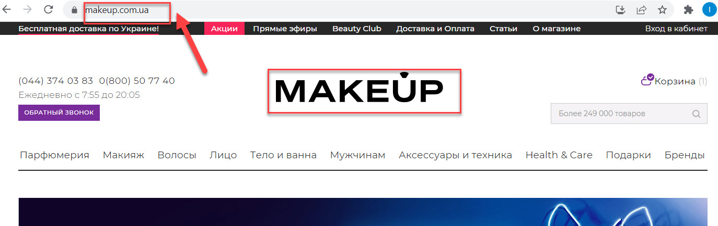

2. Choose the category of item (for example "Волосы") from the horizontal menu.
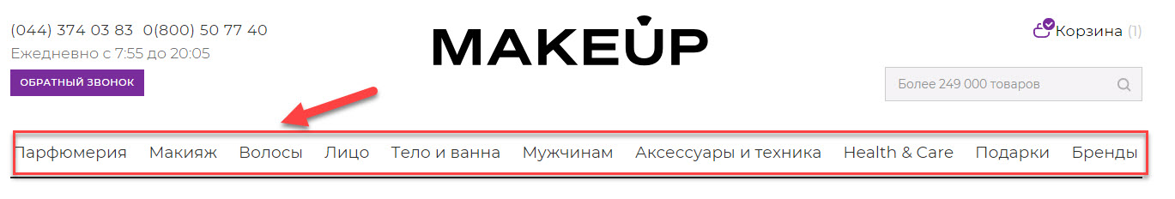

3. Select suitable category from drop-down menu (for example "Для детей").

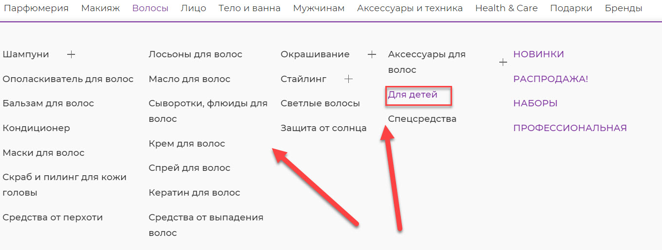

4. Find the item on the product page.

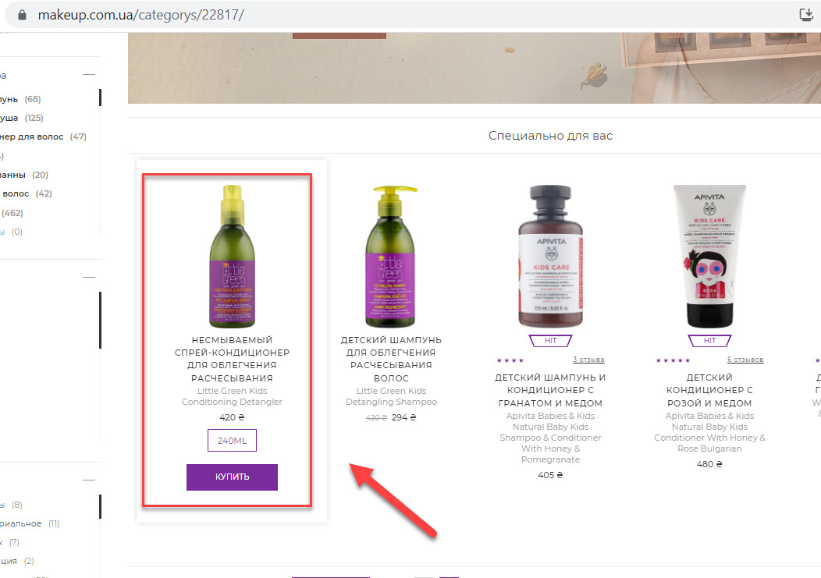
5. Click on this item.
6. Click the "Купить" button.
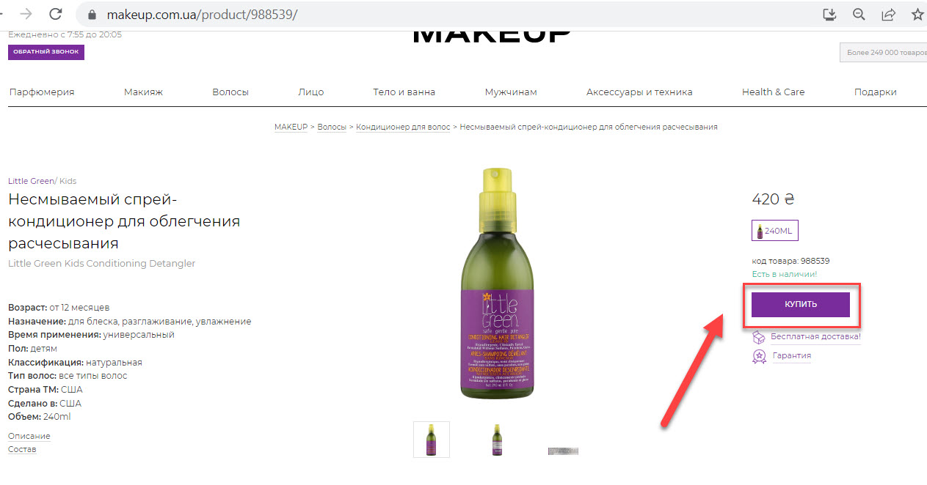

7. Click the "Оформить заказ" button.
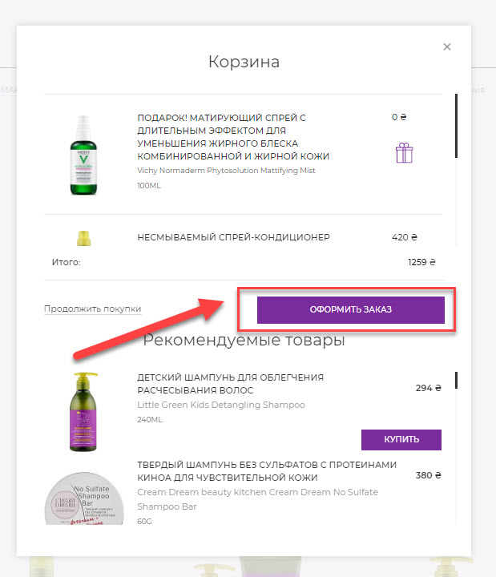

8. Enter your name on the "Ваше имя" field. Enter your Surname on the "Ваша фамилия" field. Enter your phone on the "Телефон" field.
9. Click the "Далее" button.

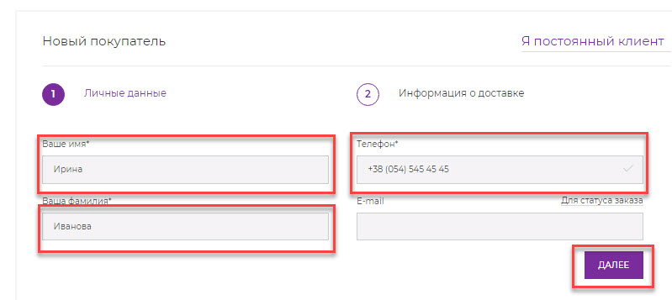

10. Enter your city on the "Город" field.
11. Enter you street and number of house on the "Улица" and "Дом" fields.
12. You can choose other delivery options and delivery time from the "Варианты доставки" and "Время доставки" dropdown lists.
13. Select a payment option from the "Варианты оплаты" dropdown list.
14. If you would like add comment to your order, you will click to the "Добавить комментарий к заказу" link and will enter the text.
15. If you would like to enter promo-code (certificate), you will enter this code to the "Введите промо-код" field and will click to the "Применить промо-код" link.
16. Click the "Оформить заказ" button.
