RAQ QUERY PIPELINE

How a Question Becomes a Validated SQL Query
An end-to-end technical reference for the CIMS RAQ Quarterly query pipeline: data sources, retrieval stages, embedding indexes, and every model call from user question to executed SQL.
■ deterministic logic ■ embedding model (BAAI/bge-large-en) ■ generative LLM (SQLCoder-7B)

Pipeline Diagram
Traced from api/routes/query.py through retrieval, gating, generation, and execution.
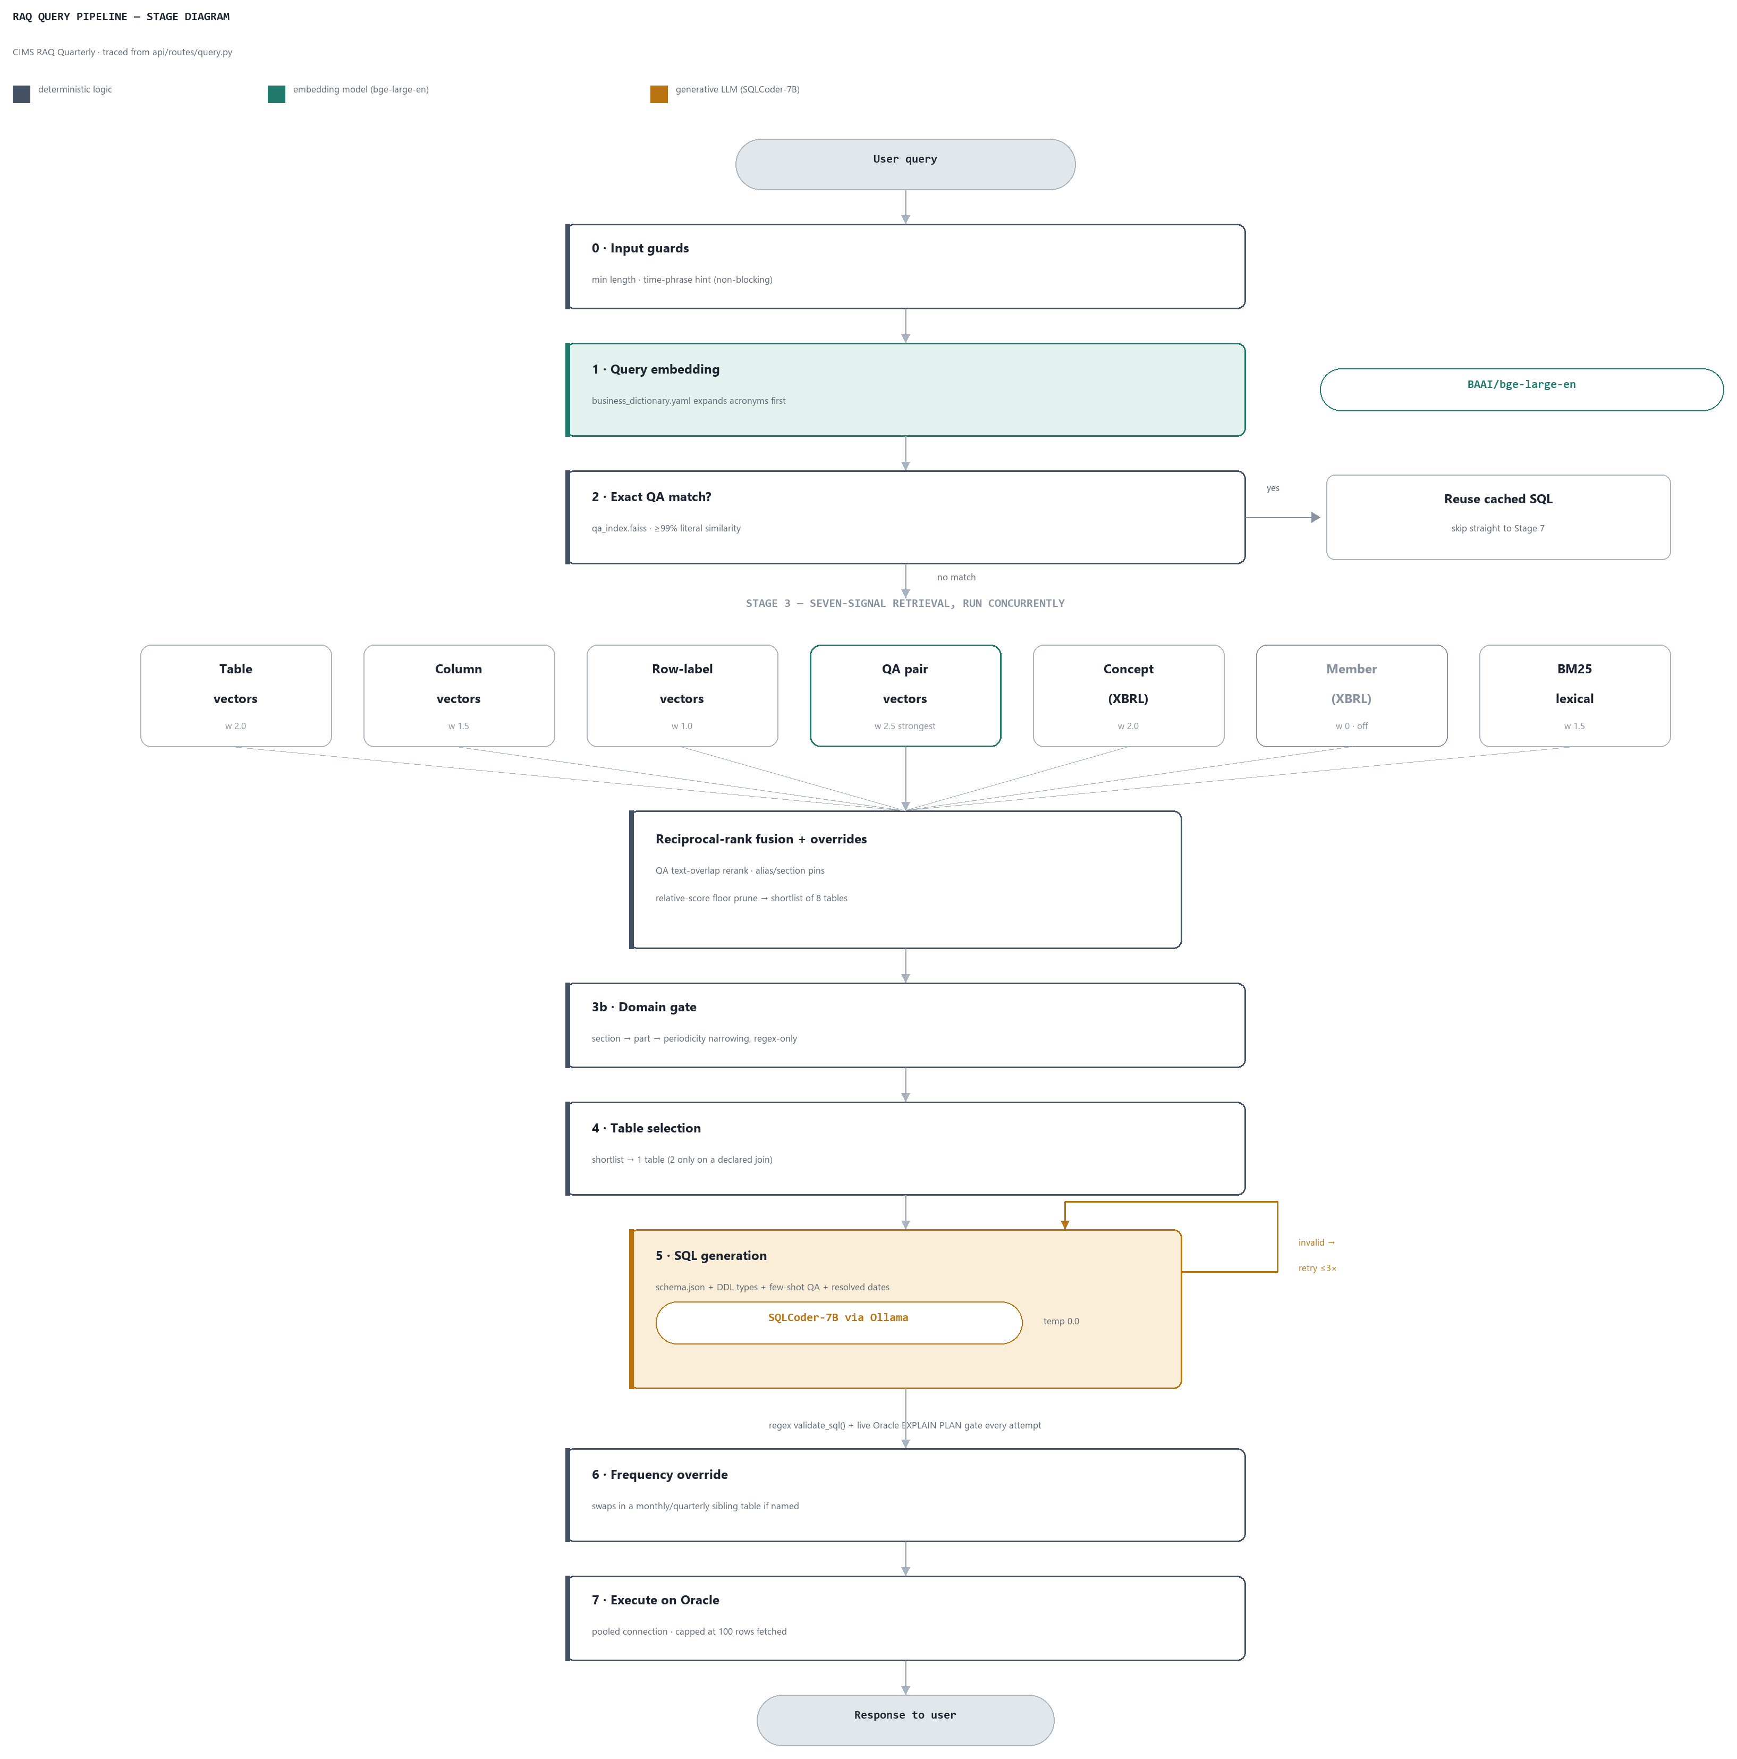
The only generative model in this path is the SQLCoder call at Stage 5 (amber). Everything else is either the local bge-large-en embedding model (teal), reused across all seven retrieval signals, or deterministic logic (slate) — regex, cached lookups, and live Oracle EXPLAIN PLAN checks.

Stage-by-Stage Breakdown

Stage 0 — Input Guards
Reads: Nothing external.
Does: Rejects queries under 20 characters; regex-checks for a time expression and attaches a soft hint if one is missing (non-blocking).
Model: None.
Output: Cleaned query string.

Stage 1 — Query Embedding
Reads: business_dictionary.yaml (acronym / alias table).
Does: Expands domain jargon and acronyms (e.g. “sec4” → “section 4”), then embeds the expanded text once with a BGE query-instruction prefix.
Model: BAAI/bge-large-en (sentence-transformers), loaded in-process locally — not a network call.
Output: 1024-dimension normalized query vector, reused for every downstream index lookup this request.

Stage 2 — Exact QA Short-Circuit
Reads: qa_index.faiss / qa_meta.pkl.
Does: FAISS top-1 lookup; if the raw query is ≥99% literally identical to a stored verified question, retrieval and generation are skipped entirely and the stored SQL is reused.
Model: Same BGE embedding already computed; no LLM.
Output: Either an early result, or falls through to Stage 3.

Stage 3 — Multi-Signal Retrieval (the RAG core)
Reads: table_index.faiss, column_index.faiss, row_label_index.faiss, qa_index.faiss, concept_index.faiss, member_index.faiss, and a BM25 lexical index — all queried concurrently.
Does: Fuses seven signals via Reciprocal Rank Fusion plus a score-magnitude blend, then layers hard overrides: QA-hit text-overlap reranking, QA-strong-match pin, business-dictionary alias pin, section-reference pin, the Domain Gate, and a relative-score floor prune.
Model: Reuses the Stage 1 embedding; no additional model calls.
Output: Shortlist of up to 8 candidate tables with fused scores.

Stage 3b — Domain Gate
Reads: Cached table-name catalog; section-alias index.
Does: Narrows candidates by explicit section reference, then explicit part reference (Part A/B), then inferred reporting periodicity (quarterly/monthly/etc from table-name prefixes). Each layer skips itself if it would empty the candidate set.
Model: None — pure regex/set logic.
Output: Filtered table list.

Stage 4 — Table Selection
Reads: semantic_layer.yaml (declared joins, verticals, metrics).
Does: Deterministic, no LLM — an LLM-based selector was removed because it added 75–135s latency and memory-thrashed the Ollama host. Picks the top-1 table unless a declared join justifies a second table.
Model: None.
Output: 1 table (occasionally 2, for a declared join).

Stage 5 — SQL Generation
Reads: schema.json, data/schema.sql (DDL type fallback), description_samples.json (row-label values), semantic_layer.yaml, the QA few-shot example, and a resolved time-range context (e.g. “last quarter” → actual dates).
Does: Builds a prompt (schema/DDL + optional XBRL business-semantics block + resolved time + few-shot example + join hint) and calls Ollama. Validates with a regex validate_sql() plus a live Oracle EXPLAIN PLAN dry-run; retries up to 3 times on failure, each with the failure reason plus a free deterministic autocorrect attempt first. Still-invalid attempts are appended to eval/results/hallucination_log.jsonl — a plain diagnostic log, not an LLM-based hallucination judge.
Model: Self-hosted Ollama over HTTP, model hf.co/defog/sqlcoder-7b-2:Q5_K_M, temperature 0.0. Configured but inactive alternates: gpt-oss:120b-cloud, qwen2.5:7b, llama3.1:latest, Arctic-Text2SQL-R1-7B.
Output: {sql, is_valid, validation_reason, warnings}.

Stage 6 — Frequency-Sibling Override
Reads: Live Oracle table catalog (not schema.json).
Does: If the query names a reporting frequency different from the generated table’s, swaps in a same-shape sibling table (quarterly ↔ monthly, etc.) purely from real Oracle table names, then re-verifies with a fresh live EXPLAIN PLAN.
Model: None.
Output: Possibly swapped SQL/table.

Stage 7 — Execution
Reads/Writes: Live Oracle DB via a pooled connection; up to 100 rows fetched.
Does: Executes the final SELECT statement.
Model: None.
Output: Columns and rows returned in the API response.

All Embedding Indexes
All seven built with the same local model, BAAI/bge-large-en — documents unprefixed at build time, queries prefixed with a BGE search instruction at query time.
Index | Purpose | Signal
table_index.faiss / table_meta.pkl | Table-level descriptions. Direct table-to-query semantic match — the primary retrieval signal. | weight 2.0
column_index.faiss / column_meta.pkl | Column-level descriptions. Votes for the table that owns the matching column. | weight 1.5
row_label_index.faiss / row_label_meta.pkl | Distinct row-label values sampled live from Oracle (e.g. “Substandard”, “Total”). Also backs literal validation in Stage 5. | weight 1.0
qa_index.faiss / qa_meta.pkl | Verified question → SQL pairs. Strongest fusion vote, source of the Stage 5 few-shot example, and the Stage 2 exact-match short-circuit. | weight 2.5
concept_index.faiss / concept_meta.pkl | XBRL regulatory-concept phrasing mapped to (table, column) pairs via the concept map. | weight 2.0
member_index.faiss / member_meta.pkl | XBRL dimension-member phrasing, routed to tables using that axis. Built at index time, disabled at query time. | weight 0 · disabled
bm25_table_index.pkl | Lexical term-frequency index over the same enriched table documents — no embedding model, exact-term precision. | weight 1.5 · lexical

Model &amp; LLM Calls
One generative model runs in the live query path. Table selection and hallucination checking were both LLM-based at one point and are now deterministic.
Call | Model / Provider | Status
SQL generation  (+ up to 3 retries) | SQLCoder-7B via self-hosted Ollama  hf.co/defog/sqlcoder-7b-2:Q5_K_M · temp 0.0 | Active
Query embedding | BAAI/bge-large-en  local sentence-transformers, in-process | Active
Table / column selection | — none — | Removed: 75–135s latency, memory-thrashed the Ollama host
Hallucination check | — none — | Regex validator + live Oracle EXPLAIN PLAN; the log is diagnostic only
QA pair authoring | Local claude CLI | Offline, build-time only — not in the query path
No Anthropic/Claude or OpenAI API is called anywhere in the live query path — the only LLM in production use is the self-hosted SQLCoder-7B via Ollama.

Key Data Sources
Everything below is read from config.EMBEDDING_DIR unless noted.
- schema.json — authoritative table/column metadata
- description_samples.json — row-label values (non-embedded)
- semantic_layer.yaml — declared joins, verticals, metrics
- concept_map.json — XBRL concept → column mapping
- business_dictionary.yaml — acronym / alias expansion
- data/schema.sql — Oracle DDL dump, column-type fallback only
- Oracle live catalog — frequency-sibling discovery + execution

Traced from the live query path starting at api/routes/query.py — CIMS RAQ Quarterly build.

