from google.colab import files
uploaded = files.upload()
<IPython.core.display.HTML object>
Saving credit_risk_dataset.csv to credit_risk_dataset.csv
import pandas as pd
df = pd.read_csv("credit_risk_dataset.csv")
import sqlite3
# Create a SQLite connection
conn = sqlite3.connect(':memory:') # Uses an in-memory database
df.to_sql('credit_risk', conn, index=False, if_exists='replace') # Load data into SQL
32581
df.head()
{"summary":"{\n \"name\": \"df\",\n \"rows\": 32581,\n \"fields\": [\n {\n \"column\": \"person_age\",\n \"properties\": {\n \"dtype\": \"number\",\n \"std\": 6,\n \"min\": 20,\n \"max\": 144,\n \"num_unique_values\": 58,\n \"samples\": [\n 22,\n 26,\n 65\n ],\n \"semantic_type\": \"\",\n \"description\": \"\"\n }\n },\n {\n \"column\": \"person_income\",\n \"properties\": {\n \"dtype\": \"number\",\n \"std\": 61983,\n \"min\": 4000,\n \"max\": 6000000,\n \"num_unique_values\": 4295,\n \"samples\": [\n 20800,\n 54417,\n 144000\n ],\n \"semantic_type\": \"\",\n \"description\": \"\"\n }\n },\n {\n \"column\": \"person_home_ownership\",\n \"properties\": {\n \"dtype\": \"category\",\n \"num_unique_values\": 4,\n \"samples\": [\n \"OWN\",\n \"OTHER\",\n \"RENT\"\n ],\n \"semantic_type\": \"\",\n \"description\": \"\"\n }\n },\n {\n \"column\": \"person_emp_length\",\n \"properties\": {\n \"dtype\": \"number\",\n \"std\": 4.142630148887972,\n \"min\": 0.0,\n \"max\": 123.0,\n \"num_unique_values\": 36,\n \"samples\": [\n 30.0,\n 18.0,\n 26.0\n ],\n \"semantic_type\": \"\",\n \"description\": \"\"\n }\n },\n {\n \"column\": \"loan_intent\",\n \"properties\": {\n \"dtype\": \"category\",\n \"num_unique_values\": 6,\n \"samples\": [\n \"PERSONAL\",\n \"EDUCATION\",\n \"DEBTCONSOLIDATION\"\n ],\n \"semantic_type\": \"\",\n \"description\": \"\"\n }\n },\n {\n \"column\": \"loan_grade\",\n \"properties\": {\n \"dtype\": \"category\",\n \"num_unique_values\": 7,\n \"samples\": [\n \"D\",\n \"B\",\n \"F\"\n ],\n \"semantic_type\": \"\",\n \"description\": \"\"\n }\n },\n {\n \"column\": \"loan_amnt\",\n \"properties\": {\n \"dtype\": \"number\",\n \"std\": 6322,\n \"min\": 500,\n \"max\": 35000,\n \"num_unique_values\": 753,\n \"samples\": [\n 13125,\n 3675,\n 13800\n ],\n \"semantic_type\": \"\",\n \"description\": \"\"\n }\n },\n {\n \"column\": \"loan_int_rate\",\n \"properties\": {\n \"dtype\": \"number\",\n \"std\": 3.2404594649559195,\n \"min\": 5.42,\n \"max\": 23.22,\n \"num_unique_values\": 348,\n \"samples\": [\n 10.28,\n 13.35,\n 18.07\n ],\n \"semantic_type\": \"\",\n \"description\": \"\"\n }\n },\n {\n \"column\": \"loan_status\",\n \"properties\": {\n \"dtype\": \"number\",\n \"std\": 0,\n \"min\": 0,\n \"max\": 1,\n \"num_unique_values\": 2,\n \"samples\": [\n 0,\n 1\n ],\n \"semantic_type\": \"\",\n \"description\": \"\"\n }\n },\n {\n \"column\": \"loan_percent_income\",\n \"properties\": {\n \"dtype\": \"number\",\n \"std\": 0.10678175634492885,\n \"min\": 0.0,\n \"max\": 0.83,\n \"num_unique_values\": 77,\n \"samples\": [\n 0.55,\n 0.34\n ],\n \"semantic_type\": \"\",\n \"description\": \"\"\n }\n },\n {\n \"column\": \"cb_person_default_on_file\",\n \"properties\": {\n \"dtype\": \"category\",\n \"num_unique_values\": 2,\n \"samples\": [\n \"N\",\n \"Y\"\n ],\n \"semantic_type\": \"\",\n \"description\": \"\"\n }\n },\n {\n \"column\": \"cb_person_cred_hist_length\",\n \"properties\": {\n \"dtype\": \"number\",\n \"std\": 4,\n \"min\": 2,\n \"max\": 30,\n \"num_unique_values\": 29,\n \"samples\": [\n 24,\n 25\n ],\n \"semantic_type\": \"\",\n \"description\": \"\"\n }\n }\n ]\n}","type":"dataframe","variable_name":"df"}
query = """
SELECT
AVG(loan_amnt) AS "Average Loan",
AVG(loan_int_rate) AS "Average Interest Rate",
loan_grade AS "Category"
FROM credit_risk
GROUP BY loan_grade;
"""
# Run SQL query
result = pd.read_sql_query(query, conn)
print(result)
Average Loan Average Interest Rate Category
0 8539.273453 7.327651 A
1 9995.483686 10.995555 B
2 9213.862651 13.463542 C
3 10849.241589 15.361448 D
4 12915.845436 17.009455 E
5 14717.323651 18.609159 F
6 17195.703125 20.251525 G
query = """
SELECT *
FROM credit_risk
WHERE loan_status = 1
ORDER BY cb_person_cred_hist_length DESC
LIMIT 10;
"""
# Run SQL query
result = pd.read_sql_query(query, conn)
print(result)
person_age person_income person_home_ownership person_emp_length \
0 55 50000 RENT 2.0
1 51 37200 RENT 4.0
2 53 34000 MORTGAGE 0.0
3 55 34000 RENT 0.0
4 52 163000 MORTGAGE 9.0
5 62 76500 RENT 0.0
6 54 33600 RENT 0.0
7 66 40000 RENT 2.0
8 52 36000 RENT 8.0
9 55 78000 MORTGAGE 2.0
loan_intent loan_grade loan_amnt loan_int_rate loan_status \
0 HOMEIMPROVEMENT A 20000 7.51 1
1 MEDICAL B 3000 10.62 1
2 MEDICAL B 10000 10.39 1
3 DEBTCONSOLIDATION A 12000 6.92 1
4 PERSONAL D 25000 14.11 1
5 EDUCATION D 20000 16.77 1
6 DEBTCONSOLIDATION B 1000 10.65 1
7 EDUCATION E 7000 15.68 1
8 DEBTCONSOLIDATION B 11200 12.18 1
9 DEBTCONSOLIDATION D 8000 NaN 1
loan_percent_income cb_person_default_on_file cb_person_cred_hist_length
0 0.40 N 30
1 0.08 N 30
2 0.29 N 30
3 0.35 N 30
4 0.15 N 30
5 0.26 Y 29
6 0.03 N 29
7 0.17 Y 29
8 0.31 N 29
9 0.10 N 29
query = """
SELECT *
FROM (
SELECT *, ROW_NUMBER() OVER (PARTITION BY loan_intent ORDER BY loan_amnt DESC) AS rank
FROM credit_risk)
ranked
WHERE rank<=5;
"""
# Run SQL query
result = pd.read_sql_query(query, conn)
print(result)
person_age person_income person_home_ownership person_emp_length \
0 23 113000 RENT 8.0
1 24 74000 OWN 8.0
2 24 95000 MORTGAGE 3.0
3 25 96000 MORTGAGE 5.0
4 23 112800 MORTGAGE 3.0
5 26 77100 RENT 8.0
6 26 108160 RENT 4.0
7 23 115000 RENT 2.0
8 23 120000 RENT 0.0
9 26 213000 MORTGAGE 6.0
10 24 72400 MORTGAGE 4.0
11 24 96000 MORTGAGE 8.0
12 25 100505 OWN 9.0
13 25 130000 MORTGAGE 9.0
14 24 151000 MORTGAGE 8.0
15 23 65500 RENT 4.0
16 24 54400 RENT 8.0
17 24 78956 RENT 5.0
18 23 92111 RENT 7.0
19 25 230000 MORTGAGE 5.0
20 22 59000 RENT 123.0
21 24 83000 RENT 8.0
22 23 277000 OWN 3.0
23 25 168000 MORTGAGE 2.0
24 23 160000 MORTGAGE 5.0
25 22 85000 RENT 6.0
26 23 95000 RENT 2.0
27 25 162500 RENT 2.0
28 26 70000 MORTGAGE 9.0
29 22 79000 MORTGAGE 3.0
loan_intent loan_grade loan_amnt loan_int_rate loan_status \
0 DEBTCONSOLIDATION D 35000 18.25 1
1 DEBTCONSOLIDATION G 35000 20.11 1
2 DEBTCONSOLIDATION B 35000 11.99 0
3 DEBTCONSOLIDATION A 35000 7.49 0
4 DEBTCONSOLIDATION B 35000 NaN 0
5 EDUCATION B 35000 12.42 1
6 EDUCATION E 35000 18.39 1
7 EDUCATION A 35000 7.90 0
8 EDUCATION A 35000 7.90 0
9 EDUCATION B 35000 10.65 1
10 HOMEIMPROVEMENT C 35000 13.99 0
11 HOMEIMPROVEMENT A 35000 7.90 0
12 HOMEIMPROVEMENT B 35000 11.99 0
13 HOMEIMPROVEMENT B 35000 NaN 0
14 HOMEIMPROVEMENT C 35000 14.27 0
15 MEDICAL C 35000 15.23 1
16 MEDICAL C 35000 14.27 1
17 MEDICAL B 35000 11.11 1
18 MEDICAL F 35000 20.25 1
19 MEDICAL C 35000 13.99 0
20 PERSONAL D 35000 16.02 1
21 PERSONAL A 35000 8.90 1
22 PERSONAL A 35000 NaN 0
23 PERSONAL B 35000 10.65 0
24 PERSONAL A 35000 7.66 0
25 VENTURE B 35000 10.37 1
26 VENTURE A 35000 7.90 1
27 VENTURE A 35000 7.49 0
28 VENTURE A 35000 7.90 0
29 VENTURE C 35000 13.80 0
loan_percent_income cb_person_default_on_file cb_person_cred_hist_length \
0 0.31 N 4
1 0.47 N 3
2 0.37 N 2
3 0.36 N 3
4 0.31 N 4
5 0.45 N 3
6 0.32 N 4
7 0.30 N 4
8 0.29 N 4
9 0.16 N 2
10 0.48 N 4
11 0.36 N 4
12 0.35 N 3
13 0.27 N 3
14 0.23 Y 2
15 0.53 N 2
16 0.55 Y 4
17 0.44 N 4
18 0.32 N 4
19 0.15 N 4
20 0.59 Y 3
21 0.42 N 2
22 0.13 N 4
23 0.21 N 2
24 0.22 N 2
25 0.41 N 4
26 0.37 N 2
27 0.22 N 4
28 0.50 N 2
29 0.44 Y 2
rank
0 1
1 2
2 3
3 4
4 5
5 1
6 2
7 3
8 4
9 5
10 1
11 2
12 3
13 4
14 5
15 1
16 2
17 3
18 4
19 5
20 1
21 2
22 3
23 4
24 5
25 1
26 2
27 3
28 4
29 5
query = """
SELECT *
FROM credit_risk
WHERE loan_amnt> (
SELECT AVG(loan_amnt)
FROM credit_risk
WHERE loan_status = 1);
"""
# Run SQL query
result = pd.read_sql_query(query, conn)
print(result)
person_age person_income person_home_ownership person_emp_length \
0 22 59000 RENT 123.0
1 23 65500 RENT 4.0
2 24 54400 RENT 8.0
3 26 77100 RENT 8.0
4 24 78956 RENT 5.0
... ... ... ... ...
10633 60 45600 RENT 1.0
10634 52 65004 RENT 4.0
10635 54 120000 MORTGAGE 4.0
10636 65 76000 RENT 3.0
10637 56 150000 MORTGAGE 5.0
loan_intent loan_grade loan_amnt loan_int_rate loan_status \
0 PERSONAL D 35000 16.02 1
1 MEDICAL C 35000 15.23 1
2 MEDICAL C 35000 14.27 1
3 EDUCATION B 35000 12.42 1
4 MEDICAL B 35000 11.11 1
... ... ... ... ... ...
10633 VENTURE B 20000 10.00 1
10634 PERSONAL D 20000 15.58 1
10635 PERSONAL A 17625 7.49 0
10636 HOMEIMPROVEMENT B 35000 10.99 1
10637 PERSONAL B 15000 11.48 0
loan_percent_income cb_person_default_on_file \
0 0.59 Y
1 0.53 N
2 0.55 Y
3 0.45 N
4 0.44 N
... ... ...
10633 0.44 N
10634 0.31 Y
10635 0.15 N
10636 0.46 N
10637 0.10 N
cb_person_cred_hist_length
0 3
1 2
2 4
3 3
4 4
... ...
10633 26
10634 19
10635 19
10636 28
10637 26
[10638 rows x 12 columns]
query = """
SELECT
COUNT(loan_percent_income) AS "Total Count",
MIN(loan_percent_income) AS "Minimum Rate",
MAX(loan_percent_income) AS "Maximum Rate",
AVG(loan_percent_income) AS "Average Rate",
sqrt(AVG(loan_percent_income * loan_percent_income) - AVG(loan_percent_income) * AVG(loan_percent_income)) AS Standard_Deviation
FROM credit_risk;
"""
# Run SQL query
result = pd.read_sql_query(query, conn)
print(result)
Total Count Minimum Rate Maximum Rate Average Rate Standard_Deviation
0 32581 0.0 0.83 0.170203 0.10678
query = """
SELECT
*,
CASE
WHEN loan_percent_income > 0.5 THEN 'High'
WHEN loan_percent_income BETWEEN 0.15 AND 0.5 THEN 'Medium'
ELSE 'Low'
END AS "Borrower Risk"
FROM credit_risk;
"""
# Run SQL query
result = pd.read_sql_query(query, conn)
print(result)
person_age person_income person_home_ownership person_emp_length \
0 22 59000 RENT 123.0
1 21 9600 OWN 5.0
2 25 9600 MORTGAGE 1.0
3 23 65500 RENT 4.0
4 24 54400 RENT 8.0
... ... ... ... ...
32576 57 53000 MORTGAGE 1.0
32577 54 120000 MORTGAGE 4.0
32578 65 76000 RENT 3.0
32579 56 150000 MORTGAGE 5.0
32580 66 42000 RENT 2.0
loan_intent loan_grade loan_amnt loan_int_rate loan_status \
0 PERSONAL D 35000 16.02 1
1 EDUCATION B 1000 11.14 0
2 MEDICAL C 5500 12.87 1
3 MEDICAL C 35000 15.23 1
4 MEDICAL C 35000 14.27 1
... ... ... ... ... ...
32576 PERSONAL C 5800 13.16 0
32577 PERSONAL A 17625 7.49 0
32578 HOMEIMPROVEMENT B 35000 10.99 1
32579 PERSONAL B 15000 11.48 0
32580 MEDICAL B 6475 9.99 0
loan_percent_income cb_person_default_on_file \
0 0.59 Y
1 0.10 N
2 0.57 N
3 0.53 N
4 0.55 Y
... ... ...
32576 0.11 N
32577 0.15 N
32578 0.46 N
32579 0.10 N
32580 0.15 N
cb_person_cred_hist_length Borrower Risk
0 3 High
1 2 Low
2 3 High
3 2 High
4 4 High
... ... ...
32576 30 Low
32577 19 Medium
32578 28 Medium
32579 26 Low
32580 30 Medium
[32581 rows x 13 columns]
df.head()
{"summary":"{\n \"name\": \"df\",\n \"rows\": 32581,\n \"fields\": [\n {\n \"column\": \"person_age\",\n \"properties\": {\n \"dtype\": \"number\",\n \"std\": 6,\n \"min\": 20,\n \"max\": 144,\n \"num_unique_values\": 58,\n \"samples\": [\n 22,\n 26,\n 65\n ],\n \"semantic_type\": \"\",\n \"description\": \"\"\n }\n },\n {\n \"column\": \"person_income\",\n \"properties\": {\n \"dtype\": \"number\",\n \"std\": 61983,\n \"min\": 4000,\n \"max\": 6000000,\n \"num_unique_values\": 4295,\n \"samples\": [\n 20800,\n 54417,\n 144000\n ],\n \"semantic_type\": \"\",\n \"description\": \"\"\n }\n },\n {\n \"column\": \"person_home_ownership\",\n \"properties\": {\n \"dtype\": \"category\",\n \"num_unique_values\": 4,\n \"samples\": [\n \"OWN\",\n \"OTHER\",\n \"RENT\"\n ],\n \"semantic_type\": \"\",\n \"description\": \"\"\n }\n },\n {\n \"column\": \"person_emp_length\",\n \"properties\": {\n \"dtype\": \"number\",\n \"std\": 4.142630148887972,\n \"min\": 0.0,\n \"max\": 123.0,\n \"num_unique_values\": 36,\n \"samples\": [\n 30.0,\n 18.0,\n 26.0\n ],\n \"semantic_type\": \"\",\n \"description\": \"\"\n }\n },\n {\n \"column\": \"loan_intent\",\n \"properties\": {\n \"dtype\": \"category\",\n \"num_unique_values\": 6,\n \"samples\": [\n \"PERSONAL\",\n \"EDUCATION\",\n \"DEBTCONSOLIDATION\"\n ],\n \"semantic_type\": \"\",\n \"description\": \"\"\n }\n },\n {\n \"column\": \"loan_grade\",\n \"properties\": {\n \"dtype\": \"category\",\n \"num_unique_values\": 7,\n \"samples\": [\n \"D\",\n \"B\",\n \"F\"\n ],\n \"semantic_type\": \"\",\n \"description\": \"\"\n }\n },\n {\n \"column\": \"loan_amnt\",\n \"properties\": {\n \"dtype\": \"number\",\n \"std\": 6322,\n \"min\": 500,\n \"max\": 35000,\n \"num_unique_values\": 753,\n \"samples\": [\n 13125,\n 3675,\n 13800\n ],\n \"semantic_type\": \"\",\n \"description\": \"\"\n }\n },\n {\n \"column\": \"loan_int_rate\",\n \"properties\": {\n \"dtype\": \"number\",\n \"std\": 3.2404594649559195,\n \"min\": 5.42,\n \"max\": 23.22,\n \"num_unique_values\": 348,\n \"samples\": [\n 10.28,\n 13.35,\n 18.07\n ],\n \"semantic_type\": \"\",\n \"description\": \"\"\n }\n },\n {\n \"column\": \"loan_status\",\n \"properties\": {\n \"dtype\": \"number\",\n \"std\": 0,\n \"min\": 0,\n \"max\": 1,\n \"num_unique_values\": 2,\n \"samples\": [\n 0,\n 1\n ],\n \"semantic_type\": \"\",\n \"description\": \"\"\n }\n },\n {\n \"column\": \"loan_percent_income\",\n \"properties\": {\n \"dtype\": \"number\",\n \"std\": 0.10678175634492885,\n \"min\": 0.0,\n \"max\": 0.83,\n \"num_unique_values\": 77,\n \"samples\": [\n 0.55,\n 0.34\n ],\n \"semantic_type\": \"\",\n \"description\": \"\"\n }\n },\n {\n \"column\": \"cb_person_default_on_file\",\n \"properties\": {\n \"dtype\": \"category\",\n \"num_unique_values\": 2,\n \"samples\": [\n \"N\",\n \"Y\"\n ],\n \"semantic_type\": \"\",\n \"description\": \"\"\n }\n },\n {\n \"column\": \"cb_person_cred_hist_length\",\n \"properties\": {\n \"dtype\": \"number\",\n \"std\": 4,\n \"min\": 2,\n \"max\": 30,\n \"num_unique_values\": 29,\n \"samples\": [\n 24,\n 25\n ],\n \"semantic_type\": \"\",\n \"description\": \"\"\n }\n }\n ]\n}","type":"dataframe","variable_name":"df"}
from matplotlib import pyplot as plt
import numpy as np
%matplotlib inline
import missingno as msno
msno.matrix(df)
<Axes: >
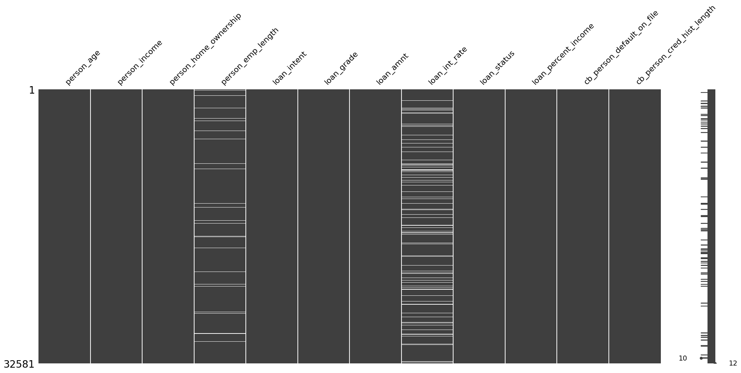
df.info()
<class 'pandas.core.frame.DataFrame'>
RangeIndex: 32581 entries, 0 to 32580
Data columns (total 12 columns):
# Column Non-Null Count Dtype
--- ------ -------------- -----
0 person_age 32581 non-null int64
1 person_income 32581 non-null int64
2 person_home_ownership 32581 non-null object
3 person_emp_length 31686 non-null float64
4 loan_intent 32581 non-null object
5 loan_grade 32581 non-null object
6 loan_amnt 32581 non-null int64
7 loan_int_rate 29465 non-null float64
8 loan_status 32581 non-null int64
9 loan_percent_income 32581 non-null float64
10 cb_person_default_on_file 32581 non-null object
11 cb_person_cred_hist_length 32581 non-null int64
dtypes: float64(3), int64(5), object(4)
memory usage: 3.0+ MB
df.describe()
{"summary":"{\n \"name\": \"df\",\n \"rows\": 8,\n \"fields\": [\n {\n \"column\": \"person_age\",\n \"properties\": {\n \"dtype\": \"number\",\n \"std\": 11505.209452641495,\n \"min\": 6.3480784192252475,\n \"max\": 32581.0,\n \"num_unique_values\": 8,\n \"samples\": [\n 27.73459992019889,\n 26.0,\n 32581.0\n ],\n \"semantic_type\": \"\",\n \"description\": \"\"\n }\n },\n {\n \"column\": \"person_income\",\n \"properties\": {\n \"dtype\": \"number\",\n \"std\": 2104411.4228170463,\n \"min\": 4000.0,\n \"max\": 6000000.0,\n \"num_unique_values\": 8,\n \"samples\": [\n 66074.84846996715,\n 55000.0,\n 32581.0\n ],\n \"semantic_type\": \"\",\n \"description\": \"\"\n }\n },\n {\n \"column\": \"person_emp_length\",\n \"properties\": {\n \"dtype\": \"number\",\n \"std\": 11195.450623137132,\n \"min\": 0.0,\n \"max\": 31686.0,\n \"num_unique_values\": 8,\n \"samples\": [\n 4.789686296787225,\n 4.0,\n 31686.0\n ],\n \"semantic_type\": \"\",\n \"description\": \"\"\n }\n },\n {\n \"column\": \"loan_amnt\",\n \"properties\": {\n \"dtype\": \"number\",\n \"std\": 12907.153470802921,\n \"min\": 500.0,\n \"max\": 35000.0,\n \"num_unique_values\": 8,\n \"samples\": [\n 9589.371105859243,\n 8000.0,\n 32581.0\n ],\n \"semantic_type\": \"\",\n \"description\": \"\"\n }\n },\n {\n \"column\": \"loan_int_rate\",\n \"properties\": {\n \"dtype\": \"number\",\n \"std\": 10413.651601664355,\n \"min\": 3.2404594649559195,\n \"max\": 29465.0,\n \"num_unique_values\": 8,\n \"samples\": [\n 11.011694892245036,\n 10.99,\n 29465.0\n ],\n \"semantic_type\": \"\",\n \"description\": \"\"\n }\n },\n {\n \"column\": \"loan_status\",\n \"properties\": {\n \"dtype\": \"number\",\n \"std\": 11519.04063760866,\n \"min\": 0.0,\n \"max\": 32581.0,\n \"num_unique_values\": 5,\n \"samples\": [\n 0.21816396059052823,\n 1.0,\n 0.4130056685601785\n ],\n \"semantic_type\": \"\",\n \"description\": \"\"\n }\n },\n {\n \"column\": \"loan_percent_income\",\n \"properties\": {\n \"dtype\": \"number\",\n \"std\": 11519.043371973277,\n \"min\": 0.0,\n \"max\": 32581.0,\n \"num_unique_values\": 8,\n \"samples\": [\n 0.1702034928332464,\n 0.15,\n 32581.0\n ],\n \"semantic_type\": \"\",\n \"description\": \"\"\n }\n },\n {\n \"column\": \"cb_person_cred_hist_length\",\n \"properties\": {\n \"dtype\": \"number\",\n \"std\": 11516.254800358192,\n \"min\": 2.0,\n \"max\": 32581.0,\n \"num_unique_values\": 8,\n \"samples\": [\n 5.804211043246064,\n 4.0,\n 32581.0\n ],\n \"semantic_type\": \"\",\n \"description\": \"\"\n }\n }\n ]\n}","type":"dataframe"}
df = df.dropna(subset=['person_emp_length'])
df['loan_int_rate'] = df['loan_int_rate'].fillna(
df.groupby('loan_grade')['loan_int_rate'].transform('median')
)
msno.matrix(df)
<Axes: >
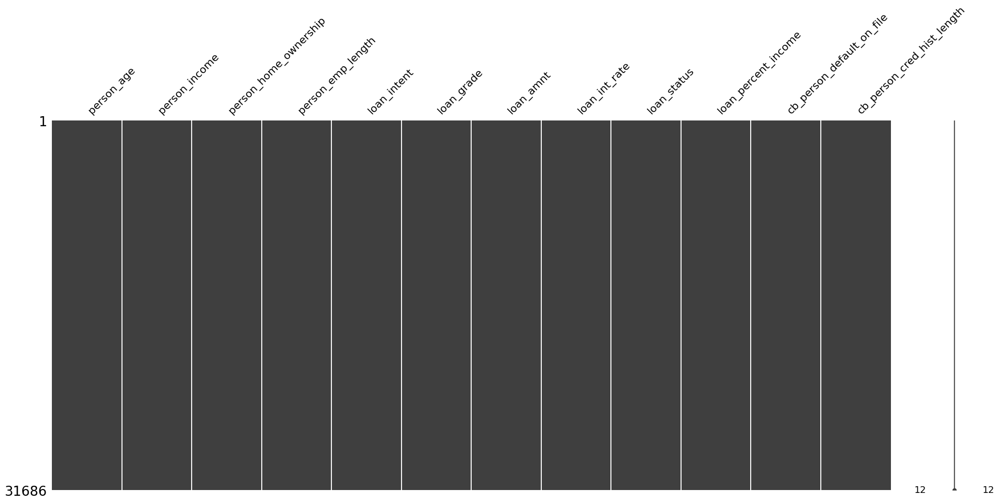
df.shape
(31686, 12)
df['person_home_ownership'].unique()
array(['RENT', 'OWN', 'MORTGAGE', 'OTHER'], dtype=object)
df['loan_intent'].unique()
array(['PERSONAL', 'EDUCATION', 'MEDICAL', 'VENTURE', 'HOMEIMPROVEMENT',
'DEBTCONSOLIDATION'], dtype=object)
df['loan_grade'].unique()
array(['D', 'B', 'C', 'A', 'E', 'F', 'G'], dtype=object)
df['loan_status'].unique()
array([1, 0])
df['cb_person_default_on_file'].unique()
array(['Y', 'N'], dtype=object)
# Columns you want to encode
categorical_cols = ['person_home_ownership', 'loan_intent', 'loan_grade', 'cb_person_default_on_file']
# Create dummies
df_dummies = pd.get_dummies(df[categorical_cols], drop_first=True)
print("Shape of the DataFrame after dummies:", df_dummies.shape)
print(df.index.equals(df_dummies.index))
# Drop original categorical columns and add dummies
df = pd.concat([df.drop(columns=categorical_cols), df_dummies], axis=1)
print("Shape of the DataFrame after concatenation:", df.shape)
Shape of the DataFrame after dummies: (31686, 15)
True
Shape of the DataFrame after concatenation: (31686, 23)
from sklearn.preprocessing import StandardScaler
# Columns you want to scale
numerical_cols = ['person_age', 'person_income', 'person_emp_length', 'loan_amnt', 'loan_int_rate', 'loan_percent_income', 'cb_person_cred_hist_length']
# Standardize selected numerical columns
scaler = StandardScaler()
df_scaled_part = pd.DataFrame(scaler.fit_transform(df[numerical_cols]), columns=numerical_cols, index=df.index)
print("Shape of the DataFrame after scaling:", df_scaled_part.shape)
print(df.index.equals(df_scaled_part.index))
# Drop original numerical columns and add scaled ones
df = pd.concat([df.drop(columns=numerical_cols), df_scaled_part], axis=1)
print("Shape of the DataFrame after concatenation:", df.shape)
Shape of the DataFrame after scaling: (31686, 7)
True
Shape of the DataFrame after concatenation: (31686, 23)
df.describe()
{"summary":"{\n \"name\": \"df\",\n \"rows\": 8,\n \"fields\": [\n {\n \"column\": \"loan_status\",\n \"properties\": {\n \"dtype\": \"number\",\n \"std\": 11202.610586463687,\n \"min\": 0.0,\n \"max\": 31686.0,\n \"num_unique_values\": 5,\n \"samples\": [\n 0.2154263712680679,\n 1.0,\n 0.4111242928213504\n ],\n \"semantic_type\": \"\",\n \"description\": \"\"\n }\n },\n {\n \"column\": \"person_age\",\n \"properties\": {\n \"dtype\": \"number\",\n \"std\": 11201.816121742664,\n \"min\": -1.2180942073254923,\n \"max\": 31686.0,\n \"num_unique_values\": 8,\n \"samples\": [\n -1.1481344464721685e-16,\n -0.2747250735844155,\n 31686.0\n ],\n \"semantic_type\": \"\",\n \"description\": \"\"\n }\n },\n {\n \"column\": \"person_income\",\n \"properties\": {\n \"dtype\": \"number\",\n \"std\": 11197.96189198264,\n \"min\": -1.0042542439643916,\n \"max\": 31686.0,\n \"num_unique_values\": 8,\n \"samples\": [\n 2.870336116180421e-17,\n -0.17127201249640545,\n 31686.0\n ],\n \"semantic_type\": \"\",\n \"description\": \"\"\n }\n },\n {\n \"column\": \"person_emp_length\",\n \"properties\": {\n \"dtype\": \"number\",\n \"std\": 11201.280548869536,\n \"min\": -1.156212769885812,\n \"max\": 31686.0,\n \"num_unique_values\": 8,\n \"samples\": [\n 1.4351680580902106e-17,\n -0.1906273864243822,\n 31686.0\n ],\n \"semantic_type\": \"\",\n \"description\": \"\"\n }\n },\n {\n \"column\": \"loan_amnt\",\n \"properties\": {\n \"dtype\": \"number\",\n \"std\": 11202.541161428435,\n \"min\": -1.445889354494791,\n \"max\": 31686.0,\n \"num_unique_values\": 8,\n \"samples\": [\n 1.1481344464721685e-16,\n -0.2622008607484837,\n 31686.0\n ],\n \"semantic_type\": \"\",\n \"description\": \"\"\n }\n },\n {\n \"column\": \"loan_int_rate\",\n \"properties\": {\n \"dtype\": \"number\",\n \"std\": 11202.550837587425,\n \"min\": -1.7558235325656646,\n \"max\": 31686.0,\n \"num_unique_values\": 8,\n \"samples\": [\n -3.224643230521442e-16,\n -0.016178633628608264,\n 31686.0\n ],\n \"semantic_type\": \"\",\n \"description\": \"\"\n }\n },\n {\n \"column\": \"loan_percent_income\",\n \"properties\": {\n \"dtype\": \"number\",\n \"std\": 11202.427729953979,\n \"min\": -1.5956722386120712,\n \"max\": 31686.0,\n \"num_unique_values\": 8,\n \"samples\": [\n -1.0046176406631473e-16,\n -0.18450645926854142,\n 31686.0\n ],\n \"semantic_type\": \"\",\n \"description\": \"\"\n }\n },\n {\n \"column\": \"cb_person_cred_hist_length\",\n \"properties\": {\n \"dtype\": \"number\",\n \"std\": 11202.41914177926,\n \"min\": -0.9380698164562193,\n \"max\": 31686.0,\n \"num_unique_values\": 8,\n \"samples\": [\n -5.740672232360842e-17,\n -0.4455563501635023,\n 31686.0\n ],\n \"semantic_type\": \"\",\n \"description\": \"\"\n }\n }\n ]\n}","type":"dataframe"}
msno.matrix(df)
<Axes: >
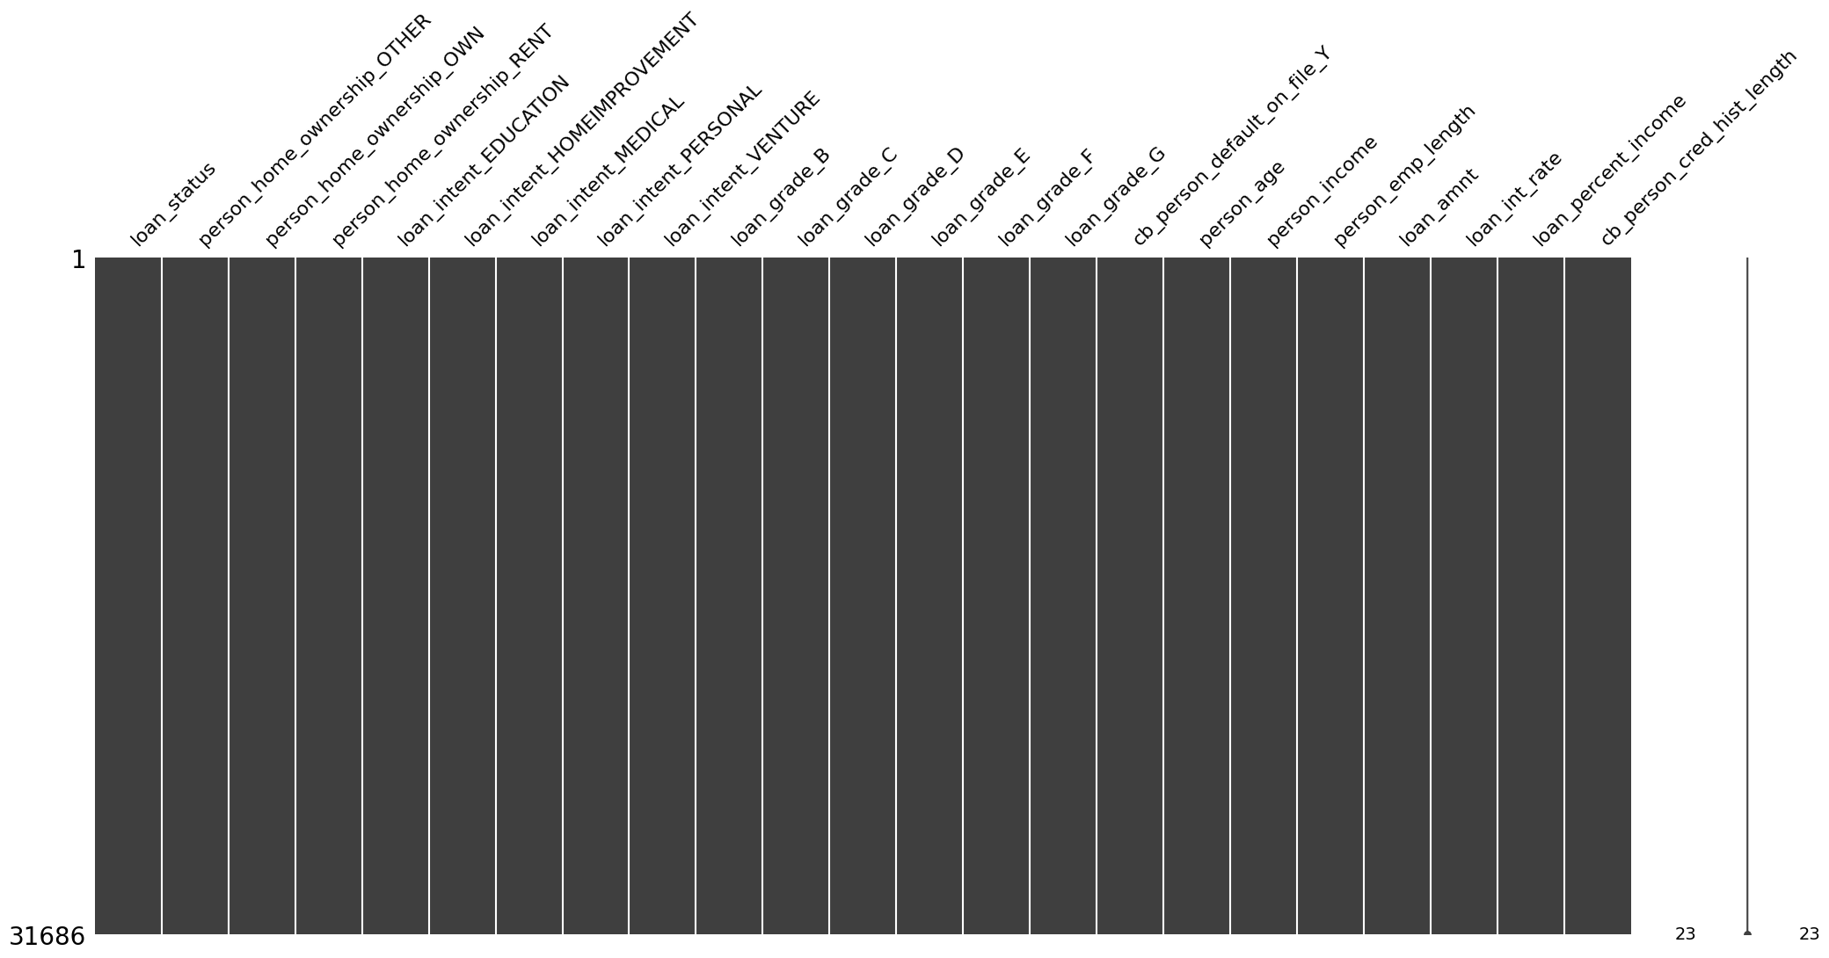
df.replace({True: 1, False: 0}, inplace=True)
<ipython-input-29-3673826116>:1: FutureWarning: Downcasting behavior in `replace` is deprecated and will be removed in a future version. To retain the old behavior, explicitly call `result.infer_objects(copy=False)`. To opt-in to the future behavior, set `pd.set_option('future.no_silent_downcasting', True)`
df.replace({True: 1, False: 0}, inplace=True)
df.describe()
{"type":"dataframe"}
msno.matrix(df)
<Axes: >
df.shape
(31686, 23)
df['loan_status'].value_counts()
loan_status
0 24860
1 6826
Name: count, dtype: int64
from sklearn.model_selection import train_test_split
# Input and Output Variable
X = df.drop(columns=['loan_status'])
y = df['loan_status'] # Target variable (1 = default, 0 = no default)
# Train-Test Split
X_train, X_test, y_train, y_test = train_test_split(X, y, test_size=0.3, random_state=21)
from sklearn.utils import resample
df_train = pd.concat([X_train, y_train], axis=1)
# Separate majority and minority classes
default_0 = df_train[df_train['loan_status'] == 0]
default_1 = df_train[df_train['loan_status'] == 1]
# Upsample minority class
default_1_upsampled = resample(
default_1,
replace=True, # Sample with replacement
n_samples=len(default_0), # Match number of majority class
random_state=25 # For reproducibility
)
# Combine majority and upsampled minority
df_train_oversampled = pd.concat([default_0, default_1_upsampled])
# Shuffle the dataset
df_train_oversampled = df_train_oversampled.sample(frac=1, random_state=25).reset_index(drop=True)
# Check the class distribution
print(df_train_oversampled['loan_status'].value_counts())
loan_status
0 17434
1 17434
Name: count, dtype: int64
df_train_oversampled.head()
{"type":"dataframe","variable_name":"df_train_oversampled"}
X_train = df_train_oversampled.drop(columns=['loan_status'])
y_train = df_train_oversampled['loan_status'] # Target variable (1 = default, 0 = no default)
X_train.head()
{"type":"dataframe","variable_name":"X_train"}
Model Training Using LogisticRegression
from sklearn.linear_model import LogisticRegression
from sklearn.metrics import accuracy_score
import pickle
# Train the PD model
model = LogisticRegression()
model.fit(X_train, y_train)
# Predict
y_pred = model.predict(X_test)
# Evaluate
accuracy = accuracy_score(y_test, y_pred)
print(f"Accuracy: {accuracy:.2f}")
Accuracy: 0.81
Model Training using XGBoost
import xgboost as xgb
# Train XGBoost model
model = xgb.XGBClassifier(n_estimators=100, max_depth=3, learning_rate=0.1, use_label_encoder=False)
model.fit(X_train, y_train)
# Predict
y_pred = model.predict(X_test)
# Evaluate
accuracy = accuracy_score(y_test, y_pred)
print(f"Accuracy: {accuracy:.2f}")
/usr/local/lib/python3.11/dist-packages/xgboost/core.py:158: UserWarning: [06:01:50] WARNING: /workspace/src/learner.cc:740:
Parameters: { "use_label_encoder" } are not used.
warnings.warn(smsg, UserWarning)
Accuracy: 0.89

