

**University of Science and Technology of Southern Philippines**

Alubijid | ***Cagayan de Oro*** | Claveria | Jasaan | Oroquieta | Panaon

COLLEGE OF SCIENCE AND TECHNOLOGY EDUCATION

DEPARTMENT OF TECHNOLOGY AND LIVELIHOOD EDUCATION

**Bachelor of Technology and Livelihood Education**

Major in **Home Economics**

**BTLED HE-3A**

**COMMERCIAL COOKING**

HE 325

**TASK 8:**

Institutional Assessment



*Bakery Products:*

**- SOFT ROLL** (Basic)

*Cake Products:*

**- VANILLA CHIFFON CAKE**

**- SWISS ROLL**

**- PETIT FOUR**

**HE 325 INSTRUCTOR:**

**SOFIA C. NAELGA**

|  |  |
| --- | --- |
| **BTLED HE – 3A : STUDENT LIST** | |
| **ID NUMBER** | **NAME** |
| 2019100950 | **AQUINO, Genica Gonzaga** |
| 2019100833 | **AYUBAN, Dorreen Madjus** |
| 2019100918 | **BAHIAN, Alexis Gaylle Alaban** |
| 2019100882 | **BAJAS, Arshelle Sihay** |
| 2019100934 | **BALGOS, Carleen Gail Gorospe** |
| 2019100863 | **BOSQUIT, Marchelie Arcenas** |
| 2009100854 | **BOYSILLO, Ara Joy Dupit** |
| 2019100933 | **CADAY, Jemelyn Mosende** |
| 2019100835 | **CALLEDO, Anna Lisa Caraoa** |
| 2019100813 | **CAPISTRANO, Ara Marie Salaosao** |
| 2019100957 | **DAEL, Sean Jayehm Escolano** |
| 2019100876 | **DOBLAS, Jc Maik Khint Jaramillo** |
| 2019100883 | **ELLEVERA, Aurie Joy Dapanas** |
| 2019100840 | **FABELA, Gabriel Ivan Retes** |
| 2019100839 | **FELICILDA, Artist Babanto** |
| 2019100893 | **GALDO, Leah Angela Janopol** |
| 2019100869 | **GOZON, Charlietta Masilang** |
| 2019100911 | **HILUDO, Maryjane Maquidato** |
| 2019100834 | **HORA, Maria Carmela Magaway** |
| 2019100952 | **HORNILLA, Rosa Ana Marie Nacua** |
| 2019100907 | **INANOD, Honember Palabrino** |
| 2019100925 | **IROC, Yvon Pearl Butanas** |
| 10613316 | **IROISA, Christopher Deligero** |
| 2019100941 | **JOHNSON, Joshua Caballero** |
| 2018102411 | **LACANG-LACANG, Kent John Visto** |
| 2019100924 | **LIGUID, Connie Mae Balbuena** |
| 2019100867 | **LLACUNA, Malyka Jhen Tabujara** |
| 2019100803 | **LLENAS, Ella Joy Libres** |
| 2019100794 | **LOLOY, Glorious Agner Neri** |
| 2019100862 | **LUAB, Marie Joy Dumaog** |
| 2019100891 | **MAESTRADO, Anna Joy Fullido** |
| 2019100819 | **MOTLOG, Reydel Jireh Pabualan** |
| 2019100899 | **ORANG, Jevellemar Alvarez** |
| 2019100862 | **PODADERA, Evangeline** |
| 2019100902 | **POLISTICO, Mildred Monares** |
| 2019100795 | **QUILACIO, Jackie Carlo Cajardo** |
| 2019100853 | **QUIROGA, Dina Rose T.** |
| 2019100929 | **RAÑOA, Rheza Lou Paullo** |
| 2019100824 | **REMOLLO, Kristina Cassandra Estrellado** |
| 2019100923 | **TAPALES, Lorellae Mae Lamaclamac** |
| 10811959 | **YAÑEZ, Merry Jesha Gayrama** |
| 2019100947 | **YARE, Regine Opcial** |
| 2017100630 | **ZAMORA, Brian Leigh Abratiguin** |

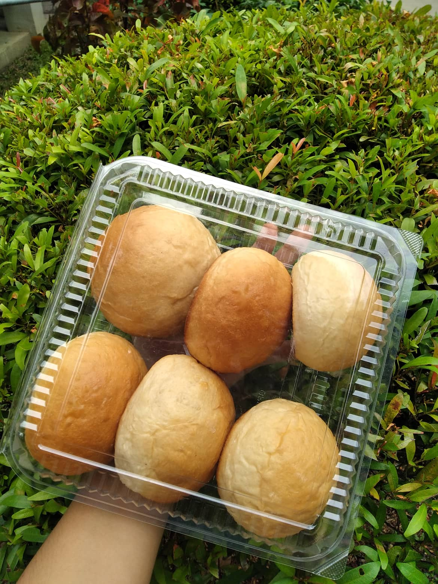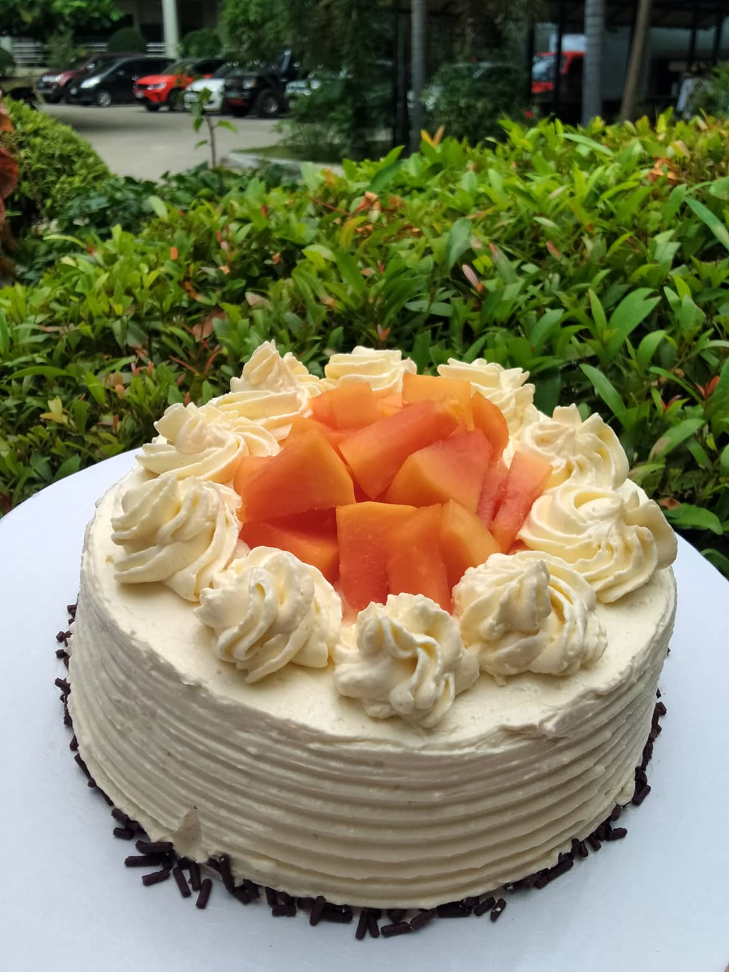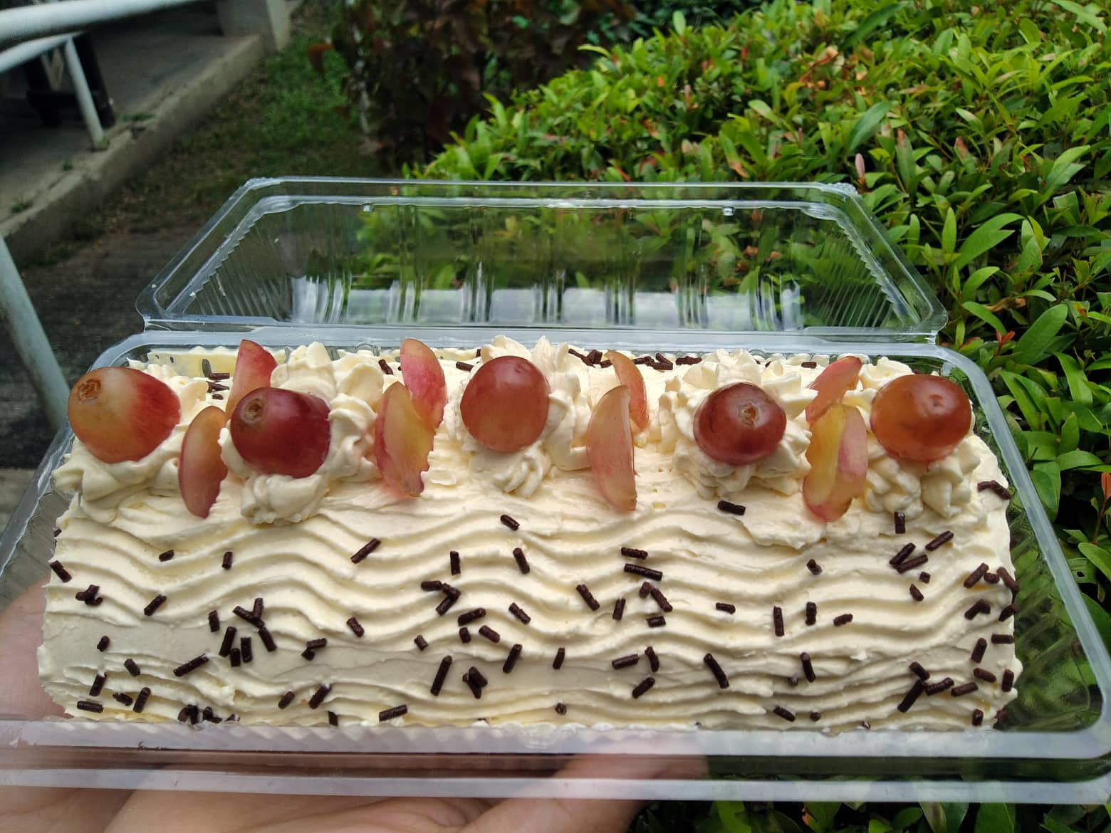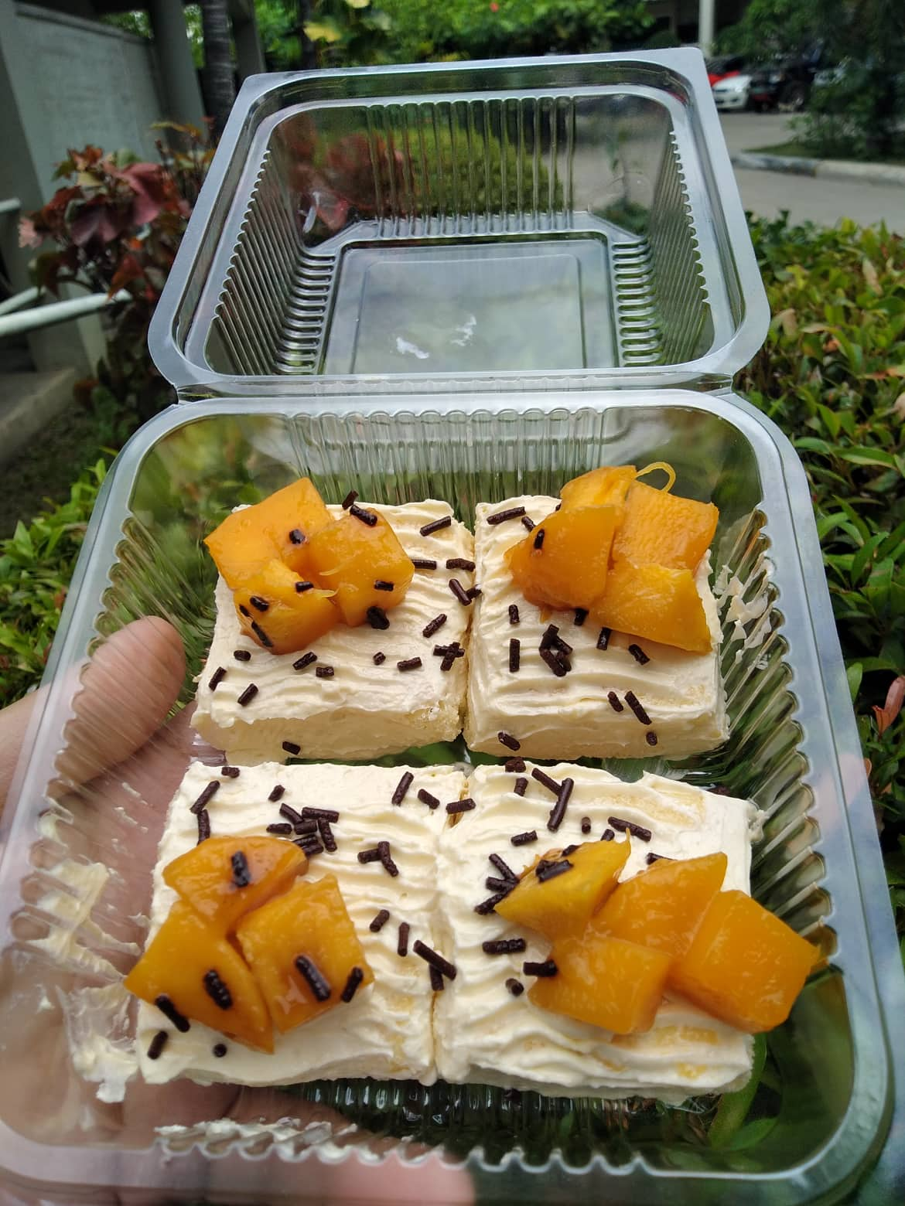

**IROC, YVON PEARL B.**

**RECIPE**

NAME OF CANDIDATE: **IROC, YVON PEARL B.**

|  |  |  |  |  |  |
| --- | --- | --- | --- | --- | --- |
| **BAKERY PRODUCTS (Soft Roll basic)** | | | | | |
| **Ingredients** | **Specification** | | **Units** | **Quantity** | |
| Milk (Diluted) | Local | | Grams | 300 | |
| Yeast | Import | | Grams | 20 or 10 | |
| Bread Flour, Sifted | Local | | Grams | 625 | |
| Sugar | Local | | Grams | 60 | |
| Eggs | Local | | Grams | 60 grams or 1 pc large | |
| Salt | Local | | Grams | 5 | |
| Butter or Margarine | Local | | Grams | 60 | |
| **Straight Dough Method:**   * Dissolve yeast in milk add sugar, eggs and mix in, add the remaining ingredients except butter. * Knead on low speed for 4 minutes scraping side down the bottom of the bowl * Knead on medium speed for 8 minutes add butter 3 minutes before the end of kneading time. * Dough should be malleable. * Bulk fermentation: 45 minutes, punch down after 20 minutes. * Scaling, rounding: 45 g. * Rest for 20 minutes. * Shaping round or oval. * When half proof brush with egg wash. * Final rising 35 minutes or until double its size.   Baking time: 15 to 25 minutes until golden brown. | | | | | |
|  | | | | | |
| **CAKE PRODUCTS** | | | | | |
| **VANILLA CHIFFON CAKE/SWISS ROLL/ PETIT FOUR** | | | | | |
| ***Type of Output*** | | | | | |
| ***Whole Cake 6x3*** | | ***Sponge roll*** | | | ***Petite four-2 bite size (2x2)*** |
| **Ingredients** | **Specification** | | **Units** | **Quantity** | |
| Corn oil | Local | | grams | 50 | |
| Egg yolks | Local | | pcs | 6 or 8 (70 grams each) | |
| Water | Local | | grams | 140 | |
| Vanilla | Local | | grams | 5 | |
| Cake flour | Local | | grams | 170 | |
| Sugar ref. | Local | | grams | 100 | |
| Baking powder | Local | | grams | 7 | |
| Egg whites | Local | | pcs | 6 or 8 (70 grams each) | |
| Sugar ref. | Local | | grams | 70 | |
| Cream of Tartar | Local | | Tsp. | 1 | |
| **Mise en Place**   * Pre-Heat the oven * Ling the cake molds with wax or aluminum foil. Set Aside * Sift cake flour and baking powder together and add 100 grams white sugar * For the sponge, Pre-heat the oven to 163c/ 350f   **Method**   * With a mixing bowl fitted with wire whip attachment, combine egg yolks, water, vanilla extract and oil together and beat on medium speed for 1 minute. * Add in the dry ingredients. Then whip at low speed for 1 minute and scrape side down of the bowl.   ✓ Whip about 2 minutes in medium speed until the batter is very smooth and fluffy. Set aside  ✓ Whip the egg whites to snow peak and gradually add the sugar, whisk to stiff peak. ✓ Gently fold meringue into the reserved batter until well incorporate.   * Divide batter into prepared pans approximately ¾ full. * Bake for approximately 30-40 minutes sponge should spring back when pressed slightly in the center. * Allow the cake to cool-down before unmolding.   For the sponge roll, bake for 10 to 12 minutes until light brown.  **Variations:**   * For chocolate chiffon cake, substitute 75 gram sifted unsweetened cocoa powder for the amount of flour, add 5 gram of baking powder. * Follow the same method   For mocha chiffon cake, add 25 grams coffee powder dissolved in 10 grams of water onto the mixture. | | | | | |
|  | | | | | |
| **SWISS BUTTER CREAM (FROSTING)** | | | | | |
| **Ingredients** | **Specification** | | **Units** | **Quantity** | |
| Egg whites | Local | | Pcs | 4 | |
| Sugar | Local | | Grams | 200 | |
| Butter (cold) | Imported | | Grams | 337.5 | |
| Vanilla extract | Local | | Grams | 10 | |
| **Mise en Place:**   * Sanitize the utensils, mixing bowls and set aside. * Prepare large pan with water heat to barely simmer point.   **Method:**   * Combine sugar and egg whites in a bowl stirring until the sugar dissolved. * Place on a barely simmering hot water bath. Whipping constantly until the temperature reaches 70c. * Transfer onto a mixing bowl fitted with wire whisk attachment. Whip until stiff peak replace attachment to paddle, beating to medium speed until cold, gradually add butter and beat in medium speed until smooth and creamy.   **Notes: Butter cream can be flavored and colored as desired.** | | | | | |

**MARKET LIST**

NAME OF CANDIDATE: **IROC, YVON PEARL B.**

|  |  |  |
| --- | --- | --- |
| **INGREDIENTS** | **SPECIFICATION** | **TENTATIVE PRICE** |
| Milk |  | ₱22.00/370ml |
| Yeast |  | ₱49.10/120g |
| Bread Flour |  | ₱46.90/500g |
| Cake Flour |  | ₱27.45/500g |
| White Sugar |  | ₱74.85/1000g |
| Egg |  | ₱7.00/60g |
| Salt |  | ₱12.50/500g |
| Butter |  | ₱41.95/200g |
| Corn Oil |  | ₱86.40/450ml |
| Baking Powder |  | ₱13.25/50g |
| Cream of Tartar |  | ₱38.00/50g |
| Vanilla Extract |  | ₱15.00/60ml |
| Sprinkles |  | ₱27.10/50g |
| Grapes |  | ₱150.00/500g |
| Mango |  | ₱120.00/1000g |
| Papaya |  | ₱30.00/250g |

**CARLEEN GAIL GOROSPE BALGOS**

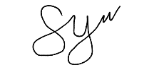Prepared by:

____­­**______IROC, YVON PEARL B._______**

**Candidate’s Signature over Printed Name**

**RECIPE COST WORKSHEET**

NAME OF CANDIDATE: **IROC, YVON PEARL B.**

NAME OF RECIPE: **SOFT ROLL**

|  |  |  |  |  |  |  |  |  |
| --- | --- | --- | --- | --- | --- | --- | --- | --- |
| **Total Yield** | **Count (pcs.)** | | **16** |  | **Preparation Time** | **__1_ Hrs ____ Mins** | |  |
| **Volume (ml)** | | **-** | **Cooking Time** | **____ Hrs __15__Mins** | |  |
| **Weight (k/gms)** | | **1,125** | **Equipment**  Digital Weighing Scale and Oven | | | |
| **Size per Portion** | **Count (pcs.)** | | **16** |
| **Volume (ml)** | | **-** | **Utensils**  Mixing bowls, containers, measuring spoon, baking sheet, dough cutter | | | |
| **Weight (k/gms)** | | **70.313** |
| **Ingredients** | **Weight** | | **Volume** | **Count** | **Unit Price** | **Total Cost** | **Price** | **Procedure** |
| **AP** | **RTC** |
| **Milk** | **9.375** | **150** | **ml** | **16** | **0.06** | **9.00** | **22/370ml** | **Straight Dough Method:**   * Dissolve yeast in milk add sugar, eggs and mix in, add the remaining ingredients except butter. * Knead on low speed for 4 minutes scraping side down the bottom of the bowl * Knead on medium speed for 8 minutes add butter 3 minutes before the end of kneading time. * Dough should be malleable. * Bulk fermentation: 45 minutes, punch down after 20 minutes. * Scaling, rounding: 50g. * Rest for 20 minutes. * Shaping round or oval. * When half proof brush with egg wash. * Final rising 35 minutes or until double its size. |
| **Water** | **9.375** | **150** | **ml** | **16** | **-** | **-** | **-** |
| **Yeast** | **0.94** | **15** | **g** | **16** | **0.41** | **6.15** | **49.10/120g** |
| **Bread Flour** | **39.063** | **625** | **g** | **16** | **0.094** | **58.75** | **46.90/500g** |
| **Sugar** | **3.75** | **60** | **g** | **16** | **0.075** | **4.50** | **74.85/1000g** |
| **Eggs** | **3.75** | **60** | **g** | **16** | **0.1167** | **7.00** | **7/60g** |
| **Salt** | **0.313** | **5** | **g** | **16** | **0.025** | **0.125** | **12.50/500g** |
| **Butter** | **3.75** | **60** | **g** | **16** | **0.21** | **12.60** | **41.95/200g** |
|  |  |  |  |  |  |  |  |
|  |  |  |  |  |  |  |  |
|  |  |  |  |  |  |  |  |
|  |  |  |  |  |  |  |  |
|  |  |  |  |  |  |  |  |
|  |  |  |  |  |  |  |  |
|  |  |  |  |  |  |  |  |
|  |  |  |  |  |  |  |  |
|  |  |  |  |  |  |  |  |
|  |  |  |  |  |  |  |  |
|  |  |  |  |  |  |  |  |
|  |  |  |  |  |  |  |  |
|  |  |  |  |  |  |  |  |
|  |  |  |  |  |  |  |  |
|  |  |  |  |  |  |  |  |
|  |  |  |  |  |  |  |  |
|  |  |  |  |  |  |  |  |
|  |  |  |  |  |  |  |  |
| Total Food Cost | | | | | | **98.125** |  |
| Number of Servings | | | | | | **16** |  |
| Food Cost per Portion | | | | | | **6.13** |  |

|  |  |
| --- | --- |
| Candidate’s Signature: | Date: |
| Assessor’s Signature: | Date: |

**RECIPE COST WORKSHEET**

NAME OF CANDIDATE: **IROC, YVON PEARL B.**

NAME OF RECIPE: **VANILLA CHIFFON CAKE**

|  |  |  |  |  |  |  |  |  |
| --- | --- | --- | --- | --- | --- | --- | --- | --- |
| **Total Yield** | **Count (pcs.)** | | **2** |  | **Preparation Time** | **____ Hrs __20__ Mins** | |  |
| **Volume (ml)** | | **-** | **Cooking Time** | **____ Hrs ___35_ Mins** | |  |
| **Weight (k/gms)** | | **1,027** | **Equipment**  Digital Weighing Scale, Electric Mixer and Oven | | | |
| **Size per Portion** | **Count (pcs.)** | | **2** |
| **Volume (ml)** | | **-** | **Utensils**  Mixing bowls, containers, measuring spoon, baking pans, wire whisk, rubber scraper, skewers | | | |
| **Weight (k/gms)** | | **513.5** |
| **Ingredients** | **Weight** | | **Volume** | **Count** | **Unit Price** | **Total Cost** | **Price** | **Procedure** |
| **AP** | **RTC** |
| **Corn oil** | **25** | **50** | **ml** | **2** | **0.192** | **9.60** | **86.40/450ml** | **Method**   * With a mixing bowl fitted with wire whip attachment, combine egg yolks, water, vanilla extract and oil together and beat on medium speed for 1 minute. * Add in the dry ingredients. Then whip at low speed for 1 minute and scrape side down of the bowl. * Whip about 2 minutes in medium speed until the batter is very smooth and fluffy. Set aside * Whip the egg whites to snow peak and gradually add the sugar, whisk to stiff peak. Gently fold meringue into the reserved batter until well incorporate. * Divide batter into prepared pans approximately ¾ full. * Bake for approximately 30-40 minutes sponge should spring back when pressed slightly in the center.   Allow the cake to cool-down before unmolding.  For the sponge roll, bake for 10 to 12 minutes until light brow |
| **Egg yolks** | **120** | **240** | **g** | **2** | **0.1167** | **28.01** | **7.00/60g** |
| **Water** | **70** | **140** | **ml** | **2** | **-** | **-** | **-** |
| **Vanilla** | **2.5** | **5** | **ml** | **2** | **0.25** | **1.25** | **15.00/60ml** |
| **Cake flour** | **85** | **170** | **g** | **2** | **0.055** | **9.35** | **27.45/500g** |
| **Sugar ref.** | **50** | **100** | **g** | **2** | **0.075** | **7.50** | **74.85/1000g** |
| **Baking powder** | **3.5** | **7** | **g** | **2** | **0.265** | **1.86** | **13.25/50g** |
| **Egg whites** | **120** | **240** | **g** | **2** | **0.1167** | **28.01** | **7.00/60g** |
| **Sugar ref.** | **35** | **70** | **g** | **2** | **0.075** | **5.25** | **74.85/1000g** |
| **Cream of Tartar** | **2.5** | **5** | **g** | **2** | **0.76** | **3.80** | **38.00/50g** |
|  |  |  |  |  |  |  |  |
|  |  |  |  |  |  |  |  |
|  |  |  |  |  |  |  |  |
|  |  |  |  |  |  |  |  |
|  |  |  |  |  |  |  |  |
|  |  |  |  |  |  |  |  |
|  |  |  |  |  |  |  |  |
|  |  |  |  |  |  |  |  |
|  |  |  |  |  |  |  |  |
|  |  |  |  |  |  |  |  |
|  |  |  |  |  |  |  |  |
|  |  |  |  |  |  |  |  |
|  |  |  |  |  |  |  |  |
|  |  |  |  |  |  |  |  |
|  |  |  |  |  |  |  |  |
| **Total Food Cost** | | | | | | **94.63** |  |
| **Number of Servings** | | | | | | **2** |  |
| **Food Cost per Portion** | | | | | | **47.32** |  |

|  |  |
| --- | --- |
| Candidate’s Signature: | Date: |
| Assessor’s Signature: | Date: |

**RECIPE COST WORKSHEET**

NAME OF CANDIDATE: **IROC, YVON PEARL B.**

NAME OF RECIPE: **SWISS BUTTER CREAM (FROSTING)**

|  |  |  |  |  |  |  |  |  |
| --- | --- | --- | --- | --- | --- | --- | --- | --- |
| **Total Yield** | **Count (pcs.)** | | **1** |  | **Preparation Time** | **____ Hrs ____ Mins** | |  |
| **Volume (ml)** | | **-** | **Cooking Time** | **____ Hrs ____ Mins** | |  |
| **Weight (k/gms)** | |  | **Equipment**  Digital Weighing Scale, Electric Mixer and Oven | | | |
| **Size per Portion** | **Count (pcs.)** | | **1** |
| **Volume (ml)** | | **-** | **Utensils**  Mixing bowls, containers, measuring spoon, baking pans, wire whisk, rubber scraper, skewers | | | |
| **Weight (k/gms)** | |  |
| **Ingredients** | **Weight** | | **Volume** | **Count** | **Unit Price** | **Total Cost** | **Price** | **Procedure** |
| **AP** | **RTC** |
| **Egg Whites** | **120** | **120** | **g** | **1** | **0.1167** | **14.00** | **7.00/60g** | **Mise en place**  Combine sugar and egg whites in a bowl stirring until the sugar dissolved.   * Place on a barely simmering hot water bath. Whipping constantly until the temperature reaches 70c. * Transfer onto a mixing bowl fitted with wire whisk attachment. Whip until stiff peak replace attachment to paddle, beating to medium speed until cold, gradually add butter and beat in medium speed until smooth and creamy. |
| **Sugar** | **200** | **200** | **g** | **1** | **0.075** | **15.00** | **74.85/1000g** |
| **Butter** | **340** | **340** | **g** | **1** | **0.21** | **71.40** | **41.95/200g** |
| **Vanilla** | **10** | **10** | **ml** | **1** | **0.25** | **2.50** | **15.00/60ml** |
|  |  |  |  |  |  |  |  |
|  |  |  |  |  |  |  |  |
|  |  |  |  |  |  |  |  |
|  |  |  |  |  |  |  |  |
|  |  |  |  |  |  |  |  |
|  |  |  |  |  |  |  |  |
|  |  |  |  |  |  |  |  |
|  |  |  |  |  |  |  |  |
|  |  |  |  |  |  |  |  |
|  |  |  |  |  |  |  |  |
|  |  |  |  |  |  |  |  |
|  |  |  |  |  |  |  |  |
|  |  |  |  |  |  |  |  |
|  |  |  |  |  |  |  |  |
|  |  |  |  |  |  |  |  |
|  |  |  |  |  |  |  |  |
|  |  |  |  |  |  |  |  |
|  |  |  |  |  |  |  |  |
|  |  |  |  |  |  |  |  |
|  |  |  |  |  |  |  |  |
|  |  |  |  |  |  |  |  |
| **Total Food Cost** | | | | | | **102.90** |  |
| **Number of Servings** | | | | | | **1** |  |
| **Food Cost per Portion** | | | | | | **102.90** |  |

|  |  |
| --- | --- |
| Candidate’s Signature: | Date: |
| Assessor’s Signature: | Date: |