University of Science and Technology of Southern Philippines

C.M Recto Avenue Lapasan, Cagayan de Oro City 9000

Philippines Enterprise Division – Display Center Garments

TOGA RENTALFORM

Name: Course/Degree:

IDNumber: Sex: ContactNumber:

|  |  |  |  |  |  |  |  |  |  |  |
| --- | --- | --- | --- | --- | --- | --- | --- | --- | --- | --- |
| QTY | Description | Size | | | | | | Date Released | Date Returned | Remarks |
| 1 | Set of Toga | XS | S | M | L | XL | XXL |  |  |  |
|  |  |  |  |  |  |
| 1 | Facemask (no need to return) |  | | | | | |  |  |  |

I hereby promise to take care of the TOGA rented by me and return it a week after graduation or not later than October 30, 2022.

Terms and Conditions:

1. If there are damages or lost items, the cost will be deducted to your rental fee
2. If you fail to return a month after the graduation date,100% of the deposit fee will be retained by the IEP Garments



Signature over Printed Name

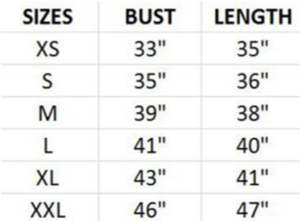Toga Rental Fee: ___________ O.RNumber: Deposit: D ate:

__________________________________________________________________________________________________________________

University of Science and Technology of Southern Philippines

C.M Recto Avenue Lapasan, Cagayan de Oro City 9000

Philippines Enterprise Division – Display Center Garments

TOGA RENTAL FORM

Name: Course/Degree:

IDNumber: Sex: ContactNumber:

|  |  |  |  |  |  |  |  |  |  |  |
| --- | --- | --- | --- | --- | --- | --- | --- | --- | --- | --- |
| QTY | Description | Size | | | | | | Date Released | Date Returned | Remarks |
| 1 | Set of Toga plus facemask | XS | S | M | L | XL | XXL |  |  |  |
|  |  |  |  |  |  |
| 1 | Facemask (no need to return) |  | | | | | |  |  |  |

I hereby promise to take care of the TOGA rented by me and return it a week after graduation or not later than October 30, 2022.

Terms and Conditions:

1. If there are damages or lost items, the cost will be deducted to your rental fee
2. If you fail to return a month after the graduation date,100% of the deposit fee will be retained by the IEP Garments



Signature over Printed Name

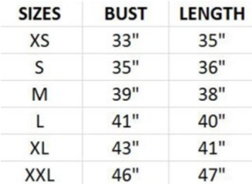Toga Rental Fee: ___________ O.RNumber: Deposit: D ate: