COMSC-110 Due: June-7-2020 11:59 PM Name: Isaac Romarri

Instructions:

Answer the following questions in this word document. Note: You must write a program for the last problem. Copy of the source code (i.e. the program that you have written) and paste screen shot of the sample results.

If you are using a MAC, COMMAND CONTROL SHIFT 4 can be used for screen shot.

If you use a PC, snipping tools can be used for screen shot.

If you use a MAC you may go to APP store and install X-Code.

If you use a PC, you may use Visual Studio to write C++ programs.

1. Convert the following binary numbers to HEX and decimal. Show your work! You can write the work on a paper and take a picture of it and paste the image.

Answer:

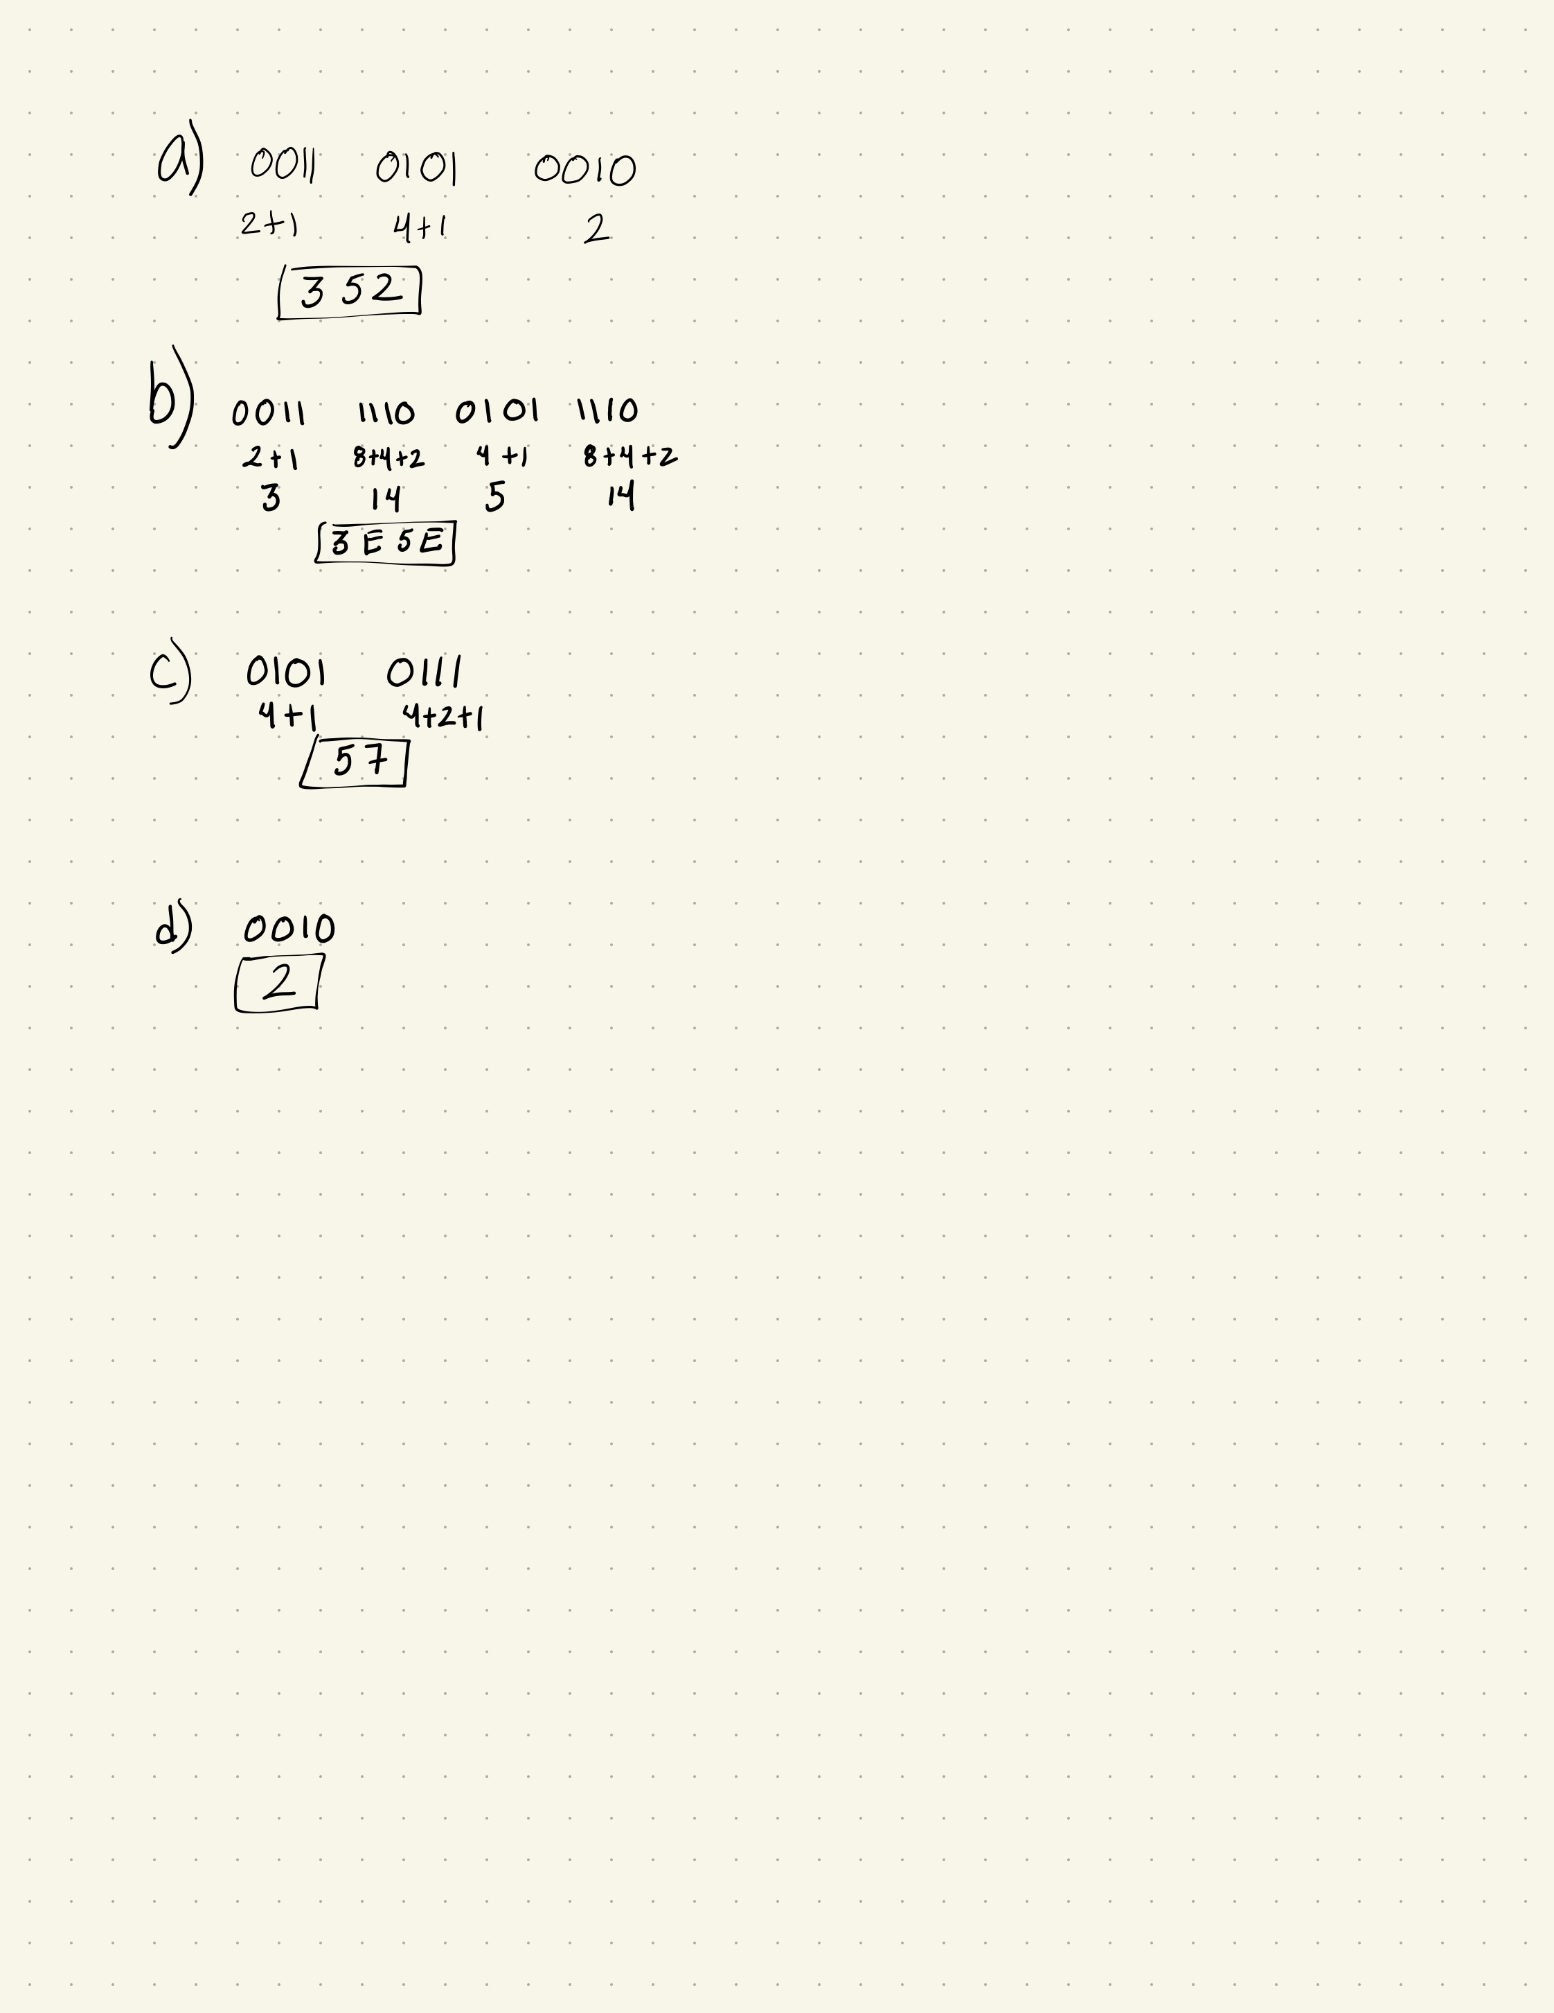

1. A computer has 38 address lines. How many locations in Mega bytes can it address?

Answer:

2 to the 38 power = 274,878 MB

1. What are the ASCII values for characters A, B, C, a, b and c? What is the relationship between ASCII values of uppercase values and lowercase values?

Answer:

Upper case “A” has a value of 65 while lower case “a” has a value of 97, which is 32-unit value over “A”. Likewise, “B” has a value of 66 and its counter part lower case “b” is 32-unit value point higher at 98. And “C “ is 67 with a lower case “c” at 99.

1. What do we mean by the address of a memory location?

Answer: In a computer each memory has set location, which is accessible by the CPU. This is what allows the computer to hold variable and information.

1. What is a smallest hardware unit that stores a bit?

Answer: A byte.

1. What is the difference between CPU registers and memory?

Answer:

Register is a small size ranging from 32 to 64 bits and it is reserve for CPU current process. Ram or memory in the other hand is larger, ranging from GB to TB and it is used for programs and instructions. Moreover the CPU access register much faster than RAM.

1. Write a program that reads two integer numbers from the keyboard (use cin). Add the two numbers and display the sum.

Source code:

#include <iostream>

using namespace std;

int main() {

int number1, number2;

cout << "Tell me a number please: ";

cin >> number1;

cout << "Tell me another number: ";

cin >> number2;

cout << "your total is: " << number1 + number2;

}

