COMSC-110 Due: June-14 at 11:59 PM Lab-2 Name: Isaac Romarri

Answer the following questions in this word document.

Copy the source code after each problem statement.

Make screen shot of the result and past it after the source code.

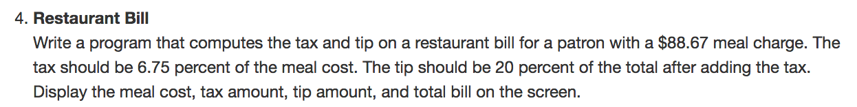

Answer:

#include <iostream>

#include <iomanip>

using namespace std;

double tax(double bill);

double tip (double bill);

int main() {

double bill = 88.67;

cout << setprecision(2) << fixed;

cout << "Yout meal cost is: " << "$" << bill << endl;

cout << "Your Tax amount is: " << "$" << tax(bill) << endl;

cout << "Your tip amount is: " << "$" << tip(bill);

return 0;

}

double tax(double bill){

return bill * .0675;

}

double tip (double bill){

return bill*.20;

}

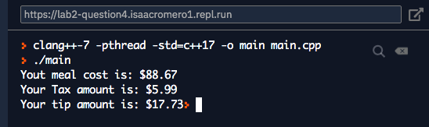

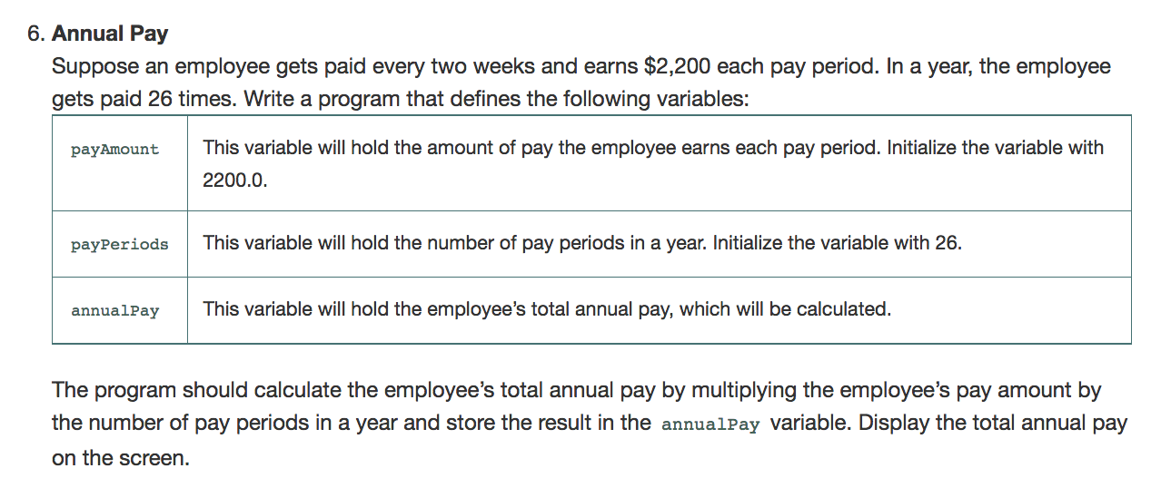

Answer:

#include <iostream>

using namespace std;

int main() {

double payAmonut = 2200.0;

int payPeriods = 26;

double annualPay;

annualPay = payAmonut*payPeriods;

cout << "Your total salary is: " << annualPay;

return 0;

}

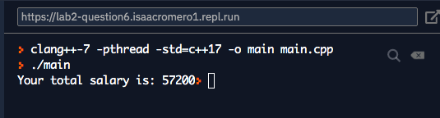

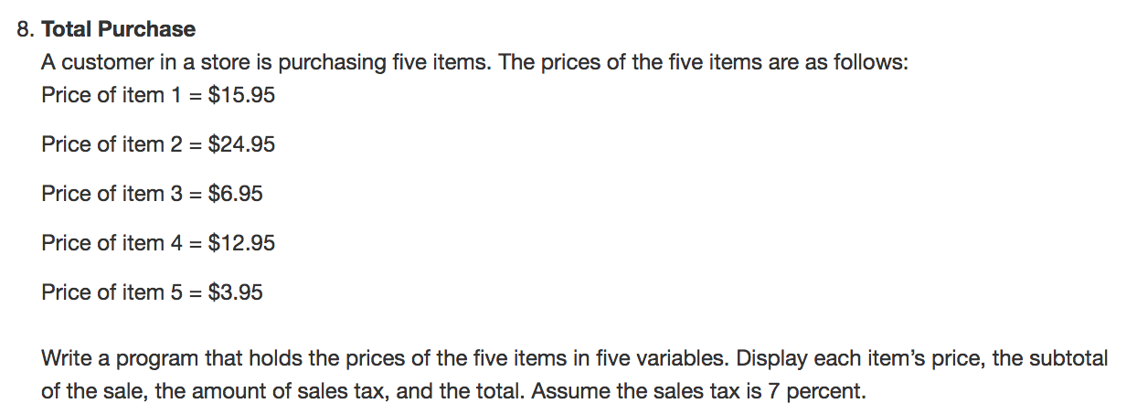

Answer:

#include <iostream>

#include <iomanip>

using namespace std;

double ItemPlusTax(double item);

int main() {

double item1 = 15.95;

double item2 = 24.95;

double item3 = 6.95;

double item4 = 12.95;

double item5 = 3.95;

cout << setprecision(2) << fixed;

cout << "Item one plus tax is " << ItemPlusTax(item1) << endl;

cout << "Item two plus tax is " << ItemPlusTax(item2) << endl;

cout << "Item three plus tax is " << ItemPlusTax(item3) << endl;

cout << "Item four plus tax is " << ItemPlusTax(item4) << endl;

cout << "Item five plus tax is " << ItemPlusTax(item5) << endl;

return 0;

}

double ItemPlusTax(double item){

return item*.07 + item;

}

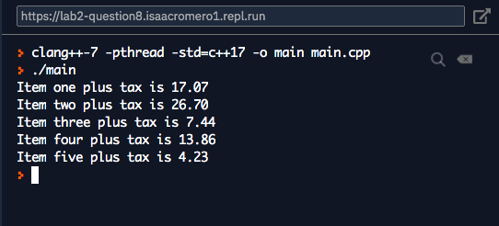­­­­­­­­

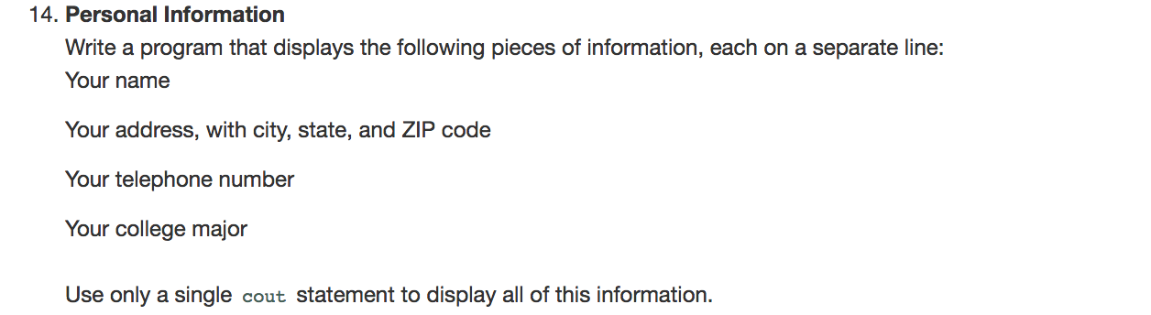

Answer:

#include <iostream>

#include <string>

using namespace std;

int main() {

string name = "Isaac Romarri";

string address = "2345 Dream Lane, Maxwell Valley, CA, 94555";

string telephone = "510 555 - 9876";

string major = "Mathematics";

cout << name << endl << address << endl << telephone << endl << major << endl;

return 0;

}

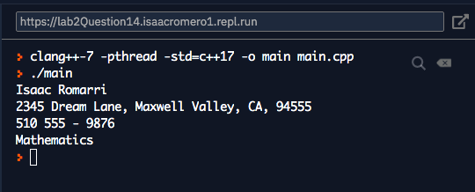

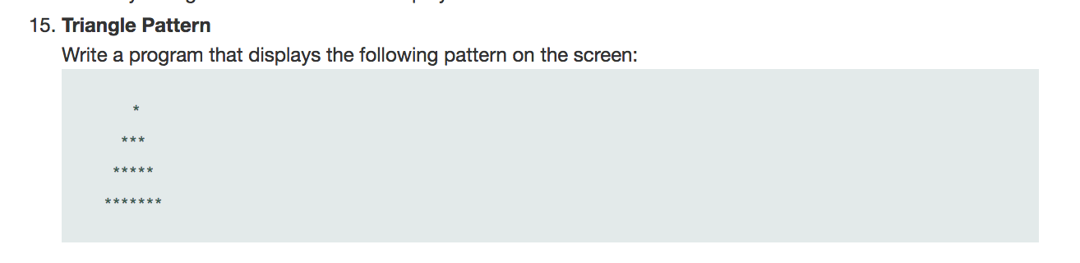

Answer:

#include <iostream>

using namespace std;

int main() {

cout << " * \n *** \n ***** \n*******";

return 0;

}

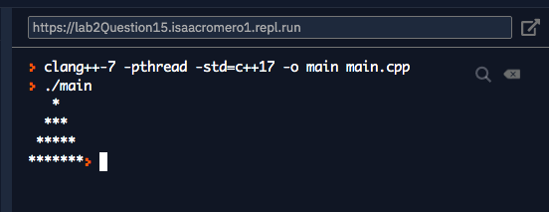

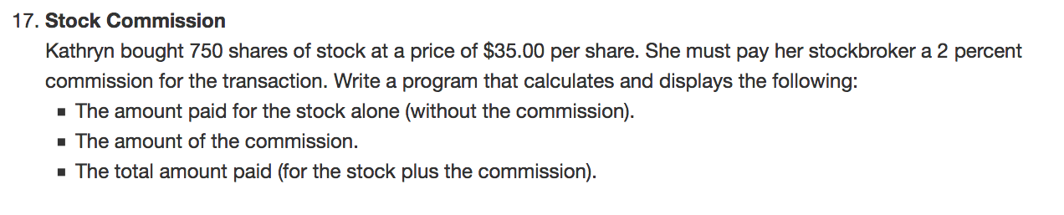

Answer:

#include <iostream>

using namespace std;

int main() {

double stocks = 750;

const double commission = .02;

double price = 35;

cout << "You purchase " << stocks << " at $"<< price << "." << endl;

cout << "You must pay $" << stocks*price << " for the stock alone" << endl;

cout << "You must pay $" << commission*stocks*price << " commission on the sale of your stock." << endl;

cout << "Your total to is $" << (1+commision)*stocks*price << "." << endl;

return 0;

}

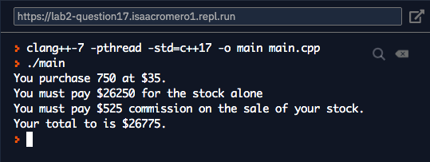

The following problems are from chapter-3.

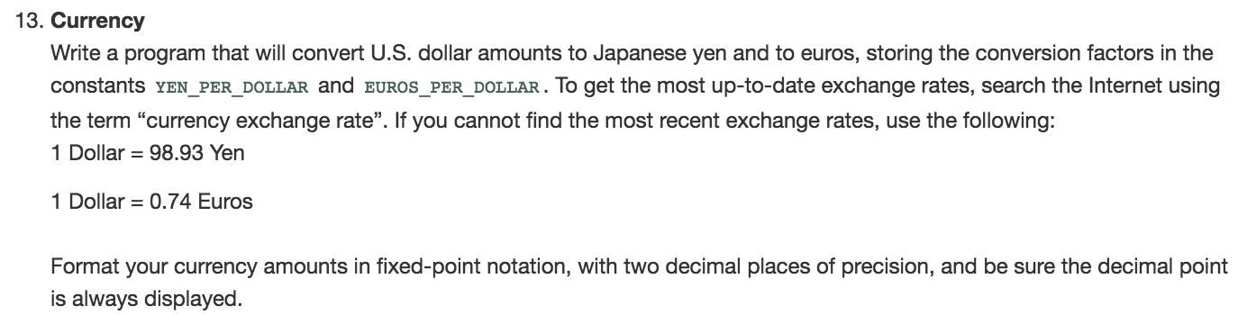

A nswer:

#include <iostream>

#include <iomanip>

using namespace std;

int main() {

const double YEN_PER_DOLLAR = .89,

EUROS_PER_DOLLAR = 107.36;

cout << setprecision(2) << fixed;

double dollars;

cout << "How many dollars do you have? " << endl;

cin >> dollars;

cout << "You have " << dollars*YEN_PER_DOLLAR << " Yen." << endl;

cout << "You also have " << dollars*EUROS_PER_DOLLAR << " Euros";

return 0;

}

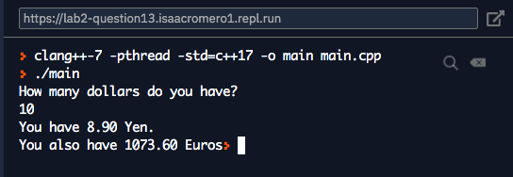

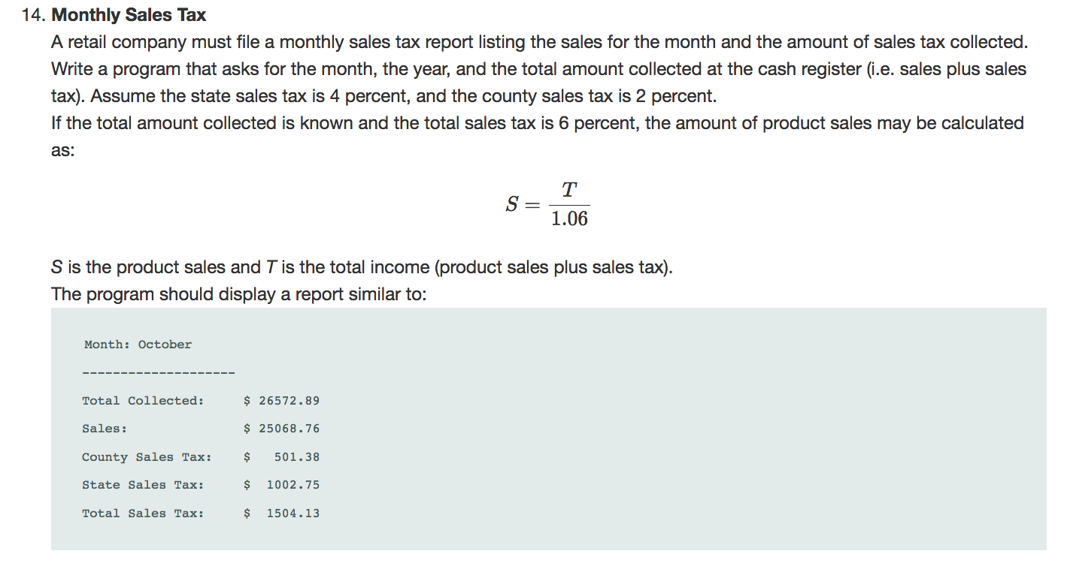

Answer:

#include <iostream>

#include <string>

#include <iomanip>

using namespace std;

int main() {

string month, year;

double amountCollected;

const double STATE_RATE = .04;

const double COUNTY_RATE = .02;

cout << setprecision(2) << fixed;

cout << "What is the month" << endl;

cin >> month;

cout << endl << "what it the year?" << endl;

cin >> year;

cout << "What were the total amount of cash from the register? " << endl;

cin >> amountCollected;

double sale = amountCollected/1.06;

cout << "Month:" << month << endl << "------------------" << endl;

cout << "Total Collected: $"<< amountCollected << endl;

cout << "Sales: $"<< sale << endl;

cout << "County Sales Tax $"<<sale*COUNTY_RATE << endl;

cout << "State Slaes Tax: $"<<sale*STATE_RATE << endl;

cout << "Total Sales Tax: $"<<(COUNTY_RATE + STATE_RATE)*sale << endl;

return 0;

}

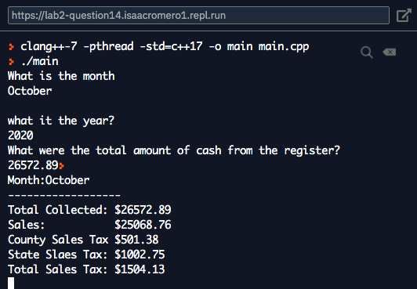

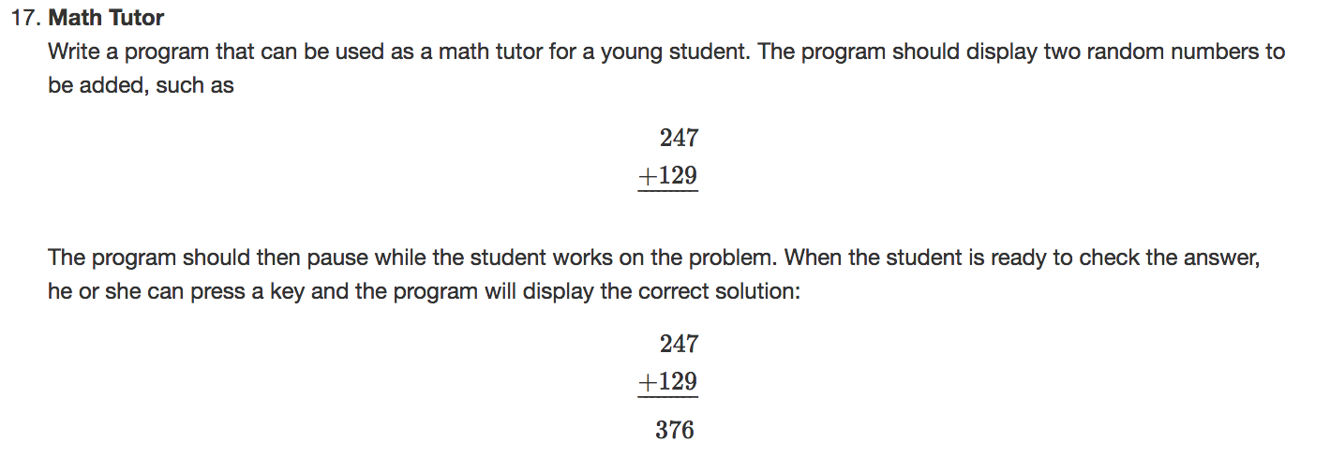

Answer:

#include <iostream>

#include <cstdlib>

using namespace std;

int main() {

char cont;

srand (time(NULL));

int firstNumber = rand() % 999;

int secondNumber = rand() % 999;

bool next = false;

cout << "If your are done press n."<< endl << endl;

cout << " " << firstNumber << endl;

cout << " " << secondNumber << endl;

cout << "+_______" << endl;

cin.get(cont);

cout << "Answer:" << firstNumber + secondNumber << endl;

if (cont == 'n'){

return 0;

}

return main();

}

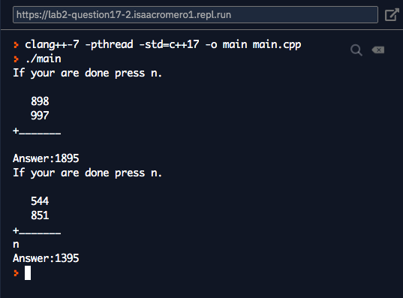

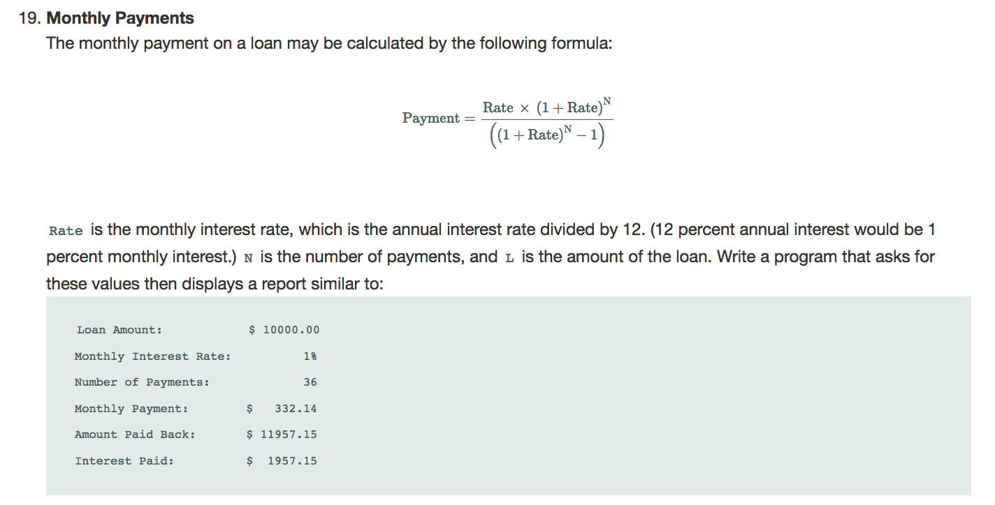

Answer:

#include <iostream>

#include <math.h>

#include <iomanip>

using namespace std;

int main() {

double rate, loan;

int installments;

cout << setprecision(2) << fixed;

cout << "What is the loan amount?" << endl;

cin >> loan;

cout << "What is the rate (non annual, percentage no decimal) ?" << endl;

cin >> rate;

cout << "How many payment? " << endl;

cin >> installments;

rate = rate/ 12/100;

double power = pow((1+rate),installments);

double payment = (rate*power)*loan/(power-1);

double payback = payment*installments;

cout << endl << left << "Loan Amount: $ " << loan << endl;

cout << "Monthly Interest Rate: "<< rate*100 << "%"<< endl;

cout << "Number of Payments: "<< installments << endl;

cout << "Monthtly Payments: $ " << payment << endl;

cout << "Amount Paid Back: $ " << payback << endl;

cout << "Interest Paid: $ " << payback - loan << endl;

return 0;

}

