COMSC-110 Lab-4 Due: June-28-2020

Format:

1- After each problem statement, copy and paste the source code.

2- After the source code, paste the screen shot of the result.

3- Submit either word or pdf file (ONLY ONE FILE – NO MAC PAGE FILES)



Answer:

#include <iostream>

using namespace std;

int main() {

int num;

do{

cout << "Enter a number: " << endl;

cin >> num;

}

while(num <= 0);

int total = 0;

for( int i = 0; i <= num; i++){

total=total+i;

}

cout << "Your total is: " << total << endl;

return 0;

}

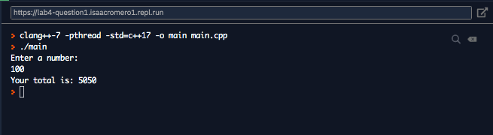

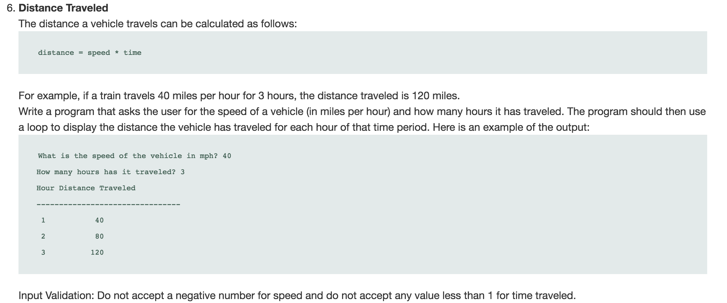

Answer:

#include <iostream>

using namespace std;

int main() {

int speed, time;

do{

cout << "What is the speed of the vehile in mph?" << endl;

cin >> speed;

}while(speed <=0);

do{

cout << "How many hours has it traveled?" << endl;

cin >> time;

}while(time < 1);

cout << "Hours Distance Traveled" << endl;

cout.width(25);

cout.fill('-');

cout << '-' << endl;

for ( int i = 1 ; i <= time; i++){

cout.width(13);

cout.fill(' ');

cout << left << i << right << i*speed << endl;

}

return 0;

}

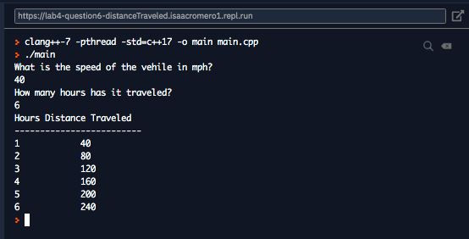

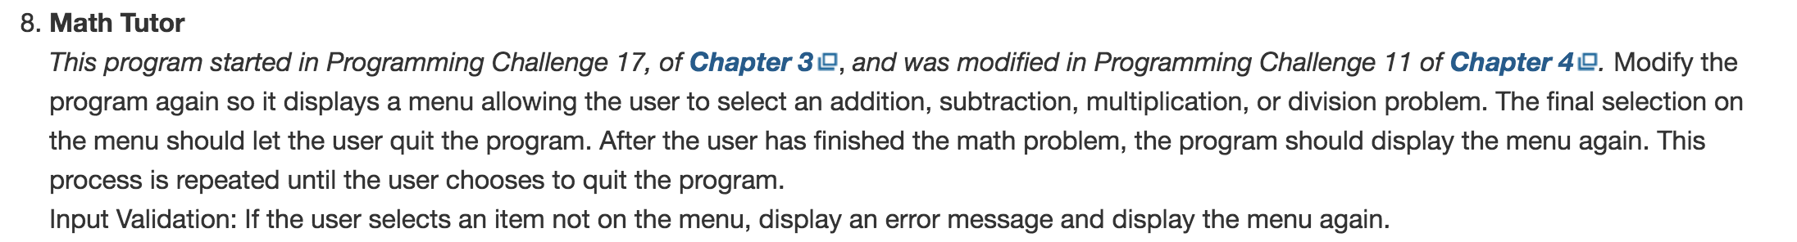

Answer:

#include <iostream>

#include <cstdlib>

#include <iomanip>

using namespace std;

int main( ) {

const int MAX = 999;

int total;

srand (time(NULL));

int firstNumber = rand() % MAX;

int secondNumber = rand() % MAX;

int selection;

int answer, guess;

cout << "What would you like to do today?" << endl;

cout << "1. Add" << endl;

cout << "2. Subtract" << endl;

cout << "3. Multiply" << endl;

cout << "4. Divide" << endl;

cout << "5. Quiz" << endl;

cout << "Enter selection: " << endl;

cin >> selection;

while(selection < 1 || selection > 5){

cout << "That is not an option, enter a valid option" << endl;

cin >> selection;

}

if(selection != 5) cout << setw(5) << firstNumber << endl;

switch(selection){

case 1:

cout << "+";

answer = firstNumber+secondNumber;

break;

case 2:

cout << '-';

answer = firstNumber-secondNumber;

break;

case 3:

cout << '*';

answer = firstNumber*secondNumber;

break;

case 4:

cout << '/';

answer = firstNumber/secondNumber;

break;

case 5:

return 0;

default:

cout << "Something went wrong restart this program" << endl;

}

cout << setw(4) << secondNumber << endl;

cout << "-----\n";

cin >> guess;

if( guess == answer){

cout << "Congrats.. press enter for the menu." << endl;

}

else {

cout << "The answer is " << answer << endl;

cout << "Press Enter to continue... \n";

}

cin.ignore();

cin.get();

return main();

}

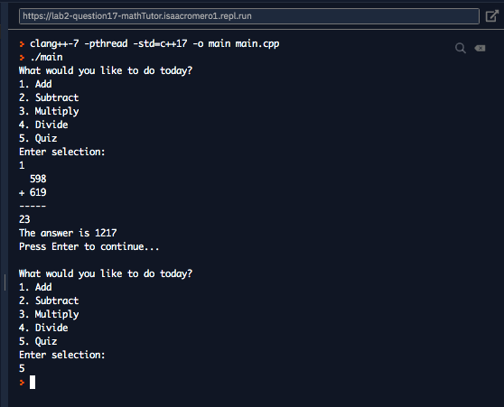



Answer:

#include <iostream>

#include <iomanip>

using namespace std;

int main() {

// c = 5/9(F-32)

// f = 9/5c + 32

const float coeff = 9/5;

cout << "The following table has Celcius to Fahrenheit:" << endl;

cout << setw(20) << left << "Celcius" << right << "Fahrenheit" << endl;

for ( int i = 0 ; i < 21; i++){

cout << setw(20);

cout << left << i << right << coeff * i +32 << endl;

}

}

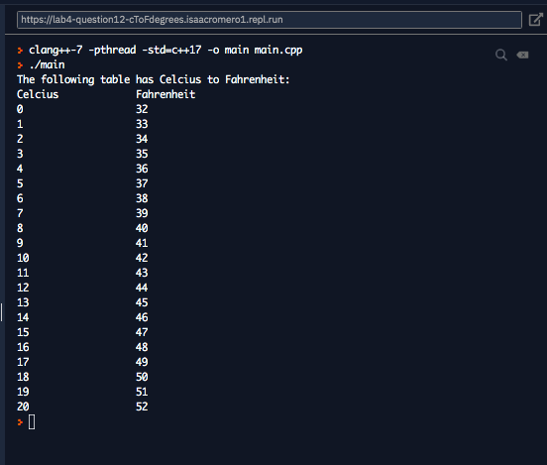



Answer:

#include <iostream>

#include <time.h>

#include <stdlib.h>

using namespace std;

int main() {

const int MAX = 200;

srand(time(NULL));

int secretNumber = rand() % MAX;

int guess;

do{

cout << "Try to guess my number: " << endl;

cin >> guess;

if(guess > secretNumber)cout << "Too high" << endl;

else if(guess < secretNumber) cout << "Too low" << endl;

else cout << "Good Job" << endl;

}while(guess != secretNumber);

return 0;

}

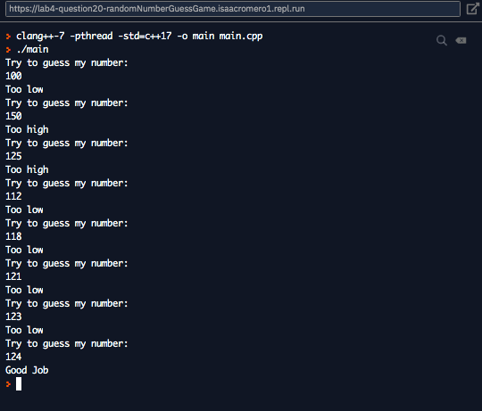

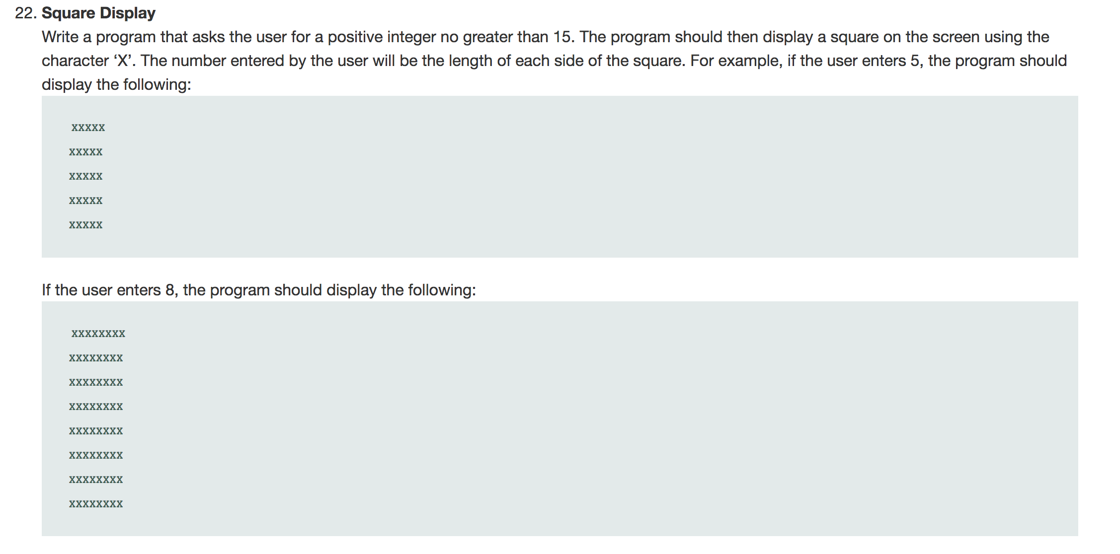

#include <iostream>

#include <iomanip>

using namespace std;

int main() {

int length;

cout << "Enter a lenght: ";

cin >> length;

cout << "\n";

for (int j =0 ; j < length; j++){

cout.fill('x'), cout << setw(length) << "" << endl;

}

}

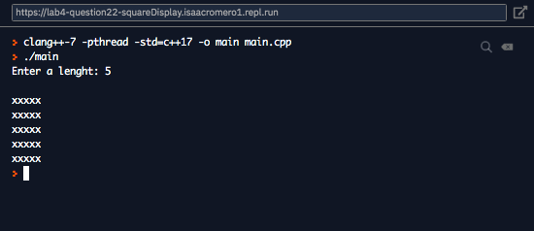

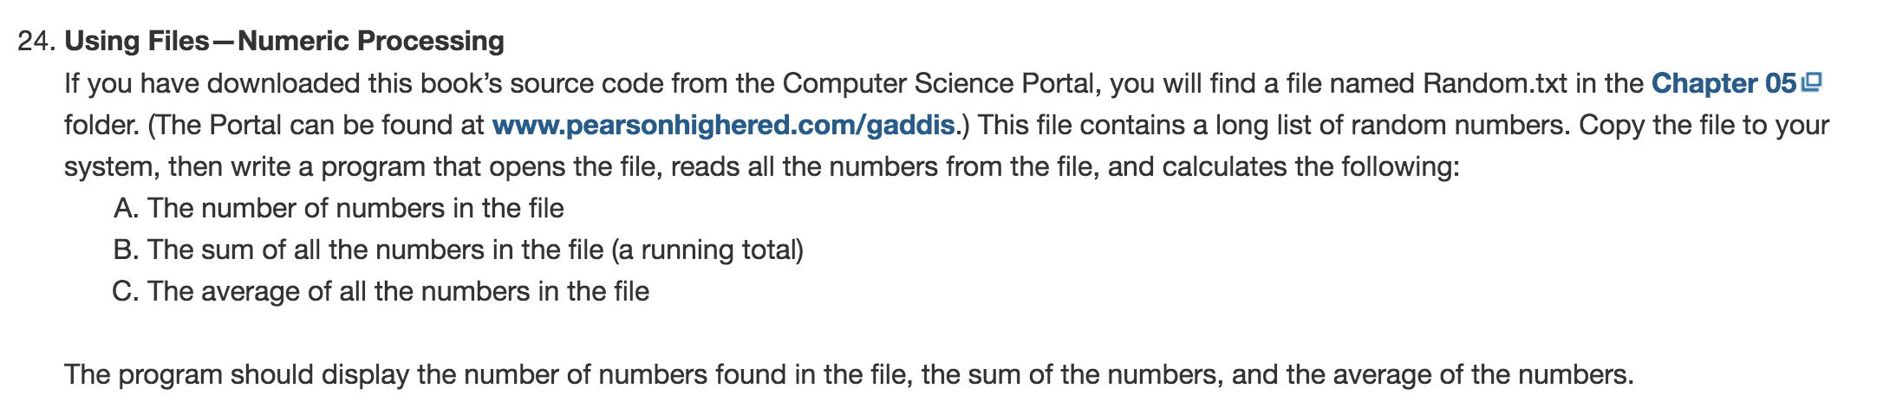

Answer:

#include <iostream>

#include <iomanip>

#include <fstream>

using namespace std;

int main() {

ifstream numbers;

numbers.open("random.txt");

int num, count = 1;

double total = 0;

if (numbers.is_open()){

while ( numbers >> num){

cout << setw(4) << num << "\t";

if (count % 8 == 0 ){

cout << endl;

}

count++;

total = total + num;

}

}

cout << "\n" << "There are " << count-1 << " numbers" << endl;

cout << "The sum is " << total << endl;

cout << setprecision(2) << fixed << "The average is " << total/(count-1) << endl;

numbers.close();

return 0;

}

N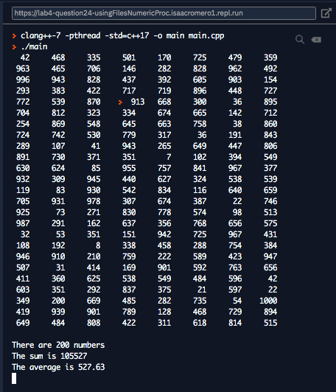OTE: YOU MAY FIND THE FILE Random.txt UNDER READING NOTES OF WEEK-4 (CANVAS).