COMSC-110 Lab-6 Due: July-12-2020

Format:

1- After each problem statement, copy and paste the source code.

2- After the source code, paste the screen shot of the result.

3- Submit either word or pdf file (ONLY ONE FILE – NO MAC PAGE FILES)



Answer:

#include <iostream>

using namespace std;

int main() {

const int SIZE = 10;

int arr[5] = {0}; // initializing the array to zeros;

for (auto &temp : arr){

cout << "Enter a number " << endl;

cin >> temp;

}

int min = arr[0];

int max = arr[0];

for (int element : arr){

if (element > max) max = element;

if (element < min) min = element;

}

cout << "The largest is: " << max << endl;

cout << "The smallest is: " << min << endl;

return 0;

}

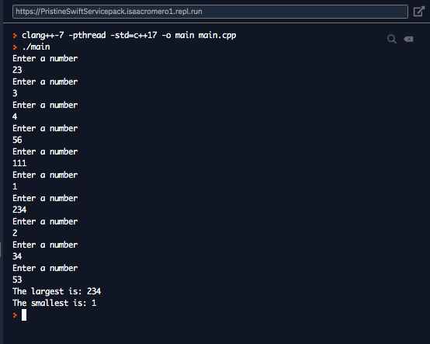



Answer:

#include <iostream>

using namespace std;

void greaterThan(int arr[], int SIZE, int n);

int main() {

const int SIZE = 5;

int arr[SIZE] = {12,23,12,45,55};

greaterThan(arr, SIZE, 20);

}

void greaterThan(int arr[], int SIZE, int n){

cout << "Numbers greater than " << n << ":" << endl;

for ( int i = 0 ; i < SIZE; i++){

if ( arr[i] > n) cout << arr[i] << endl;

}

}

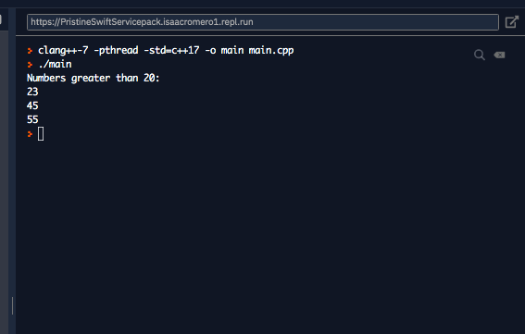

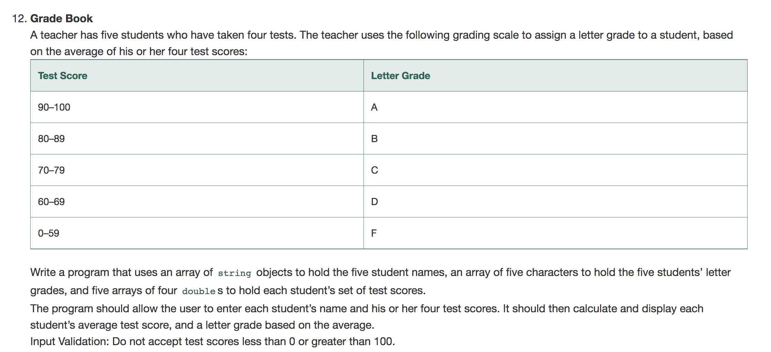

Answer: #include <iostream>

#include <string>

using namespace std;

double averageScore(double scores[][4], int SIZE, int student);

int main() {

const int SIZE = 5;

string name[SIZE];

char letterGrade[SIZE];

double quizes[SIZE][4];

for (int student = 0; student < SIZE; student++){

cout << "Enter Student Name: " << endl;

getline(cin, name[student], '\n');

for (int quiz = 0; quiz < 4; quiz++){

do{

cout << "Enter their grade: (range 0 - 100)" << endl;

cin >> quizes[student][quiz];

}while(quizes[student][quiz]< 0 || quizes[student][quiz] > 100);

}

cin.ignore(2, '\n');

}

for (int student = 0; student < SIZE; student++){

double average = averageScore(quizes,SIZE,student);

letterGrade[student] = average <= 59 ? 'F' :

average <= 69 ? 'D' :

average <= 79 ? 'C' :

average <= 89 ? 'B' :

average <= 100 ? 'A' : 'N';

cout << "Name: " << name[student] << " Grade: " << letterGrade[student] << endl;

}

return 0;

}

double averageScore(double scores[][4], int SIZE, int student){

double total = 0;

for (int testNumber = 0 ; testNumber < SIZE-1; testNumber++){

total+= scores[student][testNumber];

}

return total/(SIZE-1);

}

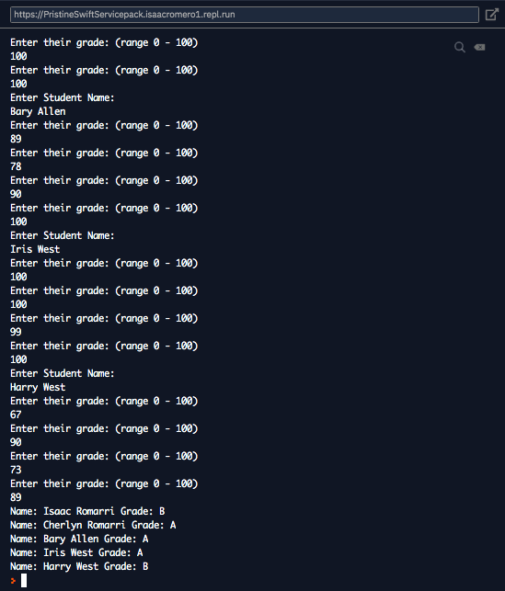



Answer: ( it is the same code but the averageScore function change to the following)

double averageScore(double scores[][4], int SIZE, int student){

double total = 0;

double min = scores[student][0];

for (int testNumber = 0 ; testNumber < SIZE-1; testNumber++){

total+= scores[student][testNumber];

min = scores[student][testNumber] < min ? scores[student][testNumber] : min;

}

return (total-min)/(SIZE-2); // take min out of the sum

}

