COMSC-110 Lab-5 Due: July-5-2020

Format:

1- After each problem statement, copy and paste the source code.

2- After the source code, paste the screen shot of the result.

3- Submit either word or pdf file (ONLY ONE FILE – NO MAC PAGE FILES)

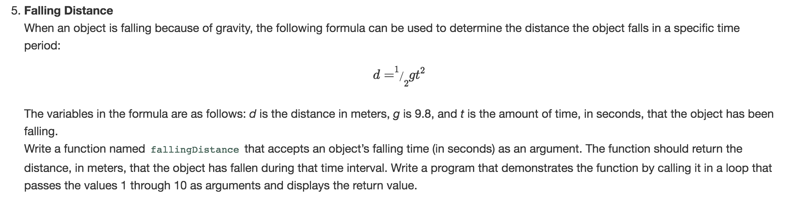

Answer:

#include <iostream>

using namespace std;

double fallingDistance(int time, double g = 9.8);

int main() {

for ( int i=1; i <= 10; i++){

cout << fallingDistance(i) << endl;

}

return 0;

}

double fallingDistance(int time,double g){

return .5 * g *time *time;

}

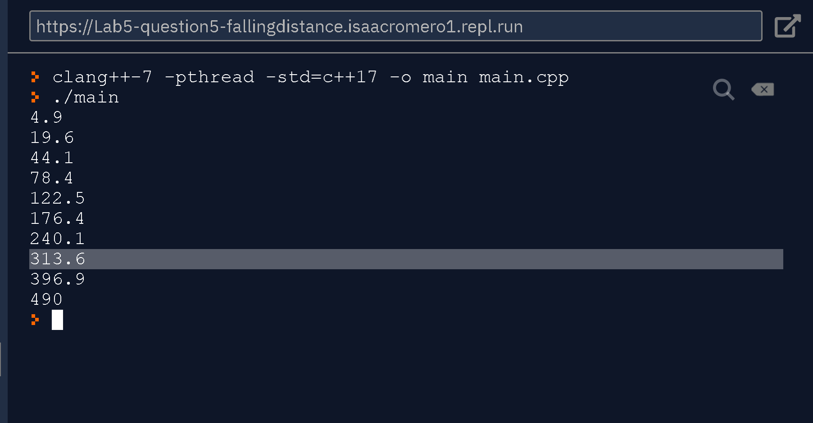

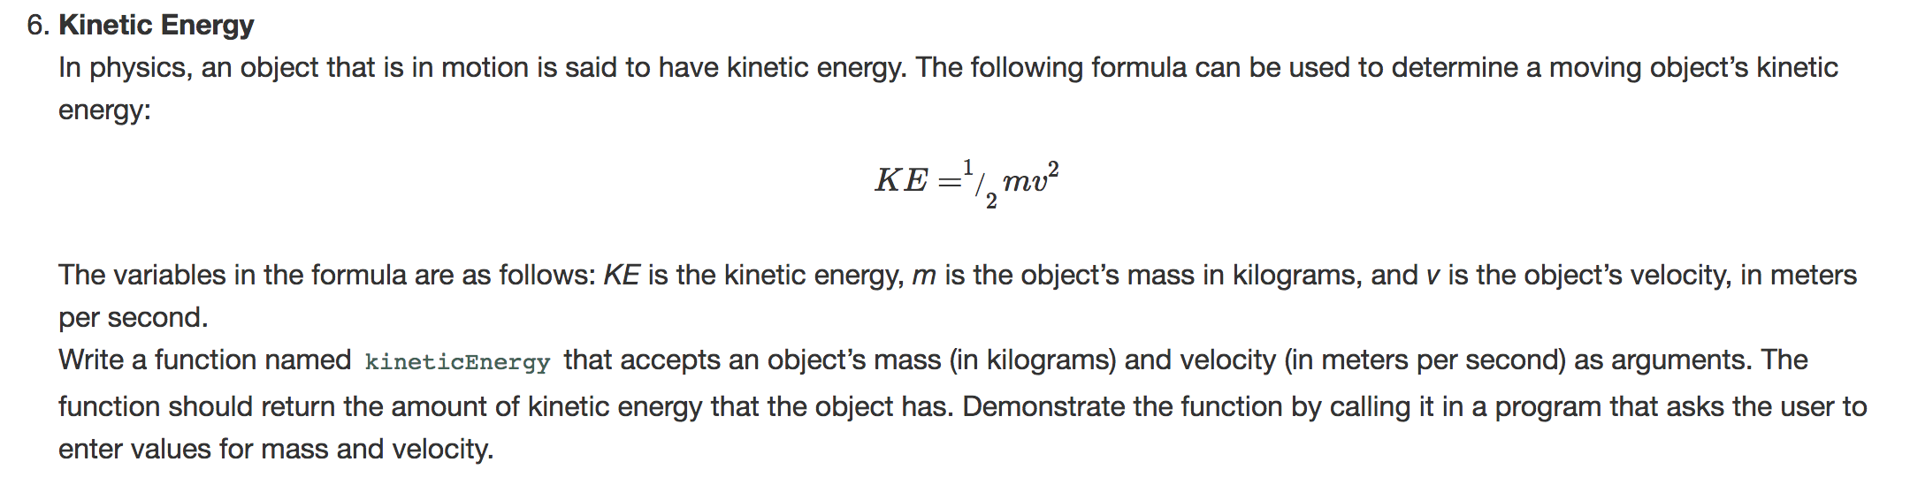

Answer:

#include <iostream>

using namespace std;

double keniticEnergy(double mass, double velocity);

int main() {

int mass, velocity;

cout << "What is the velocity of the object? " << endl;

cin >> velocity;

cout << "What is the mass of the object?" << endl;

cin >> mass;

cout << "The energy of the object is: " << keniticEnergy(mass,velocity) << endl;

return 0;

}

double keniticEnergy(double mass, double velocity){

return .5 * mass * velocity* velocity;

}

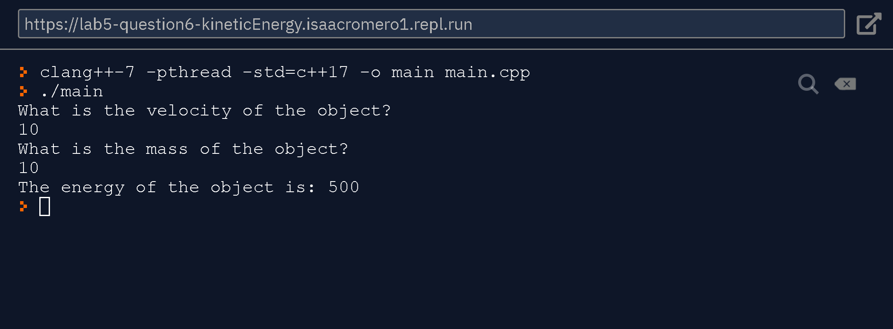

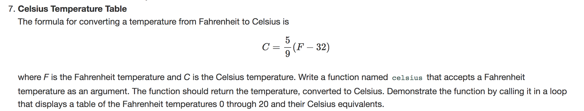

Answer:

#include <iostream>

#include <iomanip>

using namespace std;

double celsius(double fahrenheit);

int main() {

for (int i = 0; i < 20; i++){

cout << setprecision(1) << fixed;

cout<< celsius(i) << endl;

}

return 0;

}

double celsius(double fahrenheit){

return 5.0/9.0 * (fahrenheit-32);

}

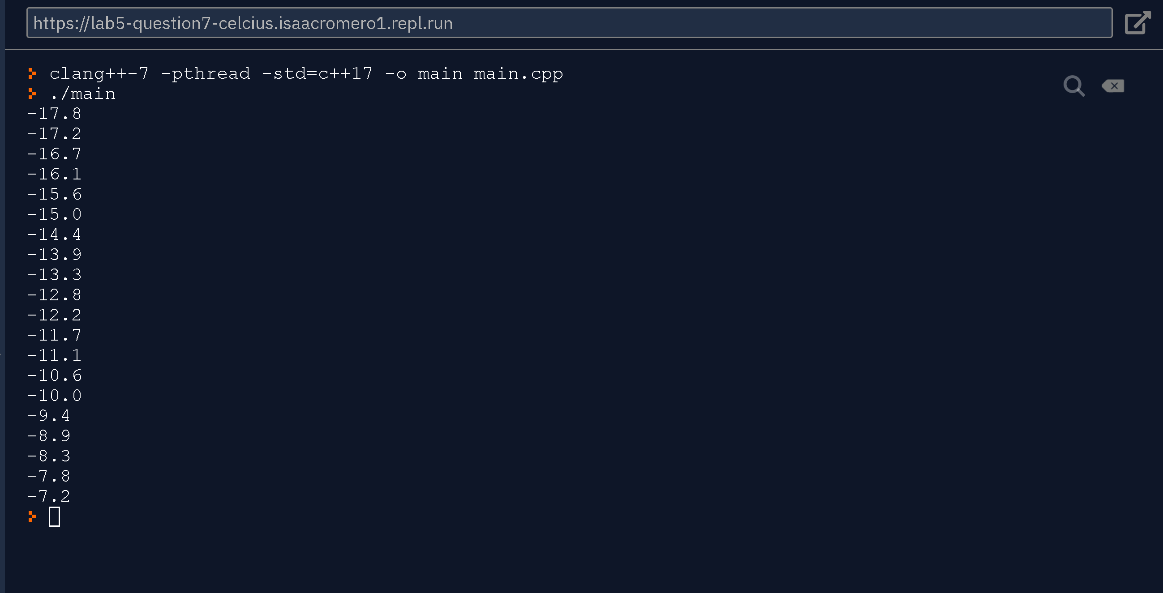

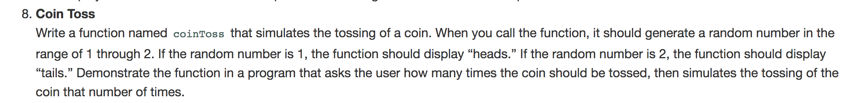

Answer:

#include <iostream>

#include <stdlib.h>

using namespace std;

void coinToss();

int main() {

srand(time(NULL));

int counter;

cout << "How many toss should we do? " << endl;

do{

cin >> counter;

}while(counter < 0);

for ( int i=0; i < counter; i++){

coinToss();

}

return 0;

}

void coinToss(){

(rand()%2+1) == 1 ? cout <<"head"<< endl : cout <<"tails" << endl;

}

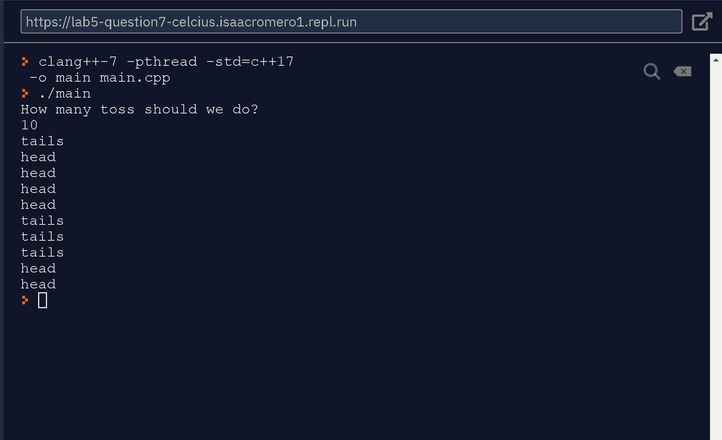

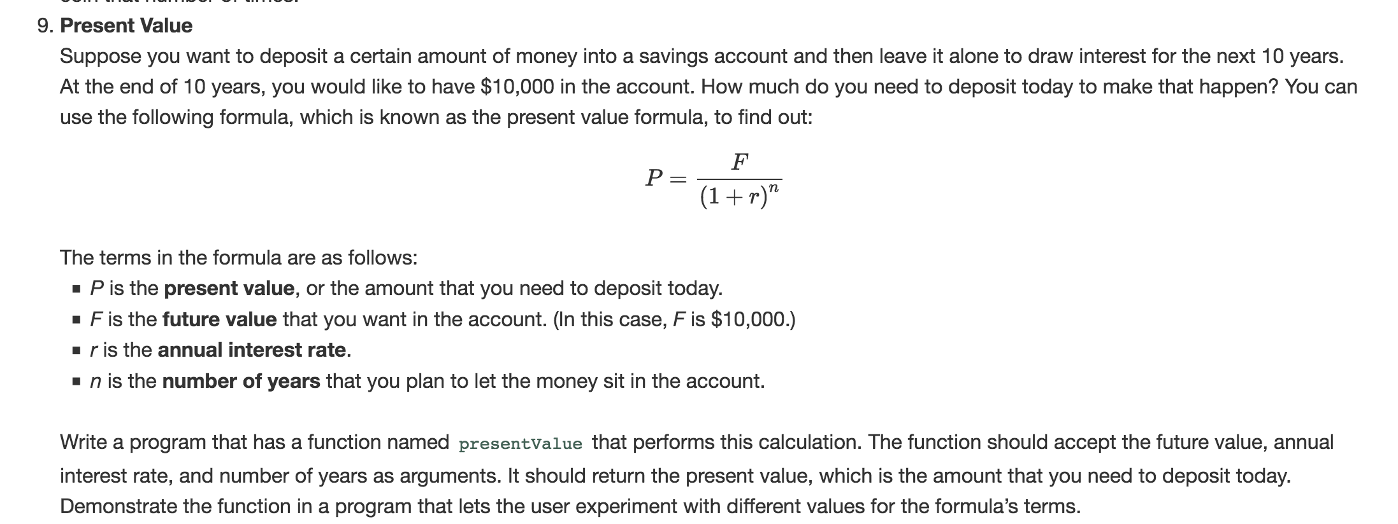

Answer:

#include <iostream>

#include <iomanip>

#include <stdlib.h>

#include <cmath>

using namespace std;

double presentValue(double futureValue, double rate, int years);

int main() {

double futureValue, rate;

int years;

cout << "How much would you like to have?" << endl;

cin >> futureValue;

cout << "In how many years?" << endl;

cin >> years;

cout << "What is the rate? (decimal)" << endl;

cin >> rate;

cout << setprecision(2) << fixed;

cout << "Your deposit is: $" << presentValue(futureValue, rate, years) << endl;

}

double presentValue(double futureValue, double rate, int years){

return futureValue / pow((1+rate), years);

}

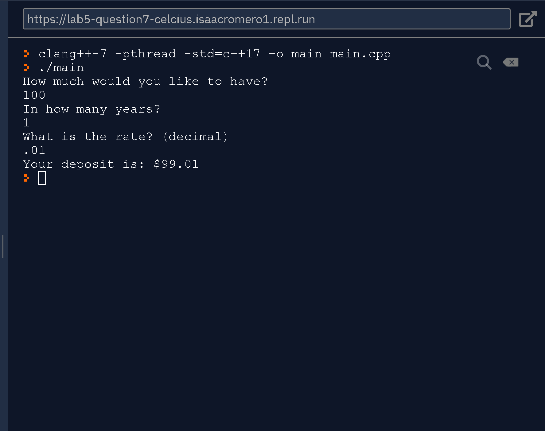

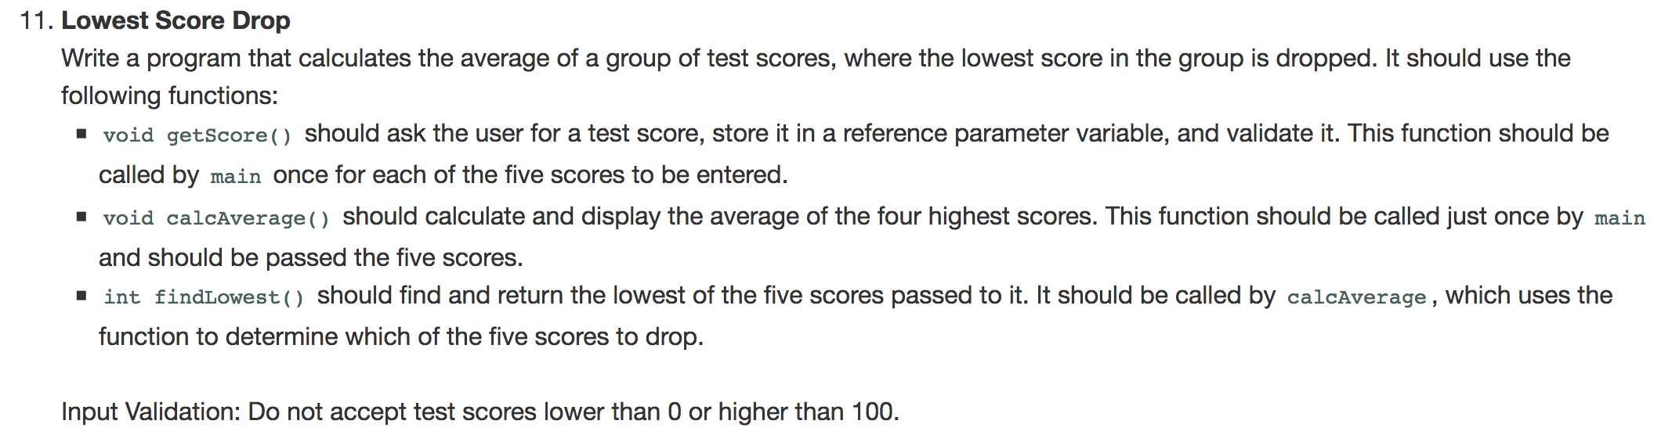

Answers:

#include <iostream>

using namespace std;

void getScore(int *score);

void calcAverage(int score1, int score2, int score3, int score4, int score5);

int findLowest(int score1, int score2, int score3, int score4, int score5);

int main() {

int score1, score2, score3, score4, score5;

do{

cout << "Score 1: " << endl;

getScore(&score1);

}while(score1 < 0 || score1 > 100);

do{

cout << "Score 2: " << endl;

getScore(&score2);

}while(score2 < 0 || score2 > 100);

do{

cout << "Score 3: " << endl;

getScore(&score3);

}while(score3 < 0 || score3 > 100);

do{

cout << "Score 4: " << endl;

getScore(&score4);

}while(score4 < 0 || score4 > 100);

do{

cout << "Score 5: " << endl;

getScore(&score5);

}while(score5 < 0 || score5 > 100);

calcAverage( score1, score2, score3, score4, score5);

return 0;

}

void getScore(int *score){

cout << "What is your test score? (Scores must be between 0 and 100)" << endl;

cin >> *score;

}

void calcAverage(int score1, int score2, int score3, int score4, int score5){

int low = findLowest(score1, score2, score3, score4, score5);

cout << "The average is: " << (score1 + score2 + score3 + score4 + score5 -low )/4.0 << endl;

}

int findLowest(int score1, int score2, int score3, int score4, int score5){

int lowestScore = score1;

if (lowestScore > score2) lowestScore = score2;

if (lowestScore > score3) lowestScore = score3;

if (lowestScore > score4) lowestScore = score4;

if (lowestScore > score5) lowestScore = score5;

return lowestScore;

}

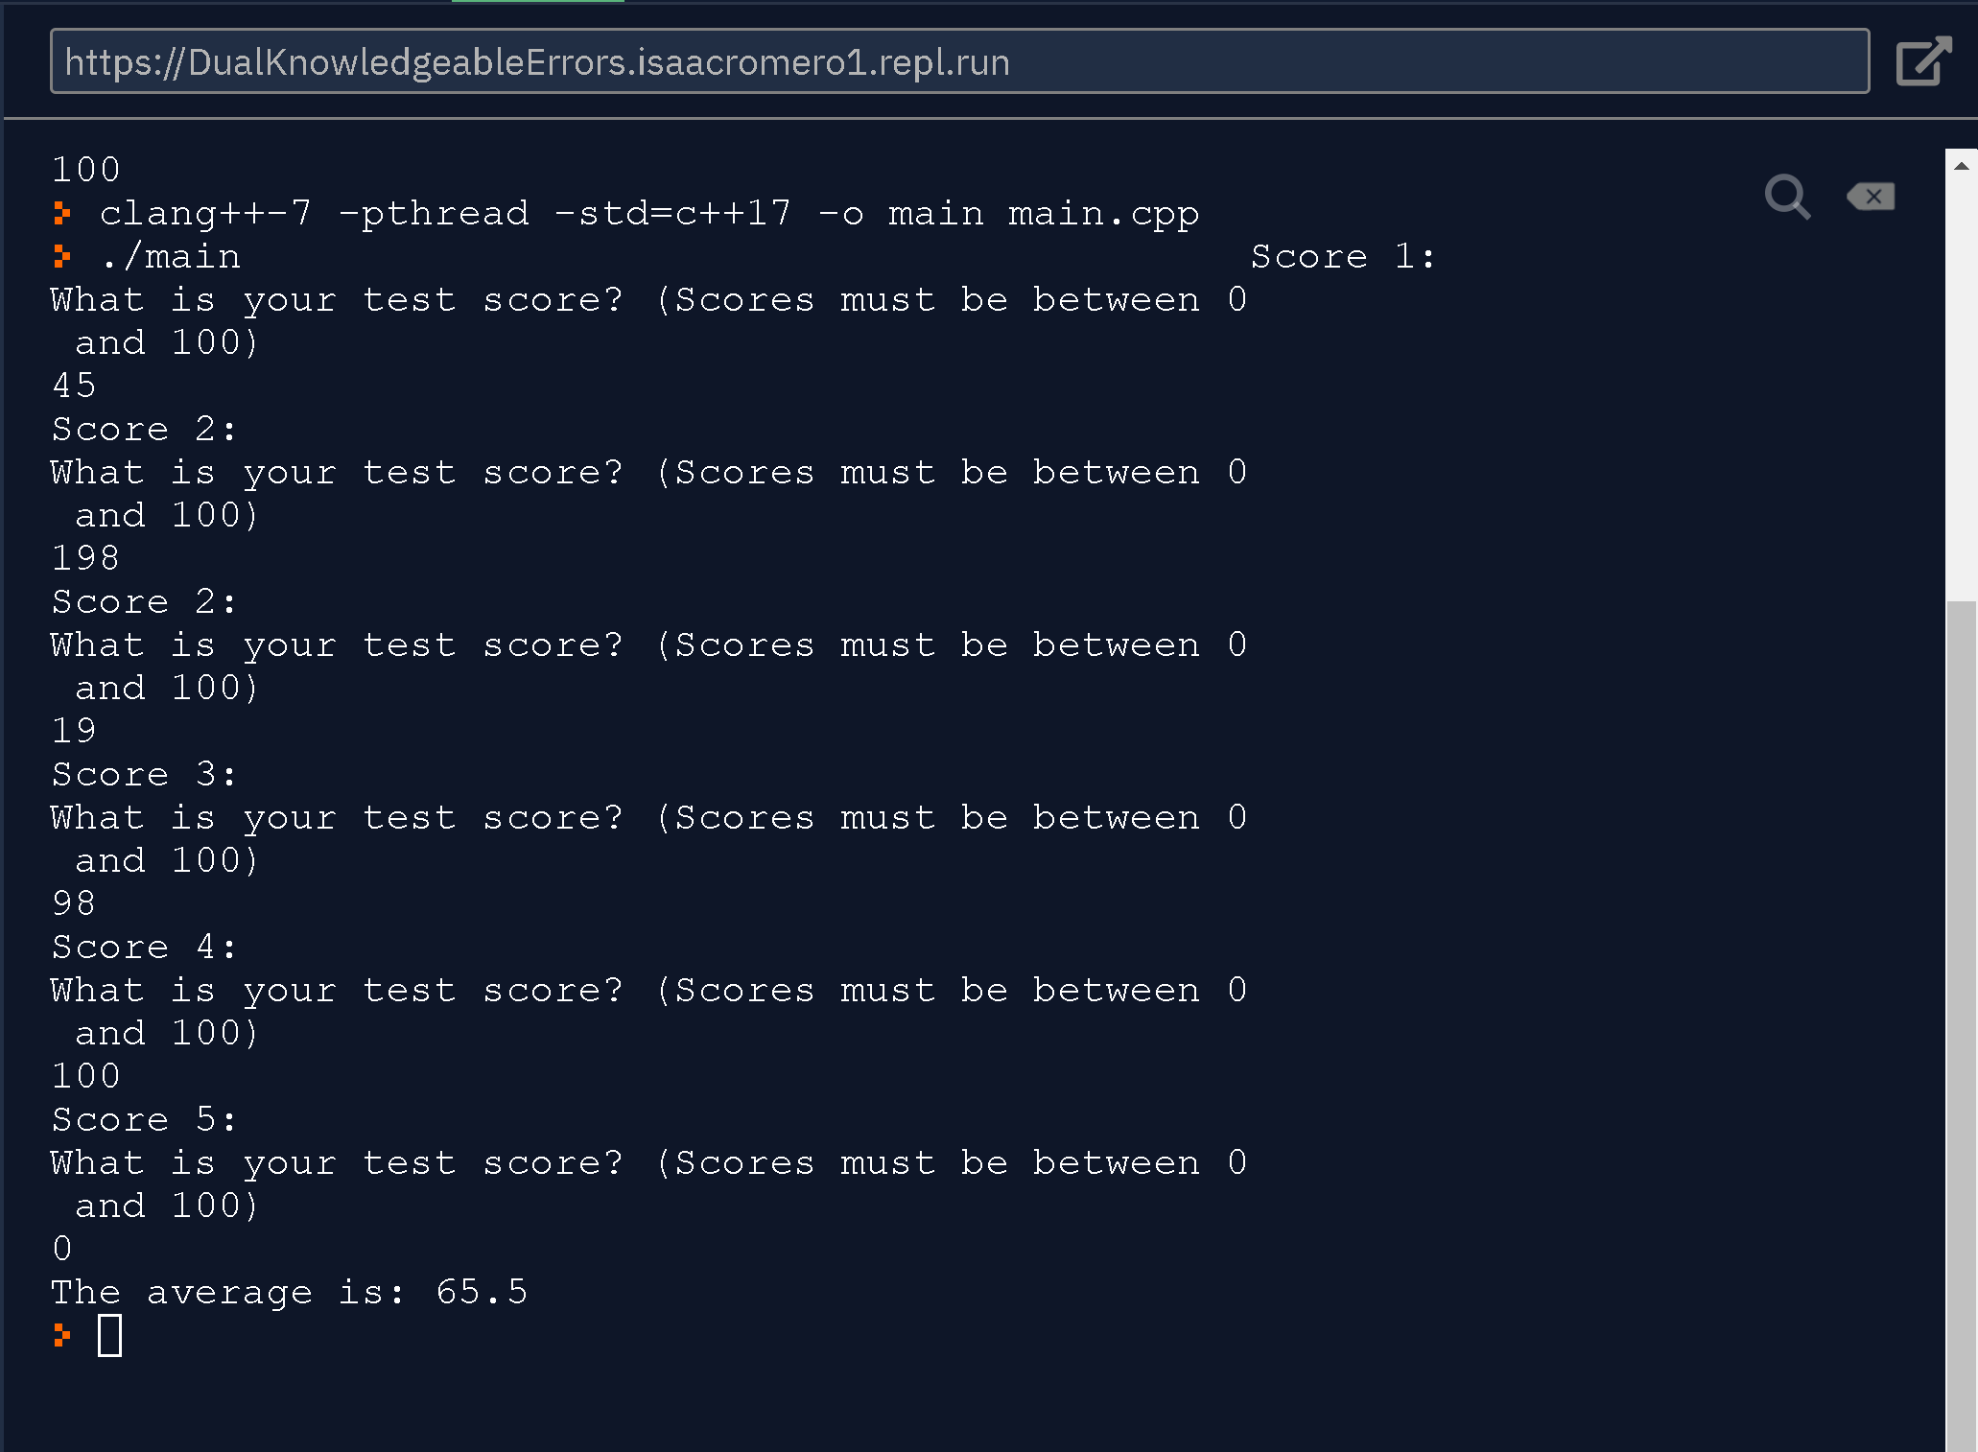

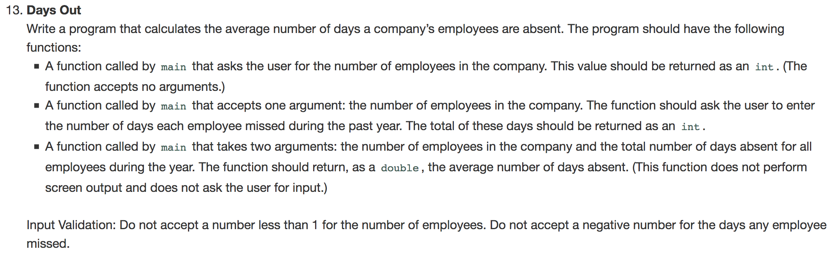

Answer:

#include <iostream>

using namespace std;

double averageOfDays(int totalEmployees, int daysInTotal);

int daysEmployeesMissed(int numberOfEmployees);

int numberOfEmployees();

int main() {

int employeesInCompany = numberOfEmployees();

int daysMissed = daysEmployeesMissed(employeesInCompany);

cout << "The average days misses are " <<

averageOfDays(employeesInCompany,daysMissed) << endl;

}

int numberOfEmployees(){

int employeeTotal;

do{

cout << "How many employees are there in the company? Employees must be more than one. " << endl;

cin >> employeeTotal;

}while(employeeTotal < 1);

return employeeTotal;

}

int daysEmployeesMissed(int numberOfEmployees){

int daysInTotal = 0;

for ( int i = 1; i <= numberOfEmployees;i++){

int days;

do{

cout << "For employee " << i << "." << endl;

cout << "How many days were they absence? (days must not be negative)" << endl;

cin >> days;

}while(days < 0 );

daysInTotal+=days;

}

return daysInTotal;

}

double averageOfDays(int totalEmployees, int daysInTotal){

return static_cast<double>(daysInTotal)/ static_cast<double>(totalEmployees);

}

