1.能供应所有零部件的厂商信息
SELECT * FROM s2022152021 S WHERE NOT EXISTS (SELECT * FROM p2022152021 P WHERE NOT EXISTS (SELECT * FROM sp2022152021 SP WHERE SP.SNO = S.SNO AND SP.PNO=P.PNO));
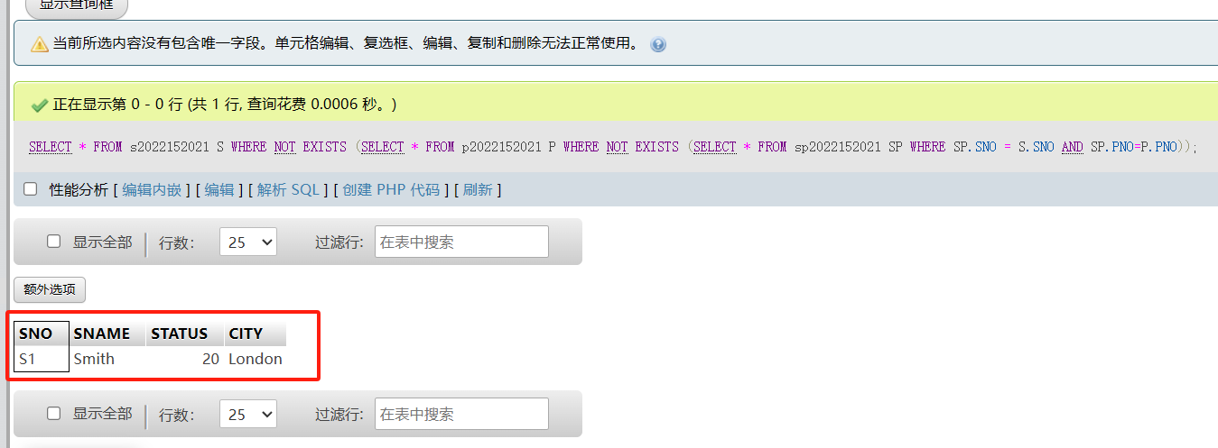

2. 能供应所有红色零部件的厂商信息
SELECT * FROM s2022152021 S WHERE NOT EXISTS (SELECT * FROM p2022152021 P WHERE NOT EXISTS (SELECT * FROM sp2022152021 SP WHERE SP.SNO = S.SNO AND sp.PNO=p.PNO )and P.COLOR="Red");
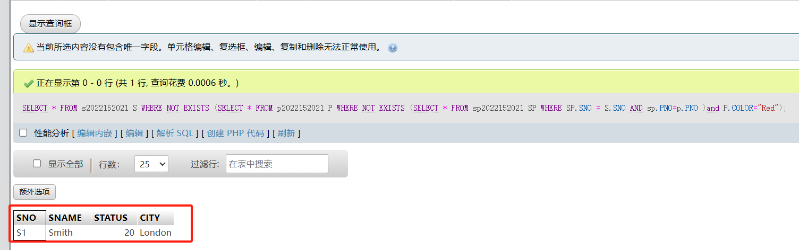

3. 能供应所有S2厂商生产零部件的供应商信息
SELECT * FROM s2022152021 S WHERE SNO!='s2' and NOT EXISTS (SELECT * FROM p2022152021 P WHERE NOT EXISTS (SELECT * FROM sp2022152021 SP WHERE SP.SNO = S.SNO AND sp.PNO=p.PNO ) and p.PNO IN (SELECT pno from sp2022152021 where SNO="S2"));
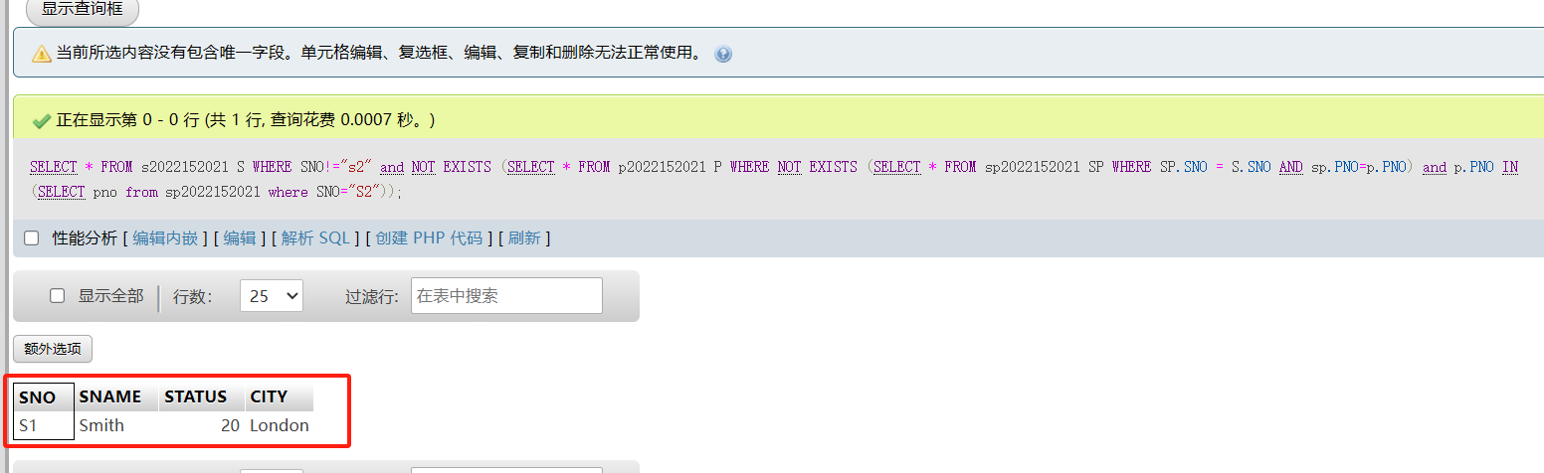

4. Get supplier names for suppliers who supply at least one red part:
SELECT S.SNAME FROM s2022152021 S WHERE SNO!='s2' and NOT EXISTS (SELECT * FROM p2022152021 P WHERE NOT EXISTS (SELECT * FROM sp2022152021 SP WHERE SP.SNO = S.SNO AND sp.PNO=p.PNO ) and p.PNO IN (SELECT pno from sp2022152021 where SNO="S2") and p.PNO not in (SELECT pno from sp2022152021 where SNO="S3"));