ZTNA Modifications

You are saying that we have not added Attribute Based Access Control and in below screen we are showing code with red comments which is checking file access based on its attached attributes. Here we have used Public or Private Access as Attribute Access Control

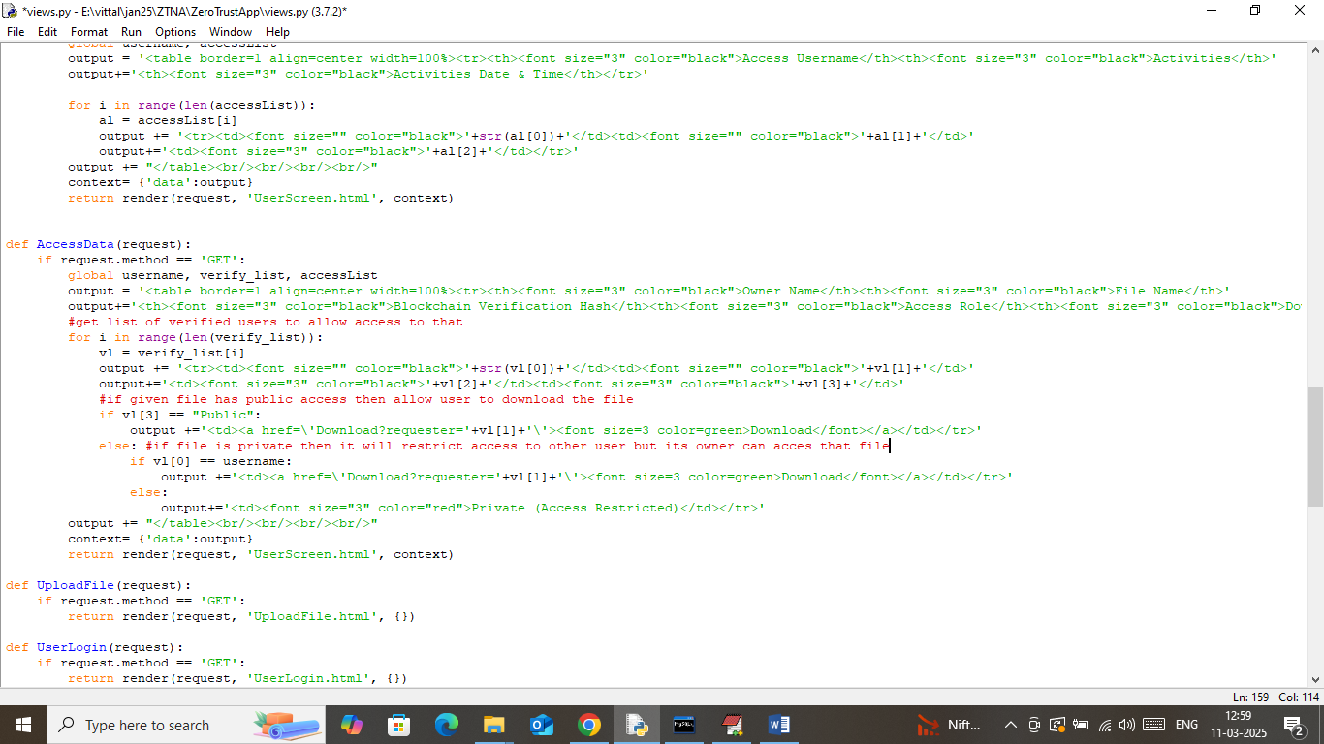

In below screen read red color comments to know about accessing file using attribute based accessed.

As second modification you are asking what new thing we have added?

Answer: We are saving all details in Blockchain which has inbuilt support for data security and tamper proof storage. To provide more security we are employing AES encryption on uploaded file to add more security to data which is showing in below screen

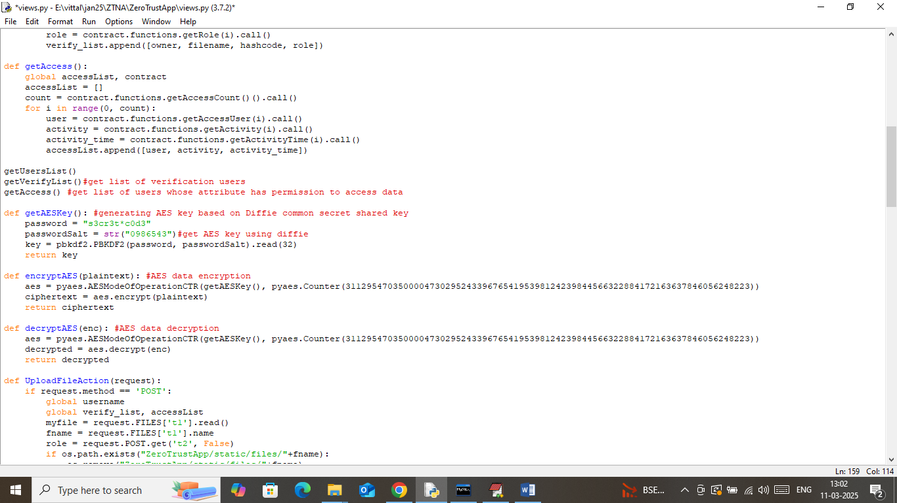

In above screen you can read red color comments where we are using functions to encrypt and decrypt data