Hexaverse Documentation

Game info
This is a game-prototype in closed-beta state. Most essential components are sufficiently completed–some even in production quality–but significant parts of the game remain unfinished.
All work done by Stefan Elsen, copyright (C) 2014-2015.

Disclaimer:
THIS SOFTWARE IS PROVIDED BY THE AUTHOR ``AS IS'' AND ANY EXPRESS OR IMPLIED WARRANTIES, INCLUDING, BUT NOT LIMITED TO, THE IMPLIED WARRANTIES OF MERCHANTABILITY AND FITNESS FOR A PARTICULAR PURPOSE ARE DISCLAIMED. IN NO EVENT SHALL THE AUTHOR BE LIABLE FOR ANY DIRECT, INDIRECT, INCIDENTAL, SPECIAL, EXEMPLARY, OR CONSEQUENTIAL DAMAGES (INCLUDING, BUT NOT LIMITED TO, PROCUREMENT OF SUBSTITUTE GOODS OR SERVICES; LOSS OF USE, DATA, OR PROFITS; OR BUSINESS INTERRUPTION) HOWEVER CAUSED AND ON ANY THEORY OF LIABILITY, WHETHER IN CONTRACT, STRICT LIABILITY, OR TORT (INCLUDING NEGLIGENCE OR OTHERWISE) ARISING IN ANY WAY OUT OF THE USE OF THIS SOFTWARE, EVEN IF ADVISED OF THE POSSIBILITY OF SUCH DAMAGE.

Requirements:
- DirectX10. The client uses DX10 to render the visual representation.
- Any sound card compatible to OpenAL. Pretty much all sound cards are.
- 64bit CPU and operating system. 4+ Cores recommended.
Multiple CPU cores are beneficial for certain operations. The more the better.
- Local Area Network. Localhost loopback is sufficient if not playing against others.

Installation
Generally no installation is required to run the provided applications. However, if any of the following error messages occur additional steps may be necessary:
- If you see something along the lines of 'OpenAL32.dll not found', then please execute the provided OpenAL installer (client/oalinst.exe). You will only need to do this once.
- If you see something along the lines of 'D3DCOMPILER_43.dll is missing from your computer', then please reinstall the direct3d runtime components (client/dxwebsetup.exe). You will only need to do this once.
Please let me know if any of these occur. They should not anymore.

Bugs
Yes, this game has bugs. Surprise! :)
If you encounter anything that you think is a bug (such as a terminal exception, or just weird behavior), please take the time to send a report to bug-reports@hexaverse.net
Please try to explain as detailed as possible what exactly the bug is, and what you did before it occurred. If you can reproduce the bug then please include a description on how to do so. A bug I can reproduce is considerably easier to fix.
Please include the following files (if existing):
- client/hexaverse.log
- client/fatal.log
- server/logs/server_*.log
Please shut down the any running hexaverse server before accessing this file.
Provide only the one generated before/during the crash – probably the newest.

THE GAME
The game concept is that of a networked, volumetric, turn/phase-based strategy game with some influence from Mechanized Assault and Exploration (M.A.X.).

Running the Game
This game is network-based. Even if you do not want to play against others you will still need a server. In order to start your own execute the provided server\server.exe program.
Note that closing the window will terminate server execution.
The server will bind to several constant ports, and periodically send out UDP-broadcasts to advertise its existence. Clients in range will receive these broadcasts and display the received server address for the user to choose from.
Since these ports are exclusive, and cannot be configured at the moment, you will not be able to start multiple servers or multiple clients on the same computer (though both one server and one client will work).

To run the client, simply execute the provided client\client.exe. Once loaded, the program will display any responding remote servers it has detected/been configured to.
As mentioned previously, any running server will advertise its existence on the local area network. If you wish to connect to a server on your LAN, the client will automatically detect it. No further configuration is necessary in this case.
If instead you wish to connect to a remote server outside your local UDP broadcasting range, you will need to add its URL to the game.ini file before starting the client. If a connection can be established, it will be shown in the server screen of the client. Connection attempts are made periodically, so if the respective server becomes available later, the client will automatically update its server list, and establish a connection.
When the client is started it will provide a list of all servers it was able to connect to. The list shows the server ID (Host ID), world ID, number of players and clients, as well as the current round number. Listed underneath are the possible network addresses of the respective server.
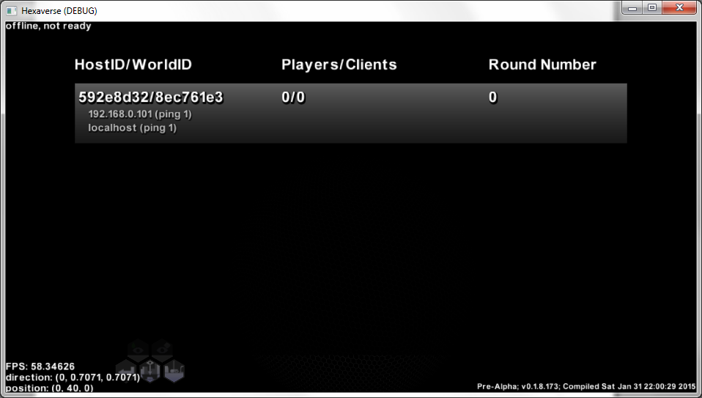
Clicking on any of the available hosts will initiate a game connection attempt via the address with least ping.
Once you have joined a server game you cannot change the active server again, unless the connection to the current server is lost. This is one of many features left in the to-do-queue. A disconnect option will become available with a better main menu, and options dialog.

game.ini
The configuration file in the game root folder allows configuring certain aspects of the game. This file will be parsed during start-up only. Options are documented in the file.

Network Ports
The server will bind the following ports: 10242 (UDP, out, broadcast), 10244 (TCP, in), 10245 (TCP, in)
The client will bind the following port: 10243 (UDP, in)

Server Control
Server control is still in its infancy. As more controls become available they will be listed here.

Saving:
The server will save the current world state every 10 rounds. Files are written in "./server/saves/auto/snapshotN.sav", where N goes from 0 to 9.
The most recent save game will always be stored in snapshot0.sav.

Loading:
If you pass the path to a save file as parameter to the server executable it will load the respective save game during start-up. This can also be achieved by drag-dropping a .sav file onto the server executable.

Configuration:
The server features a configuration file server/server.ini
The available settings are defined as:
- closed (true/false)
Indicates the players can join with new sessions only during the first round. Joining during latter rounds is possible only with a valid access token to a non-destroyed faction. A victor will be determined if due to faction death only one faction remains. This can occur only if combined with basesRequired, however.
- roundTimer (any number)
Time (in seconds) that players can remain in Command-phase. If this deadline is reached without all players requesting a new round, then a new round is enforced. Set to 0 or a negative number to deactivate.
- goal (string)
Game goal to achieve. Currently only 'None' and 'ConquerNexus' are supported.
If 'ConquerNexus' is chosen, 12 Nexus Port buildings are placed on focal points of the planet.
The goal is to conquer 7 of these 12. Conquering is done by connecting the respective port to any complex you own, and then keeping it powered for at least 10 rounds. The Port will change ownership when a new building of your's is constructed next to it. Currently 10 units of energy are required to enable a Nexus Port. If the connection to your compound is forcefully severed or the it is switched off, the Nexus Port will reset. You cannot connect to a Nexus Port that is already connected to a compound of another player. Dispose of the hostile surrounding structures first.
- basesRequired (true/false)
Indicates that players must maintain minimal bases to be considered 'alive'. Minimal bases include a mandatory compound capable of generating infinite amounts of minerals. Such a compound includes a live mine that can deliver at least 10 units of fuel, one that can deliver at least 5 units of minerals, a generator, and mineral container. Additionally, the player must own at least one terraformer or a vehicle plant that can be switched on. If any one of these conditions is not met, a death counter will count down each round for the respective faction, until it reaches zero. If it does, all vehicles and structures of that faction are destroyed. If the game is closed and only one faction remains, that faction is declared victor.
- startBases (true/false)
Indicates that new factions will start with minimal bases and vehicles that justify the basesRequired condition. In this mode only one terraformer and one surveyor are issued per player–no radars, or tanks. If this setting is disabled, new players are given one tank, radar, surveyor, and full terraformer, instead.

Controls
Right mouse button: Click and hold to drag camera around the globe. Right click to move a selected vehicle to that location.
Left mouse button: Select a building, vehicle, or cell, choose a target to attack or move to (depending on active mode), or select an option from the menu.
ASDW : Rotate camera around focus point.
Arrow up/down / Mouse-wheel: Zoom camera
Arrow left/right: Select previous/next vehicle that you control
Space button: Select next idle vehicle / vehicle plant
Enter key: Request new round
Page up / page down: Increase/decrease terrain clipping level (see Terrain-Clipping)
F3: Takes snapshot of the current scene. A 'screenshots' folder will be created (if not already there) in the game folder, and a new PNG file 'screenshotX.png' (where X is a running number) be inserted. Background areas will be made transparent in the png. The size of the image will match the current window client size. Output processing is asynchronous. While an image is being exported, no additional screenshots can be taken. You will see a notification on screen when processing is done.

Terrain-Clipping
This game is volumetric, that means things may exist or happen beneath the terrain. In order to explore occluded areas you can enable the global menu option 'Clip Terrain' in the menu (see MENU).
Alternatively, this mode will auto-activate (and later deactivate) if terrain is found above the selected object.
While in clip-mode a roughly cylindrical area above the current clip focus point (e.g. the selected object) will be visually (not actually) removed, so that you can see any occluded caves, tunnels, or objects on the respective height.
(Left: clipped. Right: not clipped)
The Page up/page down keys can be used to manually adjust the clipping height. If the clipping height is left unchanged then it will automatically adjust as the selected object changes/moves. The clipping area will center on, and follow the selected object. If no object is selected then any active clipping will instead follow the camera focus point.

Sensory
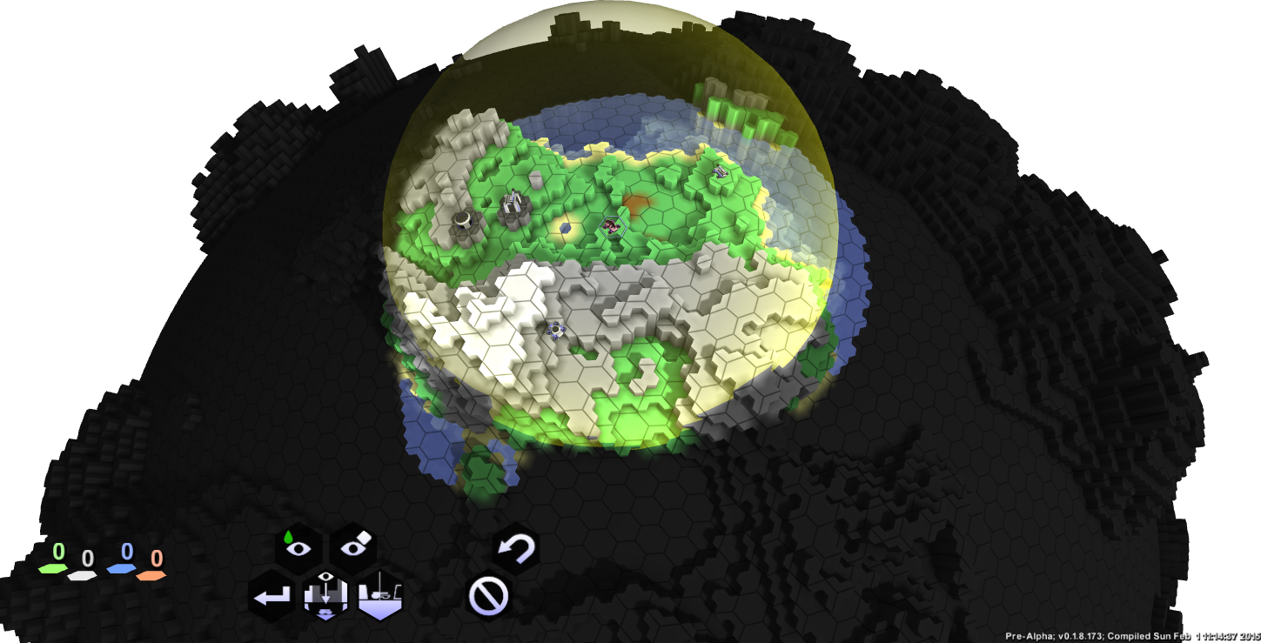
All objects have a sensor range. In the scene this range is visualized as a yellow sphere around the selected object. Terrain or hostile objects (and their activities) will be visible only, if they are/occur in sensor range of at least one of your objects.
The terrain is initially undiscovered/grayed out. This initial terrain is identical regardless of how game-progression has changed it. Unless any of your vehicles move to a specific location you cannot be certain that even this rough outline is correct. Once visited, the revealed terrain sections will be shown in their actual material composition and current state. Any subsequent changes to the respective area will, however, only update if still in sensor-range. Otherwise you will see a 'memory' - the terrain as you last knew it was, not as it may be now.
Hostile vehicles or structures are displayed only while in sensor range.
The actually visible terrain will be rendered fully lit, while terrain out of sensor range will be rendered slightly shaded (i.e. fog of war).

Resource-Sensory
Surveyor turrets can be used to detect resources in the surrounding core area. As the vehicle moves, new resources may be detected, and visualized as vertical bars, by using the global command 'View Resources'. Detected resources never change or disappear, but hostile mines may have been constructed above them, while out of sensor range (see Sensory).
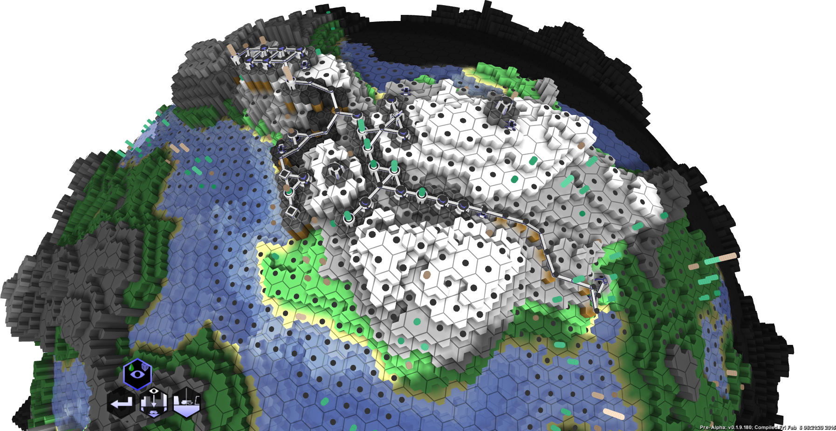
Resources. The dark gray discs indicate that these areas are known, but no resources of the selected type were found. Turquoise bars indicate rich fuel resources, light gray/orange bars indicate mineral resources.

Phases
The general game-logic follows a phase-model. While playing the game, the most apparent phases are the command- and animation-phases. While in command-phase (which will be most of the time), you can issue commands to your vehicles and structures, or undo them. With few exceptions (e.g. the spawning of a new vehicle, or aborting a construction job), actions performed in this phase will not take immediate effect. During animation phase, these commands are executed in order, as time permits it. All players are in command-phase at the same time.
Once every active player has issued the 'End Round' menu command (see MENU), the server iterates through a number of intermediate phases to determine the correct order of command execution.

- Attack Phase
The first phase processed is the attack phase, during which vehicles and towers with active attack commands can execute as many of those as they are allowed to. Any allowed attack command is guaranteed to be executed before the first vehicle can move. Attacks are processed in order of the respective object's attack initiative. The attack initiative depends on the vehicle/tower composition, as well as the remaining attack action. A stationary vehicle as well as a tower start with 100% attack action left, and thus their full initiative. Each attack reduces this attack action and thus also its initiative by 100%/maxAttacks. A vehicle/tower than can attack twice per round, will thus have only half its initial initiative during its second attack. Objects of identical attack initiative are executed in random order.
Some vehicles (e.g. the artillery tank vehicle) will be affected by movement in the previous round. As their movement range is exhausted, so is their attack action during the next round. If they exhausted their maximum possible movement range during one round, they will have no attack action left, and will have to wait one round before attacking (assuming they don't move again).
Towers with no explicit attack command will target and attack the closest visible hostile vehicle in range. Towers generally have heightened initiative, compared to their mobile counterparts.

- Movement Phase
Once all attacks are processed, surviving vehicles can proceed with their non-attack queues. This includes plain movement as well as construction or other tasks. These operations are executed in order of their respective vehicles' movement initiative, and movement action left. Similar to attack action and initiative, movement action and initiative affect each other. For most operations, the order of execution is irrelevant, but some operations may create or clear obstacles, or trigger tower attacks.
Some vehicles (e.g. the artillery tank vehicle) will be affected by attacks performed during the attack phase of the current round. As their attack action is exhausted, so is their movement range during the movement phase. If they reached their maximum possible attacks per round, they will have no movement action left, and will have to wait one round before moving (assuming they don't attack again).
Towers with any attack action left will automatically target and attack any moving, visible, and hostile vehicle in range. This, in combination with their behavior during the Attack Phase, makes towers significantly more deadly than their mobile counterparts (albeit stationary, and thus predictable).

- Animation Phase
Any actions executed during the previous two phases are queued until the server enters its animation phase. This phase may last at most 10 seconds, visualizing any attack, motion, construction, or other activity, in their respective order. Common attacks are visualized in order of their execution, while vehicle non-attack activities will be animated in parallel.
If the calculated animation length exceeds 10 seconds, all animation playback will be accelerated accordingly.
After these at most 10 seconds, the game enters the command phase.

- Command Phase
Allows to monitor changes, issue new commands, revise existing commands, spawn new vehicles, or plain do nothing and continue on. This phase ends, once all active players have issue the 'End Round' command.

Structures

State
The color of the notification areas (colored surfaces) on a structure will signal its state. It may be disabled (dark blue), active (pulsing light blue), or unstable (blinking light blue).
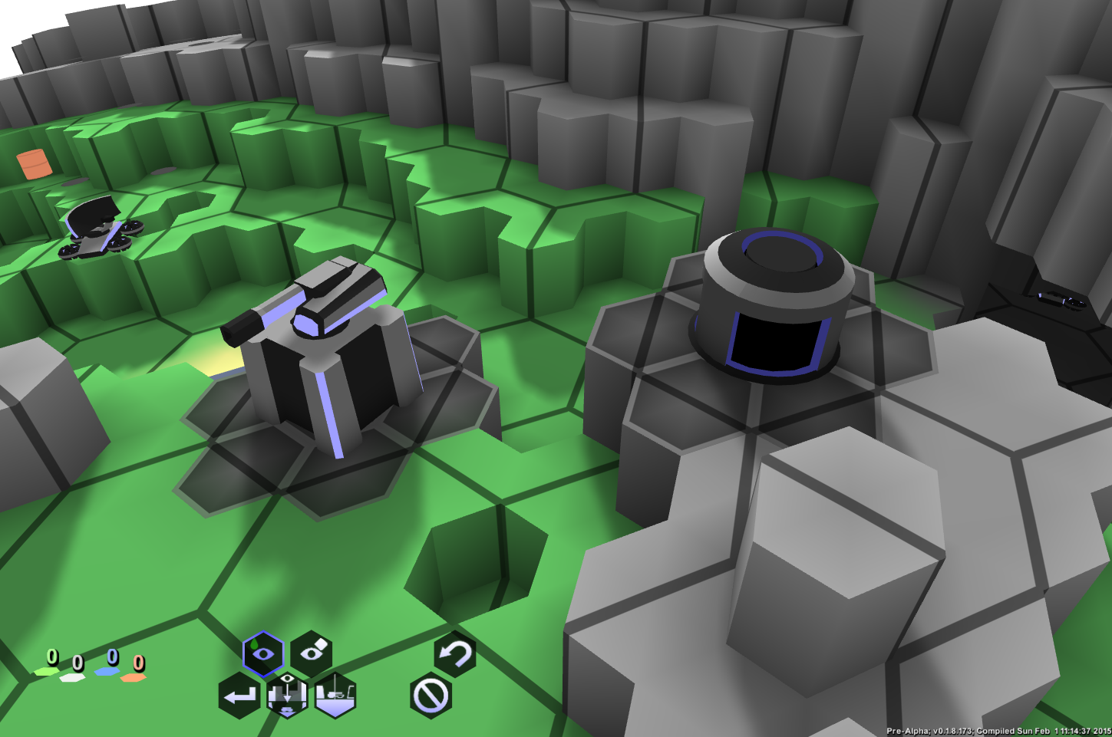
Left: Enabled tower. Right: Disabled Vehicle Plant
If just one structure is blinking, it indicates that this structure requires user interaction to continue. Right now the only time this happens is if the vehicle plant has finished construction. Clicking on the building will provide spawning-locations.
If all structures of a compound are blinking then the compound resource vector is not stable (more demand than supply of one or more resources). In this case, disable structures until the state balances out.

Common commands
All structures have the 'Demolish'-option to instantly remove the respective structure.

Any foundation elements it may have created remain in place. The demolish command may split one compound into multiple disconnected compounds.
All structures except the 'Connector'- and 'Tower'-structures also feature an 'Enable' switch.

If solid blue, the respective building is currently enabled. Enabling or disabling a structure may be instantly reverted by the auto-balancing mechanism, if the network becomes unstable as a result of the operation. The auto-balancing may also enable other structures to balance out additional resource-demand as a result of a newly enabled structure.

Mine
Requires a full foundation.
Consumes 10 units of energy per round.
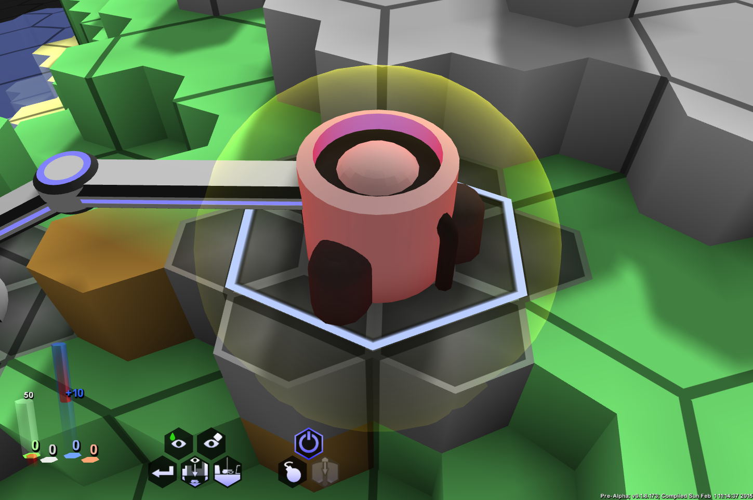
Mine connected to a generator and fuel container.
A mine provides any natural resource of the mine's vertical core location to the local compound. If no electricity is available, it will shut down automatically. Upon construction, a mine will connect vertically to the core, and not operate if this connection is disrupted. Due to this restriction, multiple mines cannot be placed atop each other, without all but the lowest to fail. A lost core-connection can be restored through the structure-menu, when selecting the mine. Connection can be lost due to terraforming.

Connector
Requires a single solid terrain block underneath.
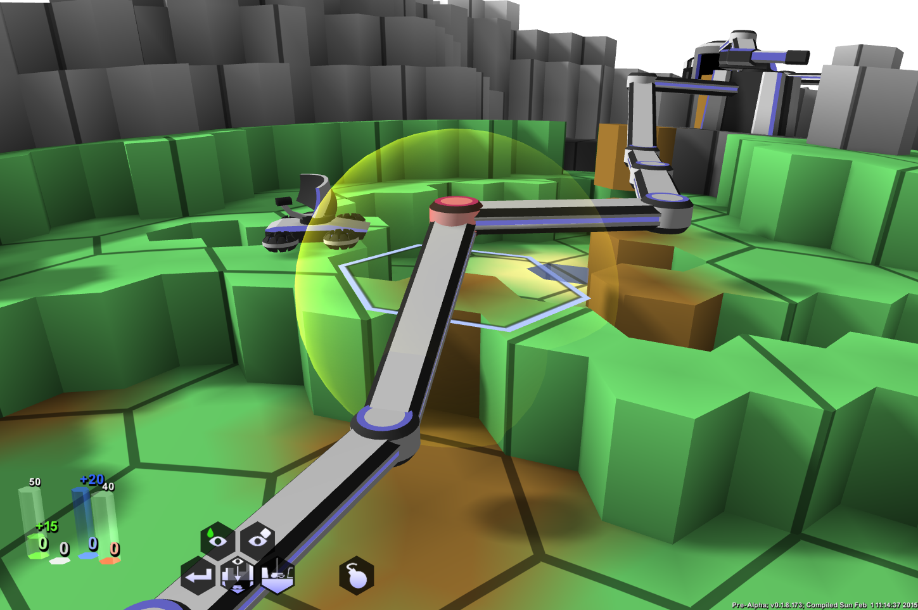
Unlike most structures, connectors only need one solid terrain block underneath. They also do not hinder vehicle movement. As the name implies, connectors connect otherwise disconnected nearby structures (including other connectors), and provide a cheap way to connected distant isolated compounds. Connectors are replaced implicitly, if another structure is built in the same cell.

Generator
Requires a full foundation.
Consumes 10 units of fuel per round.
Produces 20 units of energy per round.
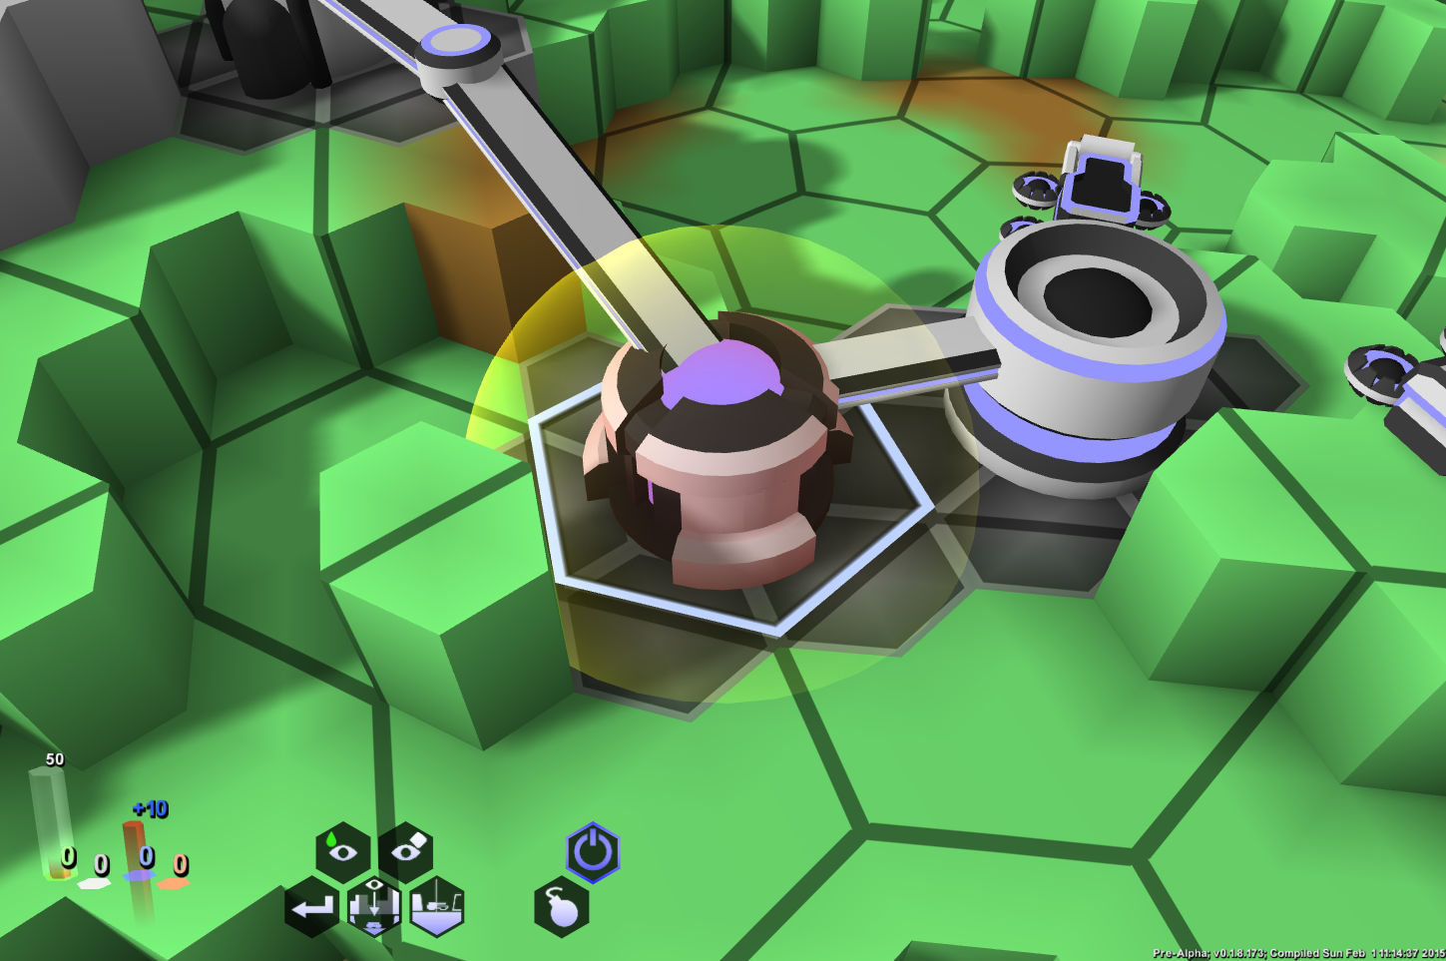
Generators are a crucial component of any compound, since they generate the necessary energy for other structures to operate.

Vehicle Plant
Requires a full foundation.
Consumes 10 units of minerals, and 10 units of energy.
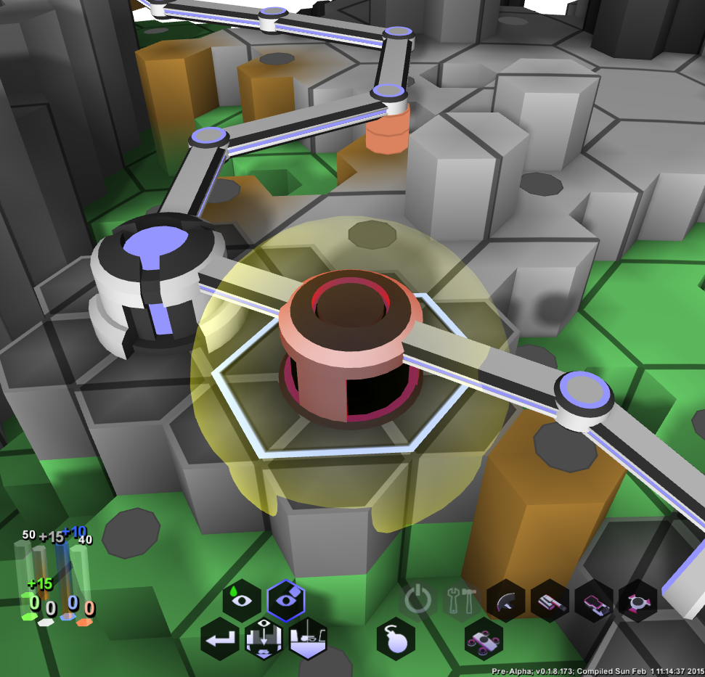
The structure menu of a vehicle plant allows to select one turret and one base.
Vehicle Plant Menu:
Select a turret from the upper row, and a base from the lower in order to define a new vehicle.
Then press the 'Construct Selected' button to en-queue a new construction order for that vehicle.
Once both are selected, the selected composition can be queued using 'Construct Selected'. The selection will be added to the end of the queue, listed above. Clicking on any element in that queue, will remove it, including partially constructed vehicles.
The top row shows the current en-queued vehicles. The left most item will be the first to be constructed.
New vehicles are added at the right end. The number in parenthesis '(14)' shows the number of rounds left until this vehicle will become available. It sums the construction time of the active item and any succeeding production.
If supplied with the necessary resources, and a non-empty queue, each new round will reduce the remaining rounds on the current left-most queue element by one. Once it reaches zero, the building will require the user to spawn the new vehicle before construction of the next queue element can begin. To spawn a finished vehicle first click on the vehicle plant (if it's not already selected) and then on one of the provided choice options. If there are no choices available, then there is no cell in the vicinity of the vehicle plant that can support the constructed vehicle. Provide the necessary space/foundation, remove any vehicles from the neighborhood, and click on the vehicle plant again. If the queue is now empty, the building will switch off.

Compounds
Neighboring structures will automatically connect to form compounds. Within a compound all production and consumption are shared, such that one structure can fill the demands of another in the local compound.
Use connector structures (via the menu command "Build Connectors to") to connect isolated structures.
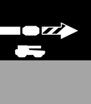
Note that connectors have infinite transfer capacity, and are cheap and quick to construct, but they are also the most vulnerable structures. Destroying a single connector may completely disable an enemy base.

Towers
Towers are sensor and defense structures, that allow mounting certain turrets onto a resilient but immobile foundation. Towers featuring offensive capabilities provide attacking range*1.2, at the expense of scanning range*0.8. Scanning towers (that cannot attack) provide scanning range*1.2
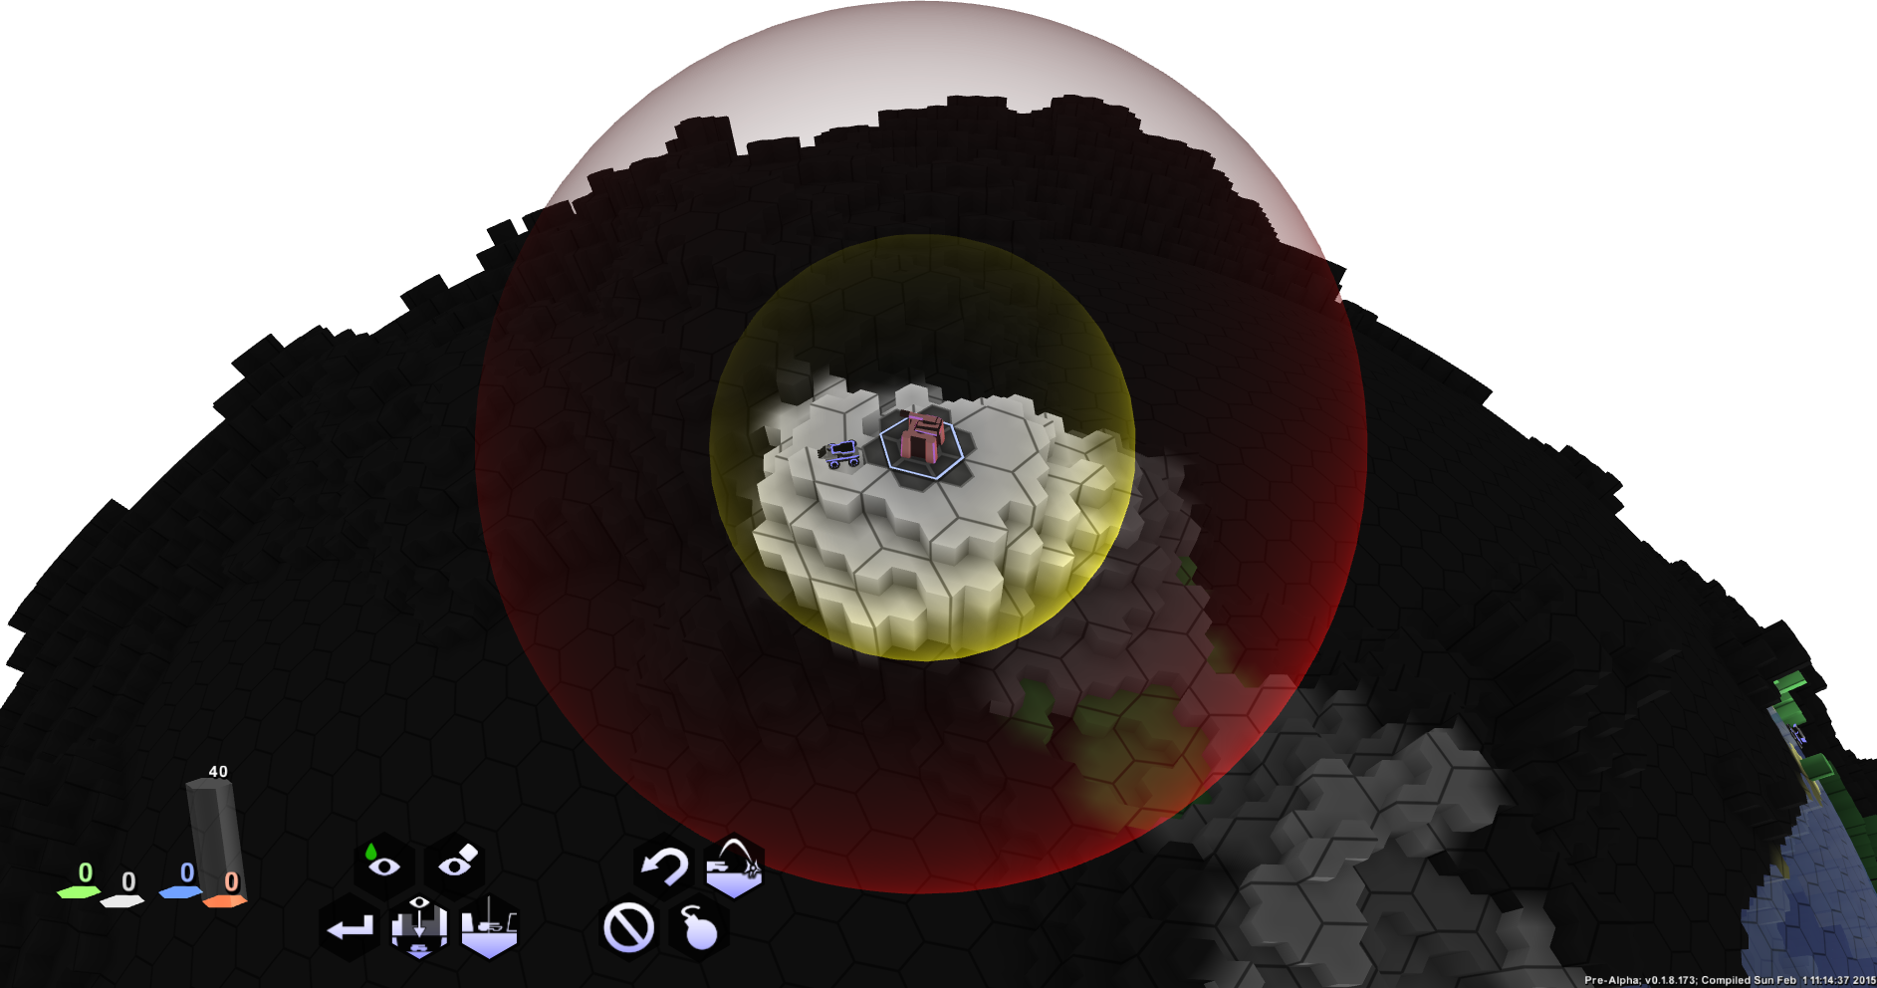
Tower scanning range shown in yellow, and firing range in red. Offensive turrets have reduced scanning range but increased firing range.

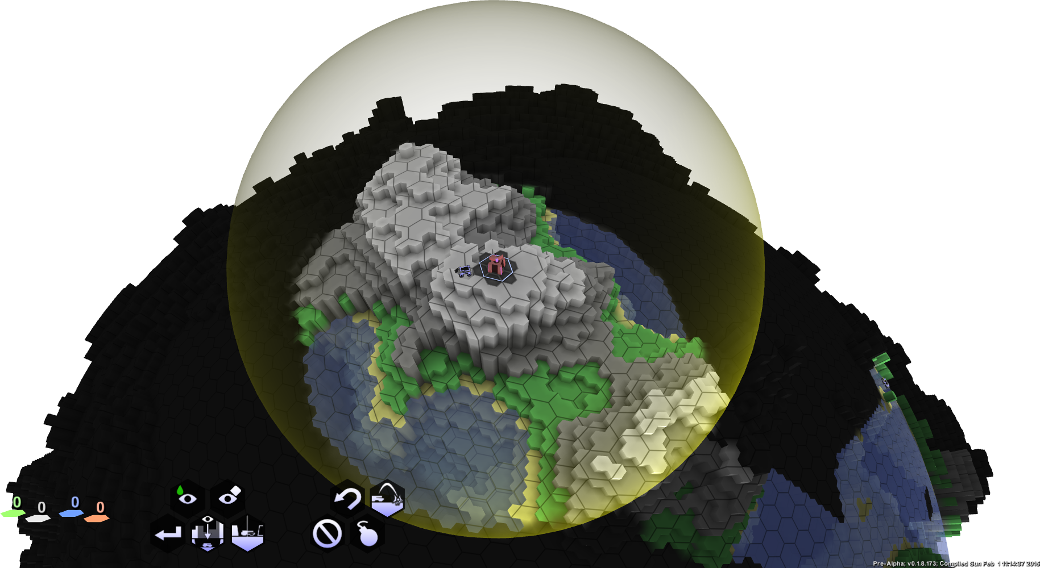
Radar tower: No offensive capabilities. Increased sensor range.

Object Status
The numerical status of the selected object is shown in the top right of the game window. Here, all relevant information is shown, such as health, initiative, remaining attacks per round, speed, storage, active tasks, etc.

Object Resources
Currently four types of resources can be generated, consumed, or stored by certain vehicles and structures: fuel, minerals, energy, and munitions.

- Fuel (displayed in green)
Retrieved from natural resource fields via powered mines. Consumed by generators to generate power. Stored by fuel containers.
- Minerals (displayed in gray)
Retrieved from natural resource fields via powered mines. Consumed/stored by terraformer vehicles. Consumed by vehicle plants. Stored by mineral containers.
- Power (displayed in blue)
Generated by generators. Consumed by mines and vehicle plants. Each generator consumes 10 units of fuel and generates 20 units of power. Mines and vehicle plants consume 10 units of power each.
- Munitions (displayed in red)
Generated by munition factories. Consumed by offensive towers and vehicles. Stored by offensive towers, vehicles, munition factories, and munition storage structures.

When enabling/disabling structures in a compound, the respective compound's balance is checked. If changing the structure's enable-state destabilizes its governing compound, actions are performed to auto-balance it. At most one structure may be enabled/disabled automatically during this procedure. If auto-balancing fails, the entire compound enters an unstable state, during which it will not generate or consume any resources. To resolve an unstable state, manually disable/enable structures until a balanced state can be reached, where all resource consumption is matched (or exceeded) by the respective production/storage.
Most typically the auto-balancing behavior manifests, when a new mine cannot be activated due to insufficient power in the compound network, or another generator in the compound automatically activates.

Resources available to, or stored in, a compound or single object are visualized in the bottom left corner of the screen (see resource visualization above).
Compound resource visualization. This particular compound provides storage capacity for 50 fuel, which are completely full. Storage capacity is also provided for 40 units of munition. Excess supply exists for fuel (15 units per round), minerals (15), and energy (10 units per round). Since all available storage capacity is exhausted for these three, the excess production is lost.
The number at the bottom displays the currently stored amount of the respective resource type. If no storage capacity is available, this number will be 0. The broadest transparent bar indicates the maximum storage capacity of the complex/vehicle. This bar fills bottom to top, and empties top to bottom. If the selected compound/vehicle does not have storage capacity for the respective type then this bar is not shown. Parts of the bar may be shown in bright red, if the locally selected structure is responsible for its storage.
The next thinner, fading bar indicates changes in the local storage. If a compound produces excess amounts of a certain resource type, then a bar of this type will exceed the storage bar, reaching further up.
Vehicles will only depict the thickest type of bar, since they do not generate resources. The cost of planned construction operations will show as red-shaded portions of this bar. Note that some construction costs are difficult to estimate and not shown.

Vehicles
All vehicles are combinations of a base with a turret. While their base gives them mobility, their turret grants abilities. When starting out, you are given control over one terraformer, one tank, one radar, and one surveyor. All four turret types are on top of hover platforms, maximizing maneuverability.
Vehicles can be directed to a destination by selecting a vehicle and right-clicking on a reachable location. If the place is reachable, the shortest possible route will be plotted. Note that multiple alternate routes may exist that yield the same time costs. In this case the actually plotted path can be any of those, and change from one round to the next.
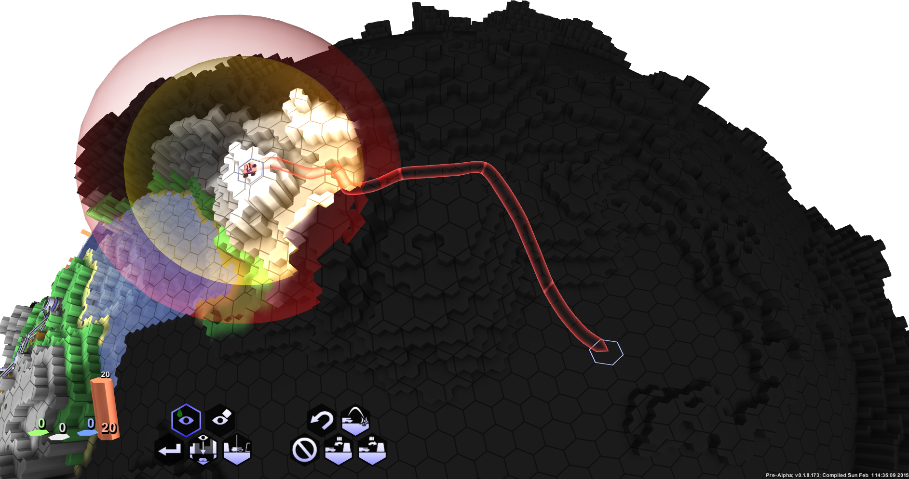
Shortest detected path. The line markers indicate where the vehicle will be after each round.

Hoverbase
Allows to move down any height without taking damage. Allows to stand on one single edge cell without falling. Can move up one block as long as the vehicle can stand there.
Can move over water. High speed, low carrying capacity. Overweight causes slowdown.
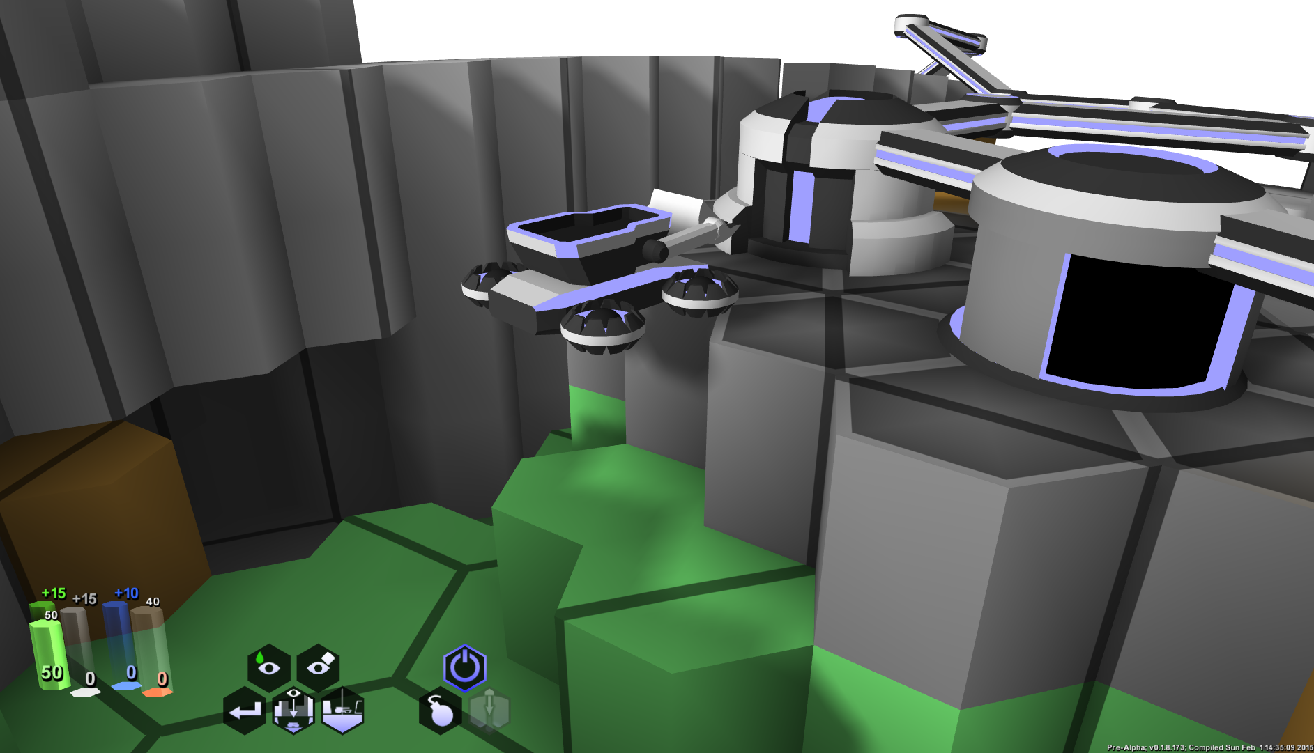
Hoverformer levitating over an edge.

Heavybase
Can climb or descend by at most one height level. Requires a solid center block to stand on. Can not move over water. Good speed, high carrying capacity. Overweight causes slowdown (nothing that heavy atm). High armor level, and storage capacity.
Heavy Tank

Surveyor
Use this turret type to detect natural resources. Its sensor range doubles as the resource detection range. Once detected, resources do not change, so surveyors are needed only until all resources are detected. While fast, surveyors are very vulnerable, and have a low sensor range.
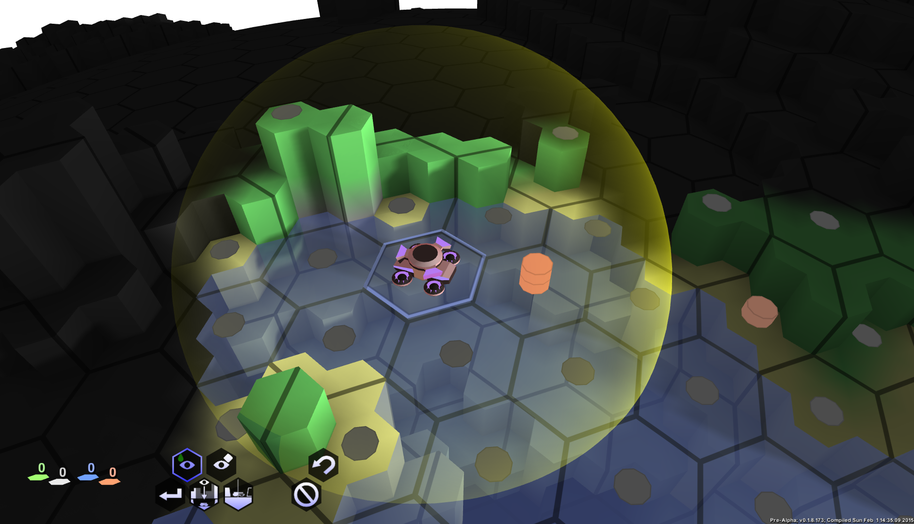

Terraformer (Hoverformer)
Used to terraform the terrain, as well as construct structures. Has a storage capacity of at most 200 units of minerals. Your first terraformer is given a full storage; any subsequently constructed terraformers start with empty storage. Terraformers can build foundations, roads, remove or deposit earth, dig tunnels, and build every type of structure available.

Artillery (Hovertank)
Offensive/defensive vehicle. Great armor, sensor, and firing range. Technically too heavy for the hover platform. Significantly slower than your other vehicles therefore. Most effective when stationary.
Hovertank with an active attack target
This turret type can also be mounted onto towers.

Menu
In the bottom section of the game window all currently available commands are shown as hexagonal icon buttons. This list will be affected by the selected object, and its respective state. Commands in white can be executed or enabled by clicking on them. Blue commands are permanently enabled, and may allow disabling the respective function by clicking on them again (some cannot be deactivated). Grayed out/semitransparent commands can currently not be activated.
All commands currently available to a hoverformer.
The five commands at the left edge of the image above are always available:
Show Resources

Toggles resource view.
Resources are shown as vertical bars atop the terrain, in turquoise (fuel) and gray/orange(minerals). These resources indicate the availability in the core. Vertically invariant; doesn't change regardless of what height level you are currently viewing. 5 Units of the respective resource are provided per vertical bar.

Hide Objects
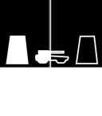
Toggles object hiding. Once enabled neither vehicles nor structures are displayed.

Clip Terrain
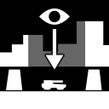
Hides terrain above the selected height level, centered on the currently selected vehicle/structure, or camera focus point if nothing is selected. This mode usually auto-enables/disables where necessary. Page-up/-down can be used to manually alter the clipping-height.
End Round

Signals the server that you wish to end the round. Once all players have issued this command, rounds progress. Currently no round timer is used, and players may use as much time as they require.

Depending on the chosen object, different commands will be visible. All vehicles, as well as towers, have the 'Abort' command, to completely clear the command queue, as well as the 'Undo' command, to remove only the last command.

Terraformer:
Dig Horizontally
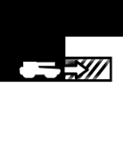
Specify a neighboring target cell to dig into. Moves the vehicle there when done.

Clear Above
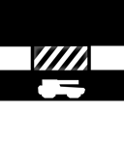
Specify a single cell directly above the vehicle, or an immediate neighbor of that cell, to clear.

Dig Down
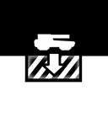
Clears the cell directly beneath the vehicle, and moves there when done.

Build Foundation
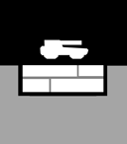
Builds a structure foundation beneath the current vehicle location. Usually unnecessary to do explicitly, since automatically queued where needed.

Build Road
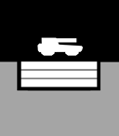
Builds a road beneath the current vehicle location. Roads allow faster travel similar to foundations, but are much cheaper.

Withdraw Resources
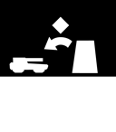
Withdraws as many units of minerals as possible from a nearby structure's compound or vehicle.

Deposit Resources
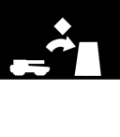
Deposits as many units of minerals as possible into a nearby structure's compound or vehicle.

Build Blocks
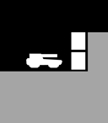
Allows to specify a set of nearby empty blocks to fill. Use 'Commit' to finish selection.

Remove Blocks
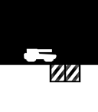
Allows to specify a set of nearby blocks to clear. Use 'Commit' to finish selection.

Commit

Use this command to finish 'Build Blocks' or 'Remove Blocks'.

Build Connectors to
Specify a target to build a string of connectors to. Automatically determines the best route. Minerals are needed per connector and per missing earth block underneath. No digging is performed.

Build Road to

Specify a target to build a road to. Automatically determines the best route. Minerals are needed per cell to build road elements. No digging is performed.

Dig Tunnel to
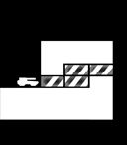
Specify a target to dig a tunnel to. Automatically determines the best route, including staircases to move both directions through the new tunnel.

Build [structure]
Starts construction of the specified structure at the current vehicle location. Attempts to fix local issues automatically, such as buildings foundations, digging down, or clearing the area.

Artillery/Armored
Withdraw Munitions
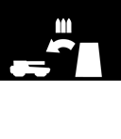
Withdraws as many units of munitions as possible from a nearby structure's compound or vehicle.

Deposit Munitions
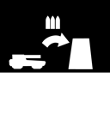
Deposits as many units of munitions as possible into a nearby structure's compound or vehicle.

Artillery & Towers
Attack
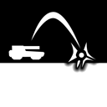
Enters attack mode. Click at any location on the map to attack there next. Red markers indicate the maximum firing range.

