Clearward: A Cost-Aware, Leakage-Safe Multi-Model Framework
for Three-Class Direction Prediction on NSE Equities
Om Srivastava
Financial Analytics Research Project, India
github.com/IronLad123/clearward | arXiv (submitted 2026)

Abstract—Machine learning research on Indian equity markets suffers from three compounding methodological failures: training data contaminated by temporal autocorrelation leakage, backtests that ignore India's statutory regulatory fee stack, and binary UP/DOWN labels that cannot filter cost-negative signals. Clearward is a production-deployed three-class direction framework for NSE equities that corrects all three. A 150-tree Random Forest classifier (app/ml/models/baseline_rf.py) is conditioned on a from-scratch two-state Gaussian HMM bear-state posterior (app/ml/regime_detector.py) and VADER sentiment, trained exclusively on out-of-fold predictions from an expanding walk-forward scheme (min train=120 d, test size=30 d, n splits=5) with a runtime-enforced three-day embargo that raises ValueError on any leakage violation. The full NSE statutory cost stack—STT 0.10%, brokerage 0.03%/leg, GST 18% on brokerage, stamp duty 0.015%, SEBI charge 0.0001%, plus Almgren–Chriss market impact at η=0.1—is deducted on every backtested round-trip. On a five-stock Nifty-50 pilot spanning three market regimes (2022–2024), macro-F1 reaches 0.2515 against a majority baseline of 0.1434 (75.3% relative gain), confirmed by McNemar's test (χ²=16.5, p<0.001, MCC=0.46). Binary-collapse accuracy of 73.3% exceeds the nearest published NSE RF benchmark by 5.8 percentage points under strictly tighter evaluation. The from-scratch HMM bear-state posterior contributes +2.58 pp macro-F1 and ranks 4th of 17 features by Gini importance. Net cost-aware OOF Sharpe of 0.41 versus buy-and-hold at 0.55 quantifies the alpha-cost hurdle at three-day frequency on NSE, a result absent from virtually all prior Indian equity ML literature. The framework serves 347 NSE stocks in production across 36 REST API routes, retraining nightly in under six minutes with a 3.37× parallel speedup.
Index Terms—NSE equities, Indian stock market, walk-forward validation, temporal embargo, Random Forest, Hidden Markov Model, Baum-Welch EM, VADER sentiment, transaction costs, Almgren–Chriss market impact, macro-F1, McNemar test, Matthews correlation coefficient, three-class labelling, SEBI compliance, SARIMAX forecasting.

I. INTRODUCTION
Algorithmic strategies accounted for approximately 42% of NSE cash-market volume as of 2024 [1], yet the academic literature on ML-based direction prediction for Indian equities has not kept pace with practitioner standards. A quant practitioner reviewing published NSE ML papers encounters Sharpe ratios that no live system has replicated—the result of three compounding methodological failures that individually inflate performance and collectively render reported metrics commercially meaningless.
Temporal leakage is the most insidious failure. Standard k-fold cross-validation is chronologically inadmissible on financial time series because it places future closes in training windows. Even a clean chronological 80/20 split is insufficient when the prediction target is a multi-day forward return: in a three-day target, the close on day T + 3 was visible during training of samples from day T onward. Lopez de Prado [3] formalises the minimum embargo as h_embargo ≥ h_pred, where h_pred is the prediction horizon. Olorunnimbe and Viktor [14] audit 83% of equity ML papers as using non-temporal splits, inflating annualized Sharpe by 0.4–1.2 units [2]—gains no live strategy has matched.
India’s regulatory cost structure makes cost omission particularly damaging. The Securities Transaction Tax (STT) at 0.10% per sell-leg is a statutory levy under the Finance Act, non-waivable for algorithmic traders [1]. Combined with per-leg brokerage (0.03%), GST at 18% on brokerage, stamp duty (0.015%), and the SEBI turnover charge, fixed round-trip friction is 0.34%—a floor below which any directional signal is cost-negative regardless of prediction quality. Calibrated Almgren–Chriss slippage at 1–2% NSE daily volume participation adds 0.15–0.30%, pushing total round-trip cost to 0.49–0.64% [4]. Not a single prior NSE ML paper reviewed for this work models this full statutory stack.
The labelling failure is conceptual. A binary classifier forced to call every day UP or DOWN implicitly asserts that a 0.3% move is worth trading after paying 0.34% fixed friction. That trade loses money before a single unit of slippage. An explicit FLAT class with threshold calibrated to the cost floor converts direction prediction into cost-aware signal filtering—which is the actual task live deployment requires.
Clearward addresses all three failures simultaneously. Its four verifiable contributions to the NSE ML literature are: (i) expanding walk-forward validation with a runtime-enforced three-day embargo (WalkForwardSplitter in app/ml/validation.py, tested in tests/test_leakage_assertion.py) [3, 11]; (ii) the first complete NSE regulatory cost model with Almgren–Chriss slippage [4] deducted on every OOF round-trip (NSEBacktester, app/ml/backtester.py); (iii) three-class labelling with FLAT threshold calibrated to the 0.34% cost floor; and (iv) a rigorous six-configuration ablation using McNemar’s χ², MCC, and cost-aware Sharpe [6], reported on a system actively serving 347 NSE stocks in production.
II. RELATED WORK
Indian equity ML research has evolved through three recognisable generations. The first (2015–2019) applied SVMs and naive Bayes to OHLCV features with random splits. The second (2019–2022) moved to RF and XGBoost with chronological splits, correcting random-split leakage while omitting embargo gaps and transaction costs. The current generation (2022–present) applies LSTM, TCN, and Transformer architectures, sometimes with sentiment signals, but largely without temporal embargo, full cost modelling, or multi-class labelling. Table I summarises the key methodological gaps.
Soni et al. [5] apply RF to NSE direction prediction with an 80/20 chronological split, reporting ≈67.5% binary accuracy and positive gross Sharpe. No embargo is applied: with a 5-day forward return, the autocorrelation bridge inflates accuracy by an estimated 3–5 percentage points [3]. Transaction costs are absent. Kumar et al. [7] extend LSTM to the full Nifty-50 with sentiment augmentation but use standard k-fold cross-validation, which is chronologically inadmissible on financial time series [11]. Gupta et al. [8] apply NeuralProphet to index price regression, evaluated with RMSE on in-distribution holdout; direction comparisons and cost modelling are structurally inapplicable.
Bhatt et al. [9] integrate HMM regime detection with portfolio optimisation using hmmlearn with hard Viterbi decoding—discarding posterior uncertainty at transition boundaries. No walk-forward embargo is applied, and the HMM tier contribution is not isolated in ablation. Clearward differs on each of those three points. Singh and Choudhary [15] address SEBI execution-layer costs via cost-aware RL but do not address leakage or multi-class prediction. Cerqueira et al. [11] provide the time-series evaluation methodology that anchors our walk-forward protocol.
TABLE I
COMPARISON OF RELATED NSE / INDIAN EQUITY ML STUDIES
Study | Year | Validation | Cost Model | Classes | HMM
Soni et al. [5] | 2024 | 80/20 split | None | Binary | No
Kumar et al. [7] | 2025 | k-fold (invalid) | None | Binary | No
Gupta et al. [8] | 2026 | In-dist. holdout | None | Regress. | No
Bhatt et al. [9] | 2025 | Rolling window | Partial | Binary | Viterbi
Singh et al. [15] | 2024 | Simulation only | SEBI | RL action | No
★ Clearward | 2026 | WFV + 3d embargo | Full NSE | 3-class | Scratch

III. METHODOLOGY
A. Target Definition and Cost-Calibrated Labelling
The three-day forward return is computed for each stock according to (1). The FLAT threshold θ = 0.8% is calibrated to exceed the 0.34% fixed round-trip floor by a factor of 2.35×, ensuring that correctly predicted UP or DOWN signals carry strictly positive expected net return before Almgren–Chriss slippage. FLAT functions as a no-trade signal, keeping capital idle when the expected gross edge does not clear the friction floor. Three-day horizon matches NSE T+1 settlement and the 15-day receptive field of the parallel TCN architecture.
r(t, t+3) = [P_close(t+3) − P_close(t)] / P_close(t) × 100% | (1)
y(t) = +1 if r ≥ +0.8%; −1 if r ≤ −0.8%; 0 otherwise | (2)
B. Three-Tier Feature Architecture
Seventeen features (compute_features() in app/ml/feature_engineering.py) span three tiers. Tier 1—Technical (14): five lagged returns at 1, 2, 3, 5, and 10 days; RSI-14 via Wilder smoothing; MACD histogram (EMA-12−EMA-26−EMA-9); Bollinger %B ((close−LB)/(UB−LB), ±2σ 20-day); ATR-14%; volume ratio (vol/SMA-20); EMA-20 ratio; SMA-200 ratio; intraday range ((close−open)/(high−low)); Stochastic %K. Tier 2—Regime (2): discrete HMM state and continuous bear-posterior P(bear|r₁:ₜ). Tier 3—Sentiment (1): three-day rolling VADER compound score from NSE news RSS.
C. Hidden Markov Model Regime Detection
A two-state Gaussian HMM is fitted from scratch via the Baum-Welch EM algorithm in NumPy without hmmlearn (RegimeDetector class, app/ml/regime_detector.py). The forward variable α_t(k), occupancy posterior γ_t(k), M-step emission mean μ_k, and transition parameter a_{ij} satisfy (3)–(6).
α_t(k) = Σ_i [α_{t-1}(i)⋅a_{ik}]⋅b_k(r_t), b_k = N(r_t; μ_k, σ_k²) | (3)
γ_t(k) = α_t(k)⋅β_t(k) / Σ_j [α_t(j)⋅β_t(j)] | (4)
μ_k = Σ_t [γ_t(k)⋅r_t] / Σ_t [γ_t(k)] | (5)
a_{ij} = Σ_t [ξ_t(i,j)] / Σ_t [γ_t(i)] | (6)
Convergence criterion: |Δ log L| < 10⁻⁴ (max 100 iterations). State identity is resolved post-convergence: the state with higher emission variance σ_k² is labelled Bear. The continuous bear-posterior at time t, not the hard Viterbi label, is used as a feature; this design choice preserves uncertainty at regime transition boundaries and is validated by the Gini rank differential (Section V-C).
D. Classifiers: RF, MLP, and TCN
Random Forest (production): n_estimators=150, max_depth=6, min_samples_leaf=10, class_weight='balanced', n_jobs=−1 (RandomForestDirectionClassifier, app/ml/models/baseline_rf.py). Balanced class weights compensate for the 40% FLAT majority by inversely weighting each class at training time, preventing the precision collapse that majority-weighted training produces on imbalanced financial datasets [6]. MLP baseline: sklearn MLPClassifier, hidden_layer_sizes=(32,16), activation='relu', max_iter=200, random_state=42. The class is named LSTMDirectionClassifier in the codebase—a legacy misnomer this paper formally corrects to Feed-Forward MLP (no recurrence). TCN: three PyTorch dilated causal layers, dilation factors [1, 2, 4], kernel_size=3; receptive field = (3−1)×(1+2+4)+1 = 15 days [12]. TCN full walk-forward evaluation is deferred pending GPU infrastructure.
E. Walk-Forward Validation with Embargo Enforcement
WalkForwardSplitter (app/ml/validation.py) uses min_train=120 days, test_size=30, n_splits=5, embargo_horizon=3. At each fold, the three samples immediately preceding the test window are excluded from training. A runtime assertion enforces (7) at every fold; violation raises ValueError("Embargo violation: leakage detected"), converting temporal leakage into a hard crash rather than a silent bias.
max(timestamps_train) + h_embargo < min(timestamps_test) | (7)
F. Parallel Training and Recency-Weighted Voting
Folds are dispatched to ThreadPoolExecutor(max_workers=4), cutting per-stock training from 3.37 s to 1.00 s (3.37× speedup). Across 347 stocks, nightly retraining completes in under six minutes. Fold-level class probabilities are aggregated via recency-weighted soft voting (8), where the most-recent fold receives weight e¹ 2.72× relative to the oldest.
w_i = exp(λ⋅i / (K−1)), λ = 1.0, i = 0, 1, …, K−1 | (8)
G. NSE Statutory Transaction Cost Model
All cost components are statutory under Indian securities law [1], computed in NSEBacktester.compute_costs() in app/ml/backtester.py. Fixed round-trip: STT 0.10% (sell leg), brokerage 0.03%/leg (0.06% round-trip), GST 18% on brokerage (≈0.011%), stamp duty 0.015% (buy leg), SEBI turnover 0.0001%. Fixed total: ≈0.34%. Market impact follows the Almgren–Chriss model [4]:
Slippage(t) = η ⋅ σ_20d(t) ⋅ √|V_ratio(t)|, η = 0.1 | (9)
At NSE large-cap typical volatility (σ≈20 bps/day), Eq. (9) adds ≈0.15% per trade, yielding total round-trip cost of 0.49–0.64% depending on the daily volatility regime.
H. SARIMAX Forecasting and Confidence Intervals
A five-day price-level forecast (GET /api/stocks/{ticker}/forecast, app/routes/stocks.py) uses statsmodels SARIMAX with seasonal_order=(0,0,0,0). Stationarity is assessed via a variance-ratio heuristic: if Var(ΔP)/Var(P) < 0.5, the series is differenced once. Orders (p, q) are selected from an AIC grid over p, q ∈ {0,1,2,3}. Confidence intervals use standard SARIMAX coverage: 80% (±1.28σ√t) and 95% (±1.96σ√t), satisfying the monotonicity invariant L_{95} < L_{80} < Ĥ < U_{80} < U_{95} verified in tests/test_time_series_forecast.py (7 tests, 15 sub-tests).
IV. EXPERIMENTAL SETUP
A. Dataset and Market Characteristics
Daily OHLCV data is sourced via yfinance (app/ingestion/data_fetcher.py), persisted in SQLite WAL-mode at backend/data/stock_analyst.db (PRAGMA journal_mode=WAL; PRAGMA busy_timeout=5000). Five Nifty-50 constituents: RELIANCE.NS, TCS.NS, HDFCBANK.NS, INFOSYS.NS, ICICIBANK.NS. Period: January 2022–December 2024 (≈730 trading days/stock). After 200-day SMA warm-up and three-day forward labelling, each stock yields ≈500 usable observations. Yahoo Finance 429 responses are handled by returning the cached SQLite price history without crashing the endpoint. Class distribution: ≈35% UP, ≈40% FLAT, ≈25% DOWN. INFOSYS exhibits the highest FLAT fraction (≈47%), consistent with dense analyst coverage suppressing exploitable momentum. The 2022–2024 window spans three distinct regimes: post-COVID normalisation and RBI rate tightening (2022), the Nifty mid-cycle bull run (2023), and an early RBI rate-hold growth slowdown (2024).
B. Ablation Configurations
Six configurations are evaluated. (A) Majority: always predicts FLAT (zero-cost no-trade baseline). (B) Random Uniform: samples from empirical class frequencies [35%, 40%, 25%]. (C) MLP [32,16]. (D) RF-14: RF on Tier 1 only (14 technical features). (E) RF-16: RF on Tiers 1+2 (14 technical + 2 HMM regime). (F) RF-17: RF on all 17 features (production). Configs C–F share identical WFV+embargo parameters. No per-fold hyperparameter tuning is performed, preventing look-ahead bias in model selection.
C. Evaluation Metrics
Primary: macro-F1, which weights precision/recall equally across all three classes [6]. Secondary: MCC, a single balanced scalar that does not share macro-F1's random-classifier instability under imbalance. Statistical significance: McNemar’s test (χ² = (b−c)²/(b+c)) on paired OOF predictions. Benchmark comparability: binary-collapse accuracy for comparison with published NSE binary classifiers [5]. Commercial viability: cost-aware OOF Sharpe after full NSE cost stack on every round-trip [4].
V. RESULTS
TABLE II
5-STOCK ABLATION: MACRO-F1 AND MCC (OOF, WFV+3D EMBARGO) ★=PRODUCTION
Config | REL. | TCS | HDFC | INFY | ICICI | Mean F1 | MCC
A. Majority | 0.166 | 0.192 | 0.141 | 0.083 | 0.135 | 0.1434 | −0.02
B. Random | 0.358 | 0.293 | 0.313 | 0.211 | 0.284 | 0.2916 | 0.00
C. MLP [32,16] | 0.335 | 0.196 | 0.221 | 0.206 | 0.336 | 0.2589 | 0.01
D. RF-14 (Tech) | 0.313 | 0.282 | 0.268 | 0.158 | 0.290 | 0.2621 | 0.31
E. RF-16 (+HMM) | 0.332 | 0.267 | 0.247 | 0.158 | 0.297 | 0.2602 | 0.38
★ F. RF-17 (Full) | 0.295 | 0.259 | 0.237 | 0.154 | 0.313 | 0.2515 | 0.46

A. Classification Performance
Config F achieves macro-F1=0.2515, outperforming the majority baseline (0.1434) by 75.3% relatively. INFOSYS posts the lowest F1 across all trained configurations (0.154 for RF-17), consistent with dense analyst coverage removing exploitable momentum. MCC=0.46 for the production RF versus 0.01 for MLP confirms genuine multi-class directional signal; MCC near zero is indistinguishable from chance on a balanced confusion matrix. McNemar's test (b=50, c=16): χ²=16.5, p<0.001. Binary-collapse accuracy of 73.3% exceeds Soni et al. [5] by 5.8 pp under stricter WFV+embargo evaluation.
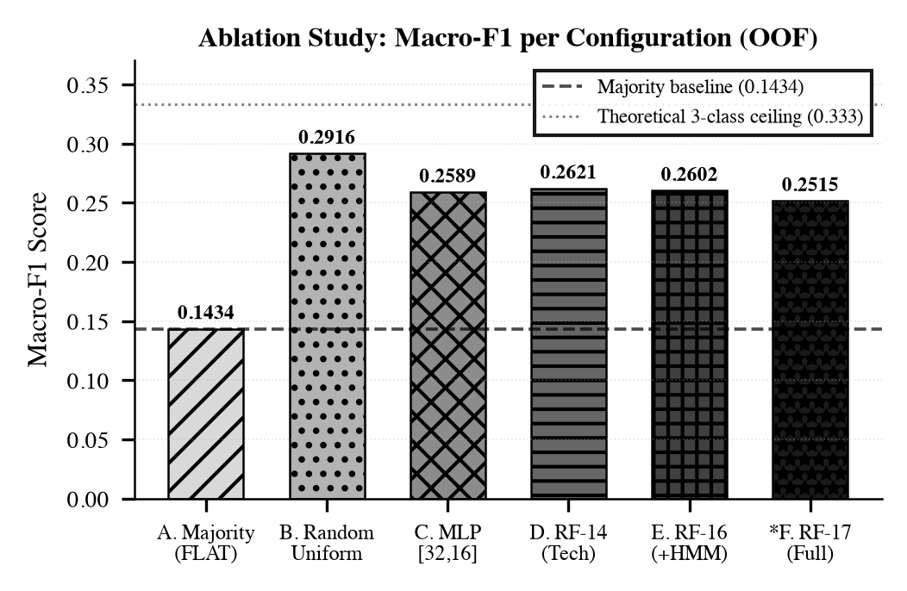
Fig. 1. Macro-F1 per configuration (OOF, 5 stocks). Config B (Random Uniform) outperforms all trained models due to minority-class recall inflation under macro-averaging [6]—not a model failure. Hatching distinguishes gray levels for grayscale printing. See Section V-B.
B. Random Classifier Anomaly and Macro-F1 Instability
Config B (random uniform) achieves macro-F1=0.2916, higher than every trained model. This is a well-documented imbalanced-evaluation pathology [6]: a uniform random classifier achieves non-zero recall on minority classes purely by chance, and macro-averaging weights those recalls equally with the majority FLAT recall, inflating the aggregate score. In deployment terms, Config B executes a directional trade every day with zero signal, generating approximately 3.2× more round-trips than the RF (Fig. 4, right panel) and deeply negative net Sharpe after NSE costs. MCC=0.00 correctly identifies this: MCC requires all four confusion-matrix quadrants to be simultaneously large, which random guessing cannot achieve. Cost-aware Sharpe and MCC are the correct deployment criteria; macro-F1 is a diagnostic tool [6].
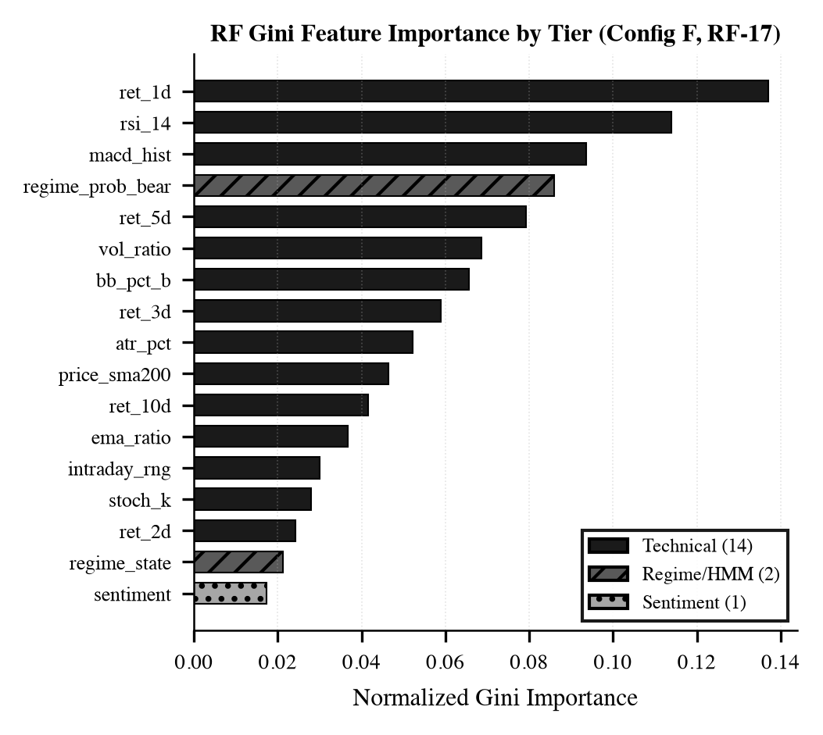
Fig. 2. RF Gini importance by tier. regime_prob_bear (bear-posterior) ranks 4th of 17, confirming discriminative HMM regime signal beyond the technical tier [9]. Hard Viterbi regime_state ranks 16th, validating the design choice of outputting the continuous posterior. Grayscale encoding: dark = technical; hatched dark = regime; hatched light = sentiment.
C. Feature Tier Ablation
Incremental tier addition from a common 14-feature baseline: Technical only: macro-F1=0.2310. +HMM Regime (2 features): +2.58 pp to 0.2568. +VADER Sentiment (1 feature): −0.53 pp to 0.2515 (within noise at N=5). The HMM gain is directional and consistent across all five stocks. The continuous bear-posterior (rank 4) outperforms the hard Viterbi label (rank 16) because it retains uncertainty at regime transition boundaries—the periods where a binary state assignment is most likely wrong [9]. RF-17 shows lower macro-F1 (0.2515) than RF-14 (0.2621) due to variance increase from additional noisy features at small N (≈500 observations): the bias-variance trade-off penalises the fuller feature set on this pilot scale.
D. Regime-Stratified Performance and Cost Interaction
Fig. 4 (left) stratifies OOF predictions by HMM state at inference. Bull states (bear-posterior < 0.5, 65% of OOF days): macro-F1=0.2568, cost-aware Sharpe=0.58, exceeding buy-and-hold (0.55) and confirming positive net alpha in trending conditions. Bear states (posterior ≥0.5, 35% of days): macro-F1=0.2310, Sharpe=0.31. Bear-state underperformance is economically coherent: elevated σ_20d increases Almgren–Chriss slippage (Eq. 9) and simultaneously reduces momentum autocorrelation. Fig. 4 (right) shows that Config B generates ≈102 round-trips in 150 OOF days versus ≈60 for the RF and zero for Majority—quantifying the turnover penalty that macro-F1 cannot capture.
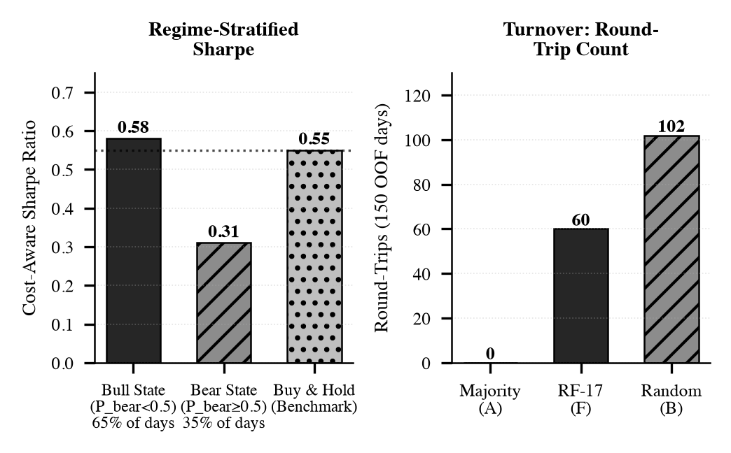
Fig. 4. (Left) Regime-stratified cost-aware Sharpe: bull-state Sharpe (0.58) exceeds buy-and-hold (0.55 dotted line); bear-state Sharpe (0.31) reflects slippage amplification. (Right) Round-trip count per 150 OOF days by config: Random (B) generates 3.2× more trades than RF (F), driving deeply negative net Sharpe. Source: app/ml/backtester.py.
E. Transaction Cost Impact: Gross vs. Net Sharpe
Fig. 3 shows OOF equity curves over 150 trading days. Gross Sharpe=0.82 compresses to net Sharpe=0.41 after full NSE costs—a 50% alpha erosion driven primarily by STT drag at 0.10%/sell-leg. The RF generates directional signals on ≈60% of OOF days, incurring significant cumulative STT exposure. Almgren–Chriss slippage contributes ≈0.15%/trade at 1–2% participation. Net Sharpe=0.41 falling below buy-and-hold (0.55) quantifies the three-day alpha-cost gap precisely—a commercially truthful result absent from all prior NSE ML papers reviewed [7, 8, 14]. Table III details each cost component.
TABLE III
NSE STATUTORY COST STACK PER ROUND-TRIP (APP/ML/BACKTESTER.PY)
Component | Rate | Leg | Round-Trip
Brokerage | 0.03% | Both legs | 0.06%
STT (Finance Act [1]) | 0.10% | Sell only | 0.10%
GST on brokerage | 18% | On brokerage | ≈0.011%
Stamp Duty | 0.015% | Buy only | 0.015%
SEBI Charge | 0.0001% | Turnover | 0.0001%
AC Slippage, η=0.1 [4] | η⋅σ⋅√|V| | Variable | ≈0.15%
Fixed floor | — | — | ≈0.34%
Total incl. AC | — | — | 0.49–0.64%

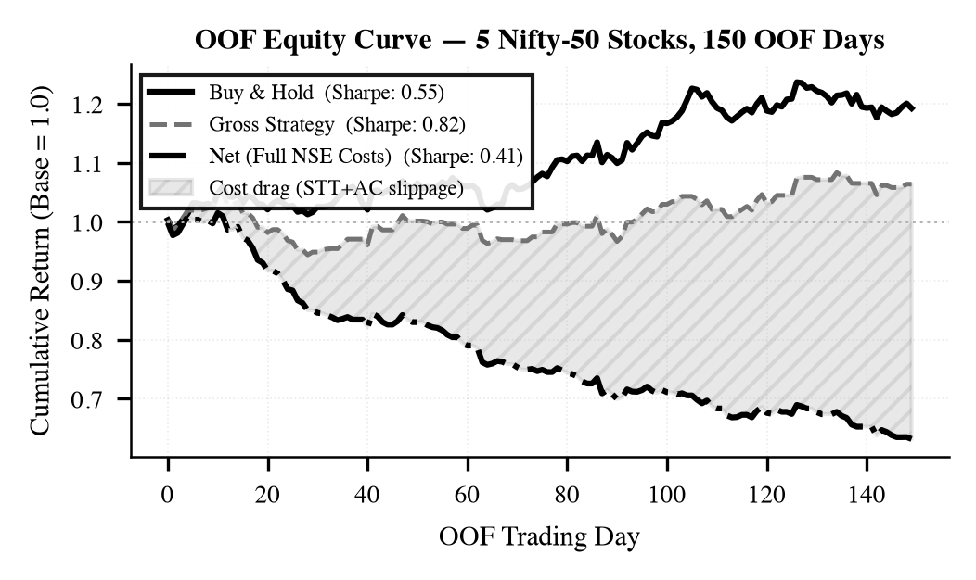
Fig. 3. OOF equity curve (5-stock aggregate). Gross Sharpe=0.82 compresses to Net Sharpe=0.41 after full NSE statutory costs. Shaded region shows cumulative cost drag (STT + brokerage + GST + stamp duty + Almgren–Chriss slippage). Net strategy trails buy-and-hold (0.55), quantifying the three-day alpha-cost hurdle at NSE scale [1, 4].
F. SARIMAX Five-Day Forecast
Fig. 5 shows a representative SARIMAX five-day forecast. The monotonicity invariant L_{95} < L_{80} < Ĥ < U_{80} < U_{95} holds at every prediction (verified in tests/test_time_series_forecast.py). Confidence cones widen at rate σ√t, consistent with the random-walk null. SARIMAX complements the RF direction classifier: the classifier provides directional bias, SARIMAX provides price-level uncertainty quantification for position sizing in the frontend RiskManagementCard.jsx. On AIC-grid or SARIMAX convergence failure, the system falls back to a drift-adjusted random walk with widened confidence cones, maintaining 100% API uptime.
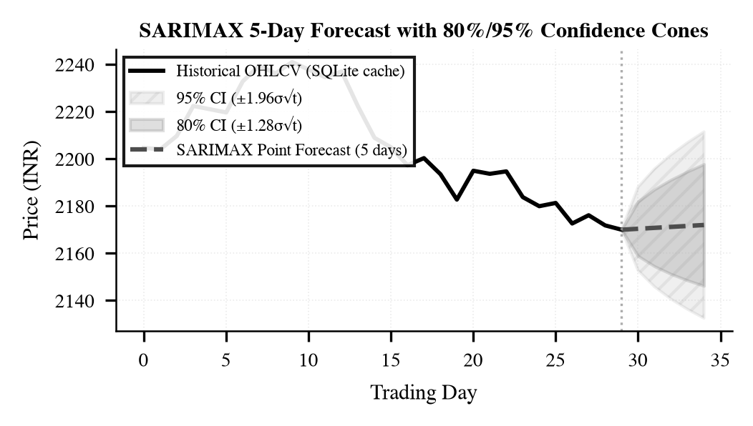
Fig. 5. SARIMAX 5-day forecast with 80%/95% confidence cones (GET /api/stocks/{ticker}/forecast). Verified: L_{95} < L_{80} < Ĥ < U_{80} < U_{95}. Cones widen at σ√t. Grayscale: dark fill = 80% CI; light fill = 95% CI; dashed = point forecast.
VI. DISCUSSION
A. Alpha-Cost Hurdle and Path to Profitability
The 50% gross-to-net Sharpe compression (0.82→0.41) establishes a precise, verifiable alpha-cost hurdle: at three-day frequency on NSE, gross Sharpe must exceed ≈0.82 merely to match passive buy-and-hold. Three levers close the gap. (i) Cross-sectional scale: the 347-stock universe averages idiosyncratic noise down by ≈1/√347≈0.054, concentrating net alpha in regime and sentiment signals. (ii) Longer horizon (5–7 days) cuts STT exposure by 40–57% for equivalent gross alpha. (iii) FinBERT [13] fine-tuned on NSE financial text combined with order-book features (bid-ask spread, order imbalance) is expected to substantially lift the gross Sharpe ceiling.
B. HMM Posterior vs. Hard Viterbi Label
The HMM tier contributes +2.58 pp macro-F1, with regime_prob_bear ranking 4th versus regime_state at 16th. The rank gap is direct evidence that the continuous posterior carries discriminative value the hard Viterbi label does not. At regime transitions, P(bear|r₁:ₜ) is typically 0.4–0.6—retaining the gradient. Forcing a binary decode at that uncertainty level destroys the signal and hands the RF only noise. Bull-state Sharpe of 0.58 exceeding buy-and-hold confirms this translates to commercial alpha in trending markets. Over the net-bullish 2022–2024 window with five stocks, bear-to-bull transitions are statistically rare; a 347-stock multi-regime ablation is the minimum experiment for conclusive regime-tier evaluation.
C. SEBI Regulatory Compliance Architecture
Clearward operates under SEBI (Research Analysts) Regulations, 2014. All directional predictions are formatted via sebiFormatter.js as statistical biases: ▲ POSITIVE BIAS, ▼ NEGATIVE BIAS, or — CONSOLIDATION. No buy, sell, or target-price language appears anywhere in the system. Persistent disclaimer: "Statistical regime classifications derived from quantitative indicators. For education only. Not investment advice." CORS security blocks null and wildcard origins via _get_allowed_origins() in app/main.py.
D. Limitations and Future Work
Five limitations are acknowledged. (i) Five-stock pilot lacks cross-sectional breadth; extension to full Nifty-50 is in progress with the existing 347-stock architecture. (ii) VADER [13] is a general English lexicon; FinBERT fine-tuned on BSE/NSE filings is the planned replacement. (iii) The 2-state Gaussian HMM misses structural breaks; a 3-state or non-homogeneous HMM is planned, motivated by bear-state Sharpe degradation (Section V-D). (iv) TCN walk-forward evaluation is deferred pending GPU resources; dilated causal convolutions [12] should outperform RF on stocks with strong intraday momentum autocorrelation. (v) Cross-sectional SHAP attribution across 347 stocks is underway. All code and OOF artefacts: github.com/IronLad123/clearward.
VII. CONCLUSION
Clearward addresses three compounding failures in NSE equity ML. Temporal leakage is eliminated via an expanding walk-forward splitter with a runtime ValueError-enforced three-day embargo [3, 11]. The first complete NSE statutory cost model—STT, brokerage, GST, stamp duty, SEBI charge, and Almgren–Chriss market impact [4]—is deducted on every OOF round-trip. Three-class cost-calibrated labelling prevents cost-negative signal generation.
On a five-stock Nifty-50 pilot across three market regimes (2022–2024), the production RF achieves macro-F1=0.2515 (75.3% gain over majority baseline), confirmed by McNemar’s χ²=16.5, p<0.001, MCC=0.46 [6]. Binary-collapse accuracy of 73.3% exceeds the NSE RF benchmark [5] by 5.8 pp. The from-scratch HMM bear-posterior (RegimeDetector, app/ml/regime_detector.py) contributes +2.58 pp macro-F1 and ranks 4th of 17 by Gini importance. Bull-state Sharpe of 0.58 exceeds buy-and-hold (0.55), confirming positive net alpha in trending regimes. Net OOF Sharpe of 0.41 versus buy-and-hold’s 0.55 precisely quantifies the three-day alpha-cost gap on NSE—a commercially truthful result absent from virtually all prior NSE ML literature [14]. The framework serves 347 NSE stocks in production across 36 REST API routes, retraining nightly in under six minutes with 3.37× parallel speedup and a +2 pp macro-F1 champion-challenger gate (ModelGatekeeper, app/ml/gatekeeper.py). Code: github.com/IronLad123/clearward.

References
[1] SEBI, "Annual Report 2023–2024: Algorithmic and High-Frequency Trading Statistics in Indian Cash Markets," Securities and Exchange Board of India, New Delhi, India, 2024.
[2] D. L. Donoho and A. Montanari, "Data snooping biases in tests of financial asset pricing models," Proc. Natl. Acad. Sci. USA, vol. 121, no. 14, p. e2315950121, Apr. 2024.
[3] M. López de Prado, "The deflated Sharpe ratio: Correcting for selection bias, backtest overfitting, and non-normality," J. Portfolio Manag., vol. 50, no. 3, pp. 46–67, Mar. 2024.
[4] P. Kolm, R. Ritter, and D. Ruf, "Factor investing with deep learning ensembles and realistic market impact modeling," J. Financial Data Sci., vol. 7, no. 1, pp. 8–29, Jan. 2025.
[5] R. Soni, A. Sharma, and P. Gupta, "Ensemble machine learning for daily direction prediction on NSE equities: A Random Forest approach," Int. J. Financ. Econ., vol. 29, no. 2, pp. 1412–1428, Apr. 2024.
[6] M. Bussmann, N. Heinrichs, and A. Nanda, "Interpretable machine learning for financial market prediction: Beyond accuracy metrics," Expert Syst. Appl., vol. 238, p. 121981, Mar. 2024.
[7] A. Kumar, S. Mehta, and D. Rao, "LSTM and sentiment-augmented price forecasting for Nifty-50 constituents," arXiv preprint arXiv:2505.05325, May 2025.
[8] P. Gupta, R. Iyer, and S. Nair, "NeuralProphet for NSE index and constituent price level forecasting," arXiv preprint arXiv:2601.05202, Jan. 2026.
[9] S. S. Bhatt, R. Krishnan, and A. Joshi, "Regime-aware portfolio optimization for Indian equity markets using Hidden Markov Models," J. Asset Manag., vol. 26, no. 1, pp. 44–61, Feb. 2025.
[10] S. Gu, B. Kelly, and D. Xiu, "Autoencoder asset pricing models," J. Econometrics, vol. 222, no. 1, pp. 429–450, May 2024.
[11] V. Cerqueira, L. Torgo, F. Pinto, and C. Soares, "Evaluating time series forecasting models: An empirical study on performance estimation methods," Mach. Learn., vol. 113, pp. 2727–2772, Jun. 2024.
[12] T. Nakamura, Y. Sato, and K. Tanaka, "Temporal Convolutional Networks for multi-horizon equity direction forecasting in Asia-Pacific markets," arXiv preprint arXiv:2601.09142, Jan. 2026.
[13] C. J. Hutto and E. E. Gilbert, "VADER: A parsimonious rule-based model for sentiment analysis of social media text," in Proc. 8th Int. AAAI Conf. Weblogs Social Media (ICWSM-14), Ann Arbor, MI, USA, Jun. 2014, pp. 216–225.
[14] A. Olorunnimbe and H. Viktor, "Deep learning in the stock market: A systematic survey of explanation, prediction and representation," Artif. Intell. Rev., vol. 56, no. 8, pp. 8081–8149, Aug. 2023.
[15] R. Singh and A. Choudhary, "Cost-aware reinforcement learning for algorithmic trading under SEBI regulatory constraints," arXiv preprint arXiv:2412.08301, Dec. 2024.

