**Solid Modelling Assignment**

**Group – 13**

|  |  |  |  |
| --- | --- | --- | --- |
| **S.no** | **Roll No** | **Name** | **Email** |
|  | **B24147** | **Piyush Kanwat** | **[B24147@students.iitmandi.ac.in](mailto:B24147@students.iitmandi.ac.in)** |
|  | **B24148** | **Pranab Pandey** | **[B24148@students.iitmandi.ac.in](mailto:B24148@students.iitmandi.ac.in)** |
|  | **B24149** | **Priyanshu Saini** | **[B24149@students.iitmandi.ac.in](mailto:B24149@students.iitmandi.ac.in)** |
|  | **B24150** | **Puspender Yadav** | **[B24150@students.iitmandi.ac.in](mailto:B24150@students.iitmandi.ac.in)** |
|  | **B24151** | **Rishabh Bagul** | **[B24151@students.iitmandi.ac.in](mailto:B24151@students.iitmandi.ac.in)** |

**Components –**

|  |  |  |  |  |  |
| --- | --- | --- | --- | --- | --- |
| **S.no** | **Roll No** | **Component** | **Material** | **Weight** | **Online Link** |
|  | **B24150** | **Battery** | **Lithium-ion** | **400 grams** | [**https://robu.in/product/orange-2200mah-2s-30c-60c-lithium-polymer-battery-pack-lipo/**](https://robu.in/product/orange-2200mah-2s-30c-60c-lithium-polymer-battery-pack-lipo/) |
|  | **B24151** | **Servo Motor** | **Cover-Plastic**  **Core-Aluminium** | **60 grams** | [**https://robu.in/product/towerpro-sg90-9g-mini-servo-9-gram/**](https://robu.in/product/towerpro-sg90-9g-mini-servo-9-gram/) |
|  | **B24149** | **DC motor*4** | **Silicon Steel** | **720 grams** | [**https://www.meesho.com/illuminatorpack-of-2-bo-dual-shaft-smart-car-robot-gear-for-arduino-motor-control-electronic-hobby-kit/p/7axiqc**](https://www.meesho.com/illuminatorpack-of-2-bo-dual-shaft-smart-car-robot-gear-for-arduino-motor-control-electronic-hobby-kit/p/7axiqc) |
|  | **B24147** | **Tyre *4** | **Rubber and Plastic** | **140 grams** | [**https://robu.in/product/robot-smart-car-wheel-tyre-bo-motor/**](https://robu.in/product/robot-smart-car-wheel-tyre-bo-motor/) |
|  | **B24148** | **Support*4** | **steel** | **240**  **grams** | **Fabrication** |
|  | **B24148** | **Chassis*2** | **Acrylic** | **250 grams** | **Fabrication** |
|  | **B24148** | **Mount*3** | **Steel** | **45 grams** | **Fabrication** |
|  | **Imported** | **Motor driver** | **Silicon** | **40 grams** | [**https://robu.in/product/l298n-2a-based-motor-driver-module-good-quality/**](https://robu.in/product/l298n-2a-based-motor-driver-module-good-quality/) |
|  | **Imported** | **Microcontroller** | **Silicon** | **9 grams** | [**https://robu.in/product/nodemcu-esp8266-v3-lua-ch340-wifi-dev-board/**](https://robu.in/product/nodemcu-esp8266-v3-lua-ch340-wifi-dev-board/) |
|  | **Imported** | **Ultrasonic sensor*3** | **Silicon** | **30**  **grams** | [**https://robu.in/product/us-100-ultrasonic-sensor-distance-measuring-module-temperature-compensation/**](https://robu.in/product/us-100-ultrasonic-sensor-distance-measuring-module-temperature-compensation/) |

**Total Weight – 1874 grams**

**Height – 99.4mm**

**Length- 213.5mm**

**Breadth- 246.5mm**

**Assembly Drive Link:-** [**https://drive.google.com/drive/folders/1syyYUq5SBoRVJVzHa6mnH9kgTAKgLbty?usp=sharing**](https://drive.google.com/drive/folders/1syyYUq5SBoRVJVzHa6mnH9kgTAKgLbty?usp=sharing)

**Group Solid Model Assembly**

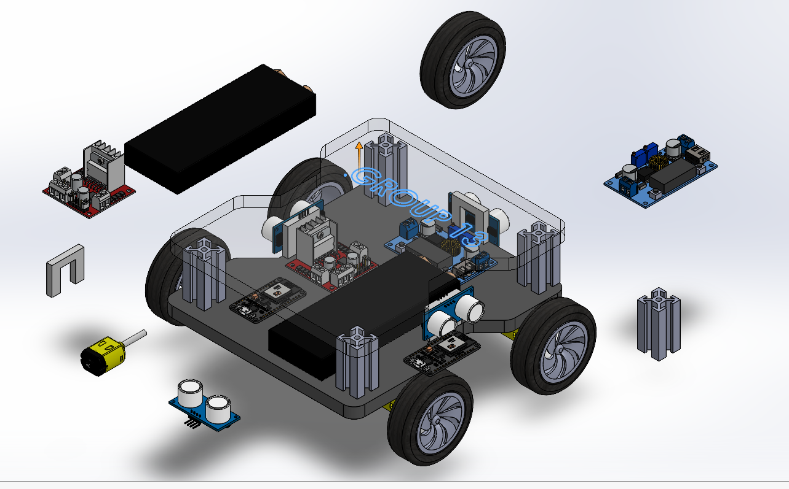

**Note: - Sir, The assembly is underdefined because we have allowed the rotation of the Tyres, for the assembly to be fully defined, we should lock the Tyres.**

**Group Solid Model Drawing**

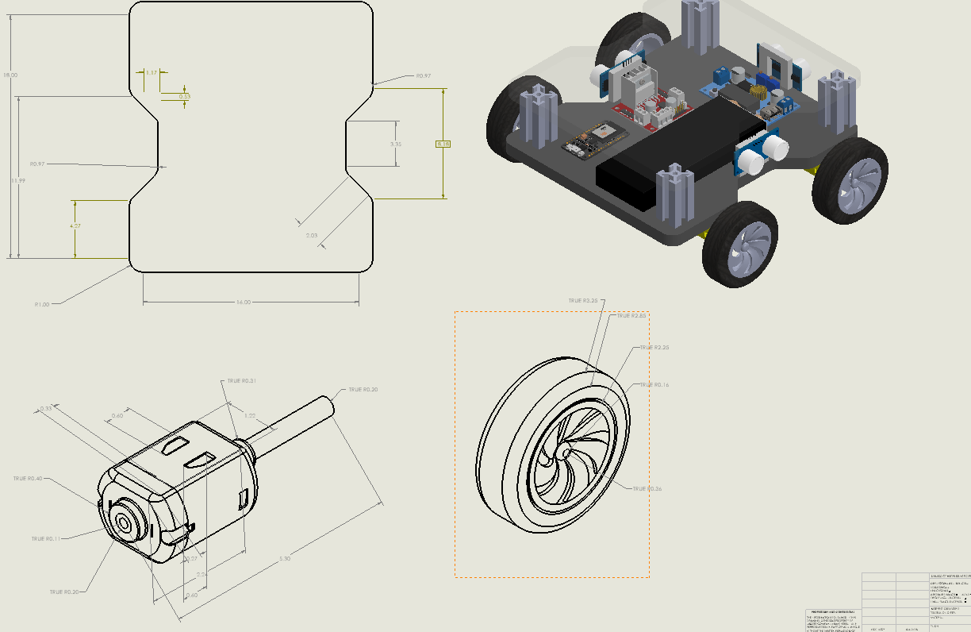

**Note—All dimensions in drawings are in cm.**

**Drawings of Parts:-**

**Battery--**

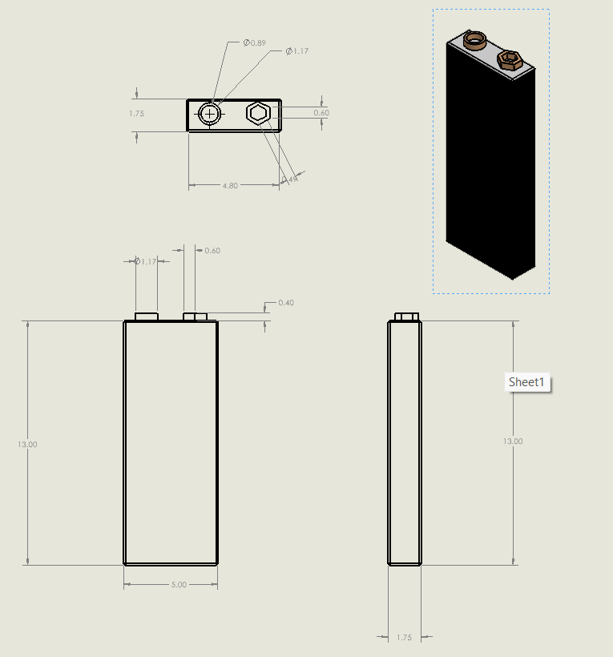

**Tyre--**

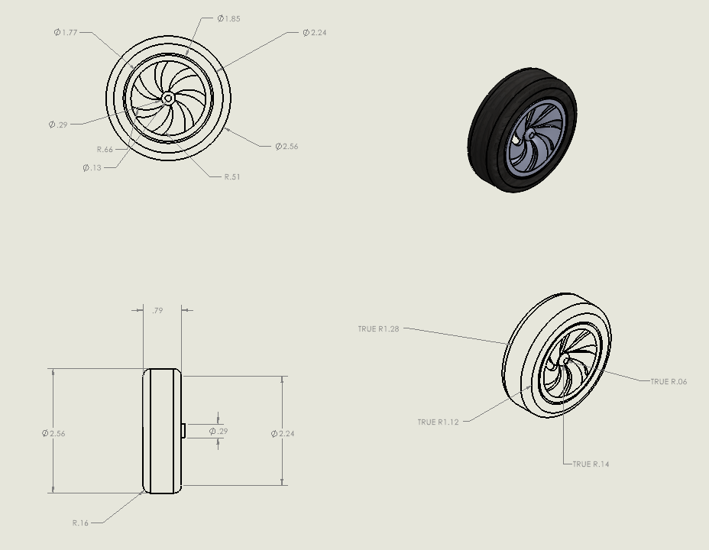

**Chassis--**

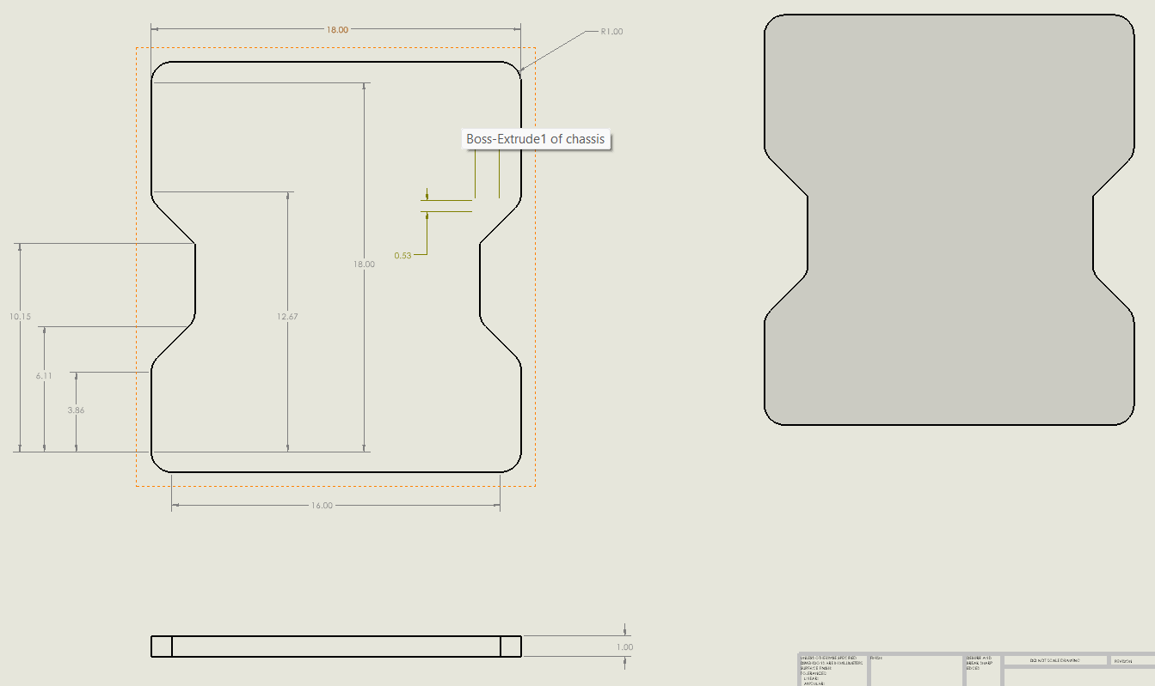

**DC Motor--**

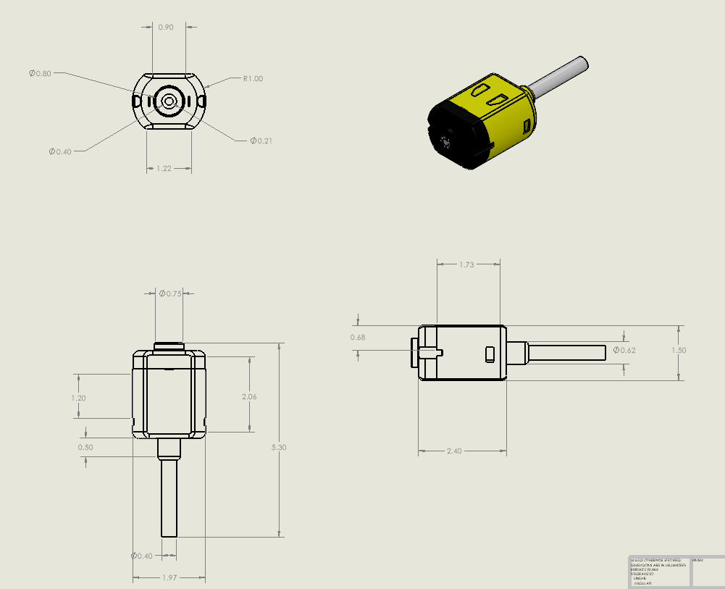

**Sensor--**

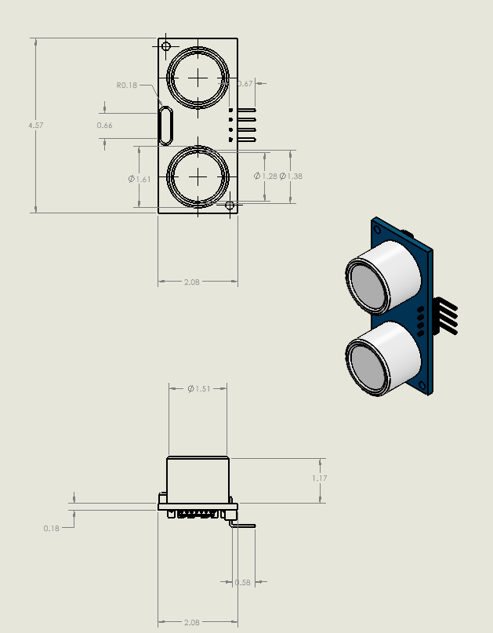

**Motor Driver--**

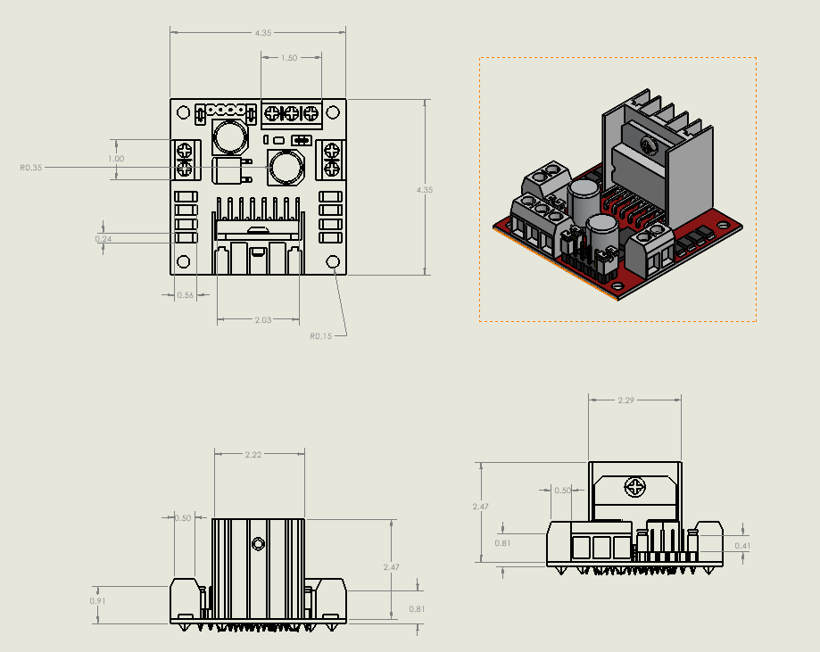

**Buck Convertor--**

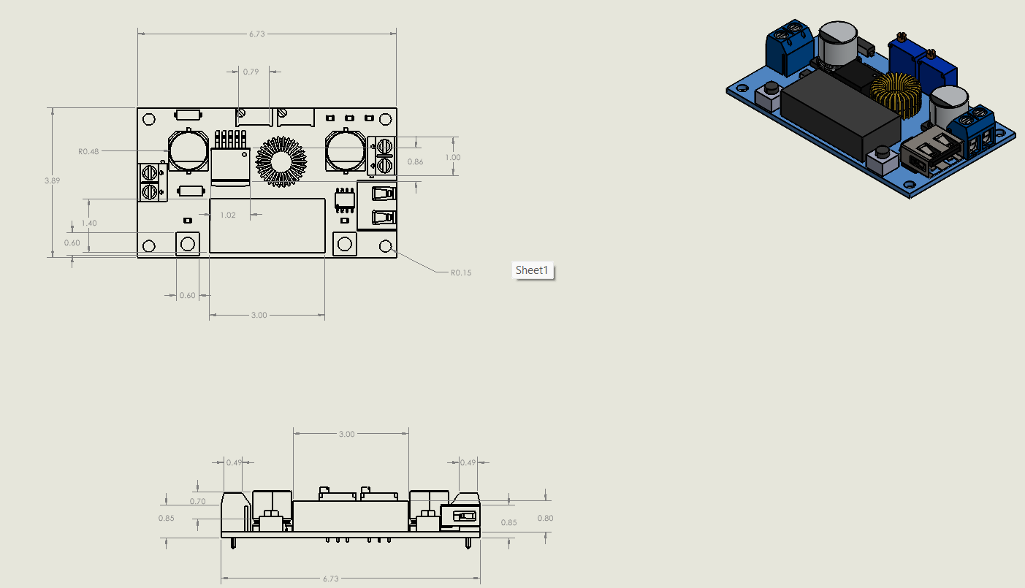

**Support--**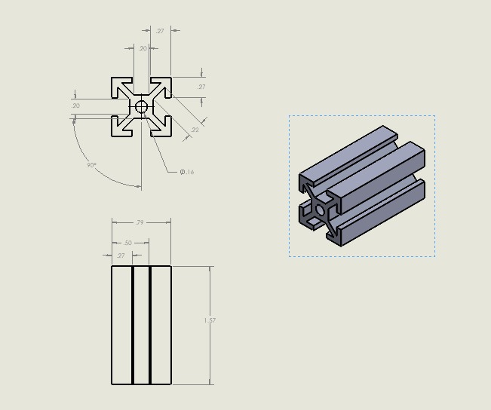

**Mount--**

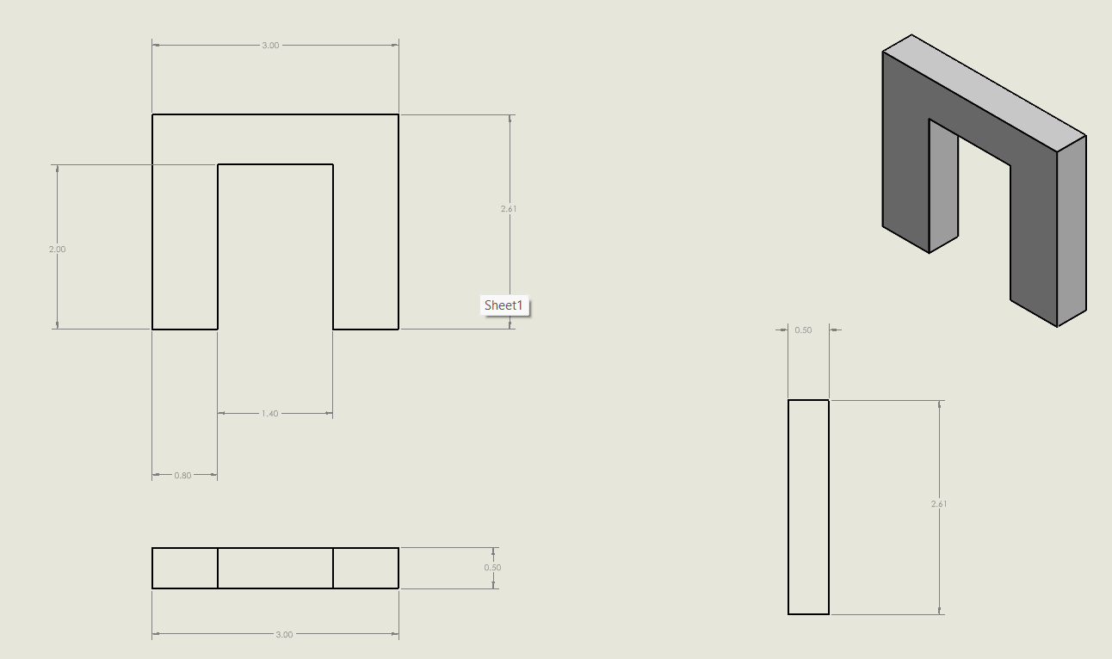

**Esp--**

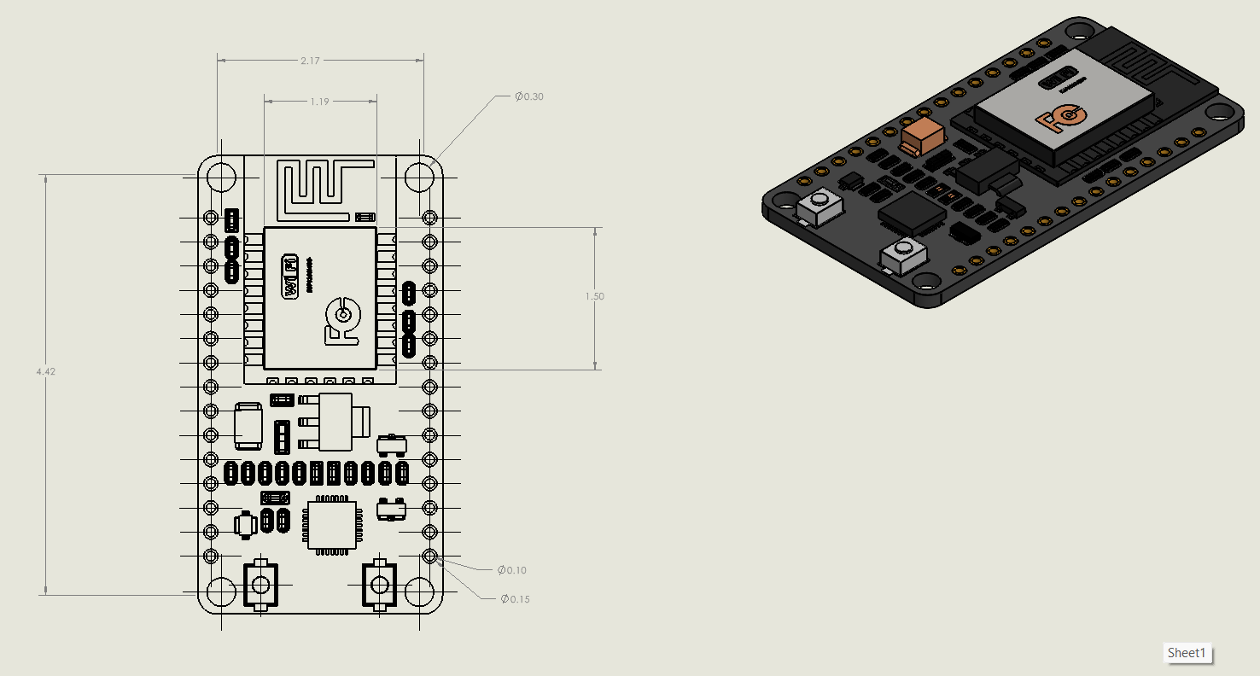

**Individual Solid Model Assembly**

|  |  |  |  |
| --- | --- | --- | --- |
| 1. **No** | **Roll Number** | **Name** | **Email** |
| **1.** | **B24147** | **Piyush Kanwat** | **[B24147@students.iitmandi.ac.in](mailto:B24147@students.iitmandi.ac.in)** |

**Image:-**

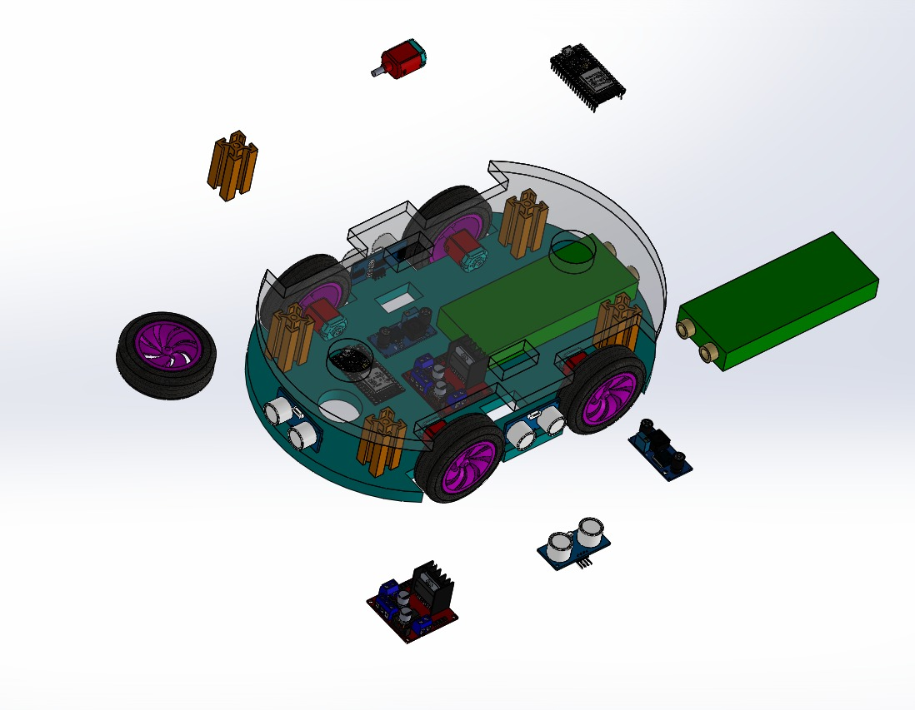

**Individual Solid Model Assembly**

|  |  |  |  |
| --- | --- | --- | --- |
| **S.No** | **Roll Number** | **Name** | **Email** |
| **2.** | **B24148** | **Pranab Pandey** | **[B24148@students.iitmandi.ac.in](mailto:B24148@students.iitmandi.ac.in)** |

**Image:-**



**Individual Solid Model Assembly**

|  |  |  |  |
| --- | --- | --- | --- |
| **S.No** | **Roll Number** | **Name** | **Email** |
| **3.** | **B24149** | **Priyanshu Saini** | **[B24149@students.iitmandi.ac.in](mailto:B24149@students.iitmandi.ac.in)** |

**Image:-**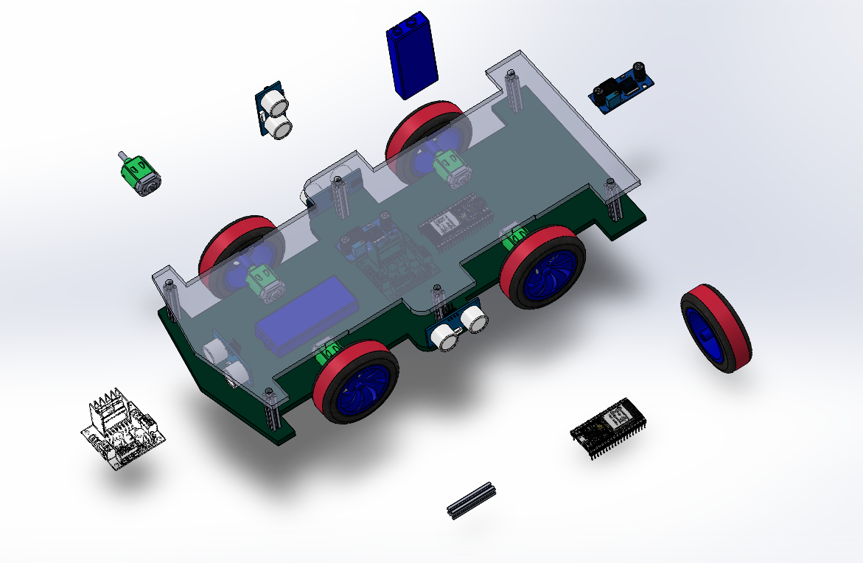

**Individual Solid Model Assembly**

|  |  |  |  |
| --- | --- | --- | --- |
| **S.No** | **Roll Number** | **Name** | **Email** |
| **4.** | **B24150** | **Puspender Yadav** | **[B24150@students.iitmandi.ac.in](mailto:B24150@students.iitmandi.ac.in)** |

**Image:-**

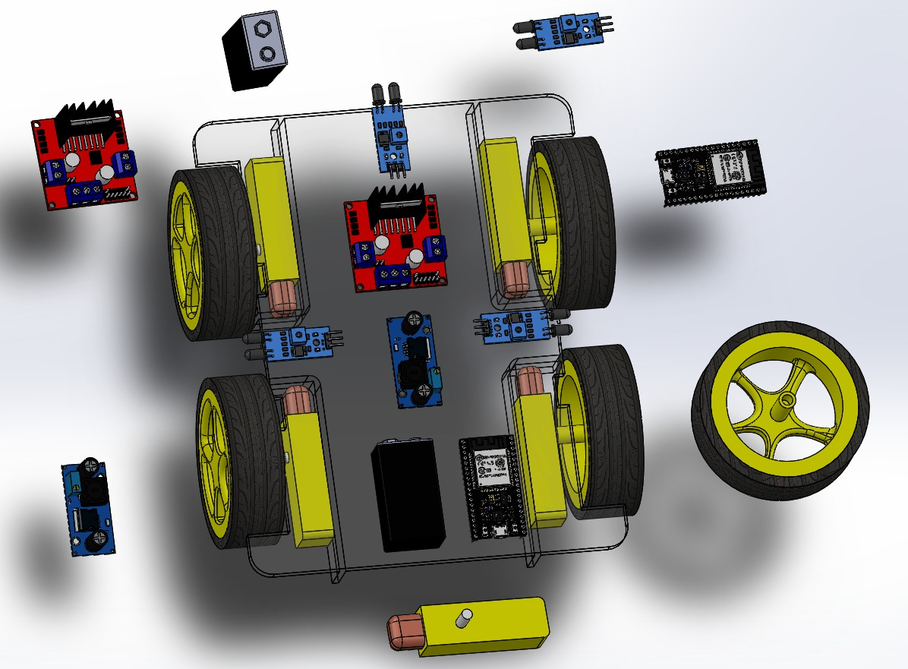

**Individual Solid Model Assembly**

|  |  |  |  |
| --- | --- | --- | --- |
| 1. **No** | **Roll Number** | **Name** | **Email** |
| **5.** | **B24151** | **Rishabh Bagul** | **[B24151@students.iitmandi.ac.in](mailto:B24151@students.iitmandi.ac.in)** |

**Image:-**

